The LangTran system –
“LangTran Update” setup information
Jim Henderson
Owner_LangTran@SIL.org

Introduction
Well, you have looked through the file 1_LangTran_setup.pdf, and you have decided to use the “LangTran Update” method to get updates of programs for language work. This will let you run a program script each day (or whenever you have a good internet connection) to get the updates from the LangTran server.
To use the system, you will need to download the installer and run it. Before you can run LangTranUpdate for the first time, you will need to specify which folders of installers you want to get. You do this by editing a control file, called LangTranUpdate.txt. For each group you want, delete the hash (#) character at the beginning of the line for that group. Save the file and close the editor. (On a Windows system, this control file opens automatically in notepad. On a Linux or Mac system, you will need to edit this file using the methods described in section 2.2 for Linux or 2.3 for Mac.)
After that, whenever you want to run the updater, just double-click its icon, on the desktop or in the START menu, (All Programs section for Windows, Internet section for Linux or in the folder Users\Public/LangTranLocal on a Mac.).
If you use a Linux system, the files in the folder called Linux will be useful to you. If you use a Macintosh system, you should get the folder Mac. If you use a Windows system, you can choose to get everything for Windows computers, or you can choose a subset of folders. (The installer will provide a folder called Basis_win for you, and it will stay up-to-date. You need it for the system to work, so please don't delete it.).
Users of all systems can find the files in the folders Android_apps, References_all, TECkit_maps and Videos useful. There are also folders for training videos in non-English languages.
Folder names that contain _win hold installers that will only work in the Windows operating system. Names containing _win64 hold installers that will only work in 64-bit versions of Windows. Group names without any platform section (or _all) hold installers or information suitable for any operating system.
In the folder where you found this file, you should also see a file called LangTranFiles.txt, which lists all the files in all the LangTran Groups. It is updated regularly, and is also downloaded to the folder for your operating system each time you run the update script. Any time you want to locate a particular installer, you can search this file for it, and find the folder where it is stored. The folder names contain descriptions of the software inside them.
If installing software is difficult or unfamiliar for you, I suggest you ask someone to help you. If you have a good internet connection, you could email me at the address above, and we could connect our computers together and I could walk you through setting up the system.

Getting the LangTranUpdate software
If you are installing this system on a Linux system, jump down to section 2.2, or on a Mac, jump down to section 2.3.

Windows
Click on this link: LangTran_Software and find the file with a name like
LangTranUpdate-v3.03-Setup.exe. Right-click this file and select Download.
Save the installer in your Downloads folder or some other suitable place, then run the program.
Work through the steps in the installer, choosing where you want the updater to put the files that it downloads for you. (This could be a folder on your computer’s hard disc, or on a thumb drive.)
After that, the installer will open the control file in Notepad so that you can select the Groups of folders that you want to get whenever you do an update. Here's part of the control file, with my comment in italics:
# Windows-only programs, English versions:
# ========================================
# If you use a Windows computer
# and you want to get installers for everything you might need,
# delete the hash (#) character at the start of the next line
# Win_everything_en This one includes all the “Windows components” below, but not the non-English folders.

# If you would rather choose individual components,
# you can choose them at "Windows components" below.
#
# But first, you might want to get the versions of Windows programs in other languages:
#
# French_win # French versions of Windows utility programs.
# Indonesian_win # Indonesian versions
# Portuguese_win # Portuguese versions etc
# Russian_win
# Spanish_win
# or you might like to get MS Office updates etc:
# Large_System_Files_win
#
# Windows components:
# ===================
# Instead of enabling "Win_everything_en" to get all of these,
# you can enable individual lines below to get smaller updates.

# Win_everything_en/Anthropology_win # Windows programs for tasks in Anthropology
# Win_everything_en/Fonts_win # Windows installers for fonts
# Win_everything_en/Internet_win # Windows progs for Internet tasks
# Win_everything_en/Linguistics_win
# Win_everything_en/Literacy_win

If you just want to select everything an English-speaking user could want on the Windows platform, delete the hash (#) character before the line: # Win_everything_en
If you want a different selection, work your way through the control file, enabling whatever lines you want to. (There is no need to remove comments from the file – just delete the hash character at the beginning of the line to enable its group.)
If you want to support Linux and Mac systems on your local network, look further down the file and enable lines as appropriate.
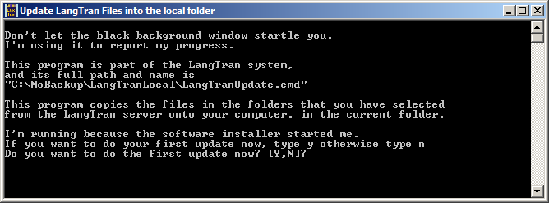
Then save the file and exit from Notepad, and the updating process will start, displaying a window like this:
If you really don't want to run the first update now, you can type in “n” instead of “y”, and the update will stop.
When you do want to do the update, run the program from its icon.
As the program continues running, it will display many messages in this window. You don't have to read them all, but if something goes wrong, a screenshot of the window can help us work out what happened.
When the update finishes, the program will list the files you have downloaded, compare them with a list of the files as they were before the download, and show you the differences in Notepad. Here are some sample differences:
@@ -1496,8 +1498,6 @@
30-Jul-2013 05:06 553,472 SetupOdtXslt-1.11.msi
-24-Aug-2013 07:05 19,435,520 SetupPw7BTE-1.4.0.3397.msi
-18-Mar-2014 07:18 20,931,584 SetupPw7BTE-1.7.2.3640.msi
+16-Sep-2014 04:23 19,722,240 SetupPw7BTE-1.12.0.4302.msi
11-Sep-2014 00:02 19,722,240 SetupPw7BTE.msi
-01-Dec-2013 13:31 17,793,024 SetupPw7BteTesting.msi
From that you can see what has changed. Three files have been removed (-) and one new one has taken their place (+).
Look through the file then close Notepad, and the update script will continue.
If you would like to use other software, such as WinMerge, to look at the before-and-after differences, you can install the program from the LangTran folder
Win_main\Utility_win\WinMerge_compare_n_merge_files_n_folders
and you will find the lists to compare in the folder FileLists.
Files of differences are stored in the folder Diffs. The update script prunes both these folders, to keep just the last 16 files in each folder.
If you would like to change the way LangTranUpdate works, such as keeping an archive of installers or making the program more persistent, see section 3 of this document.

Linux
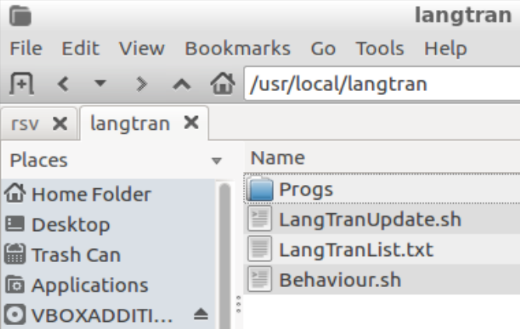
You will find the Linux installer in the folder LangTran_Software, and it will have a name like langtran-3.03.deb. Download it to your Downloads folder, and then use the filesystem explorer to navigate there and double-click the installer.
It will install the program and control files in /usr/local/langtran, like this:
Before you run the update script you will need to tell it which folders of installers you want to get and keep up-to-date on your computer. To do this, you need to edit the file LangTranList.txt, so right-click that file and select a suitable editor in your system, such as Leafpad or Gedit.
(You can also open the Menu, go to Preferences and select the option
LangTran List of folders to get. This will open the file in the simple editor, nano.)
Here’s part of the control file, with my comment in italics.
# Software only for Linux computers:
# ==================================
# If you want to get all software suitable for Linux systems,
# remove the hash (#) character from the start of the next line:
# Linux # General Linux programs, settings and utilities
That one includes all the Linux items below, but not the folders described as “large”.
# If you want to choose only some of those,
# select from the lines below and remove the hash characters
# at the beginnings of these lines:
# Linux/Linux # The main Linux programs, not including the lines below
# Linux/Anthropology_all
# Linux/Fonts_all
# Linux/Literacy_all
# Linux/References_etc_all
# Linux/TECkit_maps # Files for converting text to another script,
# such as Unicode
# The following folders are large:
# Linux_Balsa # Balsa is Linux with language tools pre-installed
# Linux_Tech_Support_32bit # Large installers for repairing boot blocks,
# Linux_Tech_Support_64bit # which can also repair Windows systems.
# Linux_Wasta # Wasta Linux distro, easy to customize and distribute
Remove the hash characters (#) from the beginnings of the lines for the folders you want to get.
If you want your local repository to support Mac or Windows users as well as Linux users, look further down in the file and remove the hash characters as appropriate. (You might like to look at the comments near the beginning of section 2.1 of this document.)
Save the control file and close the editor (If you are editing it with nano, hold down the Ctrl key and tap O to write Out the file, then tap Enter to save the file, then do Ctrl-X to eXit the editor).

Now it’s time to run the script to do the first update. Open the menu system and select the Internet section, and in there select the option
LangTranUpdate.
You’ll see a display like this.
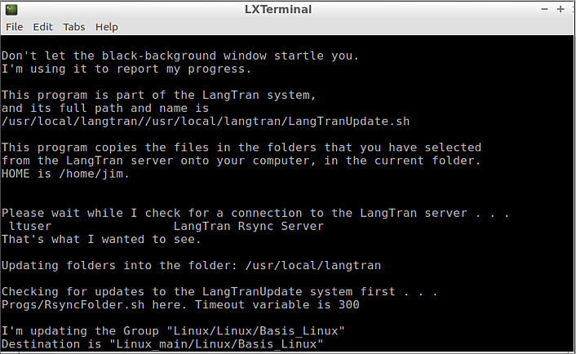
There is no need to read all the comments, but if something goes wrong, send us a screenshot and we’ll work on fixing the problem.

At this point, the program rsync on your computer is checking for a connection to the LangTran server, and finding it.
Further reports continue as the script checks for updates in the different folders.
When the update finishes, the program will list the files you have downloaded, compare them with a list of the files as they were before the download, and show you the differences in your pager, which is less by default. Here are some sample differences:
@@ -1496,8 +1498,6 @@
30-Jul-2013 05:06 553,472 SetupOdtXslt-1.11.msi
-24-Aug-2013 07:05 19,435,520 SetupPw7BTE-1.4.0.3397.msi
-18-Mar-2014 07:18 20,931,584 SetupPw7BTE-1.7.2.3640.msi
+16-Sep-2014 04:23 19,722,240 SetupPw7BTE-1.12.0.4302.msi
11-Sep-2014 00:02 19,722,240 SetupPw7BTE.msi
-01-Dec-2013 13:31 17,793,024 SetupPw7BteTesting.msi
From that you can see what has changed. Three files have been removed (-) and one new one has taken their place (+).
Look through the file then type q to close your pager, and the update script will continue.
If you would like to use other software to look at the before-and-after differences, you will find the lists to compare in the folder FileLists.
Files of differences are stored in the folder Diffs. The update script prunes both these folders, to keep just the last 16 files in each folder.
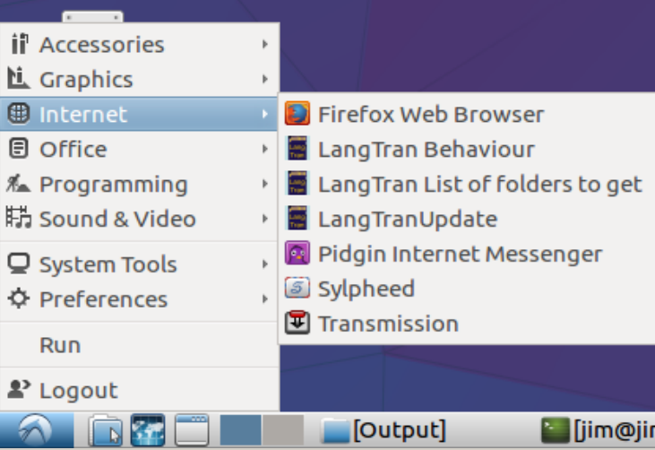
Whenever you want to run the Update script, open the START menu and go to the Internet section.
There you will find LangTran Behaviour to enable archiving or Persistent mode,
LangTran List of folders to get to change selections and LangTranUpdate to run the update script each day.
The Preferences menu also contains these items for changing how LangTranUpdate operates.
Modifying Behaviour is described in section 3.

Mac
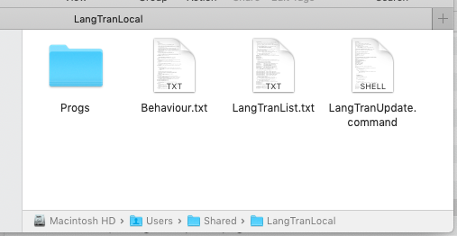
You will find the Mac installer in the folder LangTran_Software, and it will have a name like LangTranUpdate-3.06.dmg. Download it to your Downloads folder, and then use Finder to navigate there and double-click the installer.
It will mount the disk image. Double-click the installer LangTranUpdate.pkg and work through the steps to install the program and control files in /Users/Shared/langTranLocal, like this:
Before you run the update script you will need to navigate to this folder.
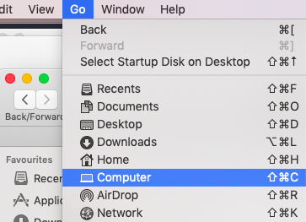
To get to that folder, in Finder, open the Go menu and select Computer. (Or you can use the shortcut, Command-Shift-C.)
Then open the startup disc, probably called Macintosh HD.
Double-click Users and then Shared, and then LangTranLocal.
Next you need to tell the system which folders of installers you want to get and keep up-to-date on your computer. To do this, you need to edit the file LangTranList.txt, so double-click it to open it in TextEdit.
Here’s part of that control file, with my comment in italics.
# LangTranList.txt
# List of folders of installers that you can automatically update.
#
# Please edit this file and save it and close the editor.
#
# This line is a comment, because it begins with a hash character (#).
#
# A list of foldernames follows.
# If you remove the hash character from the beginning of a line,
# the program LangTranUpdate will get updates
# from that folder at the LangTran repository.
#
# Don't remove the # characters from lines indented like this.
#
# Software only for Mac computers:
# ================================
# If you want to get all software suitable for Mac systems,
# remove the hash (#) character from the start of the next line:
# Mac # A wide selection of Mac programs

# If you want to choose only some of those,
# select from the lines below and remove the hash characters
# at the beginnings of these lines:
# Mac/Mac # the main Mac programs, not including the lines below
# Mac/Anthropology_all
# Mac/Fonts_all
# Mac/Internet_Mac
# Mac/Literacy_all
# Mac/References_etc_all
# Mac/TECkit_maps
Remove the hash characters (#) from the beginnings of the lines for the folders you want to get.
If you want your local repository to support Linux or Windows users as well as Mac users, look further down in the file and remove the hash characters as appropriate. (You might like to look at the comments near the beginning of section 2.1 of this document.)
Save the control file and close the editor.
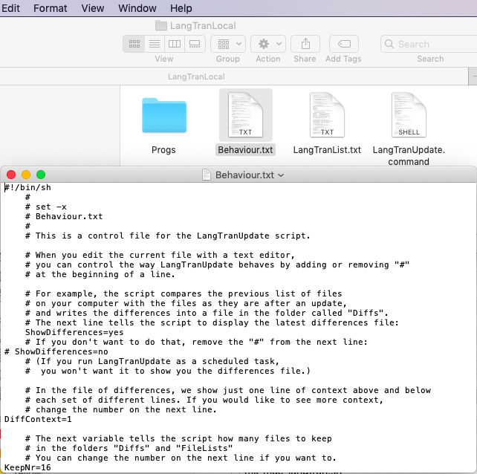
If you would like to keep an archive of older versions of installers, double-click the file Behaviour.txt and work through the comments in it, removing a hash character or changing a value as appropriate.

When you have finished editing the behaviour options, save the file and close the editor.
Now it’s time to run the script to do the first update. Double-click LangTranUpdate.command.
You’ll see a display like this.
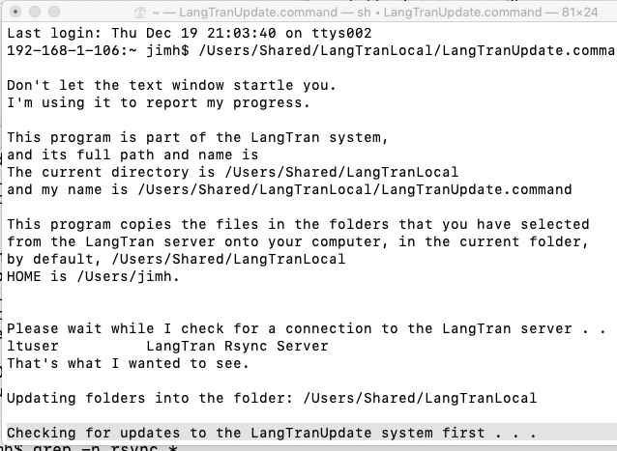
There is no need to read all the comments, but if something goes wrong, send us a screenshot and we’ll work on fixing the problem.

At this point, the program rsync on your computer is checking for a connection to the LangTran server, and finding it.
Further reports continue as the script checks for updates in the different folders.
When the update finishes, the program will list the files you have downloaded, compare them with a list of the files as they were before the download, and show you the differences in your pager, which is less by default. Here are some sample differences:
@@ -1496,8 +1498,6 @@
30-Jul-2013 05:06 553,472 SetupOdtXslt-1.11.msi
-24-Aug-2013 07:05 19,435,520 SetupPw7BTE-1.4.0.3397.msi
-18-Mar-2014 07:18 20,931,584 SetupPw7BTE-1.7.2.3640.msi
+16-Sep-2014 04:23 19,722,240 SetupPw7BTE-1.12.0.4302.msi
11-Sep-2014 00:02 19,722,240 SetupPw7BTE.msi
-01-Dec-2013 13:31 17,793,024 SetupPw7BteTesting.msi
From that you can see what has changed. Three files have been removed (-) and one new one has taken their place (+).
Look through the file then type q to close your pager, and the update script will continue.
If you would like to use other software to look at the before-and-after differences, you will find the lists to compare in the folder FileLists.
Files of differences are stored in the folder Diffs. The update script prunes both these folders, to keep just the last 16 files in each folder.
Whenever you want to run the Update script, use Finder to go to the folder /Users/Shared/LangTranLocal as described above and double-click LangTranUpdate.command.
Modifying Behaviour is described in section 3.

Modifying how LangTranUpdate works
This system reads preferences from a file that you can edit, so you can modify how the program works. On Windows systems there is an icon in the START menu (All Programs section), and perhaps also on the desktop, which will let you Change behaviour of LangTranUpdate that will open this file for you to edit.
On a Linux system, the Preferences menu contains an item, LangTran Behaviour for changing how LangTranUpdate operates.
On a Mac, use Finder to Go to Computer and then to Users/Shared/LangTranLocal and open the file Behaviour.txt.

To keep an archive of things you have downloaded:
In the Behaviour file there is a section for controlling archiving, like this
rem Some people like to keep an archive of files,
rem in case the latest version of a program doesn't work properly
rem and they want to remove it and reinstall the previous version.
set KeepArchive=no
rem If you want to keep old versions on your computer,
rem remove the "rem" from the next line:
rem set KeepArchive=yes
(For Linux and Mac systems, the comment marker is “#”, not “rem”.)
If your internet connection is usually unreliable, you can turn on the option called Persistent. This will increase the timeout for the rsync connection, and try five times for each folder.
There are other points in this file where you can remove rem (or #) or change a number to modify how the program behaves.

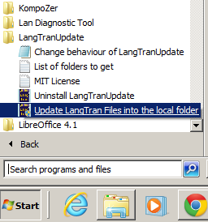
Running LangTranUpdate each day
Whenever you want to update your local LangTran repository from the international one, run the script LangTranUpdate. On a Windows system, the installer will place an icon in the START menu, in the section All Programs. The program group looks like this:
The icon to do the update is called
Update LangTran Files into the local folder.
You can also see in that picture the icon
Change behaviour of LangTranUpdate, that you can use to change how the program operates.
And if you want to change the folders that you update each time, the icon to help you do that is called List of folders to get.
End of file 2 in LangTran Update setup documentation.

