LangTran data flow diagram
Owner_LangTran@SIL.org

LangTranUpdate and BTSync
server
downloads.sil.org
or
downloads.palaso.org
or wherever

Synchronization
on request
automatic
synchronization



Ketarin
program
BTSync
client


LangTranUpdate
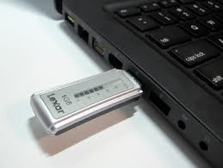

Developers

BTSync
User
LangTranUpdate User

Developers put their programs up on their websites as usual.
The LangTran administrator runs the Ketarin program on the LangTran server every day to get any updated programs.
BTSync users find that the BTSync clients on their computers get the updates automatically, whenever they are available.
Whenever a LangTranUpdate user wants to update her installers, she runs the LangTranUpdate program
to update the installers to her LangTranLocal folder, which may be on her hard disk or on a USB memory stick.

