Credit Card Fraud Detection in R

Langat Erick

2023-06-18

# **Credit Card Fraud Detection in R**

### **Introduction**

Credit card fraud is a major concern for financial institutions and consumers alike. Fraudulent transactions not only result in financial loses for banks, but can damage their reputation and lose the trust of customers. The increase in online transactions over the past decade has made real-time detection and prevention of financial fraud even more important.

A dataset has been provided that contains credit card transactions over a period of 2 days from September 2013. The dataset is highly unbalanced - containing 492 fraudulent transactions out of 284,807 total. To maintain anonymity and confidentiality, most of the original features have been transformed into principle components. Only the features time, class and amount have been preserved in their original form.

This notebook represents an attempt to analyse the data within the dataset and recommend a model that could be used for a practical credit card fraud detection system.

**Project Outline**

1. Importing libraries and dataset
2. Data Exploration
3. Data Manipulation
4. Data Modelling
   * 4.1 Logistic Regression
   * 4.2 Naive Bayes Classifier
   * 4.3 Decision Tree
5. Results and Limitations
6. Conclusion

#### **Importing libraries and dataset**

library(tidyverse)  
# library(Hmisc)  
library(caret)  
library(ROSE)  
library(ggplot2)  
#library(gridExtra)  
library(e1071)  
library(corrplot)  
library(broom)  
library(partykit)

# Load the dataset  
  
data <- read.csv('C:/Users/JIT/Desktop/creditcard.csv',  
 stringsAsFactors = T)  
head(data)

## Time V1 V2 V3 V4 V5 V6  
## 1 0 -1.3598071 -0.07278117 2.5363467 1.3781552 -0.33832077 0.46238778  
## 2 0 1.1918571 0.26615071 0.1664801 0.4481541 0.06001765 -0.08236081  
## 3 1 -1.3583541 -1.34016307 1.7732093 0.3797796 -0.50319813 1.80049938  
## 4 1 -0.9662717 -0.18522601 1.7929933 -0.8632913 -0.01030888 1.24720317  
## 5 2 -1.1582331 0.87773675 1.5487178 0.4030339 -0.40719338 0.09592146  
## 6 2 -0.4259659 0.96052304 1.1411093 -0.1682521 0.42098688 -0.02972755  
## V7 V8 V9 V10 V11 V12  
## 1 0.23959855 0.09869790 0.3637870 0.09079417 -0.5515995 -0.61780086  
## 2 -0.07880298 0.08510165 -0.2554251 -0.16697441 1.6127267 1.06523531  
## 3 0.79146096 0.24767579 -1.5146543 0.20764287 0.6245015 0.06608369  
## 4 0.23760894 0.37743587 -1.3870241 -0.05495192 -0.2264873 0.17822823  
## 5 0.59294075 -0.27053268 0.8177393 0.75307443 -0.8228429 0.53819555  
## 6 0.47620095 0.26031433 -0.5686714 -0.37140720 1.3412620 0.35989384  
## V13 V14 V15 V16 V17 V18  
## 1 -0.9913898 -0.3111694 1.4681770 -0.4704005 0.20797124 0.02579058  
## 2 0.4890950 -0.1437723 0.6355581 0.4639170 -0.11480466 -0.18336127  
## 3 0.7172927 -0.1659459 2.3458649 -2.8900832 1.10996938 -0.12135931  
## 4 0.5077569 -0.2879237 -0.6314181 -1.0596472 -0.68409279 1.96577500  
## 5 1.3458516 -1.1196698 0.1751211 -0.4514492 -0.23703324 -0.03819479  
## 6 -0.3580907 -0.1371337 0.5176168 0.4017259 -0.05813282 0.06865315  
## V19 V20 V21 V22 V23 V24  
## 1 0.40399296 0.25141210 -0.018306778 0.277837576 -0.11047391 0.06692807  
## 2 -0.14578304 -0.06908314 -0.225775248 -0.638671953 0.10128802 -0.33984648  
## 3 -2.26185710 0.52497973 0.247998153 0.771679402 0.90941226 -0.68928096  
## 4 -1.23262197 -0.20803778 -0.108300452 0.005273597 -0.19032052 -1.17557533  
## 5 0.80348692 0.40854236 -0.009430697 0.798278495 -0.13745808 0.14126698  
## 6 -0.03319379 0.08496767 -0.208253515 -0.559824796 -0.02639767 -0.37142658  
## V25 V26 V27 V28 Amount Class  
## 1 0.1285394 -0.1891148 0.133558377 -0.02105305 149.62 0  
## 2 0.1671704 0.1258945 -0.008983099 0.01472417 2.69 0  
## 3 -0.3276418 -0.1390966 -0.055352794 -0.05975184 378.66 0  
## 4 0.6473760 -0.2219288 0.062722849 0.06145763 123.50 0  
## 5 -0.2060096 0.5022922 0.219422230 0.21515315 69.99 0  
## 6 -0.2327938 0.1059148 0.253844225 0.08108026 3.67 0

str(data)

## 'data.frame': 284807 obs. of 31 variables:  
## $ Time : num 0 0 1 1 2 2 4 7 7 9 ...  
## $ V1 : num -1.36 1.192 -1.358 -0.966 -1.158 ...  
## $ V2 : num -0.0728 0.2662 -1.3402 -0.1852 0.8777 ...  
## $ V3 : num 2.536 0.166 1.773 1.793 1.549 ...  
## $ V4 : num 1.378 0.448 0.38 -0.863 0.403 ...  
## $ V5 : num -0.3383 0.06 -0.5032 -0.0103 -0.4072 ...  
## $ V6 : num 0.4624 -0.0824 1.8005 1.2472 0.0959 ...  
## $ V7 : num 0.2396 -0.0788 0.7915 0.2376 0.5929 ...  
## $ V8 : num 0.0987 0.0851 0.2477 0.3774 -0.2705 ...  
## $ V9 : num 0.364 -0.255 -1.515 -1.387 0.818 ...  
## $ V10 : num 0.0908 -0.167 0.2076 -0.055 0.7531 ...  
## $ V11 : num -0.552 1.613 0.625 -0.226 -0.823 ...  
## $ V12 : num -0.6178 1.0652 0.0661 0.1782 0.5382 ...  
## $ V13 : num -0.991 0.489 0.717 0.508 1.346 ...  
## $ V14 : num -0.311 -0.144 -0.166 -0.288 -1.12 ...  
## $ V15 : num 1.468 0.636 2.346 -0.631 0.175 ...  
## $ V16 : num -0.47 0.464 -2.89 -1.06 -0.451 ...  
## $ V17 : num 0.208 -0.115 1.11 -0.684 -0.237 ...  
## $ V18 : num 0.0258 -0.1834 -0.1214 1.9658 -0.0382 ...  
## $ V19 : num 0.404 -0.146 -2.262 -1.233 0.803 ...  
## $ V20 : num 0.2514 -0.0691 0.525 -0.208 0.4085 ...  
## $ V21 : num -0.01831 -0.22578 0.248 -0.1083 -0.00943 ...  
## $ V22 : num 0.27784 -0.63867 0.77168 0.00527 0.79828 ...  
## $ V23 : num -0.11 0.101 0.909 -0.19 -0.137 ...  
## $ V24 : num 0.0669 -0.3398 -0.6893 -1.1756 0.1413 ...  
## $ V25 : num 0.129 0.167 -0.328 0.647 -0.206 ...  
## $ V26 : num -0.189 0.126 -0.139 -0.222 0.502 ...  
## $ V27 : num 0.13356 -0.00898 -0.05535 0.06272 0.21942 ...  
## $ V28 : num -0.0211 0.0147 -0.0598 0.0615 0.2152 ...  
## $ Amount: num 149.62 2.69 378.66 123.5 69.99 ...  
## $ Class : int 0 0 0 0 0 0 0 0 0 0 ...

# Convert Class column into Factors  
  
data$Class <- as.factor(data$Class)  
levels(data$Class) <- c("Legit", "Fraud")

#### **Data Exploration**

summary(data)

## Time V1 V2 V3   
## Min. : 0 Min. :-56.40751 Min. :-72.71573 Min. :-48.3256   
## 1st Qu.: 54202 1st Qu.: -0.92037 1st Qu.: -0.59855 1st Qu.: -0.8904   
## Median : 84692 Median : 0.01811 Median : 0.06549 Median : 0.1799   
## Mean : 94814 Mean : 0.00000 Mean : 0.00000 Mean : 0.0000   
## 3rd Qu.:139321 3rd Qu.: 1.31564 3rd Qu.: 0.80372 3rd Qu.: 1.0272   
## Max. :172792 Max. : 2.45493 Max. : 22.05773 Max. : 9.3826   
## V4 V5 V6 V7   
## Min. :-5.68317 Min. :-113.74331 Min. :-26.1605 Min. :-43.5572   
## 1st Qu.:-0.84864 1st Qu.: -0.69160 1st Qu.: -0.7683 1st Qu.: -0.5541   
## Median :-0.01985 Median : -0.05434 Median : -0.2742 Median : 0.0401   
## Mean : 0.00000 Mean : 0.00000 Mean : 0.0000 Mean : 0.0000   
## 3rd Qu.: 0.74334 3rd Qu.: 0.61193 3rd Qu.: 0.3986 3rd Qu.: 0.5704   
## Max. :16.87534 Max. : 34.80167 Max. : 73.3016 Max. :120.5895   
## V8 V9 V10 V11   
## Min. :-73.21672 Min. :-13.43407 Min. :-24.58826 Min. :-4.79747   
## 1st Qu.: -0.20863 1st Qu.: -0.64310 1st Qu.: -0.53543 1st Qu.:-0.76249   
## Median : 0.02236 Median : -0.05143 Median : -0.09292 Median :-0.03276   
## Mean : 0.00000 Mean : 0.00000 Mean : 0.00000 Mean : 0.00000   
## 3rd Qu.: 0.32735 3rd Qu.: 0.59714 3rd Qu.: 0.45392 3rd Qu.: 0.73959   
## Max. : 20.00721 Max. : 15.59500 Max. : 23.74514 Max. :12.01891   
## V12 V13 V14 V15   
## Min. :-18.6837 Min. :-5.79188 Min. :-19.2143 Min. :-4.49894   
## 1st Qu.: -0.4056 1st Qu.:-0.64854 1st Qu.: -0.4256 1st Qu.:-0.58288   
## Median : 0.1400 Median :-0.01357 Median : 0.0506 Median : 0.04807   
## Mean : 0.0000 Mean : 0.00000 Mean : 0.0000 Mean : 0.00000   
## 3rd Qu.: 0.6182 3rd Qu.: 0.66251 3rd Qu.: 0.4931 3rd Qu.: 0.64882   
## Max. : 7.8484 Max. : 7.12688 Max. : 10.5268 Max. : 8.87774   
## V16 V17 V18   
## Min. :-14.12985 Min. :-25.16280 Min. :-9.498746   
## 1st Qu.: -0.46804 1st Qu.: -0.48375 1st Qu.:-0.498850   
## Median : 0.06641 Median : -0.06568 Median :-0.003636   
## Mean : 0.00000 Mean : 0.00000 Mean : 0.000000   
## 3rd Qu.: 0.52330 3rd Qu.: 0.39968 3rd Qu.: 0.500807   
## Max. : 17.31511 Max. : 9.25353 Max. : 5.041069   
## V19 V20 V21   
## Min. :-7.213527 Min. :-54.49772 Min. :-34.83038   
## 1st Qu.:-0.456299 1st Qu.: -0.21172 1st Qu.: -0.22839   
## Median : 0.003735 Median : -0.06248 Median : -0.02945   
## Mean : 0.000000 Mean : 0.00000 Mean : 0.00000   
## 3rd Qu.: 0.458949 3rd Qu.: 0.13304 3rd Qu.: 0.18638   
## Max. : 5.591971 Max. : 39.42090 Max. : 27.20284   
## V22 V23 V24   
## Min. :-10.933144 Min. :-44.80774 Min. :-2.83663   
## 1st Qu.: -0.542350 1st Qu.: -0.16185 1st Qu.:-0.35459   
## Median : 0.006782 Median : -0.01119 Median : 0.04098   
## Mean : 0.000000 Mean : 0.00000 Mean : 0.00000   
## 3rd Qu.: 0.528554 3rd Qu.: 0.14764 3rd Qu.: 0.43953   
## Max. : 10.503090 Max. : 22.52841 Max. : 4.58455   
## V25 V26 V27   
## Min. :-10.29540 Min. :-2.60455 Min. :-22.565679   
## 1st Qu.: -0.31715 1st Qu.:-0.32698 1st Qu.: -0.070840   
## Median : 0.01659 Median :-0.05214 Median : 0.001342   
## Mean : 0.00000 Mean : 0.00000 Mean : 0.000000   
## 3rd Qu.: 0.35072 3rd Qu.: 0.24095 3rd Qu.: 0.091045   
## Max. : 7.51959 Max. : 3.51735 Max. : 31.612198   
## V28 Amount Class   
## Min. :-15.43008 Min. : 0.00 Legit:284315   
## 1st Qu.: -0.05296 1st Qu.: 5.60 Fraud: 492   
## Median : 0.01124 Median : 22.00   
## Mean : 0.00000 Mean : 88.35   
## 3rd Qu.: 0.07828 3rd Qu.: 77.17   
## Max. : 33.84781 Max. :25691.16

The majority of the data has undergone PCA, limiting the amount of information that can be obtained from most features. However, the “Amount” and “Class” features could provide some insight of the data.

ggplot(data, aes(x=Class, fill = Class)) +  
 geom_bar(color = "black") +   
 ggtitle("Bar Distribution of Class") +   
 theme(plot.title = element_text(hjust = 0.5, face = "bold"))

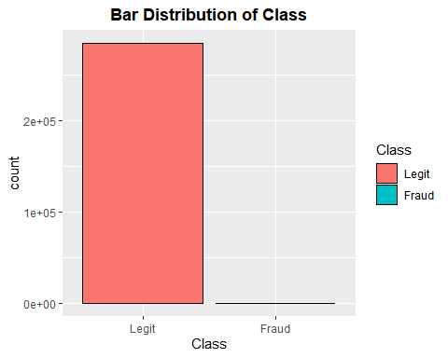

counts <- table(data$Class)  
result <- data.frame(table(data$Class), round(prop.table(counts), 5))  
noms <- c("Class", "Value", "none", "Proportion")  
  
names(result) <- noms  
  
print(result[c(1,2,4)])

## Class Value Proportion  
## 1 Legit 284315 0.99827  
## 2 Fraud 492 0.00173

* **Legit** cases constitute 99.8% (284315) of the dataset.
* **Fraud** cases constitute 0.2% (492)

As expected from the brief, analysis of the Class feature shows that the dataset is unbalanced and the vast majority of the cases are legitimate. Accuracy will not be an appropriate measure of performance here and AUC will be used instead.

p <- ggplot(data, aes(x=Amount)) + geom_histogram(fill = "green",  
 color = "black", bins = 30) +   
 ggtitle("Histogram Distribution of Amount") +  
 theme(plot.title = element_text(hjust = 0.5, face = "bold"))   
  
p

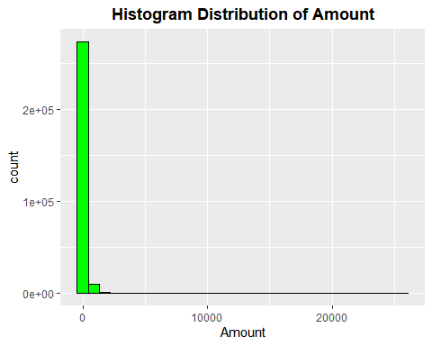

# Function to find range of outliers in Amount  
  
find_outlier_range <- function(x){  
 outliers <- boxplot.stats(x)$out  
 return(range(outliers))  
}  
  
find_outlier_range(data$Amount)

## [1] 184.52 25691.16

The histogram above shows that the vast majority of the transactions have low values. However, there are a non-neglible number of outliers with values ranging from 184.52 up to 25691.16 dollars. There is clearly a positive skew in the feature that will need to be considered during feature selection and modelling.

**Data Manipulation**

# Check for missing values  
  
colSums(is.na(data))

## Time V1 V2 V3 V4 V5 V6 V7 V8 V9 V10   
## 0 0 0 0 0 0 0 0 0 0 0   
## V11 V12 V13 V14 V15 V16 V17 V18 V19 V20 V21   
## 0 0 0 0 0 0 0 0 0 0 0   
## V22 V23 V24 V25 V26 V27 V28 Amount Class   
## 0 0 0 0 0 0 0 0 0

sum(is.na(data))

## [1] 0

There are no missing values in the dataset.

# Check for duplicate rows  
  
sum(duplicated(data))

## [1] 1081

# Remove any duplicate rows  
  
data <- distinct(data)

There are 1081 duplicate rows in the dataset which can be removed.

Also the Time feature can be removed as each value is unique and provides no predictive power.

data$Time <- NULL

# Standardise Amount feature  
  
data$Amount <- scale(data$Amount)  
  
summary(data$Amount)

## V1   
## Min. : -0.35333   
## 1st Qu.: -0.33096   
## Median : -0.26547   
## Mean : 0.00000   
## 3rd Qu.: -0.04378   
## Max. :102.24738

data2 <- data  
  
data2$Class <- as.numeric(data2$Class)  
  
corr <- cor(data2[], method = "pearson")  
  
corrplot(corr)

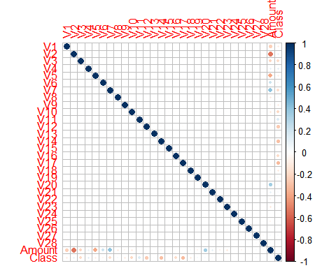

As the data has previously gone through PCA, there is little to no correlation between most of the features. Correlation between the target variable and the PCA features varys with no particular features standing out.

#### **Data Modelling**

The dataset will be split for training and testing, with 80% of the data used for training and 20% used for testing. The seed will also be set to reproduce results.

set.seed(123)  
  
indices <- createDataPartition(data$Class, p=0.8, list = F)  
trainData <- data[indices,]  
testData <- data[-indices,]

We are going to be building using the following models:

* Logistic Regression
* Naive Bayes Classifier
* Decision Tree
* **Logistic Regression**
* model_lr <- glm(Class ~ ., data = trainData, family = "binomial")

model_lr_prediction <- predict(model_lr, newdata = testData, type = 'response')   
  
roc.curve(testData$Class, model_lr_prediction, plotit = TRUE)

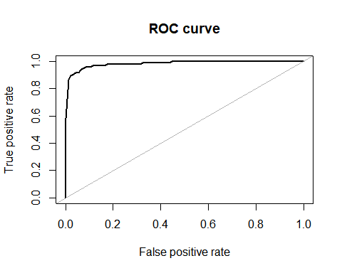

## Area under the curve (AUC): 0.983

**Naive Bayes Classifier**

NBmodCCF <- naiveBayes(Class ~ ., data = trainData, laplace = 1)  
model_nb_prediction <- predict(NBmodCCF,  
 newdata = testData,   
 type = "class")  
  
roc.curve(testData$Class, model_nb_prediction, plotit = TRUE)

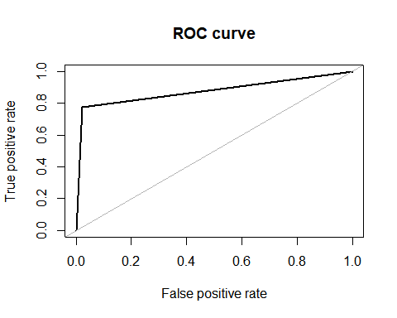

## Area under the curve (AUC): 0.877

**Decision Tree**

set.seed(123)  
  
DTmodCCF <- ctree(Class ~ .,  
 data=trainData)  
model_ctree_prediction <- predict(DTmodCCF, newdata = testData, type = "response")  
  
roc.curve(testData$Class, model_ctree_prediction, plotit = TRUE)

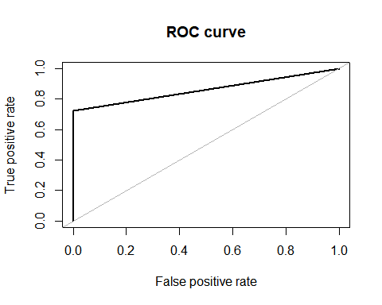

## Area under the curve (AUC): 0.862

#### **Results and Limitations**

The AUC performance results for the 3 models are as follows:

* Logistic Regression: 0.983
* Naive Bayes Classifier: 0.877
* Decision Tree: 0.856

Although the naive bayes classifier and decision tree performed well, logistic regression is the clear winner in this group.

There are some limitations of the project that may be addressed in the future that may change the outcome. These would include:

* Use of only 3 modelling techniques. If we add more modelling types in the future, there may be a model that performs even better than the LR model.
* Lack of different sampling techniques. This is something I will learn more about and add to future projects.

### **Conclusion**

In conclusion, this project aimed to develop machine learning models to detect credit card fraud. Three models were evaluated: Logistic Regression, Naive Bayes Classifier, and Decision Tree. The results showed that the Logistic Regression model achieved the highest AUC score of 0.983, while the Naive Bayes Classifier and Decision Tree models achieved AUC scores of 0.877 and 0.856, respectively.

The high AUC score of the Logistic Regression model indicates that it is able to accurately distinguish between fraudulent and non-fraudulent transactions with a high degree of confidence. Both the Naive Bayes Classifier and Decision Tree models also demonstrated good performance, with AUC scores of 0.877 and 0.856.

However, it is important to note that there are some limitations to the project, including the use of only three modeling techniques and the lack of different sampling techniques. These limitations could be addressed in future work to improve the performance of the models.

Overall, the results of this project demonstrate the potential of machine learning models in detecting credit card fraud, and highlight the importance of continued research and development in this field. With the increasing prevalence of credit card fraud, it is essential to develop accurate and efficient methods for detecting and preventing fraud. This project provides a starting point for further research in this area, and offers insights into the potential of machine learning models for detecting credit card fraud.