**TOPIC: Exams creating and managing system for teachers/lecturers  
  
  
CHAPTER 1**

1. GENERAL INTRODUCTION

In recent years, "Information Technology" has made it way to every part of our life and developed strongly in our country. The convenience and easiness of Information Technology applications is so crucial that we use them in almost all areas of life such as in education, businesses, agencies, industries, health care... We used to do it all by hands and papers, especially in education where thousands of paperwork need to be done precisely and fast. Time is of the essence and this has to change.  
  
Even as of today, simple software like MS Word and Excel are still used in education for managing paperwork, from simple timetables to complicated e-bank storing, managing and  
distributing. We need something that is cheap, easy to use, to access from anywhere, anytime. To save time is to reduce the cost of everything else, and that is the main objective of a management system.

The system our team is building is based on a website, with its own database and functions, all included in a single URL that you can access via a web browser.

Building a complete system requires many factors. As a matter of fact, software engineering procedures must be followed precisely. Although we tried our best, due to limited time and limited conditions and lack of information at first, it is inevitable that there are shortcomings in this report. Without further ado, below are the details of how the system works and its prototype.

1. PROJECT INTRODUCTION
   1. Name of project:

Developing software to manage exam questions and grading for teachers

* 1. List of project teams:

Hồ Văn Hiệu _19521497 (leader)

Nguyễn Thị Minh Loan _ 20521542

Dương Minh Thành_17521044

* 1. Project implementation time:

Total time: 1 Month

Start date: October 22, 2022

End date : November 22, 2022

1. TARGET

Complete project work according to technical requirements, within budget, on schedule (Technical - Financial - Time)

Project management is the application of tools, knowledge, and techniques to define, plan, implement, organize, control, and close projects.

Building a software to "manage the making and marking of exams" in order to systematically improve the quality of management, reduce human labor, search, store and report statistical information easily and accurately

1. PROPOSED SOLUTIONS

E-Bank management and assessment are complicated tasks, requiring managers to have meticulous, thoughtful and scientific management methods. However, as data tends to grow larger, the number of E-bank questions increases, with different subjects, courses, the job of administrators becomes more and more problematic. The only solution to this problem is: to store them all on a computer. And specifically, online.

* 1. Schedule management

Teachers and lecturers will find hard it hard to reserve a room at a particular time for planning an exam without any means to check for reservations, as for the school to manage and consult with the responsible teachers/lecturers. A schedule system is in need to ensure teachers and lecturers can coordinate time and place for an upcoming exam in the most scientific way possible.

* 1. Planning, arranging and assessing exams manually

Teachers and lecturers can create, edit and plan an exam manually on the system, with rules and orders applied to ensure consistency and precision. An assessment will also be automatically created after an exam has ended or after a particulate date, with a deadline and objectives assigned by the administrators of the system (high level personnel of the school, responsible faculties v.v..). Questions for an exam can also be manually and customarily created. They will then be collected and stored in the E-bank database.

* + 1. Regularly review and check

While choosing the exam questions, the teacher can mess up the position of each question. Therefore, to be able to ensure the position of each exam question in the library, regularly review and check each item to detect problems that arise, and find ways to fix them in a timely manner. For that matter the system also support removing, editing exam, test questions.

When a new exam is imported to the E-bank database, it requires the teacher/lecturer’s account and authentication to enable access to the E-bank database, then from there the new exam will receive a code that is associated with the responsible uploader.

Teachers/Lecturers can only obtain an account from the school’s system administrators. Teachers/Lecturers must fill in all the required information on the registration form. The administrators will check the information whether if they are correct and will proceed to save the information in the system, granting an account for them.

Each account contains the teacher/lecturer’s basic information, the department he/she is in, a schedule for exams, assessment results and the ability to access the E-bank database at will. The teacher/lecturer can also add, edit exams created by them but not others’, and exams will be validated once uploaded into the database.

The administrators report directly back to the school.

* + 1. System building

As mentioned in 1., the system will be a website, including its own database and functions like grading, assessment and schedule management, exams planning and making. The website will be built based on:

* + - Front end: HTML5, CSS, Java script
    - Back end: Java
    - Library: Node.js
    - Database: SQL server, SSMS
    - Design prototype: Figma
    - Testing platform (browser): Google Chrome(MS Windows 10)
  1. Required list

|  |  |  |  |  |
| --- | --- | --- | --- | --- |
| # | Name of requirements | Form | Rules | Notes |
| 1 | Compose the question | Form 1 | Rule 1 |  |
| 2 | Compose the exam | Form 2 | Rule 2 |  |
| 3 | Score recognition | Form 3 | Rule 3 |  |
| 4 | Look up the exams | Form 4 | Rule 4 |  |
| 5 | Make annual report | Form 5 | Rule 5 |  |

* 1. List of forms and requirements

|  |  |  |
| --- | --- | --- |
| **Form 1** | **QUESTION** |  |
| Subject: |  |  |
| Level: |  |  |
| The content of the question: |  |  |

* + 1. Requirements for making a list of questions

Rule 1:

* The lecturer is currently teaching 4 subjects.
* There are 4 difficulty levels (Easy, Medium, Complex, Hard).
  + 1. Requirements for making a list of exam

|  |  |
| --- | --- |
| **Form 2** | **EXAM** |
| Exam name: Class name: | |
| Exam duration: Exam form: | |
| Times: | |
| Question 1: The content of the question 1. | |
| Question 2: The content of the question 2. | |
|  | |

Rule 2:

* There are two forms of the exam (documented, non-documented).
* The test has a maximum of 5 questions.
* A subject has a maximum of two exams (1st time, 2nd time).
* The lecturer estimates the number of classes taught in a year to be 50 classes
* The maximum exam duration is 180 minutes and the minimum is 30 minutes.
  + 1. Requirements for making the result

|  |  |  |  |  |  |
| --- | --- | --- | --- | --- | --- |
| **Form 3** | **EXAM RESULTS** | | | | |
| Exam name: | | | | | |
| Class name: | | | | | |
| Instructor's name: | | | | | |
|  | | | | | |
| **#** | **Student ID** | **Full name** | **Scores** | **Letter point** | **Notes** |
| 1 |  |  |  |  |  |
| 2 |  |  |  |  |  |

Rule 3: Minimum score is 0 and maximum is 10

* + 1. Requirements for making list of the exam

|  |  |  |  |  |  |  |
| --- | --- | --- | --- | --- | --- | --- |
| **Form 4** | **LIST OF EXAM** | | | | | |
| **#** | **Exam code** | **Class name** | **Exam duration** | **Exam day** | **Exam form** |
| 1 |  |  |  |  |  |
| 2 |  |  |  |  |  |

* + 1. Requirements for making annual report

|  |  |  |  |  |  |  |
| --- | --- | --- | --- | --- | --- | --- |
| **Form 5** **THE REPORT** | | | | | | |
| Year: | | | | | | |
|  | Total exams: |  | | Total marks: | | |
| **#** | **Subject name** | **Number of exams** | **Total marks** | | **Exam rate** | **Score rate** |
| 1 |  |  |  | |  |  |
| 2 |  |  |  | |  |  |

**CHAPTER 2**

1. Use Case model
   1. List of Actor

|  |  |  |
| --- | --- | --- |
| # | Actor | Meaning, Notes |
| 1 | Instructor | Responsible for creating questions and exam |
| 2 | Students | View, search the list of exam |
| 3 | Management | Manage data, add/remove accounts |
| 4 | Principal | The full access |

* 1. Use case diagram
     1. Use case for instructors

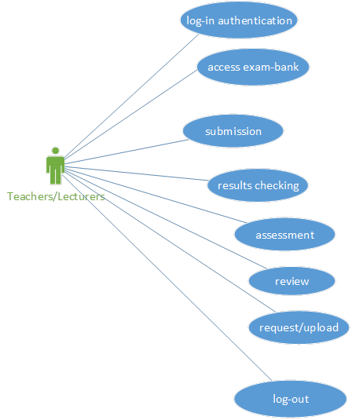

* + 1. Use case for Admin

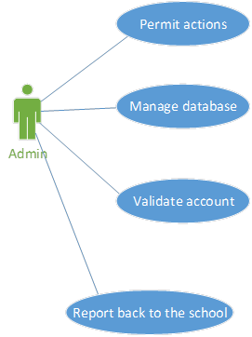

* 1. List of Use case

|  |  |  |
| --- | --- | --- |
| # | Use case | Meaning |
| 1 | Log-in | Log-in using an account |
| 2 | Log-out | Log-out from the system |
| 3 | Access E-bank | Access the exam-bank of the school |
| 4 | Submit | Task and work submission |
| 5 | Check results | Exams’ results checking |
| 6 | Assess exams | Exams’ grading and valuation |
| 7 | Review | Exams review |
| 8 | Request/Upload | Create(request) and upload test questions to the E-bank |
| 9 | Permit actions | Permit actions of the TEACHER/LECTURER actor |
| 10 | Manage database | Database management |
| 11 | Validate account | Account validation |
| 12 | Report | Report details back to the school |

* 1. Use case Specification
     1. Log-in

|  |  |  |
| --- | --- | --- |
|  | Use case Log-in |  |
| Describe | Log-in using an account |  |
| Agent | Lecturers, administrator |  |
| Main stream | Agent’s behavior | System’s behavior |
|  | 1. User clicks on login button | 2. Show login form |
|  | 3. Enter the username and password in the form | 4. Check account name and password |
|  |  | 5. Successful login message |
|  |  | 6. Switch to main interface |
| Alternative stream | *A1. User entered wrong account/password* |  |
|  | 5. Requires re-login |  |
|  | Go back to step 2 |  |
| Preconditions | Must be a teacher or administrator with an account on the system |  |
| Following conditions | Logged in to the system |  |

* + 1. Log-out

|  |  |  |
| --- | --- | --- |
|  | Use case Log-out |  |
| Describe | Log-out from the system |  |
| Agent | Lecturers, adminnistrator |  |
| Main stream | Agent’s behavior | System’s behavior |
|  | 1. User clicks on logout button | 2. Show logout form |
|  |  | 3. Successful logout message |
| Alternative stream |  |  |
| Preconditions | Logged into the system |  |
| Following conditions |  |  |

* + 1. Access E-bank

|  |  |  |
| --- | --- | --- |
|  | Use case Access E-bank |  |
| Describe | Access the exam-bank of the school |  |
| Agent | Lecturers |  |
| Main stream | Agent’s behavior | System’s behavior |
|  | 1. User clicks on “Test bank” button | 2. Show list of “Test bank” |
|  | 3. Select the exam users want to see | 4. Show the content of the exam |
| Alternative stream |  |  |
|  |  |  |
|  |  |  |
| Preconditions | The agent has logged into the system. |  |
| Following conditions |  |  |

* + 1. Submit

|  |  |  |
| --- | --- | --- |
|  | Use case Submit |  |
| Describe | Task and work submission |  |
| Agent | Lecturers |  |
| Main stream | Agent’s behavior | System’s behavior |
|  | 1. Create the assessment details | 2. Show “STEP1:Create the assessment details” form |
|  | 3. Enter the requested information | 4. The screen will skip to STEP 2: Adding questions |
|  | 5.Create the questions | 6. The interface screen will move to STEP 3: Begin assessment  - Begin assessment later - Begin assessment now |
|  | Agent chooses 1 of 2 choices |  |
| Alternative stream |  |  |
|  |  |  |
|  |  |  |
| Preconditions | Logged in to the system |  |
| Following conditions |  |  |

* + 1. Check results

|  |  |  |
| --- | --- | --- |
|  | Use case Check results |  |
| Describe | Exams’ results checking |  |
| Agent | Lecturers |  |
| Main stream | Agent’s behavior | System’s behavior |
|  | 1. User clicks on the “Check results” button | 2.Displays the list of topic |
|  | 3. Select the topic | 4. Displays the list, scores of students who have taken the topic and display the top 10 students with the highest scores in the topic |
| Alternative stream |  |  |
|  |  |  |
|  |  |  |
| Preconditions | Must be a teacher or administrator with an account on the system |  |
| Following conditions |  |  |

* + 1. Assess exams

|  |  |  |
| --- | --- | --- |
|  | Use case Assess exams |  |
| Describe | Exams’ grading and valuation |  |
| Agent | Lecturers |  |
| Main stream | Agent’s behavior | System’s behavior |
|  | 1. | 2. Show login form |
|  | 3. Enter the username and password in the form | 4. Check account name and password |
|  |  | 5. Successful login message |
|  |  | 6. Switch to main interface |
| Alternative stream | *A1. User entered wrong account/password* |  |
|  | 5. Requires re-login |  |
|  | Go back to step 2 |  |
| Preconditions | Must be a teacher or administrator with an account on the system |  |
| Following conditions | Logged in to the system |  |

* + 1. Review

|  |  |  |
| --- | --- | --- |
|  | Use case Review |  |
| Describe | Exams review |  |
| Agent | Lecturers |  |
| Main stream | Agent’s behavior | System’s behavior |
|  | 1. | 2. Show login form |
|  | 3. Enter the username and password in the form | 4. Check account name and password |
|  |  | 5. Successful login message |
|  |  | 6. Switch to main interface |
| Alternative stream | *A1. User entered wrong account/password* |  |
|  | 5. Requires re-login |  |
|  | Go back to step 2 |  |
| Preconditions | Must be a teacher or administrator with an account on the system |  |
| Following conditions | Logged in to the system |  |

* + 1. Request/Upload

|  |  |  |
| --- | --- | --- |
|  | Use case Review |  |
| Describe | Create(request) and upload test questions to the E-bank |  |
| Agent | Lecturers |  |
| Main stream | Agent’s behavior | System’s behavior |
|  | 1. | 2. Show login form |
|  | 3. Enter the username and password in the form | 4. Check account name and password |
|  |  | 5. Successful login message |
|  |  | 6. Switch to main interface |
| Alternative stream | *A1. User entered wrong account/password* |  |
|  | 5. Requires re-login |  |
|  | Go back to step 2 |  |
| Preconditions | Must be a teacher or administrator with an account on the system |  |
| Following conditions | Logged in to the system |  |

* + 1. Permit actions

|  |  |  |
| --- | --- | --- |
|  | Use case Review |  |
| Describe | Permit actions of the TEACHER/LECTURER actor |  |
| Agent | Lecturers |  |
| Main stream | Agent’s behavior | System’s behavior |
|  | 1. | 2. Show login form |
|  | 3. Enter the username and password in the form | 4. Check account name and password |
|  |  | 5. Successful login message |
|  |  | 6. Switch to main interface |
| Alternative stream | *A1. User entered wrong account/password* |  |
|  | 5. Requires re-login |  |
|  | Go back to step 2 |  |
| Preconditions | Must be a teacher or administrator with an account on the system |  |
| Following conditions | Logged in to the system |  |

* + 1. Manage database

|  |  |  |
| --- | --- | --- |
|  | Use case Review |  |
| Describe | Database management |  |
| Agent | Lecturers |  |
| Main stream | Agent’s behavior | System’s behavior |
|  | 1. | 2. Show login form |
|  | 3. Enter the username and password in the form | 4. Check account name and password |
|  |  | 5. Successful login message |
|  |  | 6. Switch to main interface |
| Alternative stream | *A1. User entered wrong account/password* |  |
|  | 5. Requires re-login |  |
|  | Go back to step 2 |  |
| Preconditions | Must be a teacher or administrator with an account on the system |  |
| Following conditions | Logged in to the system |  |

* + 1. Validate account

|  |  |  |
| --- | --- | --- |
|  | Use case Review |  |
| Describe | Account validation |  |
| Agent | Lecturers |  |
| Main stream | Agent’s behavior | System’s behavior |
|  | 1. | 2. Show login form |
|  | 3. Enter the username and password in the form | 4. Check account name and password |
|  |  | 5. Successful login message |
|  |  | 6. Switch to main interface |
| Alternative stream | *A1. User entered wrong account/password* |  |
|  | 5. Requires re-login |  |
|  | Go back to step 2 |  |
| Preconditions | Must be a teacher or administrator with an account on the system |  |
| Following conditions | Logged in to the system |  |

* + 1. Report

|  |  |  |
| --- | --- | --- |
|  | Use case Review |  |
| Describe | Report details back to the school |  |
| Agent | Lecturers |  |
| Main stream | Agent’s behavior | System’s behavior |
|  | 1. | 2. Show login form |
|  | 3. Enter the username and password in the form | 4. Check account name and password |
|  |  | 5. Successful login message |
|  |  | 6. Switch to main interface |
| Alternative stream | *A1. User entered wrong account/password* |  |
|  | 5. Requires re-login |  |
|  | Go back to step 2 |  |
| Preconditions | Must be a teacher or administrator with an account on the system |  |
| Following conditions | Logged in to the system |  |

CHƯƠNG 3. PHÂN TÍCH  
3.1. Sơ đồ lớp3.1.1. Sơ đồ lớp mức phân tích

3.1.2. Danh sách các lớp đối tượng

|  |  |
| --- | --- |
| STT | Tên lớp |
| 1 | Câu hỏi |
| 2 | Bài thi |
| 3 | Kho bài thi |
| 4 | Điểm |
| 5 | Báo cáo năm |
| 6 | Học sinh |

3.1.3. Danh sách quan hệ

|  |  |
| --- | --- |
| STT | Tên quan hệ |
| 1 | Câu hỏi_Bài thi |
| 2 | Bài thi_Kho bài thi |
| 3 | Học sinh_Điểm |
| 4 | Điểm_Báo cáo năm |
| 5 | Bài thi_Báo cáo năm |

3.1.4. Mô tả từng lớp đối tượng

3.1.4.1 Câu hỏi

|  |  |  |
| --- | --- | --- |
| Mô tả | Thuộc tính và hàm | Diễn giải |
| Lưu thông tin câu hỏi | ID | Mã câu hỏi |
| Subject | Têm môn học |
| Difficulty | Độ khó |
| Content | Nội dung câu hỏi |

3.1.4.2 Bài thi

|  |  |  |
| --- | --- | --- |
| Mô tả | Thuộc tính và hàm | Diễn giải |
| Lưu thông tin câu hỏi | ExamID | Mã bài thi |
| Subject | Tên môn học |
| QuestionID | Mã câu hỏi |
| Duration | Thời lượng làm bài |
| ExamTimes | Số lần làm bài thi |
| ClassName | Tên lớp |
| ExamType | Loại bài thi |

3.1.4.3 Kho bài thi

|  |  |  |
| --- | --- | --- |
| Mô tả | Thuộc tính và hàm | Diễn giải |
| Lưu thông tin câu hỏi | ClassName | Tên lớp |
| ExamID | Mã bài thi |
| Duration | Thời lượng làm bài |
| ExamDate | Ngày làm nài thi |
| ExamType | Loại bài thi |

3.1.4.4 Học sinh

|  |  |  |
| --- | --- | --- |
| Mô tả | Thuộc tính và hàm | Diễn giải |
| Lưu thông tin câu hỏi | StudentID | Mã học sinh |
| StudentName | Tên học sinh |
| ScoreNumber | Điểm số |
| ScoreText | Điểm chữ |
| Note | Ghi chú |

3.1.4.5 Điểm

|  |  |  |
| --- | --- | --- |
| Mô tả | Thuộc tính và hàm | Diễn giải |
| Lưu thông tin câu hỏi | ScoreID | Mã điểm số |
| Subject | Tên môn học |
| ClassName | Tên lớp |
| LecturerName | Tên giảng viên |
| StudentID | Mã học sinh |
| StudentName | Tên học sinh |
| ScoreNumber | Điểm số |
| ScoreText | Điểm chữ |
| Note | Ghi chú |

3.1.4.6 Báo cáo năm

|  |  |  |
| --- | --- | --- |
| Mô tả | Thuộc tính và hàm | Diễn giải |
| Lưu thông tin câu hỏi | Year | Năm |
| TotalExams | Tổng số bài thi |
| TotalScore | Tổng số bài chấm |
| Subject | Tên môn học |
| ExamID | Mã bài thi |
| ScoreID | Mã điểm số |
| ExamAmount | Số lượng bài thi |
| ExamRate | Tỉ lệ bài thi |
| ScoreRate | Tỉ lệ điểm |

**3.2. Sơ đồ tuần tự**3.2.1. Đăng nhập / Đăng xuất / Đăng ký

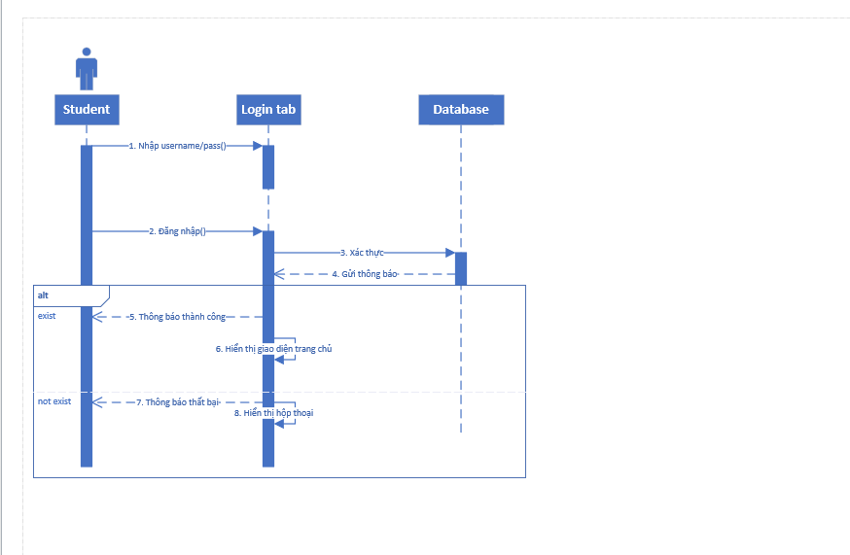

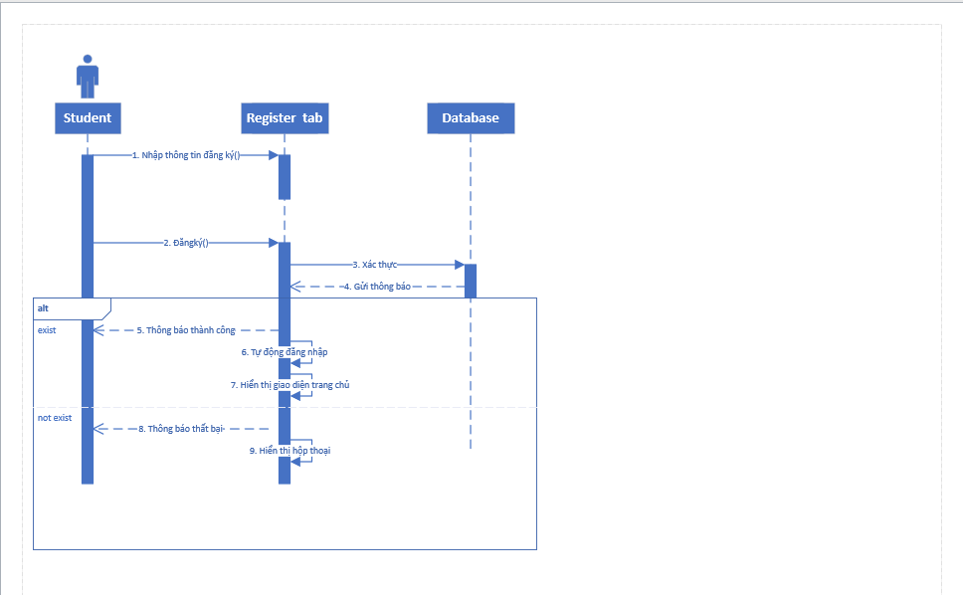

3.2.2. Soạn câu hỏi

3.2.2.1 Thêm câu hỏi

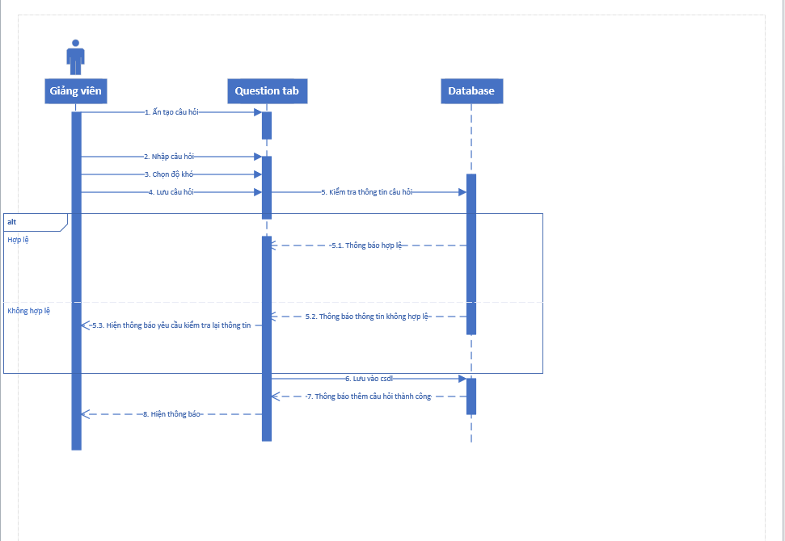

3.2.2.2 Xóa câu hỏi

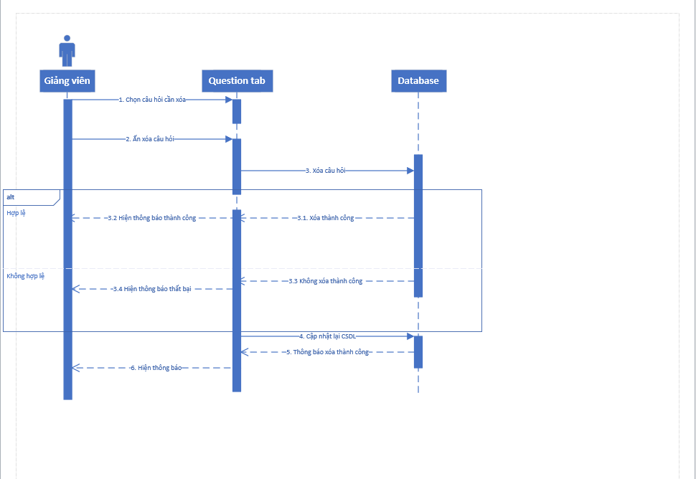

3.2.2.3 Sửa câu hỏi

3.2.3. Soạn bài thi

3.2.3.1 Sửa bài thi

3.2.3.2 Xóa bài thi

3.2.3.3 Sửa bài thi

3.2.4. Kết quả chấm thi

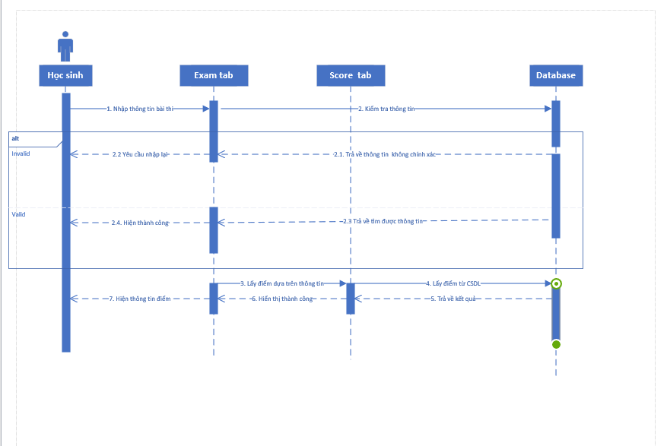

3.2.6. Kết quả chấm thi

**CHAPTER 4  
  
CHAPTER 5  
  
INTERFACE DESIGN**

* 1. List of pages

|  |  |  |  |
| --- | --- | --- | --- |
| # | Name | Type | Function |
| 1 | Log-in | Input page | Allows user to log in |
| 2 | Dashboard | Main page | Displays information about exams schedule, students’ reports and to-do list |
| 3 | My Department | Information page | Displays information about users departments and functions inside of it |
| 3.1 | Assessment |  | Allows users to assess exams and check for finished ones |
| 3.1.1 | Exam Summary | Information  page | Displays exam summary |
| 3.1.2 | Create Assessment Adding details | Input page | Allows users to create an assessment and add details like duration, location, title, description |
| 3.1.3 | Create Assessment Adding questions |  | Allows users to add questions from My Test Bank to the assessment |
| 3.1.4 | Create Assessment Begin assessment |  | Allows users to schedule the newly created assessment |
| 3.2 | Submission |  | Allows users to submit works, assessment |
| 3.3 | Review form | Input page | Allows users to write a review form regarding exams and test results |
| 4 | Profile | Information page | Displays account’s information |
| 5 | Drive | Upload page | Allows users to upload files to the school’s drive |
| 6 | My Test Bank | storage page | Used to create, store and manage users’ test questions, exams |
| 6.1 | Add questions -  multiple choices |  | Allows users to add questions of multiple methods ( MC, T/F, open ) and store them inside My Test Bank |
| 6.2 | Add questions -  true/false |  |
| 6.3 | Add questions -  open |  |
| 6.4 | View questions -  multiple choices |  | Allows users to view questions that were created |
| 6.5 | View questions –  true/false |  |
| 6.6 | View questions –  open |  |
| 7 | E-Library | Information  page | Used by the school’s administrators to manage the Exam bank and is used by users to download, view and export exams from the E-library database |

* 1. Detailed description of each page
     1. Dashboard  
        Interface:

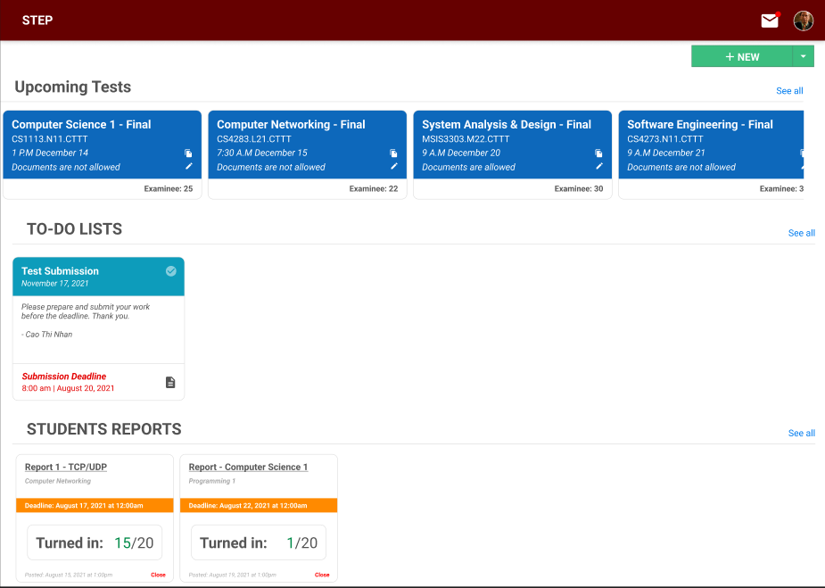

* + 1. Log-in screen  
       Interface:

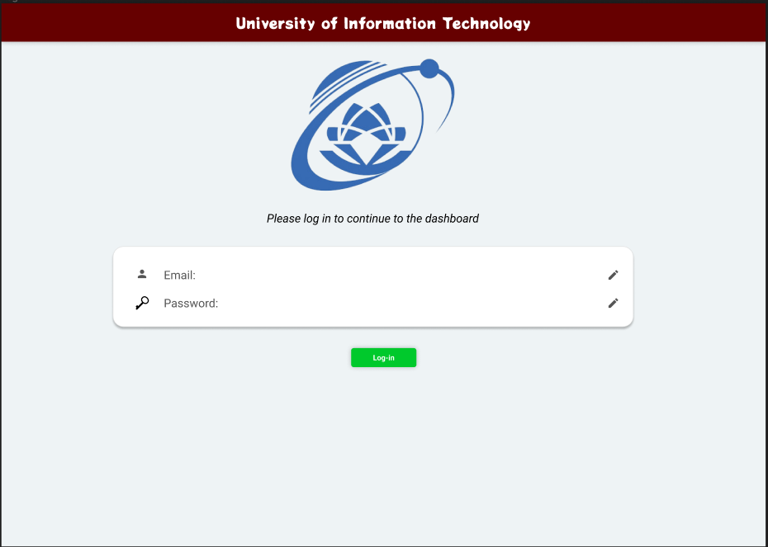

* + 1. Assessment page

Interface:

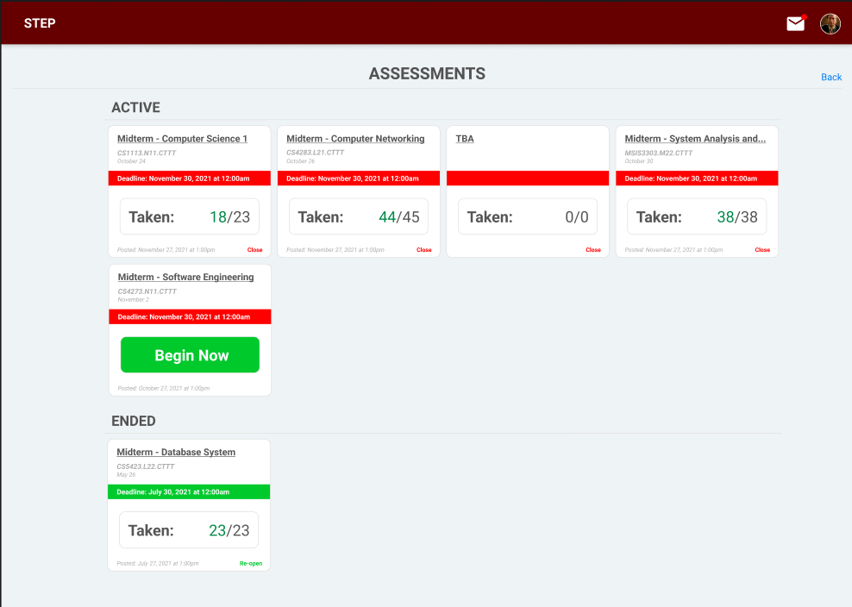

* + 1. Submission

Interface:

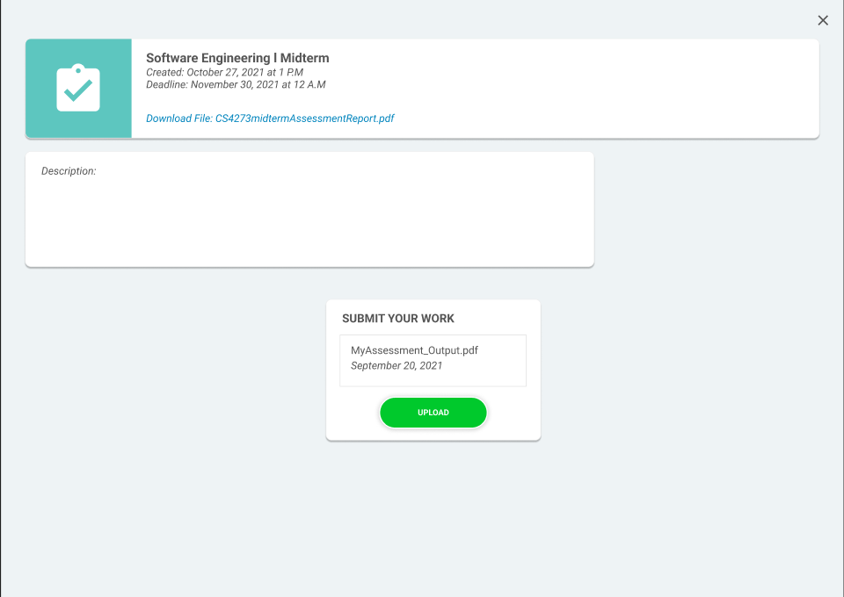

* + 1. Exam Summary

Interface:

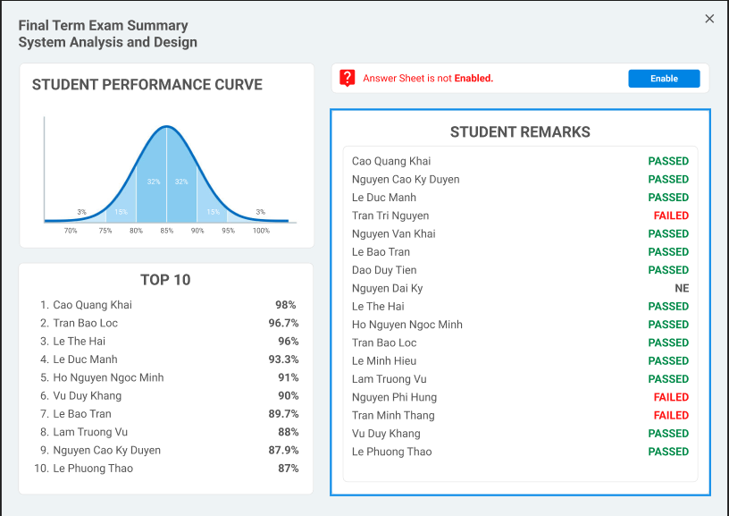

* + 1. Review form

Interface:

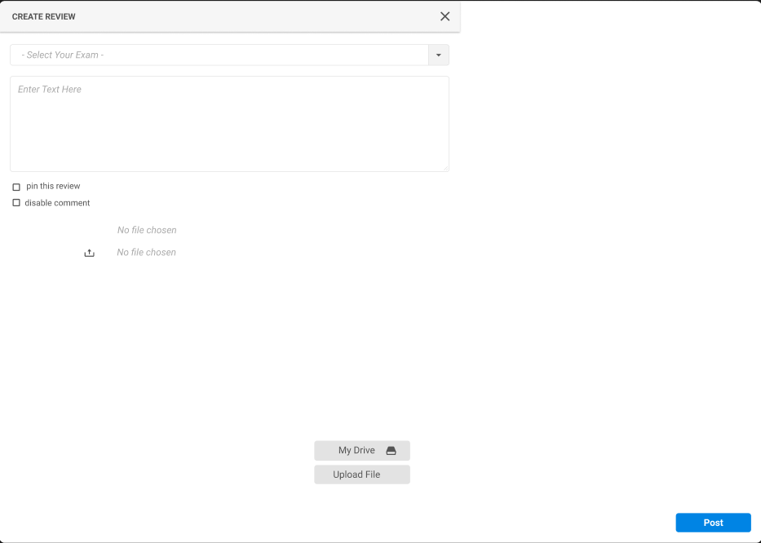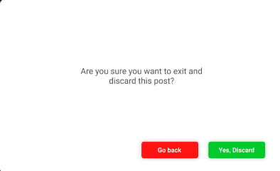

* + 1. Profile

Interface:

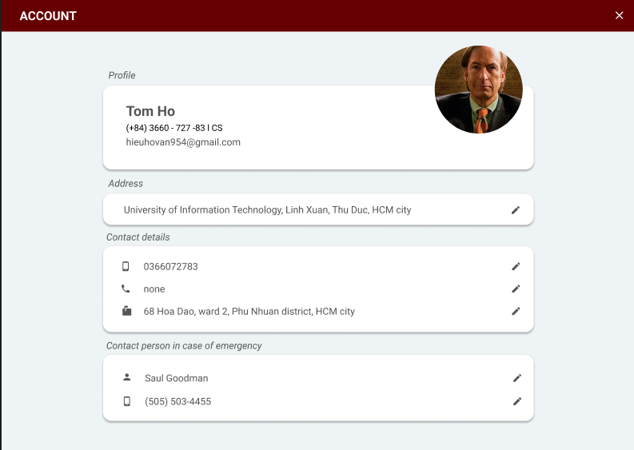

* + 1. Sub-profile and log-out dialogue

Interface:

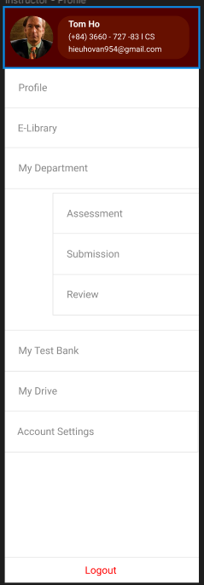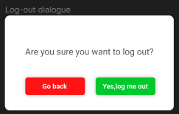

* + 1. Drive

Interface:

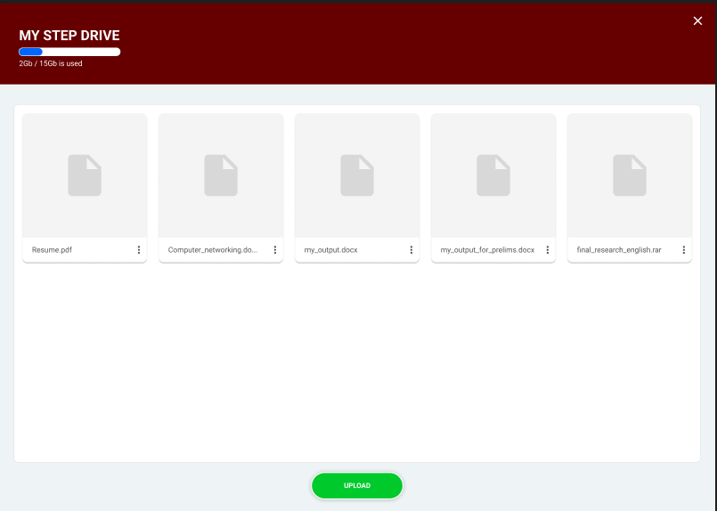

* + 1. My Test Bank

Interface:

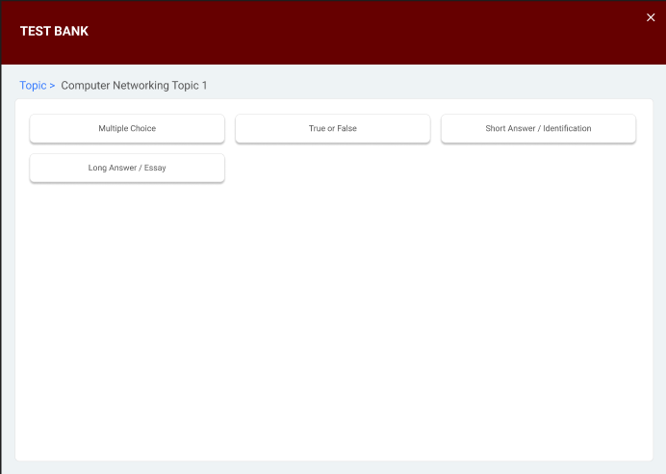  
  
Choosing methods in My Test Bank

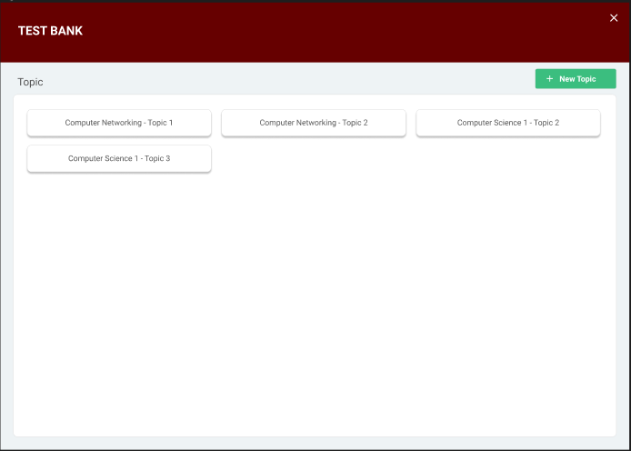

Choosing test topic from the available collection

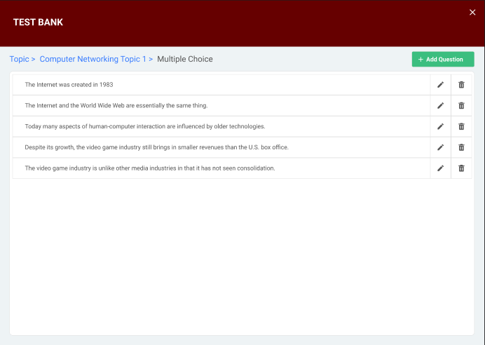

Viewing TRUE/FALSE questions to the assigned topic in My Test Bank

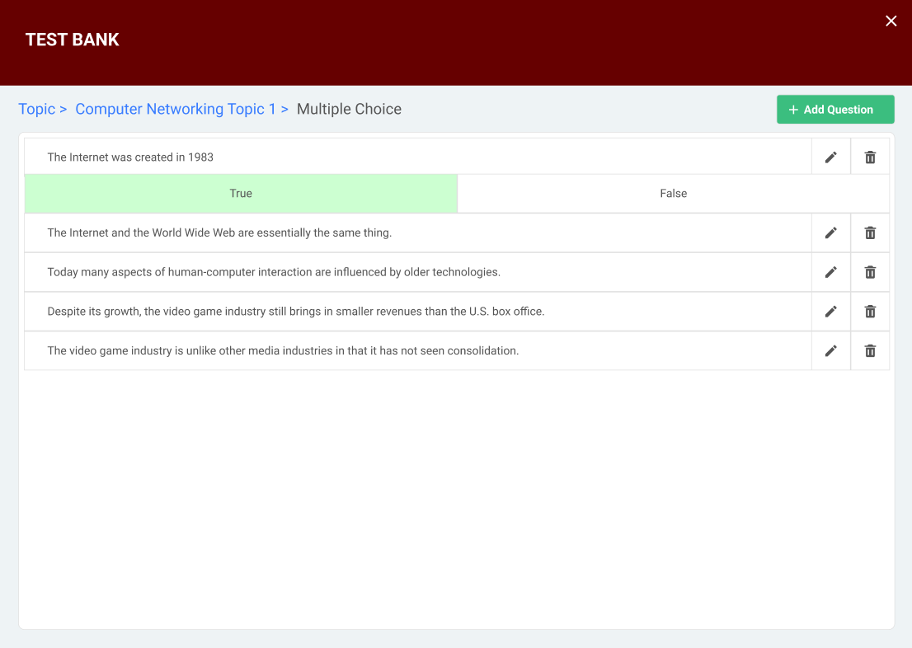  
 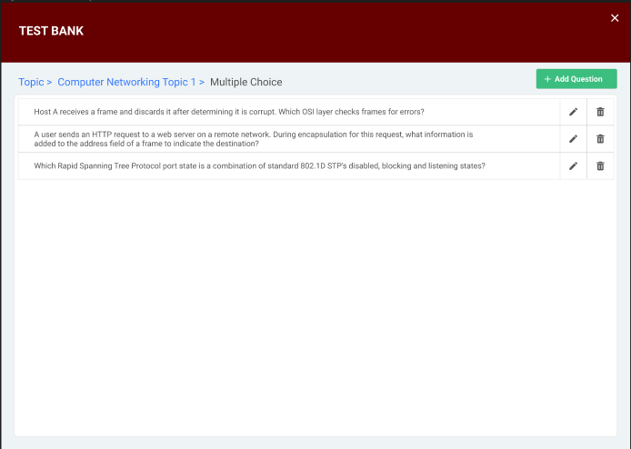

Viewing Multiple choices questions to the assigned topic in My Test Bank

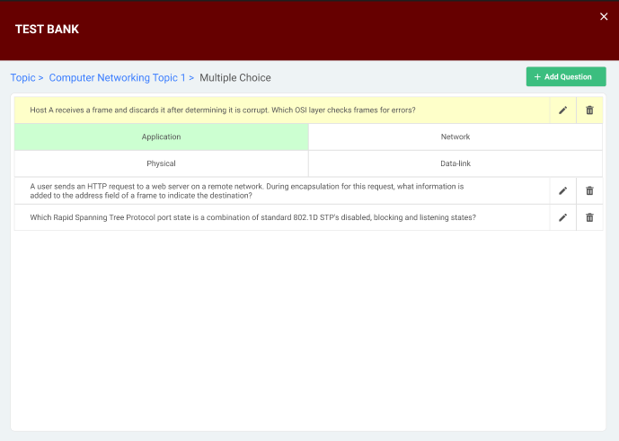

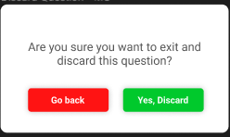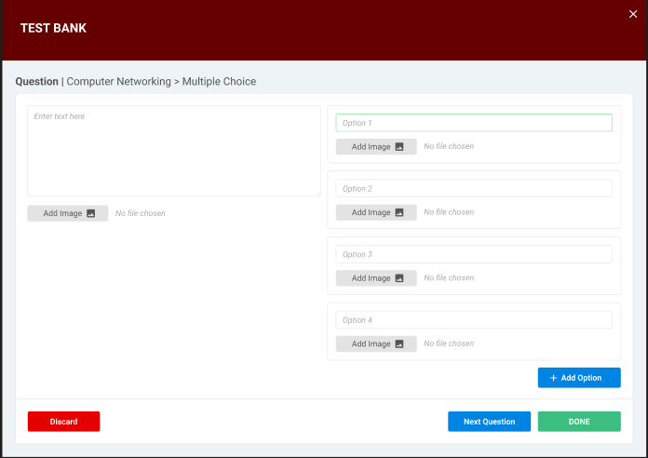

Adding Multiple choices questions to the assigned topic in My Test Bank

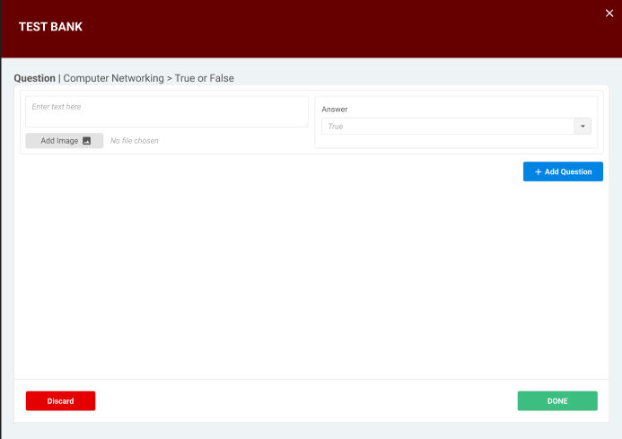

Adding TRUE/FALSE questions to the assigned topic in My Test Bank

* + 1. Create Assessment

Interface:

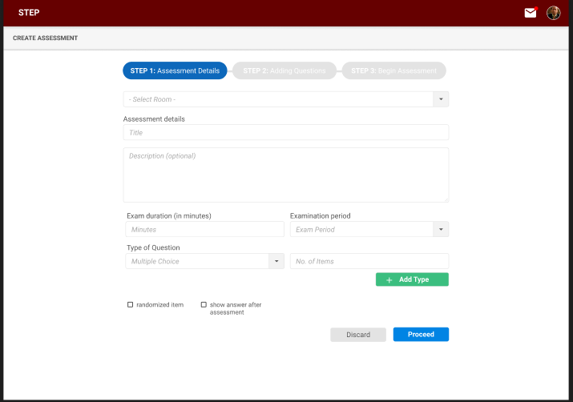 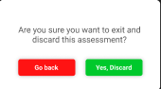

* + 1. Create Assessment – Adding questions

Interface:

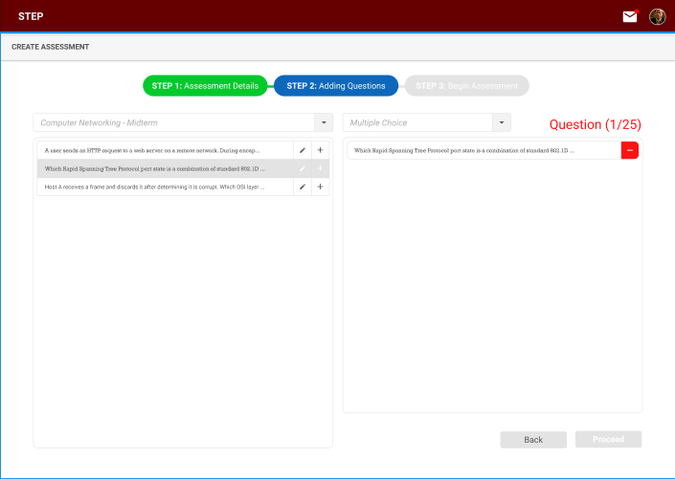

* + 1. Create Assessment – Begin assessment

Interface:

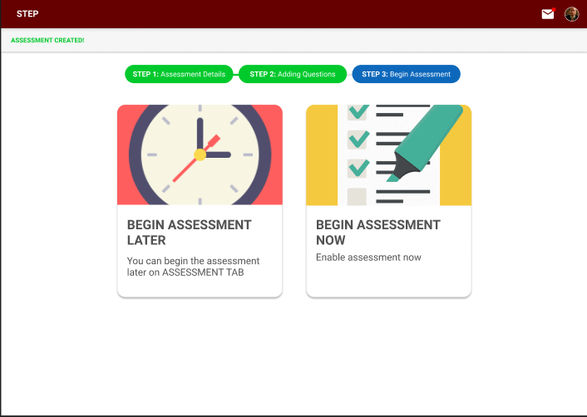

**CHAPTER 6**

**SUMMARY**

1. Developing environment and executing environment

|  |  |  |  |
| --- | --- | --- | --- |
| # | Requirements | Completion | Note |
| 1 | Composing test questions | 100% |  |
| 2 | Creating assessment | 100% |  |
| 3 | Grading assessment | 100% |  |
| 4 | Exam questions look-up | 100% |  |
| 5 | Annual report | 0% | Not included in the interface |

1. Results

* Reliability: The system provides simple and effective exam-test questions storing, as well as providing users the ability to manage their own test bank, assessment, schedule and useful functions such as uploading documents, submitting works which will help users go through procedures faster to reduce time and labor.
* Security: The system decentralizes user level into 2 groups, with the superior group being the administrators with much more administrative authority over the system thus making it more safe and secure.
* Ease of use: The interface was designed with users in mind, providing simple but helpful, intuitive interface and it comes with sufficient, easy to use functions as well.
* The website can be run on almost all kinds of computers with a variety of platforms.

1. Cons

* Test questions can only be input by hands, not from a file.
* Missing the download function for the E-library
* Test questions stored in the database can’t be automatically collected to form an exam for printing.
* Grading requires teachers/lecturers to do separately from the website before uploading the results
* The results need to be manually input

1. Development orientations

* Improve the interface for better navigation
* Automate functions to reduce manual tasks
* Provide users with more functions like print out a collection of test questions in a standardized form for use outside of the website, automatically valuate results input by users for assessment without having to manually input one by one