1. Scope of This Design
This document covers the product design and functional prototype for the Facility Booking module of the Community Facility and Maintenance Management System. In line with the project's phased delivery, the prototype demonstrates the five core booking functions: facility search, availability checking, booking request submission, conflict detection, and cancellation. The companion Maintenance module (reporting, task assignment, closures) is specified in the WBS and WBS Dictionary but is out of scope for this prototype build.

2. System Architecture
The system follows a simple three-tier architecture appropriate for a semester-length prototype: a browser-based presentation layer, an application layer containing the booking business logic, and a data layer holding facility, booking and audit records. In the prototype, the application and data layers are simulated in-memory on the client; in a production build they would sit behind a web API and a relational database.
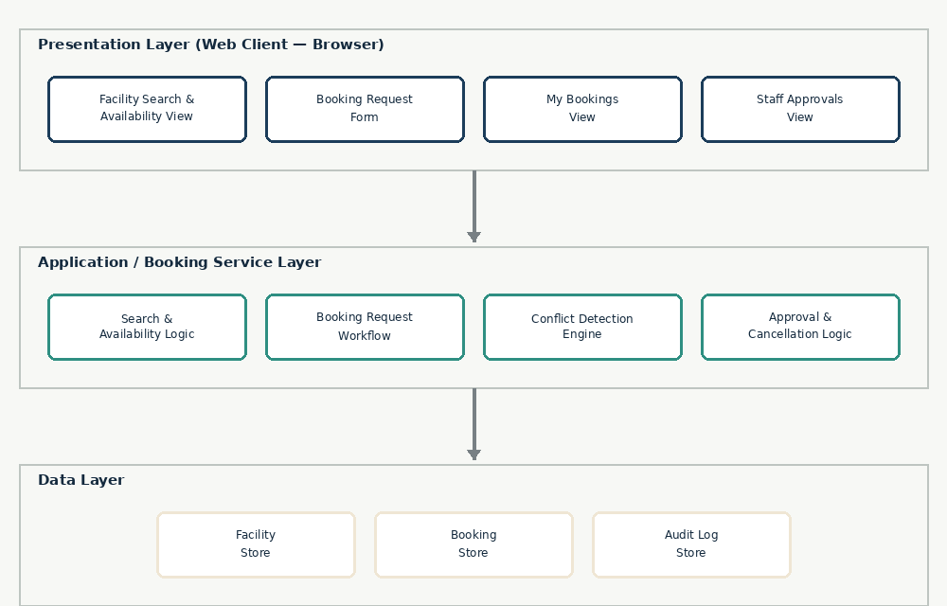
Figure 1 — Three-tier architecture for the Facility Booking module

3. Data Design (Entity-Relationship Diagram)
The data model centers on two entities: FACILITY and BOOKING. Each facility can have many bookings; each booking belongs to exactly one facility. Every state change (submitted, approved, rejected, cancelled) writes an AUDIT_LOG_ENTRY, supporting the project's audit-history requirement.
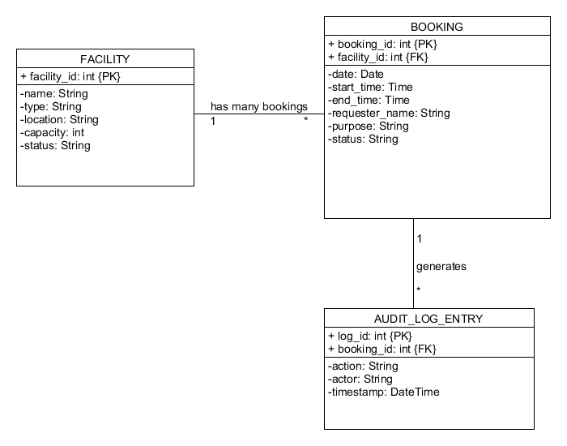
Figure 2 — Entity-Relationship Diagram for the Facility Booking module

3.1 Data Dictionary
Entity | Field(s) | Notes
FACILITY | facility_id | Primary key
FACILITY | name, type, location, capacity | Descriptive attributes used in search and filtering
FACILITY | status | Active / Temporarily Closed
BOOKING | booking_id | Primary key
BOOKING | facility_id | Foreign key to FACILITY
BOOKING | date, start_time, end_time | Used by the conflict-detection engine to test for overlap
BOOKING | requester_name, purpose | Captured at request time
BOOKING | status | Pending / Approved / Rejected / Cancelled
AUDIT_LOG_ENTRY | log_id, booking_id, action, actor, timestamp | One row per state change, for audit history

4. UI Design — Wireframes
Four screens cover the in-scope booking workflow. Wireframes are shown below; the working prototype implements each of these screens with live, interactive behavior (see Section 5).

4.1 Search & Book
Residents filter facilities by type and date and see an hourly availability strip per facility before requesting a booking.
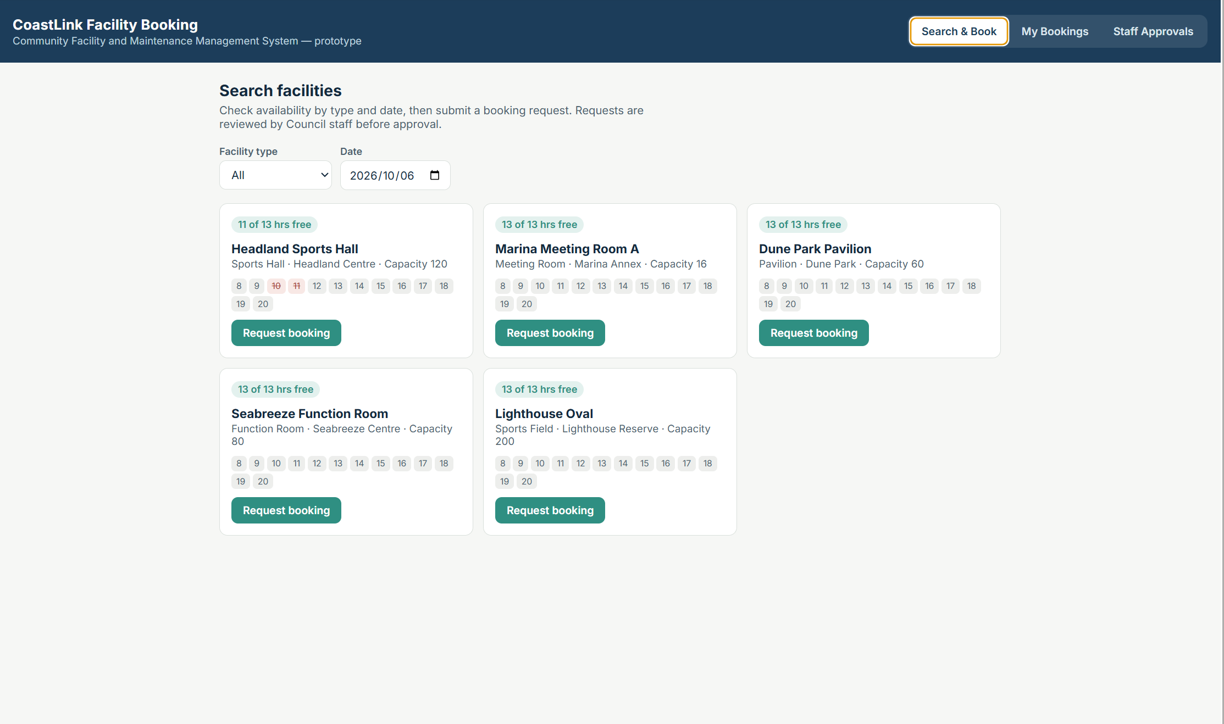
Figure 3 — Search & Book screen

4.2 Booking Request Form
Selecting "Request booking" opens an inline form capturing date, time range, requester name and purpose.
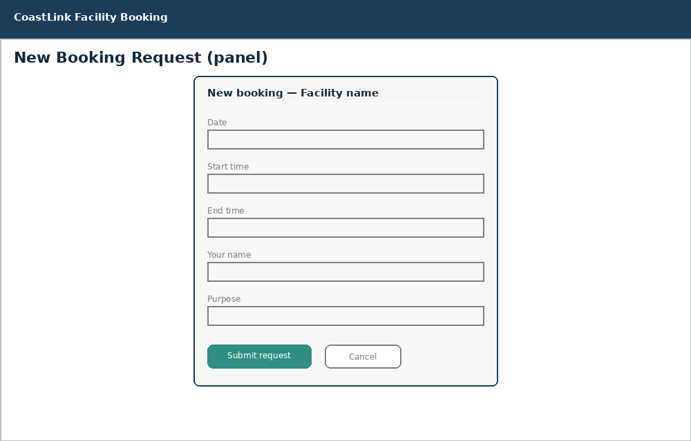
Figure 4 — Booking request form

4.3 My Bookings
Requesters look up their bookings by name and can cancel a Pending or Approved booking.
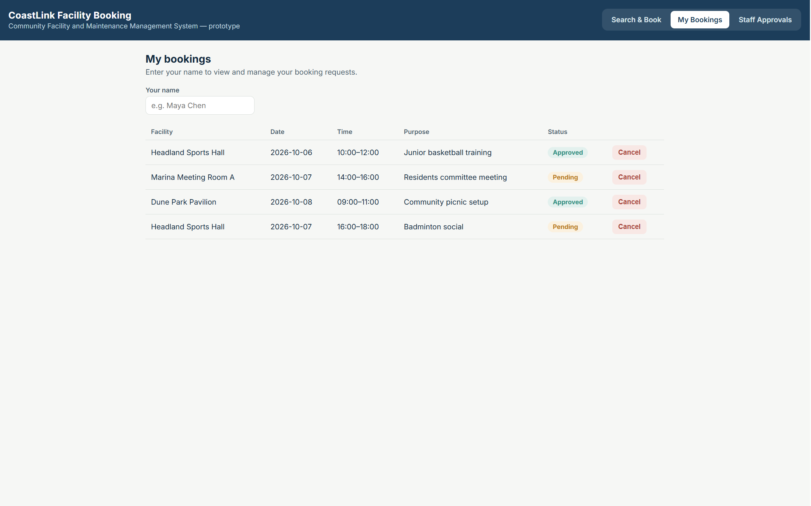
Figure 5 — My Bookings screen

4.4 Staff Approvals
Council staff review Pending requests; the system flags any request that conflicts with an already-approved booking and disables Approve until the conflict is resolved.
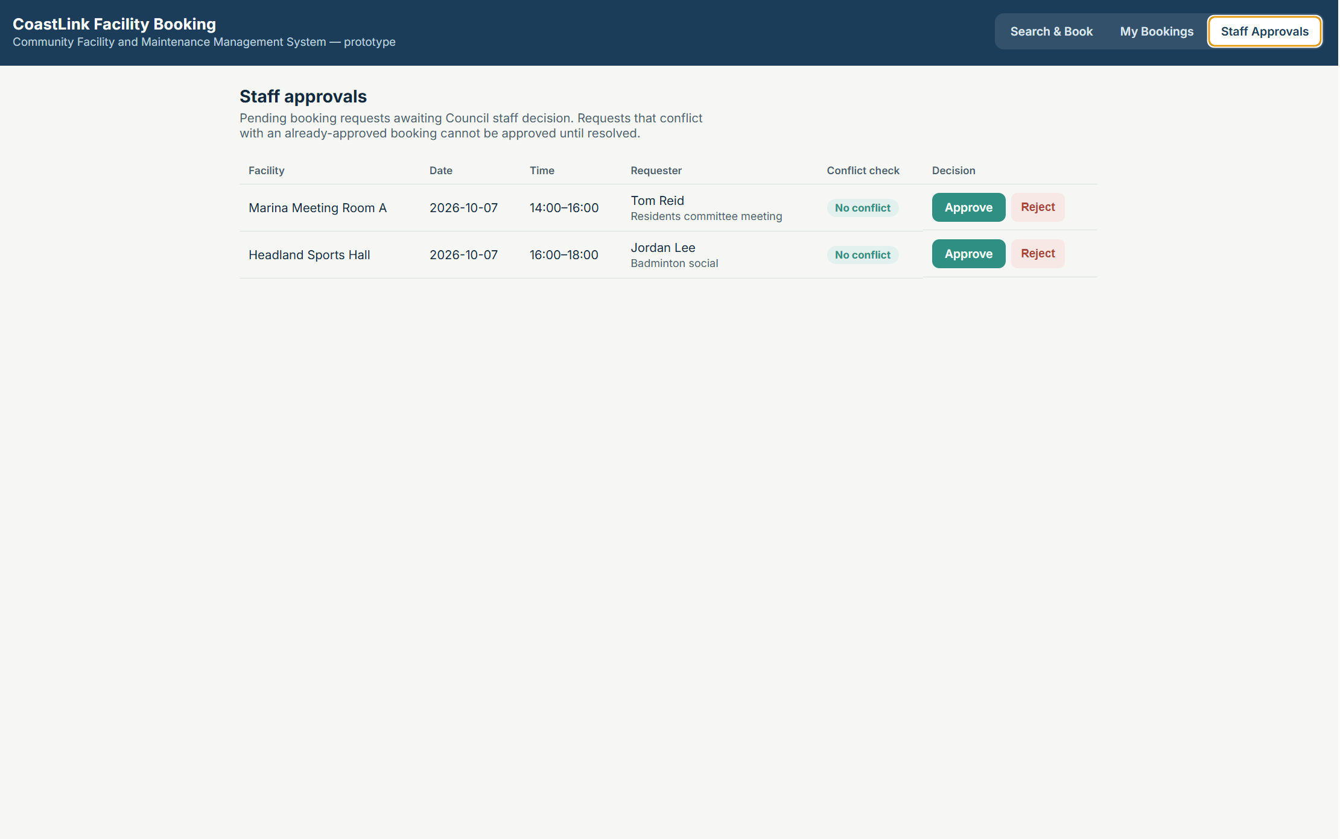
Figure 6 — Staff Approvals screen

5. Functional Prototype
A working, click-through prototype has been built as a single-page web application implementing the screens and logic described above, including live conflict detection (overlapping time-slot checks against Pending and Approved bookings) and status-driven cancellation. It is delivered separately as an interactive web artifact so it can be demonstrated live, consistent with the subject's requirement for a functional prototype rather than a static mock-up.
Feature | Behaviour demonstrated in the prototype
Facility search & availability | Filter by type and date; hourly availability strip per facility
Booking request | Inline form with validation (name, purpose, end after start)
Conflict detection | Overlapping Pending/Approved bookings are blocked at submission time and flagged to staff
Approval / rejection | Staff can approve (blocked if a conflict exists) or reject a Pending request
Cancellation | Requesters or staff can cancel a Pending or Approved booking, freeing the slot

Prototype link: https://claude.ai/artifact/YNNuoTSJQmKXFVSb6Wvr6G

