32x32

100%|██████████| 4824/4824 [00:18<00:00, 266.52it/s]

100%|██████████| 603/603 [00:00<00:00, 731.84it/s]

EPOCH: 0

TRAIN LOSS: 4617.575077971385

VALIDATION LOSS: 435.29231237620115

TRAIN ACC: 0.6955516685106093

VAL ACC: 0.7713221821620663

TRAIN F-1: 0.6653220335515176

VAL F-1: 0.759453461235441

100%|██████████| 4824/4824 [00:20<00:00, 237.73it/s]

100%|██████████| 603/603 [00:00<00:00, 745.05it/s]

EPOCH: 1

TRAIN LOSS: 2922.618155312164

VALIDATION LOSS: 362.5678100641817

TRAIN ACC: 0.8084380466156955

VAL ACC: 0.8093267923636148

TRAIN F-1: 0.789001609130362

VAL F-1: 0.805007646898313

100%|██████████| 4824/4824 [00:17<00:00, 279.17it/s]

100%|██████████| 603/603 [00:00<00:00, 761.75it/s]

EPOCH: 2

TRAIN LOSS: 2507.641053382642

VALIDATION LOSS: 332.7424439843744

TRAIN ACC: 0.8332416512661397

VAL ACC: 0.8243986051185058

TRAIN F-1: 0.8200400029702325

VAL F-1: 0.8205361040246473

100%|██████████| 4824/4824 [00:17<00:00, 282.57it/s]

100%|██████████| 603/603 [00:00<00:00, 773.63it/s]

EPOCH: 3

TRAIN LOSS: 2285.9495963784066

VALIDATION LOSS: 314.46704884432256

TRAIN ACC: 0.847358629342794

VAL ACC: 0.8339145339559075

TRAIN F-1: 0.8366665465048438

VAL F-1: 0.8308401266452711

100%|██████████| 4824/4824 [00:16<00:00, 294.23it/s]

100%|██████████| 603/603 [00:00<00:00, 759.29it/s]

EPOCH: 4

TRAIN LOSS: 2120.424415964607

VALIDATION LOSS: 302.1954968906939

TRAIN ACC: 0.856611307180251

VAL ACC: 0.8395886281695135

TRAIN F-1: 0.8475531911926736

VAL F-1: 0.8368673657716016

100%|██████████| 4824/4824 [00:16<00:00, 291.89it/s]

100%|██████████| 603/603 [00:00<00:00, 762.66it/s]

EPOCH: 5

TRAIN LOSS: 1995.5139768796116

VALIDATION LOSS: 290.8908023266122

TRAIN ACC: 0.8633298514750511

VAL ACC: 0.8478042437496306

TRAIN F-1: 0.8553008828778415

VAL F-1: 0.8453280537661424

100%|██████████| 4824/4824 [00:17<00:00, 273.83it/s]

100%|██████████| 603/603 [00:00<00:00, 790.00it/s]

EPOCH: 6

TRAIN LOSS: 1902.1219678058424

VALIDATION LOSS: 283.9298060340807

TRAIN ACC: 0.8702585434294862

VAL ACC: 0.8503457651161416

TRAIN F-1: 0.8633431115692864

VAL F-1: 0.8478873660262671

100%|██████████| 4824/4824 [00:16<00:00, 291.63it/s]

100%|██████████| 603/603 [00:00<00:00, 764.80it/s]

EPOCH: 7

TRAIN LOSS: 1818.043733849574

VALIDATION LOSS: 279.6725887786597

TRAIN ACC: 0.8753515337688746

VAL ACC: 0.8543649151841125

TRAIN F-1: 0.8689509631365593

VAL F-1: 0.8522660827749966

100%|██████████| 4824/4824 [00:16<00:00, 292.42it/s]

100%|██████████| 603/603 [00:00<00:00, 766.49it/s]

EPOCH: 8

TRAIN LOSS: 1744.1174642171004

VALIDATION LOSS: 272.669183219783

TRAIN ACC: 0.879838804383433

VAL ACC: 0.8581476446598498

TRAIN F-1: 0.8743165091061825

VAL F-1: 0.8564060622894932

100%|██████████| 4824/4824 [00:16<00:00, 288.74it/s]

100%|██████████| 603/603 [00:00<00:00, 740.00it/s]

EPOCH: 9

TRAIN LOSS: 1683.0200928138297

VALIDATION LOSS: 267.9550450826064

TRAIN ACC: 0.8832011669375923

VAL ACC: 0.8618121638394705

TRAIN F-1: 0.8779469813627512

VAL F-1: 0.8599037354327098

100%|██████████| 4824/4824 [00:16<00:00, 292.51it/s]

100%|██████████| 603/603 [00:00<00:00, 773.84it/s]

EPOCH: 10

TRAIN LOSS: 1622.1559212709535

VALIDATION LOSS: 263.8890993949026

TRAIN ACC: 0.8875030131465903

VAL ACC: 0.8653584727229742

TRAIN F-1: 0.8828235346838185

VAL F-1: 0.8643065197634702

100%|██████████| 4824/4824 [00:17<00:00, 274.06it/s]

100%|██████████| 603/603 [00:00<00:00, 772.49it/s]

EPOCH: 11

TRAIN LOSS: 1571.3256533003632

VALIDATION LOSS: 264.06807871256024

TRAIN ACC: 0.8905130693301853

VAL ACC: 0.8650038418346238

TRAIN F-1: 0.8862565512897361

VAL F-1: 0.8636193257577556

100%|██████████| 4824/4824 [00:16<00:00, 290.06it/s]

100%|██████████| 603/603 [00:00<00:00, 753.45it/s]

EPOCH: 12

TRAIN LOSS: 1516.9931339266047

VALIDATION LOSS: 257.2526103677228

TRAIN ACC: 0.8938630702573073

VAL ACC: 0.8690820970506531

TRAIN F-1: 0.8900394339234085

VAL F-1: 0.8678274957908653

100%|██████████| 4824/4824 [00:16<00:00, 292.63it/s]

100%|██████████| 603/603 [00:00<00:00, 759.93it/s]

EPOCH: 13

TRAIN LOSS: 1470.8717407621734

VALIDATION LOSS: 260.092836368829

TRAIN ACC: 0.897027646778869

VAL ACC: 0.8681364146817188

TRAIN F-1: 0.8934656329427484

VAL F-1: 0.8666392664728352

100%|██████████| 4824/4824 [00:16<00:00, 292.47it/s]

100%|██████████| 603/603 [00:00<00:00, 771.15it/s]

EPOCH: 14

TRAIN LOSS: 1426.04250408313

VALIDATION LOSS: 255.69903910765424

TRAIN ACC: 0.8997719279811609

VAL ACC: 0.8695549382351203

TRAIN F-1: 0.8965894748297966

VAL F-1: 0.8680677911495626

100%|██████████| 4824/4824 [00:16<00:00, 288.75it/s]

100%|██████████| 603/603 [00:00<00:00, 767.58it/s]

EPOCH: 15

TRAIN LOSS: 1394.0177451906093

VALIDATION LOSS: 246.3997445856221

TRAIN ACC: 0.9016879801719503

VAL ACC: 0.8739287191914415

TRAIN F-1: 0.8985687932892553

VAL F-1: 0.8725667306114975

100%|██████████| 4824/4824 [00:16<00:00, 292.32it/s]

100%|██████████| 603/603 [00:00<00:00, 762.12it/s]

EPOCH: 16

TRAIN LOSS: 1354.2338990315511

VALIDATION LOSS: 251.34329884173349

TRAIN ACC: 0.9032579068056937

VAL ACC: 0.8735740883030912

TRAIN F-1: 0.9003138742887088

VAL F-1: 0.8727601275532154

100%|██████████| 4824/4824 [00:17<00:00, 270.57it/s]

100%|██████████| 603/603 [00:00<00:00, 762.40it/s]

EPOCH: 17

TRAIN LOSS: 1326.1326639347349

VALIDATION LOSS: 247.53699749754742

TRAIN ACC: 0.9062556013622513

VAL ACC: 0.8738696140433831

TRAIN F-1: 0.9034610125535814

VAL F-1: 0.8728596454553303

100%|██████████| 4824/4824 [00:16<00:00, 290.66it/s]

100%|██████████| 603/603 [00:00<00:00, 778.06it/s]

EPOCH: 18

TRAIN LOSS: 1286.810155074588

VALIDATION LOSS: 250.01175986975431

TRAIN ACC: 0.9082149192476714

VAL ACC: 0.8735149831550328

TRAIN F-1: 0.9056707642263095

VAL F-1: 0.8727639351364924

100%|██████████| 4824/4824 [00:16<00:00, 289.53it/s]

100%|██████████| 603/603 [00:00<00:00, 764.30it/s]

EPOCH: 19

TRAIN LOSS: 1258.4497929596298

VALIDATION LOSS: 248.84221443603747

TRAIN ACC: 0.9100753441167927

VAL ACC: 0.8772386074827118

TRAIN F-1: 0.9077127563490386

VAL F-1: 0.8761698980222853

00%|██████████| 603/603 [00:00<00:00, 773.90it/s]VALIDATION LOSS: 253.13598257355625

VAL F-1: 0.8737711443202993

VAL ACC: 0.8737836290784201

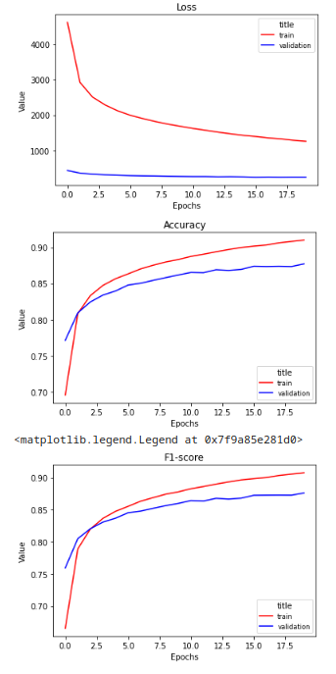

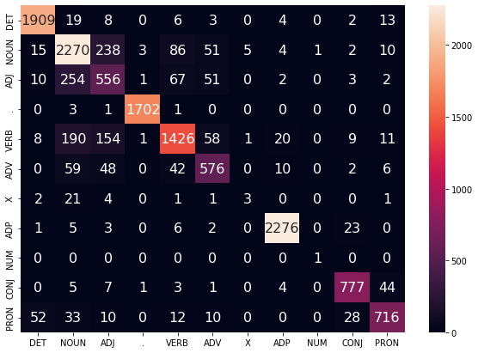

64x64

100%|██████████| 4824/4824 [01:43<00:00, 46.77it/s]

100%|██████████| 603/603 [00:03<00:00, 200.46it/s]

EPOCH: 0

TRAIN LOSS: 3920.7606122115394

VALIDATION LOSS: 362.35799127072096

TRAIN ACC: 0.7463023283124525

VAL ACC: 0.8083220048466221

TRAIN F-1: 0.720491841383188

VAL F-1: 0.80126581555459

100%|██████████| 4824/4824 [01:43<00:00, 46.83it/s]

100%|██████████| 603/603 [00:03<00:00, 200.39it/s]

EPOCH: 1

TRAIN LOSS: 2327.0094713889703

VALIDATION LOSS: 300.94771810621023

TRAIN ACC: 0.8461410090796151

VAL ACC: 0.8457355635675867

TRAIN F-1: 0.8343677973972802

VAL F-1: 0.8425589532261522

100%|██████████| 4824/4824 [01:42<00:00, 46.87it/s]

100%|██████████| 603/603 [00:02<00:00, 206.61it/s]

EPOCH: 2

TRAIN LOSS: 1918.272892450721

VALIDATION LOSS: 274.86396898701787

TRAIN ACC: 0.8716863113523002

VAL ACC: 0.8594479579171346

TRAIN F-1: 0.8645768917050476

VAL F-1: 0.8573322049078148

100%|██████████| 4824/4824 [01:42<00:00, 47.16it/s]

100%|██████████| 603/603 [00:02<00:00, 202.96it/s]

EPOCH: 3

TRAIN LOSS: 1670.6243913447943

VALIDATION LOSS: 262.20300234435126

TRAIN ACC: 0.8865264446106397

VAL ACC: 0.8673680477569596

TRAIN F-1: 0.8814519946854297

VAL F-1: 0.8649848579130132

100%|██████████| 4824/4824 [01:42<00:00, 46.86it/s]

100%|██████████| 603/603 [00:02<00:00, 213.52it/s]

EPOCH: 4

TRAIN LOSS: 1497.077887273229

VALIDATION LOSS: 253.2157915495336

TRAIN ACC: 0.8969472962031263

VAL ACC: 0.8746379809681423

TRAIN F-1: 0.8930861478794213

VAL F-1: 0.8730658868229232

100%|██████████| 4824/4824 [01:42<00:00, 46.98it/s]

100%|██████████| 603/603 [00:02<00:00, 204.01it/s]

EPOCH: 5

TRAIN LOSS: 1367.2372216898439

VALIDATION LOSS: 246.14983172155917

TRAIN ACC: 0.9053222985209314

VAL ACC: 0.8781842898516461

TRAIN F-1: 0.9024279105054794

VAL F-1: 0.8766622973874358

100%|██████████| 4824/4824 [01:47<00:00, 44.85it/s]

100%|██████████| 603/603 [00:03<00:00, 181.20it/s]

EPOCH: 6

TRAIN LOSS: 1263.2949098966849

VALIDATION LOSS: 242.13886522036046

TRAIN ACC: 0.9110951783473741

VAL ACC: 0.8822625450676754

TRAIN F-1: 0.9088176142202282

VAL F-1: 0.8812376165038699

100%|██████████| 4824/4824 [01:49<00:00, 44.23it/s]

100%|██████████| 603/603 [00:03<00:00, 191.18it/s]

EPOCH: 7

TRAIN LOSS: 1167.865127050735

VALIDATION LOSS: 243.19549548137002

TRAIN ACC: 0.9171338331551199

VAL ACC: 0.8827944914002009

TRAIN F-1: 0.9150902449344833

VAL F-1: 0.8816397636088057

100%|██████████| 4824/4824 [01:48<00:00, 44.56it/s]

100%|██████████| 603/603 [00:03<00:00, 183.07it/s]

EPOCH: 8

TRAIN LOSS: 1087.2708451392896

VALIDATION LOSS: 240.78391669801204

TRAIN ACC: 0.9219981333943174

VAL ACC: 0.8848631715822448

TRAIN F-1: 0.9203005444839524

VAL F-1: 0.8839552641341416

100%|██████████| 4824/4824 [01:48<00:00, 44.26it/s]

100%|██████████| 603/603 [00:03<00:00, 192.86it/s]

EPOCH: 9

TRAIN LOSS: 1025.070557236714

VALIDATION LOSS: 242.02740115276538

TRAIN ACC: 0.9257993337083027

VAL ACC: 0.8834446480288433

TRAIN F-1: 0.9243099317984893

VAL F-1: 0.8828791123032701

100%|██████████| 4824/4824 [01:47<00:00, 44.91it/s]

100%|██████████| 603/603 [00:02<00:00, 204.29it/s]

EPOCH: 10

TRAIN LOSS: 967.9652028183219

VALIDATION LOSS: 240.34204985271208

TRAIN ACC: 0.9287228585026361

VAL ACC: 0.8865181157278799

TRAIN F-1: 0.9274569852841257

VAL F-1: 0.8860599428635163

100%|██████████| 4824/4824 [01:42<00:00, 47.09it/s]

100%|██████████| 603/603 [00:02<00:00, 209.17it/s]

EPOCH: 11

TRAIN LOSS: 913.9780353962462

VALIDATION LOSS: 242.78939752932638

TRAIN ACC: 0.9328083762384806

VAL ACC: 0.8881139547254566

TRAIN F-1: 0.9317454573090432

VAL F-1: 0.8879688325694924

100%|██████████| 4824/4824 [01:44<00:00, 46.37it/s]

100%|██████████| 603/603 [00:02<00:00, 211.71it/s]

EPOCH: 12

TRAIN LOSS: 867.7060623414945

VALIDATION LOSS: 239.46057114657015

TRAIN ACC: 0.9351879894431705

VAL ACC: 0.8898280040191501

TRAIN F-1: 0.9341641307244095

VAL F-1: 0.8891289496810049

100%|██████████| 4824/4824 [01:42<00:00, 47.12it/s]

100%|██████████| 603/603 [00:02<00:00, 205.63it/s]

EPOCH: 13

TRAIN LOSS: 826.2889344521077

VALIDATION LOSS: 241.14271789591294

TRAIN ACC: 0.9380991526104666

VAL ACC: 0.8914829481647851

TRAIN F-1: 0.937203612708222

VAL F-1: 0.8910712468601935

100%|██████████| 4824/4824 [01:49<00:00, 44.09it/s]

100%|██████████| 603/603 [00:03<00:00, 177.36it/s]

EPOCH: 14

TRAIN LOSS: 786.2477106938184

VALIDATION LOSS: 239.81862427247688

TRAIN ACC: 0.941059762285912

VAL ACC: 0.8920148944973108

TRAIN F-1: 0.9402155766082718

VAL F-1: 0.8915987153017031

100%|██████████| 4824/4824 [01:48<00:00, 44.44it/s]

100%|██████████| 603/603 [00:03<00:00, 179.10it/s]

EPOCH: 15

TRAIN LOSS: 744.5212203679702

VALIDATION LOSS: 244.27690351579804

TRAIN ACC: 0.9429634528496641

VAL ACC: 0.892369525385661

TRAIN F-1: 0.9421802031980293

VAL F-1: 0.892402013421642

100%|██████████| 4824/4824 [01:48<00:00, 44.27it/s]

100%|██████████| 603/603 [00:03<00:00, 189.60it/s]

EPOCH: 16

TRAIN LOSS: 714.6341864520377

VALIDATION LOSS: 247.2423437901307

TRAIN ACC: 0.9453925125625035

VAL ACC: 0.8916011584609019

TRAIN F-1: 0.9447085111939475

VAL F-1: 0.891208441756298

100%|██████████| 4824/4824 [01:48<00:00, 44.37it/s]

100%|██████████| 603/603 [00:03<00:00, 181.28it/s]

EPOCH: 17

TRAIN LOSS: 681.2810286169031

VALIDATION LOSS: 243.57875183213037

TRAIN ACC: 0.9476237862427452

VAL ACC: 0.8926650511259531

TRAIN F-1: 0.9470116805607203

VAL F-1: 0.8924492188663536

100%|██████████| 4824/4824 [01:49<00:00, 43.93it/s]

100%|██████████| 603/603 [00:03<00:00, 181.48it/s]

EPOCH: 18

TRAIN LOSS: 651.051306213895

VALIDATION LOSS: 238.1923347528209

TRAIN ACC: 0.9500775692096594

VAL ACC: 0.8959749394172233

TRAIN F-1: 0.9495122438824029

VAL F-1: 0.8958759970450877

100%|██████████| 4824/4824 [01:48<00:00, 44.38it/s]

100%|██████████| 603/603 [00:03<00:00, 186.14it/s]

EPOCH: 19

TRAIN LOSS: 621.4005947333025

VALIDATION LOSS: 252.72917774273083

TRAIN ACC: 0.9521852266195276

VAL ACC: 0.8939653643832378

TRAIN F-1: 0.9516639592497632

VAL F-1: 0.8934723788136251

100%|██████████| 603/603 [00:02<00:00, 226.46it/s]VALIDATION LOSS: 247.2928415418428

VAL F-1: 0.8886420624768926

VAL ACC: 0.8885947338294219

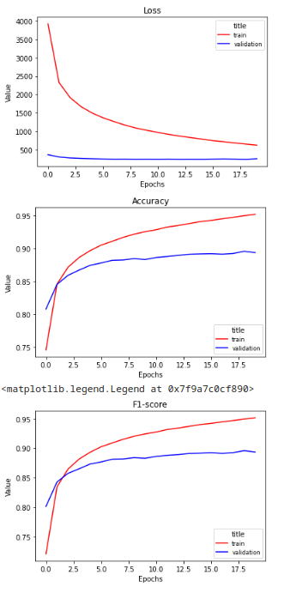

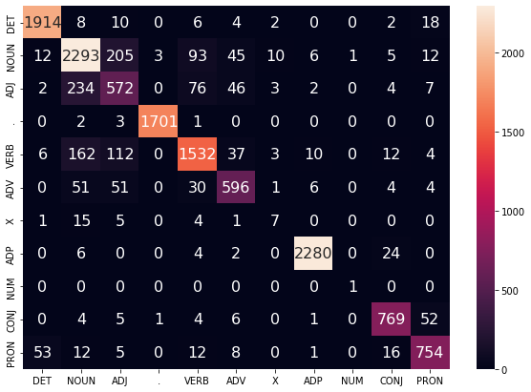

128x128

100%|██████████| 4824/4824 [00:18<00:00, 260.94it/s]

100%|██████████| 603/603 [00:00<00:00, 652.63it/s]

EPOCH: 0

TRAIN LOSS: 6474.293408656493

VALIDATION LOSS: 591.119651645422

TRAIN ACC: 0.6019617902108275

VAL ACC: 0.7072522016667652

TRAIN F-1: 0.5604442106442887

VAL F-1: 0.6771962064156453

100%|██████████| 4824/4824 [00:18<00:00, 265.48it/s]

100%|██████████| 603/603 [00:00<00:00, 667.92it/s]

EPOCH: 1

TRAIN LOSS: 4024.539823593106

VALIDATION LOSS: 466.3363990187645

TRAIN ACC: 0.7475323102026689

VAL ACC: 0.7631065665819493

TRAIN F-1: 0.7141969529702272

VAL F-1: 0.7361267358259226

100%|██████████| 4824/4824 [00:18<00:00, 266.72it/s]

100%|██████████| 603/603 [00:00<00:00, 663.97it/s]

EPOCH: 2

TRAIN LOSS: 3352.548727352172

VALIDATION LOSS: 405.2949430346489

TRAIN ACC: 0.7855813982236342

VAL ACC: 0.7917134582422128

TRAIN F-1: 0.7545621201515424

VAL F-1: 0.771535877671039

100%|██████████| 4824/4824 [00:18<00:00, 265.19it/s]

100%|██████████| 603/603 [00:00<00:00, 636.27it/s]

EPOCH: 3

TRAIN LOSS: 2954.4379528700374

VALIDATION LOSS: 365.6853361055255

TRAIN ACC: 0.8087470872916294

VAL ACC: 0.8110999468053668

TRAIN F-1: 0.7820565784329288

VAL F-1: 0.796942026451247

100%|██████████| 4824/4824 [00:20<00:00, 229.96it/s]

100%|██████████| 603/603 [00:00<00:00, 667.39it/s]

EPOCH: 4

TRAIN LOSS: 2675.345738809672

VALIDATION LOSS: 338.91090343147516

TRAIN ACC: 0.8264118523280034

VAL ACC: 0.8229800815651043

TRAIN F-1: 0.8057698528026744

VAL F-1: 0.8121963832455336

100%|██████████| 4824/4824 [00:18<00:00, 267.62it/s]

100%|██████████| 603/603 [00:00<00:00, 654.19it/s]

EPOCH: 5

TRAIN LOSS: 2453.0088700802007

VALIDATION LOSS: 317.26716777682304

TRAIN ACC: 0.8398736641716783

VAL ACC: 0.8353330575093091

TRAIN F-1: 0.8234544502105713

VAL F-1: 0.8272000770899152

100%|██████████| 4824/4824 [00:18<00:00, 264.66it/s]

100%|██████████| 603/603 [00:00<00:00, 652.49it/s]

EPOCH: 6

TRAIN LOSS: 2278.7062266474823

VALIDATION LOSS: 299.85153863951564

TRAIN ACC: 0.8509373203701072

VAL ACC: 0.8427212010166085

TRAIN F-1: 0.8375122236959712

VAL F-1: 0.835960416234593

100%|██████████| 4824/4824 [00:18<00:00, 265.79it/s]

100%|██████████| 603/603 [00:00<00:00, 664.18it/s]

EPOCH: 7

TRAIN LOSS: 2128.1497743521177

VALIDATION LOSS: 287.02102375775576

TRAIN ACC: 0.860573208645722

VAL ACC: 0.8487499261185649

TRAIN F-1: 0.8489290292639661

VAL F-1: 0.843447542587033

100%|██████████| 4824/4824 [00:18<00:00, 266.19it/s]

100%|██████████| 603/603 [00:00<00:00, 670.43it/s]

EPOCH: 8

TRAIN LOSS: 1998.0299604417814

VALIDATION LOSS: 274.5912263765931

TRAIN ACC: 0.869195443504274

VAL ACC: 0.8559607541816893

TRAIN F-1: 0.859052889821886

VAL F-1: 0.8510974119830392

100%|██████████| 4824/4824 [00:19<00:00, 251.49it/s]

100%|██████████| 603/603 [00:00<00:00, 638.11it/s]

EPOCH: 9

TRAIN LOSS: 1883.9495246837541

VALIDATION LOSS: 266.50096334517

TRAIN ACC: 0.8761488587127838

VAL ACC: 0.8609255866185945

TRAIN F-1: 0.8673000283392146

VAL F-1: 0.8563347331646266

100%|██████████| 4824/4824 [00:18<00:00, 263.36it/s]

100%|██████████| 603/603 [00:00<00:00, 656.50it/s]

EPOCH: 10

TRAIN LOSS: 1783.3514233726892

VALIDATION LOSS: 258.3798811919987

TRAIN ACC: 0.8822431408421977

VAL ACC: 0.8652402624268574

TRAIN F-1: 0.8745371883765518

VAL F-1: 0.8612471070037837

100%|██████████| 4824/4824 [00:18<00:00, 265.10it/s]

100%|██████████| 603/603 [00:00<00:00, 668.45it/s]

EPOCH: 11

TRAIN LOSS: 1690.9611502460102

VALIDATION LOSS: 248.64400810562074

TRAIN ACC: 0.888442496801429

VAL ACC: 0.8706188309001714

TRAIN F-1: 0.8816856665177382

VAL F-1: 0.8670791381357694

100%|██████████| 4824/4824 [00:18<00:00, 264.24it/s]

100%|██████████| 603/603 [00:00<00:00, 631.89it/s]

EPOCH: 12

TRAIN LOSS: 1602.012865525845

VALIDATION LOSS: 243.60366931930184

TRAIN ACC: 0.8941473876791663

VAL ACC: 0.8745197706720256

TRAIN F-1: 0.8882737157099708

VAL F-1: 0.8712467302861825

100%|██████████| 4824/4824 [00:19<00:00, 249.90it/s]

100%|██████████| 603/603 [00:00<00:00, 669.60it/s]

EPOCH: 13

TRAIN LOSS: 1533.9891902322488

VALIDATION LOSS: 237.81943712104112

TRAIN ACC: 0.8981154699581559

VAL ACC: 0.8781842898516461

TRAIN F-1: 0.8927863821241656

VAL F-1: 0.87474229968664

100%|██████████| 4824/4824 [00:18<00:00, 266.98it/s]

100%|██████████| 603/603 [00:00<00:00, 668.52it/s]

EPOCH: 14

TRAIN LOSS: 1462.2951205235731

VALIDATION LOSS: 233.86797466874123

TRAIN ACC: 0.902967408570316

VAL ACC: 0.8787162361841716

TRAIN F-1: 0.8983603700650855

VAL F-1: 0.8761170574660198

100%|██████████| 4824/4824 [00:18<00:00, 266.65it/s]

100%|██████████| 603/603 [00:00<00:00, 659.50it/s]

EPOCH: 15

TRAIN LOSS: 1403.00791747123

VALIDATION LOSS: 228.5587981096469

TRAIN ACC: 0.9062370589216953

VAL ACC: 0.8827944914002009

TRAIN F-1: 0.9020534583031712

VAL F-1: 0.8797327538000826

100%|██████████| 4824/4824 [00:17<00:00, 269.46it/s]

100%|██████████| 603/603 [00:00<00:00, 653.68it/s]

EPOCH: 16

TRAIN LOSS: 1344.3921555216875

VALIDATION LOSS: 225.89453706797212

TRAIN ACC: 0.9099888127275312

VAL ACC: 0.8832673325846682

TRAIN F-1: 0.9062542288616099

VAL F-1: 0.880593382785819

100%|██████████| 4824/4824 [00:18<00:00, 265.49it/s]

100%|██████████| 603/603 [00:00<00:00, 647.34it/s]

EPOCH: 17

TRAIN LOSS: 1287.250634120639

VALIDATION LOSS: 222.0265486817807

TRAIN ACC: 0.9136973008387363

VAL ACC: 0.885336012766712

TRAIN F-1: 0.910342185267685

VAL F-1: 0.8826097998595762

100%|██████████| 4824/4824 [00:19<00:00, 252.57it/s]

100%|██████████| 603/603 [00:00<00:00, 646.81it/s]

EPOCH: 18

TRAIN LOSS: 1230.555976323034

VALIDATION LOSS: 218.673963165842

TRAIN ACC: 0.917208002917344

VAL ACC: 0.8874046929487558

TRAIN F-1: 0.914172293860537

VAL F-1: 0.8852277153299298

100%|██████████| 4824/4824 [00:18<00:00, 266.26it/s]

100%|██████████| 603/603 [00:00<00:00, 665.99it/s]

EPOCH: 19

TRAIN LOSS: 1189.3771536075164

VALIDATION LOSS: 215.43512439727783

TRAIN ACC: 0.9197421364600009

VAL ACC: 0.8873455878006974

TRAIN F-1: 0.916918495823555

VAL F-1: 0.8849125230846433

100%|██████████| 603/603 [00:00<00:00, 694.94it/s]VALIDATION LOSS: 230.07427918189205

VAL F-1: 0.8821373683998943

VAL ACC: 0.8836576989124213

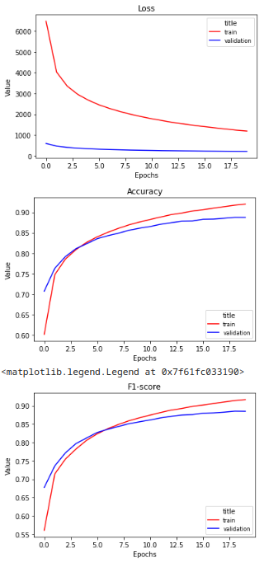

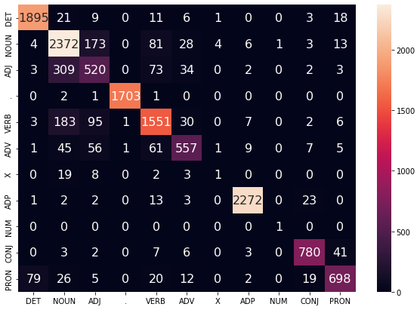

256x256

100%|██████████| 4824/4824 [00:23<00:00, 201.88it/s]

100%|██████████| 603/603 [00:01<00:00, 533.12it/s]

EPOCH: 0

TRAIN LOSS: 5424.0074958298355

VALIDATION LOSS: 487.1398173868656

TRAIN ACC: 0.6741907769900675

VAL ACC: 0.7563094745552338

TRAIN F-1: 0.6357369086053432

VAL F-1: 0.7286083005487093

100%|██████████| 4824/4824 [00:23<00:00, 205.46it/s]

100%|██████████| 603/603 [00:01<00:00, 528.27it/s]

EPOCH: 1

TRAIN LOSS: 3318.785936168977

VALIDATION LOSS: 390.79576873779297

TRAIN ACC: 0.7896669159594786

VAL ACC: 0.7998108635262131

TRAIN F-1: 0.7590263942099533

VAL F-1: 0.7815439429901089

100%|██████████| 4824/4824 [00:24<00:00, 198.68it/s]

100%|██████████| 603/603 [00:01<00:00, 361.80it/s]

EPOCH: 2

TRAIN LOSS: 2758.0353464183863

VALIDATION LOSS: 342.55292388796806

TRAIN ACC: 0.8224932165571632

VAL ACC: 0.8252260771913233

TRAIN F-1: 0.7995994685000584

VAL F-1: 0.8141681654930435

100%|██████████| 4824/4824 [00:24<00:00, 198.83it/s]

100%|██████████| 603/603 [00:01<00:00, 533.73it/s]

EPOCH: 3

TRAIN LOSS: 2424.1490131432656

VALIDATION LOSS: 312.14950627088547

TRAIN ACC: 0.8434276319449165

VAL ACC: 0.8384656303564041

TRAIN F-1: 0.827443716983502

VAL F-1: 0.8308201659860014

100%|██████████| 4824/4824 [00:24<00:00, 193.49it/s]

100%|██████████| 603/603 [00:01<00:00, 520.99it/s]

EPOCH: 4

TRAIN LOSS: 2172.3618288963335

VALIDATION LOSS: 290.7725551649928

TRAIN ACC: 0.8592875994338375

VAL ACC: 0.8489863467107985

TRAIN F-1: 0.847029115684049

VAL F-1: 0.8430607345763886

100%|██████████| 4824/4824 [00:23<00:00, 203.46it/s]

100%|██████████| 603/603 [00:01<00:00, 543.92it/s]

EPOCH: 5

TRAIN LOSS: 1969.8217958180176

VALIDATION LOSS: 271.34509317576885

TRAIN ACC: 0.8710991340680261

VAL ACC: 0.8586795909923755

TRAIN F-1: 0.8611623004796634

VAL F-1: 0.8543317561881303

100%|██████████| 4824/4824 [00:24<00:00, 193.76it/s]

100%|██████████| 603/603 [00:01<00:00, 538.74it/s]

EPOCH: 6

TRAIN LOSS: 1798.2472507140192

VALIDATION LOSS: 256.87876408547163

TRAIN ACC: 0.8821813327070109

VAL ACC: 0.8670725220166676

TRAIN F-1: 0.8741518911531704

VAL F-1: 0.8634303041797787

100%|██████████| 4824/4824 [00:23<00:00, 204.54it/s]

100%|██████████| 603/603 [00:01<00:00, 524.32it/s]

EPOCH: 7

TRAIN LOSS: 1652.4063066816962

VALIDATION LOSS: 243.5145845785737

TRAIN ACC: 0.8915514460013227

VAL ACC: 0.8739287191914415

TRAIN F-1: 0.8852921915800059

VAL F-1: 0.870653547457325

100%|██████████| 4824/4824 [00:23<00:00, 201.03it/s]

100%|██████████| 603/603 [00:01<00:00, 526.64it/s]

EPOCH: 8

TRAIN LOSS: 1527.7107737597544

VALIDATION LOSS: 234.78112954087555

TRAIN ACC: 0.8990673152400319

VAL ACC: 0.8806667060700987

TRAIN F-1: 0.8941014074061563

VAL F-1: 0.8777011068931245

100%|██████████| 4824/4824 [00:25<00:00, 191.37it/s]

100%|██████████| 603/603 [00:01<00:00, 454.45it/s]

EPOCH: 9

TRAIN LOSS: 1408.996871487987

VALIDATION LOSS: 226.21936095226556

TRAIN ACC: 0.9073063396604261

VAL ACC: 0.8818488090312666

TRAIN F-1: 0.9034246773544765

VAL F-1: 0.8795325309155921

100%|██████████| 4824/4824 [00:24<00:00, 200.84it/s]

100%|██████████| 603/603 [00:01<00:00, 526.30it/s]

EPOCH: 10

TRAIN LOSS: 1309.6591478508908

VALIDATION LOSS: 219.54417275078595

TRAIN ACC: 0.9135427805007695

VAL ACC: 0.8861634848395296

TRAIN F-1: 0.9102617316308955

VAL F-1: 0.884147101316401

100%|██████████| 4824/4824 [00:23<00:00, 201.86it/s]

100%|██████████| 603/603 [00:01<00:00, 526.19it/s]

EPOCH: 11

TRAIN LOSS: 1213.6720900911423

VALIDATION LOSS: 213.0368788689375

TRAIN ACC: 0.9193712876488803

VAL ACC: 0.8894142679827413

TRAIN F-1: 0.9166472691513736

VAL F-1: 0.8877682230224904

100%|██████████| 4824/4824 [00:23<00:00, 202.36it/s]

100%|██████████| 603/603 [00:01<00:00, 536.51it/s]

EPOCH: 12

TRAIN LOSS: 1130.3114672581396

VALIDATION LOSS: 207.3977294433862

TRAIN ACC: 0.9252183372375472

VAL ACC: 0.8918375790531355

TRAIN F-1: 0.9228889735118532

VAL F-1: 0.8906554736698263

100%|██████████| 4824/4824 [00:25<00:00, 192.66it/s]

100%|██████████| 603/603 [00:01<00:00, 534.39it/s]

EPOCH: 13

TRAIN LOSS: 1052.9565385083588

VALIDATION LOSS: 204.04425144009292

TRAIN ACC: 0.9299837444604458

VAL ACC: 0.8937880489390626

TRAIN F-1: 0.9279735441534543

VAL F-1: 0.8930298518980133

100%|██████████| 4824/4824 [00:24<00:00, 200.34it/s]

100%|██████████| 603/603 [00:01<00:00, 530.94it/s]

EPOCH: 14

TRAIN LOSS: 981.4288997112308

VALIDATION LOSS: 200.44743594434112

TRAIN ACC: 0.9347862365644566

VAL ACC: 0.893847154087121

TRAIN F-1: 0.9330553246263746

VAL F-1: 0.8928820193288356

100%|██████████| 4824/4824 [00:23<00:00, 203.18it/s]

100%|██████████| 603/603 [00:01<00:00, 533.67it/s]

EPOCH: 15

TRAIN LOSS: 921.0578136652657

VALIDATION LOSS: 194.1446513212286

TRAIN ACC: 0.9380991526104666

VAL ACC: 0.9015308233347125

TRAIN F-1: 0.9364920833524945

VAL F-1: 0.9004861274382772

100%|██████████| 4824/4824 [00:25<00:00, 191.17it/s]

100%|██████████| 603/603 [00:01<00:00, 518.68it/s]

EPOCH: 16

TRAIN LOSS: 859.7681885311495

VALIDATION LOSS: 192.01281282817945

TRAIN ACC: 0.9418014599081531

VAL ACC: 0.9012352975944204

TRAIN F-1: 0.9404098027016564

VAL F-1: 0.9005314770351732

100%|██████████| 4824/4824 [00:27<00:00, 174.57it/s]

100%|██████████| 603/603 [00:02<00:00, 274.22it/s]

EPOCH: 17

TRAIN LOSS: 808.2355032838823

VALIDATION LOSS: 188.86218713247217

TRAIN ACC: 0.9454048741895408

VAL ACC: 0.9012352975944204

TRAIN F-1: 0.9441567720602174

VAL F-1: 0.9000394013299257

100%|██████████| 4824/4824 [00:28<00:00, 170.92it/s]

100%|██████████| 603/603 [00:01<00:00, 522.99it/s]

EPOCH: 18

TRAIN LOSS: 759.7507443039276

VALIDATION LOSS: 184.0087524484843

TRAIN ACC: 0.9488661297599991

VAL ACC: 0.9062592351793841

TRAIN F-1: 0.9477568332325477

VAL F-1: 0.9051760759586902

100%|██████████| 4824/4824 [00:24<00:00, 194.46it/s]

100%|██████████| 603/603 [00:01<00:00, 380.97it/s]

EPOCH: 19

TRAIN LOSS: 711.5172035302585

VALIDATION LOSS: 184.44466257002205

TRAIN ACC: 0.9518205586219258

VAL ACC: 0.9060228145871505

TRAIN F-1: 0.9508093401094068

VAL F-1: 0.9055587467891639

100%|██████████| 603/603 [00:01<00:00, 569.58it/s]VALIDATION LOSS: 196.48824550083373

VAL F-1: 0.8993433599244558

VAL ACC: 0.8998282770463651

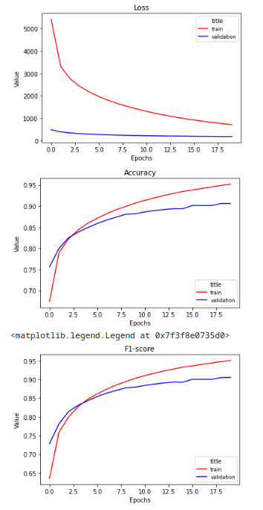

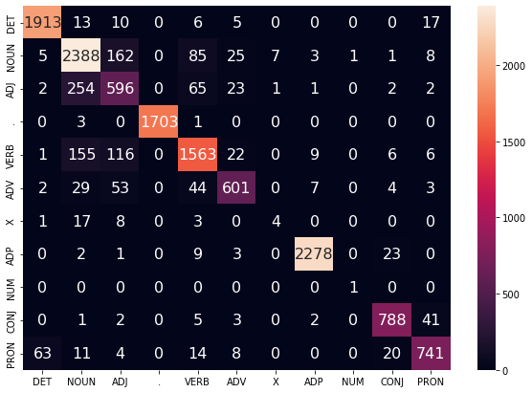

100%|██████████| 4824/4824 [00:29<00:00, 162.50it/s]

100%|██████████| 603/603 [00:01<00:00, 456.00it/s]

EPOCH: 0

TRAIN LOSS: 4724.12356989691

VALIDATION LOSS: 413.1559923738241

TRAIN ACC: 0.7142548102181209

VAL ACC: 0.7911815119096873

TRAIN F-1: 0.6800144560140243

VAL F-1: 0.7673946577795582

100%|██████████| 4824/4824 [00:29<00:00, 161.29it/s]

100%|██████████| 603/603 [00:01<00:00, 452.96it/s]

EPOCH: 1

TRAIN LOSS: 2758.1684606873896

VALIDATION LOSS: 329.20488765090704

TRAIN ACC: 0.8220729212378933

VAL ACC: 0.8304864353685206

TRAIN F-1: 0.7978203801483315

VAL F-1: 0.8198500174000937

100%|██████████| 4824/4824 [00:30<00:00, 158.66it/s]

100%|██████████| 603/603 [00:02<00:00, 282.19it/s]

EPOCH: 2

TRAIN LOSS: 2240.5571171973133

VALIDATION LOSS: 288.63679122924805

TRAIN ACC: 0.8542007899079677

VAL ACC: 0.8522371298540102

TRAIN F-1: 0.8396173753102079

VAL F-1: 0.8459389458248956

100%|██████████| 4824/4824 [00:29<00:00, 163.53it/s]

100%|██████████| 603/603 [00:01<00:00, 453.18it/s]

EPOCH: 3

TRAIN LOSS: 1919.6210867873888

VALIDATION LOSS: 263.67060201242566

TRAIN ACC: 0.8746840059088578

VAL ACC: 0.8637035285773391

TRAIN F-1: 0.8654226730026348

VAL F-1: 0.8594437726488797

100%|██████████| 4824/4824 [00:30<00:00, 159.87it/s]

100%|██████████| 603/603 [00:01<00:00, 454.39it/s]

EPOCH: 4

TRAIN LOSS: 1680.920649972999

VALIDATION LOSS: 246.5701031051576

TRAIN ACC: 0.8895859473023839

VAL ACC: 0.870855251492405

TRAIN F-1: 0.8830483929212557

VAL F-1: 0.867642594276946

100%|██████████| 4824/4824 [00:29<00:00, 163.41it/s]

100%|██████████| 603/603 [00:01<00:00, 449.39it/s]

EPOCH: 5

TRAIN LOSS: 1491.0386449585967

VALIDATION LOSS: 230.29835071228445

TRAIN ACC: 0.901558183088058

VAL ACC: 0.8796028134050475

TRAIN F-1: 0.8969834140635429

VAL F-1: 0.876983321199037

100%|██████████| 4824/4824 [00:29<00:00, 163.17it/s]

100%|██████████| 603/603 [00:01<00:00, 452.90it/s]

EPOCH: 6

TRAIN LOSS: 1329.236747443938

VALIDATION LOSS: 220.2063386682421

TRAIN ACC: 0.9123807875592586

VAL ACC: 0.8843312252497193

TRAIN F-1: 0.9090319909061219

VAL F-1: 0.8822364281366297

100%|██████████| 4824/4824 [00:30<00:00, 160.20it/s]

100%|██████████| 603/603 [00:01<00:00, 444.42it/s]

EPOCH: 7

TRAIN LOSS: 1190.3275777719427

VALIDATION LOSS: 210.50125978514552

TRAIN ACC: 0.9220475799024668

VAL ACC: 0.8900644246113837

TRAIN F-1: 0.9195417969454257

VAL F-1: 0.8884093931177929

100%|██████████| 4824/4824 [00:29<00:00, 162.85it/s]

100%|██████████| 603/603 [00:01<00:00, 450.06it/s]

EPOCH: 8

TRAIN LOSS: 1071.017351614988

VALIDATION LOSS: 204.2128653009422

TRAIN ACC: 0.9296067148358067

VAL ACC: 0.8947928364560553

TRAIN F-1: 0.9276273638283957

VAL F-1: 0.8933569798761531

100%|██████████| 4824/4824 [00:30<00:00, 158.39it/s]

100%|██████████| 603/603 [00:01<00:00, 449.52it/s]

EPOCH: 9

TRAIN LOSS: 966.2159829611082

VALIDATION LOSS: 197.71634332183748

TRAIN ACC: 0.9373327317341509

VAL ACC: 0.8974525681186831

TRAIN F-1: 0.9356887732847262

VAL F-1: 0.8961317087101073

100%|██████████| 4824/4824 [00:29<00:00, 161.96it/s]

100%|██████████| 603/603 [00:01<00:00, 452.22it/s]

EPOCH: 10

TRAIN LOSS: 872.2371680596607

VALIDATION LOSS: 190.94997231382877

TRAIN ACC: 0.9425987848520623

VAL ACC: 0.9031266623322891

TRAIN F-1: 0.941199424864639

VAL F-1: 0.9021789367260066

100%|██████████| 4824/4824 [00:29<00:00, 161.89it/s]

100%|██████████| 603/603 [00:01<00:00, 445.40it/s]

EPOCH: 11

TRAIN LOSS: 786.768446943348

VALIDATION LOSS: 186.13100920524448

TRAIN ACC: 0.9483778454920236

VAL ACC: 0.9053135528104498

TRAIN F-1: 0.9472594091941554

VAL F-1: 0.9042958960935507

100%|██████████| 4824/4824 [00:30<00:00, 159.61it/s]

100%|██████████| 603/603 [00:01<00:00, 452.81it/s]

EPOCH: 12

TRAIN LOSS: 719.3554668641209

VALIDATION LOSS: 183.1341535076499

TRAIN ACC: 0.9523459277710132

VAL ACC: 0.9066729712157929

TRAIN F-1: 0.951339023684693

VAL F-1: 0.9057622113262873

100%|██████████| 4824/4824 [00:29<00:00, 162.23it/s]

100%|██████████| 603/603 [00:01<00:00, 453.29it/s]

EPOCH: 13

TRAIN LOSS: 648.115650175474

VALIDATION LOSS: 181.65574079868384

TRAIN ACC: 0.9575748960078125

VAL ACC: 0.908032389621136

TRAIN F-1: 0.9567543711081706

VAL F-1: 0.9072001109909548

100%|██████████| 4824/4824 [00:29<00:00, 162.56it/s]

100%|██████████| 603/603 [00:01<00:00, 451.85it/s]

EPOCH: 14

TRAIN LOSS: 593.985918886875

VALIDATION LOSS: 177.88444315665402

TRAIN ACC: 0.9611041405269761

VAL ACC: 0.9109876470240558

TRAIN F-1: 0.9603834518503497

VAL F-1: 0.9105778859545711

100%|██████████| 4824/4824 [00:30<00:00, 158.74it/s]

100%|██████████| 603/603 [00:01<00:00, 447.38it/s]

EPOCH: 15

TRAIN LOSS: 540.0973732929906

VALIDATION LOSS: 172.85062026476953

TRAIN ACC: 0.9649362449085549

VAL ACC: 0.9122879602813405

TRAIN F-1: 0.9643156898098446

VAL F-1: 0.91144745557963

100%|██████████| 4824/4824 [00:29<00:00, 162.15it/s]

100%|██████████| 603/603 [00:01<00:00, 452.29it/s]

EPOCH: 16

TRAIN LOSS: 493.79391353295796

VALIDATION LOSS: 175.78305132710375

TRAIN ACC: 0.9682491609545648

VAL ACC: 0.913115432354158

TRAIN F-1: 0.9677097217417634

VAL F-1: 0.9124566513083318

100%|██████████| 4824/4824 [00:29<00:00, 162.03it/s]

100%|██████████| 603/603 [00:01<00:00, 363.03it/s]

EPOCH: 17

TRAIN LOSS: 453.8200927429689

VALIDATION LOSS: 172.75546618248336

TRAIN ACC: 0.9708203793783338

VAL ACC: 0.9154205331284355

TRAIN F-1: 0.9703665277169508

VAL F-1: 0.9147692374751474

100%|██████████| 4824/4824 [00:29<00:00, 162.05it/s]

100%|██████████| 603/603 [00:01<00:00, 451.64it/s]

EPOCH: 18

TRAIN LOSS: 416.00394585561753

VALIDATION LOSS: 172.83261189237237

TRAIN ACC: 0.9733915978021027

VAL ACC: 0.9160706897570778

TRAIN F-1: 0.9729978906559572

VAL F-1: 0.915684020583706

26%|██▌ | 1265/4824 [00:07<00:21, 169.10it/s]

100%|██████████| 603/603 [00:02<00:00, 259.61it/s]

VALIDATION LOSS: 176.84045710013015

VAL F-1: 0.9089160192560095

VAL ACC: 0.9101316542644533

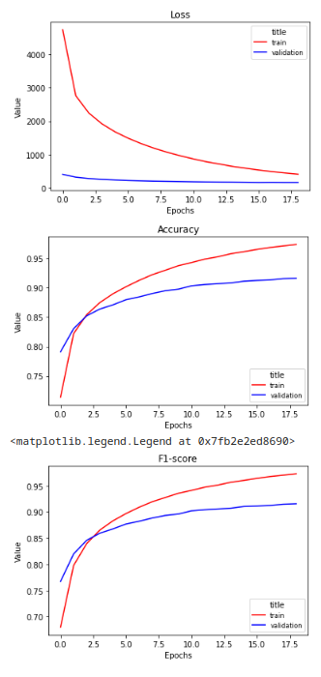

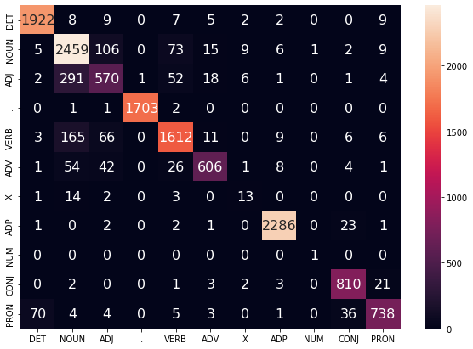

1024x1024

100%|██████████| 4824/4824 [00:57<00:00, 83.31it/s]

100%|██████████| 603/603 [00:02<00:00, 246.12it/s]

EPOCH: 0

TRAIN LOSS: 4048.6330678362865

VALIDATION LOSS: 352.7766009271145

TRAIN ACC: 0.7521864627822314

VAL ACC: 0.8200248241621845

TRAIN F-1: 0.7204853417294009

VAL F-1: 0.8063092146515018

100%|██████████| 4824/4824 [00:59<00:00, 81.36it/s]

100%|██████████| 603/603 [00:02<00:00, 244.01it/s]

EPOCH: 1

TRAIN LOSS: 2262.5708284039865

VALIDATION LOSS: 279.0396443605423

TRAIN ACC: 0.8522476528360663

VAL ACC: 0.8561971747739228

TRAIN F-1: 0.8367460291641454

VAL F-1: 0.8510622817692398

100%|██████████| 4824/4824 [00:58<00:00, 83.12it/s]

100%|██████████| 603/603 [00:02<00:00, 247.09it/s]

EPOCH: 2

TRAIN LOSS: 1762.6711092742771

VALIDATION LOSS: 244.87520116195083

TRAIN ACC: 0.8834793035459327

VAL ACC: 0.8720964596016313

TRAIN F-1: 0.8759134348214452

VAL F-1: 0.868329442734689

100%|██████████| 4824/4824 [00:58<00:00, 82.99it/s]

100%|██████████| 603/603 [00:02<00:00, 244.37it/s]

EPOCH: 3

TRAIN LOSS: 1457.3568147757978

VALIDATION LOSS: 224.08439445868134

TRAIN ACC: 0.9028932388080919

VAL ACC: 0.8841539098055441

TRAIN F-1: 0.8988427725426871

VAL F-1: 0.8817614435761016

100%|██████████| 4824/4824 [00:58<00:00, 82.63it/s]

100%|██████████| 603/603 [00:02<00:00, 245.94it/s]

EPOCH: 4

TRAIN LOSS: 1237.4253455335784

VALIDATION LOSS: 209.0437668375671

TRAIN ACC: 0.9177086488123567

VAL ACC: 0.8920739996453692

TRAIN F-1: 0.9151360556433008

VAL F-1: 0.8902210227859271

100%|██████████| 4824/4824 [00:58<00:00, 83.04it/s]

100%|██████████| 603/603 [00:02<00:00, 244.24it/s]

EPOCH: 5

TRAIN LOSS: 1059.1306623291384

VALIDATION LOSS: 197.6998964594677

TRAIN ACC: 0.9297612351737736

VAL ACC: 0.8989893019682015

TRAIN F-1: 0.9279319621196526

VAL F-1: 0.897689186984192

100%|██████████| 4824/4824 [00:58<00:00, 82.82it/s]

100%|██████████| 603/603 [00:02<00:00, 244.52it/s]

EPOCH: 6

TRAIN LOSS: 912.018060669554

VALIDATION LOSS: 189.1665500230156

TRAIN ACC: 0.9388964775543757

VAL ACC: 0.9012352975944204

TRAIN F-1: 0.9374504854203597

VAL F-1: 0.9001724118381739

100%|██████████| 4824/4824 [00:58<00:00, 83.14it/s]

100%|██████████| 603/603 [00:02<00:00, 245.78it/s]

EPOCH: 7

TRAIN LOSS: 793.1971471816214

VALIDATION LOSS: 181.45482590142637

TRAIN ACC: 0.9473271071938488

VAL ACC: 0.9063183403274425

TRAIN F-1: 0.9462011199084617

VAL F-1: 0.9052967563084754

100%|██████████| 4824/4824 [00:58<00:00, 82.89it/s]

100%|██████████| 603/603 [00:02<00:00, 243.69it/s]

EPOCH: 8

TRAIN LOSS: 689.6477375907707

VALIDATION LOSS: 176.211776382057

TRAIN ACC: 0.9544226811132881

VAL ACC: 0.9080914947691944

TRAIN F-1: 0.9535301536721166

VAL F-1: 0.9073946027012828

100%|██████████| 4824/4824 [00:58<00:00, 82.72it/s]

100%|██████████| 603/603 [00:02<00:00, 244.70it/s]

EPOCH: 9

TRAIN LOSS: 602.0112576403262

VALIDATION LOSS: 172.71737365890294

TRAIN ACC: 0.9604675167345526

VAL ACC: 0.9110467521721142

TRAIN F-1: 0.9597765952701494

VAL F-1: 0.9102624784913664

100%|██████████| 4824/4824 [00:57<00:00, 83.48it/s]

100%|██████████| 603/603 [00:02<00:00, 243.08it/s]

EPOCH: 10

TRAIN LOSS: 527.7030897907425

VALIDATION LOSS: 167.1602862816071

TRAIN ACC: 0.9657830163606134

VAL ACC: 0.9139429044269756

TRAIN F-1: 0.9652223907518243

VAL F-1: 0.9133876406223757

100%|██████████| 4824/4824 [00:57<00:00, 83.21it/s]

100%|██████████| 603/603 [00:02<00:00, 244.17it/s]

EPOCH: 11

TRAIN LOSS: 465.51239876493946

VALIDATION LOSS: 164.78388428641483

TRAIN ACC: 0.9703073718562837

VAL ACC: 0.9141793250192092

TRAIN F-1: 0.9698744274354832

VAL F-1: 0.9136210210632248

100%|██████████| 4824/4824 [00:58<00:00, 83.05it/s]

100%|██████████| 603/603 [00:02<00:00, 245.44it/s]

EPOCH: 12

TRAIN LOSS: 408.8679485245775

VALIDATION LOSS: 162.83023638522718

TRAIN ACC: 0.9743990704056468

VAL ACC: 0.9161889000531946

TRAIN F-1: 0.9740508594472743

VAL F-1: 0.915912214936709

100%|██████████| 4824/4824 [00:58<00:00, 83.11it/s]

100%|██████████| 603/603 [00:02<00:00, 244.28it/s]

EPOCH: 13

TRAIN LOSS: 363.00732658445304

VALIDATION LOSS: 162.0969957964262

TRAIN ACC: 0.9778170602814742

VAL ACC: 0.917430108162421

TRAIN F-1: 0.9775382727503455

VAL F-1: 0.9170013839050838

100%|██████████| 4824/4824 [00:57<00:00, 83.54it/s]

100%|██████████| 603/603 [00:02<00:00, 244.72it/s]

EPOCH: 14

TRAIN LOSS: 321.8923806398316

VALIDATION LOSS: 160.8953290968784

TRAIN ACC: 0.9807776699569197

VAL ACC: 0.9184940008274721

TRAIN F-1: 0.9805590283323583

VAL F-1: 0.9180177778104053

100%|██████████| 4824/4824 [00:58<00:00, 83.01it/s]

100%|██████████| 603/603 [00:02<00:00, 245.77it/s]

EPOCH: 15

TRAIN LOSS: 285.9130189552361

VALIDATION LOSS: 158.30723168107215

TRAIN ACC: 0.9832438145508712

VAL ACC: 0.91967610378864

TRAIN F-1: 0.9830718297732528

VAL F-1: 0.9193188884716759

100%|██████████| 4824/4824 [00:58<00:00, 83.11it/s]

100%|██████████| 603/603 [00:02<00:00, 244.51it/s]

EPOCH: 16

TRAIN LOSS: 257.16307927874595

VALIDATION LOSS: 156.26884355943184

TRAIN ACC: 0.98530202545259

VAL ACC: 0.9209764170459247

TRAIN F-1: 0.9851640455170703

VAL F-1: 0.920593630977344

100%|██████████| 4824/4824 [00:58<00:00, 83.11it/s]

100%|██████████| 603/603 [00:02<00:00, 246.88it/s]

EPOCH: 17

TRAIN LOSS: 230.41067658068823

VALIDATION LOSS: 157.1309120237711

TRAIN ACC: 0.9872675241515289

VAL ACC: 0.920267155269224

TRAIN F-1: 0.9871609950676136

VAL F-1: 0.9199595195495353

16%|█▌ | 783/4824 [00:09<00:49, 81.43it/s]

100%|██████████| 603/603 [00:02<00:00, 274.53it/s]VALIDATION LOSS: 172.24780550639844

VAL F-1: 0.9110968176565992

VAL ACC: 0.9114195764167143

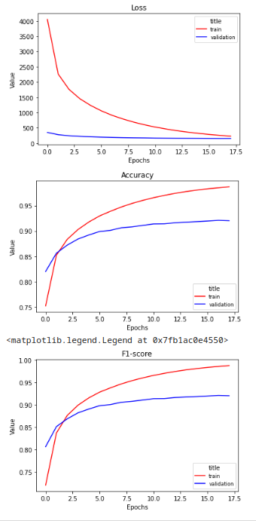

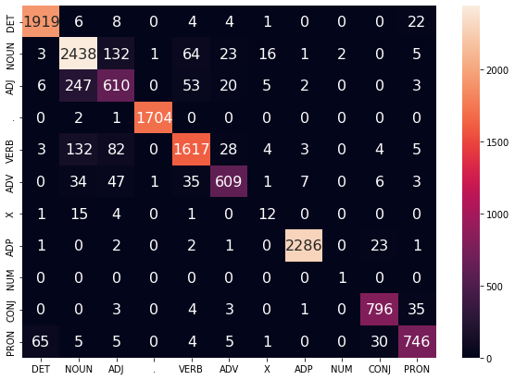

WORD_EMBEDDING_DIM = 128

CHAR_EMBEDDING_DIM = 32

WORD_HIDDEN_DIM = 128

CHAR_HIDDEN_DIM = 32

KEEP_DROPOUT = 0.8

100%|██████████| 4824/4824 [01:33<00:00, 51.46it/s]

100%|██████████| 603/603 [00:04<00:00, 137.33it/s]

EPOCH: 0

TRAIN LOSS: 6594.280827086419

VALIDATION LOSS: 575.1991092562675

TRAIN ACC: 0.5818865079021701

VAL ACC: 0.715290501802707

TRAIN F-1: 0.5404398727744284

VAL F-1: 0.6860590973327149

100%|██████████| 4824/4824 [01:31<00:00, 52.97it/s]

100%|██████████| 603/603 [00:04<00:00, 138.23it/s]

EPOCH: 1

TRAIN LOSS: 3842.096387229394

VALIDATION LOSS: 442.7451514750719

TRAIN ACC: 0.7526994703042814

VAL ACC: 0.7676576629824458

TRAIN F-1: 0.7210936010303025

VAL F-1: 0.7491788290999352

100%|██████████| 4824/4824 [01:37<00:00, 49.24it/s]

100%|██████████| 603/603 [00:04<00:00, 137.37it/s]

EPOCH: 2

TRAIN LOSS: 3152.3376484992914

VALIDATION LOSS: 381.9737789481878

TRAIN ACC: 0.7939934854225513

VAL ACC: 0.8010520716354395

TRAIN F-1: 0.7719405431409312

VAL F-1: 0.7925673486780654

100%|██████████| 4824/4824 [01:32<00:00, 52.29it/s]

100%|██████████| 603/603 [00:04<00:00, 138.99it/s]

EPOCH: 3

TRAIN LOSS: 2743.1256665214896

VALIDATION LOSS: 342.5904129073024

TRAIN ACC: 0.8228084380466157

VAL ACC: 0.8230391867131627

TRAIN F-1: 0.8095762095626285

VAL F-1: 0.8176157142614109

100%|██████████| 4824/4824 [01:31<00:00, 52.83it/s]

100%|██████████| 603/603 [00:04<00:00, 124.11it/s]

EPOCH: 4

TRAIN LOSS: 2446.150022615446

VALIDATION LOSS: 311.922022677958

TRAIN ACC: 0.842278000630443

VAL ACC: 0.8384065252083457

TRAIN F-1: 0.8319950594881027

VAL F-1: 0.8334716488172316

100%|██████████| 4824/4824 [01:32<00:00, 52.05it/s]

100%|██████████| 603/603 [00:04<00:00, 135.35it/s]

EPOCH: 5

TRAIN LOSS: 2178.797667609062

VALIDATION LOSS: 285.46854169666767

TRAIN ACC: 0.8582924884573307

VAL ACC: 0.8536556534074118

TRAIN F-1: 0.8495320285802997

VAL F-1: 0.850237986826013

100%|██████████| 4824/4824 [01:32<00:00, 51.87it/s]

100%|██████████| 603/603 [00:04<00:00, 136.42it/s]

EPOCH: 6

TRAIN LOSS: 1973.0726428814232

VALIDATION LOSS: 266.8182992748916

TRAIN ACC: 0.8708209974596857

VAL ACC: 0.8625805307642296

TRAIN F-1: 0.8629245924464662

VAL F-1: 0.8587047221576849

100%|██████████| 4824/4824 [01:30<00:00, 53.16it/s]

100%|██████████| 603/603 [00:05<00:00, 118.13it/s]

EPOCH: 7

TRAIN LOSS: 1734.0096159914974

VALIDATION LOSS: 247.1433816254139

TRAIN ACC: 0.885512791193577

VAL ACC: 0.8727466162302736

TRAIN F-1: 0.8798826245931022

VAL F-1: 0.8688729405786519

100%|██████████| 4824/4824 [01:31<00:00, 52.85it/s]

100%|██████████| 603/603 [00:04<00:00, 138.89it/s]

EPOCH: 8

TRAIN LOSS: 1543.4856307086302

VALIDATION LOSS: 237.10047087818384

TRAIN ACC: 0.8979547688066704

VAL ACC: 0.8763520302618358

TRAIN F-1: 0.8941547933208642

VAL F-1: 0.8729447920836473

100%|██████████| 4824/4824 [01:31<00:00, 52.52it/s]

100%|██████████| 603/603 [00:04<00:00, 139.70it/s]

EPOCH: 9

TRAIN LOSS: 1387.9185274461051

VALIDATION LOSS: 220.65994361788034

TRAIN ACC: 0.9087217459562028

VAL ACC: 0.8861043796914712

TRAIN F-1: 0.9061799283147065

VAL F-1: 0.8836501347594707

100%|██████████| 4824/4824 [01:30<00:00, 53.07it/s]

100%|██████████| 603/603 [00:04<00:00, 136.76it/s]

EPOCH: 10

TRAIN LOSS: 1254.5246887431713

VALIDATION LOSS: 209.53497975319624

TRAIN ACC: 0.9172821726795681

VAL ACC: 0.8921331047934276

TRAIN F-1: 0.915403722219712

VAL F-1: 0.8904326390021085

100%|██████████| 4824/4824 [01:33<00:00, 51.80it/s]

100%|██████████| 603/603 [00:04<00:00, 138.69it/s]

EPOCH: 11

TRAIN LOSS: 1141.0871126038255

VALIDATION LOSS: 200.3025977294892

TRAIN ACC: 0.92436538497197

VAL ACC: 0.896388675453632

TRAIN F-1: 0.9228881589261066

VAL F-1: 0.8949995426470376

100%|██████████| 4824/4824 [01:33<00:00, 51.70it/s]

100%|██████████| 603/603 [00:04<00:00, 139.85it/s]

EPOCH: 12

TRAIN LOSS: 1043.1223400366725

VALIDATION LOSS: 192.14244761876762

TRAIN ACC: 0.9309417705558406

VAL ACC: 0.9003487203735445

TRAIN F-1: 0.9297999445290438

VAL F-1: 0.8991246767329443

100%|██████████| 4824/4824 [01:31<00:00, 52.60it/s]

100%|██████████| 603/603 [00:04<00:00, 129.11it/s]

EPOCH: 13

TRAIN LOSS: 958.8627900739084

VALIDATION LOSS: 185.91659139748663

TRAIN ACC: 0.9364056097063496

VAL ACC: 0.9028311365919972

TRAIN F-1: 0.9354718051578966

VAL F-1: 0.9018713592243155

100%|██████████| 4824/4824 [01:31<00:00, 52.55it/s]

100%|██████████| 603/603 [00:04<00:00, 138.36it/s]

EPOCH: 14

TRAIN LOSS: 902.3657063397695

VALIDATION LOSS: 185.69702525436878

TRAIN ACC: 0.9402191716473722

VAL ACC: 0.9041314498492818

TRAIN F-1: 0.9394160099861912

VAL F-1: 0.9032373824682132

100%|██████████| 4824/4824 [01:31<00:00, 52.64it/s]

100%|██████████| 603/603 [00:04<00:00, 139.62it/s]

EPOCH: 15

TRAIN LOSS: 841.4928853791789

VALIDATION LOSS: 179.7136609479785

TRAIN ACC: 0.9441996155533992

VAL ACC: 0.90714581240026

TRAIN F-1: 0.9435052728209146

VAL F-1: 0.9063815293714635

100%|██████████| 4824/4824 [01:30<00:00, 53.28it/s]

100%|██████████| 603/603 [00:04<00:00, 139.99it/s]

EPOCH: 16

TRAIN LOSS: 779.3806937155896

VALIDATION LOSS: 175.6315676504746

TRAIN ACC: 0.9481800594594261

VAL ACC: 0.9100419646551214

TRAIN F-1: 0.9475385207149251

VAL F-1: 0.909240479900285

100%|██████████| 4824/4824 [01:31<00:00, 52.71it/s]

100%|██████████| 603/603 [00:04<00:00, 139.35it/s]

EPOCH: 17

TRAIN LOSS: 727.0059012256679

VALIDATION LOSS: 171.29061895702034

TRAIN ACC: 0.9515671452676602

VAL ACC: 0.911460488208523

TRAIN F-1: 0.9510005033238748

VAL F-1: 0.9107510861765113

100%|██████████| 4824/4824 [01:31<00:00, 52.81it/s]

100%|██████████| 603/603 [00:04<00:00, 140.85it/s]

EPOCH: 18

TRAIN LOSS: 677.9303219413559

VALIDATION LOSS: 168.17275817738846

TRAIN ACC: 0.9553559839546081

VAL ACC: 0.914297535315326

TRAIN F-1: 0.9548438307554645

VAL F-1: 0.9137151893642684

100%|██████████| 4824/4824 [01:30<00:00, 53.50it/s]

100%|██████████| 603/603 [00:04<00:00, 140.99it/s]

EPOCH: 19

TRAIN LOSS: 635.3040318573476

VALIDATION LOSS: 165.1738489214331

TRAIN ACC: 0.957908659937821

VAL ACC: 0.915656953720669

TRAIN F-1: 0.9574389804505998

VAL F-1: 0.9150211457409227

100%|██████████| 4824/4824 [01:31<00:00, 52.76it/s]

100%|██████████| 603/603 [00:04<00:00, 138.02it/s]

EPOCH: 20

TRAIN LOSS: 595.1893769963062

VALIDATION LOSS: 162.0109109999612

TRAIN ACC: 0.9605973138184448

VAL ACC: 0.9173710030143626

TRAIN F-1: 0.9601687448134822

VAL F-1: 0.9167896649452918

100%|██████████| 4824/4824 [01:31<00:00, 52.75it/s]

100%|██████████| 603/603 [00:04<00:00, 140.24it/s]

EPOCH: 21

TRAIN LOSS: 559.2158847091778

VALIDATION LOSS: 160.2430976415053

TRAIN ACC: 0.9630881816664709

VAL ACC: 0.9190259471599976

TRAIN F-1: 0.9627263565736597

VAL F-1: 0.9185310769796254

100%|██████████| 4824/4824 [01:30<00:00, 53.33it/s]

100%|██████████| 603/603 [00:04<00:00, 139.37it/s]

EPOCH: 22

TRAIN LOSS: 525.5652840649709

VALIDATION LOSS: 157.73422595486045

TRAIN ACC: 0.9650042338572603

VAL ACC: 0.9208582067498079

TRAIN F-1: 0.9646646232249662

VAL F-1: 0.920255044256506

100%|██████████| 4824/4824 [01:30<00:00, 53.09it/s]

100%|██████████| 603/603 [00:04<00:00, 141.58it/s]

EPOCH: 23

TRAIN LOSS: 496.47193702487857

VALIDATION LOSS: 156.2605498174671

TRAIN ACC: 0.9670068174373111

VAL ACC: 0.9215674685265086

TRAIN F-1: 0.9666973312451572

VAL F-1: 0.9209206847866195

100%|██████████| 4824/4824 [01:30<00:00, 53.24it/s]

100%|██████████| 603/603 [00:04<00:00, 141.34it/s]

EPOCH: 24

TRAIN LOSS: 468.69057680288097

VALIDATION LOSS: 154.50555215333588

TRAIN ACC: 0.9688981463740257

VAL ACC: 0.9221585200070926

TRAIN F-1: 0.9686058527411315

VAL F-1: 0.9215914416918817

100%|██████████| 603/603 [00:03<00:00, 167.69it/s]VALIDATION LOSS: 169.00286400096957

VAL F-1: 0.9166413720225884

VAL ACC: 0.9174298797939324

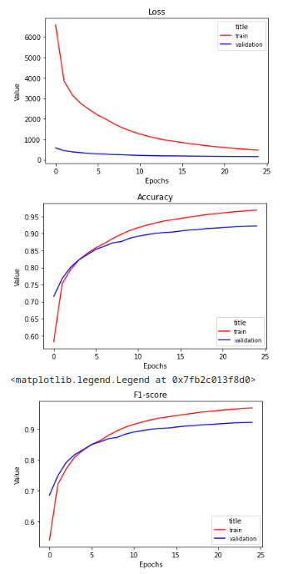

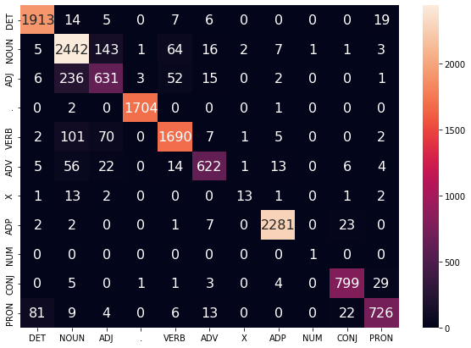

128x128

64x64

100%|██████████| 4824/4824 [01:32<00:00, 52.27it/s]

100%|██████████| 603/603 [00:04<00:00, 139.39it/s]

EPOCH: 0

TRAIN LOSS: 4395.783683811314

VALIDATION LOSS: 376.1619627326727

TRAIN ACC: 0.7125983521951159

VAL ACC: 0.8019386488563154

TRAIN F-1: 0.6873413002436989

VAL F-1: 0.7944763994876337

100%|██████████| 4824/4824 [01:32<00:00, 52.41it/s]

100%|██████████| 603/603 [00:04<00:00, 139.51it/s]

EPOCH: 1

TRAIN LOSS: 2383.3414969982114

VALIDATION LOSS: 271.25937412679195

TRAIN ACC: 0.8400590885772385

VAL ACC: 0.8576156983273243

TRAIN F-1: 0.8311847128864197

VAL F-1: 0.8526598124625402

100%|██████████| 4824/4824 [01:31<00:00, 52.60it/s]

100%|██████████| 603/603 [00:04<00:00, 139.49it/s]

EPOCH: 2

TRAIN LOSS: 1641.1552600751165

VALIDATION LOSS: 217.24509231559932

TRAIN ACC: 0.8894499694049731

VAL ACC: 0.8891778473905078

TRAIN F-1: 0.886860504196397

VAL F-1: 0.887855912348126

100%|██████████| 4824/4824 [01:30<00:00, 53.18it/s]

100%|██████████| 603/603 [00:04<00:00, 139.07it/s]

EPOCH: 3

TRAIN LOSS: 1220.5885346710565

VALIDATION LOSS: 184.50384092703462

TRAIN ACC: 0.9180176894882904

VAL ACC: 0.9072049175483184

TRAIN F-1: 0.9166599813560969

VAL F-1: 0.906557079877559

100%|██████████| 4824/4824 [01:31<00:00, 52.50it/s]

100%|██████████| 603/603 [00:04<00:00, 136.97it/s]

EPOCH: 4

TRAIN LOSS: 962.0863813956967

VALIDATION LOSS: 165.41128977481276

TRAIN ACC: 0.9353239673405813

VAL ACC: 0.9157751640167858

TRAIN F-1: 0.9344443605691581

VAL F-1: 0.9151828554690414

100%|██████████| 4824/4824 [01:32<00:00, 52.42it/s]

100%|██████████| 603/603 [00:04<00:00, 138.94it/s]

EPOCH: 5

TRAIN LOSS: 787.5059117972851

VALIDATION LOSS: 154.34217787301168

TRAIN ACC: 0.9462701880821554

VAL ACC: 0.9210355221939831

TRAIN F-1: 0.9456506747034112

VAL F-1: 0.9204317344514665

100%|██████████| 4824/4824 [01:31<00:00, 52.92it/s]

100%|██████████| 603/603 [00:04<00:00, 138.60it/s]

EPOCH: 6

TRAIN LOSS: 652.7067067963071

VALIDATION LOSS: 144.75984898372553

TRAIN ACC: 0.9545833822647737

VAL ACC: 0.9254684082983627

TRAIN F-1: 0.9541329898200369

VAL F-1: 0.9248886149481864

100%|██████████| 4824/4824 [01:31<00:00, 52.85it/s]

100%|██████████| 603/603 [00:04<00:00, 140.61it/s]

EPOCH: 7

TRAIN LOSS: 546.3993098233477

VALIDATION LOSS: 136.92682468681596

TRAIN ACC: 0.9622043253333004

VAL ACC: 0.9289556120338082

TRAIN F-1: 0.961907200382288

VAL F-1: 0.9285634768059141

100%|██████████| 4824/4824 [01:31<00:00, 52.88it/s]

100%|██████████| 603/603 [00:04<00:00, 140.10it/s]

EPOCH: 8

TRAIN LOSS: 463.04318316825083

VALIDATION LOSS: 130.4672349236207

TRAIN ACC: 0.9682862458356769

VAL ACC: 0.9358709143566405

TRAIN F-1: 0.968088505403523

VAL F-1: 0.9354326815694083

100%|██████████| 4824/4824 [01:30<00:00, 53.13it/s]

100%|██████████| 603/603 [00:04<00:00, 138.70it/s]

EPOCH: 9

TRAIN LOSS: 395.7514744212094

VALIDATION LOSS: 127.44858308671974

TRAIN ACC: 0.973082557126169

VAL ACC: 0.9370530173178084

TRAIN F-1: 0.972948105309488

VAL F-1: 0.9367202459282735

100%|██████████| 4824/4824 [01:31<00:00, 52.63it/s]

100%|██████████| 603/603 [00:04<00:00, 139.58it/s]

EPOCH: 10

TRAIN LOSS: 344.1321730229247

VALIDATION LOSS: 125.710572789656

TRAIN ACC: 0.9767786836103368

VAL ACC: 0.9396536438323778

TRAIN F-1: 0.9766630793192516

VAL F-1: 0.9392217619276575

100%|██████████| 4824/4824 [01:31<00:00, 52.77it/s]

100%|██████████| 603/603 [00:04<00:00, 139.68it/s]

EPOCH: 11

TRAIN LOSS: 301.3147995379113

VALIDATION LOSS: 125.16880254133139

TRAIN ACC: 0.9795662305072593

VAL ACC: 0.9423133754950056

TRAIN F-1: 0.9794695868572385

VAL F-1: 0.9419403326385318

100%|██████████| 4824/4824 [01:30<00:00, 53.49it/s]

100%|██████████| 603/603 [00:04<00:00, 139.27it/s]

EPOCH: 12

TRAIN LOSS: 266.3948223277548

VALIDATION LOSS: 124.22083630604902

TRAIN ACC: 0.9821374489310283

VAL ACC: 0.942372480643064

TRAIN F-1: 0.9820612046781756

VAL F-1: 0.9419689160763897

100%|██████████| 4824/4824 [01:31<00:00, 52.83it/s]

100%|██████████| 603/603 [00:04<00:00, 140.89it/s]

EPOCH: 13

TRAIN LOSS: 238.77331565313216

VALIDATION LOSS: 125.9061888185679

TRAIN ACC: 0.9839051615973694

VAL ACC: 0.9419587446066552

TRAIN F-1: 0.9838434918623374

VAL F-1: 0.941399609374841

18%|█▊ | 854/4824 [00:18<01:23, 47.42it/s]

100%|██████████| 603/603 [00:03<00:00, 164.82it/s]VALIDATION LOSS: 148.17032563581597

VAL F-1: 0.9295269511022628

VAL ACC: 0.9294504865483686

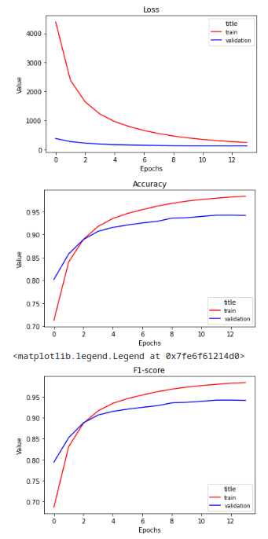

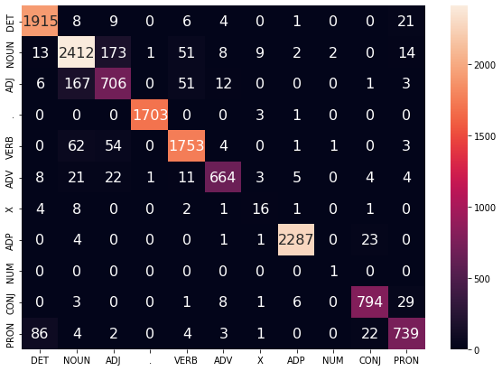

WORD_EMBEDDING_DIM = 300

CHAR_EMBEDDING_DIM = 100

WORD_HIDDEN_DIM = 256

CHAR_HIDDEN_DIM = 64

KEEP_DROPOUT = 0.8

100%|██████████| 4824/4824 [01:38<00:00, 48.74it/s]

100%|██████████| 603/603 [00:04<00:00, 141.75it/s]

EPOCH: 0

TRAIN LOSS: 3614.877630661358

VALIDATION LOSS: 305.80164931714535

TRAIN ACC: 0.7671872971920565

VAL ACC: 0.8398841539098055

TRAIN F-1: 0.7486356730609535

VAL F-1: 0.8341863427866724

100%|██████████| 4824/4824 [01:35<00:00, 50.34it/s]

100%|██████████| 603/603 [00:04<00:00, 140.42it/s]

EPOCH: 1

TRAIN LOSS: 1856.615572819719

VALIDATION LOSS: 230.01935844868422

TRAIN ACC: 0.8771068848081784

VAL ACC: 0.8824989656599089

TRAIN F-1: 0.870531577359803

VAL F-1: 0.8792253104967731

100%|██████████| 4824/4824 [01:36<00:00, 49.82it/s]

100%|██████████| 603/603 [00:04<00:00, 140.87it/s]

EPOCH: 2

TRAIN LOSS: 1215.8060444247676

VALIDATION LOSS: 183.94717332161963

TRAIN ACC: 0.9196803283248142

VAL ACC: 0.9075595484366689

TRAIN F-1: 0.9180919720767168

VAL F-1: 0.9062718158129207

100%|██████████| 4824/4824 [01:36<00:00, 49.87it/s]

100%|██████████| 603/603 [00:04<00:00, 142.15it/s]

EPOCH: 3

TRAIN LOSS: 824.6437232843891

VALIDATION LOSS: 161.32060404215008

TRAIN ACC: 0.9449227707350841

VAL ACC: 0.9192032626041728

TRAIN F-1: 0.9443159219986118

VAL F-1: 0.9185815904879816

100%|██████████| 4824/4824 [01:35<00:00, 50.35it/s]

100%|██████████| 603/603 [00:04<00:00, 139.07it/s]

EPOCH: 4

TRAIN LOSS: 590.2133111802832

VALIDATION LOSS: 147.1561642298475

TRAIN ACC: 0.9602326458208429

VAL ACC: 0.9275370884804066

TRAIN F-1: 0.9598347735926286

VAL F-1: 0.9269401737307705

100%|██████████| 4824/4824 [01:37<00:00, 49.50it/s]

100%|██████████| 603/603 [00:04<00:00, 144.06it/s]

EPOCH: 5

TRAIN LOSS: 437.5479980954551

VALIDATION LOSS: 139.75429250765592

TRAIN ACC: 0.9706349549727735

VAL ACC: 0.9322655003250783

TRAIN F-1: 0.9703836656145948

VAL F-1: 0.931907188289263

100%|██████████| 4824/4824 [01:36<00:00, 49.87it/s]

100%|██████████| 603/603 [00:04<00:00, 142.52it/s]

EPOCH: 6

TRAIN LOSS: 335.58319119632506

VALIDATION LOSS: 135.58402244991157

TRAIN ACC: 0.9775574661136899

VAL ACC: 0.9351616525799397

TRAIN F-1: 0.9773953075097529

VAL F-1: 0.9348043907320761

100%|██████████| 4824/4824 [01:37<00:00, 49.60it/s]

100%|██████████| 603/603 [00:04<00:00, 140.29it/s]

EPOCH: 7

TRAIN LOSS: 265.53830740763806

VALIDATION LOSS: 133.21590896765701

TRAIN ACC: 0.9826010099449289

VAL ACC: 0.9378213842425676

TRAIN F-1: 0.9825017569878837

VAL F-1: 0.937451098616775

100%|██████████| 4824/4824 [01:35<00:00, 50.43it/s]

100%|██████████| 603/603 [00:04<00:00, 143.70it/s]

EPOCH: 8

TRAIN LOSS: 213.56570619141712

VALIDATION LOSS: 131.67252029298106

TRAIN ACC: 0.9865876346644745

VAL ACC: 0.9401264850168449

TRAIN F-1: 0.9865207902226617

VAL F-1: 0.9397806502043923

100%|██████████| 4824/4824 [01:36<00:00, 49.87it/s]

100%|██████████| 603/603 [00:04<00:00, 142.86it/s]

EPOCH: 9

TRAIN LOSS: 173.71854652620095

VALIDATION LOSS: 130.9499890889856

TRAIN ACC: 0.9894740745776959

VAL ACC: 0.9406584313493705

TRAIN F-1: 0.9894269024512653

VAL F-1: 0.9403560171288222

100%|██████████| 4824/4824 [01:36<00:00, 50.01it/s]

100%|██████████| 603/603 [00:04<00:00, 142.37it/s]

EPOCH: 10

TRAIN LOSS: 144.2758280171838

VALIDATION LOSS: 130.6833816417493

TRAIN ACC: 0.9915384662929335

VAL ACC: 0.942372480643064

TRAIN F-1: 0.9915032347030932

VAL F-1: 0.9420794624131503

100%|██████████| 4824/4824 [01:37<00:00, 49.40it/s]

100%|██████████| 603/603 [00:04<00:00, 141.88it/s]

EPOCH: 11

TRAIN LOSS: 121.74243204281447

VALIDATION LOSS: 129.74452296618256

TRAIN ACC: 0.9929229685211167

VAL ACC: 0.9431999527158815

TRAIN F-1: 0.9928964295040252

VAL F-1: 0.9429668254765986

11%|█▏ | 545/4824 [00:11<01:33, 45.98it/s]

100%|██████████| 603/603 [00:03<00:00, 169.27it/s]VALIDATION LOSS: 145.45177462339052

VAL F-1: 0.9342138649028047

VAL ACC: 0.9348168288494562

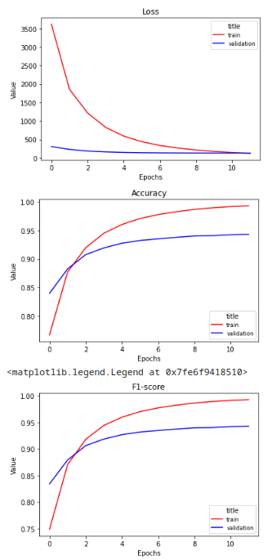

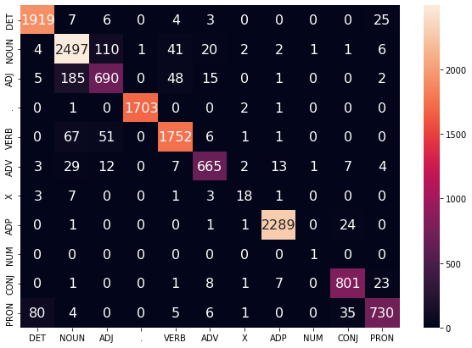

WORD_EMBEDDING_DIM = 300

CHAR_EMBEDDING_DIM = 100

WORD_HIDDEN_DIM = 512

CHAR_HIDDEN_DIM = 64

KEEP_DROPOUT = 0.8

100%|██████████| 4824/4824 [01:37<00:00, 49.44it/s]

100%|██████████| 603/603 [00:04<00:00, 137.90it/s]

EPOCH: 0

TRAIN LOSS: 5407.539028679952

VALIDATION LOSS: 466.9376450628042

TRAIN ACC: 0.6642334864114815

VAL ACC: 0.7567232105916425

TRAIN F-1: 0.6333388284981621

VAL F-1: 0.7350586996741689

100%|██████████| 4824/4824 [01:38<00:00, 48.97it/s]

100%|██████████| 603/603 [00:04<00:00, 137.64it/s]

EPOCH: 1

TRAIN LOSS: 3090.1502015845035

VALIDATION LOSS: 360.35999055951834

TRAIN ACC: 0.795637581818519

VAL ACC: 0.8105680004728412

TRAIN F-1: 0.7728088845303732

VAL F-1: 0.803613544430616

100%|██████████| 4824/4824 [01:41<00:00, 47.64it/s]

100%|██████████| 603/603 [00:04<00:00, 135.34it/s]

EPOCH: 2

TRAIN LOSS: 2501.634000366379

VALIDATION LOSS: 308.0273767448962

TRAIN ACC: 0.8355903604032363

VAL ACC: 0.837579053135528

TRAIN F-1: 0.8238926434634554

VAL F-1: 0.8331100302406893

100%|██████████| 4824/4824 [01:41<00:00, 47.53it/s]

100%|██████████| 603/603 [00:04<00:00, 137.63it/s]

EPOCH: 3

TRAIN LOSS: 2123.929831921181

VALIDATION LOSS: 274.03912525624037

TRAIN ACC: 0.8595842784827339

VAL ACC: 0.8558425438855725

TRAIN F-1: 0.8510656904594691

VAL F-1: 0.8520391570994114

100%|██████████| 4824/4824 [01:38<00:00, 49.02it/s]

100%|██████████| 603/603 [00:04<00:00, 122.45it/s]

EPOCH: 4

TRAIN LOSS: 1770.123178859125

VALIDATION LOSS: 245.2699038386345

TRAIN ACC: 0.8817486757607036

VAL ACC: 0.8713280926768722

TRAIN F-1: 0.8764828940825855

VAL F-1: 0.8686256432179332

100%|██████████| 4824/4824 [01:38<00:00, 48.79it/s]

100%|██████████| 603/603 [00:04<00:00, 136.48it/s]

EPOCH: 5

TRAIN LOSS: 1466.7217405472184

VALIDATION LOSS: 220.97761986777186

TRAIN ACC: 0.9024482202347472

VAL ACC: 0.885336012766712

TRAIN F-1: 0.9000210412445413

VAL F-1: 0.8839058033005026

100%|██████████| 4824/4824 [01:39<00:00, 48.45it/s]

100%|██████████| 603/603 [00:04<00:00, 136.95it/s]

EPOCH: 6

TRAIN LOSS: 1205.3892287013587

VALIDATION LOSS: 199.64859688840806

TRAIN ACC: 0.9202427823550136

VAL ACC: 0.8972752526745079

TRAIN F-1: 0.9190767764365504

VAL F-1: 0.8961118883762784

100%|██████████| 4824/4824 [01:39<00:00, 48.46it/s]

100%|██████████| 603/603 [00:04<00:00, 138.28it/s]

EPOCH: 7

TRAIN LOSS: 1011.8360167230712

VALIDATION LOSS: 183.96037330012769

TRAIN ACC: 0.9325796861382896

VAL ACC: 0.9059637094390921

TRAIN F-1: 0.9316467937192386

VAL F-1: 0.9051111071439354

100%|██████████| 4824/4824 [01:39<00:00, 48.56it/s]

100%|██████████| 603/603 [00:04<00:00, 135.01it/s]

EPOCH: 8

TRAIN LOSS: 859.3352514395665

VALIDATION LOSS: 171.91784718073905

TRAIN ACC: 0.9428460173928093

VAL ACC: 0.9122879602813405

TRAIN F-1: 0.9421487252234104

VAL F-1: 0.9116072454294166

100%|██████████| 4824/4824 [01:38<00:00, 48.88it/s]

100%|██████████| 603/603 [00:04<00:00, 137.88it/s]

EPOCH: 9

TRAIN LOSS: 732.777617691725

VALIDATION LOSS: 162.48645949130878

TRAIN ACC: 0.950998510423942

VAL ACC: 0.9179029493468881

TRAIN F-1: 0.9504640301957756

VAL F-1: 0.9173550203593945

100%|██████████| 4824/4824 [01:39<00:00, 48.54it/s]

100%|██████████| 603/603 [00:04<00:00, 134.95it/s]

EPOCH: 10

TRAIN LOSS: 633.4891332150437

VALIDATION LOSS: 154.9274005945772

TRAIN ACC: 0.9575254494996631

VAL ACC: 0.9225722560435013

TRAIN F-1: 0.9571044584023967

VAL F-1: 0.9220804370106443

100%|██████████| 4824/4824 [01:39<00:00, 48.27it/s]

100%|██████████| 603/603 [00:04<00:00, 137.03it/s]

EPOCH: 11

TRAIN LOSS: 550.6566538212355

VALIDATION LOSS: 150.00020555220544

TRAIN ACC: 0.9630943624799896

VAL ACC: 0.9255866185944795

TRAIN F-1: 0.9627568085107445

VAL F-1: 0.9251563888307978

100%|██████████| 4824/4824 [01:39<00:00, 48.59it/s]

100%|██████████| 603/603 [00:04<00:00, 137.19it/s]

EPOCH: 12

TRAIN LOSS: 485.605841774086

VALIDATION LOSS: 146.12195368111134

TRAIN ACC: 0.9677485150595522

VAL ACC: 0.9289556120338082

TRAIN F-1: 0.9674896625465939

VAL F-1: 0.9285664941013808

100%|██████████| 4824/4824 [01:38<00:00, 49.17it/s]

100%|██████████| 603/603 [00:04<00:00, 138.36it/s]

EPOCH: 13

TRAIN LOSS: 428.37550989192096

VALIDATION LOSS: 145.24861451378092

TRAIN ACC: 0.9715744386276122

VAL ACC: 0.9295466635143921

TRAIN F-1: 0.9713800886569827

VAL F-1: 0.9291536176634325

100%|██████████| 4824/4824 [01:38<00:00, 48.74it/s]

100%|██████████| 603/603 [00:04<00:00, 138.55it/s]

EPOCH: 14

TRAIN LOSS: 380.09424741912517

VALIDATION LOSS: 141.8979678421747

TRAIN ACC: 0.9750851407062198

VAL ACC: 0.9313198179561439

TRAIN F-1: 0.9749308179356151

VAL F-1: 0.9309154108409371

100%|██████████| 4824/4824 [01:38<00:00, 48.80it/s]

100%|██████████| 603/603 [00:04<00:00, 137.59it/s]

EPOCH: 15

TRAIN LOSS: 342.83137716838974

VALIDATION LOSS: 140.53822391526774

TRAIN ACC: 0.9778170602814742

VAL ACC: 0.9317926591406112

TRAIN F-1: 0.9776894939793646

VAL F-1: 0.9313339410690724

100%|██████████| 4824/4824 [01:38<00:00, 48.82it/s]

100%|██████████| 603/603 [00:04<00:00, 138.29it/s]

EPOCH: 16

TRAIN LOSS: 304.8469749672513

VALIDATION LOSS: 138.11207192135043

TRAIN ACC: 0.9808765629732186

VAL ACC: 0.9341568650629469

TRAIN F-1: 0.9807703076044437

VAL F-1: 0.9337278005219908

100%|██████████| 4824/4824 [01:37<00:00, 49.36it/s]

100%|██████████| 603/603 [00:04<00:00, 137.88it/s]

EPOCH: 17

TRAIN LOSS: 273.284435684036

VALIDATION LOSS: 136.77171755745076

TRAIN ACC: 0.983095475026423

VAL ACC: 0.9345706010993557

TRAIN F-1: 0.9830092566897676

VAL F-1: 0.9341517639879179

100%|██████████| 4824/4824 [01:39<00:00, 48.48it/s]

100%|██████████| 603/603 [00:04<00:00, 139.00it/s]

EPOCH: 18

TRAIN LOSS: 245.41177599554067

VALIDATION LOSS: 137.26556809293106

TRAIN ACC: 0.9851351434875858

VAL ACC: 0.9346888113954726

TRAIN F-1: 0.9850661887385891

VAL F-1: 0.9342822410193182

100%|██████████| 4824/4824 [01:38<00:00, 48.76it/s]

100%|██████████| 603/603 [00:04<00:00, 137.48it/s]

EPOCH: 19

TRAIN LOSS: 221.1690540387208

VALIDATION LOSS: 136.55694096768275

TRAIN ACC: 0.9868348672052215

VAL ACC: 0.9356935989124653

TRAIN F-1: 0.9867750407704337

VAL F-1: 0.9353182142269374

100%|██████████| 4824/4824 [01:38<00:00, 48.84it/s]

100%|██████████| 603/603 [00:04<00:00, 137.26it/s]

EPOCH: 20

TRAIN LOSS: 200.5903998046997

VALIDATION LOSS: 136.1478002857184

TRAIN ACC: 0.9883738897713717

VAL ACC: 0.9362255452449908

TRAIN F-1: 0.9883230702411366

VAL F-1: 0.9358529439258396

100%|██████████| 4824/4824 [01:38<00:00, 49.20it/s]

100%|██████████| 603/603 [00:04<00:00, 135.36it/s]

EPOCH: 21

TRAIN LOSS: 180.9859109071258

VALIDATION LOSS: 136.85903085849714

TRAIN ACC: 0.9898634658293725

VAL ACC: 0.9368165967255748

TRAIN F-1: 0.9898220025002158

VAL F-1: 0.936403138405053

100%|██████████| 4824/4824 [01:39<00:00, 48.65it/s]

100%|██████████| 603/603 [00:04<00:00, 139.53it/s]

EPOCH: 22

TRAIN LOSS: 164.0766143156361

VALIDATION LOSS: 136.56669266702374

TRAIN ACC: 0.990976012262734

VAL ACC: 0.9378213842425676

TRAIN F-1: 0.9909421232549203

VAL F-1: 0.9374716834441335

100%|██████████| 4824/4824 [01:39<00:00, 48.50it/s]

100%|██████████| 603/603 [00:04<00:00, 135.74it/s]

EPOCH: 23

TRAIN LOSS: 149.50729735638743

VALIDATION LOSS: 136.62905467883684

TRAIN ACC: 0.9920391121879462

VAL ACC: 0.9384715408712099

TRAIN F-1: 0.9920083782989058

VAL F-1: 0.9380950181671504

100%|██████████| 4824/4824 [01:40<00:00, 48.13it/s]

100%|██████████| 603/603 [00:04<00:00, 136.49it/s]

EPOCH: 24

TRAIN LOSS: 136.0876023130404

VALIDATION LOSS: 136.79261953796959

TRAIN ACC: 0.9928549795724113

VAL ACC: 0.9385897511673267

TRAIN F-1: 0.9928288299867917

VAL F-1: 0.9382556027465065

100%|██████████| 603/603 [00:03<00:00, 164.29it/s]VALIDATION LOSS: 160.08454081442324

VAL F-1: 0.9282483642394345

VAL ACC: 0.9289496279336005

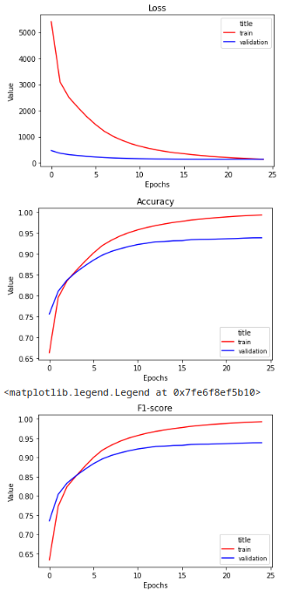

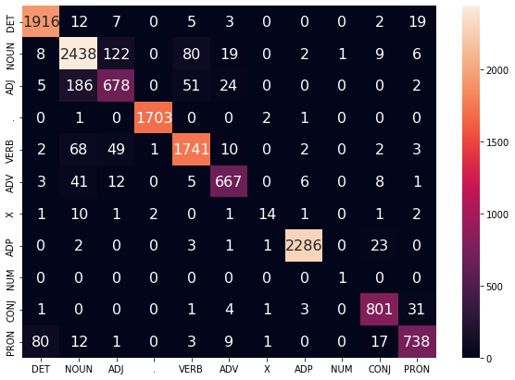

**WORD_EMBEDDING_DIM = 300**

**CHAR_EMBEDDING_DIM = 100**

**WORD_HIDDEN_DIM = 1024**

**CHAR_HIDDEN_DIM = 128**

**KEEP_DROPOUT = 0.8**

100%|██████████| 4824/4824 [01:43<00:00, 46.49it/s]

100%|██████████| 603/603 [00:05<00:00, 119.02it/s]

EPOCH: 0

TRAIN LOSS: 5299.0740587352775

VALIDATION LOSS: 469.023690700531

TRAIN ACC: 0.6642458480385188

VAL ACC: 0.7550682664460074

TRAIN F-1: 0.6332330006776156

VAL F-1: 0.7367796308625283

100%|██████████| 4824/4824 [01:43<00:00, 46.48it/s]

100%|██████████| 603/603 [00:05<00:00, 118.43it/s]

EPOCH: 1

TRAIN LOSS: 3149.3009059977485

VALIDATION LOSS: 371.7860746085644

TRAIN ACC: 0.7917004036071228

VAL ACC: 0.8024705951888409

TRAIN F-1: 0.773125188583174

VAL F-1: 0.7940687212296973

100%|██████████| 4824/4824 [01:43<00:00, 46.82it/s]

100%|██████████| 603/603 [00:05<00:00, 118.30it/s]

EPOCH: 2

TRAIN LOSS: 2622.883142851293

VALIDATION LOSS: 331.0105709284544

TRAIN ACC: 0.8257690477220612

VAL ACC: 0.823984869082097

TRAIN F-1: 0.8149517448767588

VAL F-1: 0.8175417073913891

100%|██████████| 4824/4824 [01:43<00:00, 46.77it/s]

100%|██████████| 603/603 [00:05<00:00, 118.76it/s]

EPOCH: 3

TRAIN LOSS: 2297.2785580556374

VALIDATION LOSS: 297.8666449636221

TRAIN ACC: 0.8465983892799971

VAL ACC: 0.8432531473491341

TRAIN F-1: 0.8382250355624168

VAL F-1: 0.8379680249014659

100%|██████████| 4824/4824 [01:42<00:00, 47.28it/s]

100%|██████████| 603/603 [00:05<00:00, 117.39it/s]

EPOCH: 4

TRAIN LOSS: 1926.5303405162413

VALIDATION LOSS: 262.1121142562479

TRAIN ACC: 0.8700731190239259

VAL ACC: 0.8619303741355873

TRAIN F-1: 0.8653318908447458

VAL F-1: 0.8582577381534925

100%|██████████| 4824/4824 [01:43<00:00, 46.49it/s]

100%|██████████| 603/603 [00:05<00:00, 116.14it/s]

EPOCH: 5

TRAIN LOSS: 1588.0591186357196

VALIDATION LOSS: 228.60630903206766

TRAIN ACC: 0.8921818889802275

VAL ACC: 0.8784207104438797

TRAIN F-1: 0.8899167174558209

VAL F-1: 0.8758260216809293

100%|██████████| 4824/4824 [01:44<00:00, 46.34it/s]

100%|██████████| 603/603 [00:05<00:00, 118.92it/s]

EPOCH: 6

TRAIN LOSS: 1325.0332074197358

VALIDATION LOSS: 203.63564221188426

TRAIN ACC: 0.9094758052054811

VAL ACC: 0.8931969974584786

TRAIN F-1: 0.907993786730038

VAL F-1: 0.892175940827384

100%|██████████| 4824/4824 [01:43<00:00, 46.48it/s]

100%|██████████| 603/603 [00:05<00:00, 119.03it/s]

EPOCH: 7

TRAIN LOSS: 1137.7622606136138

VALIDATION LOSS: 186.95882633142173

TRAIN ACC: 0.9214974874993047

VAL ACC: 0.9025356108517052

TRAIN F-1: 0.9203632121071069

VAL F-1: 0.9016902182875648

100%|██████████| 4824/4824 [01:43<00:00, 46.60it/s]

100%|██████████| 603/603 [00:05<00:00, 119.85it/s]

EPOCH: 8

TRAIN LOSS: 971.2197916247242

VALIDATION LOSS: 172.56531950458884

TRAIN ACC: 0.93337083026868

VAL ACC: 0.9092735977303623

TRAIN F-1: 0.9325481294566061

VAL F-1: 0.9085480192006464

100%|██████████| 4824/4824 [01:43<00:00, 46.62it/s]

100%|██████████| 603/603 [00:05<00:00, 119.69it/s]

EPOCH: 9

TRAIN LOSS: 835.3924412924389

VALIDATION LOSS: 159.63624355290085

TRAIN ACC: 0.9420857773300122

VAL ACC: 0.9179620544949465

TRAIN F-1: 0.941462843369728

VAL F-1: 0.9172226429122003

100%|██████████| 4824/4824 [01:42<00:00, 47.06it/s]

100%|██████████| 603/603 [00:05<00:00, 116.23it/s]

EPOCH: 10

TRAIN LOSS: 719.7972238452057

VALIDATION LOSS: 149.88294002972543

TRAIN ACC: 0.9503433441909624

VAL ACC: 0.923104202376027

TRAIN F-1: 0.9498862884246202

VAL F-1: 0.9225057788765136

100%|██████████| 4824/4824 [01:43<00:00, 46.78it/s]

100%|██████████| 603/603 [00:05<00:00, 120.08it/s]

EPOCH: 11

TRAIN LOSS: 608.8887683759676

VALIDATION LOSS: 139.87777407234535

TRAIN ACC: 0.9581497116650494

VAL ACC: 0.9292511377741002

TRAIN F-1: 0.9578096361185948

VAL F-1: 0.9287691995346912

100%|██████████| 4824/4824 [01:43<00:00, 46.53it/s]

100%|██████████| 603/603 [00:05<00:00, 119.40it/s]

EPOCH: 12

TRAIN LOSS: 519.0859491197916

VALIDATION LOSS: 133.0637999875471

TRAIN ACC: 0.9647940861976253

VAL ACC: 0.9341568650629469

TRAIN F-1: 0.9645332527280157

VAL F-1: 0.9336841440494187

100%|██████████| 4824/4824 [01:43<00:00, 46.65it/s]

100%|██████████| 603/603 [00:05<00:00, 119.28it/s]

EPOCH: 13

TRAIN LOSS: 444.9248915269127

VALIDATION LOSS: 127.47614259272814

TRAIN ACC: 0.9697263753855282

VAL ACC: 0.9372894379100419

TRAIN F-1: 0.9695251988369384

VAL F-1: 0.936750867182775

100%|██████████| 4824/4824 [01:43<00:00, 46.65it/s]

100%|██████████| 603/603 [00:05<00:00, 119.54it/s]

EPOCH: 14

TRAIN LOSS: 392.5416840622929

VALIDATION LOSS: 123.05848593218252

TRAIN ACC: 0.9734410443102521

VAL ACC: 0.9392990129440274

TRAIN F-1: 0.9732805652800205

VAL F-1: 0.9388183870195987

100%|██████████| 4824/4824 [01:43<00:00, 46.71it/s]

100%|██████████| 603/603 [00:05<00:00, 117.69it/s]

EPOCH: 15

TRAIN LOSS: 343.9713413152567

VALIDATION LOSS: 123.4343615253456

TRAIN ACC: 0.9767601411697807

VAL ACC: 0.9400082747207281

TRAIN F-1: 0.9766317087778466

VAL F-1: 0.9395518795667602

100%|██████████| 4824/4824 [01:43<00:00, 46.72it/s]

100%|██████████| 603/603 [00:05<00:00, 120.32it/s]

EPOCH: 16

TRAIN LOSS: 302.2732825521307

VALIDATION LOSS: 121.17556792451069

TRAIN ACC: 0.9799679833859732

VAL ACC: 0.9417223240144217

TRAIN F-1: 0.9798699194463621

VAL F-1: 0.9412367558057013

100%|██████████| 603/603 [00:04<00:00, 141.89it/s]VALIDATION LOSS: 146.81756515725283

VAL F-1: 0.9303811357357307

VAL ACC: 0.931310818546079

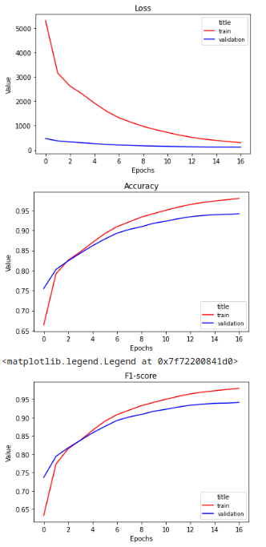

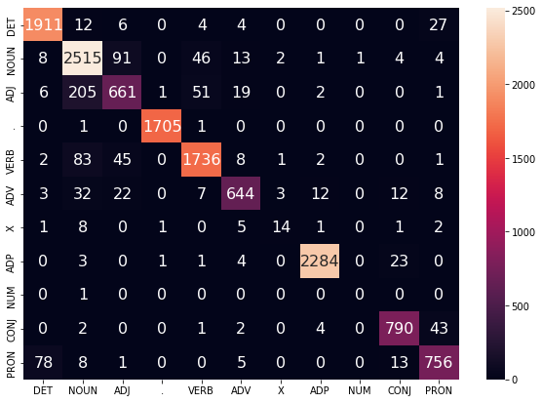

**WORD_EMBEDDING_DIM = 300**

**CHAR_EMBEDDING_DIM = 100**

**WORD_HIDDEN_DIM = 1024**

**CHAR_HIDDEN_DIM = 256**

**KEEP_DROPOUT = 0.8**

**100%|██████████| 4824/4824 [02:45<00:00, 29.12it/s]**

**100%|██████████| 603/603 [00:07<00:00, 84.70it/s]**

**EPOCH: 0**

**TRAIN LOSS: 5189.276324915234**

**VALIDATION LOSS: 452.69461722671986**

**TRAIN ACC: 0.6684858861123301**

**VAL ACC: 0.7617471481766062**

**TRAIN F-1: 0.6374922670626549**

**VAL F-1: 0.7432833451101581**

**100%|██████████| 4824/4824 [02:45<00:00, 29.23it/s]**

**100%|██████████| 603/603 [00:07<00:00, 84.63it/s]**

**EPOCH: 1**

**TRAIN LOSS: 2973.7968919316772**

**VALIDATION LOSS: 350.3860444650054**

**TRAIN ACC: 0.7997972693165875**

**VAL ACC: 0.814114309356345**

**TRAIN F-1: 0.7829585978377457**

**VAL F-1: 0.8067492528098947**

**100%|██████████| 4824/4824 [02:45<00:00, 29.21it/s]**

**100%|██████████| 603/603 [00:07<00:00, 84.39it/s]**

**EPOCH: 2**

**TRAIN LOSS: 2457.5993920248**

**VALIDATION LOSS: 313.49342173710465**

**TRAIN ACC: 0.8364680359228882**

**VAL ACC: 0.8348602163248419**

**TRAIN F-1: 0.8265821313984724**

**VAL F-1: 0.8284500224126193**

**100%|██████████| 4824/4824 [02:45<00:00, 29.10it/s]**

**100%|██████████| 603/603 [00:07<00:00, 84.99it/s]**

**EPOCH: 3**

**TRAIN LOSS: 2093.8412272012793**

**VALIDATION LOSS: 277.65856786444783**

**TRAIN ACC: 0.8597078947531074**

**VAL ACC: 0.8514687629292511**

**TRAIN F-1: 0.8538183644582591**

**VAL F-1: 0.8444792987781535**

**100%|██████████| 4824/4824 [02:45<00:00, 29.16it/s]**

**100%|██████████| 603/603 [00:07<00:00, 84.34it/s]**

**EPOCH: 4**

**TRAIN LOSS: 1714.3722319160588**

**VALIDATION LOSS: 244.05311092361808**

**TRAIN ACC: 0.8852964627204233**

**VAL ACC: 0.8704415154559962**

**TRAIN F-1: 0.8826317678723795**

**VAL F-1: 0.8657633945748902**

**100%|██████████| 4824/4824 [02:46<00:00, 29.02it/s]**

**100%|██████████| 603/603 [00:07<00:00, 84.81it/s]**

**EPOCH: 5**

**TRAIN LOSS: 1437.3097264319658**

**VALIDATION LOSS: 218.443439360708**

**TRAIN ACC: 0.903387703889586**

**VAL ACC: 0.8870500620604055**

**TRAIN F-1: 0.9016749777818645**

**VAL F-1: 0.8840253161702794**

**100%|██████████| 4824/4824 [02:45<00:00, 29.07it/s]**

**100%|██████████| 603/603 [00:07<00:00, 79.02it/s]**

**EPOCH: 6**

**TRAIN LOSS: 1217.6987909665331**

**VALIDATION LOSS: 201.12691061012447**

**TRAIN ACC: 0.9178817115908796**

**VAL ACC: 0.896684201193924**

**TRAIN F-1: 0.9166495115051608**

**VAL F-1: 0.8944215952129752**

**100%|██████████| 4824/4824 [02:46<00:00, 28.98it/s]**

**100%|██████████| 603/603 [00:07<00:00, 84.96it/s]**

**EPOCH: 7**

**TRAIN LOSS: 1045.723326108884**

**VALIDATION LOSS: 185.5651261024177**

**TRAIN ACC: 0.9297859584278483**

**VAL ACC: 0.905195342514333**

**TRAIN F-1: 0.9288632203971569**

**VAL F-1: 0.9037443959268476**

**100%|██████████| 4824/4824 [02:45<00:00, 29.17it/s]**

**100%|██████████| 603/603 [00:07<00:00, 84.81it/s]**

**EPOCH: 8**

**TRAIN LOSS: 911.7935146898963**

**VALIDATION LOSS: 171.95448685158044**

**TRAIN ACC: 0.9385318095567738**

**VAL ACC: 0.9125834860216325**

**TRAIN F-1: 0.937851745288554**

**VAL F-1: 0.9115635837411326**

**100%|██████████| 4824/4824 [02:45<00:00, 29.18it/s]**

**100%|██████████| 603/603 [00:08<00:00, 75.02it/s]**

**EPOCH: 9**

**TRAIN LOSS: 789.3901968958089**

**VALIDATION LOSS: 163.75638231262565**

**TRAIN ACC: 0.9462145607604873**

**VAL ACC: 0.9167208463857202**

**TRAIN F-1: 0.945719215131968**

**VAL F-1: 0.9157874406591731**

**100%|██████████| 4824/4824 [02:45<00:00, 29.19it/s]**

**100%|██████████| 603/603 [00:07<00:00, 85.28it/s]**

**EPOCH: 10**

**TRAIN LOSS: 681.5118151395**

**VALIDATION LOSS: 155.90590433916077**

**TRAIN ACC: 0.9536562602369724**

**VAL ACC: 0.9224540457473845**

**TRAIN F-1: 0.9532784023939463**

**VAL F-1: 0.9217872455024408**

**100%|██████████| 4824/4824 [02:45<00:00, 29.14it/s]**

**100%|██████████| 603/603 [00:07<00:00, 85.02it/s]**

**EPOCH: 11**

**TRAIN LOSS: 590.2858651485876**

**VALIDATION LOSS: 152.25939022004604**

**TRAIN ACC: 0.9599236051449092**

**VAL ACC: 0.9246409362255452**

**TRAIN F-1: 0.9596432284747076**

**VAL F-1: 0.9241436022971459**

**100%|██████████| 4824/4824 [02:45<00:00, 29.10it/s]**

**100%|██████████| 603/603 [00:07<00:00, 85.01it/s]**

**EPOCH: 12**

**TRAIN LOSS: 516.3603600160568**

**VALIDATION LOSS: 147.3140218204353**

**TRAIN ACC: 0.9652514663980073**

**VAL ACC: 0.9273597730362314**

**TRAIN F-1: 0.9650307539650282**

**VAL F-1: 0.9267657174955732**

**100%|██████████| 4824/4824 [02:45<00:00, 29.23it/s]**

**100%|██████████| 603/603 [00:07<00:00, 84.77it/s]**

**EPOCH: 13**

**TRAIN LOSS: 450.97670934867347**

**VALIDATION LOSS: 141.92236194736324**

**TRAIN ACC: 0.9699859695533126**

**VAL ACC: 0.9295466635143921**

**TRAIN F-1: 0.9698119778196385**

**VAL F-1: 0.9289415342079134**

**100%|██████████| 4824/4824 [02:45<00:00, 29.08it/s]**

**100%|██████████| 603/603 [00:07<00:00, 83.81it/s]**

**EPOCH: 14**

**TRAIN LOSS: 394.1987071654876**

**VALIDATION LOSS: 139.6510044299066**

**TRAIN ACC: 0.9735893838347003**

**VAL ACC: 0.9313789231042023**

**TRAIN F-1: 0.9734507541129319**

**VAL F-1: 0.9306729100232224**

**100%|██████████| 4824/4824 [02:47<00:00, 28.83it/s]**

**100%|██████████| 603/603 [00:07<00:00, 79.63it/s]**

**EPOCH: 15**

**TRAIN LOSS: 346.95194556572824**

**VALIDATION LOSS: 134.91262007097248**

**TRAIN ACC: 0.9770939050997892**

**VAL ACC: 0.9345706010993557**

**TRAIN F-1: 0.9769830229317206**

**VAL F-1: 0.9340658127338078**

**100%|██████████| 4824/4824 [02:47<00:00, 28.78it/s]**

**100%|██████████| 603/603 [00:07<00:00, 82.50it/s]**

**EPOCH: 16**

**TRAIN LOSS: 306.19291164993774**

**VALIDATION LOSS: 134.5745966794202**

**TRAIN ACC: 0.9797454740993009**

**VAL ACC: 0.9368165967255748**

**TRAIN F-1: 0.9796574328889425**

**VAL F-1: 0.9363326445966029**

100%|██████████| 603/603 [00:05<00:00, 104.83it/s]VALIDATION LOSS: 158.6155585643428

VAL F-1: 0.9244401522343998

VAL ACC: 0.9257298225529479

