es/word

32x32

EPOCH: 0

TRAIN LOSS: 3652.892156049609

VALIDATION LOSS: 294.33010628819466

TRAIN ACC: 0.6452372980145591

VAL ACC: 0.7704131584100254

TRAIN F-1: 0.6108716340828536

VAL F-1: 0.7431429162973985

100%|██████████| 3131/3131 [00:30<00:00, 104.25it/s]

100%|██████████| 391/391 [00:01<00:00, 308.64it/s]

EPOCH: 1

TRAIN LOSS: 2233.435536213219

VALIDATION LOSS: 224.62921342998743

TRAIN ACC: 0.7821595545469201

VAL ACC: 0.8264147248874094

TRAIN F-1: 0.7617750170958466

VAL F-1: 0.813348055301103

100%|██████████| 3131/3131 [00:32<00:00, 95.32it/s]

100%|██████████| 391/391 [00:01<00:00, 298.23it/s]

EPOCH: 2

TRAIN LOSS: 1810.2012642137706

VALIDATION LOSS: 197.89602909609675

TRAIN ACC: 0.8218683730793557

VAL ACC: 0.8413941648717447

TRAIN F-1: 0.81076636944766

VAL F-1: 0.833309823406403

100%|██████████| 3131/3131 [00:31<00:00, 99.45it/s]

100%|██████████| 391/391 [00:01<00:00, 309.06it/s]

EPOCH: 3

TRAIN LOSS: 1568.4293671417981

VALIDATION LOSS: 182.69948876369745

TRAIN ACC: 0.8434093530265263

VAL ACC: 0.8504993146661445

TRAIN F-1: 0.8355886465384993

VAL F-1: 0.8453714383726184

100%|██████████| 3131/3131 [00:31<00:00, 100.43it/s]

100%|██████████| 391/391 [00:01<00:00, 255.41it/s]

EPOCH: 4

TRAIN LOSS: 1416.966207032092

VALIDATION LOSS: 171.57814694941044

TRAIN ACC: 0.8570011285142056

VAL ACC: 0.8619541805365185

TRAIN F-1: 0.8512192496984891

VAL F-1: 0.8578963289003942

100%|██████████| 3131/3131 [00:31<00:00, 100.08it/s]

100%|██████████| 391/391 [00:01<00:00, 243.42it/s]

EPOCH: 5

TRAIN LOSS: 1288.4205364417285

VALIDATION LOSS: 165.4730954617262

TRAIN ACC: 0.8698612299564716

VAL ACC: 0.8696886626199334

TRAIN F-1: 0.8652340654433252

VAL F-1: 0.8666285708433675

100%|██████████| 3131/3131 [00:31<00:00, 99.55it/s]

100%|██████████| 391/391 [00:01<00:00, 276.13it/s]

EPOCH: 6

TRAIN LOSS: 1202.192032283172

VALIDATION LOSS: 156.72820166684687

TRAIN ACC: 0.8769299453104654

VAL ACC: 0.8780105737223419

TRAIN F-1: 0.8731805600043158

VAL F-1: 0.8753008570365174

100%|██████████| 3131/3131 [00:31<00:00, 99.02it/s]

100%|██████████| 391/391 [00:01<00:00, 263.38it/s]

EPOCH: 7

TRAIN LOSS: 1122.7816597959027

VALIDATION LOSS: 151.6398767568171

TRAIN ACC: 0.8845939209047956

VAL ACC: 0.8799686704523203

TRAIN F-1: 0.8812731415181281

VAL F-1: 0.8776443574446696

100%|██████████| 3131/3131 [00:31<00:00, 100.44it/s]

100%|██████████| 391/391 [00:01<00:00, 280.15it/s]

EPOCH: 8

TRAIN LOSS: 1054.849646025803

VALIDATION LOSS: 145.9069573218003

TRAIN ACC: 0.8902612944429976

VAL ACC: 0.8873115331897395

TRAIN F-1: 0.8873881218874854

VAL F-1: 0.8858691252734776

100%|██████████| 3131/3131 [00:33<00:00, 93.60it/s]

100%|██████████| 391/391 [00:01<00:00, 273.49it/s]

EPOCH: 9

TRAIN LOSS: 989.9084920941386

VALIDATION LOSS: 147.39931571949273

TRAIN ACC: 0.8951225864057443

VAL ACC: 0.8851576267867632

TRAIN F-1: 0.8925318255792545

VAL F-1: 0.8838178944452034

100%|██████████| 3131/3131 [00:33<00:00, 93.23it/s]

100%|██████████| 391/391 [00:01<00:00, 272.67it/s]

EPOCH: 10

TRAIN LOSS: 939.3920037574135

VALIDATION LOSS: 140.88321072701365

TRAIN ACC: 0.9008643674739883

VAL ACC: 0.8899549637752106

TRAIN F-1: 0.8987016130951583

VAL F-1: 0.8890829720694956

92%|█████████▏| 2871/3131 [00:29<00:02, 95.19it/s]

EPOCH: 11

TRAIN LOSS: 894.4499788793037

VALIDATION LOSS: 141.28216763352975

TRAIN ACC: 0.9048699728412515

VAL ACC: 0.8918151556686901

TRAIN F-1: 0.9029221995198219

VAL F-1: 0.8903880946076526

100%|██████████| 3131/3131 [00:33<00:00, 94.51it/s]

100%|██████████| 391/391 [00:01<00:00, 253.29it/s]

EPOCH: 12

TRAIN LOSS: 852.241156923119

VALIDATION LOSS: 136.99492367263883

TRAIN ACC: 0.9088631769535077

VAL ACC: 0.8959271588016448

TRAIN F-1: 0.9071576867889101

VAL F-1: 0.8947538222782663

100%|██████████| 3131/3131 [00:32<00:00, 95.23it/s]

100%|██████████| 391/391 [00:01<00:00, 285.59it/s]

EPOCH: 13

TRAIN LOSS: 817.4049668829539

VALIDATION LOSS: 135.40259536518715

TRAIN ACC: 0.9115914530550492

VAL ACC: 0.8957313491286469

TRAIN F-1: 0.9100161489390407

VAL F-1: 0.8946967158853067

100%|██████████| 3131/3131 [00:32<00:00, 97.31it/s]

100%|██████████| 391/391 [00:01<00:00, 278.39it/s]

EPOCH: 14

TRAIN LOSS: 773.3170235602884

VALIDATION LOSS: 133.3538876278326

TRAIN ACC: 0.9160062998375436

VAL ACC: 0.8993538280791071

TRAIN F-1: 0.9146010506738407

VAL F-1: 0.8982056719471956

100%|██████████| 3131/3131 [00:31<00:00, 98.51it/s]

100%|██████████| 391/391 [00:01<00:00, 247.59it/s]

EPOCH: 15

TRAIN LOSS: 746.3764466930879

VALIDATION LOSS: 131.2278771698475

TRAIN ACC: 0.9194042437094634

VAL ACC: 0.8996475425886039

TRAIN F-1: 0.9181275769502129

VAL F-1: 0.8989216501662223

100%|██████████| 3131/3131 [00:33<00:00, 93.60it/s]

100%|██████████| 391/391 [00:01<00:00, 262.76it/s]

EPOCH: 16

TRAIN LOSS: 711.1248723611934

VALIDATION LOSS: 133.9794408697635

TRAIN ACC: 0.9216488708657317

VAL ACC: 0.8999412570981007

TRAIN F-1: 0.9205656542049385

VAL F-1: 0.89952345000258

100%|██████████| 3131/3131 [00:33<00:00, 94.52it/s]

100%|██████████| 391/391 [00:01<00:00, 264.23it/s]

EPOCH: 17

TRAIN LOSS: 679.1515050919843

VALIDATION LOSS: 128.23122013395187

TRAIN ACC: 0.9255180624279177

VAL ACC: 0.9022909731740748

TRAIN F-1: 0.9244703493426312

VAL F-1: 0.9013813839024987

100%|██████████| 3131/3131 [00:31<00:00, 98.69it/s]

100%|██████████| 391/391 [00:01<00:00, 277.67it/s]

EPOCH: 18

TRAIN LOSS: 657.561908048694

VALIDATION LOSS: 129.52460083924234

TRAIN ACC: 0.9264357552984362

VAL ACC: 0.9022909731740748

TRAIN F-1: 0.9255163159984244

VAL F-1: 0.9018454653682519

100%|██████████| 3131/3131 [00:32<00:00, 97.14it/s]

100%|██████████| 391/391 [00:01<00:00, 262.37it/s]

EPOCH: 19

TRAIN LOSS: 630.7644135490991

VALIDATION LOSS: 127.08111837483011

TRAIN ACC: 0.9298585016803701

VAL ACC: 0.9035637360485608

TRAIN F-1: 0.9290091882516146

VAL F-1: 0.9031370422089376

VALIDATION LOSS: 991.6422028541565

VAL F-1: 0.14138746880433348

VAL ACC: 0.30351145038167937

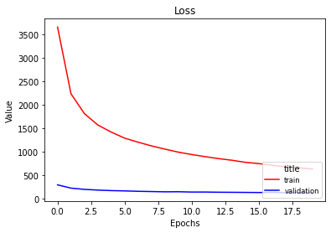

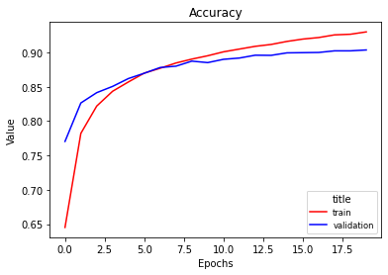

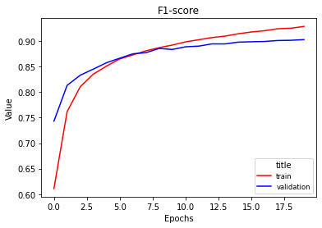

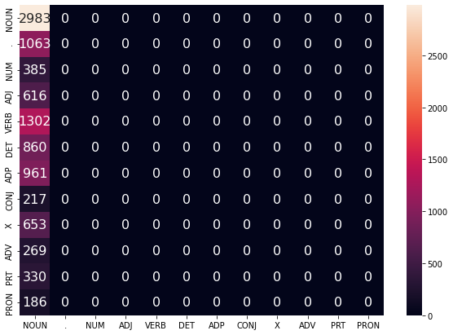

64x64

EPOCH: 0

TRAIN LOSS: 3073.4557028636336

VALIDATION LOSS: 228.92563140392303

TRAIN ACC: 0.7067971278693403

VAL ACC: 0.8255335813589191

TRAIN F-1: 0.683925051326649

VAL F-1: 0.8111430556535228

100%|██████████| 3131/3131 [00:36<00:00, 85.30it/s]

100%|██████████| 391/391 [00:01<00:00, 249.93it/s]

EPOCH: 1

TRAIN LOSS: 1629.9015321861953

VALIDATION LOSS: 170.96485951170325

TRAIN ACC: 0.8412515346553071

VAL ACC: 0.871450949676914

TRAIN F-1: 0.8313447957350067

VAL F-1: 0.8661379766730359

100%|██████████| 3131/3131 [00:37<00:00, 84.12it/s]

100%|██████████| 391/391 [00:01<00:00, 260.28it/s]

EPOCH: 2

TRAIN LOSS: 1219.3051517996937

VALIDATION LOSS: 146.00885989051312

TRAIN ACC: 0.8767191239753463

VAL ACC: 0.889367534756217

TRAIN F-1: 0.872346975599591

VAL F-1: 0.8864463210357922

100%|██████████| 3131/3131 [00:39<00:00, 78.77it/s]

100%|██████████| 391/391 [00:01<00:00, 259.77it/s]

EPOCH: 3

TRAIN LOSS: 999.6314770830795

VALIDATION LOSS: 128.42331330804154

TRAIN ACC: 0.8980492825873978

VAL ACC: 0.9013119248090856

TRAIN F-1: 0.8953844828486667

VAL F-1: 0.8993761260216478

100%|██████████| 3131/3131 [00:37<00:00, 82.47it/s]

100%|██████████| 391/391 [00:01<00:00, 250.92it/s]

EPOCH: 4

TRAIN LOSS: 850.3321517156437

VALIDATION LOSS: 121.8375640255399

TRAIN ACC: 0.9106985626945446

VAL ACC: 0.9069904053260232

TRAIN F-1: 0.9090510779822457

VAL F-1: 0.9056290933149689

100%|██████████| 3131/3131 [00:38<00:00, 81.98it/s]

100%|██████████| 391/391 [00:01<00:00, 231.01it/s]

EPOCH: 5

TRAIN LOSS: 742.2884805839276

VALIDATION LOSS: 117.37243637023494

TRAIN ACC: 0.9208427892902762

VAL ACC: 0.9112982181319758

TRAIN F-1: 0.9195675289575846

VAL F-1: 0.9102242876797763

100%|██████████| 3131/3131 [00:39<00:00, 79.46it/s]

100%|██████████| 391/391 [00:01<00:00, 236.77it/s]

EPOCH: 6

TRAIN LOSS: 652.6378013329231

VALIDATION LOSS: 115.30294949363451

TRAIN ACC: 0.9282587397844662

VAL ACC: 0.9133542196984531

TRAIN F-1: 0.9272661082216508

VAL F-1: 0.9125992790724426

100%|██████████| 3131/3131 [00:39<00:00, 79.62it/s]

100%|██████████| 391/391 [00:01<00:00, 263.95it/s]

EPOCH: 7

TRAIN LOSS: 586.8726214068301

VALIDATION LOSS: 112.5808605151251

TRAIN ACC: 0.9347817999181517

VAL ACC: 0.9139416487174467

TRAIN F-1: 0.9341057691619105

VAL F-1: 0.9131433867006857

100%|██████████| 3131/3131 [00:37<00:00, 82.75it/s]

100%|██████████| 391/391 [00:01<00:00, 248.49it/s]

EPOCH: 8

TRAIN LOSS: 525.5616454120318

VALIDATION LOSS: 109.9009308784589

TRAIN ACC: 0.9424333742574749

VAL ACC: 0.9196201292343842

TRAIN F-1: 0.9418584567578947

VAL F-1: 0.9187401031120027

100%|██████████| 3131/3131 [00:39<00:00, 79.33it/s]

100%|██████████| 391/391 [00:01<00:00, 240.27it/s]

EPOCH: 9

TRAIN LOSS: 478.7119492320926

VALIDATION LOSS: 114.79023539787158

TRAIN ACC: 0.9455212867542195

VAL ACC: 0.9183473663598982

TRAIN F-1: 0.9450225736345786

VAL F-1: 0.9175770869742366

100%|██████████| 3131/3131 [00:38<00:00, 81.50it/s]

100%|██████████| 391/391 [00:01<00:00, 232.56it/s]

EPOCH: 10

TRAIN LOSS: 432.8625629293092

VALIDATION LOSS: 109.67371356056537

TRAIN ACC: 0.950208961146868

VAL ACC: 0.9220677501468573

TRAIN F-1: 0.9497957566297678

VAL F-1: 0.921278534027536

100%|██████████| 3131/3131 [00:38<00:00, 80.48it/s]

100%|██████████| 391/391 [00:01<00:00, 236.84it/s]

EPOCH: 11

TRAIN LOSS: 398.6073217537196

VALIDATION LOSS: 110.8179752806318

TRAIN ACC: 0.9540905539640612

VAL ACC: 0.9213824162913647

TRAIN F-1: 0.9537511392438771

VAL F-1: 0.9208521873753939

100%|██████████| 3131/3131 [00:38<00:00, 81.06it/s]

100%|██████████| 391/391 [00:01<00:00, 246.06it/s]

EPOCH: 12

TRAIN LOSS: 366.7433082642383

VALIDATION LOSS: 108.80835608727648

TRAIN ACC: 0.9566204099854906

VAL ACC: 0.9225572743293519

TRAIN F-1: 0.9563235169697114

VAL F-1: 0.921975538247515

100%|██████████| 3131/3131 [00:37<00:00, 82.50it/s]

100%|██████████| 391/391 [00:01<00:00, 241.44it/s]

EPOCH: 13

TRAIN LOSS: 345.98988214805286

VALIDATION LOSS: 111.28588485709042

TRAIN ACC: 0.9589394446718008

VAL ACC: 0.9248090855688271

TRAIN F-1: 0.9586688454628648

VAL F-1: 0.9242253979983664

100%|██████████| 3131/3131 [00:38<00:00, 80.65it/s]

100%|██████████| 391/391 [00:01<00:00, 221.47it/s]

EPOCH: 14

TRAIN LOSS: 313.50524556014534

VALIDATION LOSS: 113.16924008385831

TRAIN ACC: 0.9626474199188958

VAL ACC: 0.918543176032896

TRAIN F-1: 0.9624412815029455

VAL F-1: 0.9180722113888969

100%|██████████| 3131/3131 [00:38<00:00, 80.63it/s]

100%|██████████| 391/391 [00:01<00:00, 254.25it/s]

EPOCH: 15

TRAIN LOSS: 285.11890475682594

VALIDATION LOSS: 112.55862568126759

TRAIN ACC: 0.9661569750858787

VAL ACC: 0.9220677501468573

TRAIN F-1: 0.9659787841919903

VAL F-1: 0.921523372128464

100%|██████████| 3131/3131 [00:38<00:00, 80.92it/s]

100%|██████████| 391/391 [00:01<00:00, 236.35it/s]

EPOCH: 16

TRAIN LOSS: 275.45581092803695

VALIDATION LOSS: 116.06812168870238

TRAIN ACC: 0.9657725361806615

VAL ACC: 0.9220677501468573

TRAIN F-1: 0.9655994170000286

VAL F-1: 0.9215547170583182

VAL F-1: 0.9172054316093272

VAL ACC: 0.9170483460559796

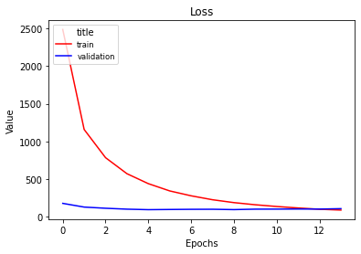

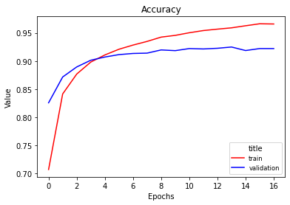

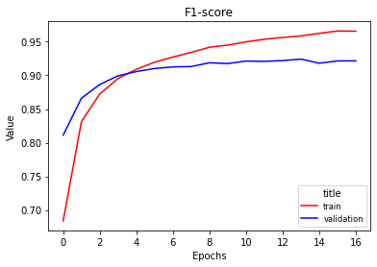

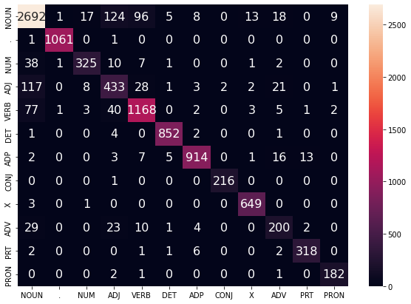

128x128

EPOCH: 0

TRAIN LOSS: 5302.369184970856

VALIDATION LOSS: 499.728463947773

TRAIN ACC: 0.49177176730285105

VAL ACC: 0.6306050518895634

TRAIN F-1: 0.4323621696833743

VAL F-1: 0.5838685936122212

100%|██████████| 3131/3131 [00:51<00:00, 60.49it/s]

100%|██████████| 391/391 [00:01<00:00, 213.77it/s]

EPOCH: 1

TRAIN LOSS: 3454.4356401860714

VALIDATION LOSS: 367.4664152562618

TRAIN ACC: 0.6797251881890447

VAL ACC: 0.7360485607989035

TRAIN F-1: 0.6367542987909985

VAL F-1: 0.6978015951972029

9%|▉ | 290/3131 [00:04<00:51, 55.15it/s]

EPOCH: 2

TRAIN LOSS: 2768.2881394550204

VALIDATION LOSS: 305.30105262994766

TRAIN ACC: 0.7413966293388891

VAL ACC: 0.7725670648130017

TRAIN F-1: 0.7063253818351822

VAL F-1: 0.7422795729112286

100%|██████████| 3131/3131 [00:51<00:00, 60.69it/s]

100%|██████████| 391/391 [00:01<00:00, 200.15it/s]

EPOCH: 3

TRAIN LOSS: 2370.1489688381553

VALIDATION LOSS: 265.49379359185696

TRAIN ACC: 0.7759837295534308

VAL ACC: 0.8037008028196593

TRAIN F-1: 0.74821415230781

VAL F-1: 0.7813303763519621

100%|██████████| 3131/3131 [00:52<00:00, 59.44it/s]

100%|██████████| 391/391 [00:01<00:00, 200.22it/s]

EPOCH: 4

TRAIN LOSS: 2091.772458255291

VALIDATION LOSS: 238.3712445050478

TRAIN ACC: 0.8029192554286494

VAL ACC: 0.823183865282945

TRAIN F-1: 0.782435037614655

VAL F-1: 0.8057548993439972

100%|██████████| 3131/3131 [00:52<00:00, 59.66it/s]

100%|██████████| 391/391 [00:01<00:00, 206.44it/s]

EPOCH: 5

TRAIN LOSS: 1880.5147479400039

VALIDATION LOSS: 217.47312032431364

TRAIN ACC: 0.822550442104741

VAL ACC: 0.8380654004307813

TRAIN F-1: 0.8070817856506416

VAL F-1: 0.8241782439872684

100%|██████████| 3131/3131 [00:52<00:00, 60.06it/s]

100%|██████████| 391/391 [00:01<00:00, 199.72it/s]

EPOCH: 6

TRAIN LOSS: 1710.2512111663818

VALIDATION LOSS: 200.27421328425407

TRAIN ACC: 0.8380272083534853

VAL ACC: 0.8512825533581359

TRAIN F-1: 0.8255263735074013

VAL F-1: 0.8407706376225544

100%|██████████| 3131/3131 [00:53<00:00, 58.89it/s]

100%|██████████| 391/391 [00:01<00:00, 201.41it/s]

EPOCH: 7

TRAIN LOSS: 1563.1371608525515

VALIDATION LOSS: 187.71259738132358

TRAIN ACC: 0.8511229336408844

VAL ACC: 0.8609751321715293

TRAIN F-1: 0.8412372004944823

VAL F-1: 0.8520052459032513

100%|██████████| 3131/3131 [00:53<00:00, 58.57it/s]

100%|██████████| 391/391 [00:01<00:00, 203.72it/s]

EPOCH: 8

TRAIN LOSS: 1445.7284726016223

VALIDATION LOSS: 175.40285816788673

TRAIN ACC: 0.861304364001637

VAL ACC: 0.8719404738594086

TRAIN F-1: 0.8530945886096114

VAL F-1: 0.8648705702382137

100%|██████████| 3131/3131 [00:52<00:00, 59.88it/s]

100%|██████████| 391/391 [00:01<00:00, 213.34it/s]

EPOCH: 9

TRAIN LOSS: 1338.2365905549377

VALIDATION LOSS: 166.06426928192377

TRAIN ACC: 0.8716470106774805

VAL ACC: 0.8783042882318387

TRAIN F-1: 0.8648987894033942

VAL F-1: 0.8719947796390998

100%|██████████| 3131/3131 [00:51<00:00, 60.30it/s]

100%|██████████| 391/391 [00:01<00:00, 210.57it/s]

EPOCH: 10

TRAIN LOSS: 1250.4356531929225

VALIDATION LOSS: 158.63588269613683

TRAIN ACC: 0.8781824720661731

VAL ACC: 0.8869199138437439

TRAIN F-1: 0.8722830797613773

VAL F-1: 0.8821584179789546

100%|██████████| 3131/3131 [00:52<00:00, 59.62it/s]

100%|██████████| 391/391 [00:02<00:00, 194.56it/s]

EPOCH: 11

TRAIN LOSS: 1166.029434390366

VALIDATION LOSS: 151.31217790395021

TRAIN ACC: 0.8860324664856083

VAL ACC: 0.8901507734482084

TRAIN F-1: 0.8812368525051258

VAL F-1: 0.8858631985750962

100%|██████████| 3131/3131 [00:51<00:00, 60.93it/s]

100%|██████████| 391/391 [00:01<00:00, 201.07it/s]

EPOCH: 12

TRAIN LOSS: 1094.474454883486

VALIDATION LOSS: 142.7758594173938

TRAIN ACC: 0.8925679278743008

VAL ACC: 0.8959271588016448

TRAIN F-1: 0.8884660366717497

VAL F-1: 0.8920581459267644

100%|██████████| 3131/3131 [00:51<00:00, 60.90it/s]

100%|██████████| 391/391 [00:01<00:00, 202.94it/s]

EPOCH: 13

TRAIN LOSS: 1034.7117322189733

VALIDATION LOSS: 140.17667118646204

TRAIN ACC: 0.898235301412503

VAL ACC: 0.8986684942236146

TRAIN F-1: 0.8945653497894083

VAL F-1: 0.8953441469169774

100%|██████████| 3131/3131 [00:51<00:00, 60.45it/s]

100%|██████████| 391/391 [00:01<00:00, 206.54it/s]

EPOCH: 14

TRAIN LOSS: 973.2638349309564

VALIDATION LOSS: 135.7793340496719

TRAIN ACC: 0.9030097845902005

VAL ACC: 0.9011161151360877

TRAIN F-1: 0.8999040176247832

VAL F-1: 0.8981108056019921

100%|██████████| 3131/3131 [00:52<00:00, 59.55it/s]

100%|██████████| 391/391 [00:01<00:00, 209.08it/s]

EPOCH: 15

TRAIN LOSS: 921.6607178896666

VALIDATION LOSS: 130.32257290091366

TRAIN ACC: 0.9081935091831294

VAL ACC: 0.9023888780105738

TRAIN F-1: 0.9054574725403396

VAL F-1: 0.8997738577412199

100%|██████████| 3131/3131 [00:51<00:00, 60.79it/s]

100%|██████████| 391/391 [00:02<00:00, 192.12it/s]

EPOCH: 16

TRAIN LOSS: 871.8490534829907

VALIDATION LOSS: 126.94882416445762

TRAIN ACC: 0.913067202400883

VAL ACC: 0.9091443117289995

TRAIN F-1: 0.9107402612224976

VAL F-1: 0.9069021599075161

100%|██████████| 3131/3131 [00:51<00:00, 60.85it/s]

100%|██████████| 391/391 [00:01<00:00, 212.28it/s]

EPOCH: 17

TRAIN LOSS: 828.0628978414461

VALIDATION LOSS: 122.51164258318022

TRAIN ACC: 0.9176556667534754

VAL ACC: 0.9099275504209908

TRAIN F-1: 0.9154653512583116

VAL F-1: 0.9082426756403463

100%|██████████| 3131/3131 [00:52<00:00, 59.59it/s]

100%|██████████| 391/391 [00:01<00:00, 205.09it/s]

EPOCH: 18

TRAIN LOSS: 795.0999838467687

VALIDATION LOSS: 120.24918489344418

TRAIN ACC: 0.920557560425115

VAL ACC: 0.9128646955159585

TRAIN F-1: 0.9186624634716217

VAL F-1: 0.9111021134008407

100%|██████████| 3131/3131 [00:53<00:00, 58.73it/s]

100%|██████████| 391/391 [00:02<00:00, 187.41it/s]

EPOCH: 19

TRAIN LOSS: 751.7281508292072

VALIDATION LOSS: 116.19678270071745

TRAIN ACC: 0.9248731971675533

VAL ACC: 0.9128646955159585

TRAIN F-1: 0.9231986423301256

VAL F-1: 0.911165352786615

100%|██████████| 3131/3131 [00:51<00:00, 61.07it/s]

100%|██████████| 391/391 [00:01<00:00, 212.74it/s]

EPOCH: 20

TRAIN LOSS: 720.129802825395

VALIDATION LOSS: 116.04821100272238

TRAIN ACC: 0.9266961816535834

VAL ACC: 0.9141374583904445

TRAIN F-1: 0.9251407895980773

VAL F-1: 0.9126850737650054

100%|██████████| 3131/3131 [00:52<00:00, 59.96it/s]

100%|██████████| 391/391 [00:01<00:00, 209.12it/s]

EPOCH: 21

TRAIN LOSS: 693.7168255744036

VALIDATION LOSS: 113.02736411150545

TRAIN ACC: 0.9293624514800898

VAL ACC: 0.9157039357744272

TRAIN F-1: 0.9279515116131407

VAL F-1: 0.9143808241329537

100%|██████████| 3131/3131 [00:52<00:00, 60.07it/s]

100%|██████████| 391/391 [00:01<00:00, 202.47it/s]

EPOCH: 22

TRAIN LOSS: 654.2335321716964

VALIDATION LOSS: 109.98937680572271

TRAIN ACC: 0.9336160819474931

VAL ACC: 0.918543176032896

TRAIN F-1: 0.9323643480367013

VAL F-1: 0.9174357555421878

100%|██████████| 3131/3131 [00:52<00:00, 60.10it/s]

100%|██████████| 391/391 [00:01<00:00, 209.12it/s]

EPOCH: 23

TRAIN LOSS: 628.6543075614609

VALIDATION LOSS: 108.77692912891507

TRAIN ACC: 0.9351538375683619

VAL ACC: 0.9212845114548659

TRAIN F-1: 0.9340420177777273

VAL F-1: 0.9203828710612584

100%|██████████| 3131/3131 [00:51<00:00, 60.99it/s]

100%|██████████| 391/391 [00:01<00:00, 198.09it/s]

EPOCH: 24

TRAIN LOSS: 602.6266898392932

VALIDATION LOSS: 109.33916785009205

TRAIN ACC: 0.9380061262199735

VAL ACC: 0.9177599373409047

TRAIN F-1: 0.9369288434761045

VAL F-1: 0.9167149133394783

100%|██████████| 3131/3131 [00:51<00:00, 60.32it/s]

100%|██████████| 391/391 [00:01<00:00, 196.22it/s]

EPOCH: 25

TRAIN LOSS: 578.519771123887

VALIDATION LOSS: 105.26020883931778

TRAIN ACC: 0.9394322705457793

VAL ACC: 0.92363422753084

TRAIN F-1: 0.9384202988953751

VAL F-1: 0.9226869993406724

100%|██████████| 3131/3131 [00:51<00:00, 60.72it/s]

100%|██████████| 391/391 [00:01<00:00, 202.54it/s]

EPOCH: 26

TRAIN LOSS: 555.1094357175753

VALIDATION LOSS: 105.10105311125517

TRAIN ACC: 0.9423465654724258

VAL ACC: 0.9215782259643627

TRAIN F-1: 0.9414391608825774

VAL F-1: 0.9206062827833975

100%|██████████| 3131/3131 [00:52<00:00, 60.12it/s]

100%|██████████| 391/391 [00:01<00:00, 196.61it/s]

EPOCH: 27

TRAIN LOSS: 530.6226514057489

VALIDATION LOSS: 101.73668209835887

TRAIN ACC: 0.9447896127088061

VAL ACC: 0.9251028000783239

TRAIN F-1: 0.9439880437551933

VAL F-1: 0.9242600599229426

100%|██████████| 3131/3131 [00:51<00:00, 60.26it/s]

100%|██████████| 391/391 [00:01<00:00, 216.46it/s]

EPOCH: 28

TRAIN LOSS: 518.7590094107436

VALIDATION LOSS: 103.25712700863369

TRAIN ACC: 0.9457569105993526

VAL ACC: 0.9234384178578422

TRAIN F-1: 0.9450062624235557

VAL F-1: 0.9225898099095591

100%|██████████| 3131/3131 [00:51<00:00, 60.81it/s]

100%|██████████| 391/391 [00:01<00:00, 206.65it/s]

EPOCH: 29

TRAIN LOSS: 495.6776122956071

VALIDATION LOSS: 104.94791749748401

TRAIN ACC: 0.9478279201855228

VAL ACC: 0.9231447033483454

TRAIN F-1: 0.947132916762692

VAL F-1: 0.9225031951402399

VAL F-1: 0.9198146512218616

VAL ACC: 0.9207124681933843

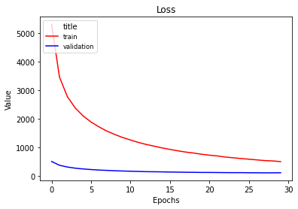

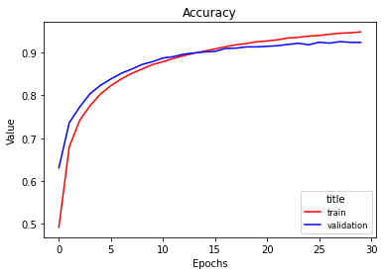

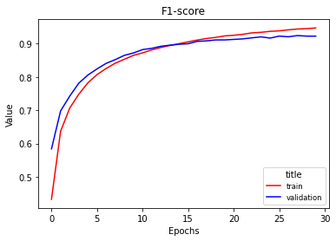

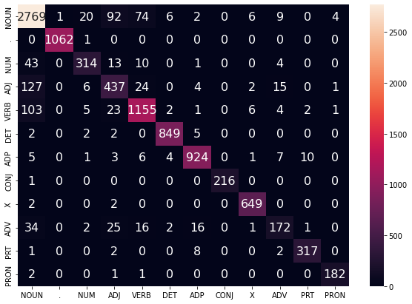

256x256

EPOCH: 0

TRAIN LOSS: 2605.385060504079

VALIDATION LOSS: 182.17296237498522

TRAIN ACC: 0.7603829507546164

VAL ACC: 0.8664578030154689

TRAIN F-1: 0.7427346204776767

VAL F-1: 0.8596577110028171

100%|██████████| 3131/3131 [01:52<00:00, 27.76it/s]

100%|██████████| 391/391 [00:03<00:00, 117.88it/s]

EPOCH: 1

TRAIN LOSS: 1250.645267950371

VALIDATION LOSS: 129.98667663894594

TRAIN ACC: 0.8804519017324554

VAL ACC: 0.9024867828470726

TRAIN F-1: 0.8753671099078052

VAL F-1: 0.899680783004118

100%|██████████| 3131/3131 [01:49<00:00, 28.55it/s]

100%|██████████| 391/391 [00:03<00:00, 123.90it/s]

EPOCH: 2

TRAIN LOSS: 848.1609367551282

VALIDATION LOSS: 106.38742857798934

TRAIN ACC: 0.9156714659523544

VAL ACC: 0.9209907969453691

TRAIN F-1: 0.9135565193480852

VAL F-1: 0.9196697604416563

100%|██████████| 3131/3131 [01:52<00:00, 27.75it/s]

100%|██████████| 391/391 [00:03<00:00, 124.62it/s]

EPOCH: 3

TRAIN LOSS: 608.3714563194662

VALIDATION LOSS: 92.83503108657897

TRAIN ACC: 0.9379565211999454

VAL ACC: 0.931368709614255

TRAIN F-1: 0.9368859687484598

VAL F-1: 0.930831339484268

100%|██████████| 3131/3131 [01:47<00:00, 28.99it/s]

100%|██████████| 391/391 [00:03<00:00, 120.27it/s]

EPOCH: 4

TRAIN LOSS: 452.26769194426015

VALIDATION LOSS: 85.2145101504866

TRAIN ACC: 0.9536193062737949

VAL ACC: 0.936263951439201

TRAIN F-1: 0.9530521159844199

VAL F-1: 0.935859895184021

100%|██████████| 3131/3131 [01:50<00:00, 28.44it/s]

100%|██████████| 391/391 [00:03<00:00, 128.83it/s]

EPOCH: 5

TRAIN LOSS: 347.19253490213305

VALIDATION LOSS: 80.23065432650037

TRAIN ACC: 0.9634411002393443

VAL ACC: 0.9417466222831408

TRAIN F-1: 0.9631206691310512

VAL F-1: 0.9416598740468063

100%|██████████| 3131/3131 [01:48<00:00, 28.87it/s]

100%|██████████| 391/391 [00:03<00:00, 114.98it/s]

EPOCH: 6

TRAIN LOSS: 269.01363588584354

VALIDATION LOSS: 76.51175500731915

TRAIN ACC: 0.9719483611741508

VAL ACC: 0.9428235754846289

TRAIN F-1: 0.9717493103665551

VAL F-1: 0.9425757732749576

100%|██████████| 3131/3131 [01:52<00:00, 27.83it/s]

100%|██████████| 391/391 [00:03<00:00, 112.39it/s]

EPOCH: 7

TRAIN LOSS: 213.8565464593703

VALIDATION LOSS: 74.97081185784191

TRAIN ACC: 0.9781241861676402

VAL ACC: 0.9436068141766203

TRAIN F-1: 0.9779953095140386

VAL F-1: 0.9433964422804895

100%|██████████| 3131/3131 [01:44<00:00, 30.02it/s]

100%|██████████| 391/391 [00:03<00:00, 125.32it/s]

EPOCH: 8

TRAIN LOSS: 173.99900634713413

VALIDATION LOSS: 74.57474348397227

TRAIN ACC: 0.9825142304401205

VAL ACC: 0.9459565302525945

TRAIN F-1: 0.9824411446103495

VAL F-1: 0.9456561677269935

100%|██████████| 3131/3131 [01:44<00:00, 30.05it/s]

100%|██████████| 391/391 [00:03<00:00, 111.55it/s]

EPOCH: 9

TRAIN LOSS: 139.1740597501048

VALIDATION LOSS: 76.4047570109251

TRAIN ACC: 0.9866686508674678

VAL ACC: 0.9456628157430977

TRAIN F-1: 0.9866250793853553

VAL F-1: 0.9455752956319511

100%|██████████| 3131/3131 [01:40<00:00, 31.21it/s]

100%|██████████| 391/391 [00:03<00:00, 128.04it/s]

EPOCH: 10

TRAIN LOSS: 116.54197122680489

VALIDATION LOSS: 75.31707186779386

TRAIN ACC: 0.98893808053375

VAL ACC: 0.9461523399255923

TRAIN F-1: 0.988910523559829

VAL F-1: 0.9457813347135414

100%|██████████| 3131/3131 [01:30<00:00, 34.48it/s]

100%|██████████| 391/391 [00:03<00:00, 122.59it/s]

EPOCH: 11

TRAIN LOSS: 98.68245489594847

VALIDATION LOSS: 74.747946207739

TRAIN ACC: 0.9908726763148431

VAL ACC: 0.9485999608380654

TRAIN F-1: 0.9908552193064265

VAL F-1: 0.9481991234060831

100%|██████████| 3131/3131 [01:41<00:00, 30.75it/s]

100%|██████████| 391/391 [00:03<00:00, 130.09it/s]

EPOCH: 12

TRAIN LOSS: 82.4525198289557

VALIDATION LOSS: 76.45742084883386

TRAIN ACC: 0.9927948708409291

VAL ACC: 0.9495790092030546

TRAIN F-1: 0.9927802911330788

VAL F-1: 0.9492813759312819

100%|██████████| 3131/3131 [01:43<00:00, 30.31it/s]

100%|██████████| 391/391 [00:02<00:00, 130.96it/s]

EPOCH: 13

TRAIN LOSS: 71.80720495159767

VALIDATION LOSS: 77.11705908006115

TRAIN ACC: 0.9936629586914195

VAL ACC: 0.9480125318190719

TRAIN F-1: 0.9936514606109846

VAL F-1: 0.9477569986546384

VALIDATION LOSS: 91.09510868548023

VAL F-1: 0.9355842047542677

VAL ACC: 0.9355725190839694

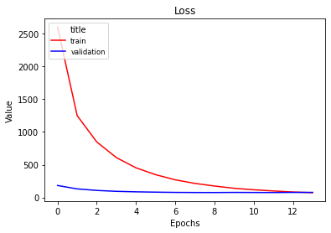

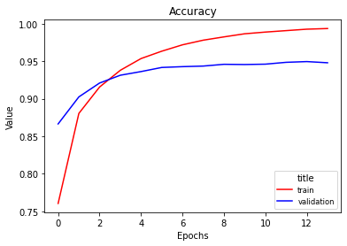

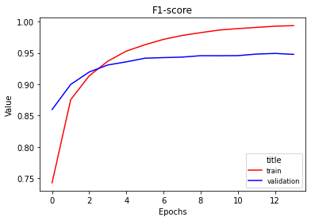

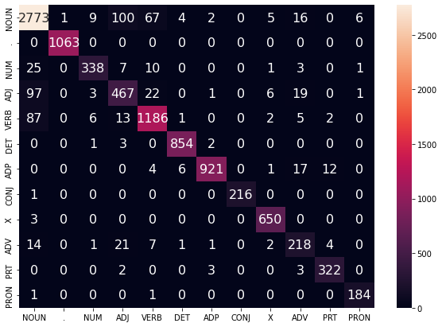

512x512

100%|██████████| 3131/3131 [11:03<00:00, 4.72it/s]

100%|██████████| 391/391 [00:11<00:00, 35.11it/s]

EPOCH: 0

TRAIN LOSS: 1653.3069265987724

VALIDATION LOSS: 116.49905760213733

TRAIN ACC: 0.8468072968984461

VAL ACC: 0.9090464068925005

TRAIN F-1: 0.841516745422232

VAL F-1: 0.9081119289580443

100%|██████████| 3131/3131 [11:01<00:00, 4.73it/s]

100%|██████████| 391/391 [00:11<00:00, 35.54it/s]

EPOCH: 1

TRAIN LOSS: 641.7377929434879

VALIDATION LOSS: 82.32467586733401

TRAIN ACC: 0.9336408844575071

VAL ACC: 0.9345995692187195

TRAIN F-1: 0.9326184061140866

VAL F-1: 0.9343806693301027

100%|██████████| 3131/3131 [10:48<00:00, 4.83it/s]

100%|██████████| 391/391 [00:11<00:00, 35.34it/s]

EPOCH: 2

TRAIN LOSS: 331.3348235237063

VALIDATION LOSS: 72.66526419424918

TRAIN ACC: 0.9645944169549958

VAL ACC: 0.9443900528686117

TRAIN F-1: 0.9642653693935628

VAL F-1: 0.9439113882317619

100%|██████████| 3131/3131 [10:59<00:00, 4.75it/s]

100%|██████████| 391/391 [00:11<00:00, 34.40it/s]

EPOCH: 3

TRAIN LOSS: 184.10189943330624

VALIDATION LOSS: 69.66040232707746

TRAIN ACC: 0.9804308195989434

VAL ACC: 0.9483062463285686

TRAIN F-1: 0.9803299438414276

VAL F-1: 0.9477975210524892

100%|██████████| 3131/3131 [10:47<00:00, 4.84it/s]

100%|██████████| 391/391 [00:11<00:00, 34.65it/s]

EPOCH: 4

TRAIN LOSS: 111.16867307820212

VALIDATION LOSS: 70.2329559849386

TRAIN ACC: 0.9893721244589953

VAL ACC: 0.9505580575680439

TRAIN F-1: 0.9893453299075243

VAL F-1: 0.9501415339908191

100%|██████████| 3131/3131 [11:01<00:00, 4.73it/s]

100%|██████████| 391/391 [00:11<00:00, 35.31it/s]

EPOCH: 5

TRAIN LOSS: 71.20279612181912

VALIDATION LOSS: 73.28443192381383

TRAIN ACC: 0.9937621687314756

VAL ACC: 0.9488936753475622

TRAIN F-1: 0.9937522525666936

VAL F-1: 0.9486269893347994

VAL F-1: 0.9461309857078616

VAL ACC: 0.9465648854961832

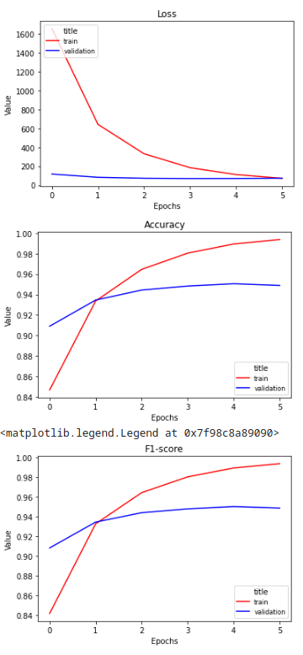

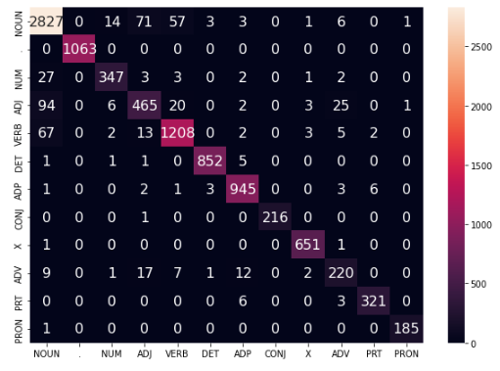

128x128

32x32

100%|██████████| 3131/3131 [04:20<00:00, 12.03it/s]

100%|██████████| 391/391 [00:12<00:00, 31.13it/s]

EPOCH: 0

TRAIN LOSS: 1821.9810706451535

VALIDATION LOSS: 161.70919182896614

TRAIN ACC: 0.824435432865806

VAL ACC: 0.8768357156843548

TRAIN F-1: 0.8075183119992063

VAL F-1: 0.8669799920209886

100%|██████████| 3131/3131 [04:14<00:00, 12.32it/s]

100%|██████████| 391/391 [00:12<00:00, 31.53it/s]

EPOCH: 1

TRAIN LOSS: 1208.2727092951536

VALIDATION LOSS: 122.82139197736979

TRAIN ACC: 0.8809107481677145

VAL ACC: 0.9035637360485608

TRAIN F-1: 0.8716826905998585

VAL F-1: 0.897810115119165

100%|██████████| 3131/3131 [04:21<00:00, 11.98it/s]

100%|██████████| 391/391 [00:12<00:00, 32.49it/s]

EPOCH: 2

TRAIN LOSS: 907.0048506110907

VALIDATION LOSS: 101.8709398265928

TRAIN ACC: 0.9085283430683185

VAL ACC: 0.9227530840023497

TRAIN F-1: 0.9032584100987203

VAL F-1: 0.9204945766183115

100%|██████████| 3131/3131 [04:09<00:00, 12.52it/s]

100%|██████████| 391/391 [00:11<00:00, 33.63it/s]

EPOCH: 3

TRAIN LOSS: 706.7226002058014

VALIDATION LOSS: 87.85386126115918

TRAIN ACC: 0.9282463385294591

VAL ACC: 0.9328372821617388

TRAIN F-1: 0.9254814324557743

VAL F-1: 0.9316365554739073

100%|██████████| 3131/3131 [04:06<00:00, 12.68it/s]

100%|██████████| 391/391 [00:11<00:00, 32.78it/s]

EPOCH: 4

TRAIN LOSS: 569.9135316358879

VALIDATION LOSS: 79.5294583006762

TRAIN ACC: 0.9411932487567742

VAL ACC: 0.9385157626786763

TRAIN F-1: 0.939655627471433

VAL F-1: 0.938070387908637

100%|██████████| 3131/3131 [04:02<00:00, 12.89it/s]

100%|██████████| 391/391 [00:11<00:00, 34.28it/s]

EPOCH: 5

TRAIN LOSS: 473.65263421740383

VALIDATION LOSS: 74.86353648174554

TRAIN ACC: 0.9507918201321974

VAL ACC: 0.941452907773644

TRAIN F-1: 0.9498673241441968

VAL F-1: 0.9411657723232479

100%|██████████| 3131/3131 [04:02<00:00, 12.89it/s]

100%|██████████| 391/391 [00:12<00:00, 31.77it/s]

EPOCH: 6

TRAIN LOSS: 399.7055783167016

VALIDATION LOSS: 71.88095456059091

TRAIN ACC: 0.9582201718813944

VAL ACC: 0.9437047190131193

TRAIN F-1: 0.957583705944535

VAL F-1: 0.9435162227962633

100%|██████████| 3131/3131 [04:10<00:00, 12.48it/s]

100%|██████████| 391/391 [00:13<00:00, 29.21it/s]

EPOCH: 7

TRAIN LOSS: 342.54165220900904

VALIDATION LOSS: 69.40536414622329

TRAIN ACC: 0.9645076081699469

VAL ACC: 0.9454670060700998

TRAIN F-1: 0.9640664434860368

VAL F-1: 0.9453581112920313

100%|██████████| 3131/3131 [04:11<00:00, 12.47it/s]

100%|██████████| 391/391 [00:12<00:00, 31.45it/s]

EPOCH: 8

TRAIN LOSS: 295.2615277838195

VALIDATION LOSS: 67.99064420070499

TRAIN ACC: 0.9694681101727495

VAL ACC: 0.9471313882905815

TRAIN F-1: 0.9691434464945606

VAL F-1: 0.9470223298467739

100%|██████████| 3131/3131 [04:04<00:00, 12.79it/s]

100%|██████████| 391/391 [00:12<00:00, 31.48it/s]

EPOCH: 9

TRAIN LOSS: 255.81058633542852

VALIDATION LOSS: 66.81574730726425

TRAIN ACC: 0.9735233205600407

VAL ACC: 0.9470334834540827

TRAIN F-1: 0.9732767739449428

VAL F-1: 0.94703195414442

100%|██████████| 3131/3131 [04:04<00:00, 12.82it/s]

100%|██████████| 391/391 [00:11<00:00, 33.72it/s]

EPOCH: 10

TRAIN LOSS: 223.28920586389722

VALIDATION LOSS: 66.2421894572908

TRAIN ACC: 0.9775289259273039

VAL ACC: 0.9485999608380654

TRAIN F-1: 0.9773411343226258

VAL F-1: 0.9485310888550631

100%|██████████| 3131/3131 [04:06<00:00, 12.71it/s]

100%|██████████| 391/391 [00:11<00:00, 34.38it/s]

EPOCH: 11

TRAIN LOSS: 197.57147714321036

VALIDATION LOSS: 66.6340477046324

TRAIN ACC: 0.9804060170889294

VAL ACC: 0.9493831995300568

TRAIN F-1: 0.9802623913703532

VAL F-1: 0.949375622294937

100%|██████████| 3131/3131 [04:04<00:00, 12.79it/s]

100%|██████████| 391/391 [00:11<00:00, 35.35it/s]

EPOCH: 12

TRAIN LOSS: 172.59171854908345

VALIDATION LOSS: 67.05493749177549

TRAIN ACC: 0.983357515780597

VAL ACC: 0.9496769140395536

TRAIN F-1: 0.9832525648067968

VAL F-1: 0.9497079039231433

95%|█████████▌| 2985/3131 [03:55<00:11, 12.68it/s]

100%|██████████| 392/392 [00:10<00:00, 36.35it/s]VALIDATION LOSS: 72.18726481392514

VAL F-1: 0.9439258471822027

VAL ACC: 0.9442239185750636

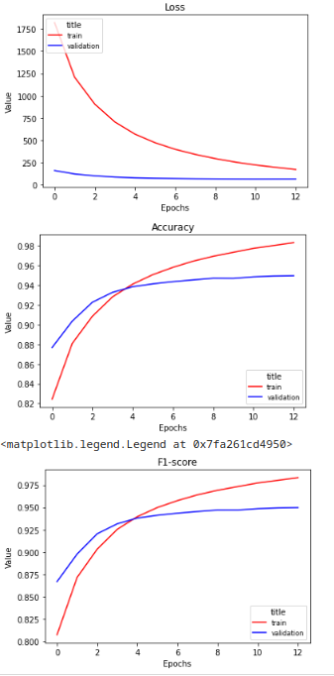

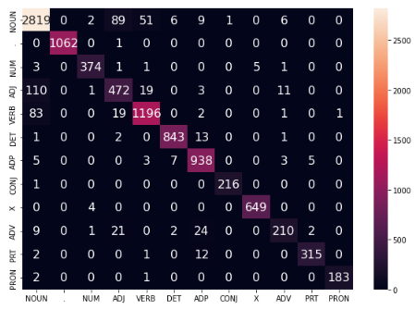

128x128

64x64

100%|██████████| 3131/3131 [04:42<00:00, 11.07it/s]

100%|██████████| 391/391 [00:13<00:00, 29.33it/s]

EPOCH: 0

TRAIN LOSS: 471.58962185680866

VALIDATION LOSS: 75.11305384058505

TRAIN ACC: 0.9523295757530662

VAL ACC: 0.9407675739181516

TRAIN F-1: 0.9514449882690708

VAL F-1: 0.9399618692729579

100%|██████████| 3131/3131 [04:32<00:00, 11.49it/s]

100%|██████████| 391/391 [00:12<00:00, 31.91it/s]

EPOCH: 1

TRAIN LOSS: 438.73682506824844

VALIDATION LOSS: 72.87248553568497

TRAIN ACC: 0.955665513349951

VAL ACC: 0.9432151948306247

TRAIN F-1: 0.9549270439729023

VAL F-1: 0.9425057766019871

100%|██████████| 3131/3131 [04:22<00:00, 11.94it/s]

100%|██████████| 391/391 [00:12<00:00, 31.36it/s]

EPOCH: 2

TRAIN LOSS: 407.1750803224277

VALIDATION LOSS: 71.28393240785226

TRAIN ACC: 0.9585798082765976

VAL ACC: 0.9444879577051106

TRAIN F-1: 0.9579584810949904

VAL F-1: 0.9439163682059066

100%|██████████| 3131/3131 [04:27<00:00, 11.69it/s]

100%|██████████| 391/391 [00:12<00:00, 30.30it/s]

EPOCH: 3

TRAIN LOSS: 380.71631715702824

VALIDATION LOSS: 69.58179709222168

TRAIN ACC: 0.9616801220283493

VAL ACC: 0.9457607205795966

TRAIN F-1: 0.9611511481186313

VAL F-1: 0.9452088760340926

100%|██████████| 3131/3131 [04:21<00:00, 11.97it/s]

100%|██████████| 391/391 [00:11<00:00, 32.62it/s]

EPOCH: 4

TRAIN LOSS: 356.0962041760795

VALIDATION LOSS: 68.49854773469269

TRAIN ACC: 0.9641851755397646

VAL ACC: 0.9468376737810847

TRAIN F-1: 0.9637316847905334

VAL F-1: 0.9464247883061689

100%|██████████| 3131/3131 [04:30<00:00, 11.58it/s]

100%|██████████| 391/391 [00:13<00:00, 29.50it/s]

EPOCH: 5

TRAIN LOSS: 333.62071621825453

VALIDATION LOSS: 67.24226360069588

TRAIN ACC: 0.9666406240311519

VAL ACC: 0.9479146269825729

TRAIN F-1: 0.9662634960759856

VAL F-1: 0.9474709281329272

100%|██████████| 3131/3131 [04:34<00:00, 11.42it/s]

100%|██████████| 391/391 [00:13<00:00, 29.54it/s]

EPOCH: 6

TRAIN LOSS: 313.3127697984455

VALIDATION LOSS: 65.80337421549484

TRAIN ACC: 0.968550417302231

VAL ACC: 0.9495790092030546

TRAIN F-1: 0.9682281272047405

VAL F-1: 0.9492229072665028

100%|██████████| 3131/3131 [04:33<00:00, 11.46it/s]

100%|██████████| 391/391 [00:12<00:00, 31.63it/s]

EPOCH: 7

TRAIN LOSS: 295.70787149248645

VALIDATION LOSS: 65.20597832044587

TRAIN ACC: 0.9706214268884011

VAL ACC: 0.9487957705110632

TRAIN F-1: 0.9703330379838918

VAL F-1: 0.9484402509759493

100%|██████████| 3131/3131 [04:12<00:00, 12.38it/s]

100%|██████████| 391/391 [00:11<00:00, 33.24it/s]

EPOCH: 8

TRAIN LOSS: 278.54675935965497

VALIDATION LOSS: 64.39258529921062

TRAIN ACC: 0.9721467812542629

VAL ACC: 0.9499706285490503

TRAIN F-1: 0.9718953214202656

VAL F-1: 0.9495201441610929

100%|██████████| 3131/3131 [04:16<00:00, 12.23it/s]

100%|██████████| 391/391 [00:13<00:00, 29.72it/s]

EPOCH: 9

TRAIN LOSS: 263.090148616815

VALIDATION LOSS: 63.73943789768964

TRAIN ACC: 0.9743045996254821

VAL ACC: 0.9501664382220482

TRAIN F-1: 0.9740780992990975

VAL F-1: 0.9500223170805573

100%|██████████| 3131/3131 [04:22<00:00, 11.93it/s]

100%|██████████| 391/391 [00:13<00:00, 29.62it/s]

EPOCH: 10

TRAIN LOSS: 248.40240350388922

VALIDATION LOSS: 63.48210443975404

TRAIN ACC: 0.976040775326463

VAL ACC: 0.9510475817505385

TRAIN F-1: 0.975845747564276

VAL F-1: 0.9508936265578489

100%|██████████| 392/392 [00:26<00:00, 14.90it/s]VALIDATION LOSS: 75.0658795813797

VAL F-1: 0.9395959598797187

VAL ACC: 0.9388295165394402

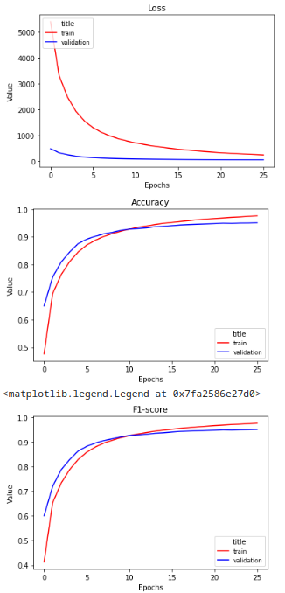

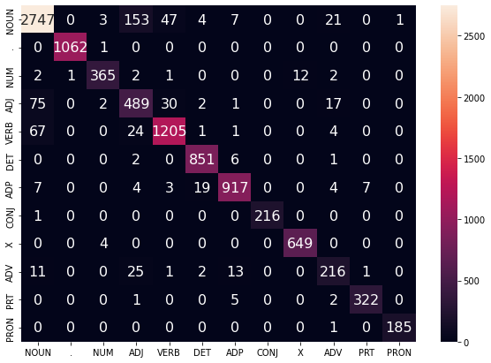

128x128

128x128

100%|██████████| 3131/3131 [05:29<00:00, 9.50it/s]

100%|██████████| 391/391 [00:15<00:00, 25.97it/s]

EPOCH: 0

TRAIN LOSS: 2704.3749367259443

VALIDATION LOSS: 144.47231687232852

TRAIN ACC: 0.7367833624762826

VAL ACC: 0.8871157235167417

TRAIN F-1: 0.7201983672791094

VAL F-1: 0.8799543712542289

100%|██████████| 3131/3131 [05:51<00:00, 8.90it/s]

100%|██████████| 391/391 [00:13<00:00, 28.66it/s]

EPOCH: 1

TRAIN LOSS: 1035.3564331624657

VALIDATION LOSS: 96.9295467287302

TRAIN ACC: 0.8958790629611717

VAL ACC: 0.919815938907382

TRAIN F-1: 0.8903843398807327

VAL F-1: 0.9185188226520303

100%|██████████| 3131/3131 [05:28<00:00, 9.53it/s]

100%|██████████| 391/391 [00:14<00:00, 27.92it/s]

EPOCH: 2

TRAIN LOSS: 706.8782381475903

VALIDATION LOSS: 75.76128146704286

TRAIN ACC: 0.927824695859221

VAL ACC: 0.9330330918347366

TRAIN F-1: 0.9256229957859937

VAL F-1: 0.9331115545474749

100%|██████████| 3131/3131 [05:21<00:00, 9.75it/s]

100%|██████████| 391/391 [00:12<00:00, 30.64it/s]

EPOCH: 3

TRAIN LOSS: 522.0246106346603

VALIDATION LOSS: 64.10801305691712

TRAIN ACC: 0.9450376378089462

VAL ACC: 0.941550812610143

TRAIN F-1: 0.943948234208677

VAL F-1: 0.9418270542524282

100%|██████████| 3131/3131 [05:26<00:00, 9.59it/s]

100%|██████████| 391/391 [00:12<00:00, 30.48it/s]

EPOCH: 4

TRAIN LOSS: 403.80992996081477

VALIDATION LOSS: 56.85845357365906

TRAIN ACC: 0.9566204099854906

VAL ACC: 0.9496769140395536

TRAIN F-1: 0.9559990217705172

VAL F-1: 0.9500374576047564

100%|██████████| 3131/3131 [05:23<00:00, 9.68it/s]

100%|██████████| 391/391 [00:13<00:00, 28.44it/s]

EPOCH: 5

TRAIN LOSS: 319.99569517589407

VALIDATION LOSS: 53.10949943808373

TRAIN ACC: 0.9655369123355284

VAL ACC: 0.9534952026630116

TRAIN F-1: 0.9651905591569374

VAL F-1: 0.9539415043958698

100%|██████████| 3131/3131 [05:14<00:00, 9.95it/s]

100%|██████████| 391/391 [00:12<00:00, 31.38it/s]

EPOCH: 6

TRAIN LOSS: 259.9471500070649

VALIDATION LOSS: 50.65723775792867

TRAIN ACC: 0.9717499410940387

VAL ACC: 0.9562365380849814

TRAIN F-1: 0.9715478638543369

VAL F-1: 0.9566734397119461

100%|██████████| 3131/3131 [05:18<00:00, 9.82it/s]

100%|██████████| 391/391 [00:21<00:00, 17.86it/s]

EPOCH: 7

TRAIN LOSS: 213.84833789846743

VALIDATION LOSS: 50.74764879408758

TRAIN ACC: 0.9768716594119324

VAL ACC: 0.9568239671039749

TRAIN F-1: 0.976727203378712

VAL F-1: 0.9574742271762942

100%|██████████| 3131/3131 [05:23<00:00, 9.67it/s]

100%|██████████| 391/391 [00:13<00:00, 28.09it/s]

EPOCH: 8

TRAIN LOSS: 176.96027276355017

VALIDATION LOSS: 50.1255409035366

TRAIN ACC: 0.9811500923893498

VAL ACC: 0.958096729978461

TRAIN F-1: 0.9810519615356129

VAL F-1: 0.9585488873926744

100%|██████████| 392/392 [00:13<00:00, 29.08it/s]VALIDATION LOSS: 67.10475621878868

VAL F-1: 0.9477798192755212

VAL ACC: 0.9474809160305343

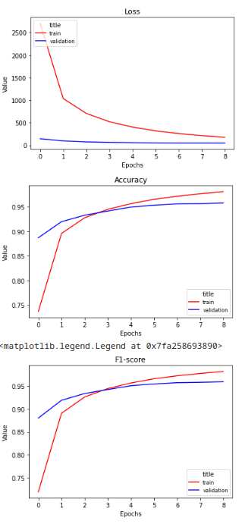

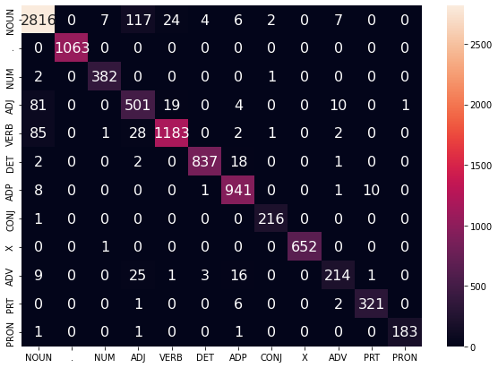

256x256

64x64

100%|██████████| 392/392 [00:13<00:00, 29.20it/s]VALIDATION LOSS: 62.17718294780934

VAL F-1: 0.9472514381983458

VAL ACC: 0.947175572519084

100%|██████████| 3131/3131 [05:23<00:00, 9.68it/s]

100%|██████████| 391/391 [00:13<00:00, 28.97it/s]

EPOCH: 0

TRAIN LOSS: 99.10893861582736

VALIDATION LOSS: 60.78131746640429

TRAIN ACC: 0.9903394223495418

VAL ACC: 0.9547679655374975

TRAIN F-1: 0.9903194395002307

VAL F-1: 0.9548399959123262

100%|██████████| 3131/3131 [05:21<00:00, 9.73it/s]

100%|██████████| 391/391 [00:13<00:00, 29.22it/s]

EPOCH: 1

TRAIN LOSS: 88.28304929742444

VALIDATION LOSS: 60.45691273605917

TRAIN ACC: 0.9920755980505227

VAL ACC: 0.9555512042294889

TRAIN F-1: 0.9920563891884597

VAL F-1: 0.9556021443315688

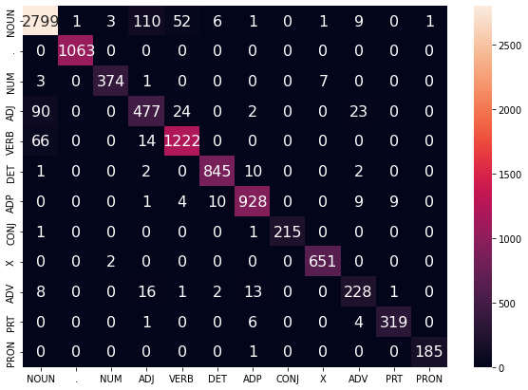

512x512

64x64

100%|██████████| 3131/3131 [09:37<00:00, 5.42it/s]

100%|██████████| 391/391 [00:18<00:00, 20.68it/s]

EPOCH: 0

TRAIN LOSS: 3216.7330693751574

VALIDATION LOSS: 225.05371533334255

TRAIN ACC: 0.7046765132631422

VAL ACC: 0.8388486391227726

TRAIN F-1: 0.6791497738658212

VAL F-1: 0.8271546598767278

100%|██████████| 3131/3131 [09:26<00:00, 5.53it/s]

100%|██████████| 391/391 [00:17<00:00, 22.52it/s]

EPOCH: 1

TRAIN LOSS: 1533.7502415142953

VALIDATION LOSS: 157.61538488045335

TRAIN ACC: 0.8529087143618934

VAL ACC: 0.880458194634815

TRAIN F-1: 0.8450231614354569

VAL F-1: 0.8768013597324819

100%|██████████| 3131/3131 [09:30<00:00, 5.49it/s]

100%|██████████| 391/391 [00:17<00:00, 22.48it/s]

EPOCH: 2

TRAIN LOSS: 1038.7699479749426

VALIDATION LOSS: 116.43973055109382

TRAIN ACC: 0.896523928221536

VAL ACC: 0.9097317407479929

TRAIN F-1: 0.8930089564827811

VAL F-1: 0.9076095276282359

100%|██████████| 3131/3131 [09:26<00:00, 5.53it/s]

100%|██████████| 391/391 [00:17<00:00, 22.63it/s]

EPOCH: 3

TRAIN LOSS: 719.6736518708058

VALIDATION LOSS: 90.24213424604386

TRAIN ACC: 0.9269442067537235

VAL ACC: 0.9299001370667711

TRAIN F-1: 0.9251036978327425

VAL F-1: 0.9282857951721998

100%|██████████| 3131/3131 [09:46<00:00, 5.34it/s]

100%|██████████| 391/391 [00:16<00:00, 23.67it/s]

EPOCH: 4

TRAIN LOSS: 515.288855118677

VALIDATION LOSS: 76.98360362509266

TRAIN ACC: 0.9470590423750883

VAL ACC: 0.9409633835911494

TRAIN F-1: 0.9459883999385995

VAL F-1: 0.9395610891569243

100%|██████████| 3131/3131 [09:27<00:00, 5.51it/s]

100%|██████████| 391/391 [00:16<00:00, 23.41it/s]

EPOCH: 5

TRAIN LOSS: 375.3763946178369

VALIDATION LOSS: 69.28260836703703

TRAIN ACC: 0.9615437082232722

VAL ACC: 0.9463481495985901

TRAIN F-1: 0.9608802109128027

VAL F-1: 0.9455083210526105

100%|██████████| 3131/3131 [09:28<00:00, 5.51it/s]

100%|██████████| 391/391 [00:17<00:00, 22.46it/s]

EPOCH: 6

TRAIN LOSS: 285.55096451193094

VALIDATION LOSS: 65.48155092343222

TRAIN ACC: 0.9708322482235202

VAL ACC: 0.951635010769532

TRAIN F-1: 0.9704636811963934

VAL F-1: 0.9509181967341797

100%|██████████| 3131/3131 [09:20<00:00, 5.58it/s]

100%|██████████| 391/391 [00:15<00:00, 24.50it/s]

EPOCH: 7

TRAIN LOSS: 222.5675173891359

VALIDATION LOSS: 63.80184387159534

TRAIN ACC: 0.977764549772437

VAL ACC: 0.9538868220090072

TRAIN F-1: 0.9775584615524503

VAL F-1: 0.9532372198737491

100%|██████████| 3131/3131 [09:31<00:00, 5.48it/s]

100%|██████████| 391/391 [00:17<00:00, 22.49it/s]

EPOCH: 8

TRAIN LOSS: 175.68382705718977

VALIDATION LOSS: 62.514319364214316

TRAIN ACC: 0.9830102806404009

VAL ACC: 0.9547679655374975

TRAIN F-1: 0.9828934014985199

VAL F-1: 0.9542077177232915

100%|██████████| 3131/3131 [09:29<00:00, 5.50it/s]

100%|██████████| 391/391 [00:16<00:00, 23.02it/s]

EPOCH: 9

TRAIN LOSS: 141.03233008089592

VALIDATION LOSS: 61.903959374292754

TRAIN ACC: 0.9868298671825588

VAL ACC: 0.9550616800469943

TRAIN F-1: 0.9867629875972947

VAL F-1: 0.9544699397577538

100%|██████████| 3131/3131 [09:40<00:00, 5.40it/s]

100%|██████████| 391/391 [00:18<00:00, 21.48it/s]

EPOCH: 10

TRAIN LOSS: 114.38359011315333

VALIDATION LOSS: 62.685944923374336

TRAIN ACC: 0.9896821558341704

VAL ACC: 0.9553553945564911

TRAIN F-1: 0.9896364653893421

VAL F-1: 0.9547764146198103

100%|██████████| 3131/3131 [09:27<00:00, 5.52it/s]

100%|██████████| 391/391 [00:17<00:00, 22.92it/s]

EPOCH: 11

TRAIN LOSS: 94.30795041736565

VALIDATION LOSS: 63.02005248266505

TRAIN ACC: 0.9918647767154036

VAL ACC: 0.9547679655374975

TRAIN F-1: 0.9918366900053379

VAL F-1: 0.9542034752622791

100%|██████████| 3131/3131 [09:19<00:00, 5.59it/s]

100%|██████████| 391/391 [00:17<00:00, 22.76it/s]

EPOCH: 12

TRAIN LOSS: 77.59852150746156

VALIDATION LOSS: 63.95926740398863

TRAIN ACC: 0.9936381561814056

VAL ACC: 0.9548658703739965

TRAIN F-1: 0.9936225375716206

VAL F-1: 0.9543013705374773

100%|██████████| 3131/3131 [09:26<00:00, 5.53it/s]

100%|██████████| 391/391 [00:17<00:00, 21.73it/s]

EPOCH: 13

TRAIN LOSS: 64.86682766358717

VALIDATION LOSS: 64.62786309901276

TRAIN ACC: 0.9951387080372534

VAL ACC: 0.9556491090659879

TRAIN F-1: 0.9951306102377429

VAL F-1: 0.9551005753975228

100%|██████████| 3131/3131 [09:30<00:00, 5.49it/s]

100%|██████████| 391/391 [00:16<00:00, 23.54it/s]

EPOCH: 14

TRAIN LOSS: 54.80569310090141

VALIDATION LOSS: 65.41206193267135

TRAIN ACC: 0.996329228517926

VAL ACC: 0.9552574897199921

TRAIN F-1: 0.9963246892499991

VAL F-1: 0.9547619274716191

100%|██████████| 392/392 [00:15<00:00, 24.72it/s]VALIDATION LOSS: 71.01416629253072

VAL F-1: 0.9465737805411696

VAL ACC: 0.9465648854961832

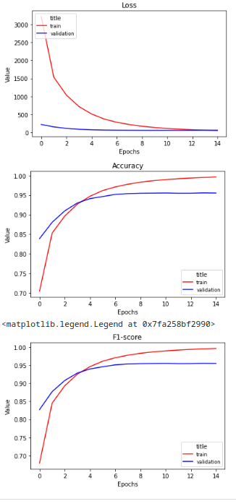

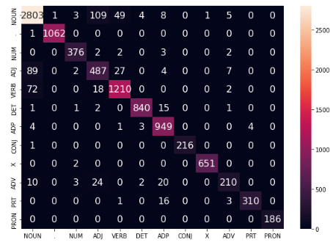

512x512

64x64

100%|██████████| 3131/3131 [00:50<00:00, 61.59it/s]

100%|██████████| 391/391 [00:02<00:00, 142.53it/s]

EPOCH: 0

TRAIN LOSS: 91.85845306209376

VALIDATION LOSS: 60.71076571318554

TRAIN ACC: 0.9919887892654736

VAL ACC: 0.952907773644018

TRAIN F-1: 0.9919741373683687

VAL F-1: 0.9525479760875792

100%|██████████| 3131/3131 [00:46<00:00, 67.27it/s]

100%|██████████| 391/391 [00:02<00:00, 144.34it/s]

EPOCH: 1

TRAIN LOSS: 85.41053663893399

VALIDATION LOSS: 60.07150063512381

TRAIN ACC: 0.992695660800873

VAL ACC: 0.9537889171725084

TRAIN F-1: 0.9926760182857077

VAL F-1: 0.9533339608236752

100%|██████████| 3131/3131 [00:47<00:00, 66.20it/s]

100%|██████████| 391/391 [00:03<00:00, 124.29it/s]

EPOCH: 2

TRAIN LOSS: 82.93258724858606

VALIDATION LOSS: 59.90656394622056

TRAIN ACC: 0.9930676984510832

VAL ACC: 0.9536910123360094

TRAIN F-1: 0.9930494046545082

VAL F-1: 0.953259716545886

100%|██████████| 3131/3131 [00:46<00:00, 67.42it/s]

100%|██████████| 391/391 [00:02<00:00, 143.93it/s]

EPOCH: 3

TRAIN LOSS: 80.87988043939549

VALIDATION LOSS: 59.79116914916085

TRAIN ACC: 0.9935265448863425

VAL ACC: 0.9539847268455062

TRAIN F-1: 0.9935089872003106

VAL F-1: 0.9535534807928071

100%|██████████| 3131/3131 [00:47<00:00, 66.31it/s]

100%|██████████| 391/391 [00:02<00:00, 142.04it/s]

EPOCH: 4

TRAIN LOSS: 79.73205337237596

VALIDATION LOSS: 59.719160333042964

TRAIN ACC: 0.9936133536713916

VAL ACC: 0.9540826316820051

TRAIN F-1: 0.9935959775848882

VAL F-1: 0.9536004797724537

100%|██████████| 3131/3131 [00:46<00:00, 67.35it/s]

100%|██████████| 391/391 [00:02<00:00, 140.07it/s]

EPOCH: 5

TRAIN LOSS: 78.54504566980904

VALIDATION LOSS: 59.60056462942157

TRAIN ACC: 0.9938117737515036

VAL ACC: 0.9544742510280008

TRAIN F-1: 0.9937951597855793

VAL F-1: 0.9540279812227165

100%|██████████| 3131/3131 [00:47<00:00, 66.29it/s]

100%|██████████| 391/391 [00:02<00:00, 142.64it/s]

EPOCH: 6

TRAIN LOSS: 77.45342826461274

VALIDATION LOSS: 59.55910091922851

TRAIN ACC: 0.9939109837915597

VAL ACC: 0.9543763461915019

TRAIN F-1: 0.9938954759419998

VAL F-1: 0.9539808007960943

100%|██████████| 3131/3131 [00:46<00:00, 67.41it/s]

100%|██████████| 391/391 [00:02<00:00, 141.31it/s]

EPOCH: 7

TRAIN LOSS: 76.38712009620212

VALIDATION LOSS: 59.698617303569335

TRAIN ACC: 0.9940846013616578

VAL ACC: 0.9545721558644997

TRAIN F-1: 0.9940684441944782

VAL F-1: 0.9541519980002471

100%|██████████| 3131/3131 [00:47<00:00, 66.58it/s]

100%|██████████| 391/391 [00:02<00:00, 143.13it/s]

EPOCH: 8

TRAIN LOSS: 75.72349456673692

VALIDATION LOSS: 59.757712215941865

TRAIN ACC: 0.9942458176767489

VAL ACC: 0.9544742510280008

TRAIN F-1: 0.9942318991639273

VAL F-1: 0.9540483862798566

100%|██████████| 3131/3131 [00:46<00:00, 67.33it/s]

100%|██████████| 391/391 [00:02<00:00, 143.32it/s]

EPOCH: 9

TRAIN LOSS: 74.69742490798671

VALIDATION LOSS: 59.77242442686111

TRAIN ACC: 0.994469040266875

VAL ACC: 0.9543763461915019

TRAIN F-1: 0.9944540647076884

VAL F-1: 0.9539498075596589

100%|██████████| 3131/3131 [00:47<00:00, 66.42it/s]

100%|██████████| 391/391 [00:02<00:00, 142.87it/s]

EPOCH: 10

TRAIN LOSS: 73.83556470946496

VALIDATION LOSS: 59.65251865715254

TRAIN ACC: 0.994493842776889

VAL ACC: 0.9540826316820051

TRAIN F-1: 0.9944795607673317

VAL F-1: 0.9536904888435477

100%|██████████| 3131/3131 [00:46<00:00, 67.48it/s]

100%|██████████| 391/391 [00:02<00:00, 142.43it/s]

EPOCH: 11

TRAIN LOSS: 72.91241104303481

VALIDATION LOSS: 59.82732950738864

TRAIN ACC: 0.9945682503069311

VAL ACC: 0.954180536518504

TRAIN F-1: 0.9945538784339898

VAL F-1: 0.9537180616934137

100%|██████████| 3131/3131 [00:47<00:00, 66.51it/s]

100%|██████████| 391/391 [00:02<00:00, 144.34it/s]

EPOCH: 12

TRAIN LOSS: 72.05114546697587

VALIDATION LOSS: 59.886961887124926

TRAIN ACC: 0.9946426578369731

VAL ACC: 0.9544742510280008

TRAIN F-1: 0.9946280180819219

VAL F-1: 0.9540653910706011

100%|██████████| 3131/3131 [00:46<00:00, 67.64it/s]

100%|██████████| 391/391 [00:02<00:00, 140.74it/s]

EPOCH: 13

TRAIN LOSS: 71.41483359954873

VALIDATION LOSS: 60.02192641835427

TRAIN ACC: 0.9947542691320361

VAL ACC: 0.9540826316820051

TRAIN F-1: 0.9947398066037755

VAL F-1: 0.9536761954062074

100%|██████████| 3131/3131 [00:47<00:00, 66.62it/s]

100%|██████████| 391/391 [00:02<00:00, 144.50it/s]

EPOCH: 14

TRAIN LOSS: 70.55608114902134

VALIDATION LOSS: 59.8730201285216

TRAIN ACC: 0.9947914728970572

VAL ACC: 0.9544742510280008

TRAIN F-1: 0.9947779229159045

VAL F-1: 0.9540642081473935

100%|██████████| 3131/3131 [00:46<00:00, 66.85it/s]

100%|██████████| 391/391 [00:02<00:00, 142.49it/s]

EPOCH: 15

TRAIN LOSS: 69.71215255471907

VALIDATION LOSS: 60.00937188108219

TRAIN ACC: 0.9949526892121483

VAL ACC: 0.9545721558644997

TRAIN F-1: 0.9949396129856515

VAL F-1: 0.9541332522891919

100%|██████████| 3131/3131 [00:46<00:00, 67.54it/s]

100%|██████████| 391/391 [00:02<00:00, 143.03it/s]

EPOCH: 16

TRAIN LOSS: 69.08286221190065

VALIDATION LOSS: 60.12713198072743

TRAIN ACC: 0.9950518992522043

VAL ACC: 0.9538868220090072

TRAIN F-1: 0.9950398413120938

VAL F-1: 0.9534829231790687

100%|██████████| 3131/3131 [00:46<00:00, 66.77it/s]

100%|██████████| 391/391 [00:02<00:00, 142.36it/s]

EPOCH: 17

TRAIN LOSS: 68.42042595730891

VALIDATION LOSS: 60.261094599205535

TRAIN ACC: 0.9951139055272393

VAL ACC: 0.9537889171725084

TRAIN F-1: 0.9951018397234017

VAL F-1: 0.9533714500370244

100%|██████████| 3131/3131 [00:46<00:00, 67.77it/s]

100%|██████████| 391/391 [00:02<00:00, 143.26it/s]

EPOCH: 18

TRAIN LOSS: 67.80847666406771

VALIDATION LOSS: 60.06548288319027

TRAIN ACC: 0.9952503193323164

VAL ACC: 0.9540826316820051

TRAIN F-1: 0.9952386027669216

VAL F-1: 0.9536405486630162

100%|██████████| 3131/3131 [00:46<00:00, 66.88it/s]

100%|██████████| 391/391 [00:02<00:00, 144.23it/s]

EPOCH: 19

TRAIN LOSS: 66.96096023655264

VALIDATION LOSS: 60.28079074656125

TRAIN ACC: 0.9952503193323164

VAL ACC: 0.9537889171725084

TRAIN F-1: 0.9952380056975435

VAL F-1: 0.9533710771571019

100%|██████████| 3131/3131 [00:46<00:00, 67.64it/s]

100%|██████████| 391/391 [00:02<00:00, 141.92it/s]

EPOCH: 20

TRAIN LOSS: 66.38493746180757

VALIDATION LOSS: 60.27731474977918

TRAIN ACC: 0.9953123256073515

VAL ACC: 0.9536910123360094

TRAIN F-1: 0.9953015805865093

VAL F-1: 0.9532712754302913

100%|██████████| 3131/3131 [00:46<00:00, 66.69it/s]

100%|██████████| 391/391 [00:02<00:00, 142.79it/s]

EPOCH: 21

TRAIN LOSS: 65.76019998026095

VALIDATION LOSS: 60.50698074843967

TRAIN ACC: 0.9954115356474075

VAL ACC: 0.9540826316820051

TRAIN F-1: 0.995400518133988

VAL F-1: 0.953644489358814

100%|██████████| 3131/3131 [00:46<00:00, 67.23it/s]

100%|██████████| 391/391 [00:02<00:00, 143.21it/s]

EPOCH: 22

TRAIN LOSS: 65.01142636185614

VALIDATION LOSS: 60.25013050425332

TRAIN ACC: 0.9954363381574215

VAL ACC: 0.954278441355003

TRAIN F-1: 0.9954253596475098

VAL F-1: 0.9538258804315877

100%|██████████| 3131/3131 [00:46<00:00, 66.83it/s]

100%|██████████| 391/391 [00:02<00:00, 143.28it/s]

EPOCH: 23

TRAIN LOSS: 64.46145784726832

VALIDATION LOSS: 60.155392046493944

TRAIN ACC: 0.9956223569825267

VAL ACC: 0.9540826316820051

TRAIN F-1: 0.9956131740958608

VAL F-1: 0.9536270378183967

100%|██████████| 3131/3131 [00:46<00:00, 67.65it/s]

100%|██████████| 391/391 [00:02<00:00, 142.58it/s]

EPOCH: 24

TRAIN LOSS: 63.74812794418904

VALIDATION LOSS: 60.299278594669886

TRAIN ACC: 0.9956595607475477

VAL ACC: 0.9532993929900138

TRAIN F-1: 0.9956498952806174

VAL F-1: 0.9528031948678474

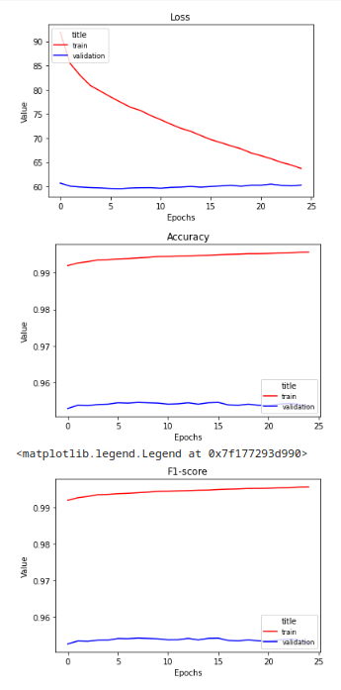

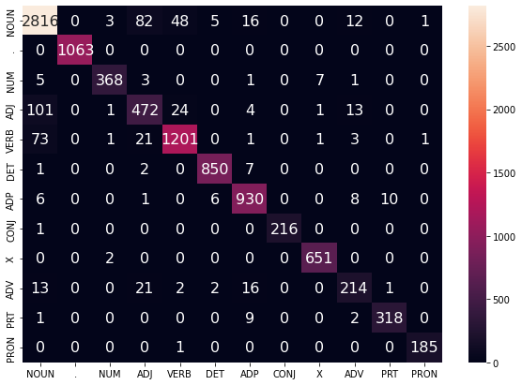

1024x1024

128x128

100%|██████████| 3131/3131 [00:54<00:00, 57.75it/s]

100%|██████████| 391/391 [00:03<00:00, 128.77it/s]

EPOCH: 0

TRAIN LOSS: 3483.251209259033

VALIDATION LOSS: 251.3477684855461

TRAIN ACC: 0.6880960353187743

VAL ACC: 0.8229880556099471

TRAIN F-1: 0.6538729388560058

VAL F-1: 0.8036145061195653

100%|██████████| 3131/3131 [00:53<00:00, 58.48it/s]

100%|██████████| 391/391 [00:03<00:00, 129.25it/s]

EPOCH: 1

TRAIN LOSS: 1730.7546314299107

VALIDATION LOSS: 173.68295162916183

TRAIN ACC: 0.8380768133735134

VAL ACC: 0.8711572351674173

TRAIN F-1: 0.8261779101222352

VAL F-1: 0.8639552310844375

100%|██████████| 3131/3131 [00:52<00:00, 59.16it/s]

100%|██████████| 391/391 [00:03<00:00, 129.99it/s]

EPOCH: 2

TRAIN LOSS: 1240.0588423162699

VALIDATION LOSS: 140.6790178604424

TRAIN ACC: 0.8801046665922592

VAL ACC: 0.8938711572351674

TRAIN F-1: 0.8749100183661126

VAL F-1: 0.8904736695908039

100%|██████████| 3131/3131 [00:52<00:00, 59.95it/s]

100%|██████████| 391/391 [00:02<00:00, 131.30it/s]

EPOCH: 3

TRAIN LOSS: 963.5091032031924

VALIDATION LOSS: 121.1691879760474

TRAIN ACC: 0.9041258975408312

VAL ACC: 0.9065008811435284

TRAIN F-1: 0.9011824995446228

VAL F-1: 0.9046859124747753

100%|██████████| 3131/3131 [00:54<00:00, 57.51it/s]

100%|██████████| 391/391 [00:03<00:00, 129.97it/s]

EPOCH: 4

TRAIN LOSS: 768.5741960220039

VALIDATION LOSS: 107.161475809291

TRAIN ACC: 0.9226533725212992

VAL ACC: 0.9158018406109262

TRAIN F-1: 0.9208803846250329

VAL F-1: 0.9144201590593701

100%|██████████| 3131/3131 [00:52<00:00, 59.34it/s]

100%|██████████| 391/391 [00:03<00:00, 128.12it/s]

EPOCH: 5

TRAIN LOSS: 614.7710701697506

VALIDATION LOSS: 95.45130417868495

TRAIN ACC: 0.9375844835497352

VAL ACC: 0.9239279420403368

TRAIN F-1: 0.9363933610752053

VAL F-1: 0.922803122441056

100%|██████████| 3131/3131 [00:52<00:00, 59.69it/s]

100%|██████████| 391/391 [00:03<00:00, 129.69it/s]

EPOCH: 6

TRAIN LOSS: 488.38759323908016

VALIDATION LOSS: 85.80759775592014

TRAIN ACC: 0.9503453749519452

VAL ACC: 0.9334247111807323

TRAIN F-1: 0.949544291204881

VAL F-1: 0.9326232114090411

100%|██████████| 3131/3131 [00:52<00:00, 59.08it/s]

100%|██████████| 391/391 [00:02<00:00, 130.60it/s]

EPOCH: 7

TRAIN LOSS: 386.0273796059191

VALIDATION LOSS: 78.46189522137865

TRAIN ACC: 0.9609112442179149

VAL ACC: 0.9387115723516741

TRAIN F-1: 0.9603809555438461

VAL F-1: 0.9381885772575198

100%|██████████| 3131/3131 [00:52<00:00, 59.28it/s]

100%|██████████| 391/391 [00:03<00:00, 129.06it/s]

EPOCH: 8

TRAIN LOSS: 308.6027799511794

VALIDATION LOSS: 73.53552035079338

TRAIN ACC: 0.9689844612274762

VAL ACC: 0.9421382416291365

TRAIN F-1: 0.9686357548350085

VAL F-1: 0.9418282754849753

100%|██████████| 3131/3131 [00:52<00:00, 59.81it/s]

100%|██████████| 391/391 [00:02<00:00, 131.29it/s]

EPOCH: 9

TRAIN LOSS: 252.2534922886407

VALIDATION LOSS: 70.67206443927716

TRAIN ACC: 0.9749246623758324

VAL ACC: 0.943998433522616

TRAIN F-1: 0.9746721751175118

VAL F-1: 0.943840401587816

100%|██████████| 3131/3131 [00:53<00:00, 58.95it/s]

100%|██████████| 391/391 [00:03<00:00, 130.17it/s]

EPOCH: 10

TRAIN LOSS: 206.8640220973175

VALIDATION LOSS: 69.24122450326104

TRAIN ACC: 0.9799595719086771

VAL ACC: 0.9463481495985901

TRAIN F-1: 0.9797986662862989

VAL F-1: 0.9462813954687797

100%|██████████| 3131/3131 [00:52<00:00, 59.83it/s]

100%|██████████| 391/391 [00:02<00:00, 130.60it/s]

EPOCH: 11

TRAIN LOSS: 172.45353311439976

VALIDATION LOSS: 68.66426597279496

TRAIN ACC: 0.9840891898260103

VAL ACC: 0.9481104366555708

TRAIN F-1: 0.9839869473634772

VAL F-1: 0.9480938306816651

100%|██████████| 3131/3131 [00:52<00:00, 59.49it/s]

100%|██████████| 391/391 [00:02<00:00, 131.35it/s]

EPOCH: 12

TRAIN LOSS: 145.0867203369562

VALIDATION LOSS: 67.38164887070889

TRAIN ACC: 0.987028287262671

VAL ACC: 0.9493831995300568

TRAIN F-1: 0.9869595422827151

VAL F-1: 0.949375012837063

100%|██████████| 3131/3131 [00:52<00:00, 59.19it/s]

100%|██████████| 391/391 [00:03<00:00, 130.03it/s]

EPOCH: 13

TRAIN LOSS: 122.88245137457852

VALIDATION LOSS: 68.0089717512019

TRAIN ACC: 0.9895953470491213

VAL ACC: 0.9495790092030546

TRAIN F-1: 0.9895484776642773

VAL F-1: 0.9496086317722932

100%|██████████| 3131/3131 [00:52<00:00, 60.01it/s]

100%|██████████| 391/391 [00:02<00:00, 131.80it/s]

EPOCH: 14

TRAIN LOSS: 104.94402131102106

VALIDATION LOSS: 68.32367888878798

TRAIN ACC: 0.9913191214950953

VAL ACC: 0.9500685333855492

TRAIN F-1: 0.9912887684947902

VAL F-1: 0.9501189151508017

100%|██████████| 3131/3131 [00:52<00:00, 59.27it/s]

100%|██████████| 391/391 [00:03<00:00, 129.43it/s]

EPOCH: 15

TRAIN LOSS: 90.30200119593792

VALIDATION LOSS: 68.96776775788749

TRAIN ACC: 0.9927576670759081

VAL ACC: 0.9499706285490503

TRAIN F-1: 0.9927343785890017

VAL F-1: 0.9500722842789477

100%|██████████| 3131/3131 [00:52<00:00, 59.90it/s]

100%|██████████| 391/391 [00:03<00:00, 130.08it/s]

EPOCH: 16

TRAIN LOSS: 78.01511277812824

VALIDATION LOSS: 70.30813408800168

TRAIN ACC: 0.9941218051266788

VAL ACC: 0.9499706285490503

TRAIN F-1: 0.9941074421455641

VAL F-1: 0.9500522959271608

23%|██▎ | 710/3131 [00:11<00:40, 59.40it/s]

100%|██████████| 392/392 [00:02<00:00, 135.04it/s]VALIDATION LOSS: 76.40534449234838

VAL F-1: 0.9383247190963117

VAL ACC: 0.9383206106870229

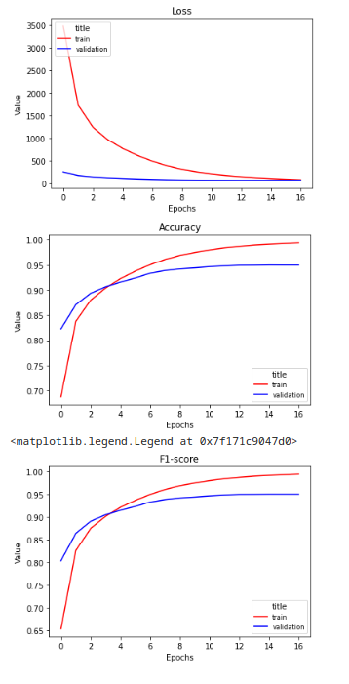

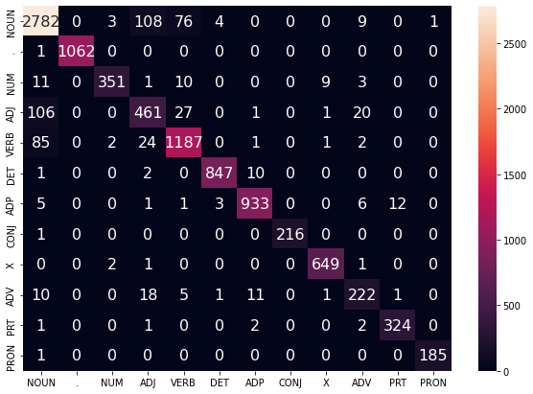

WORD_EMBEDDING_DIM = 1024

CHAR_EMBEDDING_DIM = 64

WORD_HIDDEN_DIM = 1024

CHAR_HIDDEN_DIM = 64

KEEP_DROPOUT = 0.8

100%|██████████| 3131/3131 [01:04<00:00, 48.89it/s]

100%|██████████| 391/391 [00:03<00:00, 112.60it/s]

EPOCH: 0

TRAIN LOSS: 3503.3128631711006

VALIDATION LOSS: 253.7779625058174

TRAIN ACC: 0.6880216277887322

VAL ACC: 0.8225964362639514

TRAIN F-1: 0.6538105786832533

VAL F-1: 0.8035682372400027

100%|██████████| 3131/3131 [01:00<00:00, 52.18it/s]

100%|██████████| 391/391 [00:03<00:00, 111.79it/s]

EPOCH: 1

TRAIN LOSS: 1769.6449929773808

VALIDATION LOSS: 176.45037057250738

TRAIN ACC: 0.8335999603159839

VAL ACC: 0.8701781868024281

TRAIN F-1: 0.8210023908515046

VAL F-1: 0.8631475891113091

100%|██████████| 3131/3131 [00:57<00:00, 54.00it/s]

100%|██████████| 391/391 [00:03<00:00, 113.66it/s]

EPOCH: 2

TRAIN LOSS: 1289.2830499075353

VALIDATION LOSS: 143.83082637563348

TRAIN ACC: 0.8750449545494003

VAL ACC: 0.8914235363226943

TRAIN F-1: 0.8693488369741217

VAL F-1: 0.8878421892800104

100%|██████████| 3131/3131 [00:58<00:00, 53.27it/s]

100%|██████████| 391/391 [00:03<00:00, 110.82it/s]

EPOCH: 3

TRAIN LOSS: 1017.6227197935805

VALIDATION LOSS: 124.94318620488048

TRAIN ACC: 0.8990909880079864

VAL ACC: 0.9057176424515371

TRAIN F-1: 0.895804422924853

VAL F-1: 0.9037116338085355

100%|██████████| 3131/3131 [00:58<00:00, 53.81it/s]

100%|██████████| 391/391 [00:03<00:00, 111.92it/s]

EPOCH: 4

TRAIN LOSS: 826.2207756871358

VALIDATION LOSS: 111.66723851673305

TRAIN ACC: 0.9163039299577117

VAL ACC: 0.9169766986489133

TRAIN F-1: 0.9141536601064996

VAL F-1: 0.9156818036705137

100%|██████████| 3131/3131 [00:58<00:00, 53.17it/s]

100%|██████████| 391/391 [00:03<00:00, 110.72it/s]

EPOCH: 5

TRAIN LOSS: 672.8212503409013

VALIDATION LOSS: 99.50871111731976

TRAIN ACC: 0.9316814861664

VAL ACC: 0.9265713726258077

TRAIN F-1: 0.9301691841297705

VAL F-1: 0.9254791799383477

100%|██████████| 3131/3131 [00:58<00:00, 53.57it/s]

100%|██████████| 391/391 [00:03<00:00, 110.97it/s]

EPOCH: 6

TRAIN LOSS: 548.7806169921532

VALIDATION LOSS: 90.39285344164819

TRAIN ACC: 0.94456639011868

VAL ACC: 0.9318582337967496

TRAIN F-1: 0.943549590472014

VAL F-1: 0.9311053981848099

100%|██████████| 3131/3131 [00:57<00:00, 54.10it/s]

100%|██████████| 391/391 [00:03<00:00, 111.21it/s]

EPOCH: 7

TRAIN LOSS: 448.38844131166115

VALIDATION LOSS: 83.10444159340113

TRAIN ACC: 0.9548470305194886

VAL ACC: 0.9378304288231839

TRAIN F-1: 0.9541022889925515

VAL F-1: 0.9372908490050171

100%|██████████| 3131/3131 [00:58<00:00, 53.37it/s]

100%|██████████| 391/391 [00:03<00:00, 109.57it/s]

EPOCH: 8

TRAIN LOSS: 366.98994404869154

VALIDATION LOSS: 78.2388007491827

TRAIN ACC: 0.9637387303595124

VAL ACC: 0.9422361464656354

TRAIN F-1: 0.9632440543674663

VAL F-1: 0.9418284245729869

100%|██████████| 3131/3131 [00:57<00:00, 54.10it/s]

100%|██████████| 391/391 [00:03<00:00, 111.87it/s]

EPOCH: 9

TRAIN LOSS: 302.77886667475104

VALIDATION LOSS: 74.21468229684979

TRAIN ACC: 0.9702245867281769

VAL ACC: 0.9448795770511064

TRAIN F-1: 0.9698649126458423

VAL F-1: 0.9444611647545713

100%|██████████| 3131/3131 [00:58<00:00, 53.57it/s]

100%|██████████| 391/391 [00:03<00:00, 110.68it/s]

EPOCH: 10

TRAIN LOSS: 251.91651264549

VALIDATION LOSS: 71.91746362950653

TRAIN ACC: 0.976040775326463

VAL ACC: 0.945369101233601

TRAIN F-1: 0.9757929281576692

VAL F-1: 0.9450067923329365

100%|██████████| 3131/3131 [00:58<00:00, 53.93it/s]

100%|██████████| 391/391 [00:03<00:00, 109.65it/s]

EPOCH: 11

TRAIN LOSS: 210.4200809833128

VALIDATION LOSS: 69.85840740264393

TRAIN ACC: 0.9803564120689013

VAL ACC: 0.9467397689445859

TRAIN F-1: 0.9801810757839746

VAL F-1: 0.9464001998216036

100%|██████████| 3131/3131 [00:58<00:00, 53.49it/s]

100%|██████████| 391/391 [00:03<00:00, 110.33it/s]

EPOCH: 12

TRAIN LOSS: 177.7658348279656

VALIDATION LOSS: 68.63506413286086

TRAIN ACC: 0.9838659672358843

VAL ACC: 0.9482083414920697

TRAIN F-1: 0.9837403790061038

VAL F-1: 0.9478424310338183

100%|██████████| 3131/3131 [00:58<00:00, 53.90it/s]

100%|██████████| 391/391 [00:03<00:00, 109.80it/s]

EPOCH: 13

TRAIN LOSS: 151.38321580350748

VALIDATION LOSS: 67.45416539732832

TRAIN ACC: 0.9867306571425029

VAL ACC: 0.9505580575680439

TRAIN F-1: 0.9866538413960868

VAL F-1: 0.950157548693594

100%|██████████| 3131/3131 [00:58<00:00, 53.83it/s]

100%|██████████| 391/391 [00:03<00:00, 113.28it/s]

EPOCH: 14

TRAIN LOSS: 130.07680294386228

VALIDATION LOSS: 67.12223408895079

TRAIN ACC: 0.9890744943388271

VAL ACC: 0.9511454865870373

TRAIN F-1: 0.9890234922812519

VAL F-1: 0.9507804618551439

17%|█▋ | 526/3131 [00:09<00:49, 52.77it/s]

100%|██████████| 392/392 [00:03<00:00, 115.37it/s]VALIDATION LOSS: 71.83873210323509

VAL F-1: 0.9421512751909066

VAL ACC: 0.9423918575063613

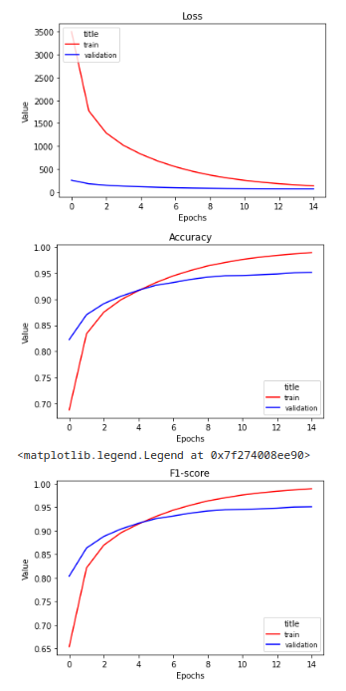

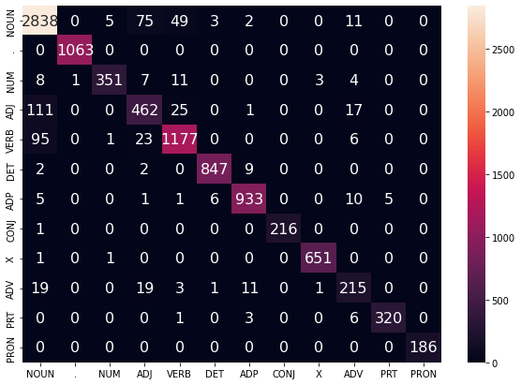

WORD_EMBEDDING_DIM = 300

CHAR_EMBEDDING_DIM = 60

WORD_HIDDEN_DIM = 256

CHAR_HIDDEN_DIM = 128

KEEP_DROPOUT = 0.8

word_num_layers = 3

char_num_layers = 2

100%|██████████| 3131/3131 [00:53<00:00, 58.88it/s]

100%|██████████| 391/391 [00:03<00:00, 130.33it/s]

EPOCH: 0

TRAIN LOSS: 6856.54838180542

VALIDATION LOSS: 845.6846313476562

TRAIN ACC: 0.2842739685256148

VAL ACC: 0.28480516937536715

TRAIN F-1: 0.1262873529849158

VAL F-1: 0.12626659113204955

100%|██████████| 3131/3131 [00:52<00:00, 59.85it/s]

100%|██████████| 391/391 [00:02<00:00, 131.50it/s]

EPOCH: 1

TRAIN LOSS: 6133.110561788082

VALIDATION LOSS: 596.7077255249023

TRAIN ACC: 0.35861949229262

VAL ACC: 0.49853142745251616

TRAIN F-1: 0.24677680618910142

VAL F-1: 0.3918012661412383

100%|██████████| 3131/3131 [00:53<00:00, 59.04it/s]

100%|██████████| 391/391 [00:02<00:00, 130.99it/s]

EPOCH: 2

TRAIN LOSS: 3325.4085473567247

VALIDATION LOSS: 272.89513382315636

TRAIN ACC: 0.6721728238897776

VAL ACC: 0.7981202271392207

TRAIN F-1: 0.6265751402277334

VAL F-1: 0.7841681325885531

100%|██████████| 3131/3131 [00:52<00:00, 59.96it/s]

100%|██████████| 391/391 [00:02<00:00, 131.10it/s]

EPOCH: 3

TRAIN LOSS: 1659.5219690725207

VALIDATION LOSS: 158.62868279591203

TRAIN ACC: 0.8435953718516314

VAL ACC: 0.8716467593499119

TRAIN F-1: 0.8307428942226499

VAL F-1: 0.8738605799108665

100%|██████████| 3131/3131 [00:52<00:00, 59.37it/s]

100%|██████████| 391/391 [00:02<00:00, 132.39it/s]

EPOCH: 4

TRAIN LOSS: 896.9807396735996

VALIDATION LOSS: 93.80765534378588

TRAIN ACC: 0.9120999045103364

VAL ACC: 0.923732132367339

TRAIN F-1: 0.9090418912677559

VAL F-1: 0.9233450088559626

100%|██████████| 3131/3131 [00:52<00:00, 60.00it/s]

100%|██████████| 391/391 [00:02<00:00, 131.46it/s]

EPOCH: 5

TRAIN LOSS: 563.7919874410145

VALIDATION LOSS: 77.31428350973874

TRAIN ACC: 0.9436362959931545

VAL ACC: 0.9378304288231839

TRAIN F-1: 0.9424919104363043

VAL F-1: 0.9376155494312138

100%|██████████| 3131/3131 [00:52<00:00, 59.27it/s]

100%|██████████| 391/391 [00:02<00:00, 133.83it/s]

EPOCH: 6

TRAIN LOSS: 383.61526103597134

VALIDATION LOSS: 73.9684229909908

TRAIN ACC: 0.96122127559309

VAL ACC: 0.9451732915606031

TRAIN F-1: 0.9607068881099219

VAL F-1: 0.9452325263680896

100%|██████████| 3131/3131 [00:52<00:00, 59.94it/s]

100%|██████████| 391/391 [00:02<00:00, 133.01it/s]

EPOCH: 7

TRAIN LOSS: 274.99015979259275

VALIDATION LOSS: 72.8918134199921

TRAIN ACC: 0.9725932264345152

VAL ACC: 0.9467397689445859

TRAIN F-1: 0.9723278629420716

VAL F-1: 0.9466846923651541

100%|██████████| 3131/3131 [00:52<00:00, 59.94it/s]

100%|██████████| 391/391 [00:02<00:00, 131.59it/s]

EPOCH: 8

TRAIN LOSS: 209.33137696265476

VALIDATION LOSS: 74.94456480373628

TRAIN ACC: 0.9799595719086771

VAL ACC: 0.9469355786175837

TRAIN F-1: 0.9798233459988215

VAL F-1: 0.9469775566201837

100%|██████████| 3131/3131 [00:52<00:00, 59.13it/s]

100%|██████████| 391/391 [00:02<00:00, 131.77it/s]

EPOCH: 9

TRAIN LOSS: 158.16824463641387

VALIDATION LOSS: 72.95893061620882

TRAIN ACC: 0.9845356350062626

VAL ACC: 0.9504601527315449

TRAIN F-1: 0.9844715168037255

VAL F-1: 0.949726843927544

100%|██████████| 3131/3131 [00:52<00:00, 60.00it/s]

100%|██████████| 391/391 [00:03<00:00, 123.65it/s]

EPOCH: 10

TRAIN LOSS: 122.8149655804009

VALIDATION LOSS: 73.69397556420881

TRAIN ACC: 0.9884544315884768

VAL ACC: 0.950362247895046

TRAIN F-1: 0.9884135004451005

VAL F-1: 0.9500917191435498

100%|██████████| 3131/3131 [00:52<00:00, 59.51it/s]

100%|██████████| 391/391 [00:03<00:00, 117.65it/s]

EPOCH: 11

TRAIN LOSS: 103.7278266143403

VALIDATION LOSS: 77.2267856405233

TRAIN ACC: 0.9903394223495418

VAL ACC: 0.9511454865870373

TRAIN F-1: 0.9903203181117838

VAL F-1: 0.9509229557855148

100%|██████████| 3131/3131 [00:52<00:00, 60.13it/s]

100%|██████████| 391/391 [00:03<00:00, 120.07it/s]

EPOCH: 12

TRAIN LOSS: 80.63063401512045

VALIDATION LOSS: 81.01594575258787

TRAIN ACC: 0.9928320746059501

VAL ACC: 0.9510475817505385

TRAIN F-1: 0.992822064019618

VAL F-1: 0.950712381221488

100%|██████████| 3131/3131 [00:52<00:00, 59.70it/s]

100%|██████████| 391/391 [00:03<00:00, 126.26it/s]

EPOCH: 13

TRAIN LOSS: 68.38775169226574

VALIDATION LOSS: 85.03749069868354

TRAIN ACC: 0.9939729900665948

VAL ACC: 0.9473271979635794

TRAIN F-1: 0.9939683828875412

VAL F-1: 0.9472895234515835

100%|██████████| 3131/3131 [00:52<00:00, 59.83it/s]

100%|██████████| 391/391 [00:02<00:00, 131.30it/s]

EPOCH: 14

TRAIN LOSS: 57.45424906556218

VALIDATION LOSS: 85.2654529245192

TRAIN ACC: 0.9950767017622183

VAL ACC: 0.9486978656745644

TRAIN F-1: 0.9950736779390064

VAL F-1: 0.9485047637258663

100%|██████████| 3131/3131 [00:52<00:00, 59.84it/s]

100%|██████████| 391/391 [00:03<00:00, 129.01it/s]

EPOCH: 15

TRAIN LOSS: 52.05192964236994

VALIDATION LOSS: 93.77361488525639

TRAIN ACC: 0.9953867331373935

VAL ACC: 0.9468376737810847

TRAIN F-1: 0.9953835766466036

VAL F-1: 0.9473371228796265

100%|██████████| 3131/3131 [00:52<00:00, 59.22it/s]

100%|██████████| 391/391 [00:02<00:00, 132.77it/s]

EPOCH: 16

TRAIN LOSS: 54.12603538771509

VALIDATION LOSS: 87.11249638587469

TRAIN ACC: 0.9952875230973375

VAL ACC: 0.9501664382220482

TRAIN F-1: 0.9952850718320735

VAL F-1: 0.9502390878198713

100%|██████████| 3131/3131 [00:52<00:00, 59.66it/s]

100%|██████████| 391/391 [00:02<00:00, 130.79it/s]

EPOCH: 17

TRAIN LOSS: 40.56310369183484

VALIDATION LOSS: 91.12280298378755

TRAIN ACC: 0.9967508711881642

VAL ACC: 0.951635010769532

TRAIN F-1: 0.9967485540356882

VAL F-1: 0.9512944345312012

100%|██████████| 3131/3131 [00:53<00:00, 58.92it/s]

100%|██████████| 391/391 [00:03<00:00, 129.67it/s]

EPOCH: 18

TRAIN LOSS: 31.343679405516014

VALIDATION LOSS: 89.57943174751563

TRAIN ACC: 0.9975321502536056

VAL ACC: 0.9500685333855492

TRAIN F-1: 0.9975308750052965

VAL F-1: 0.9497279484019564

100%|██████████| 3131/3131 [00:52<00:00, 59.85it/s]

100%|██████████| 391/391 [00:02<00:00, 131.75it/s]

EPOCH: 19

TRAIN LOSS: 30.223368514009053

VALIDATION LOSS: 99.57493118879938

TRAIN ACC: 0.9978545828837878

VAL ACC: 0.9469355786175837

TRAIN F-1: 0.9978536119957022

VAL F-1: 0.9475506199089719

100%|██████████| 3131/3131 [00:52<00:00, 59.18it/s]

100%|██████████| 391/391 [00:02<00:00, 132.16it/s]

EPOCH: 20

TRAIN LOSS: 21.366461741425155

VALIDATION LOSS: 97.63064319632394

TRAIN ACC: 0.9984250406141102

VAL ACC: 0.9471313882905815

TRAIN F-1: 0.9984244997657977

VAL F-1: 0.947582970547735

100%|██████████| 3131/3131 [00:52<00:00, 59.58it/s]

100%|██████████| 391/391 [00:02<00:00, 130.80it/s]

EPOCH: 21

TRAIN LOSS: 19.783810344235462

VALIDATION LOSS: 95.18728146800277

TRAIN ACC: 0.9985366519091732

VAL ACC: 0.9500685333855492

TRAIN F-1: 0.9985363577368884

VAL F-1: 0.9497584260231354

100%|██████████| 3131/3131 [00:52<00:00, 59.13it/s]

100%|██████████| 391/391 [00:02<00:00, 132.02it/s]

EPOCH: 22

TRAIN LOSS: 14.91971597754673

VALIDATION LOSS: 101.90495626624033

TRAIN ACC: 0.9988714857943624

VAL ACC: 0.9466418641080869

TRAIN F-1: 0.9988711304849457

VAL F-1: 0.946913692372832

100%|██████████| 3131/3131 [00:52<00:00, 59.53it/s]

100%|██████████| 391/391 [00:02<00:00, 133.13it/s]

EPOCH: 23

TRAIN LOSS: 12.96726355130977

VALIDATION LOSS: 100.56266410871467

TRAIN ACC: 0.9991195108945026

VAL ACC: 0.9466418641080869

TRAIN F-1: 0.9991192469357009

VAL F-1: 0.9468952998136649

100%|██████████| 3131/3131 [00:52<00:00, 60.00it/s]

100%|██████████| 391/391 [00:03<00:00, 130.27it/s]

EPOCH: 24

TRAIN LOSS: 10.509163247386823

VALIDATION LOSS: 101.48838748672642

TRAIN ACC: 0.9993799372496497

VAL ACC: 0.9487957705110632

TRAIN F-1: 0.9993798691513683

VAL F-1: 0.9485888538044638

00%|██████████| 392/392 [00:02<00:00, 135.62it/s]VALIDATION LOSS: 119.33619459728652

VAL F-1: 0.941650864374256

VAL ACC: 0.9415776081424937

