**Quantifying the Hierarchical Scales of Scientists’ Mobility**

Yurui Huang1✝, Langtian Ma1✝, Chaolin Tian1, Xunyi Jiang1, Roberta Sinatra2,3,4, Yifang Ma1*

1Department of Statistics and Data Science, Southern University of Science and Technology, Shenzhen 518055, Guangdong, China

2Copenhagen Center for Social Data Science (SODAS), University of Copenhagen, Denmark

3Networks, Data, and Society (NERDS) group, IT University of Copenhagen, Denmark

4ISI Foundation, Turin, Italy

*Email: [mayf@sustech.edu.cn](mailto:mayf@sustech.edu.cn)

✝These authors contributed equally to this work.

**Abstract**

Hierarchical geographical scales play a crucial role in shaping researchers’ mobility patterns, which in turn, influence various dimensions of the scientific community, including career development, knowledge exchange, collaboration networks, and policy formation. Despite growing acknowledgment of their significance, the relationship between hierarchical regional scales and scientists’ mobility remains insufficiently explored. In this study, we examine how different geographical scales—cities, countries, and continents—affect scientists’ mobility by analyzing the career trajectories of 3.03 million researchers over the period 1960 to 2024. We built a model that incorporates administrative-level hierarchical regions and examined the coefficients representing region attractiveness and mobility tendencies. Our findings reveal the crucial role of "attractiveness," encompassing elements such as regional prestige, living condition, education level and transportation convenience. Behind that, we observe a consistent trend among scientists to increasingly avoid developed regions such as North America and Europe as destinations for mobility. In contrast, Asia is becoming an increasingly attractive choice for scientists during this period. Another key determinant, "transition probability," is based on "level distance" and integrates cultural, linguistic, and economic factors varying across countries. These coefficients not only shape relocation decisions but also provide quantitative insights into the efficiency of global information exchange. Moreover, our analysis reveals that transition probability aligns with geographical considerations: shorter distances within the same country tend to facilitate mobility, while longer distances between cities, countries, or continents tend to discourage it. This study sheds light on the complex dynamics of scientists’ mobility and offers insights into how geographical scale and administrative divisions influence career trajectories, enhancing our understanding of the global brain circulation landscape.

**Keywords**: Scientists’ Mobility; Hierarchical Scales; Region Attractiveness; Science of Science; Computational Social Science

## Introduction

The mobility of scientists is pivotal to advancing scientific communication, knowledge diffusion, and the development of science and technology across cities, countries, and continents [1, 2]. A thorough understanding of researchers’ mobility patterns is crucial for multiple reasons: informing scientific career development [3-8], facilitating geographical knowledge propagation [9-11], and fostering both international and domestic collaborations [12, 13]. Historically, geographical factors have shaped scientific mobility, resulting in hierarchical mobility patterns among cities, countries, and continents [14, 15]. Economic disparities, cultural differences, and varied policies across nations can further bias the movements of scientists, exacerbated by issues such as visa restrictions, language barriers, and cultural differences [9].

Scientists’ movement tendencies are often constrained by geographical boundaries. Intuitively, given the same geographical distance, the likelihood of domestic movements is higher than that of cross-border movements. Consequently, comprehensive understanding of scientific mobility at various scales, and the effects of geographical hierarchical scales on such mobility, are imperative. Insights drawn from this understanding have substantial implications for career trajectories, the circulation of knowledge across regions, and evidence-based policy development.

Extensive studies have demonstrated that scientists’ mobility is shaped by various factors. Greater geographical distance typically reduces mobility between regions, with regional characteristics like language, culture, and economics also playing significant roles [16, 17]. Gargiulo and Carletti, for instance, have used data from the American Physical Society to analyze researcher trajectories with network theory and complex system analysis, discovering that institutions with linguistic similarities between countries tend to exchange researchers more frequently than those without such similarities [18]. Vaccario et al. highlighted the importance of institutional path dependence in scientific careers and its implications for mobility programs through the exploration of temporal correlations in mobility patterns [19].

In addition to these factors, research has examined the relationship between career mobility and academic performance. Deville et al. tracked the affiliation information of individual scientists and found that career moves between institutions are highly stratified. Transitions from elite to lower-ranked institutions are associated with modest declines in scientific performance, while moves to elite institutions do not lead to significant performance gains[20]. Petersen found that mobile researchers experience up to a 17% increase in citations compared to their non-mobile counterparts, driven by greater diversity in co-authors, research topics, and geographical coordination. However, 11% of cross-border mobility events result in the severing of prior collaborations with the source country[6]. Liu and Hu, in an observational study of 62,330 Chinese computer scientists, identified a positive effect of mobility on both research productivity and collaboration opportunities[21]. These studies emphasize the importance of mobility, not only as a factor influencing institutional and regional exchange, but also as a key determinant of individual academic success.

Several modeling frameworks for general human mobility prove valuable in interpreting scientists’ mobility. Gravity model, for instance, offer a simplified representation of complex mobility patterns by highlighting the role of geographical distance as a primary barrier [22-24]. Radiation model captures the density of populations in each location along the path from the departure location to the destination [25], and the container model infers nested geographical scales in the mobility network [14]. Agent-based models delve into nuanced decision-making processes and emerging behaviors [26, 27], while natural language processing (NLP) techniques, such as word embeddings of mobility networks and lower-dimensional vector representations, enrich our understanding of high-dimensional mobility data [28-30]. Collectively, these models lay the groundwork for developing sophisticated models of scientist mobility [18, 31-34].

Despite these advancements, there remains a gap in analyzing hierarchical regional scales to fully understand scientists’ mobility[35, 36]. As researchers are a part of the broader human workforce, they share certain characteristics with general human mobility patterns[37]. Building on this analogy, we adapt concepts from human mobility studies, adjusting key variables to suit the context of academic mobility[11, 14, 24]. In doing so, we develop the Scientific Mobility and Administrative Regions (SMART) model, which incorporates both geographical and administrative regions to capture the complex, multiscale nature of scientists' mobility over the course of their careers. This model incorporates geographical and administrative regions to capture the intricate, multiscale complexity of scientists’ mobility throughout their careers. We incorporated data from the OpenAlex database, which includes records of publications, authors, citations, and institutions[38, 39], then classified the institutions, cities, countries, and continents involved in scientists’ mobility according to their respective administrative levels, treating them as regions of scientific activities. This allows us to estimate the attractiveness of each region and the mobility propensity between regions, offering critical insights into the evolution of global science systems.

## Results

### Data processing

We used data from the OpenAlex database, covering papers published from 1960 to 2024 (as of July 2024), to analyze scientists' mobility. The dataset includes details on authors, citations, affiliations, and publication dates from 93,004 academic institutions. To ensure accuracy, institutions without valid geographic information were excluded, reducing the dataset to 92,855 institutions [38].

Scientists’ mobility was tracked by identifying changes in a researcher’s institutional affiliation across consecutive publications. The date of move was defined as the publication date of the individual’s first work at the new institution. To calculate tenure at each institution, the interval between a researcher’s first and last publication at that institution was measured. To ensure robustness and focus on significant career transitions, a two-year minimum threshold was imposed, thereby excluding short-term stays. In case of multi-affiliated publications, only the primary affiliation was retained to avoid introducing spurious mobility records. Geographic data (city, country, and continent) were used to map institutional movements, and the distance between institutions was calculated.

Since 2023, Openalex has employed an enhanced author name disambiguation approach using a machine learning model that integrates an author’s name, publication record, citation patterns, and external identifiers such as ORCID (where available). To further improve accuracy in the present study, for all scientists with recorded career mobility, we verified the continuity of their publication history before and after each identified move. This step helped to eliminate cases in which multiple scientists with the same or similar names could be conflated.

Finally, to analyze changes in scientific mobility trends over time, we divided the data into five-year intervals. Through these processes, mobility trajectories were extracted for 3,035,421 scientists.

### Evidence of hierarchical scales in scientists’ mobility

Our exploratory analysis indicates that nested hierarchical scales among regions constrain scientists’ free movement. Under an ideal scenario without geographical constraints, the mobility flux from region *a* to region *b* would be proportional to the volume of out-flux of region *a* and that of in-flux of region *b*, as predicted by the weighted configuration model (WCM) [40, 41]. This model randomizes flux between nodes while preserving each node’s in-degree and out-degree, thus providing a hypothetical scenario where scientists’ willingness to relocate is the sole driver of mobility, without regional or geographical barriers.

We applied this degree-preserving configuration modeling at the city, country, and continent levels. To assess how actual mobility flux compares to the ideal scenario, we compared the real flux from region denoted as

Our analysis revealed that movement across administrative boundaries were less frequent than movement within boundaries. As illustrated in Fig. 1(A–C), the kernel density estimations (KDE) of the ratios between the real flux and the expectation show large differences within and across boundaries at the city (Fig. 1A), country (Fig. 1B), and continent (Fig. 1C) levels. This discrepancy suggests a distinct preference for relocating within the same geographical entity rather than crossing its boundaries, underscoring the impact of spatial scale on scientists’ mobility patterns.

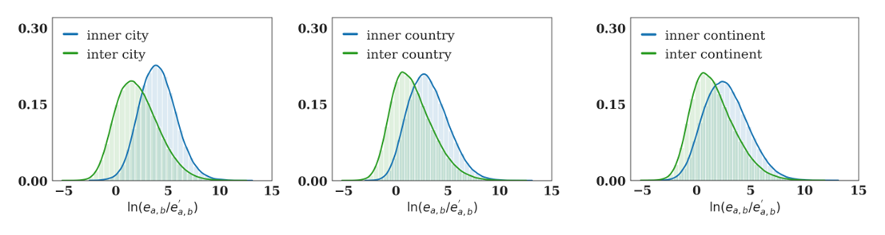

**Figure 1. The scales of scientists’ mobility across hierarchical geographical levels.** The KDE of the ratio, , between real mobility flow and the configuration model expectation, for pairs of institutions within and across cities (A), countries (B), and continents (C).

The pronounced disparities observed motivated us to construct a hierarchical framework for modeling scientists’ mobility, depicted in Fig. 2B. Within the framework, scientists’ movements are globally categorized into nested scales such as cities, countries, and continents. Moves can occur within the same administrative level, such as a transition from Harvard to MIT within Cambridge, or across multiple levels, like moving from George Washington University to the University of London, encompassing city, country, and continent changes. This framework enables us to systematically analyze variation in propensities for intra-level versus inter-level mobility and to quantify the attractiveness of each potential destination region for scientists.

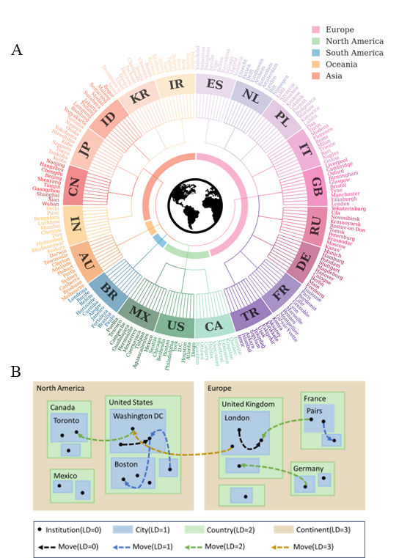

**Figure 2. The scales of scientists’ mobility across hierarchical geographical levels.** **A.** Hierarchical geographical structure of selected cities involved in the global scientific mobility network. The dendrogram presents the hierarchical organization from continents to countries and cities. The histogram for each city indicates the average number of publications per author in the city. **B.** Hierarchical scale framework: Researchers transition between institutions (represented by black dots) within the nested geographical regions. Rectangles with different colors represent regions at different hierarchical levels. Dashed arrows in color illustrate potential transitions across different level distances(For example, blue arrow means scientist conducts inter-city mobility). The transition probability between any two institutions is determined by the level distance of the transition and the attractiveness of the destination region.

**The SMART Model**

In our model, each scientist moves in a hierarchical physical space with four levels: institutions, cities, countries, and continents, ordered from smallest to largest (The data included all scientifically-active cities in the world, and a sample of 200 major cities involved in global scientific activity is illustrated in Figure 2A). Each level is partitioned into geographical regions, with each lower-level region entirely contained within a single higher-level region. For instance, an institution at level 0 is part of a city at level 1. Consequently, the geographical location of institution can be identified as a sequence of nested regions , where each region is included in , and indicates the level.

The level distance, between two institutions and is defined as the highest index (start from 0) at which and differ. For example, let be Beijing Normal University, and be Tokyo University, then:

,

and

.

Since both tuples differ in the third elements, the level distance .

Based on this setting, the model was characterized by the following parameters [14]:

1. The attractiveness of the nested regions , denoted as . Attractiveness represents the probability of visiting region among all regions nested within . It is required that .
2. The transition probability of traveling at level distance starting from country is , where is the country (third element) of .

According to our model, the probability of a scientist moving from institution to institution can be written as:



Here, denotes the transition probability of traveling at level distance given the country of being , that is, the country in which institution is located, and represents the attractiveness of the region .

Using maximum likelihood estimation, we fitted this model and obtained the attractiveness and transition probabilities as defined by Equation (1). This estimation was performed for each of the 5-year periods from 1960 to 2024 (see details in the Methods section).

### Dynamics of region attractiveness

The SMART model allows for the estimation of regional attractiveness as scientists select locations for settlement and work. Attractiveness, as defined in the SMART model, reflects a region’s capacity to attract researchers over each five-year period. This coefficient is influenced by various factors, including the quality of the scientific environment, the prestige of scientific entrepreneurship, and the availability of funding and policy incentives designed to attract researchers. Figure 3 illustrates the temporal trends in attractiveness across continents, leading countries, and major cities.

Since 1960, the attractiveness of North America has been steadily declining, although it remained relatively stable during the three five-year periods from 1970 to 1989 (See Fig.3 A). In contrast, Europe experienced a slow but continuous increase in attractiveness from 1960 to 2000, followed by a sudden decline in attractiveness during the periods from 2015–2019 to 2020–2024. Asia’s attractiveness, on the other hand, has been consistently rising from 1960 to 2024, with a sharp increase during the period from 2020 to 2024. The attractiveness of continental regions globally is influenced by various factors, particularly when rapidly developing countries within a continent contribute to an overall increase in regional attractiveness.

Based on our observations, the overall attractiveness of Asia is largely driven by the rapid economic development of emerging developing countries like China and India after 1960. In Asia, Japan’s attractiveness began to decline steadily from 1979, with a more pronounced decrease after 2000. During this period, China’s attractiveness experienced two significant surges. Between 1985 and 2014, the gap in attractiveness widened, and the increase was particularly noticeable between the periods of 2015–2019 and 2020–2024. India, on the other hand, saw a decline in attractiveness for about 30 years, but this trend reversed after 2000, when its attractiveness began to rise. The economic growth and strengthening of these countries have significantly enhanced their appeal to foreign scientists, particularly due to their large populations, government policies encouraging scholars to study abroad and return to contribute to local economic and scientific development. This has led to a cross-continental flow of scientists from developed Western regions to relatively less-developed areas. Japan's declining attractiveness to scientists can be attributed to factors such as an aging population, stagnant research funding, limited international collaboration, rigid academic structures.

In Europe, the two countries with the highest attractiveness, the United Kingdom and Germany, have both seen a gradual decline in attractiveness since 1960. This decline has been distributed across other European countries, leading to smaller differences in attractiveness among European nations in recent years. The decrease in attractiveness for the UK and Germany can be attributed to a range of factors, such as economic shifts, changes in research funding, or political developments, which have led to a redistribution of research opportunities across other European countries. This has resulted in a more balanced scientific environment across Europe today. In contrast, North America has seen the United States consistently maintain its dominant position in terms of attractiveness, holding an absolute advantage over other countries in the region. This might be the consequence of its continued investment in research and development, robust scientific infrastructure, and policies that attract top talent from around the world.

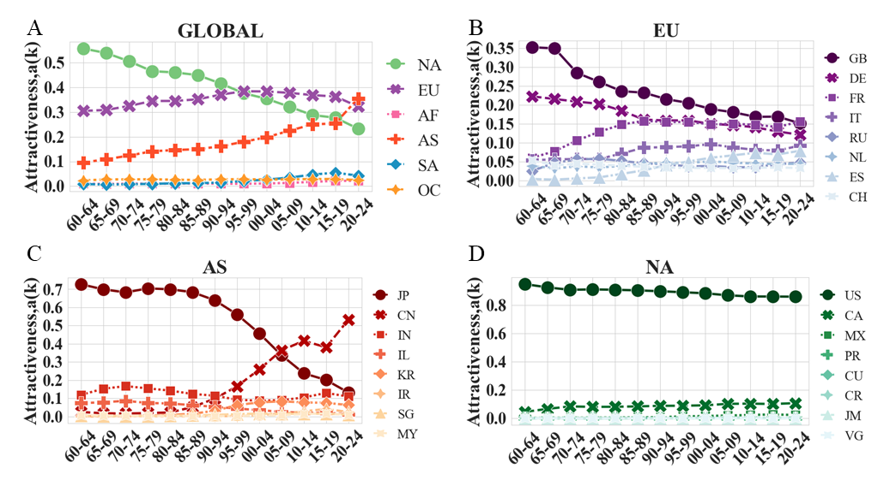

**Figure 3. The attractiveness of regions at different administrative levels. A.** Attractiveness at continent level calculated every 5 years from 1960 to 2024. Different colors, markers shape, and line types identify different continents, including South America (SA), Europe (EU), Oceania (OC), Africa (AF), Asia (AS), and North America (NA). **B–D.** Attractiveness of different countries (selected the top 8 based on their attractiveness) in EU (B), AS (C), and NA (D).

What characteristics enhance the appeal of regions at different levels of mobility? While scientists' mobility decisions are influenced by a variety of factors related to both personal and professional development, this analysis focuses on the measurable attributes of regions that can be quantified using available data. Specifically, we examine several key indicators representing the local and national levels of geographical regions. For example, AirlineFreq is used to measure the volume of domestic and international airline passengers in a country, while the Human Development Index (HDI) is employed to reflect the general living conditions within a country. Other indicators include average life expectancy, GDP (both national and per capita), the share of GDP allocated to research spending, average publications per capita, and the number of researchers in R&D.

Our analysis reveals several significant relationships. Economic indicators, such as GDP and GDP per capita, exhibit strong positive correlations, suggesting that the size of the economy is closely linked to regional attractiveness. Research-related factors, including the number of researchers (log-transformed), intellectual output(Avepaper), and research spending share of GDP, also show significant associations, highlighting the importance of investment in research and the availability of human capital in enhancing a region's appeal. Furthermore, human development indicators play a crucial role in enhancing the attractiveness of regions. Similarly, Human Development Index (HDI), life expectancy (LifeExp) and educational indicators (AverageLearning) are significant, underscoring the relevance of human well-being and education in attracting scientific talent. In addition, transportation accessibility, measured by AirlineFreq, is positively associated with mobility, emphasizing the role of infrastructure in facilitating scientific labor mobility.

Incorporating these factors into our analysis allows us to better understand the dynamics that drive scientists’ decisions to relocate across geographical regions. Notably, we observe that regions with high levels of economic development, human capital, research investment, and infrastructure tend to be more attractive to scientists. This suggests that policies aimed at enhancing these aspects—such as increasing research funding, improving education, and expanding transportation networks—could potentially strengthen a region's position as a global hub for scientific activity. Our findings also suggest that the interplay between these factors varies across different geographical scales, highlighting the need for region-specific strategies to attract and retain scientific talent.

**Table 1.** Separate Regression Analysis on the attractiveness of Socioeconomic and Developmental Indicators: HDI, R&D, GDP, Education, transportation and Health (Details on variables see Method).

|  |  |  |  |
| --- | --- | --- | --- |
| **Measurement** | **Coef** |  |  |
| AirlineFreq(log10) | 0.0468*** | 0.000 | 0.179 |
| ResearchersRD(log10) | 0.0284* | 0.023 | 0.040 |
| GDPpc(log10) | 0.0418* | 0.015 | 0.028 |
| GDP(log10) | 0.0477*** | 0.000 | 0.177 |
| ResearchShare | 0.0452*** | 0.000 | 0.100 |
| Avepaper | 0.0311*** | 0.000 | 0.065 |
| hdi | 0.1467** | 0.005 | 0.037 |
| AverageLearning | 0.0086* | 0.016 | 0.030 |
| LifeExp | 0.0020* | 0.029 | 0.018 |
| *p<0.05, **p<0.01, ***p<0.001 | | | |

**Mobility propensity across different scales**

The graph illustrates the average transition probability of the SMART model across four geographical level distances (LD = 0, 1, 2, 3) for countries worldwide, covering the period from 1960–1964 to 2020–2024. Since this variable is normalized for each country at the four level distances, some countries may exhibit fewer than four level distances. This occurs when the number of scientists from these countries is small, and limited representation is due to a preference for domestic employment. As a result, the curves in the graph consistently show an upward trend across all levels. This trend suggests a steady increase in researcher mobility over time, reflecting the growing demand for global research collaboration.

Additionally, the curve for LD = 0 increases more rapidly than the others, indicating that scientists are increasingly likely to move between institutions in a city during this period. The curve for LD = 3 remains relatively stable, with fluctuations observed during 1990–1994 and 2020–2024. This suggests that intercontinental mobility is less influenced by global economic developments and scientific mobility trends. Specifically, the most recent period (2020–2024) reveals a ranking of mobility frequency, from most to least, as follows: intercontinental, inter-country, inter-institution, and inter-city.

As academic research becomes more complex and interdisciplinary, researchers are increasingly moving to access diverse scientific environments, advanced research facilities, and opportunities for collaboration with experts from different regions. This mobility not only facilitates the exchange of ideas but also strengthens the global research ecosystem by enabling the sharing of resources and expertise across institutions, cities, and countries.

The increasing mobility is particularly notable in the context of the growing globalization of research. Researchers are no longer limited to local or national networks but are increasingly involved in global initiatives aimed at addressing complex scientific challenges, such as climate change, public health, and technological innovation. This rise in mobility reflects a broader trend in academia, where traditional boundaries between local, national, and international research environments are becoming more fluid and interconnected.

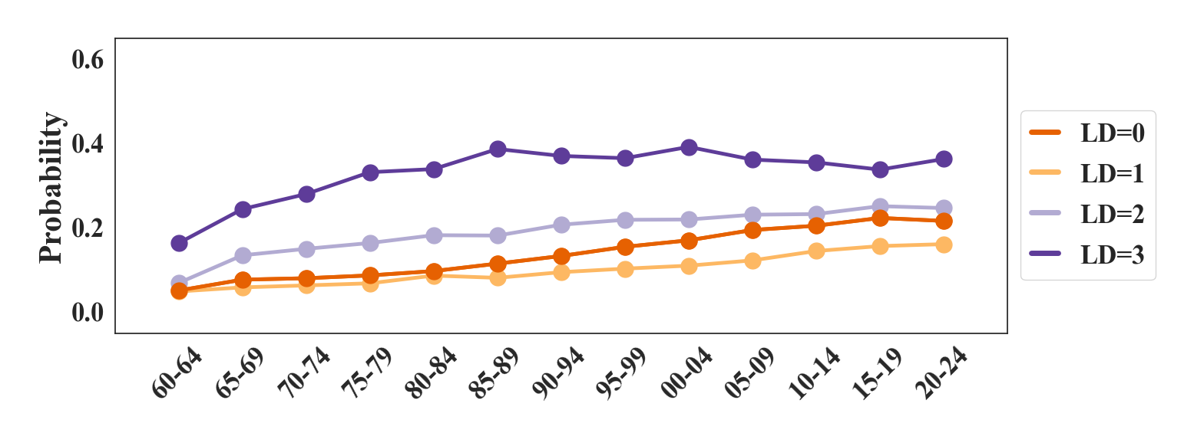

**Figure 4. The transition probability of mobility across different level distances.** Average transition probability of different cohorts categorized by different level distances.

To better understand these trends, we analyze the mobility patterns within the 13th cohort, visualizing the transition probabilities for LD = 1, LD = 2, and LD = 3 (where the transition probability for LD = 0 is the complement of the sum of the other three). The analysis includes all countries in the SMART model, with a focus on China, Brazil, England, Russia, and the United States, chosen for their distinctive transition probability characteristics and relatively large number of scientists.

The results reveal distinct mobility patterns across these countries. In China, the high LD = 1 value reflects significant inter-city mobility, while the lower LD = 2 and LD = 3 values indicate less frequent international and intercontinental movement. In Brazil, the moderately high LD = 1 is accompanied by a very low LD = 2 and a relatively higher LD = 3 compared to China. The United States shows a similar LD = 1 value to Brazil, but with a lower LD = 2 and the highest LD = 3 among the three countries. European countries, particularly Russia, are concentrated in the upper-left corner of the transition probability ternary plot, suggesting that scientists in these countries are less likely to engage in intercontinental mobility. However, the UK stands out with a 50% likelihood of intercontinental mobility, while European countries generally exhibit more intensive cross-border mobility (LD = 2).

These patterns are shaped by national policies and global trends. In China, urbanization and the concentration of research institutions in major cities drive high inter-city mobility, while geographic and institutional barriers limit international movement. In Brazil, moderate intra-city mobility corresponds to the distribution of research institutions, while higher international mobility is facilitated by increased participation in global research initiatives. In the U.S., the moderate inter-city mobility is supported by world-class institutions, while high intercontinental mobility reflects its role as a global research hub, backed by policies promoting international collaboration. In Africa, higher inter-city mobility is largely due to infrastructural challenges that impede international and intercontinental movement. Limited transportation networks and fewer international collaborations restrict mobility, yet researchers often relocate to urban centers with better resources and research opportunities.

**Figure 5. Comparative Analysis of Mobility Probabilities among Different Regions in a Ternary Plot.** This ternary plot illustrates the probabilities of mobility (P(LD = 1), P(LD = 2), and P(LD = 3), P(LD=0) = 1- P(LD = 1)- P(LD = 2)- P(LD = 3)) for six continents. The results of Brazil (BR), China (CN), Russia (RU), the United Kingdom (GB), and the United States (US) are highlighted.

### Level distance implies geographical distance

In human mobility, the proximity between origin and destination locations, or geographical distance, often plays a crucial role in influencing scientists’ decisions to migrate [42, 43]. In our model, the level distance, and the correlated transition probability which measures the likelihood of scientists relocating to different locations based on their home countries, incorporate this geographical proximity and additional influencing factors such as cultural differences, salary disparities, travel expenses, and political factors—elements often closely tied to distance.

Our analysis demonstrates that mobility distances at different hierarchical levels correlate with the magnitude of these levels, as illustrated in Fig. 6. This correlation indicates that our model effectively captures geographical distance information within its parameters. Further, we analyzed the transition probabilities of different levels occurring within countries from 2020 to 2024, as the function of the average geographical mobility distances at these levels. Notably, Fig. 6B indicates that except for level distances 1, the geographical mobility distance and the transition probabilities exhibit a negative correlation, which suggests that scientists tend to move to locations with shorter geographical distances when conducting movements between institutions in the same city or between institutions in different countries but on the same continent, or between institutions in different continent. This pattern is likely because scientists tend to seek new positions within familiar or previously collaborated institutions within their current cities, thereby increasing their likelihood of employment there. The observed frequent intra - continental movement tend to occur within culturally similar regions, leading to the noted negative correlation between geographical distance and transition probability at level distance 2.

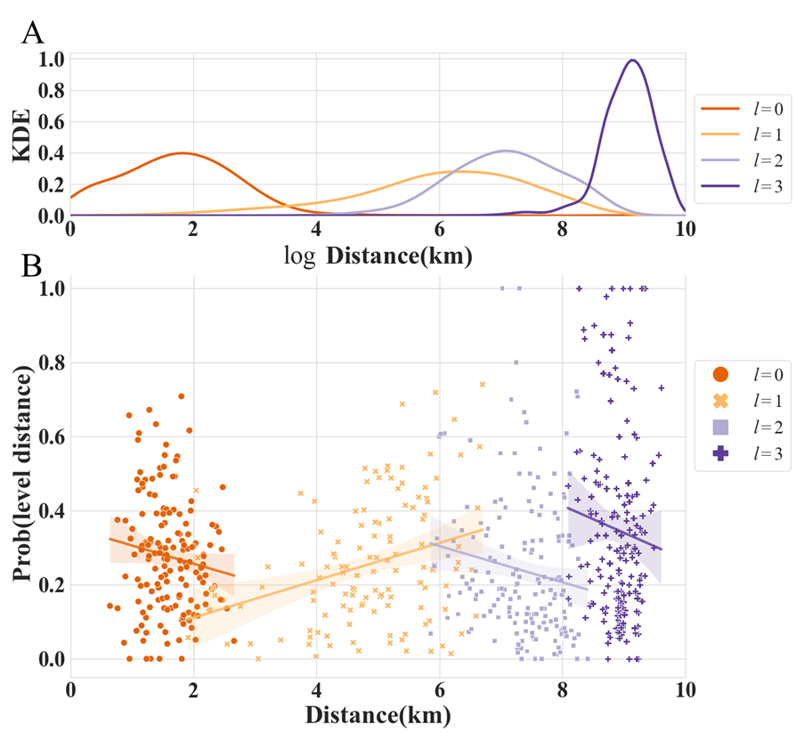

**Figure 6. The distance of scientists’ mobility and its relationship to transition probability at different level distances. A.** The KDE of distance of scientists’ mobility at different levels. **B.** The correlation between geographical distance and transition probability at different level distances given home countries in the 13th cohort. Color indicates mobility at different levels or with different level distance. Lines show the linear regression trends with 95% confidence intervals.

## Discussion

Empirical studies have established the presence of scales in human mobility behavior [14, 44]. Our findings illustrate comparable patterns in scientific mobility, as depicted in Fig. 1(A, B, and C), where scientists’ internal mobility within regions, such as cities, nations, or continents, is greater than their external movements to other regions. Building the SMART model and maximum likelihood estimation, we analyzed the trajectories of 3.03 million scientists from 1960 to 2024, segmented into 5-year intervals. This analysis underscores the importance of administrative units as fundamental entities for studying scientist mobility.

Our model highlights how “attractiveness” of a region and “transition probabilities” at different level distances contribute to understanding mobility dynamics. Attractiveness reveals the relative appeal of a region compared to regions within the same parent region, while defined transition probabilities at different level distances reflect the likelihood of moves relative to a scientist’s home country. Notably, we observed varying correlations between geographical distance and transition probability across different level distances, with negative correlations at levels 0, 1 and 2, an insight not previously documented.

The concept of “transition probability” encompasses various factors influencing international scientists’ mobility, such as culture differences, language disparities, and economic variations, all crucial in shaping a scientist’s ease of transition to a new academic or research environment. Meanwhile, “attractiveness” relates to the prestige and potential for further development of a geographical region, suggesting that institutions are not merely chosen for their scientific reputation but also for the living condition, education service and convenient transportation they offer.

This study is among the first to use actual administrative regions to analyze scientists’ mobility patterns, advancing our understanding of how proximity within cities and across continents is differently valued by researchers. While scientists tend to prioritize proximity within the same city, intercontinental relocations appear to be less influenced by geographic distance. A limitation of our approach is the use of 5-year segmentation, which simplifies the calculation of coefficients within the SMART model. However, this segmentation sacrifices finer data granularity and may compromise accuracy due to the varying durations of scientists' careers and their institutional affiliations.

Significantly, Asia has undergone substantial changes since the 1960s in its capacity to attract scientific talent, driven by economic growth and strategic investments in education and research. Nations like China and South Korea have become notably attractive, as demonstrated by their rising attractiveness coefficients, bolstered by enhanced education systems and research infrastructures.

Our findings are instrumental for institutions and policymakers aiming to attract and retain scientific talent, offering new perspectives that challenge traditional views and pave new paths for research in scientific mobility. Understanding the complex interplay of geographical distance, regional attractiveness, and administrative levels allows for more effective strategic planning and policy development to enhance scientific vibrancy and collaboration. These insights are critical for shaping human resource strategies and governmental policies, potentially fostering to a more equitable and effective scientific ecosystem. By recognizing the multifaceted factors influencing scientists’ mobility decisions, universities can better position themselves as attractive hubs for international talent, and governments can tailor policies to mitigate barriers and incentivize scientific exchange.

## Methods

### Data

By integrating and processing data from OpenAlex, we filtered out all publication records, including information on authors, host institutions, and publication dates, from 1960 to 2024. Our efforts yielded comprehensive career trajectories of scientists spanning from 1960 to 2024, involving 93,004 academic institutions. This refinement was crucial for accurately mapping researchers' movements. The filtered set included (See Fig. S1). After excluding organizations that lacked complete geographic information, we retained a dataset comprising 92,855 institutions .

To investigate the mobility patterns of scientists within these institutions, we segmented the data into 5-year intervals from 1960 to 2024. We defined mobility as the shift in the publications associated with a scientist’s host institution in each timeframe. For each 5-year segment, we constructed a link table (adjacent matrix), where rows represent the origin institution, and columns represent the destination institution. Each cell in the matrix indicates the number of scientists who moved from one institution to another during that timeframe. For reference, the period from 1960–1964 is labeled as the 1st cohort, and the period from 2020–2024 as the 13th cohort .

In the main paper, we present the results of applying the SMART model to analyze the mobility data, focusing on movements where the origin is any institution within the top 20 countries, and the destination is within the top 10 cities of these countries. Here, “top” refers to the countries with the highest number of institutions, indicating a higher density of academic opportunities and potential mobility.

### Maximum likelihood estimation of

Note that for a certain country , is independent of all movements that do not start from . Thus, we need only show how to estimate for one country, and the method can also be applied to other countries.

Under our settings, the level distance can only take the values of . For a fixed country , write ; then, the likelihood is:



and the log-likelihood function is:



where denotes the number of movements with level distance starting from country . 

The objective for MLE is:

.

By the Kuhn–Tucker (KT) conditions, we can obtain the optimal solution. The Lagrangian function is:

.

Taking the partial derivative of and setting it to zero, we obtain:



Because can be neither nor , the KT conditions force all and to be . Then we have:



We also have , and we can solve the optimal solution and get:



### Maximum likelihood estimation of attractiveness

For all regions in a parent region, , the likelihood function and log-likelihood function of attractiveness are:



,

where is the number of movements to the destination in region . The objective of MLE is:



The Lagrangian function is:



Taking the partial derivative of and setting it to zero, we have:



Similarly, the KT conditions forces and to be . Then, we have:



Because , the optimal solution is:



### The meaning of the level distance and attractiveness

The SMART model employs a five-year timeframe to illustrate the movement patterns of scientists, focusing on changes in their affiliated institutions as reflected by their publication history. For instance, if a scientist published an article affiliated with Peking University in China in 1968, followed by another article affiliated with Northwestern University in the USA, the scientist effectively transitioned from Peking University in Beijing, China (Asia) to Northwestern University in Evanston, USA (North America). The pre-move location is defined as (Peking University, Beijing, China, Asia), while the post-move location is (Northwestern University, Evanston, USA, North America).

In determining scientists’ decisions to shift between institutions, we assume their willingness to move across city, country, or continental borders is rooted in their “home country”, i.e., the country they were in before the move. Consequently, we employ the concept of “transition probability” based on “level distance” to quantify the effort involved when scientists undergo such mobility. This “level distance” refers to the initial administrative level difference between the scientist’s pre-move and post-move locations of institutions. In the earlier example, the level distance would be 3 due to the continents’ disparity between Peking University and Northwestern University. Conversely, if a scientist moves from Peking University to Tsinghua University, the level distance would be 0, given both universities are situated in Beijing.

The transition probability of a scientist traveling a level distance starting from country is denoted by . This implies, when scientist is in university , located in country c, the probability of the mobility to another university in the same city , country , continent , or a different continent as university . Once the level distance of a mobility is determined, the scientist’s choice of destination follows a hierarchical pattern. For instance, a scientist from Peking University deciding to move to the USA signifies the initial level distance choice. The subsequent choice is to opt for continents other than Asia, then specifically selecting North America over other continents, followed by choosing the USA within North America and subsequently selecting Evanston in the USA and Northwestern University within Evanston.

The coefficient describing a scientist’s selection of a sub-region under a parent region is termed as “attractiveness.” This measure signifies the probability of choosing that region among all regions nested within the same parent region. For instance, between 1995 and 1999, the attractiveness values for the USA, Canada, and Mexico were 0.63, 0.32, and 0.05, respectively. This indicates that when scientists decide to move to North America from a location in other continents, the probability of choosing the USA as their destination is 0.63.

### The weighted configuration model

We calculated the expected number of movements across different institutions using a configuration model in which all the movements were randomized[40]. Let denote the set of institutions involved with detailed geographical information. The simulated number of movements from institution to institution is denoted as and calculated by



where denotes the number of movements starting from with the destination being any institution in , and denotes the number of movements starting from any institution in with the destination being .

**Acknowledgments**

Y.M. was supported by the National Natural Science Foundation of China (No. NSFC62006109 and NSFC12031005). R.S. acknowledges support by Villum Fonden through the Villum Young Investigator program (project number: 00037394).

**Competing Interests:**

The authors declare no competing interests in this work.

**Data and Code Availability**

The OpenAlex data is publicly available [38]. The code and data for reproducing our main results will be shared in a permanent repository.

**References**

1. Wagner, C.S. and K. Jonkers, *Open countries have strong science.* Nature, 2017. **550**(7674): p. 32-33.

2. Sugimoto, C.R., N. Robinson-García, and R. Costas, *Towards a global scientific brain: Indicators of researcher mobility using co-affiliation data.* arXiv preprint arXiv:1609.06499, 2016.

3. Morano‐Foadi, S., *Scientific mobility, career progression, and excellence in the european research area1.* International migration, 2005. **43**(5): p. 133-162.

4. Shi, D., W. Liu, and Y. Wang, *Has China’s Young Thousand Talents program been successful in recruiting and nurturing top-caliber scientists?* Science, 2023. **379**(6627): p. 62-65.

5. Cao, C. and D.F. Simon, *China’s Talent Challenges Revisited.* Innovation and China’s Global Emergence, 2021: p. 90.

6. Petersen, A.M., *Multiscale impact of researcher mobility.* Journal of The Royal Society Interface, 2018. **15**(146): p. 20180580.

7. Millard, D., *The impact of clustering on scientific mobility: A case study of the UK.* Innovation, 2005. **18**(3): p. 343-359.

8. Zhang, F., et al., *The Evolution of China’s High-Level Talent Mobility Network: A Comparative Analysis Based on School and Work Stage.* Complexity, 2022. **2022**: p. 1-14.

9. Czaika, M. and S. Orazbayev, *The globalisation of scientific mobility, 1970–2014.* Applied Geography, 2018. **96**: p. 1-10.

10. Trippl, M., *Scientific mobility and knowledge transfer at the interregional and intraregional level.* Regional studies, 2013. **47**(10): p. 1653-1667.

11. Lengyel, B. and R.H. Eriksson, *Co-worker networks, labour mobility and productivity growth in regions.* Journal of Economic Geography, 2017. **17**(3): p. 635-660.

12. Markova, Y.V., N.A. Shmatko, and Y.L. Katchanov, *Synchronous international scientific mobility in the space of affiliations: evidence from Russia.* SpringerPlus, 2016. **5**: p. 1-19.

13. Rodrigues, M.L., L. Nimrichter, and R.J. Cordero, *The benefits of scientific mobility and international collaboration.* FEMS microbiology letters, 2016. **363**(21).

14. Alessandretti, L., U. Aslak, and S. Lehmann, *The scales of human mobility.* Nature, 2020. **587**(7834): p. 402-407.

15. Lengyel, B. and B. Ságvári, *Creative occupations and regional development in Hungary: mobility of talent in a one-centred transition economy.* European Planning Studies, 2011. **19**(12): p. 2073-2093.

16. Barbosa, H., et al., *Human mobility: Models and applications.* Physics Reports, 2018. **734**: p. 1-74.

17. Song, C., et al., *Modelling the scaling properties of human mobility.* Nature physics, 2010. **6**(10): p. 818-823.

18. Gargiulo, F. and T. Carletti, *Driving forces of researchers mobility.* Scientific reports, 2014. **4**(1): p. 1-10.

19. Vaccario, G., L. Verginer, and F. Schweitzer, *The mobility network of scientists: Analyzing temporal correlations in scientific careers.* Applied Network Science, 2020. **5**: p. 1-14.

20. Deville, P., et al., *Career on the move: Geography, stratification and scientific impact.* Scientific reports, 2014. **4**(1): p. 1-7.

21. Liu, M. and X. Hu, *Movers’ advantages: The effect of mobility on scientists’ productivity and collaboration.* Journal of Informetrics, 2022. **16**(3): p. 101311.

22. Ramos, R., *Gravity models: A tool for migration analysis.* IZA World of Labor, 2016.

23. Anderson, J.E., *The gravity model.* Annu. Rev. Econ., 2011. **3**(1): p. 133-160.

24. Simini, F., et al., *A deep gravity model for mobility flows generation.* Nature communications, 2021. **12**(1): p. 6576.

25. Simini, F., et al., *A universal model for mobility and migration patterns.* Nature, 2012. **484**(7392): p. 96-100.

26. Jia, T., et al., *An empirical study on human mobility and its agent-based modeling.* Journal of Statistical Mechanics: Theory and Experiment, 2012. **2012**(11): p. P11024.

27. Frias-Martinez, E., G. Williamson, and V. Frias-Martinez. *An agent-based model of epidemic spread using human mobility and social network information*. in *2011 IEEE third international conference on privacy, security, risk and trust and 2011 IEEE third international conference on social computing*. 2011. IEEE.

28. Gao, Q., et al. *Identifying Human Mobility via Trajectory Embeddings*. in *IJCAI*. 2017.

29. Yao, Z., et al. *Representing urban functions through zone embedding with human mobility patterns*. in *Proceedings of the Twenty-Seventh International Joint Conference on Artificial Intelligence (IJCAI-18)*. 2018.

30. Feng, J., et al. *Learning to simulate human mobility*. in *Proceedings of the 26th ACM SIGKDD international conference on knowledge discovery & data mining*. 2020.

31. Jałowiecki, B. and G.J. Gorzelak, *Brain drain, brain gain, and mobility: Theories and prospective methods.* Higher Education in Europe, 2004. **29**(3): p. 299-308.

32. Jonkers, K. and R. Tijssen, *Chinese researchers returning home: Impacts of international mobility on research collaboration and scientific productivity.* Scientometrics, 2008. **77**: p. 309-333.

33. Geuna, A., *Global mobility of research scientists: The economics of who goes where and why*. 2015: Academic Press.

34. Murray, D., et al., *Unsupervised embedding of trajectories captures the latent structure of mobility.* arXiv preprint arXiv:2012.02785, 2020.

35. Zweig, D., C.S. Fung, and D. Han, *Redefining the brain drain: China's ‘diaspora option’.* Science, Technology and Society, 2008. **13**(1): p. 1-33.

36. Séguin, B., et al., *Scientific diasporas as an option for brain drain: re-circulating knowledge for development.* International Journal of Biotechnology, 2006. **8**(1-2): p. 78-90.

37. Bauder, H., *The international mobility of academics: A labour market perspective.* International Migration, 2015. **53**(1): p. 83-96.

38. Priem, J., H. Piwowar, and R. Orr, *OpenAlex: A fully-open index of scholarly works, authors, venues, institutions, and concepts.* arXiv preprint arXiv:2205.01833, 2022.

39. Wang, K., et al., *A review of microsoft academic services for science of science studies.* Frontiers in Big Data, 2019. **2**: p. 45.

40. Serrano, M.Á. and M. Boguñá. *Weighted configuration model*. in *AIP conference proceedings*. 2005. American Institute of Physics.

41. Molloy, M. and B. Reed, *A critical point for random graphs with a given degree sequence.* Random structures & algorithms, 1995. **6**(2‐3): p. 161-180.

42. Cassi, L., A. Morrison, and R. Rabellotti, *Proximity and scientific collaboration: Evidence from the global wine industry.* Tijdschrift voor economische en sociale geografie, 2015. **106**(2): p. 205-219.

43. Katz, J., *Geographical proximity and scientific collaboration.* Scientometrics, 1994. **31**(1): p. 31-43.

44. Alessandretti, L., et al., *Multi-scale spatio-temporal analysis of human mobility.* PloS one, 2017. **12**(2): p. e0171686.