A Guide to chaos2crate
Building a Language Resources collection from a folder of finding-aid PDFs
Language Resources profile · two build workflows

What is chaos2crate?
chaos2crate is a small browser app (for Chrome or Edge) that turns a local folder of files into an RO-Crate — a standard way of packaging a collection with rich, structured metadata. Point it at a folder, answer a few questions, click Build, and it writes RO-Crate files back into that same folder:
- ro-crate-metadata.json — the crate as structured data (JSON-LD)
- ro-crate-metadata.xlsx — the same crate as a spreadsheet
- ro-crate-preview.html — a self-contained, browsable HTML site
It reads and writes your folder directly through the browser's File System Access API. Nothing is uploaded; your files stay on your machine.

Quick Steps
- Open the tool from https://language-research-technology.github.io/chaos2crate/
- Select the folder of resources.
- Click “Allow” to give the tool permission to read and write the contents of the folder.
- Select a profile. A profile is a template that says what this particular kind of collection looks like, which metadata fields to ask you for, and which features (like language identification) are available.
This guide uses the Language Resources profile. It's a good fit for a folder of finding aids, wordlists, field notes and similar PDFs.
- Describe the collection
- Click Build, then select plugin options
- Click Build RO-Crate

Two workflows, one profile
This guide walks through the same setup steps twice, then splits into two ways of running Build:
- Workflow 1 — use the PDFs exactly as they are, with AUSTLANG subject-language lookups switched on, so chaos2crate identifies which language each file is about from its filename.
- Workflow 2 — everything in Workflow 1, plus merging in a separate metadata spreadsheet (collector, dates, extent, languages, access conditions…) that you can't get from filenames alone.
Both produce an ro-crate-preview.html site built with the Language Resources template.

2. Before you start
- Chrome or Edge. chaos2crate relies on the File System Access API, which only these browsers support. It will not work in Safari or Firefox.
- Online tool. The tool is hosted at https://language-research-technology.github.io/chaos2crate
- A folder of PDFs. The worked example uses a folder named finding aids holding seven real AIATSIS finding-aid PDFs.
- Filenames that name the language, for Workflow 1. AUSTLANG language identification works from the filename, not the PDF's contents. The current version of chaos2crate does not yet read inside the PDF to detect language.
- A metadata spreadsheet, for Workflow 2 only. An .xlsx with one row per file, with a column named @id that matches each file's name exactly. Section 5 explains why that column name matters and what happens if you get it wrong.

3. Steps 1–3: choose your folder, profile, and describe the collection
These first three steps are identical for both workflows — the two workflows only diverge at Step 4 (Build). Do this part once.

Step 1 — Choose folder
Open chaos2crate and click Choose folder on the Build card. Your browser's native folder picker opens; select the folder holding your PDFs. chaos2crate asks for read/write permission on that folder. It needs write access so it can save the three output files back into it. Once granted, the context bar along the top shows the folder name and the Build steps become active.
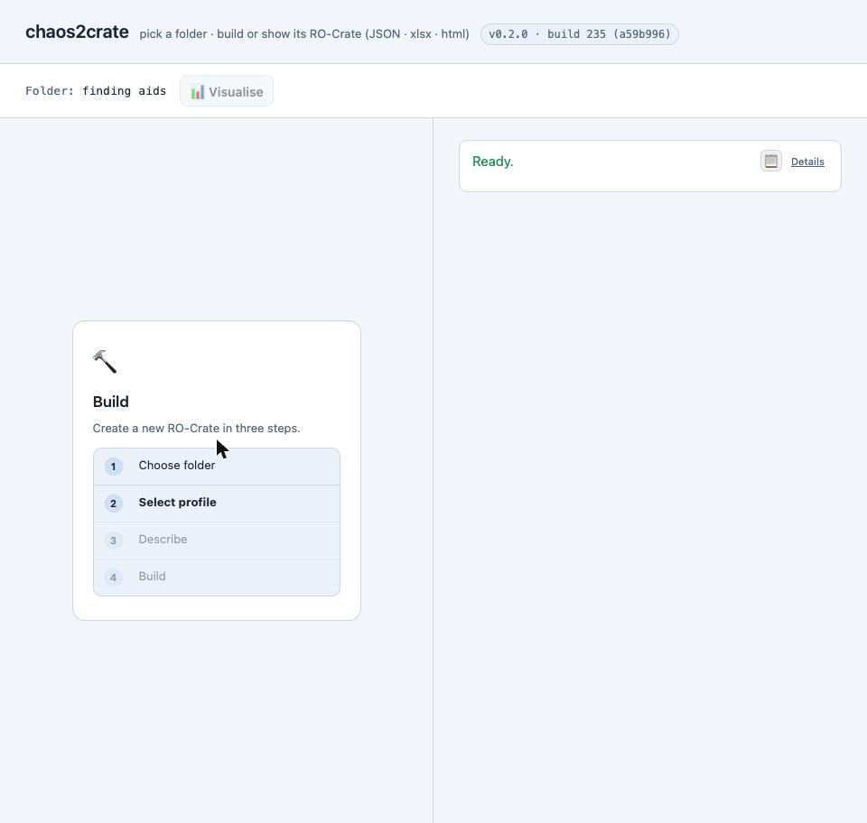
Figure 1. Folder selected — the context bar now shows “Folder: finding aids” and the four-step Build flow is live, ready for Step 2.

Step 2 — Select profile
chaos2crate fetches the available profiles from the project's c2c-masp-profiles repository and lists them as cards. In this build there are five options, plus the bundled schema.org default: birds, chordpro-songs, language-resources, ldac, and structured-docs. Choose language-resources. This choice determines every field the Describe step asks for next, and every option the Build screen offers after that.
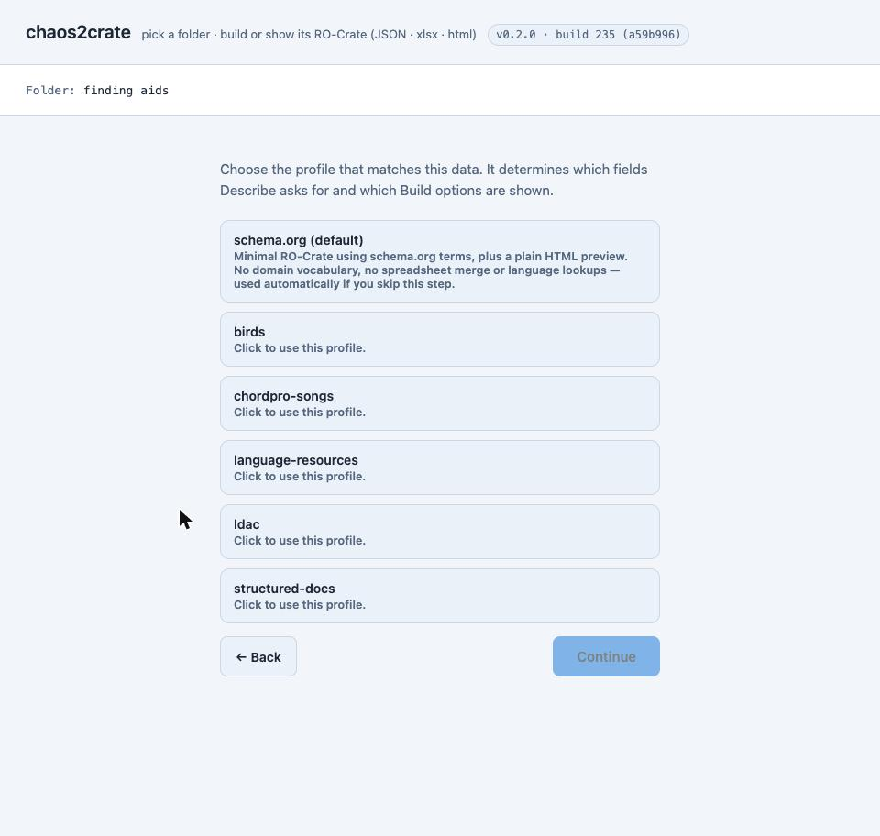
Figure 2. The five available profiles plus the schema.org default, before a selection is made.
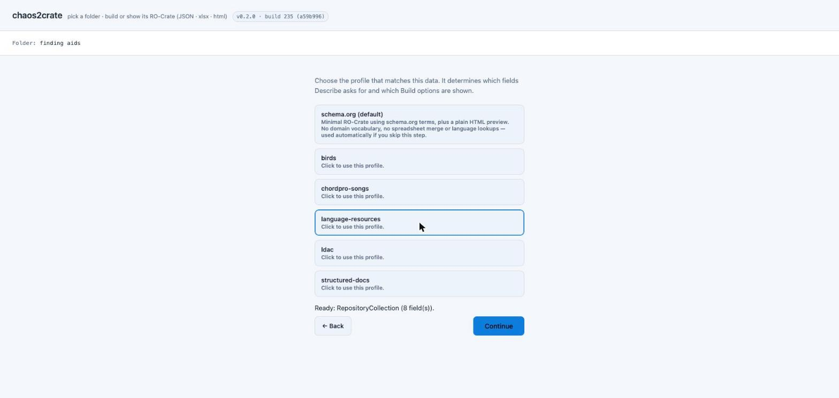
Figure 3. language-resources selected — the app confirms “Ready: RepositoryCollection (8 field(s))” and Continue becomes active.

Step 3 — Describe
Fill in the root-dataset (collection-level) fields the profile's schema asks for. The identifier should be a brief nickname of the collection. Name defaults to the folder name but can be changed; Description, Date Published, In Language, Creator and License are all offered too. This step only sets collection-level metadata; details about individual files are handled during Build instead.
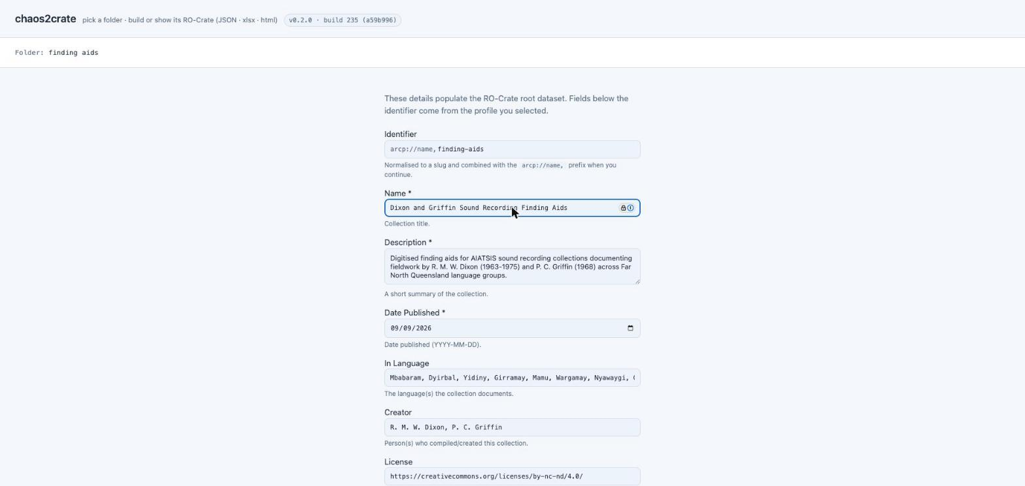
Figure 4. The Describe form, filled in for the worked example: Name “Dixon and Griffin Sound Recording Finding Aids”, a description of the collection's scope, and In Language / Creator populated from the finding aids' own catalogue data.

4. Workflow 1 — build directly from the PDFs, with AUSTLANG lookups
With the folder chosen, the Language Resources profile selected, and the collection described, continue to Step 4 (Build). This is where the workflow choice happens.

Set the Build options
- Identify subject languages (AUSTLANG, by filename) — leave this on (it's on by default). chaos2crate matches language names it finds in each PDF's filename against the AUSTLANG data pack it ships with, entirely offline.
- Identify file formats (PRONOM, by content) — leave this on too; it records each file's PRONOM format ID (values like image/jpeg or application/pdf).
- Merge metadata from a spreadsheet — switch this off for Workflow 1 (it's on by default in this build of the app). Workflow 2 will demonstrate how to use this feature, see §5.
- Generate ro-crate-preview.html — switch this on. Because you're using the Language Resources profile, the template is already preset to language-resources for you.
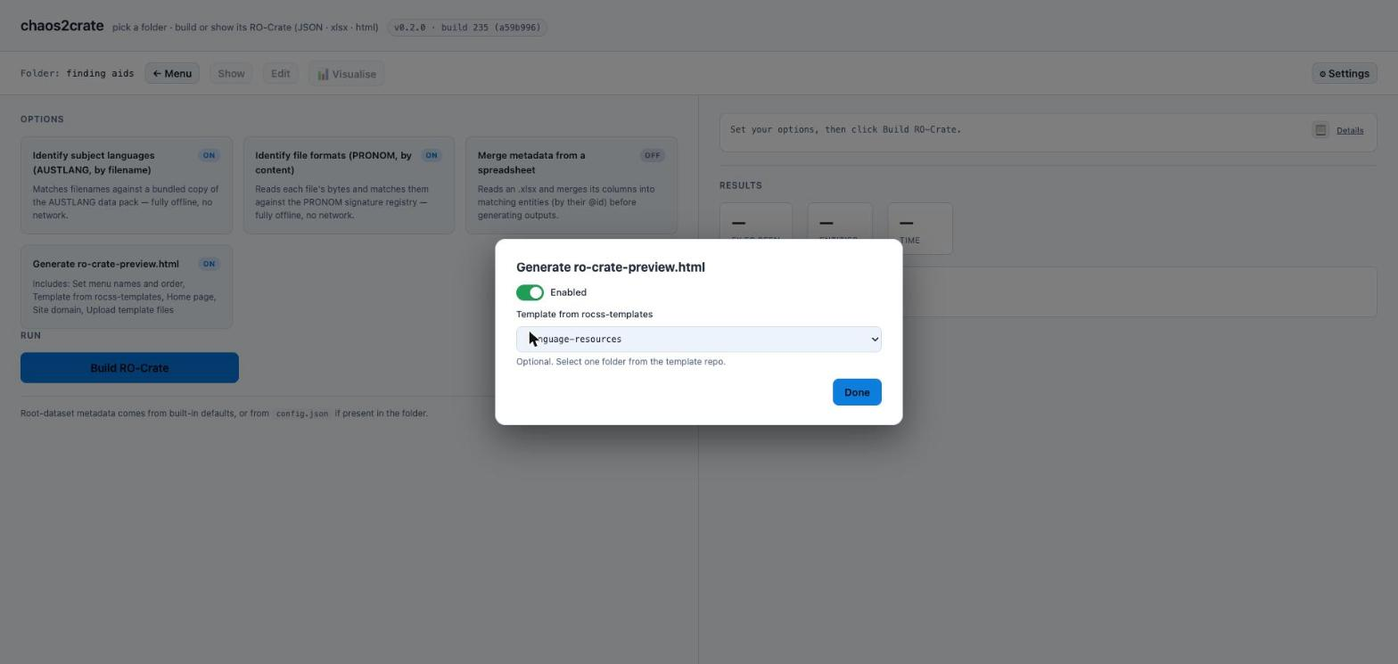
Figure 5. Turning on ro-crate-preview.html — the Template dropdown has already defaulted to language-resources because that's the selected profile.
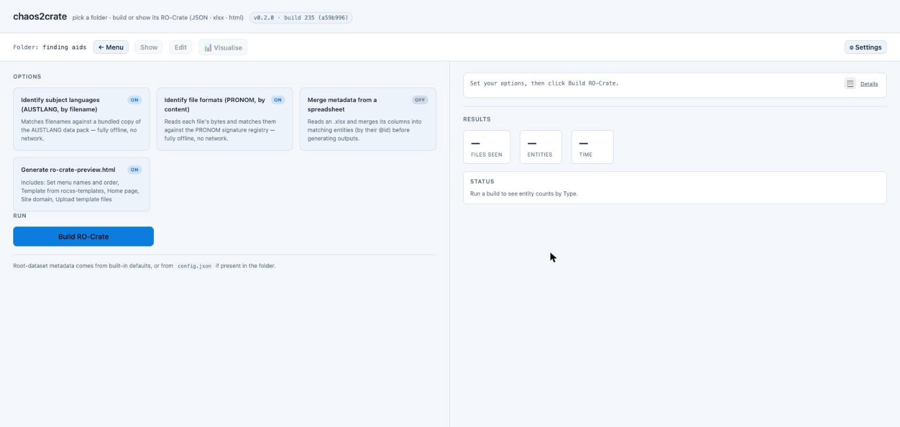
Figure 6. Workflow 1's final option set: AUSTLANG on, PRONOM on, spreadsheet merge off, HTML preview on.

Run the build
Click Build RO-Crate. chaos2crate scans the folder, matches each filename against AUSTLANG, identifies file formats, then writes the three output files. The Results panel summarises what happened:
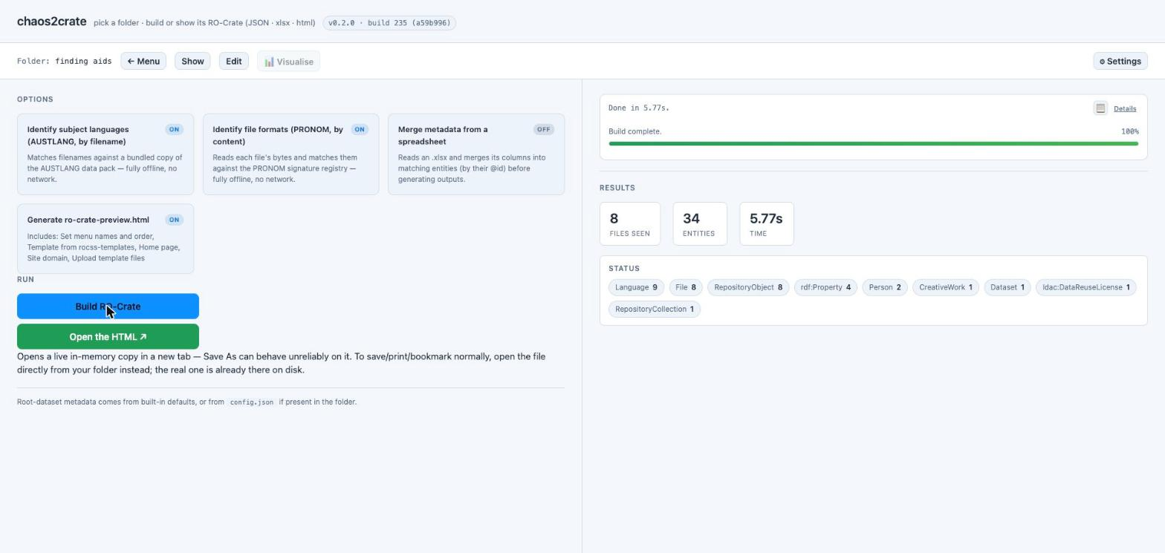
Figure 7. Build results for the finding-aids folder.

Open the result
Click Open the HTML to view the generated site. It opens as an in-memory copy in a new tab; the generated HTML is already sitting in your folder alongside the PDFs, and that's the one to open directly in a browser for normal use (bookmarking, printing, sharing); ro-crate-preview.html.
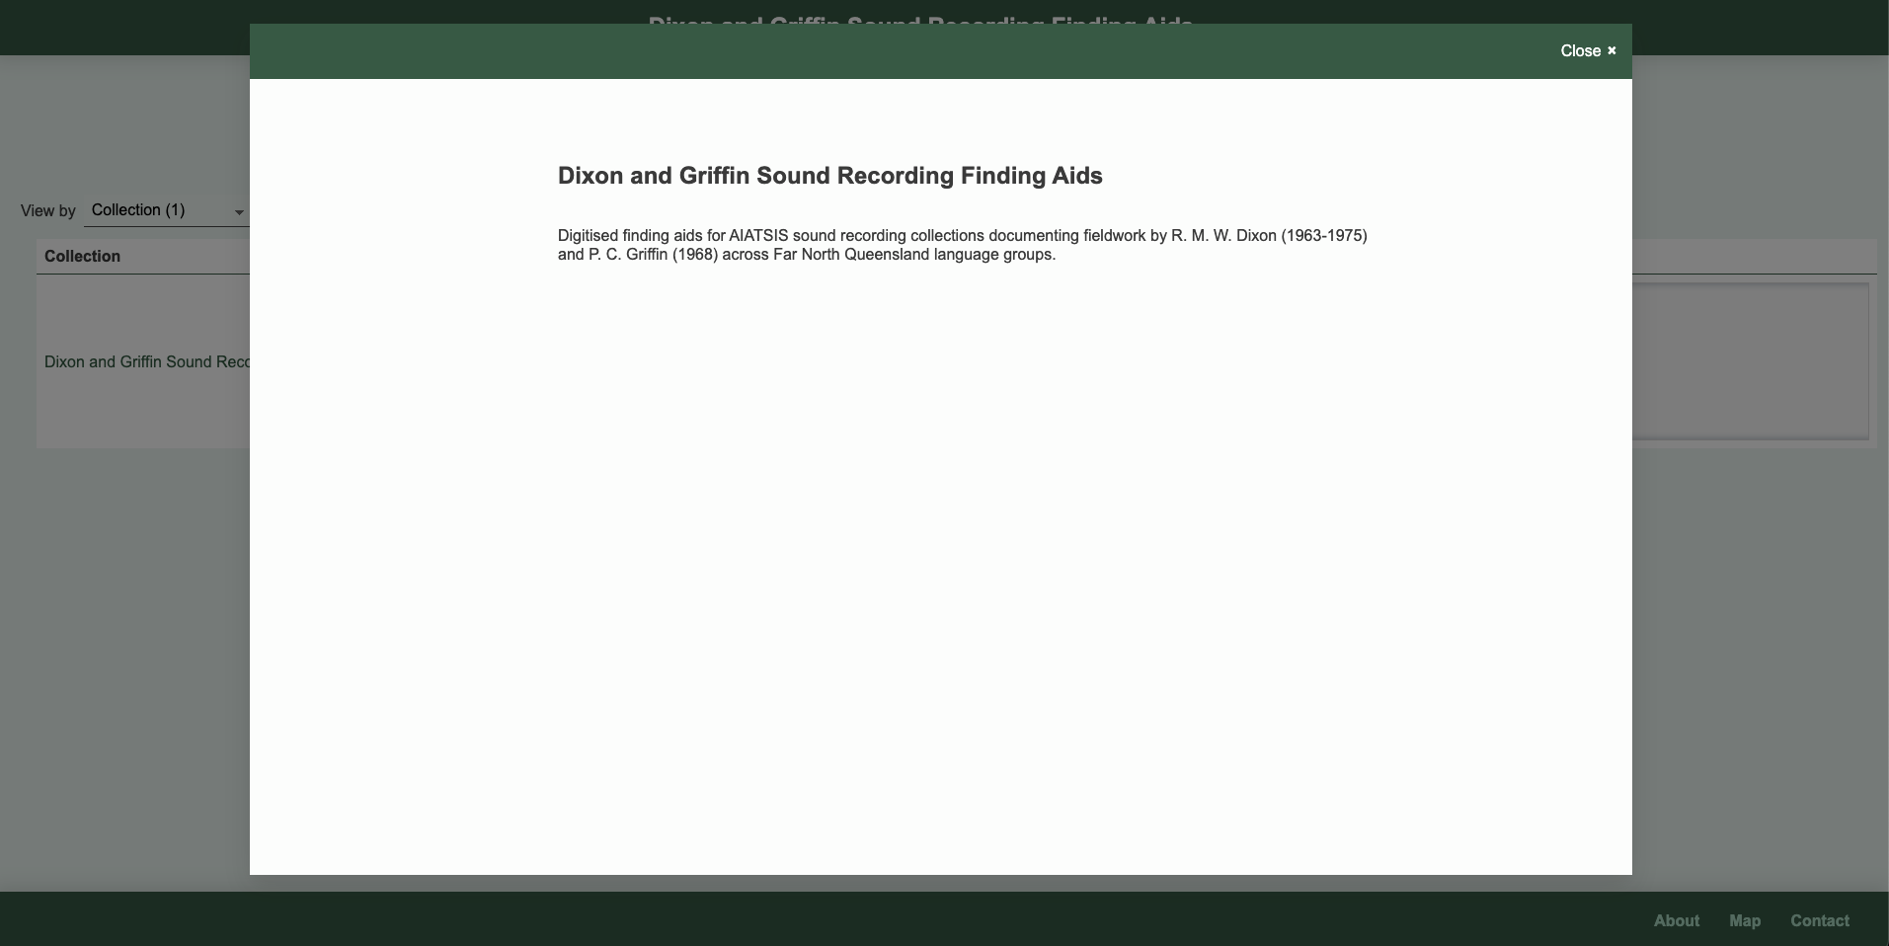
Figure 8. The generated site's collection-level popup, opened from the language-resources template.
Close that popup (or view the page behind it) to see the collection browsed as a table, with each finding aid listed under Contains:
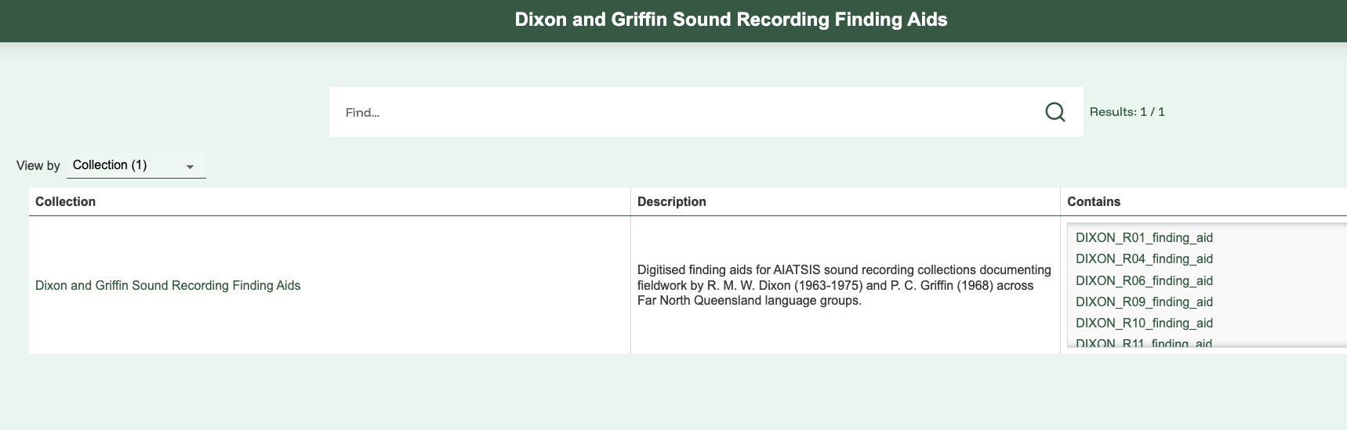
Figure 9. The underlying collection table — one row for “Dixon and Griffin Sound Recording Finding Aids”, its description, and the seven finding-aid PDFs it contains.

5. Workflow 2 — merge in a metadata spreadsheet
Filenames alone can include a language name, but details about who collected the material, when, over what extent, or under what access conditions are added through merging metadata. Workflow 2 adds that detail from a separate spreadsheet you prepare, without touching the PDFs themselves.

Prepare the spreadsheet
Build one .xlsx with a row per file. The source spreadsheet needs a column header spelled exactly @id, holding each file's filename. Rows are matched to entities in the RO-Crate by the @id column.
Spreadsheet column | Maps to | Notes
@id | (matching key) | Must exactly match the PDF's filename in the folder
Title | name | Sets the file's display name
Collector | creator | Who collected the recordings
Date | temporal | Collection date or date range
Extent | extent | Physical/duration extent, as free text
Languages | inLanguage | Comma-separated language names
Access | conditionsOfAccess | Access/restriction notice from the finding aid

Set the Build options
Return to Step 4 (Build). Leave the Workflow 1 options as they were. The two workflows combine rather than replace each other, and additionally switch on Merge metadata from a spreadsheet, then upload the file:
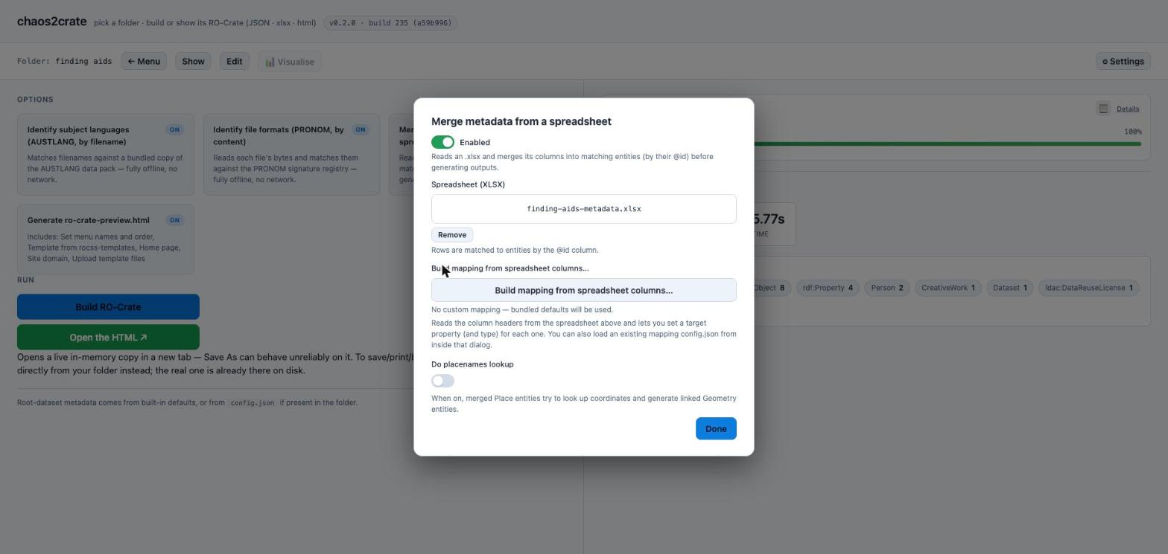
Figure 10. Merge metadata from a spreadsheet, enabled, with finding-aids-metadata.xlsx uploaded.
Click Build mapping from spreadsheet columns… to open the mapping dialog. It reads the workbook's header row and lists every column found; set each one's target property (Type left as “(plain value)” is fine for all of these — the Person/Organization/Place/Language/License/File options are for columns that should create or link to a typed entity instead):
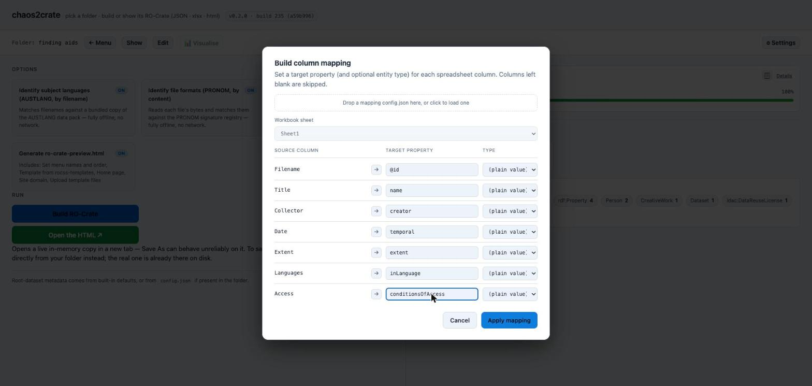
Figure 11. The column-mapping dialog, populated from the uploaded spreadsheet's header row, with each column mapped to a target property.

After setting the columns, continue with the build by clicking Build RO-Crate.
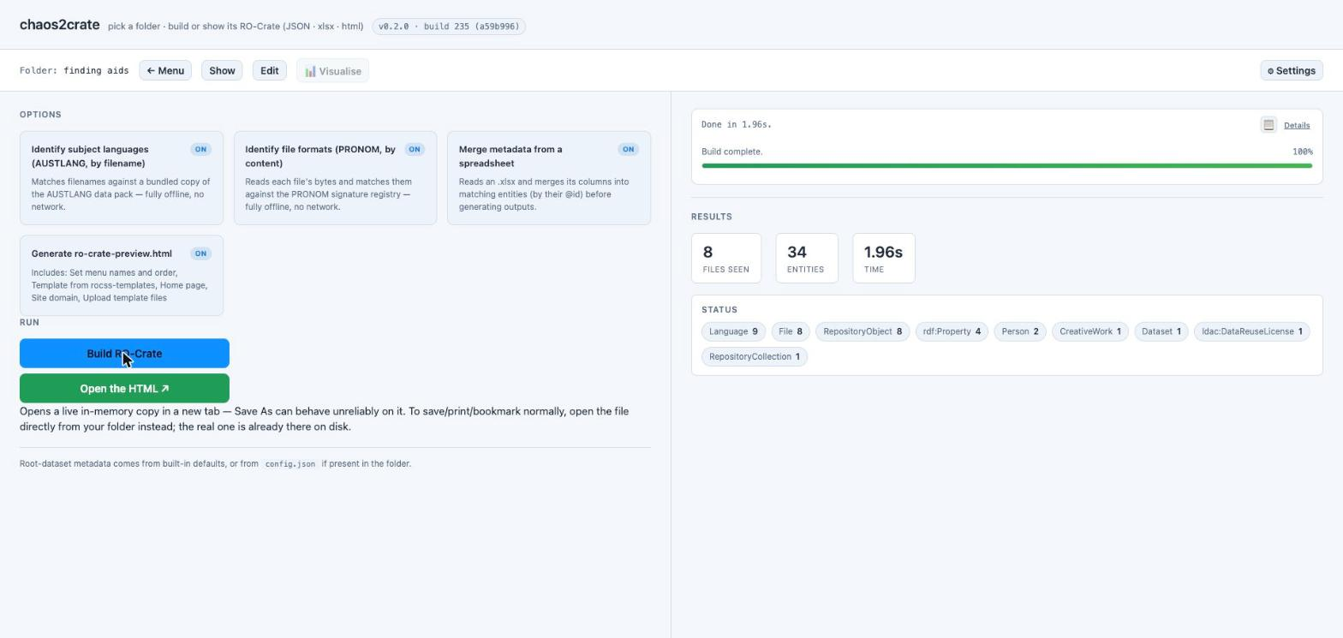
Figure 13. Workflow 2's results after the fix — the same 8 files / 34 entities, built in 1.96s this time.
The build log confirms the merge itself, not just that the build finished without error:
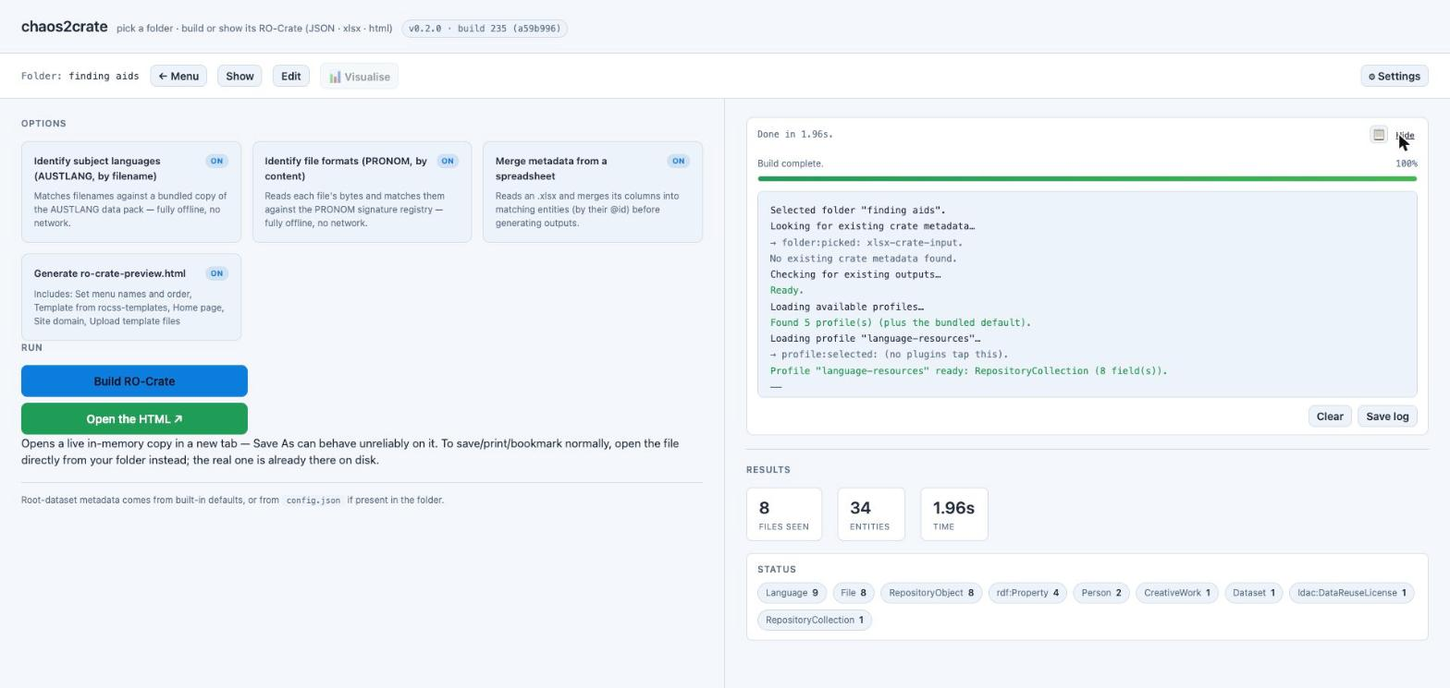
Figure 14. Build log detail. The key line: “Merged 42 value(s) from ‘Sheet1’ into 7 entity/ies; generated 0 new entity/ies.” 7 entities × 6 mapped columns = 42 values — exactly the seven finding-aid rows, each contributing six merged fields.

Check the merge in the generated site
Open the HTML again. Individual items now carry the merged fields — shown here for the Griffin collection's finding aid, alongside chaos2crate's embedded viewer for the PDF itself:
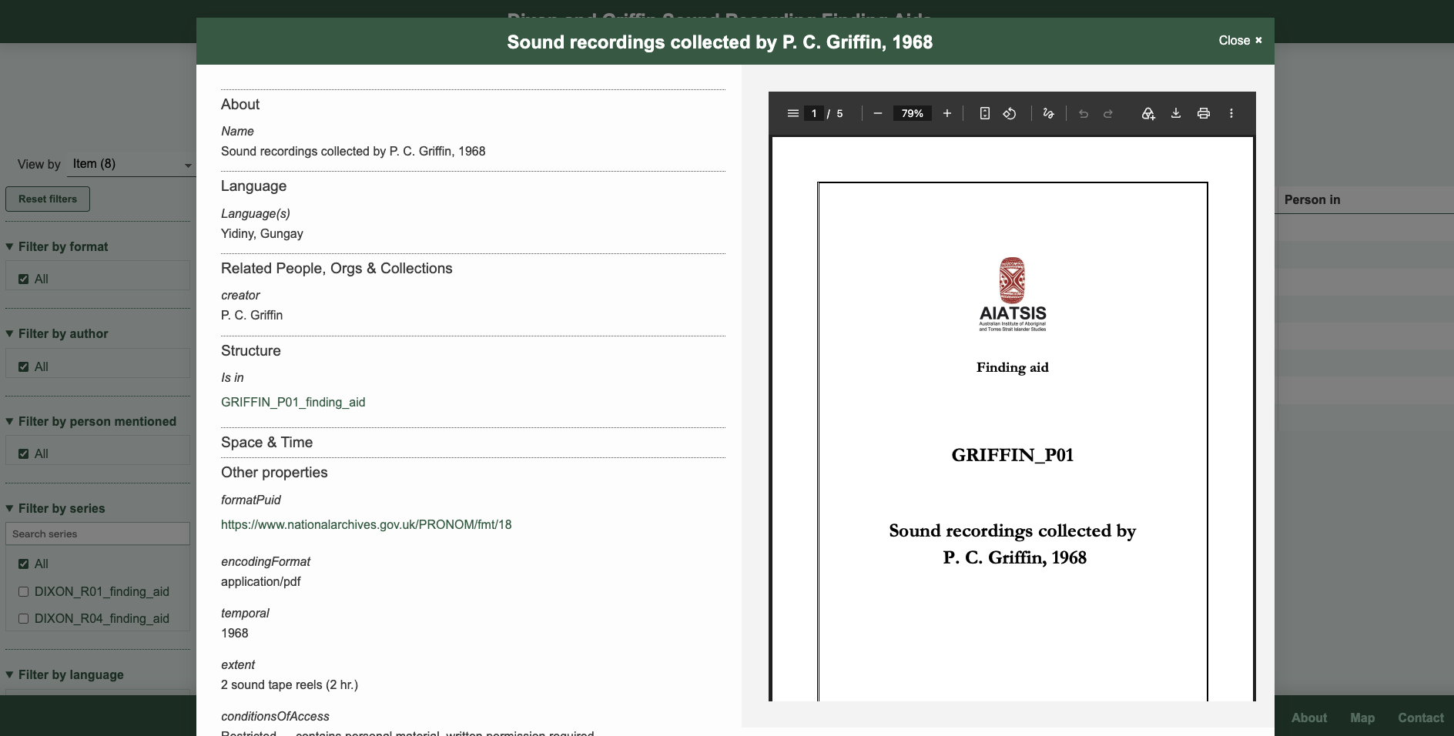
Figure 15. An item's detail view after merge: Language(s) “Yidiny, Gungay”, creator “P. C. Griffin”, temporal “1968”, extent “2 sound tape reels (2 hr.)”, and conditionsOfAccess showing the finding aid's own access restriction — all merged in from the spreadsheet, next to the real scanned finding aid.
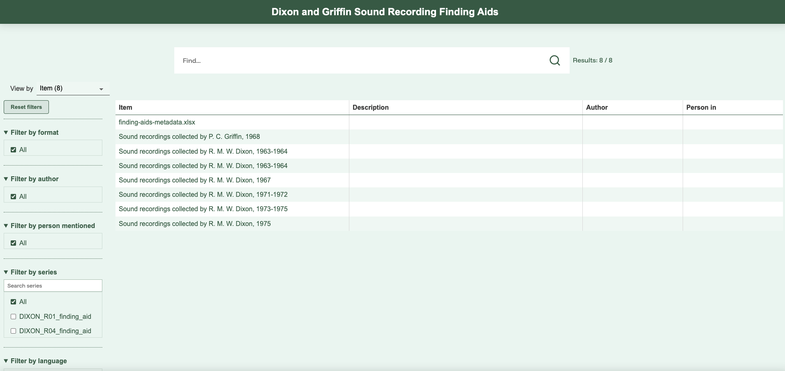
Figure 16. The collection browsed as an item table after merge — 8 items, because the metadata spreadsheet itself (finding-aids-metadata.xlsx) is listed as an item alongside the seven finding aids. See the note below.
A row that merges nothing usually means its @id value doesn't exactly match a filename in the folder — check for a missing file extension, a trailing space, or a typo. Here, one “file” had no matching row by design: the spreadsheet itself. chaos2crate scans every file in the folder, including finding-aids-metadata.xlsx, and it obviously has no row matching its own name — the build log reports this plainly (“1 file(s) had NO matching spreadsheet row”) rather than treating it as an error.
Keeping the merge spreadsheet inside the source folder means it gets scanned and listed as an extra item in the collection (Figure 16 shows 8 items, not 7). If you don't want the spreadsheet itself appearing in the generated site, keep it somewhere else on disk and upload it through the Spreadsheet (XLSX) file picker in Figure 10 — chaos2crate doesn't require it to live inside the folder being built.

6. What you get
Whichever workflow you ran, chaos2crate leaves three files in your source folder, next to the PDFs:
- ro-crate-metadata.json — the crate as JSON-LD; the authoritative, machine-readable record of everything chaos2crate captured.
- ro-crate-metadata.xlsx — the same data as a spreadsheet, handy for review or for handing to someone who'd rather work in Excel.
- ro-crate-preview.html — a self-contained, offline-browsable site built with the language-resources template — open it directly in a browser, or upload the whole folder to any static web host to publish it.
You can come back to a folder that already has a crate at any time: chaos2crate's Show card opens the existing preview/JSON, and Edit lets you change entities directly and save — both without repeating Steps 1–3.

7. Tips, limits, and troubleshooting
- The @id column name is literal. As shown in Figure 12, the source spreadsheet must have a column header spelled exactly @id. Mapping a differently-named column to the @id property in the mapping dialog does not satisfy this — the mapping dialog only controls what happens to columns other than the matching key.
- AUSTLANG matching is filename-only. chaos2crate does not read the text inside your PDFs to identify language — only the filename. In the worked example, none of the seven real AIATSIS filenames (e.g. DIXON_R01_finding_aid.pdf) contained a recognisable language name, so AUSTLANG matched 0 unique languages even with the option switched on — the build log said so plainly (“Identified 0 unique language(s)”) rather than failing. Filenames that do include a language name will match.
- Everything in the source folder gets scanned. chaos2crate treats every file it finds in the chosen folder as part of the collection — including a merge spreadsheet you've left in there, as seen in Figure 16. Keep working files you don't want listed as items outside the source folder.
- Profile-validation warnings aren't necessarily errors. Both builds in this guide reported “Profile validation found 2 issue(s)” — one about an expected RepositoryCollection count, one a known false positive around URL-typed license properties — yet both builds completed and wrote all three output files normally. Read what the specific message says before assuming a build has failed.
- The blob: preview tab is temporary; the file on disk is not. Open the HTML opens a live in-memory copy in a new browser tab — convenient for a quick look, but that tab's Save As can behave unreliably, and the tab itself is gone once closed. The real ro-crate-preview.html chaos2crate wrote into your folder is the one to open directly, bookmark, print, or publish.
- Everything stays local. Both workflows run entirely in your browser against your local folder — no files are uploaded to a server, whether you're using the hosted build or a local one. The only network activity is fetching the profile and template lists, and, if you use it, live place-name lookups for the optional placenames feature (left off in this guide).

