

人工智能上机实验报告

题目：利用A*算法解决搜索问题
Search Based on A* Algorithm

学院名称 智能与计算学部
专 业 软件工程
学生姓名 郎文翀
学 号 3019244247
年 级 2019级
班 级 5班
时 间 2021.10.07

Experimental Requirements
# 阅读题干，简述实验要求
# Read the description, and conclude the requirements of the experiment.
# Introduce the tasks of your experiment

#本次实验旨在练习A*算法的应用。首先我们需要阅读node.py文件中的代码，#在理解代码逻辑后完善search.py文件中的代码完成A*搜索算法的基本算法骨
#架。然后我们会使用这个search.py中的A*算法去解决两个例题。第一个例题
#是4*4的16数码问题，需要用A*算法找出最优步数路径，第二个问题是最少
#冲突N皇后问题，同样需要用到A*算法来寻找怎样摆放N个超级皇后使得冲
#突最少。最后我们要运行text.py文件进行测试，当输出OK时即表示任务完成！

The purpose of this experiment is to practice the application of the A* algorithm. First we need to read the code in the node.py file and refine the code in the search.py file after understanding the code logic to complete the basic algorithm skeleton of the A* search algorithm. Then we will use the A* algorithm in this search.py to solve two example problems. The first example is a 4*4 16-digit problem, which requires the A* algorithm to find the optimal step path, and the second problem is the least conflicting N queens problem, which also requires the A* algorithm to find how to place the N super queens to make the least conflict. Finally we have to run the text.py file for testing, when the output OK that means the task is complete!

Configuration
# 介绍你的环境和配置
# The configuration of your experiment
# The environment required for your experiment

#环境只需要保证配置好Python环境即可，同时我使用了vscode编辑器进行代码编辑，安
#装了一系列代码美化插件和python插件。

The environment just needs to ensure that the Python environment is configured, while I used the vscode editor for code editing and installed a series of code beautification plugins and python plugins.

Implementation
# 描述实验内容
# 详细介绍实验过程的基本步骤，有必要的情况下可以通过图片、伪代码等形式介绍
# 不建议直接粘贴所有代码，必要的情况下可以粘贴部分代码段，请保证格式正确，且不影响阅读体验。

# Describe the implementation of the experiment
# Elaborate each step of your experiment, you can use figures and pseudocode to fully explain your work.
# Please DO NOT copy the entire code to this report, you can copy code snippets (some part of your code) if necessary. Please make sure the pattern of the code is clear and up to coding standard. Please make sure your code does not influence the reading.

#首先我们来简述一下什么是A*搜索，A*搜索使用中使用了启发函数来辅助寻
#找最优解的算法，他通过f=h+g来完成代价的预测，其中h是预测从当前节点#K到达目的节点N的估计代价，而g是已知的到当前节点K的最优路径代价值，#因此我们可以通过上面的公式预估出从当前节点到达所有可能前往的节点的代#价值并且把所有可能的节点放置到openList列表中进行维护，同时对于已经展
#开过的节点我们将其放置到closeList列表中以避免出现环路。
#我们根据A*算法的思路，每次都选取f最小即当前条件下预估代价最小的节点#作为下一个搜索情况。这样我们就可以在问题完备的情况下找到最优解，亦或
#者是openList为空时代表问题非完备。这种利用启发函数和两个列表进行的高#效搜索算法即A*算法。

First of all, let us briefly explain what is A* search, A* search uses a heuristic function to assist in finding the optimal solution of the algorithm, he completes the prediction of the cost by f = h + g, where h is the estimated cost of predicting the arrival of the destination node N from the current node K, and g is the known optimal path generation value to the current node K, so we can use the above formula to predict the generation value of the node from the current node to The above equation allows us to estimate the generation value of all possible nodes from the current node to the destination node N and place all possible nodes in the openList list for maintenance, while for nodes that have been expanded we place them in the closeList list to avoid loops.
We follow the idea of the A* algorithm by selecting each time the node with the smallest f , i.e., the node with the smallest predicted cost under the current condition, as the next search case. This allows us to find the optimal solution in case the problem is complete or when the openList is empty which means the problem is non-complete. This efficient search algorithm using heuristic function and two lists is known as A* algorithm.

#因此我们首先根据上面A*算法的逻辑完成search.py文件，代码如下：
So we first complete the search.py file based on the logic of the A* algorithm above, with the following code.
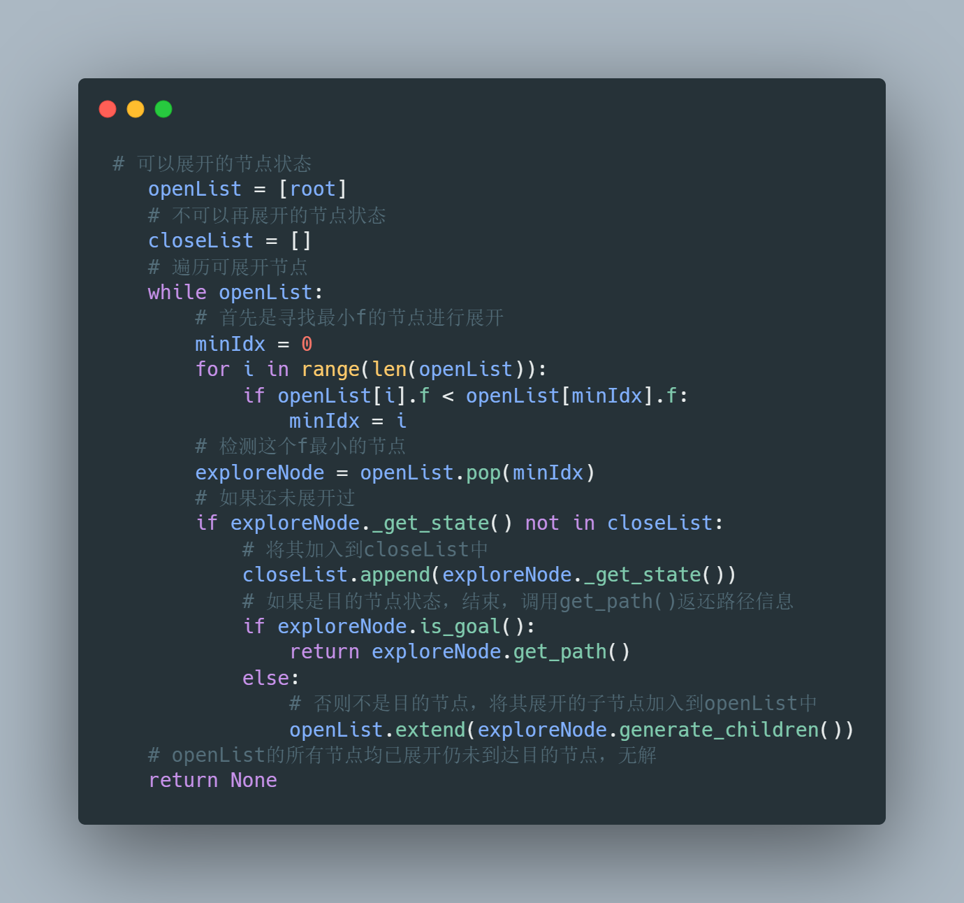

#这样我们就完成了search.py文件中对A*算法的完善。然后我们尝试进行第一
#个问题16数码的解决。我们首先阅读题干不难得知可以使用self对象来表示当#前情况，用self.board表示当前情况的棋盘布置，然后通过不断的调用#generate_children函数完成对当前节点的扩展，因此我们需要将#genereate_children函数每次展开的所有可能子节点存储到一个列表中这里我命#名为children。同时我们还需要完成h预估代价值的函数以及判断当前情况是否#为目的情况的函数。

This completes our refinement of the A* algorithm in the search.py file. Then we try to carry out the solution of the first problem 16 digits. We first read the stem and it is not difficult to know that we can use self object to represent the current situation, and use self.board to represent the board arrangement of the current situation, and then finish the expansion of the current node by continuously calling the generate_children function, so we need to genereate_children function each time the expansion of all possible child We also need to complete the function that estimates the value of the generation and the function that determines whether the current situation is the destination situation.

#接下来我们尝试完成h预估函数，实际上就是一个简单的曼哈顿距离的书写，
#曼哈顿距离就是横向距离差加上纵向距离差如下:

Next we try to complete the h prediction function, which is actually a simple Manhattan distance writing, Manhattan distance is the horizontal distance difference plus the vertical distance difference as follows:
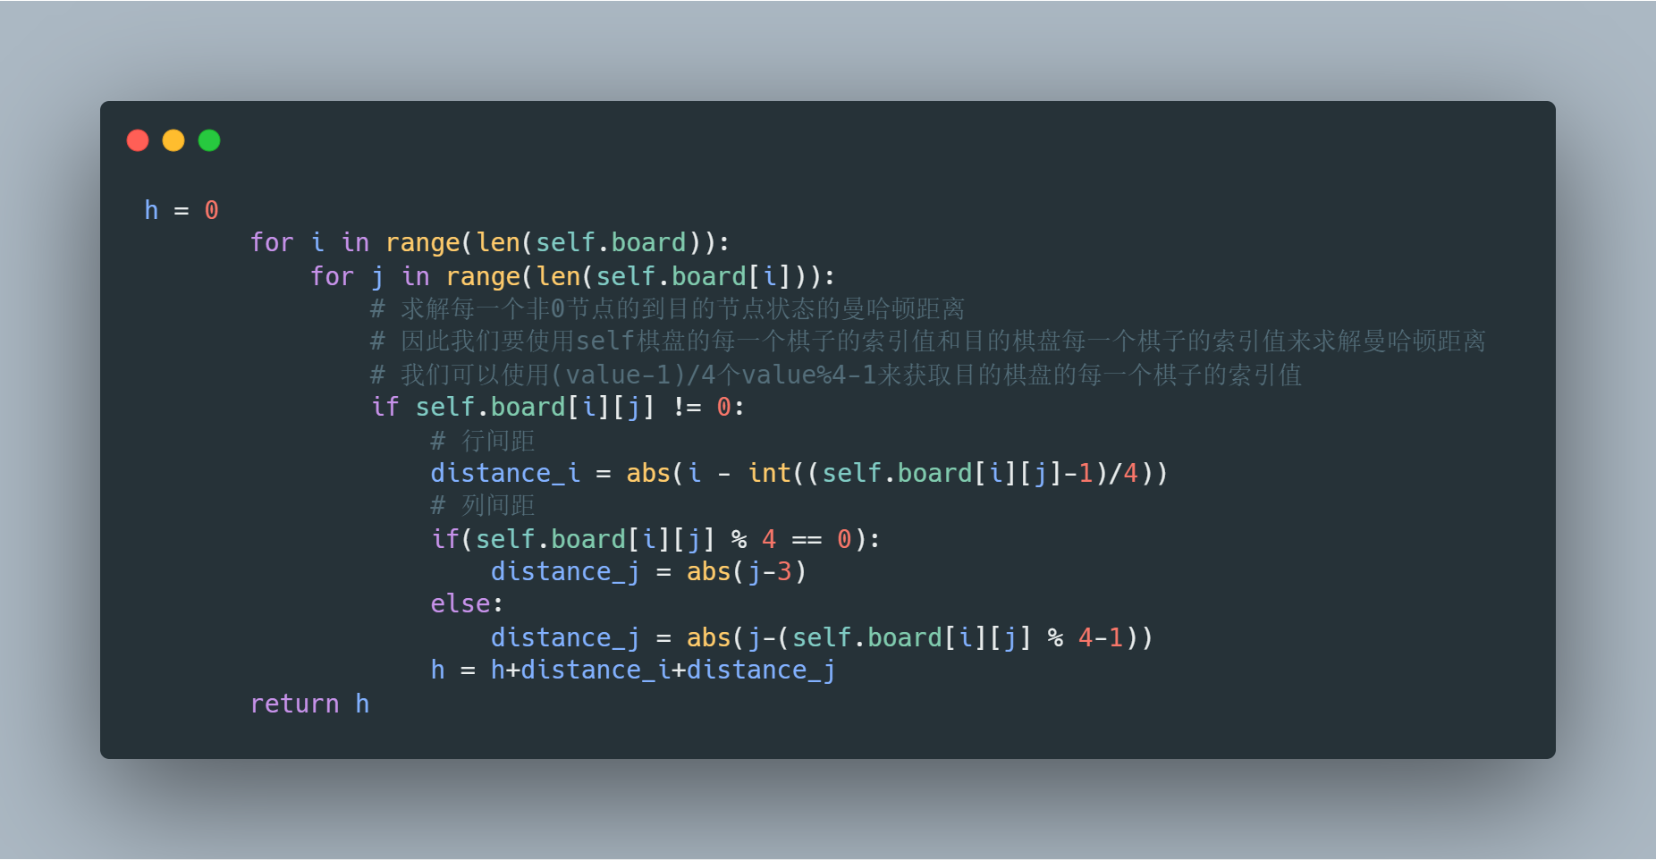

#接下来我们先来完成简单的目的节点的判断函数，他也很简单，我这里就用了
#暴力枚举的方法判断每一个数值棋子是否位于自己的正确位置，因为有16个棋#子，因此是16个条件的与关系，如下图：

Next we first complete the simple judgment function of the destination node, he is also very simple, I used the method of violent enumeration here to determine whether each numerical piece is located in its correct position, because there are 16 pieces, so it is 16 conditions with the relationship, as follows.

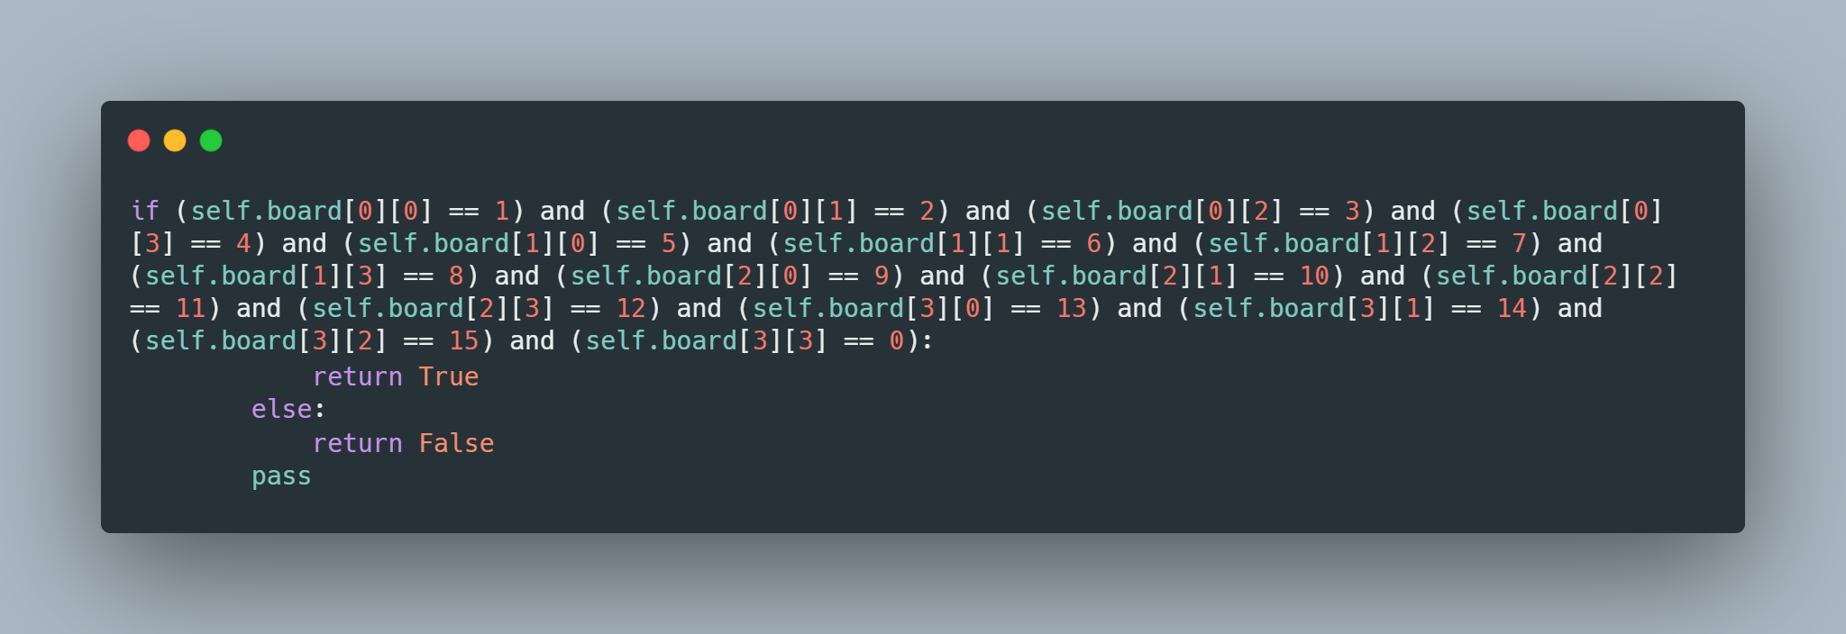

#最后我们来完成代码逻辑较为复杂的扩展节点生成子节点的函数，首先我们是
#按照如下思路进行节点的扩展的。
#我们要先从维护的children列表中选取一个f最小的节点进行扩展，取出当前
#情况的棋盘情况，然后按照0棋子能否上下左右依次交换移动依次生成至多四
#种情况，然后对于每一种情况都分别进行一个f的计算，然后放到children列
#表中等待下一次选取。这路我们要特别注意边界情况，当0棋子位于最上，最
#下，最左，最右侧时是无法移动四次的，因此我们需要为每一次移动都添加一
#个判断条件。

Finally, let's finish the code logic of the more complex function of expanding the node to generate children nodes.
We have to first select a node with the smallest f from the list of children maintained for expansion, take out the current case of the board, then generate up to four cases in order of whether the 0 pieces can be moved up, down, left, and right in turn, and then for each case perform a calculation of f respectively, and then put it into the children list to wait for the next selection. This way we have to pay special attention to the boundary case, when the 0 piece is at the top, bottom, left and right side, it cannot be moved four times, so we need to add a judgment condition for each move.

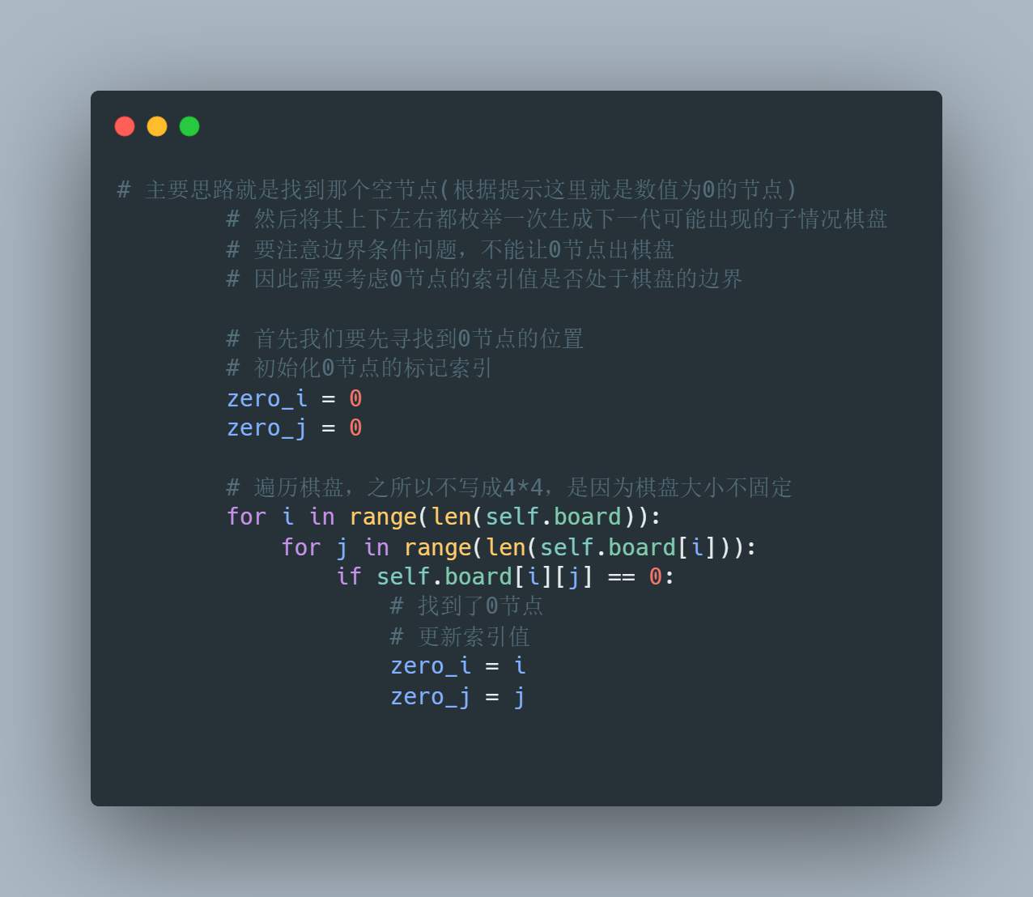

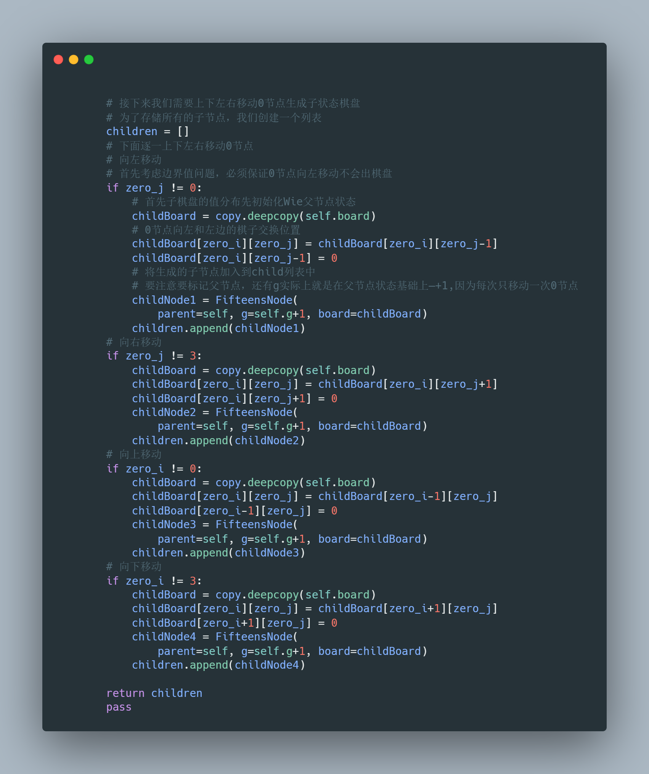

#这样我们就完成了问题一16数码的求解。接下来我们尝试利用A*算法解决最
#少冲突N超级皇后问题。注意我这里说的是超级皇后，因为他和生活中国际象#棋的皇后有一点不同，这个皇后除了能够上下左右斜上斜下斜左和斜右移动以
#外，还可以走骑士的路径，即'日'字形行走，因此我们在讨论冲突时要综合考虑#以上情况

This completes our solution of Problem 1 with 16 digits. Next we try to use the A* algorithm to solve the least conflicting N-superqueens problem. Note that I say super queen here, because he is a little different from the queen in life chess, this queen can move up and down, diagonally up, diagonally down, diagonally left and diagonally right, in addition to the path of the knight, i.e., the 'day' walk, so we have to consider all of the above when discussing the conflict

#同时我们要注意这里的h我们不需要进行预估了，因为每一次摆放一个皇后以
#后我们都可以直接通过判断寻找到确切的冲突数值即f值，每一次都选取f最
#小即冲突最小的情况进行展开最终就可以得到最少冲突的摆放情况了，因此这
#里我们只需要重点完成generate_children函数即可。

At the same time, we should note that we do not need to estimate the h here, because after each placement of a queen we can directly find the exact value of the conflict through the judgment, that is, the f value, each time we choose the f minimum, that is, the minimum conflict for the expansion of the final placement of the least conflict, so here we only need to focus on completing the generate_children function can be.

#由于我们是从左往右逐列每一次放置一个Q皇后，因此我们可以肯定每一个皇#后都不可能出现列冲突，同时我们也可以通过for循环保证每一个皇后位于不
#同的行上面，因此此时可能出现的冲突只会是对角线冲突以及'日'字形冲突。

Since we are placing one Q queen at a time from left to right, we can be sure that there is no possibility of a column conflict for each queen, and we can also ensure that each queen is on a different row by for looping, so the only possible conflicts at this point would be diagonal conflicts and 'day' conflicts.

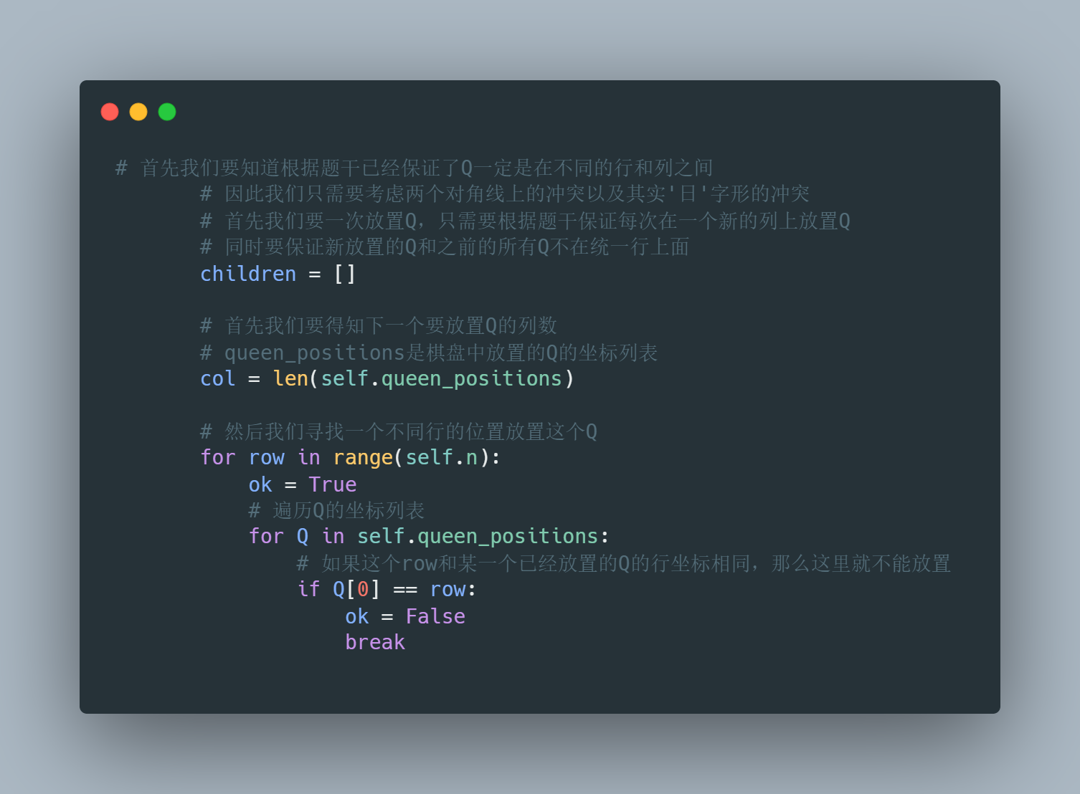

#接下来我们需要对此时放置一个新的Q的情况重新统计冲突个数，只需要考虑#对角线冲突和'日'字形冲突即可。我们根据queen_positions可以获得之前放置的#Q的坐标位置。然后我们从刚刚新放置的Q的坐标出发，以左上，左下，向左#上日字形和向左下日字形四个不同的步姿进行搜索，当发现到达的坐标和#queen_positions中的某一个坐标相同时则意味着产生了一个冲突，则f++，这样#我们就可以统计出每一个新情况的冲突个数了，并且把这个新产生的情况放置
#到children列表中进行维护。我们要注意我只向左侧进行了冲突查找而并没有
#向右侧进行冲突查找，这是因为每一次放置的Q一定是最右侧列的皇后，这是#因为我是自左向右逐列放置皇后的，因此右侧是一定没有冲突的，因为新放置
#的皇后Q右侧就不可能有其他皇后，这样子我们只需要向左侧寻找加快了搜索#效率！

Next we need to recount the number of conflicts for the case of placing a new Q at this point, considering only diagonal conflicts and 'day' conflicts. We can get the coordinate positions of the previously placed Qs according to the queen_positions. Then we search from the coordinates of the newly placed Q in four different steps: top-left, bottom-left, top-left sunset and bottom-left sunset, and when we find that the coordinates reached are the same as one of the coordinates in the queen_positions, it means that a conflict has been generated, then f++, so that we can count the number of conflicts for each new case and put the new and place the new cases in the children list for maintenance. We have to note that I only to the left side of the conflict search and not to the right side of the conflict search, this is because each time the Q placed must be the rightmost column of queens, this is because I am from the left to the right to place the queens column by column, so the right side is certainly no conflict, because the newly placed queen Q right can not have other queens, this way we only need to look to the left side to speed up the search efficiency!

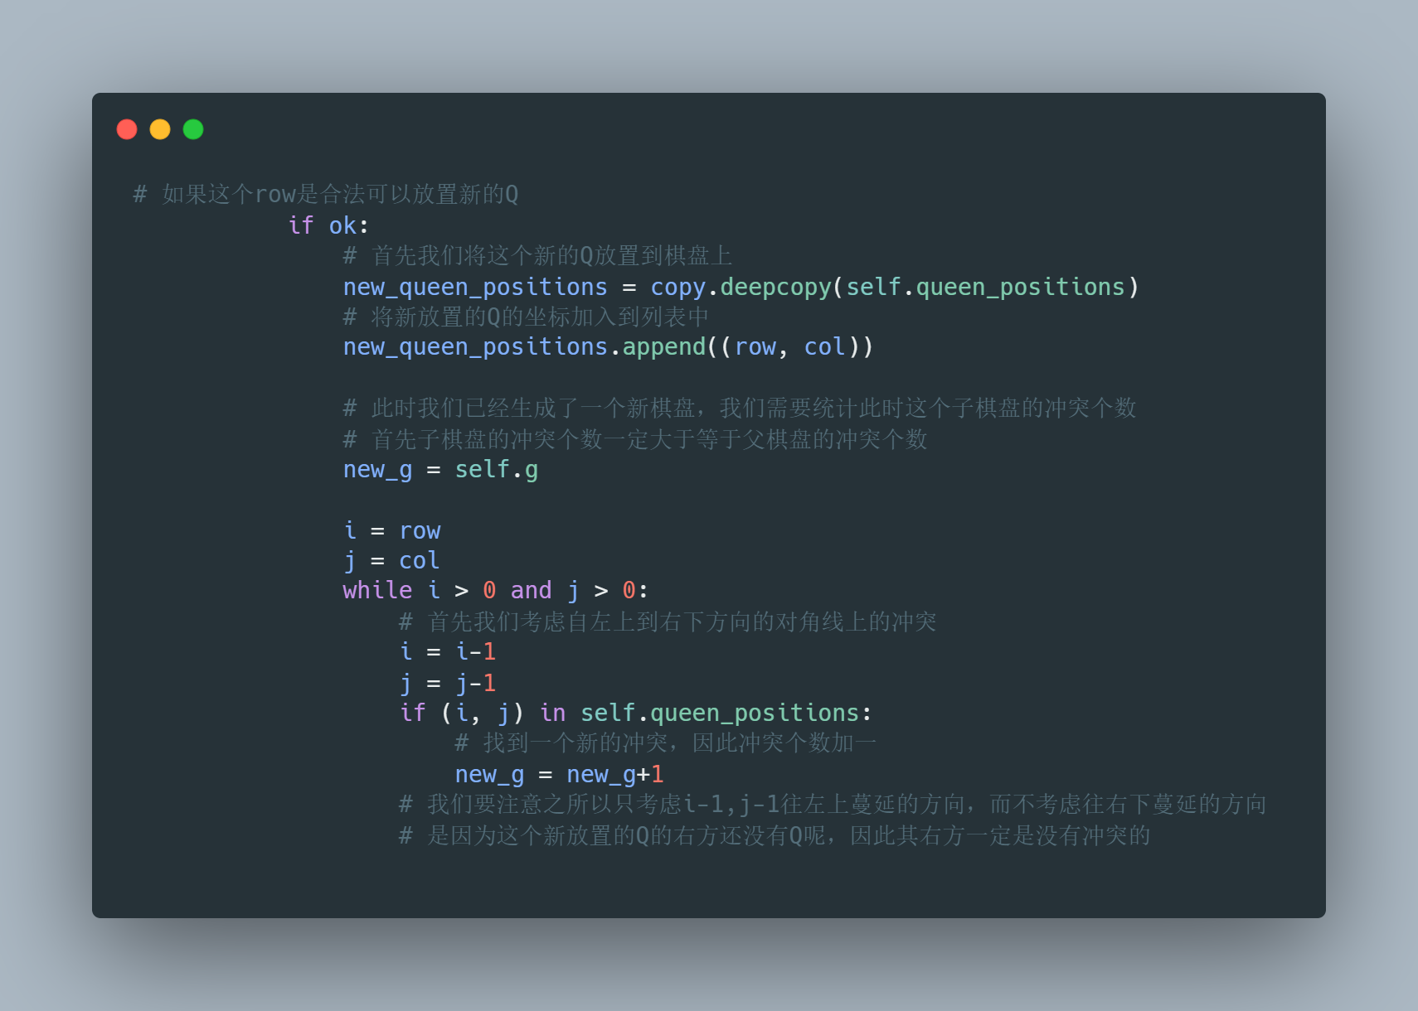
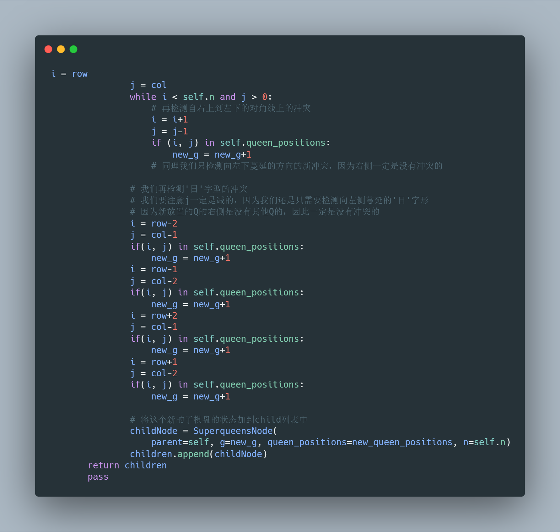

4. Result Analysis
# 介绍实验结果；
# 对实验结果进行分析，
# 例如：该结果是否符合你的预期，有什么优势（或者不足）
# 允许使用图片、表格等格式详细介绍你的实验结果
# 不建议直接粘贴所有代码，必要的情况下可以粘贴部分代码段，请保证格式正确，且不影响阅读体验。

# Explain the result of your experiment
# Analyze your result
# Here are some points of view you can used for analysis
# Does the result meet your expectations ? What are the advantages or advantages of your implementation.
# You can use figures and tables to conclude the results of your experiment.
# Please DO NOT copy the entire code to this report, you can copy code snippets (some part of your code) if necessary. Please make sure the pattern of the code is clear and up to coding standard. Please make sure your code does not influence the reading.

#接下来我们运行test.py文件查看能否成功解决两个问题，最终终端输出如下：
Next we run the test.py file to see if we can successfully solve the two problems, and the final terminal output is as follows.
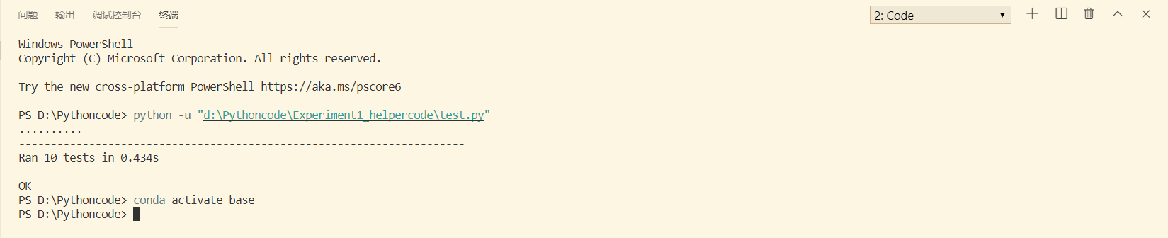
输出为ok说明成功完成任务。具体的代码可以查看附件或者是我的git仓库：
https://github.com/Langwenchong/A-Star-Search

5. Conclusion
# 简要介绍实验结论
# 介绍你的心得体会，以及对实验过程的反思

# Brief Introduction on your experiment results.
# How do you feel about your result and How do you feel about the experiment?

#本次实验用时三天，主要是在理解了A*算法的原理之后仍然无法立刻上手应用#A*算法去解决问题，因此消耗了大量的时间去查找参考思路以及代码逻辑的构#件上。同时在短暂的时间里也基本上掌握了python的编程方式，并且发现了许#多python高效的库函数方便进行操作比如copy中的deepCopy赋值列表等等。#通过本次实验我透彻理解了A*算法的原理同时体验到了A*算法通过使用启发#式函数来进行搜索的高效性！

The experiment took three days, mainly because after understanding the principle of the A* algorithm, we still could not immediately start to apply the A* algorithm to solve the problem, so we consumed a lot of time to find reference ideas and the building blocks of the code logic. At the same time, in a short period of time, I basically mastered the python programming style, and found many python efficient library functions to facilitate operations such as the deepCopy assignment list in copy, etc. Through this experiment I thoroughly understood the principle of A* algorithm and experienced the efficiency of A* algorithm by using heuristic functions to search!

