
Software Engineering Department
Braude College of Engineering
Final Project – Phase A (61998)
SmartLeafDetection-Hybrid-Deep-Model-for-Tomato-Leaf-Disease-Detection

CODE: 26-1-D-6
By:
Ariel Laniado | Ariel.Laniado@e.braude.ac.il
Noy Ben Ezra | Noy.Ben.Ezra@e.braude.ac.il

Advisor:
Dr. Dan Lemberg | lembergdan@braude.ac.il
Dr. Elena Kremer | elenak@braude.ac.il

GitHub Link: Smart Leaf Detection Hybrid model - GitHub

Table Of Contents
Abstract 4
1 Introduction 4
2 Background and related work 5
2.1 Precision agriculture and computer vision for disease detection 5
2.2 PlantVillage Datasets and real-world generalization challenges 5
2.3 Object detection in agricultural imagery 6
2.3.1 YOLO-Based object detection models 6
2.3.2 Comparative studies and scientific justification for YOLOv11 6
2.3.3 UAV field deployment challenges for YOLO-based detection 7
2.4 Object tracking and identity in video analysis 7
2.4.1 SORT and DeepSORT 7
2.4.2 ByteTrack 7
2.5 CNN-Based classification 7
2.5.1 ResNet50 as a Leaf disease classification 8
2.5.2 Transfer learning for tomato leaf diseases 8
2.6 Two-stage detection classification pipelines in the literature 8
2.7 Temporal aggregation in video-based analysis 9
2.8 UAV-Based monitoring in precision agriculture 9
2.9 Summary of literature review 9
3 Project description 10
3.1 Project pipeline 10
3.2 Requirements 10
3.2.1 Functional 10
3.2.2 Non-Functional 10
3.3 Development process description 11
3.3.1 Problem description 11
3.3.2 Dataset 11
3.3.3 Database 11
3.3.4 Preprocessing 12
3.3.5 Development process stages 12
3.4 Expected challenges 13
3.4.1 Plant overlap and collision in dense field scenes 13
3.4.2 Intermittent leaf visibility 13
3.4.3 Identity confusion due to leaf replacement over time 13
3.4.4 Limited disease visibility due to leaf orientation 13
3.4.5 Motion blur and frame degradation 13
3.4.6 Illumination variability in open-field conditions 14
3.4.7 Maintaining tracking consistency in long video sequences 14
3.5 Tools and technologies 14
3.5.1 Programming language and environment 14
3.5.2 Computer vision and video processing 14
3.5.3 Deep learning frameworks 14
3.5.4 Object detection and tracking 14
3.5.5 Dataset and model training resources 14
3.5.6 Database management 14
3.5.7 Visualization and output handling 15
3.6 System architecture 15
3.6.1 Architecture overview 15
3.6.2 Use-Case diagram 15
3.6.3 Activity diagram 16
3.7 Evaluation and Verification 17
3.7.1 Evaluation 17
3.7.2 Verification plan 17
3.8 Client interface 19
3.9 AI tools example prompts 21
3.9.1 AI tools (Links) 21
3.9.2 Example prompts 21
References 22
Appendices 23
Appendix A: System pipeline 23
Appendix B: Extended activity diagram 24

Abstract
Early detection of tomato leaf diseases is essential for maintaining crop health and yield, yet manual field inspection is time consuming and impractical for large scale monitoring. This project presents SmartLeafDetection, a UAV-based system for automated analysis of tomato fields using aerial video data. The proposed approach processes UAV videos by detecting tomato plants and individual leaves using a two-stage object detection strategy, tracking detected leaves across frames and classifying leaf diseases using a convolutional neural network. To improve robustness under open-field conditions, classification results are aggregated temporally before inferring plant-level disease status. The system produces GPS-linked outputs that associate detected diseases with spatial plant locations and maintains historical analysis results for later review. The proposed framework demonstrates a scalable and practical foundation for precision agriculture based on UAV-assisted computer vision.

1 Introduction
In today’s world, characterized by continuous population growth and increasing pressure on global food systems, agriculture plays a critical role in ensuring food security and economic stability. As demand for agriculture products continues to rise, the need for efficient, reliable and sustainable crop management practices has become more pronounced. Within this context, tomato is among the most widely cultivated crops worldwide and holds significant nutritional and economic importance.
Despite its importance, tomato cultivation is highly vulnerable to a wide range of diseases caused by pathogens such as bacteria, fungi and viruses. These diseases can lead to substantial yield reduction, deterioration in fruit quality and increase production costs. Foliar diseases may spread rapidly among neighboring plants. Therefore, early detection of symptoms and timely intervention are critical factors in minimizing economic losses and maintaining stable crop productivity.
Traditionally, disease detection in agricultural fields has relied on manual scouting, where trained personnel visually inspect plants for discoloration, lesions, or signs of leaf degradation. While this approach can be effective on a small scale, it is labour-intensive, time-consuming, and heavily dependent on the inspector’s expertise. Moreover, the manual nature of field scouting limits its ability to provide consistent and continuous coverage across large areas, thereby reducing its effectiveness for long-term and large-scale monitoring.
In recent years, advances in machine learning and computer vision have enabled automated approaches for agricultural monitoring, allowing rapid analysis of field imagery and early identification of disease symptoms. In parallel, growing interest in unmanned aerial vehicles (UAVs) has driven the adoption of aerial imaging for large-scale data acquisition, providing high-resolution coverage and an aerial perspective that can reveal foliar patterns not easily observed from the ground.
When combined with deep learning–based image analysis, UAV imagery provides a strong technological foundation for developing automated monitoring systems for tomato crops. However, aerial imaging also introduces practical challenges: individual leaves often occupy only a small portion of the frame and may be partially occluded by overlapping vegetation or background clutter. These conditions underscore the need for advanced object detection models capable of robust small-object detection in real-world field environments.
In response to these constraints, we propose an automated UAV-based framework for tomato crop monitoring that is specifically designed for small, partially occluded leaf targets. The system combines deep learning–based detection of plants and leaves with leaf-level disease analysis to produce actionable outputs for precision agriculture. The remainder of this work presents the supporting background and related studies, details the proposed architecture and end-to-end processing pipeline, and concludes with the evaluation methodology used to validate performance in realistic field conditions.

2 Background and related work

2.1 Precision agriculture and computer vision for disease detection
Precision agriculture aims to enhance crop management through site-specific monitoring and targeted intervention, rather than uniform treatment across entire fields. Within this context, computer vision and deep learning have emerged as key enabling technologies for identifying visually observable disease symptoms at scale. Prior work such as Kamilaris and Prenafeta (2018) demonstrates that vision-based approaches can efficiently process large volumes of imagery under variable field conditions, including changes in illumination, background complexity, and plant motion. As a result, visual monitoring systems are widely recognized in the literature as a practical foundation for automated plant health assessment and data-driven decision support in precision agriculture.

2.2 PlantVillage Datasets and real-world generalization challenges
PlantVillage is a widely used public dataset for plant leaf disease research, providing labeled images of healthy and diseased leaves acquired under controlled conditions. In Too et al. (2019) and Brahimi et al. (2018), deep learning models trained on PlantVillage dataset achieved high classification accuracy for leaf-level disease identification, demonstrating the effectiveness of CNN-based approaches under controlled imaging conditions.
Nevertheless, the literature identifies a domain generalization challenge: models trained on PlantVillage data often experience degraded performance when applied to real-world field imagery, which is characterized by complex backgrounds, illumination variability, occlusions and scale changes. This gap underscores the limitations of controlled datasets for direct deployment in operational agricultural environments.

2.3 Object detection in agricultural imagery
Object detection is a fundamental task in agricultural computer vision, enabling the localization of relevant plant structures, including individual leaves, within complex visual frames. Unlike image-level classification, object detection identifies both the presence and spatial location of multiple targets, making it particularly suitable for agricultural imagery where each plant comprises multiple leaves and both appear at different spatial scales within a single frame.

2.3.1 YOLO-Based object detection models
YOLO-based architectures perform object detection by directly predicting bounding box coordinates and associated class probabilities from the input image. These predictions provide spatial localization of detected objects without relying on an explicit region proposal stage. The resulting bounding boxes can subsequently serve as localized regions of interest for downstream analysis in multi-stage processing pipelines.

2.3.2 Comparative studies and scientific justification for YOLOv11
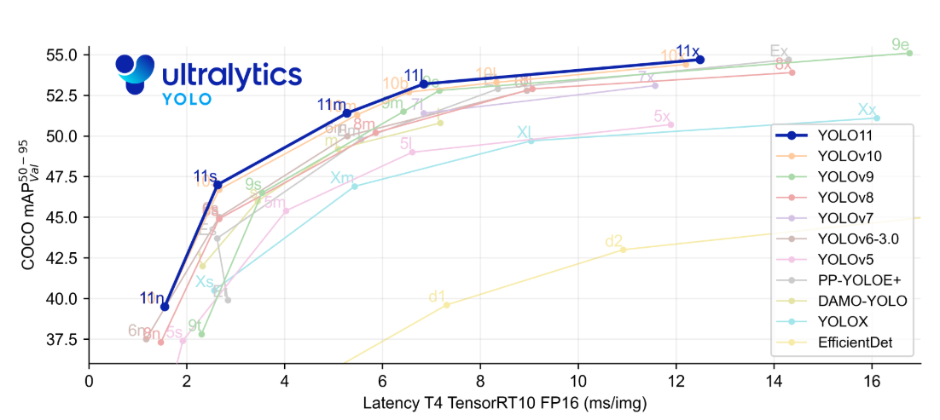
In Ramos and Sappa (2025), modern object detectors were benchmarked under consistent conditions to evaluate detection accuracy, inference latency and robustness across varying imaging conditions. These evaluations are particularly relevant for agricultural scenarios, where small targets and complex backgrounds require models that balance precision with computational efficiency.

Figure 1

Based on these comparisons, YOLO-based detectors commonly show strong accuracy-latency trade-off, with newer versions generally improving upon earlier ones. As shown in Figure 1, YOLOv11 is positioned among the higher-accuracy models while maintaining low inference latency relative to other evaluated detectors, supporting its suitability for small object detection in agricultural imagery.

2.3.3 UAV field deployment challenges for YOLO-based detection
In UAV-based tomato field monitoring, object detection is challenging due to viewpoint variability, scale changes, background clutter, and high object density across frames. These difficulties are amplified in open-field conditions, where plants may appear small and partially occluded, making reliable localization difficult. In the broader literature, robust plant localization is commonly treated as a prerequisite for downstream leaf-level analysis, since it enables subsequent disease recognition to focus on relevant plant regions rather than the full scene. Lu et al. (2024) demonstrate that YOLO-based detectors can be effectively applied to UAV color imagery under real field conditions for robust plant localization, supporting the suitability of YOLO-based detection for field deployment scenarios.

2.4 Object tracking and identity in video analysis
In video-based agricultural analysis, independent frame-by-frame detection is insufficient for maintaining consistent object identities over time. Leaves and plants may undergo temporary occlusion, partial visibility or brief detection failures. Consequently, the literature emphasizes the integration of object tracking to associate detections across frames and preserve temporal continuity, which is essential for reliable video-based analysis.

2.4.1 SORT and DeepSORT
SORT is a widely used tracking framework that associates detections across frames using motion estimation and spatial overlap, offering an efficient baseline for multi-object tracking. However, its reliance on motion cues can lead to identity switches in the presence of occlusions. DeepSORT extends this approach by incorporating visual appearance features, improving identity preservation when objects are visually similar or temporarily obscured.

2.4.2 ByteTrack
ByteTrack further enhances tracking robustness by associating not only high-confidence detections but also lower-confidence bounding boxes. This strategy reduces track fragmentation in dense or cluttered scenes, where many objects are partially visible or weakly detected. The literature reports that this approach is particularly effective in environments such as agricultural imagery.

2.5 CNN-Based classification
CNNs are widely used for image-based classification tasks due to their ability to learn hierarchical visual representations from localized image regions. In detection-based pipelines, CNN classifiers are typically applied to regions of interest extracted from bounding boxes, enabling focused classification at the object level.

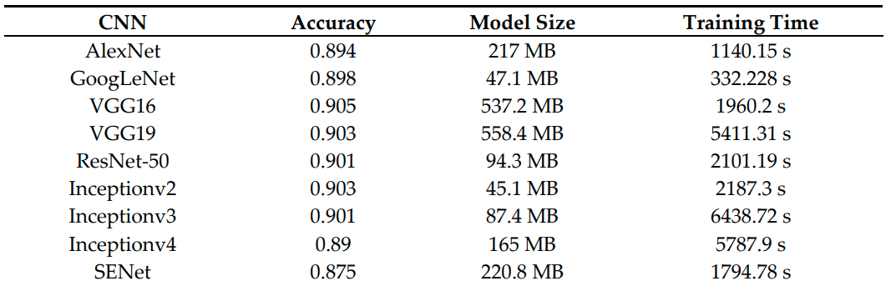
Table 1

2.5.1 ResNet50 as a Leaf disease classification
The ResNet family was introduced as a major advancement by enabling deeper networks through residual connections, which improve training stability and feature extraction. As shown in Table 1, ResNet50 achieves accuracy comparable to deeper CNN architectures while maintaining a substantially smaller model size. This balance between accuracy and model complexity explains its frequent use of a baseline for leaf image classification, as also reflected in recent leaf disease studies that successfully employ ResNet-based classifiers Liang and Jiang (2023). Tomato specific extensions of ResNet50 have further been purposed in the literature to adapt this architecture to disease related visual patterns.

2.5.2 Transfer learning for tomato leaf diseases
In video-based analysis, visual appearance varies across frames due to motion, illumination changes and partial occlusions, increasing the difficulty of stable classification. Transfer learning using a pretrained CNN model enables robust feature extraction across such variability, making it well suited for tomato leaf disease classification in video processing scenarios.
In Saeed et al. (2023), transfer learning is applied to tomato leaf disease classification by fine-tuning pretrained CNN on tomato leaf dataset rather than training a network from scratch. The study reports improved performance when pretrained feature representations are adapted to disease related visual patterns such as lesions and texture changes.

2.6 Two-stage detection classification pipelines in the literature
In Lu et al. (2024) and Ramos and Sappa (2025), plant disease analysis is framed around a detection-classification paradigm in which spatial localization is treated as a necessary step before disease identification. These works address agricultural scenes that contain multiple plants and numerous leaves within a single image, making direct image-level classification impractical. Object detection is therefore used to isolate relevant plant structures, enabling subsequent disease-related analysis to be applied to localized regions rather than the full scene.
This separation between localization and classification is commonly adopted to manage scene complexity and reduce the influence of background content on disease recognition. By first constraining analysis to detected plant regions, classification methods can focus on visual cues that are more directly associated with disease symptoms.

2.7 Temporal aggregation in video-based analysis
In video-based plant analysis, the same leaf may receive different predictions across consecutive frames due to illumination changes, motion, partial occlusions and visual noise. Such frame-to-frame variability does not necessarily indicate changes in the underlying leaf condition but rather reflects transient fluctuations in visual appearance and detection quality.
To address this variability, video-based analysis commonly incorporates temporal decision aggregation, in which predictions are combined across a time window to derive a more stable entity-level outcome. By integrating probability estimates or classification decisions over multiple frames, temporal aggregation improves reliability and supports consistent disease inference, including scenarios involving multiple co-occurring diseases. This aggregation layer functions as a stabilizing stage that complements frame-level classification by mitigating short-term noise while preserving persistent disease-related evidence.

2.8 UAV-Based monitoring in precision agriculture
Integrating UAV platforms with deep learning models enables broad spatial coverage, high-resolution data collection and the extraction of insights that can be translated into targeted actions. Tsouros et al. (2019) describe a clear trend toward adopting this approach in precision agriculture, particularly for crop monitoring.
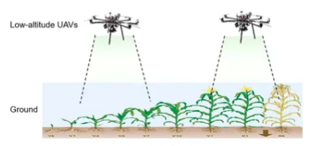

Figure 2
Illustrative of UAV-based crop monitoring

In precision agriculture, the highest value is achieved when the system produces operational outputs for decision support rather than detection alone. As emphasized by Tsouros et al. (2019), practical outputs include spatial analysis of affected areas. Accordingly, GPS-tagged acquisition plays an important role in translating diagnostic results into location-specific by indicating where intervention should be applied.

2.9 Summary of literature review
The reviewed literature indicates a consistent direction across key components of tomato leaf disease analysis. Controlled datasets such as PlantVillage enable string training for leaf classification, yet generalization to open-field conditions remain limited due to variability in illumination, occlusions and background complexity. YOLO-based object detectors are widely used as a foundation for isolating plants and leaves in multi-object agricultural scenes, with recent research support in the context of tomato leaf diseases. In video-based analysis, maintaining temporal consistency requires tracking and identity assignments to handle weak detections and partial occlusions. ResNet50 is repeatedly supported as a strong backbone for leaf disease classification, including tomato specific studies, while temporal aggregation across frames provides a stabilizing layer that improves decision reliability in sequential data. Finally, integrating UAV-based acquisition with geo-referenced localization supports the transition from research models toward practical precision agriculture decision support by linking diagnostic to spatially actionable treatment locations.
3 Project description

3.1 Project pipeline
The project pipeline processes UAV video frames by detecting plants and then detecting, tracking and classifying leaves within each plant region. Results are aggregated over time and integrated at the plant level. The output provides a 12-digit GPS location and detected disease label(s) for diseased plants. A detailed pipeline diagram is provided in Appendix A.

3.2 Requirements

3.2.1 Functional
1 | The system should be able to process drone-captured video as input
2 | The system should be able to process long-duration videos
3 | The system should detect tomato plants in each frame
4 | The system should track detected plants across frames
5 | The system should assign a consistent PlantID to each tracked plant
6 | The system should crop Plant ROI for each detected plant in the frame
7 | The system should detect leaves within each plant ROI
8 | The system should track detected tomato leaves across frames
9 | The system should assign consistent LeafID to each tracked leaf
10 | The system should crop a leaf ROI for every detected leaf
11 | The system should classify each tracked leaf
12 | The system should determine the plant status
13 | The system should provide output information for each diseased plant
Table 2

3.2.2 Non-Functional
Table 3
1 | Easy to use interface for the user
2 | Plants should be sufficiently separated from one to another
3 | Robust operation under open-field drone conditions (motion, lighting changes, shadows, occlusions)
4 | Stable tracking performance with minimal PlantID/LeafID switching across frames
5 | Displayed results include GPS location and detected disease label(s)
6 | Compatibility with videos captured by different drone models
7 | Steady frame rate (20fps at least)
8 | Efficient frame processing for long drone videos

3.3 Development process description

3.3.1 Problem description
Detecting diseases in tomato leaves under open-field conditions presents several technical challenges. When using UAV imagery, leaves appear as small objects within wide-field images, making reliable identification difficult. Disease symptoms can be subtle and visually similar across different conditions, which complicates accurate classification at the leaf level. In addition, motion, lighting changes, shadows and partial occlusions can cause inconsistent observations across image sequences, leading to unstable diagnostic decisions over time.

3.3.2 Dataset
The PlantVillage dataset is used as a primary source of labeled data for training and evaluating the leaf disease classification component. It contains high quality images of individual tomato leaves captured under controller conditions and annotated with disease and healthy classes. The structured labeling and visual clarity support supervised learning and provide a consistent benchmark for measuring classification performance.

3.3.3 Database
To manage user accounts and flight records, the system utilizes a lightweight database structure. User account information, including usernames and authentication credentials, is stored in the “User Accounts” table, enabling controlled system access and basic user management. In Addition, the “Flight History” table is used to store metadata related to past UAV flights, such as flight identifiers, timestamps and associated field information. The “Results per Flight” table stores analysis outputs generated for each flight, including detected diseases and relevant spatial data.
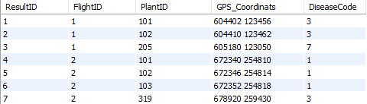
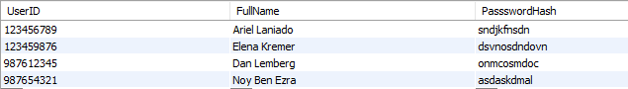
Together, these tables provide an organized and efficient mechanism for managing users and preserving historical data, allowing past analyses to be retrieved when required.
Figure 3

3.3.4 Preprocessing
Video input is decomposed into sequential frames and processed serially using OpenCV. Operational inputs are normalized to ensure consistent handling across long-duration videos. In addition, a continuous preprocessing pipeline is defined to support uninterrupted frame processing while maintaining a minimum processing rate target of at least 20 FPS.

3.3.5 Development process stages

3.3.5.1 Leaf Detection using YOLOv11
A YOLOv1-based detector is used in a two-stage manner. In the first stage, YOLOv11 is applied to the full UAV frame to detect tomato plants. For each detected plant, the corresponding plat ROI is cropped. In the second stage, the same YOLOv11 model is applied to each cropped plant ROI to detect individual tomato leaves. This hierarchical detection strategy enables reliable localization of small leaf objects while reducing background clutter.

3.3.5.2 Tracking and identity assignment
Multi-object tracking is applied after detection to associate leaf bounding boxes across consecutive frames. Each detected leaf is assigned a consistent LeafID, and where applicable, linked to corresponding PlantID. The goal of this stage is to minimize identity switching, support partial occlusions and preserve entity continuity throughout the video.

3.3.5.3 ROI cropping and input normalization
Leaf regions of interest are cropped from each frame based on the detected bounding boxes. The cropped ROIs are resized to fixed resolution of 224×224 pixels to provide a uniform input for the classifier. This step reduces background noise, Standardizes and lowers computational load to enable efficient processing of long video sequences.

3.3.5.4 Disease classification using ResNet50
A ResNet50-based CNN is applied using transfer learning to classify leaf diseases at the ROI level. The model is trained on PlantVillage dataset on a labelled test set, followed by generalization assessment on field data. The output of this stage is a probability vector over healthy and disease classes for each processed ROI.

3.3.5.5 Temporal aggregation
Classification probabilities are accumulated for each LeafID over predefined temporal window. A final leaf-level label is determined by averaging the aggregated probabilities. The purpose of this stage is to reduce frame-to-frame variability and improve reliability at the entity level.

3.3.5.6 Plant status inference
Leaf-level results associated with the same PlantID are combined to infer the overall condition of the plant. This stage produces a plant-level output record that includes the plant identifier, relevant disease labels and a final status assessment.

3.3.5.7 Spatial mapping and GPS-linked output
Plant-level classification results are associated with spatial location information derived from flight data. The final operational output includes GPS coordinates and disease labels to support field-level treatment and decision making.

3.4 Expected challenges
The development of a UAV-based leaf disease detection pipeline involves several practical challenges arising from open-field conditions and sequential video analysis. The following challenges reflect expected limitations related to detection, tracking classification and temporal consistency throughout the processing pipeline.

3.4.1 Plant overlap and collision in dense field scenes
In open-field conditions, neighboring plants may overlap or collide within the camera view, making it difficult to clearly separate plant boundaries. Such interactions can affect both plant detection accuracy and the association of leaves to the correct plant.

3.4.2 Intermittent leaf visibility
Leaf may be visible in certain frames and become temporarily occluded or exit the field view in others. This intermittent visibility complicates tracking and may disrupt temporal aggregation.

3.4.3 Identity confusion due to leaf replacement over time
A leaf tracked in earlier frames may later be replaced by another visually similar leaf occupying a nearby spatial position. This can lead to incorrect reuse of LeafID assignments and reduce tracking consistency.

3.4.4 Limited disease visibility due to leaf orientation
Disease symptoms may not always be visible due to leaf orientation to the camera, such as side-facing of folded leaves. In such cases, visual information may be insufficient for reliable disease classification.

3.4.5 Motion blur and frame degradation
UAV motion, wind or rapid camera movement may introduce motion blur or reduce image quality. Degraded frames can negatively affect both detection and classification performance.

3.4.6 Illumination variability in open-field conditions
Changing lighting conditions, including shadows and sunlight intensity, introduce visual variability across frames. These effects can reduce consistency in detection and classification results.

3.4.7 Maintaining tracking consistency in long video sequences
Long-duration video sequences increase the likelihood of accumulated tracking errors over time. Preserving stable LeafID and PlantID throughout extended flights remains a practical challenge.

3.5 Tools and technologies

3.5.1 Programming language and environment
The system is developed using Python, which provides extensive support for computer vision and deep learning workflows. Development and experimentation are conducted in a standard desktop environment using common Python tools and libraries.

3.5.2 Computer vision and video processing
OpenCV is used for video decoding, frame extraction and basic image processing operations. It enables sequential processing of UAV video data and supports efficient handling of long video sequences.

3.5.3 Deep learning frameworks
PyThorch is used as the primary learning framework for model implementation and inference. It supports integration of both detection and classification models within a unified processing pipeline.

3.5.4 Object detection and tracking
YOLOv11 is used for hierarchical detection of tomato plants in full UAV frames and tomato leaves within cropped plant regions. A multi-object approach is applied to maintain consistent LeafID and PlantID assignments across consecutive frames.

3.5.5 Dataset and model training resources
The PlantVillage dataset is used as the primary labeled dataset for training and evaluating the leaf disease classification model. Pretrained model weights are utilized as part of transfer learning approach.

3.5.6 Database management
A MySQL database is used to manage user accounts, flight history metadata and detection results. Thise supports structured storage of system data and retrieval of historical analysis records.

3.5.7 Visualization and output handling
Processed outputs, including detected disease labels and GPS-linked plant locations, are organized into structured results suitable for presentation and further analysis.

3.6 System architecture

3.6.1 Architecture overview
The system architecture is organized as a modular processing pipeline that operates on UAV video data. The architecture separates functionality into distinct components responsible for video handling, detection, tracking, classification and data management. Each module processes structured inputs and produces well-defined outputs, enabling clear data flow and maintainability. This architecture supports sequential video analysis while allowing integration of spatial information and persistent storage of results.

3.6.2 Use-Case diagram
The use-case diagram presented in this section shows the primary interactions between the user and the system.
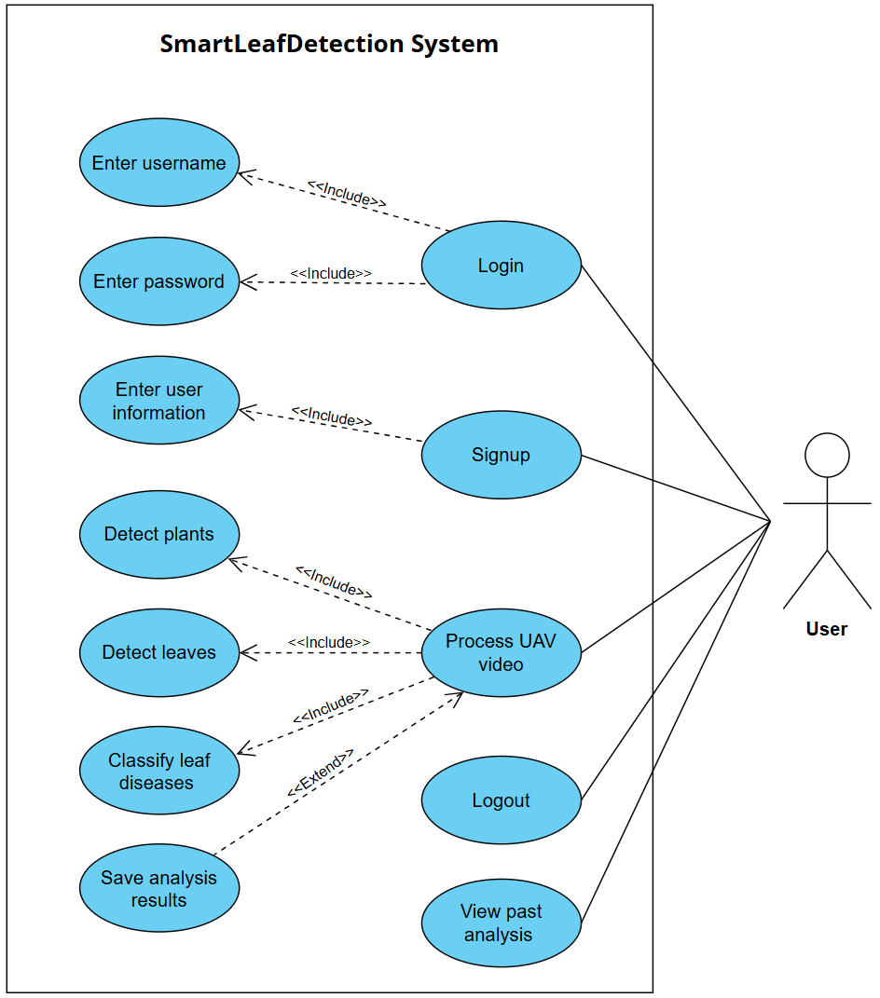

Figure 4

3.6.3 Activity diagram
The activity diagram presented in this section provides a simplified representation of the UAV-based tomato leaf analysis workflow.
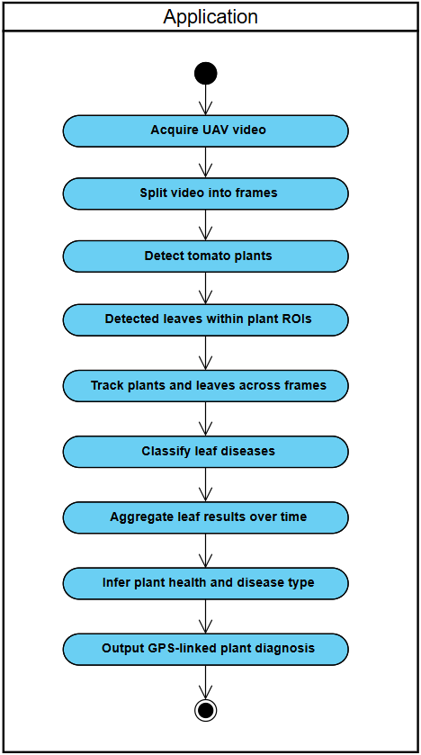

Figure 5

A more detailed version of the activity diagram is provided in Appendix B.

3.7 Evaluation and Verification

3.7.1 Evaluation
We will evaluate the system in several stages that follow the processing pipeline. First, we will evaluate plant and leaf detection performance on UAV frames by comparing detected bounding boxes to ground-truth annotations, to measure leaf detection accuracy under open-field imaging conditions. We will then evaluate leaf disease classification by running the ResNet50 classifier on cropped ROIs from labeled PlantVillage test data and measuring classification accuracy across the healthy and disease classes. After validating single-frame performance, we will evaluate temporal diagnosis stability by processing UAV video sequences and examining whether the predicted label for the same LeafID remains consistent across a predefined time window.
In addition to accuracy, we will evaluate tracking and system-level performance on long UAV videos. Plant and leaf tracking consistency will be evaluated by analyzing PlantID and LeafID continuity across frames and counting identity switches in annotated sequences. Runtime performance will be evaluated by measuring the achieved processing rate (FPS) during continuous processing of long videos.
Furthermore, we will evaluate field disease coverage by measuring the proportion of diseased plants that are successfully identified in open-field flights. Generalization gap will be assessed by comparing results obtained on controlled PlantVillage data to results obtained on field videos.
Finally, we will evaluate the contribution of the detection stage by comparing classification outcomes when using leaf ROIs versus attempting classification directly from full field frames, and we will evaluate plant-level decision reliability by comparing inferred plant status to available ground-truth labels.

3.7.2 Verification plan
This verification plan describes how the proposed system will be tested, together with the supporting components used to store and manage analysis. To ensure reliable and systematic validation of the system, the testing process will be conducted in a structured and repeatable manner. The verification process is intended to confirm the system’s functional correctness, performance and robustness under both controlled and field conditions. Each test is defined by the tested module, the specific function under examination and the expected outcome. An overview of the verification tests is presented on the table below.

Test | Module | Testing Function | Expected Results
1 | Authentication | Login & registration | Users can register and login successfully
2 | Video processing | Video decoding & frame extraction | Video is processed into frames successfully
3 | Plant detection | Plant detection | Plant boxes are produced correctly under representative field conditions (lighting, occlusion, blur)
4 | Leaf detection | Leaf detection within plant ROI | Leaf boxes are produced correctly under representative field conditions (lighting, occlusion, blur)
5 | ROI cropping | ROI extraction | ROIs are cropped from bounding boxes and normalized
6 | Disease classification | Leaf-level classification | Valid disease probability vector and class label are produced for each leaf ROI
7 | Temporal aggregation | Probability aggregation | Leaf label is computed by averaging probabilities across frames for each LeafID
8 | Plant tracking | PlantID assignment | PlantIDs remain consistent across frames with minimal identity switching
9 | Leaf tracking | LeafID assignment | LeafIDs remain consistent across frames with minimal identity switching
10 | Plant-level Inference | Plant status inference | Leaf results are combined into a plant-level disease decision consistent with ground truth
11 | Runtime Performance | Processing speed (FPS) | Average throughput meets target at least 20 FPS on long videos
12 | Generalization & Coverage | Field coverage & generalization gap | Diseased plant coverage meets target of at least 98% and gap up to 9%
Table 4

3.8 Client interface
Login UI
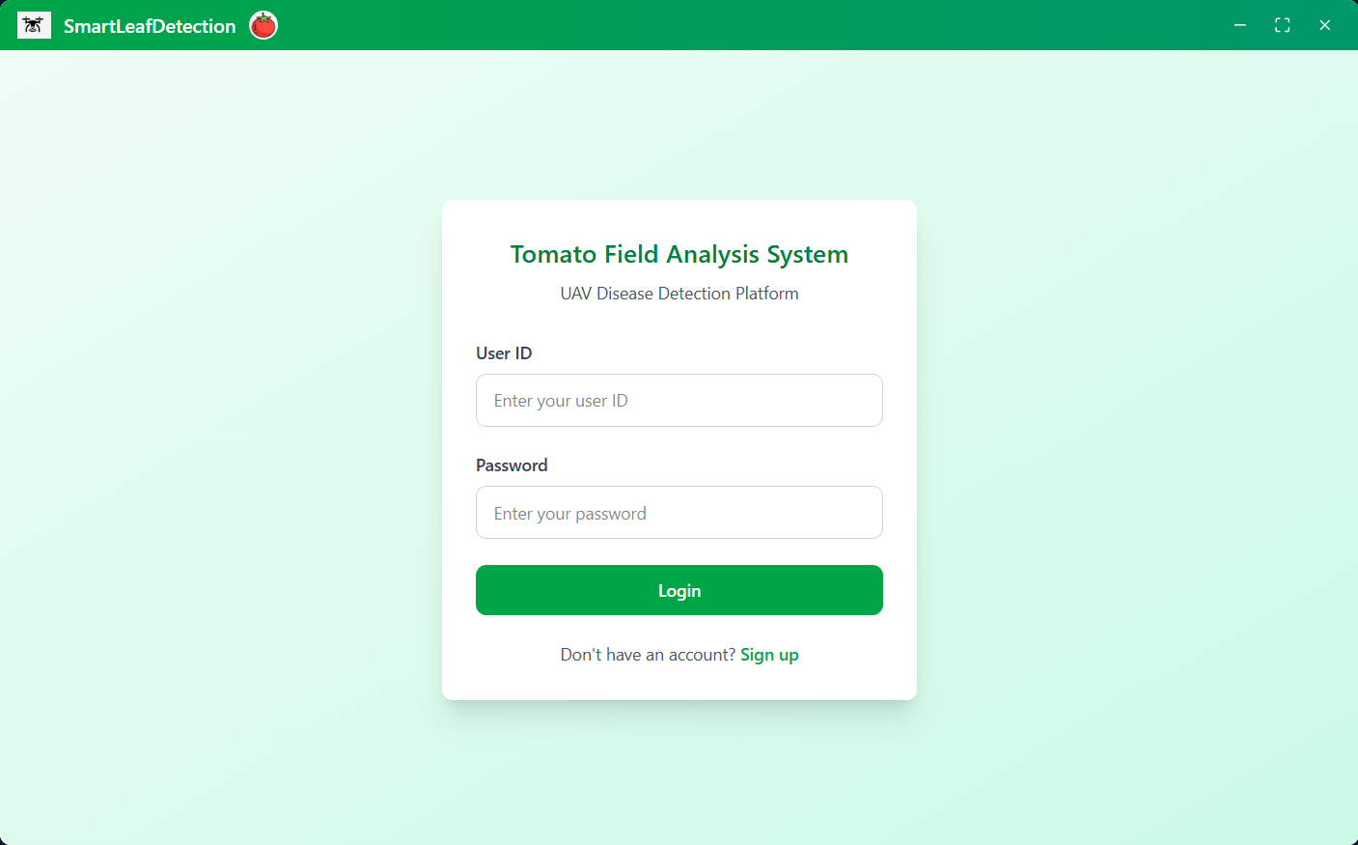
Figure 6

Registration UI
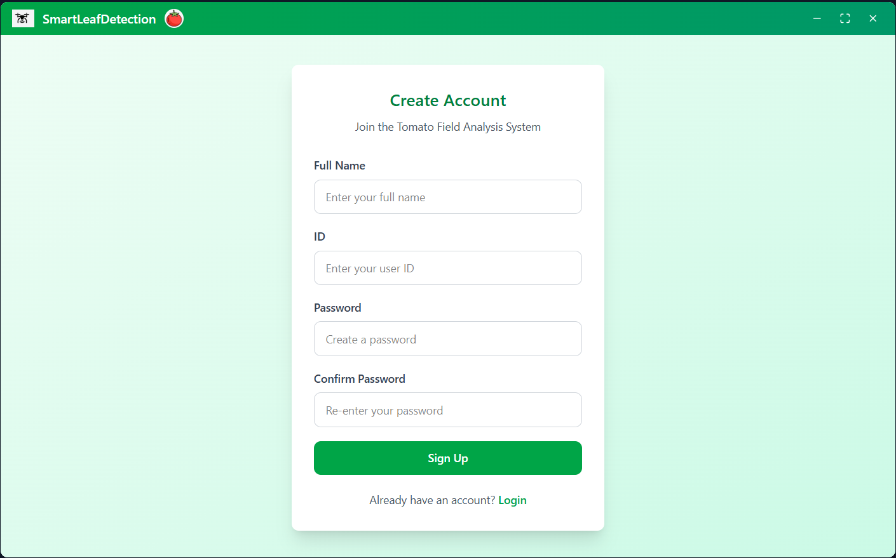
Figure 7
Dashboard UI
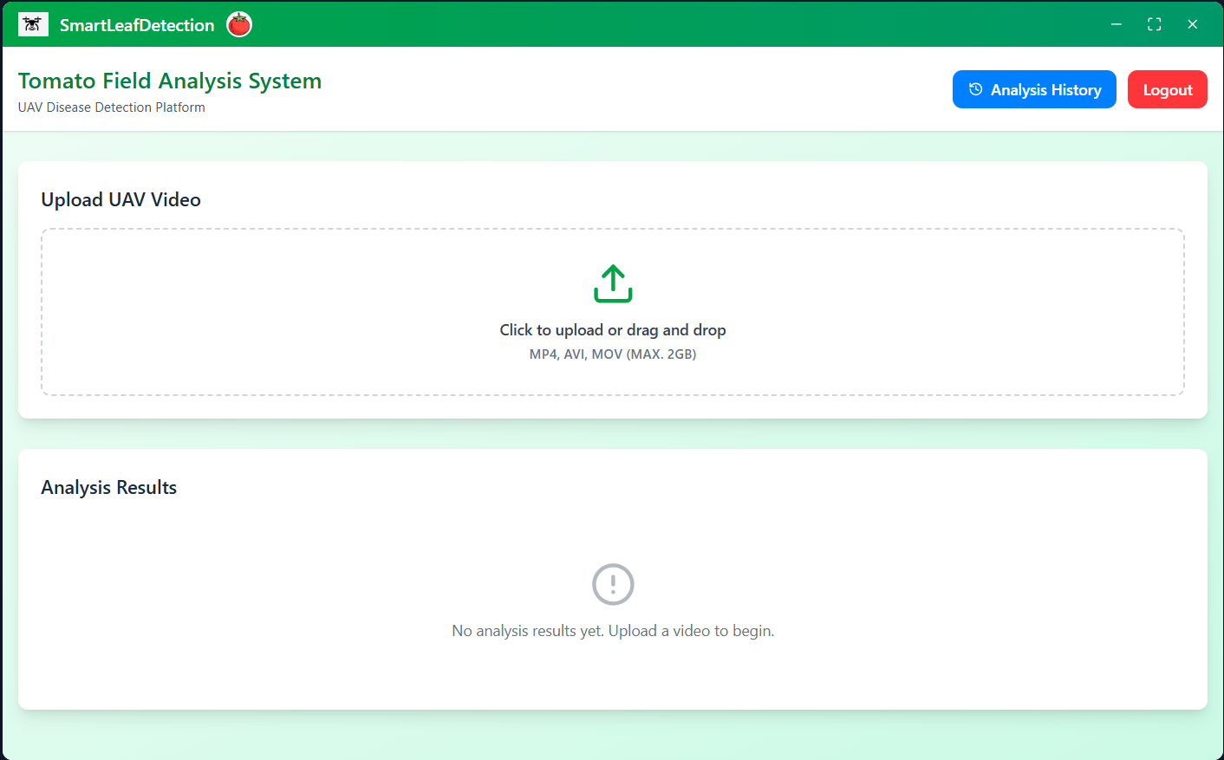
Figure 8

Flight history UI
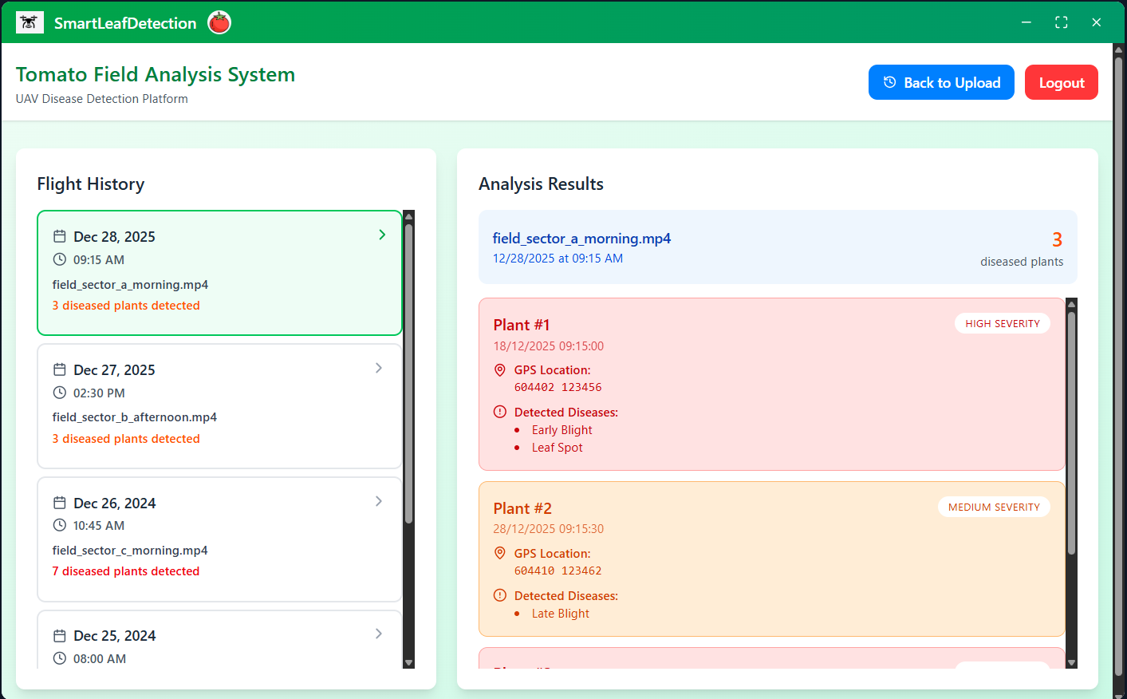
Figure 9

3.9 AI tools example prompts
As part of the research and design process, AI-based tools were used to support exploration of technical concepts, system modeling decisions and interface prototyping. In accordance with this project requirements, this section documents the AI tools used during the research phase, provides direct links to each tool and presents representative example of prompts written for them. The listed prompts reflect typical interactions used to clarify concepts, structure system diagrams and support preparation of the project documentation.

3.9.1 AI tools (Links)
ChatGPT - https://chat.openai.com
Figma AI - https://www.figma.com
Gemini - https://gemini.google.com
NotebookLM - https://notebooklm.google.com
Miro AI - https://miro.com/ai

Example prompts
The following list present prompts written and used during interactions with the AI tools listed above. These prompts reflect research, design and documentation-related queries used throughout the project.
ChatGPT
- What information should be included in a simplified activity diagram for an academic report?
- I’m in the section of Background and related work, how do I cite references correctly using APA style?
Figma AI
- Generate a clean login screen layout for agricultural monitoring application
Gemini
- Find recent academic articles on UAV based crop disease detection using YOLO
- How is this article related to my project on tomato leaf disease detection?
NotebookLM
- Summarize the following article
- What are the main points of this article and how does it relate to tracking objects across video frames?
Miro AI
- Generate simple visual icons representing the processing stages in the system pipeline

References
- Brahimi, M., Boukhalfa, K., & Moussaoui, A. (2017). Deep learning for tomato diseases: classification and symptoms visualization. Applied Artificial Intelligence, 31(4), 299-315.‏
- Kamilaris, A., & Prenafeta-Boldú, F. X. (2018). Deep learning in agriculture: A survey. Computers and electronics in agriculture, 147, 70-90.‏
- Liang, J., & Jiang, W. (2023). A ResNet50-DPA model for tomato leaf disease identification. Frontiers in Plant Science, 14, 1258658.‏
- Lu, C., Nnadozie, E., Camenzind, M. P., Hu, Y., & Yu, K. (2024). Maize plant detection using UAV-based RGB imaging and YOLOv5. Frontiers in Plant Science, 14, 1274813.‏
- Ramos, L. T., & Sappa, A. D. (2025). A comprehensive analysis of YOLO architectures for tomato leaf disease identification. Scientific Reports, 15(1), 26890.‏
- Saeed, A., Abdel-Aziz, A. A., Mossad, A., Abdelhamid, M. A., Alkhaled, A. Y., & Mayhoub, M. (2023). Smart detection of tomato leaf diseases using transfer learning-based convolutional neural networks. Agriculture, 13(1), 139.‏
- Too, E. C., Yujian, L., Njuki, S., & Yingchun, L. (2019). A comparative study of fine-tuning deep learning models for plant disease identification. Computers and Electronics in Agriculture, 161, 272-279.‏
- Tsouros, D. C., Bibi, S., & Sarigiannidis, P. G. (2019). A review on UAV-based applications for precision agriculture. Information, 10(11), 349.‏

Appendices

Appendix A: System pipeline

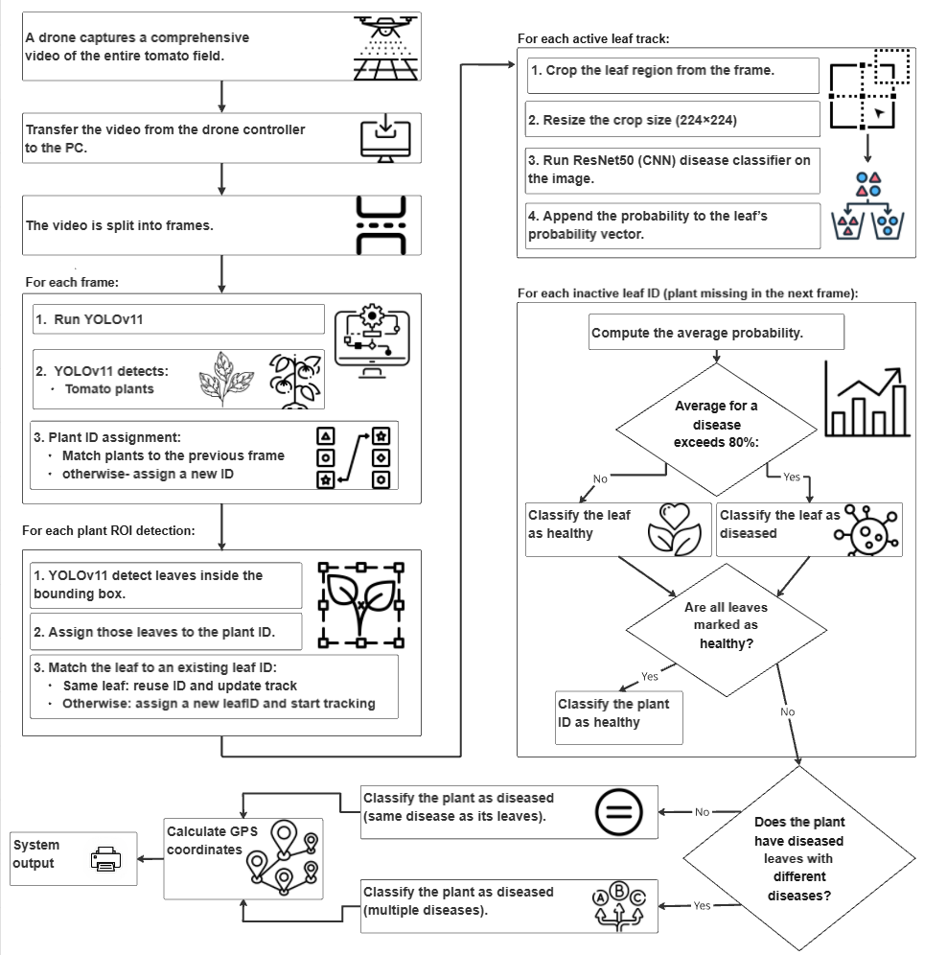
Appendix A presents the high-level processing pipeline of the proposed UAV-based tomato leaf disease detection system, illustrating the main stages from video acquisition through plant- and leaf-level analysis to final GPS-linked output.

Appendix B: Extended activity diagram
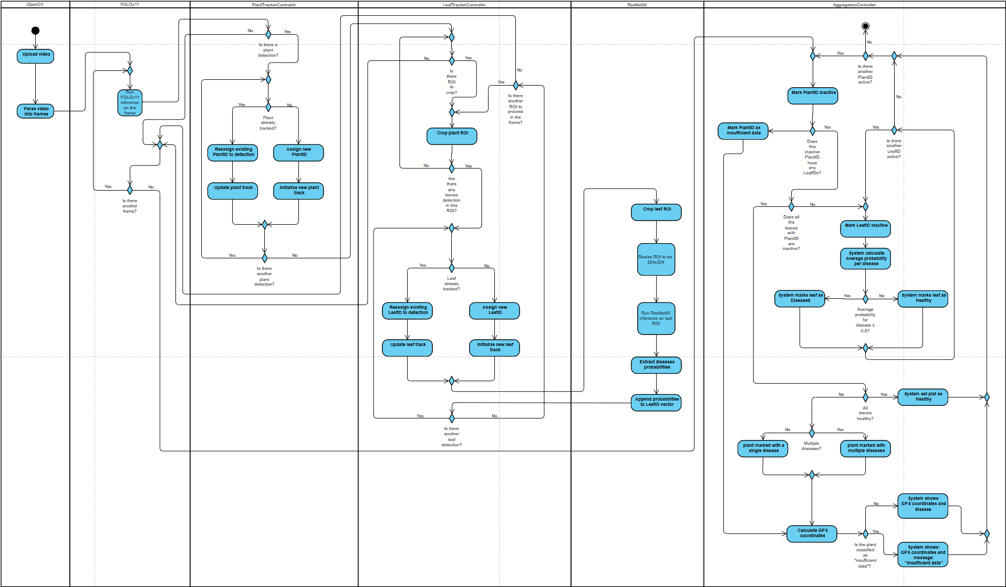
Appendix B presents the extended activity diagram of the proposed system, detailing the control flow across modules for plat/leaf detection, tracking, classification and temporal aggregation. This diagram complements the simplified activity diagram presented in 3.6.3.

