**Book Management System Guide**

**Part 1: The Website**

The system can be run by putting all the HTML, PHP files and CSS files into the *htdocs* directory:  
 - Linux: /opt/lampp/htdocs/  
 - Windows 10: C:\xampp\htdocs\

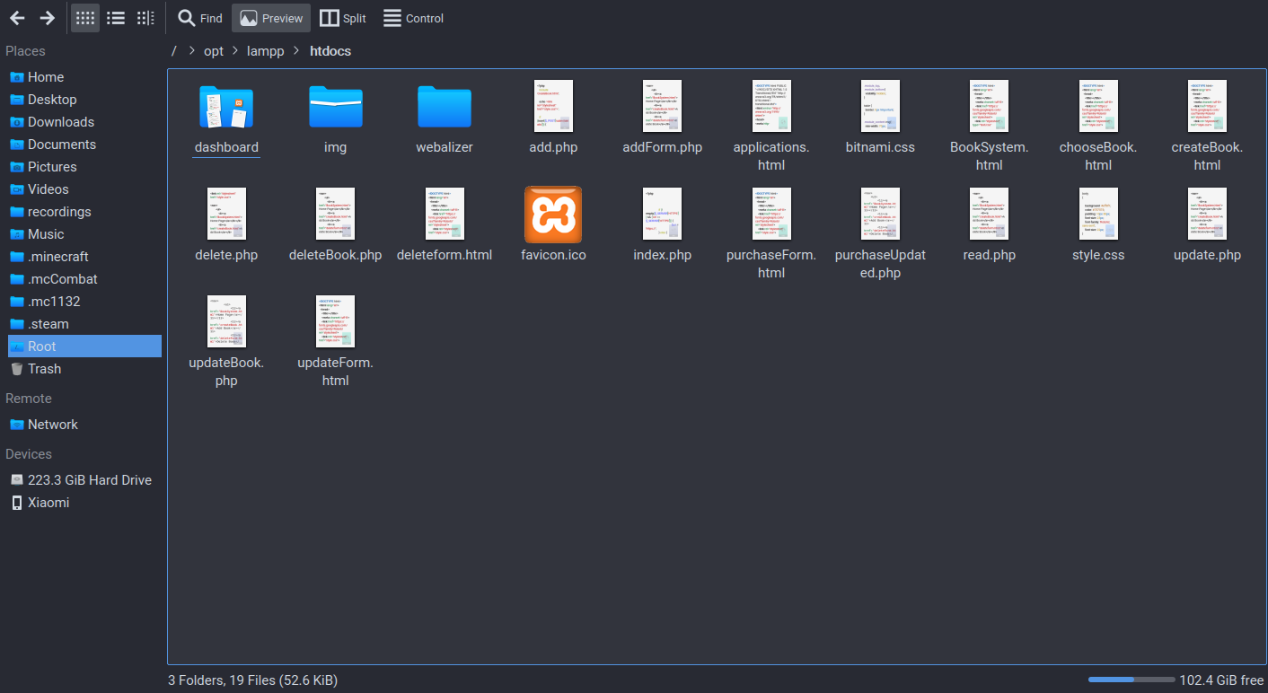

Make sure XAMPP and MYSQL are running on your system. Going to *localhost* on your web browser should show the greetings page for xampp.

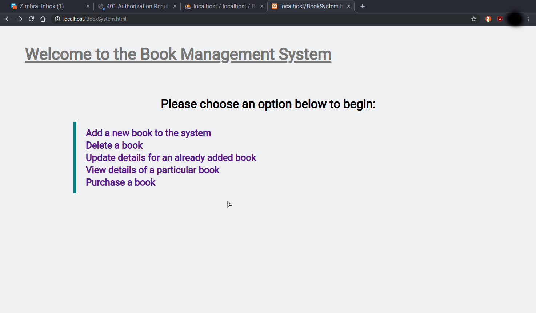Once *localhost* is working, you can go to *localhost/BookSystem.html* to start the Book system and to get to the options you can have.

On this screen you can choose any of the 5 options below.  
 - Add a Book

- Delete a Book  
 - Update Details  
 - View details of a book  
 - Buy a Book

On the main page, *BookSystem.html*, there is no navbar because the options are already in the list on the page. There is no need for the navbar in this case.

Once you choose an option, you can easily go back to the home page at any time or go to another page by using the navigation bar at the top of any page, except the home page.



The *Add Book* page gives you the option to create a new entry in the database, it asks you for the book details apart from the *BookID* as this value is auto incremented in the database system.  
Press the submit button once done giving the details and it will add this book to the system assuming no errors occur.

The *Delete Book* page gives you the option to enter the *BookID* for the book you want to delete and then it will remove that entry from the database table when you press submit.

The *Update Book* page lets you give a *BookID* to edit and then puts the details into text boxes for you to freely change. This is also the way to update the *stoc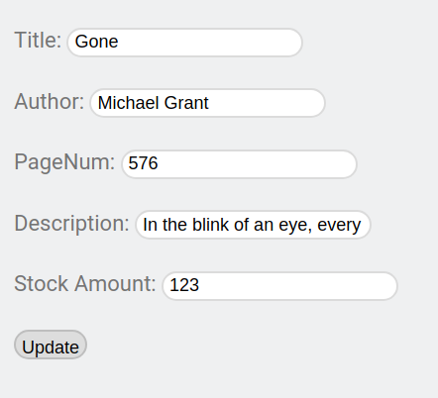k amount* of any book in the table.

The *View Book* page allows you to view thew details of any book you want that is in the table, this is different to the update page because you can only read the details and not change them.

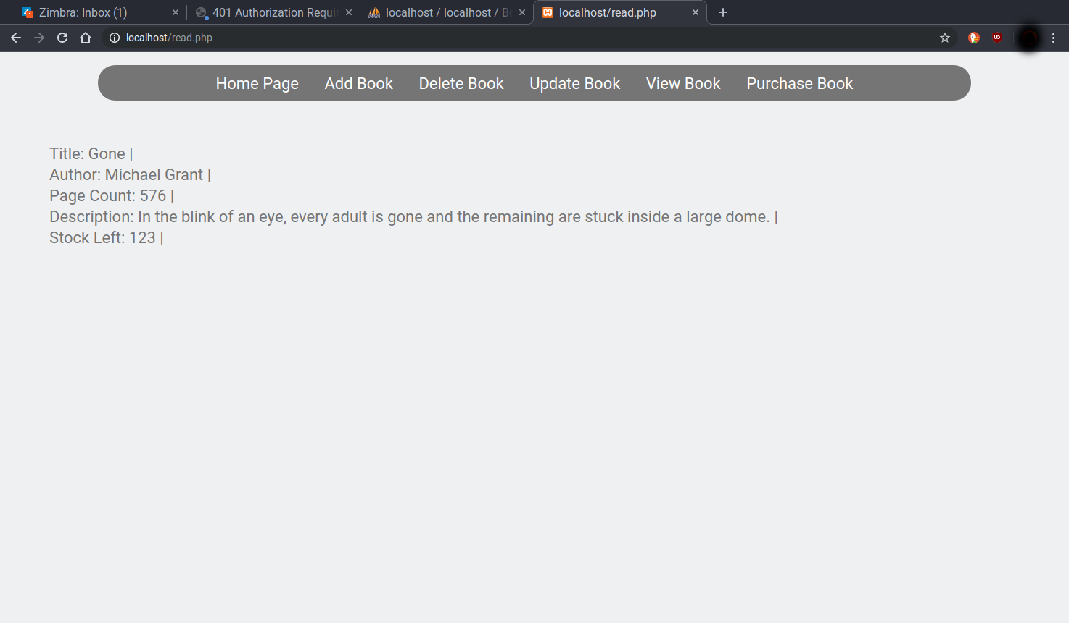

Lastly, the *Purchase Book* page lets you buy a book using it’s ID number.  
This will tell you that you have bought the book and also it will reduce the stock count for that book by 1. I tried to make the purchase use the Title instead of BookID, as it would make more sense for this trask but everything I tried did not work using that.

**Part 2: The Database**

To get the database set up, you can use the commands in *BookSite.sql*.  
You can use the *phpMyAdmin* page that you can get to from the localhost dashboard to import this script into. You could also copy/paste into the SQL query writing page.

This will create the database called *BookSite*, it will also create the table *Books* and insert 3 entries into it for testing purposes. Of course, you can add more or remove any on the *Add Book* and *Delete Book* pages.

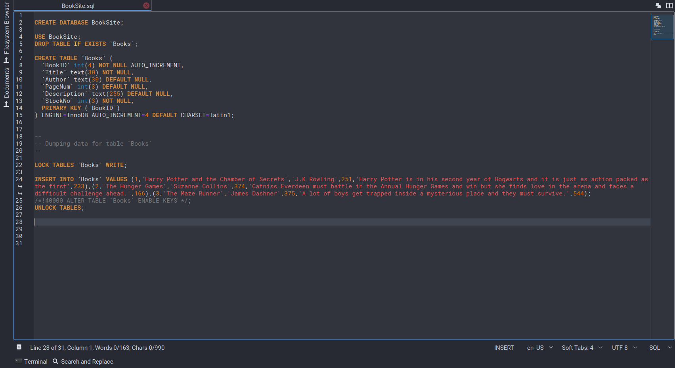

After the commands have been run, you should get this database and table for you to use.