**Team Jackson Class Roll Program Documentation**

**DESIGN**

1. Requirements:

The program needs to implement a small student maintenance system. It will store the name, UID, email, and three specific grades for each student. The three grades are for the presentation, essay, and term project. The system needs to incorporate the ability to read and write student data, add and delete students, as needed, and update any of the student data fields within the record. Also, the ability to search and retrieve student data should be available. The search can be based on name, ID, or email.

1. Architecture:

The architecture of the program consists of three classes: a Student class, a ClassRecords class, and a ClassRecordsUI class. The Student class contains all the data fields as described in the requirements. The ClassRecords class is a vector of Student objects. This class contains the functions for creating, deleting, and updating the data within each of the Student objects. It also has the function for searching for a specific Student object based on the name, ID, or email. The ClassRecordsUI class manages the visual presentation within the console, as well as console input and output.

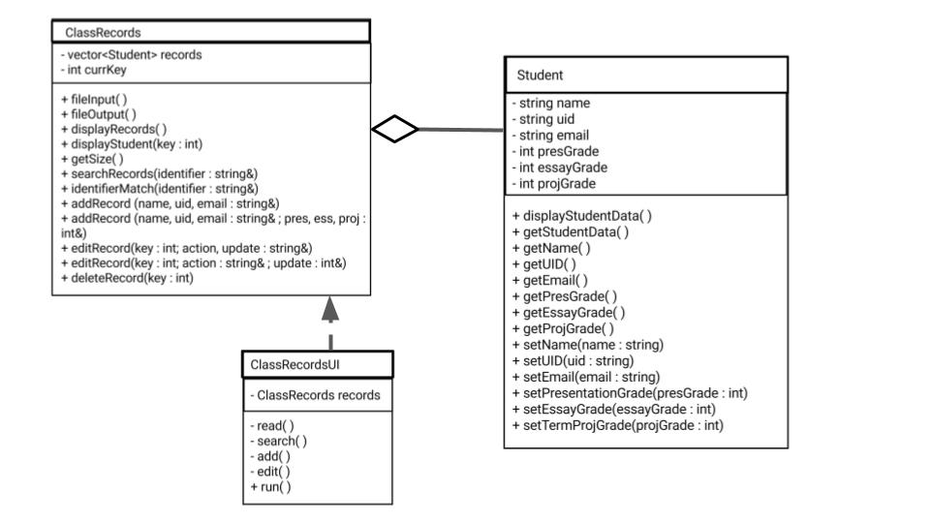

1. Data:

Each of the Student objects contain six editable attributes. The name, UID, and email are stored as strings and the three grades are stored as doubles. The storage of each of these Student objects is maintained via the C++ standard library vector container. This allows for varying the class roll size and a simple search by attribute feature.

As for file storage, records are read from and stored in the file named “ClassRecords.csv”. Student records are stored as comma separated values with fields appearing in the following order: Name, UID, Email, Presentation Grade, Essay Grade, Project Grade.

1. Usage:

Simply build the program and run to be greeted with a console menu.

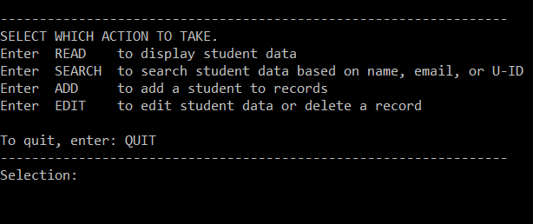

Here simply enter the desired action (not case-sensitive). The results of the action will be displayed below.

