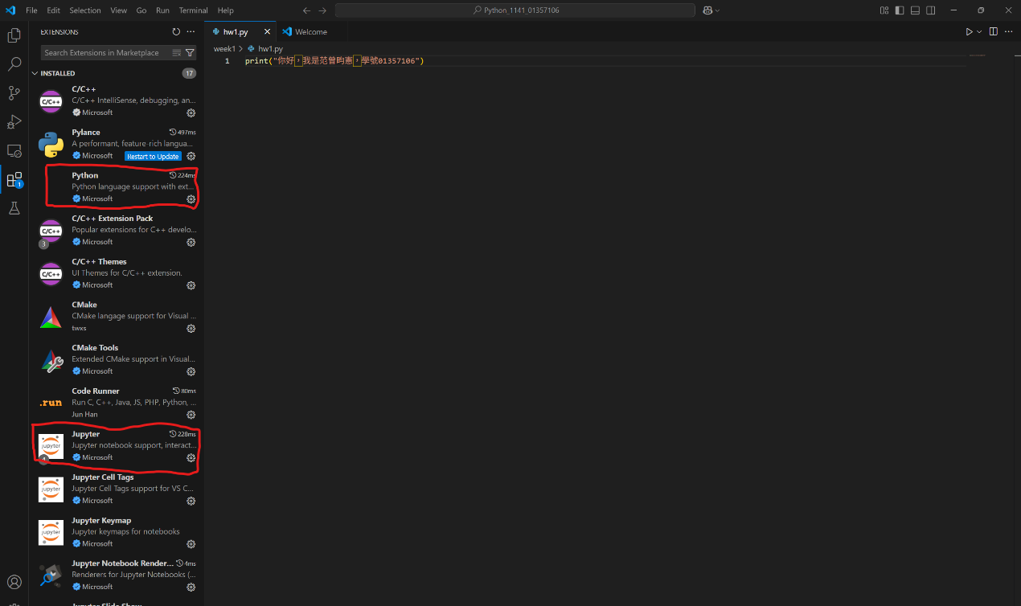
https://github.com/Lankongs/Python_1141_01357106.git

