**FPT UNIVERSITY DA NANG**



**FINAL REPORT**

**EXPERIENTIAL ENTREPRENEURSHIP 1**

**ONLINE CLOTHING PASS PLATFORM**

| **Lecturer:** | **Nguyen Thi Tu Suong** |
| --- | --- |
| **Class:** | **EXE101_7XE101_7** |
|  |  |
|  |  |

**Members:**

| 1. **Van Thi Phuc - DS180401** |
| --- |
| 1. **Nguyen Le Phuong Uyen - DS180486** |
| 1. **Dang Nguyen Phu Cuong - DS180431** |
| 1. **Nguyen Thi Lan Nhi - DE180829** |
| 1. **La An Thien - DE180858** |
| 1. **Tran Thi Truc Vy - DE180838** |
|  |

**MEMBER PROFILE**

**Nguyen Thi Lan Nhi, CEO (Chief Executive Officer)**

* The CEO is the head of the company, responsible for overall leadership, strategic direction and making the most important decisions.

**Nguyen Le Phuong Uyen, COO (Chief Operating Officer):**

* The COO is the person who ensures the company runs smoothly every day. The COO will coordinate closely with departments to optimize work processes, helping the company operate effectively, save costs and achieve high performance.

**Dang Nguyen Phu Cuong, CFO (Chief Financial Officer):**

* The CFO is responsible for monitoring the company's financial situation, including budget management, preparing income and expenditure reports, controlling cash flow and building short-term and long-term financial plans.

**La An Thien, CTO (Chief Technology Officer)**

* CTO is the head of technology, responsible for choosing the technical platform, designing the system architecture and managing the product development team. CTO ensures that the product (app, website, platform...) is built in the right direction, secure, scalable and stable.

**Van Thi Phuc, CMO (Marketing Director)**

* CMO is the person in charge of the entire marketing strategy of the company, from brand communication, digital marketing, advertising, to market research and building customer files.

**Tran Thi Truc Vy, DEV**

* Developer is the person who directly writes code to build the product. They turn ideas into specific features on the technology platform, fix bugs, optimize performance and update new functions.

1. **Overview**
2. **Start up idea and reason**

* ReVibe is a platform designed to build a modern, sustainable ecosystem for trading secondhand fashion—catering to the needs of both sellers and buyers. For sellers, ReVibe makes it simple to list items, manage orders transparently, and grow their reputation through a built-in review system. On the buyer’s side, the platform offers a secure and up-to-date shopping experience with fair prices, unique fashion choices, and clear, honest product information.
* But ReVibe is more than just a marketplace. It’s also a growing community that promotes eco-friendly living, where users are encouraged to share and support sustainable consumption habits with one another and the broader society.

**Reasons for the idea**: The idea of ReVibe was born from the awareness of three main problems in modern society:

* Cutting Down Waste & Protecting the Planet: The fast fashion industry is one of the biggest contributors to environmental waste. By giving clothes a second life, ReVibe helps reduce pollution and the overall environmental impact of discarded garments.
* Helping Students & Young Adults Save Money: Many young people and students live on limited budgets. Secondhand clothing offers them access to stylish, good-quality pieces at affordable prices—and sometimes even through free exchanges.
* Tapping into a Growing Market: The secondhand fashion industry is expanding quickly, both in Vietnam and worldwide. This presents an exciting opportunity to launch a meaningful startup that meets the rising demand for more sustainable and budget-friendly fashion choices.

1. **Business name**

* The name “ReVibe” is a blend of two words: “Re” and “Vibe.” “Re” comes from recycle, representing the act of reusing and giving new life to something old. “Vibe” refers to personal style, individual expression, and aesthetic taste.
* Together, ReVibe reflects the idea of reviving emotions, renewing personal style, and bringing fresh energy to pre-loved fashion. It’s about recreating value from the past and turning secondhand clothing into something meaningful, stylish, and sustainable again.

1. **Logo & Slogan**

** Logo:** The ReVibe logo centers around the image of a piece of clothing—symbolizing the heart of the platform. Surrounding it is a soft blue arc, representing circularity and continuous flow. Together, these two elements convey ReVibe’s core message: breathing new life into old garments and creating sustainable fashion cycles. It’s a visual representation of renewal, movement, and mindful consumption.

**Slogan: “Saving for you – Sustainable for the Earth”:** This slogan highlights the two key values ReVibe aims to deliver to the community: helping users save money while also protecting the planet. Through affordable secondhand fashion and a focus on reusability, ReVibe empowers individuals to make choices that are both financially and environmentally responsible.

1. **Vision & Mission**

**Vision:** ReVibe aspires to become the leading platform for modern secondhand fashion, redefining how the community views pre-owned clothing. The goal is to shift the perception—from secondhand being “used” to secondhand being smart, stylish, and sustainable.

ReVibe seeks to inspire Gen Z to embrace fashion not just as a form of self-expression, but as a way to take responsibility for the planet. Fashion isn’t only about buying new things—it’s about making choices that reflect values, purpose, and environmental awareness.

**Mission:** ReVibe’s mission is to empower Gen Z and the younger generation to take control of how they buy, sell, and exchange fashion—quickly, easily, and consciously. Through a user-friendly, community-driven platform, ReVibe enables young people to become active participants in a circular fashion economy that values both style and sustainability.

1. **Main objectives**

**a. Encourage sustainable fashion through sharing and reusing clothes.**

* ReVibe encourages the habit of reusing clothing by regularly sharing messages about the importance of sustainable fashion. By making it easy and accessible, the platform helps users embrace a lifestyle of mindful consumption.
* With just a few simple steps, users can list their pre-loved items on ReVibe. The platform includes built-in support tools such as suggested product descriptions, brand tagging, material indicators, and condition labels—making it easier for sellers to present their items clearly and attractively.

**b. Raise public awareness of environmental protection**

* ReVibe runs a variety of communication campaigns to educate the public about the impact of fashion waste and the value of sustainable alternatives. These include engaging articles, infographics, and short videos that highlight both the environmental harm caused by fast fashion and the positive changes sustainable fashion can bring.
* Additionally, ReVibe actively shares content about eco-friendly lifestyles and reuse culture across social media channels—helping spread green values to a wider audience.

**c. Facilitate access to quality clothing at reasonable prices**

* To make fashion more inclusive, ReVibe offers a smart filtering system that allows users to search by price range, size, brand, and personal style. From affordable basics to premium labels, the platform curates a wide range of clothing to meet the needs of different customer segments.
* ReVibe also runs frequent promotions and special offers, giving users more opportunities to shop sustainably without stretching their budgets. All transactions are transparent and secure, ensuring fairness and trust for both buyers and sellers.

**d. Extending the Life Cycle of Garments**

* ReVibe motivates users to refresh their wardrobes by selling, exchanging, or donating clothes that are still in good condition. The platform also provides helpful tips and guides on how to care for and preserve garments—encouraging users to extend the life of each item.

By doing so, ReVibe helps reduce waste and promotes a circular economy where clothing is valued, not discarded.

1. **Market and Target Customers**

**6.1.Market**

* ReVibe is primarily focused on major urban centers with high population density, such as Hanoi, Ho Chi Minh City, and Da Nang. These cities are not only economic and cultural hubs but also home to a large number of universities and young people—the core audience for ReVibe.
* This demographic is ideal for the platform: digitally active, fashion-conscious, and increasingly aware of sustainability issues. By targeting these vibrant, youthful communities, ReVibe aims to build a strong foundation of engaged users who are ready to adopt new habits in fashion consumption and become ambassadors for sustainable living.

1. **Industry outlook**

* 83% of Vietnamese users have bought second-hand goods – this habit is increasingly popular among young people (Carousell 2021)
* 72% of consumers prioritize environmentally friendly products (VnEconomy 2024)
* 57 million Vietnamese people shop online, accounting for 70% of Internet users. This is a great opportunity to promote second-hand trading floors to switch to digital platforms. This industry has strong growth potential and high demand; consumers are ready to welcome new platforms like Revibe.

1. **Market size**

The second-hand market in Vietnam is valued at 1.1 billion USD in 2021. It is expected to triple in size by 2026, reaching around 5–5.1 billion USD (according to RedSeer Strategy Consultants, 2021). This is a large and rapidly growing market.

1. **TAM - SAM - SOM**

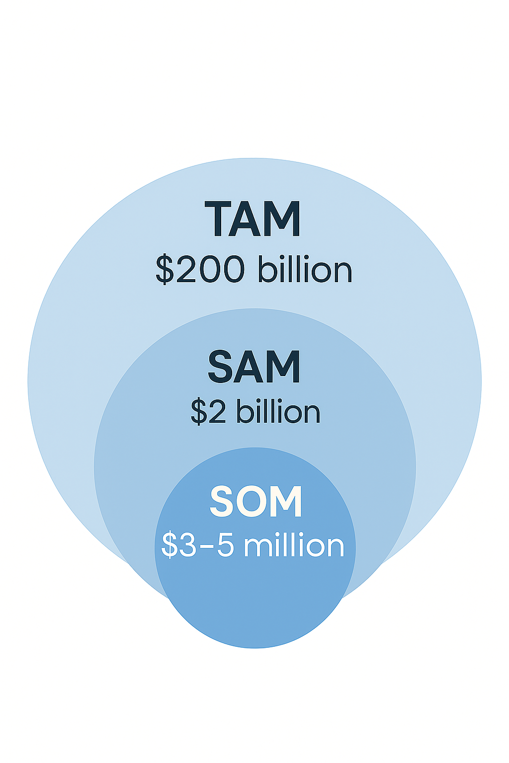

* TAM (Total Addressable Market): **~200 billion USD**

Total estimated value of the global second-hand clothing market.The second-hand resale industry is estimated to reach over 200 billion USD by 2025–2030.

* SAM (Serviceable Available Market): **~2 billion USD**

The market segment that REVIBE can realistically reach and serve in Vietnam. The entire potential market if it serves all buyers and sellers.

* SOM (Serviceable Obtainable Market): **~3–5 million USD** in 2–3 years

Achievable revenue target in the first 2–3 years. (0,15% - 0,25% of SAM)

1. **Market trend**

* Online shopping is becoming more and more popular (After COVID-19, 57 million Vietnamese people shop online, accounting for 70% of Internet users), this is a trend that changes customers' shopping and consumption behavior, which is a condition for REVIBE to develop.
* Generation Z and Millennials lead the trend. The demand for unique and individual second-hand fashion is increasing. The community of people who love second-hand style is expanding.
* Shopping for investment. Some products are limited editions, an opportunity to invest and resell
* Shopping for second-hand goods to protect the environment, sustainable consumption is a positive trend in today's life. Contributing to saving and protecting the surrounding living environment from the huge amount of old clothes thrown away every day

**6.2.Target customers**

***Buyer Segments***

| **Segment** | **Demographic** | **Geographic** | **Psychographic** | **Behavioral** | **Core Needs** |
| --- | --- | --- | --- | --- | --- |
| Gen Z (18–25) | Female, 18–25 years old | Urban areas | Enjoys beauty and fashion, trend-driven, tech-savvy | Shops quickly, loves new experiences, loyal to stylish and trustworthy brands | Affordable – Unique – Fast – Stylish – Trustworthy |
| Young Office Workers | Male & female, 25–30, employed, stable income | Major cities | Practical, values convenience and transparency | Frequently shops online, responsive to clear and smooth services | Smooth transactions – Transparent sourcing – Convenient payment |
| Moms / Homemaker | Female, with children, 25–40 | Urban and suburban | Safety-conscious, budget-minded | Shops based on family needs, values good deals and safe delivery | Convenient delivery – Safety – Easy access – Good value |
| Vintage/Style Seekers | Male or female, 20–35 | Urban areas | Individualistic, fashion-forward, expressing personal style | Seeks unique items, frequently visits fashion marketplaces | Unique items – Verified origins – Trusted sellers – Clear fashion sense |

***Seller Segments***

| **Segment** | **Demographic** | **Geographic** | **Psychographic** | **Behavioral** | **Core Needs** |
| --- | --- | --- | --- | --- | --- |
| Gen Z Student | Male/Female, 18–24, students | Urban areas, near universities | Energetic, budget-conscious, eco-friendly, dislike complex processes | Sell used clothes/items via Facebook or Zalo | Quick posting – No lowball offers – Avoid fake buyers – Easy to use |
| Occasional Resellers | Male/Female, 25–40, freelancers or stay-at-home | Cities and suburbs | Want extra income, not tech-savvy, view selling as a side job | Sell in short bursts, lack deep online selling experience | More visibility – Shipping support – Build personal reputation |
| Moms | Female, 30–50, with families | Urban and rural areas | Careful, not tech-savvy, prefer simplicity and saving money | Re-sell kids’/family clothes, limited digital skills | Simple interface – Price suggestions – Reach right buyers |
| Vintage Sellers | Male/Female, 25–35, fashion lovers | Large cities | Stylish, love fashion, want to express identity through what they sell | Sell unique/vintage items, invest in product presentation | Professional seller profile – Good rating system – Protect brand/reputation |

1. **Key Player & Competitive advantages**
2. **Key Player in Viet Nam**

**-Direct**

| **Platform** | **Price Range** | **Key Feature** | **User Insight** | **Limitations** |
| --- | --- | --- | --- | --- |
| **Chợ Tốt** | 50K – 10M VND | Large user base, free listings, diverse categories | Users trust local, peer-to-peer deals, especially in electronics & clothing | No secure payment, outdated UI |
| **Facebook Marketplace** | 50K – 5M+ VND | Familiar & accessible, peer-to-peer transactions | Highly used by Gen Z & parents for convenience, despite trust concerns | No verification, scams common, hard to search fashionably |

**-Indirect**

| **Platform** | **Price Range** | **Key Value** | **User Insight** | **Limitations** |
| --- | --- | --- | --- | --- |
| **Tiktok Shop** | 50K – 300K VND | Trend-driven, influencer/visual-led content | Strong influence on Gen Z purchase habits; “vibe shopping” | Focused on new/fast fashion; no second-hand model or buyer protection |
| **Lazada/Tiki** | 50K – 400K VND | Vietnam-only resale site with diverse categories | Used for general low-price finds, less attractive to style-focused users | No app, minimal UX, no fashion community features |
| **Shopee (Used section)** | 100K – 700K VND | Logistics, secure payment, huge reach | Shoppers expect Shopee-level convenience even for second-hand items | Not fashion-focused, lacks personalization |
| **2hand.vn** | 50K – 300K VND | Active vintage & sustainability community | Preferred for rare & eco-friendly outfits | No in-app search/navigation, informal posting, no buyer protection |

1. **Competitive advantages**

* **Specialized platform for secondhand goods**

Unlike general online marketplaces that mix a wide range of product categories, ReVibe is fully dedicated to secondhand fashion. This focused approach allows the platform to build a tailored ecosystem, where every feature, tool, and algorithm is specifically designed to support the unique nature of buying, selling, and exchanging used clothing.

From personalized product suggestions to smart filters and an intuitive posting process, everything on ReVibe is optimized to make secondhand fashion transactions faster, easier, and more effective. This specialization helps both buyers and sellers save time, find better matches, and enjoy a smoother, more enjoyable experience on the platform.

* **Friendly interface, optimized for fashion needs**

ReVibe’s mobile application features a modern, intuitive interface inspired by leading international fashion platforms. From the moment users open the app, they’re welcomed into a clean, visually appealing space that makes it easy to browse products, view detailed information, compare items, and place orders seamlessly.

What sets ReVibe apart is how its features are personalized and optimized specifically for fashion shopping. Users can filter items by style, brand, size, condition, and more—allowing for a curated, enjoyable browsing experience that feels both efficient and inspiring.

Every visit to the app is designed to spark new outfit ideas, promote mindful purchases, and keep users engaged with a sense of discovery and personal connection to style.

* **Clear user community with transparent reviews**

ReVibe isn’t just a marketplace—it’s a real community for people who love secondhand fashion. Every member has a verified profile, adding a layer of trust and transparency to the platform. Buyers and sellers are connected through a public rating and review system, where honest feedback and real user comments help others make informed decisions.

This open, community-driven approach reduces the risk of fake accounts, scams, and unreliable transactions, while encouraging respectful and responsible behavior. By fostering trust and accountability, ReVibe creates a safe, supportive space where users can confidently buy, sell, and connect over shared values in sustainable fashion.

* **Brand positioning towards green lifestyle and sustainable fashion**

Unlike traditional e-commerce platforms that focus solely on sales, ReVibe positions itself clearly as a brand dedicated to sustainable fashion. From the start, ReVibe has been built not just to facilitate transactions, but to spread a broader message of green living and conscious consumption.

By promoting the value of secondhand clothing, ReVibe aims to shift public perception—showing that used items are not outdated or undesirable, but rather a smart, stylish, and responsible choice. Through every product listed, every campaign launched, and every feature developed, ReVibe is committed to driving a cultural change around fashion and sustainability.

* **Integrating intermediary shipping and payment, ensuring safety**

ReVibe integrates intermediary shipping and payment systems directly into the app to ensure that every transaction is safe, smooth, and transparent. This built-in protection helps minimize common risks like canceled orders ("ghosting" or "bombing goods") or fraudulent money transfers—issues that often occur in peer-to-peer trading.

With ReVibe, users can confidently buy and sell with strangers on the platform, knowing that their payments and deliveries are handled securely. This level of convenience and safety builds trust within the community and encourages more people to participate in sustainable fashion trading without hesitation.

**8. PESTLE analysis**

1. **P – Political**

* The Vietnamese government is accelerating digital transformation, especially in e-commerce, cashless payments, and the platform economy. This creates favorable conditions for C2C apps like ReVibe to grow.
* Startup support policies and the promotion of circular economy models are being advanced through national innovation and entrepreneurship programs, helping platforms like ReVibe gain easier access to funding, media exposure, and support networks.

There is an opportunity to benefit from macro-level policies, but it’s essential to establish an internal legal framework to build trust and ensure effective operations.

1. **E – Economic**

* Gen Z makes up the majority of Vietnam’s young population, with low to middle income, so they prioritize smart spending and enjoy “saving wisely” through buying secondhand items.
* Vietnam’s e-commerce market is growing at around 20% annually, especially in the fashion sector – providing momentum for online fashion platforms to thrive.

By aligning with the saving trend, ReVibe can become a popular choice among Gen Z if it offers a seamless buying–selling experience and clear value proposition.

1. **S – Social**

* Gen Z values self-expression and unique fashion styles, rather than following mass-market trends.
* The fashion-loving community is shifting toward a model of connection – inspiration – outfit sharing, creating an opportunity for ReVibe to become more than just a marketplace, but a fashion-focused social network.

If ReVibe can build a “community vibe” that resonates with Gen Z, it can retain users longer than traditional e-commerce platforms.

1. **T – Technological**

* ~80% of Vietnam’s population uses smartphones, and mobile-first shopping behavior is widespread.
* Platforms like TikTok, Reels, and swipe-based UX have shaped a habit of “swipe – view – like – buy” quickly → this provides a foundation for ReVibe to apply Tinder-style left/right swiping in fashion discovery.
* AI technology and habit-based product recommendations are trending, allowing ReVibe to enhance personalized experiences.

Gen Z’s tech-savviness makes it easy for them to adopt the app; the swipe interface sets ReVibe apart from Shopee or Facebook Groups.

1. **L – Legal**

* Regulations on personal data protection and consumer rights are becoming increasingly strict in the online space.
* The C2C secondhand market still lacks a clear legal framework, especially regarding issues like counterfeit items, returns, and prohibited content.
* Platforms like ReVibe need to proactively design systems for reviews, reporting, and automated moderation – to protect users and mitigate future legal liabilities.

This presents both an opportunity for autonomy and a challenge in terms of social responsibility and platform trustworthiness.

1. **E – Environmental**

* The fashion industry accounts for 10% of global carbon emissions – making it one of the most polluting sectors.
* Young people are increasingly conscious of “buying less – reusing – protecting the environment.” Secondhand shopping is no longer a temporary solution but a lifestyle choice.
* ReVibe, positioned as a sustainable fashion platform, aligns perfectly with this shift toward responsible consumption.

This is a major advantage if ReVibe clearly communicates its identity as a “green lifestyle platform” – not just a place to buy used clothes.

**9. SWOT analysis**

**Strengthens**

* A specialized platform for secondhand fashion, not mixed with general e-commerce.
* Swipe interface like Tinder, delivering a personalized feature experience
* Integrated reviews, reporting, and badge system → enhances trust.
* Aligned with green lifestyle messaging, targeting eco-conscious Gen Z.

**Weaknesses**

* As a new platform model, brand awareness is still low.
* Risk of poor quality control and limited return policies.
* Lacks its own logistics/delivery network.
* Needs strong marketing efforts to scale and build trust.

**Opportunities**

* Gen Z shifting toward secondhand fashion for cost and sustainability reasons.
* Potential to collaborate with sustainable brands to boost credibility.
* Swipe-shopping is still rare in Vietnam → first-mover advantage.
* The growing fashion community is seeking a platform for connection and expression.

**Threats**

* Major players like Shopee and TikTok Shop could enter this niche market.
* Difficult to prevent counterfeit products without a solid moderation system.
* If the user experience is not engaging enough, users may return to fast fashion.

**II. BMC - Business Model Canvas**

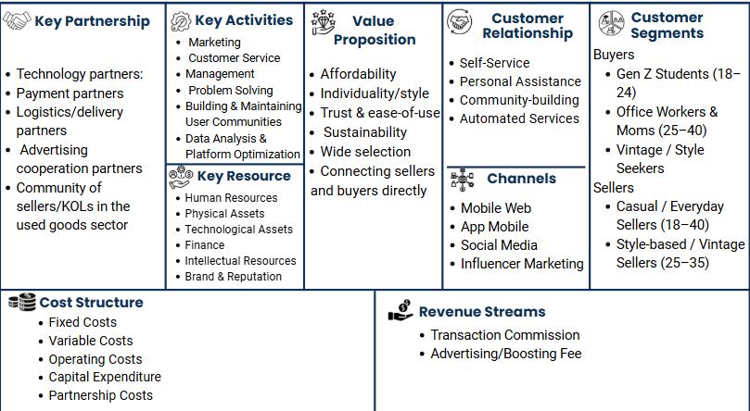

**III. MVP / PROTOTYPE**

ReVibe focuses on a simple, fast, fashionable & community-based 2nd hand buying & selling experience. The prototype version is designed on Figma with the main processing flows.

1. **Main buyer flow**

| **Screen** | **Description** |
| --- | --- |
| **Home** | Displays products in a swipe card format – users swipe left/right to like or skip items |
| **Search Filters** | Filter by size, gender, style tag, price, etc. to personalize search results |
| **Product Details** | View images, description, price, seller ratings; includes "Add to cart" and "Checkout" buttons |
| **Shopping Cart** | Choose payment method – shipping – confirm the order |
| **Product Rating** | Track order status and rate the seller |

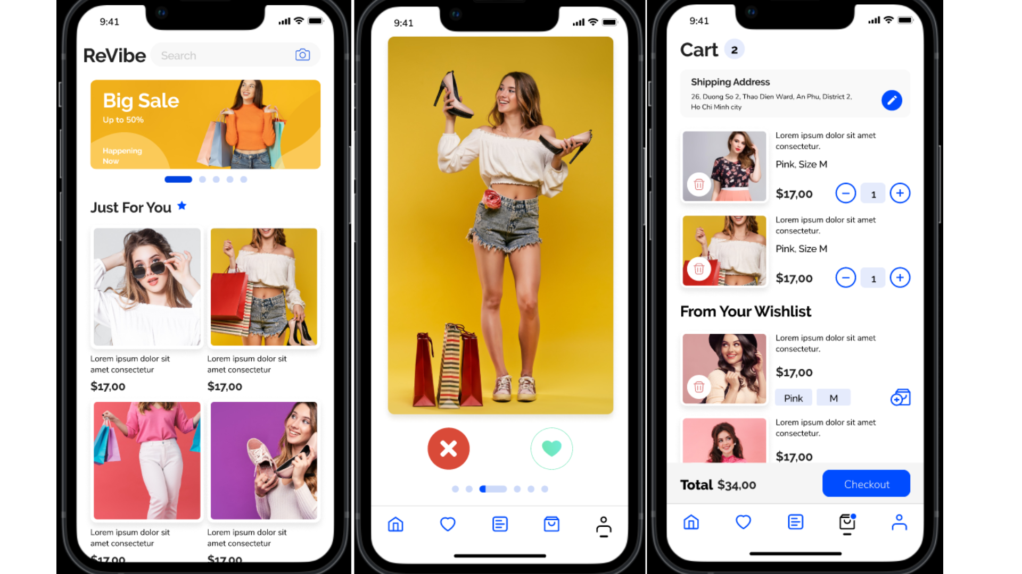

1. **Seller Main Flow**

| **Screen** | **Description** |
| --- | --- |
| **Post a sale** | Enter name, image, description, tag style, suggested price |
| **Manage products** | Edit or delete the sale content |
| **Personal page** | Show sales profile - create personal style, have reviews, followers |

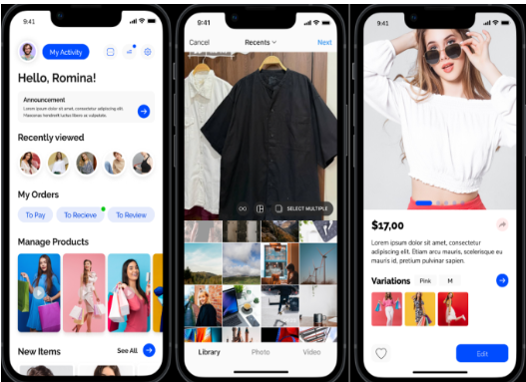

**III.Project roadmap**

Project status: Establishing a core team, doing market research, making an overview plan for each stage, building a basic prototype, orienting for the next few years and estimating costs for each stage.

**Project roadmap:**

| Year | Main Objectives | Key activities | KPIs |
| --- | --- | --- | --- |
| 2026 | Product improvement and expansion | -Complete MVP to test on the first group of users  -Adjusting and perfecting features based on real feedback.  -Organize marketing campaigns on social media and official launch in the market | -Reach 6000 users in the first year  -80% customer satisfaction rate |
| 2027 | Product upgrade, market expansion and strong revenue growth | -Optimize App features  -Cooperate with second-hand brands and expand the network of usage areas to some Asian countries  -Increase marketing to attract investors | -Reach over 20.000 user in 2027  -90% customer satisfaction rate |
| 2028 | Optimize and become the leader in the Secondhand industry | -Invest in technology and human resource management  -Optimize revenue and expand into neighboring markets | -Reach over 55,000 user domestic and foreign markets  -Break-even |

**IV. Finance**

1. **Cost and revenue forecast**

### **3-Year Cost Structure – ReVibe**

| **Year** | **Domain and hosting rental** | **Fixed salary for core team Marketing** | **Marketing costs** | **Mobile app development costs (native iOS/Android apps)** | **Cooperation with KOLs, local brands, vintage shops** | **Total Cost** |
| --- | --- | --- | --- | --- | --- | --- |
| **2026** | 324,000 | 360,000,000 | 120,000,000 | 7,824,000 | 30,000,000 | 518,148,000 |
| **2027** | 324,000 | 432,000,000 | 96,000,000 | 7,824,000 |  | 536,148,000 |
| **2028** | 324,000 | 504,000,000 | 60,000,000 | 7,824,000 |  | 572,148,000 |

### **3-Year Revenue Stream Forecast – ReVibe**

| **Year** | **Successful transaction** | **Commission Revenue (7%)** | **Boost Price (per use)** | **Boosts Used** | **Boost Ads Revenue** | **Total Revenue** |
| --- | --- | --- | --- | --- | --- | --- |
| **2026** | 6.000 | 6.000 × 200K × 7% = 84.000.000 ₫ | 120.000 ₫ | 800 | 800 × 120K = 96.000.000 ₫ | 180.000.000 ₫ |
| **2027** | 21,000 | 21.000 × 200K × 7% = 294.000.000 ₫ | 120.000 ₫ | 1.800 | 1.800 × 120K = 216.000.000 ₫ | 510.000.000 ₫ |
| **2028** | 56.160 | 56.160 × 200K × 7% = 786.240.000 ₫ | 120.000 ₫ | 3.600 | 3.600 × 120K = 432.000.000 ₫ | 1.218.240.000 ₫ |

1. **Fundraising**

- Goals

* Product Improvement
* Technology Equipment Investment
* Early User Reach
* Marketing & Community Building
* Testing & Optimizing Business Model

| Object | Estimated | Percentage | Purpose |
| --- | --- | --- | --- |
| Product Improvement | 250,000,000 VND | 30% | App/web development, UI/UX design |
| Technology Equipment Investment | 150,000,000 VND | 10% | Purchasing servers, testing equipment |
| Early User Reach | 150,000,000 VND | 10% | First-user incentives, early-stage testing |
| Marketing & Community Building | 250,000,000 VND | 16.7% | Advertising, KOLs, social media |
| Testing & Optimizing Business Model | 300,000,000 VND | 20% | Data analysis, validating the business model |
| Incurred costs | 200,000,000 VND | 13.3% | Legal, accounting, contingency expenses… |
| **Total** | **1,300,000,000 VND** | **100%** |  |

To develop a strong REVIBE platform, the support of investors at the right time is extremely important. Therefore, REVIBE is looking for an investment of 1,300,000 billion VND for 20% shares of REVIBE. The support of investors will be the key factor to help REVIBE go faster and further, with the goal of becoming the leader in the second-hand trading field. REVIBE is committed to using capital transparently, effectively, and bringing sustainable value to users and investors.

**References:**

RedSeer Strategy Consultants. (2021, December 16). *Vietnam's secondhand market is expected to top $5 billion by 2026*. Tuổi Trẻ News. <https://tuoitrenews.vn/news/business/20211216/vietnams-secondhand-market-expected-to-top-5bn-by-2026/64665.html>

Carousell. (2021, December 1). *Recommerce Index 2021: Growth of secondhand trading markets across Southeast Asia*. <https://press.carousell.com/2021/12/01/bao-cao-cua-tap-doan-carousell-ve-su-tang-truong-cua-mua-ban-do-qua-su-dung-huong-den-tieu-dung-ben-vung/>

VnEconomy. (2024). *Trade in second-hand goods to reach $5.1 billion by 2026*. <https://en.vneconomy.vn/trade-in-second-hand-goods-to-reach-5-1bln-by-2026.htm>

Carousell. (2022, November 30). Impact of secondhand trade on sustainability in Southeast Asia. <https://press.carousell.com/2022/11/30/cho-tot-cung-tap-doan-me-carousell-cong-bo-tac-dong-cua-viec-mua-ban-do-cu-doi-voi-phat-trien-ben-vung-trong-10-nam-qua/>

Carousell. (2021). *Recommerce Index 2021: Growth of secondhand trading markets across Southeast Asia*. <https://press.carousell.com/2021/12/01/bao-cao-cua-tap-doan-carousell-ve-su-tang-truong-cua-mua-ban-do-qua-su-dung-huong-den-tieu-dung-ben-vung/>

Tuổi Trẻ News. (2021). *Vietnam's secondhand market expected to top $5 billion by 2026*. <https://tuoitrenews.vn/news/business/20211216/vietnams-secondhand-market-expected-to-top-5bn-by-2026/64665.html>

**THE END**