**SOFTWARE REQUIREMENTS SPECIFICATION DOCUMENTS**

**(Software Requirement Specification – SRS)**

**Developing a building material sales system**

**Version 1.0.1**

**Guided by: Nguyễn Thành Ý**

**Written by: Team4_SE1637**

**Hanoi, February, 2023**

# Table of contents

Table of contents 1

List of images, tables 3

I Introduce 4

1 Purpose 4

2 Scope 4

3 Glossary 5

4 Bibliography 5

5 General 6

II Functional requirements 6

1 Agents 6

2 The functions of the system 7

3 Overview use case chart 8

1. Decay use case chart 9

4.1  Decomposition of the "Administrator" use case 9

### 4.2 Decomposite of the"Employee" use case……………………………………………...10

1. Business process ..11

5.1  The process of using the software 11

### 5.2 Employee management process................................................................................12

### 5.3 Product management process......................................................................................13

### 5.4 Guest management process..........................................................................................14

### 5.5 Frequently Asked Questions Management Process .................................................15

### 5.6The process of using the customer's software..........................................................16

III Specification of usecase……………………………………………………….....................17

1 Customer…………………………………………………………………………………….17

1.1 Login…………………………………………………………………………………........17

1.1.1 Sign in……………………………………………………………………………………17

1.1.2 Sign up…………………………………………………………………………………...18

1.1.3 Forgot password…………………………………………………………………………19

1.1.4 Change password………………………………………………………………………19

1.1.5 Edit profile……………………………………………………………………………….20

1.2 Product…………………………………………………………………………………….21

1.2.1 List Product……………………………………………………………………………...21

1.2.2 Search product…………………………………………………………………………...22

1.2.3 Product details…………………………………………………………………………...22

1.3 Order………………………………………………………………………………………23

1.3.1 Orders product…………………………………………………………………………...23

1.3.2 Order details……………………………………………………………………………..24

1.4 Main screen………………………………………………………………………………..24

1.4.1 Home…………………………………………………………………………………….24

1.4.2 About us…………………………………………………………………………………25

1.4.3 Chat box…………………………………………………………………………………26

2 Admin………………………………………………………………………………………..26

2.1 User management………………………………………………………………………….26

2.1.1 View user list…………………………………………………………………………….26

2.2 Product management………………………………………………………………………27

2.2.1 Add product……………………………………………………………………………...27

2.2.2 Edit product……………………………………………………………………………...27

2.2.3 Delete product…………………………………………………………………………...27

2.3 Orders management………………………………………………………………………..27

2.3.1 View list Order…………………………………………………………………………..27

2.4 Dashboard…………………………………………………………………………………28

2.5 Export from exel…………………………………………………………………………..28

2.6 Import to exel………………………………………………………………………………28

# List of images, tables

**Figure** 2-1: **Overview use case chart**............................................................................. 6

**Figure** 2-2: **Administrator use case chart** .................................................................... 7

**Figure** 2-3: **Use Case Employee chart**........................................................................... 8

**Figure** 2-4: **Software usage activity chart**..................................................................... 9

**Figure** 2-5: **Employee management activity chart**.......................................................10

**Figure** 2-6: **Sales management activity chart**............................................................... 11

**Figure** 2-7: **Guest management activity chart**............................................................. 12

**Figure** 2-8: **Frequently Asked Questions Management Activity Chart**..................... 13

**Figure** 2-9: **Customer software usage process chart**.................................................... 14

# Introduce

## Purpose

* The project of a sales website with products such as scaffolding, steel poles, formwork, accessories (locking scaffolding locks), wheels is built with the purpose of providing customers with high quality products. and full of utility features, helping customers easily search, compare, select and purchase necessary products for construction works.
* This document will be used to develop the software requirements specification document, helping to ensure that the software developed meets the product's specification and feature requirements. In addition, the document provides the necessary information to develop new features and enhance the customer experience on this sales site.

## Scope

* The vision of the project is to become one of the leading sales websites in the field of providing professional building materials and solutions in Vietnam. With high-quality, diverse and constantly updated products, the website will bring convenience and reliability to customers in shopping and choosing the necessary products for their projects. Above all, we hope to provide the basic, comfortable user experience that is available to our users.

## Glossary

|  |  |
| --- | --- |
| Software Requirements SpecificationsSRS | Software requirements specification |
| Use Case(s) | Diagram depicting system requirements |
| Web server | Server software provides functions and resources to the client |
| Hypertext Markup Language (HTML) | HyperText Markup Language or HTML is the standard markup language for documents designed to be displayed in a web browser. |

**Table 1-1: Glossary**

## Bibliography

 IEEE Recommended Practice for Software Requirements Specifications," in IEEE Std 830-1998, vol., no., pp.1-40, 20 Oct. 1998.

 IEEE Guide for Developing System Requirements Specifications," in IEEE Std 1233-1996, vol., no., pp.1-30, 22 Dec. 1996.

* Custom Software Requirements Specification Document Example (International Standard) - Software Development Company.

## General

This document is written in accordance with the Software Requirements Specifications (SRS) described in the "IEEE Recommended Practice for Software Requirements Specifications" and the "IEEE Guide for Developing System Requirements Specifications".

With the structure divided into three parts:

1. Part 1: Provides an overview of the components of SRS.
2. Part 2: An overview of the factors, constraints, user characteristics, execution environment that impact the system and its requirements. Provides detailed information on functional requirements, providing software developers with information to develop software that meets those requirements.
3. Part 3: Non-functional requirements.

# Functional requirements

## Agents

The system consists of agents who are Guest, Customer, Employee and Administrator.

* Guest: This is a user who visits the website and performs activities on the website, but has not registered for an account. Customers can view product information, prices and policies of the online store. The role of the customer is to consult and learn about products and services before deciding to buy.
* Customer: This is a user who has registered an account on the website and can log in to use the website's functions such as placing orders, viewing order history, managing personal information and registering to receive news. instant, promotion from online store. The customer's role is to be the consumer of the online store's products and services.
* Employees: These are the people who work in the online store, responsible for performing tasks such as processing orders, taking care of customers, answering customer questions, updating product information and prices chief. The staff's role is to support customers and keep the online store running efficiently.
* Administrator: This is the person who manages and runs the entire operation of the online store, including tasks such as product management, order management, customer information management, staff management and Store activity statistics. The administrator's role is to ensure that the operations of the online store are carried out efficiently, that the customer needs are met, and that the store's business goals are achieved.

## The functions of the system

* Customers: Customers have the right to view product and service information of the online store, place orders and pay for their orders. Customers are also responsible for ensuring that their personal and payment information is secure and true.
* Customer: Customer has the right to register and log in to an account, view order history, manage personal information, perform activities on the website such as placing orders, discussing with customer support staff and product reviews. The customer is also responsible for performing activities on the website in accordance with the regulations of the online store.
* Employees: Employees have the right to access and manage customer information, process orders, provide customer support, and update product and pricing information. Employees are also responsible for ensuring the accuracy and confidentiality of customer and order information.
* Administrator: Administrator has access to and manages the entire operation of the online store, including product management, orders, customer information, employees, and store activity reporting statistics. row. The administrator is also responsible for ensuring the operation of the online store is carried out in accordance with regulations, protecting the personal information and customer orders, and monitoring the activities of the employees.

## Overview use case chart

**Figure 2-1: Overview use case chart**

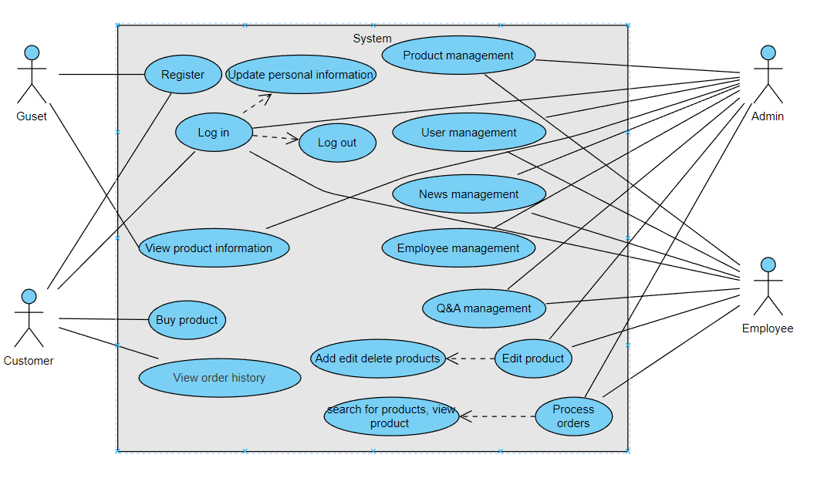

## Decay use case chart

### Decomposition of the "Administrator" use case

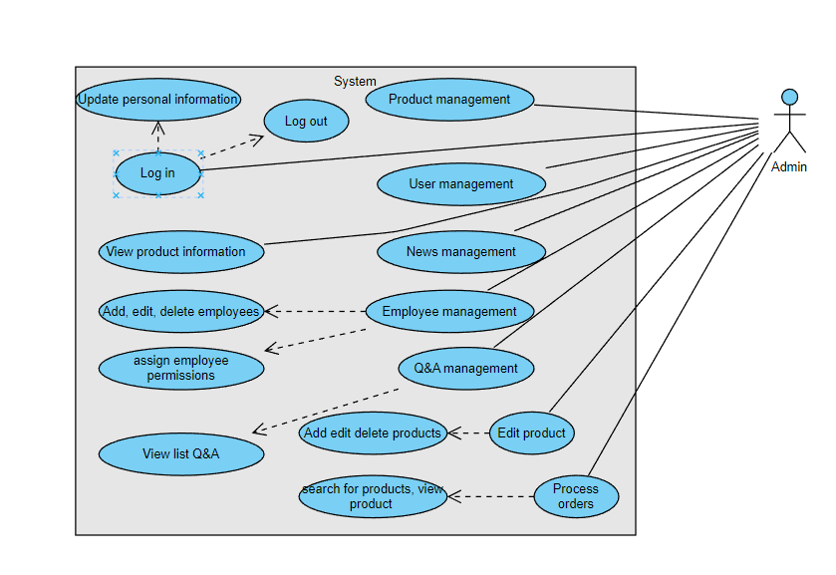

**Figure 2-2: Administrator use case chart**

### **Decay use case "Employee"**

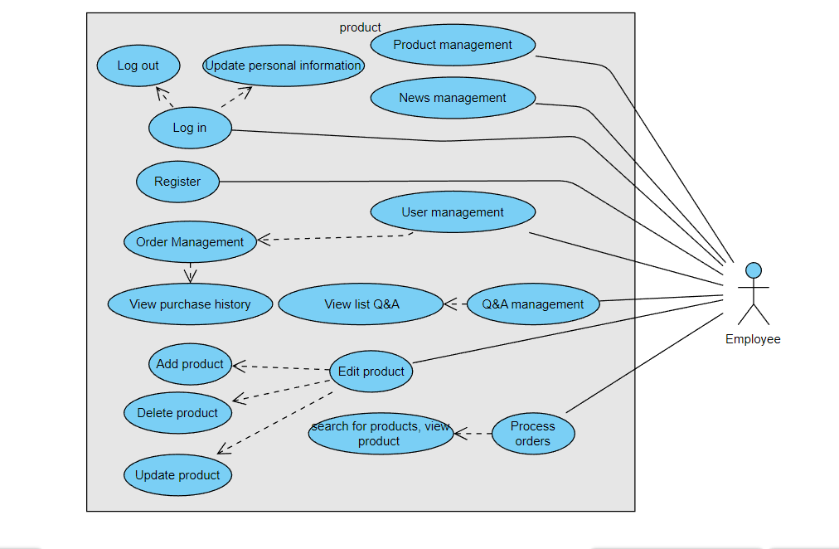

**Hình 2-3: Use Case Employee chart**

## Business process

### **The process of using the software**

* Customers visit the website to view product and service information on the website and select the products they want to buy. After logging in to their account or paying with the customer account, the customer will complete the order. and payment. Store staff pack the products and deliver them to the shipping unit. Customers receive goods and confirm order information.
* The process of using software in the project will ensure speed, accuracy and security to ensure the best buying experience for customers. Information about orders, products, customer and payment information must be strictly managed and confidential. In addition, the process of using the software also needs to be monitored to ensure correctness and avoid errors.

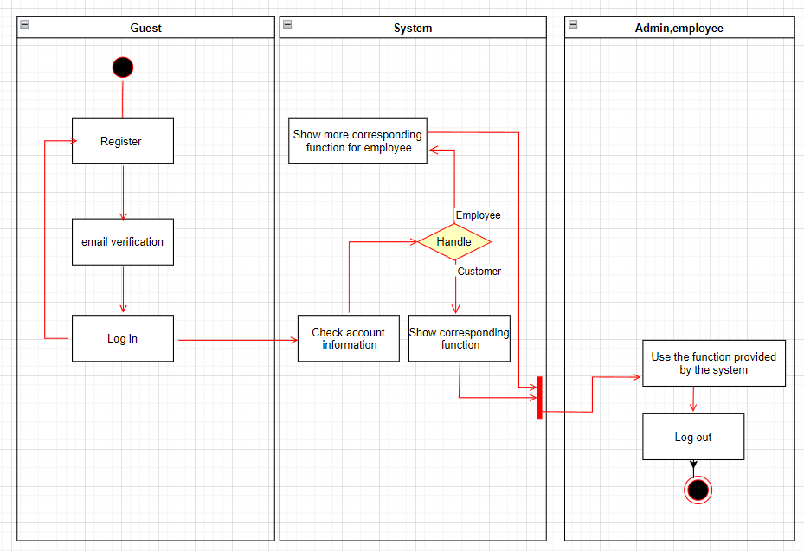

**Figure 2-4: Software usage activity chart**

### **Employee management process**

-) Employee management system: After employees complete the steps of logging into the system, they can search for products, edit products whenever there is a preferential price, participate in discussions to answer customers' questions. The system will display the information accurately and clearly.

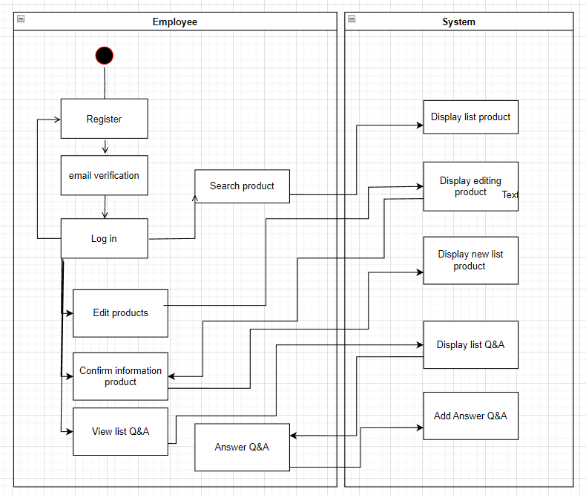

**Figure 2-5: Employee management activity chart**

### **Product management process**

Administrators and employees first need to log into the system to authenticate users. After that, the administrator has access to the quantity statistics function to check the amount of goods in the warehouse, the system will display the processing data on the screen, other functions such as adding and deleting products are similar to employees.

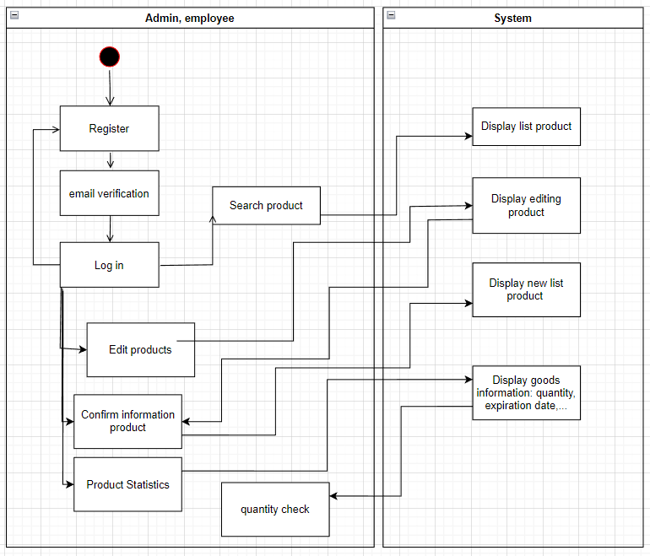

**Figure 2-6: Sales management activity chart**

### **Guest management process**

-) Guests can access the website then can use the account registration function, when they have a personal account, they will have the same functions as customers. The system will also provide a registration interface, check and save registration information.

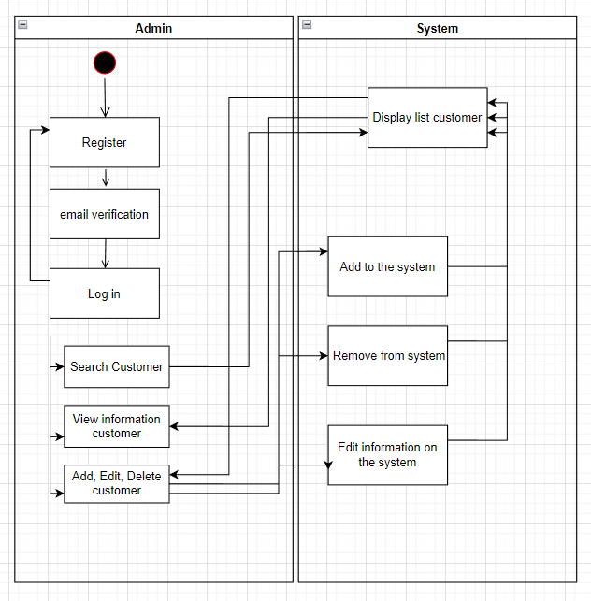

**Figure 2-7: Guest management activity chart**

### **Frequently Asked Questions Management Process**

-) Administrators, and employees after successfully logging into the system can view the list of questions and have the right to answer those questions. Besides, they can also edit some questions in case the answer is wrong or not enough.

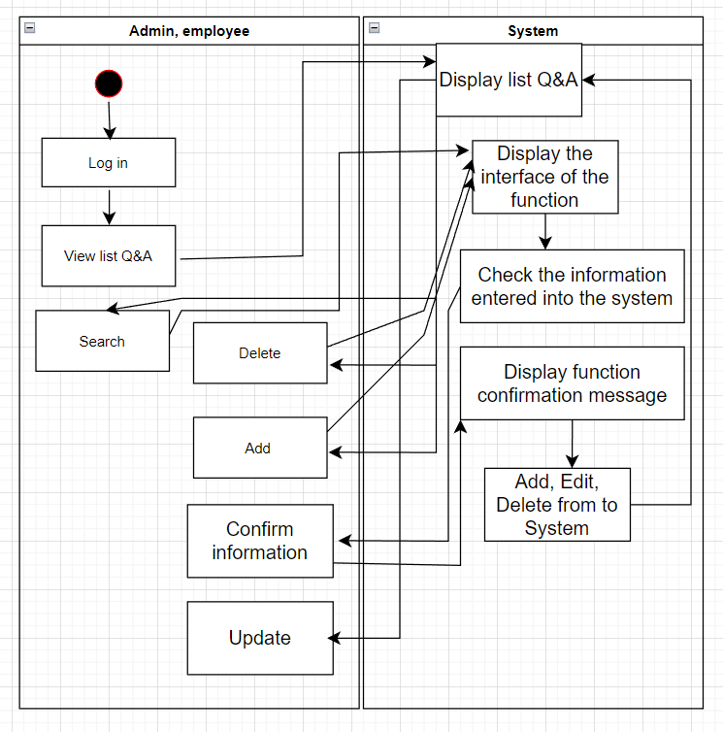

**Figure 2-8: Frequently Asked Questions Management Activity Chart**

### **The process of using the customer's software**

-) Customers who log in to the system can then view the list of products and the history of products that customers have previously purchased. Customers can search for products they need to refer to, buy products and give reviews for that product. The system will clearly display the information that customers need to know about the product.

-) In addition, the system gives customers the right to change their password every time they request.

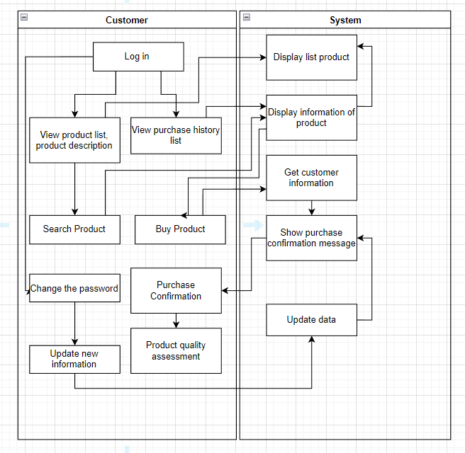

**Figure 2-9: Customer software usage process chart**

1. **Specification of usecase**

**1.**    **Customer**

*1.* ***Login***

1. Sign in

- Function trigger: function is triggered when the user clicks button login.

-       Function description: when a user needs to login to an account they must enter account and password.

- Screen layout 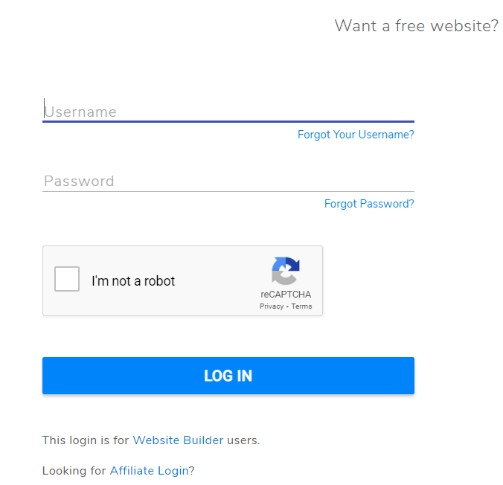

-        Function details: accounts to be remembered in a database about information relation account users. System will  use information user in database to confirm account login of user when user enter account.

2. Sign up

-     Function trigger: function is trigger when user sign up

-        Function description: sign up for an account to access the website. Users will register then the system will automatically send an email to invite Welcome to the website and confirm.

- Screen layout 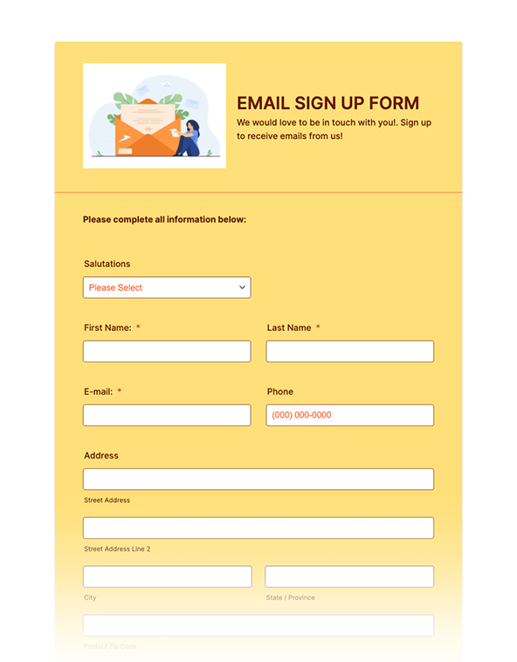

-        Function details:  The system will use cookies to remember passwords and usernames. The website will save all information to the database and create new users.

* + 1. Forgot password

-        Function trigger: Function is triggered when a user forgot their password .

-        Function description: when this function is clicked, the system will display a page asking the user to enter their username to confirm forgot password. Only then the users can change their password.

- Screen layout 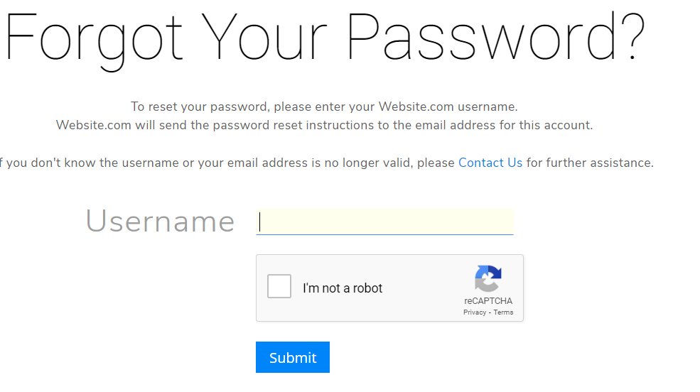

-        Function details: send the user a confirmation that they forgot their password, then have the user enter the new password and confirm the new password.

* + 1. Change password
* function trigger: when customers click the button change password.
* Function description: when customers click a button they have to fill full the information in the blank.
* Function layout:

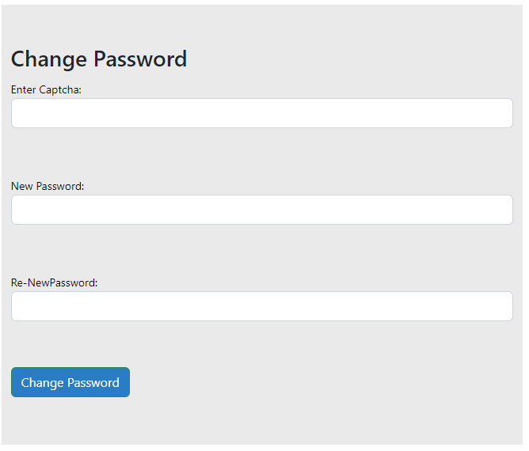

5. Edit profile

Function trigger: function is triggered when the user clicks edit profile button.

Function description: when a user clicks a button they can change any information in their profile then it will be updated in the database.

Function layout:

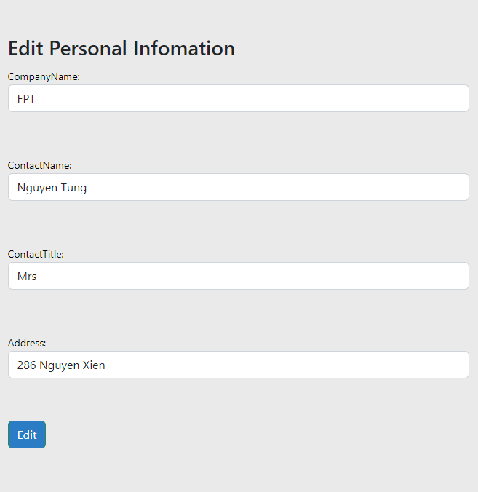

1. ***Product***
   1. List product

* Function trigger: function is triggered when the customer wants to see all the products.
* Function description: when the customer wants to see the list of products, the system will display a list of products.
* Screen layout

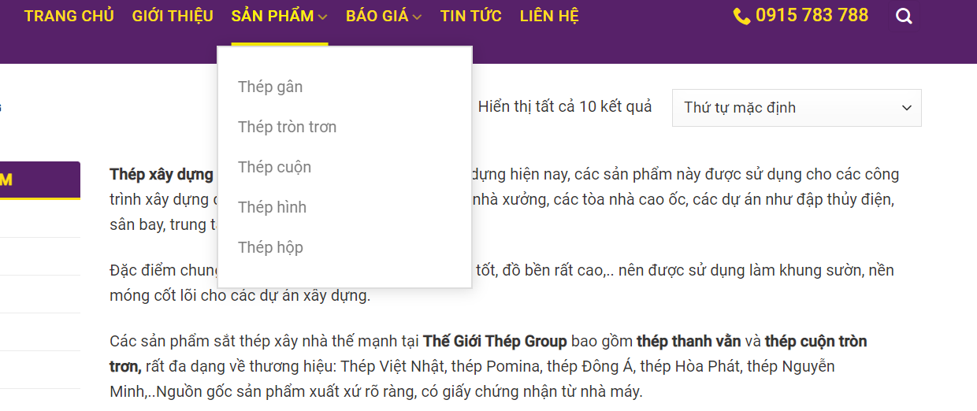

* Function details: when the user clicks on the button to view the products, they can view the list of all products.
  1. Search product
* Function trigger: function is triggered when the user clicks on the button search.
* Function description: when the customer clicks search they will see the product that they want to find.
* Screen layout 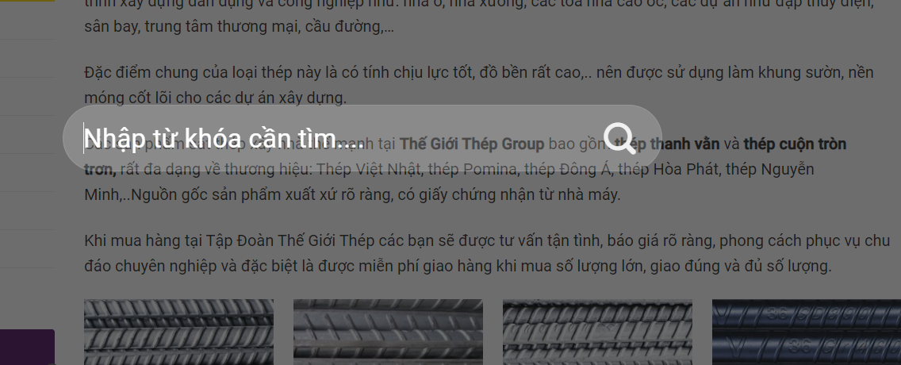
* Function details: users will enter the name of the product and click the button search then they can see the product with its information.

1. Product details

* Function trigger: function is triggered when the user wants to see all the information of one product.
* Function description: when the customer needs the information of the product.

- Screen layout 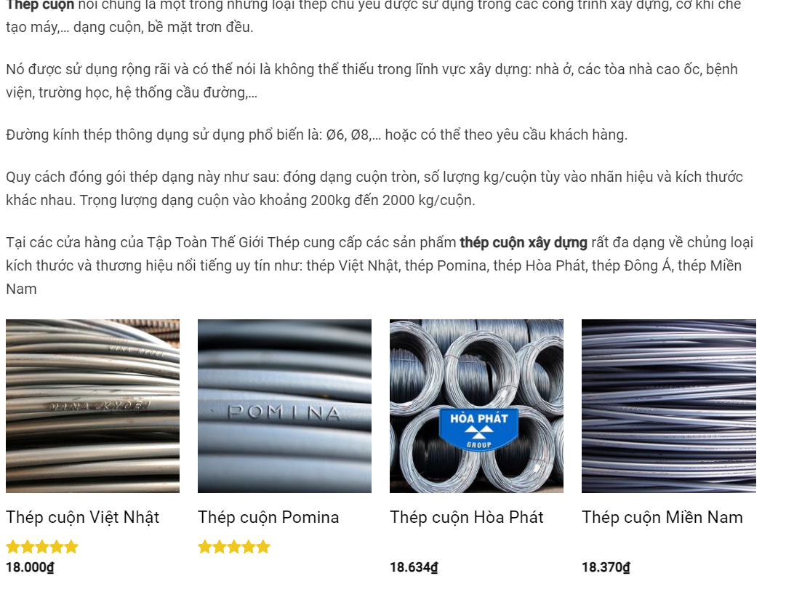

- Function details: when the user clicks to the name of the product, the screen will show all information of this product.

3.   ***Order***

* 1. Order
* Function trigger: function is triggered when the user needs to buy the product on the website.
* Function description: customers can click the order button and choose the number of products they want to buy.
* Screen layout 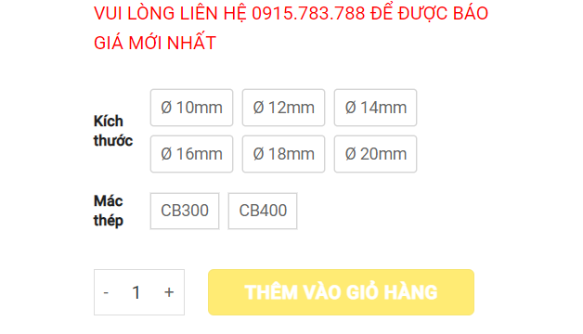
* Function details: customers can choose the order button then choose the umber of product they want and the system will calculate the total money of order.
  1. Order details
* Function trigger: the customer wants to see what product they are ordered and the information of all the orders.
* Function description: when the user needs to check their order and the amount of the order.
* Screen layout 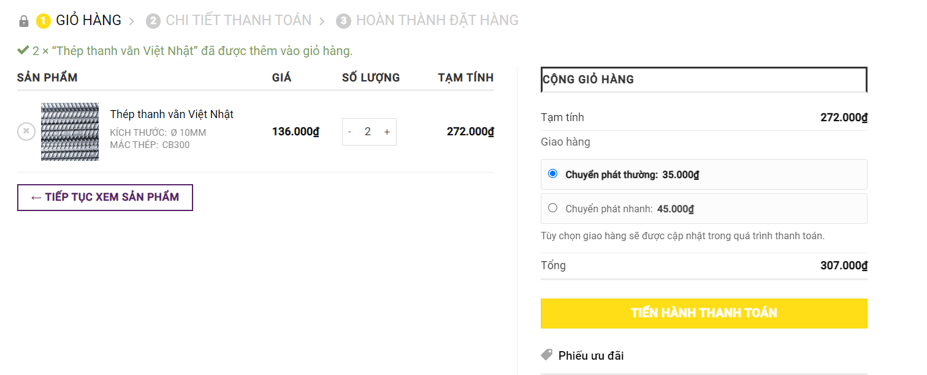

- Function details: Customers click to the view orders button then they can see all the products that they have ordered.

4.  ***Main screen***

* + 1. Home
* Function trigger: functions are triggered when the guest needs to return to the beginning screen.
* Function description: the customers just clicks to the home button and they will return to the main screen.
* Screen layout 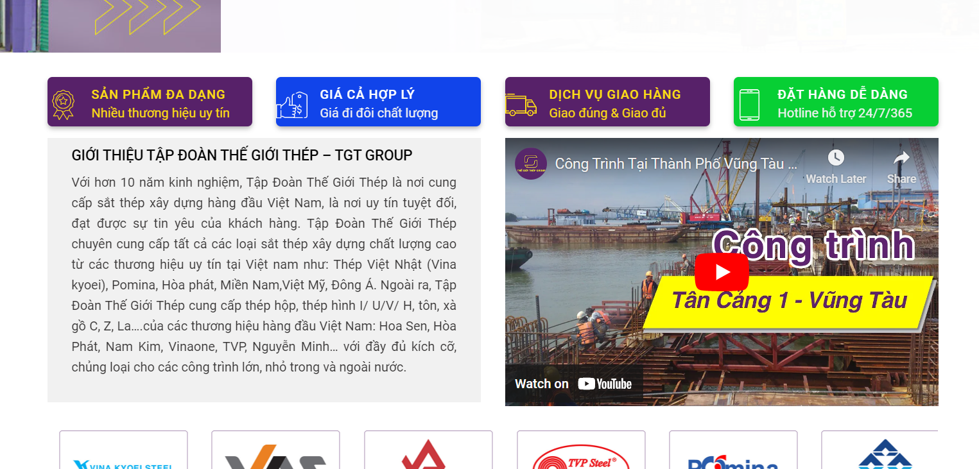
* Function details: when the customers press the home button the system will show the customers some information about the company and some type of newest products.
  + 1. About us
* Function trigger: function triggered when the customers clicks to the button about us
* Function description: the user clicks to the button the system will show all the information about the company.
* Screen layout 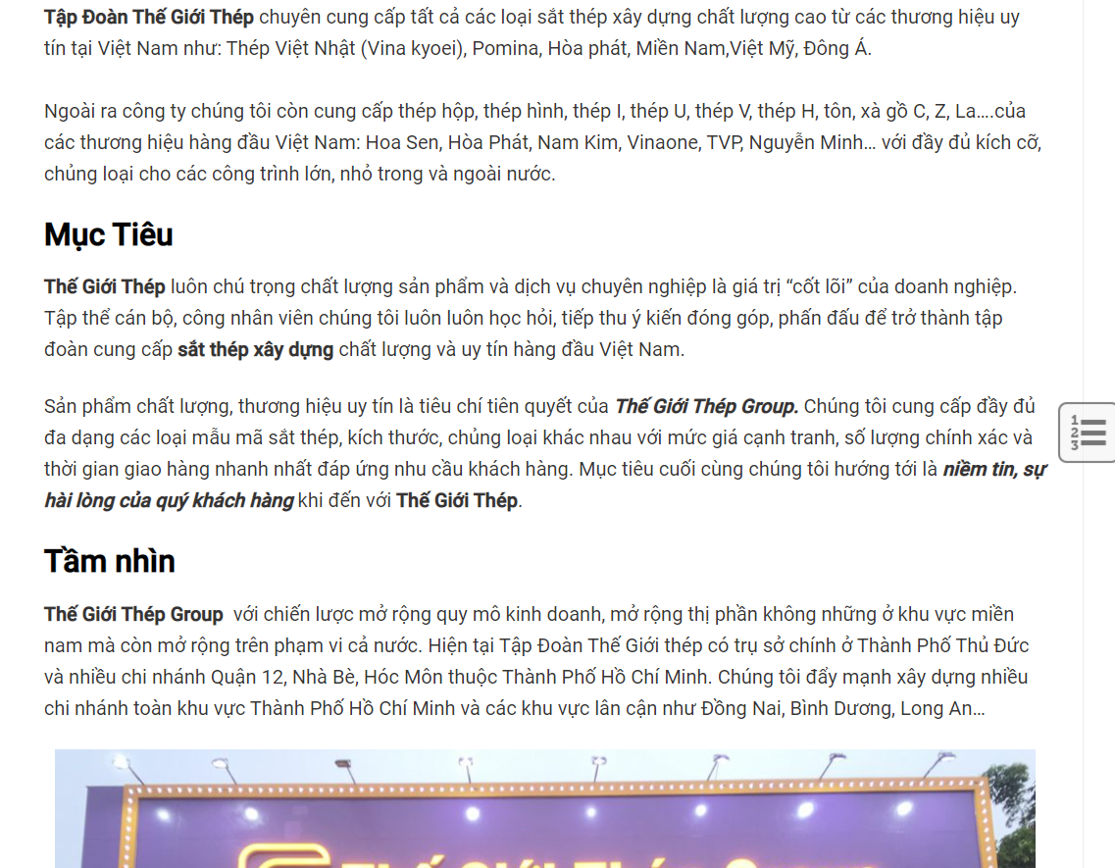
* Function details: when the user clicks the button they can see the information such as the target, the vision of the company and the contact method.
  1. Chat box
* Function trigger: function triggered when the guest clicks to the chat box.
* Function description: the guests want to ask for some information about the company or products.
* Screen layout
* Function details: when the users clicks to the chat box they can chat online with the manager of the company and other customers to ask about the products.

**2.**    **Admin**

1.     ***User management***

* + 1. View users list

-       Function trigger: function is triggered when admin clicks show list users.

-        Function description:  When the admin wants to see the list user. The system will display a list of users who registered on the website.

-        Function details: When the admin clicks on the button to view the user list, they can view the list of users with their information.

2. ***product management***

* + - 1. Add product

-        Function trigger: function is triggered when the admin clicks the button to add a new product.

-       Function description: display the blank information of the product so that admin can enter information and the picture.

-        Function details: when the admin wants to add a new product to the system they must enter the details and the image related to that product.

* + 1. Edit product

-        Function trigger: function is triggered when the admin clicks the edit product button.

-        Function description: edit the information and images of the products.

- Function details: when the admin needs to edit the information of the product because the current information in the system is no longer relevant or the information is corrupted. After clicking the edit button the admin will see the product’s information screen so that they can edit.

* + 1. Delete product

-        Function trigger: function is triggered when the admin wants to delete the product and its information from the website.

-        Function description: delete product then its information from the system.

-        Function details: when the admin wants to delete the product, they will enter the name of the product and click the delete button. The product will disappear from the display screen.

3.   ***Orders management***

* + - 1. View list orders
* Function trigger: functions are triggered when the admin wants to see all the orders of the company.
* Function description: admin can click to the view orders button and they can see the list of all orders.
* Function details: when the admin clicks to the button the system will show the orders and the information of the customer that made the order and total of all the orders.

1. ***Dashboard***

* Function trigger: Function is triggered when the admin login the website
* Function description: when admin sign in to the website by their account they can see information about the website in the main screen.
* Function details: admin can see the information and the data of the website such as number of user, number of orders, …..

1. Export to exel

* Function trigger: function is trigger when admin clicks to the export button.
* Function description: admin clicks to see the list of product they can see the botton to export the data to the exel.
* Function details: help admin can save data to the exel file and they can edit the information easily.

1. Import from exel

* Function trigger: function is triggered admin want to import the data to the database.
* Function description: admin can clicks to the import button and all data in the exel file will transfer to the database.
* Function details: admin need import exel file have the same structure with the table in the database. If one blank in file exel do not have data admin can edit it in the website.