Site Performance: The image in the center took the longest to load and had a heavy impact on the performance on the site. (140.56 ms to load.)

|  |  |  |  |  |
| --- | --- | --- | --- | --- |
| 144.2 ms | 0 ms | 0 ms | Receive Response |  |
| 144.4 ms | 0 ms | 0 ms | Receive Response |  |
| 21.9 ms | 0 ms | 0 ms | Send Request |  |
| 16.6 ms | 0 ms | 0 ms | responseEnd |  |
| 22.2 ms | 0 ms | 0 ms | unloadEventEnd |  |
| 22.2 ms | 0 ms | 0 ms | unloadEventStart |  |
| 167.4 ms | 0.7 ms | 0.7 ms | Update Layer Tree |  |
| 217.5 ms | 0.2 ms | 0.2 ms | Update Layer Tree |  |
| 157.1 ms | 7.4 ms | 7.4 ms | Recalculate Style |  |
|  |  |  |  |  |

Composite Layers

Memory Usage: A Snapshot taken reveals that around 1.9 MB of memory is being used. This is quite low memory usage, but then again, this is a small site. A Much larger site would have much more memory being used. Gigabytes and even Terabytes of memory would be used at a time.

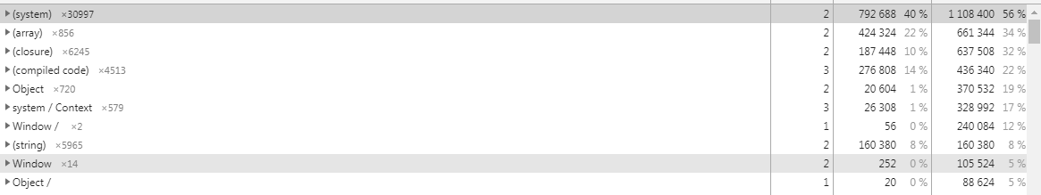

As seen from this screenshot, most of the memory is being taken up from the system with array being in second, and the compiled code being in third. Objects are taking up the least memory. I could not post the full memory report snapshot here as it would take up several pages to read, plus it would not matter as much of the stuff near the bottom takes up next to zero memory. Here is a tab from the System line:

|  |  |  |  |  |
| --- | --- | --- | --- | --- |
| (system)×30997 | 2 | 792 68840 % | 1 108 40056 % |  |
| system / NativeContext@4393 | 2 | 9880 % | 144 1287 % |  |
| initial_regexp_string_iterator_prototype_map::system / Map@56503 | 3 | 400 % | 2360 % |  |
| initial_set_prototype_map::system / Map@81287 | 3 | 400 % | 2280 % |  |
| type_error_function::*TypeError()*@55061🗖 | 2 | 320 % | 2240 % |  |
| promise_prototype::Promise@81333🗖 | 3 | 280 % | 2200 % |  |
| js_map_fun::*Map()*@81307🗖 | 2 | 320 % | 2080 % |  |
| js_set_fun::*Set()*@81313🗖 | 2 | 320 % | 2080 % |  |
| async_function_constructor::*AsyncFunction()*@32125 | 3 | 320 % | 2040 % |  |
| context_extension_function::*()*@38937 | 3 | 320 % | 1960 % |  |
| sloppy_function_map::system / Map@20697 | 3 | 400 % | 1880 % |  |
| function_function::*Function()*@32127🗖 | 2 | 320 % | 1840 % |  |
| initial_set_prototype::Set@81285🗖 | 3 | 280 % | 1840 % |  |
| sloppy_function_with_readonly_prototype_map::system / Map@47987 | 3 | 400 % | 1840 % |  |
| global_proxy_function::*()*@56893 | 3 | 320 % | 1680 % |  |
| make_error::*()*@56971 | 3 | 320 % | 1680 % |  |
| make_range_error::*()*@56981 | 3 | 320 % | 1680 % |  |
| make_syntax_error::*()*@56991 | 3 | 320 % | 1680 % |  |
| make_type_error::*()*@57001 | 3 | 320 % | 1680 % |  |
| make_uri_error::*()*@57011 | 3 | 320 % | 1680 % |  |
| opaque_reference_function::*()*@56477 | 3 | 320 % | 1680 % |  |
| proxy_function::*Proxy()*@81327🗖 | 2 | 280 % | 1680 % |  |
| initial_array_iterator_prototype::Array Iterator@56379 | 3 | 280 % | 1640 % |  |
| initial_map_iterator_prototype::Map Iterator@56393 | 3 | 280 % | 1640 % |  |
| initial_set_iterator_prototype::Set Iterator@56403 | 3 | 280 % | 1640 % |  |
| initial_string_iterator_prototype::String Iterator@56413 | 3 | 280 % | 1640 % |  |
| initial_error_prototype::Object@56919🗖 | 3 | 280 % | 1600 % |  |
| async_generator_function_function::*AsyncGeneratorFunction()*@59765 | 3 | 320 % | 1560 % |  |
| generator_function_function::*GeneratorFunction()*@56335 | 3 | 320 % | 1560 % |  |
| initial_weakmap_prototype_map::system / Map@60779 | 3 | 400 % | 1560 % |  |
| initial_iterator_prototype::Object@56361 | 3 | 280 % | 1520 % |  |
| initial_weakset_prototype_map::system / Map@81289 | 3 | 400 % | 1440 % |  |
| iterator_result_map::system / Map@76905 | 3 | 400 % | 1440 % |  |
| regexp_prototype:: |  |  |  |  |

As you can see, this is why I cannot put the full memory usage report here.

Security: Because the site is not HTTPS, there is very little security to speak of as seen here:

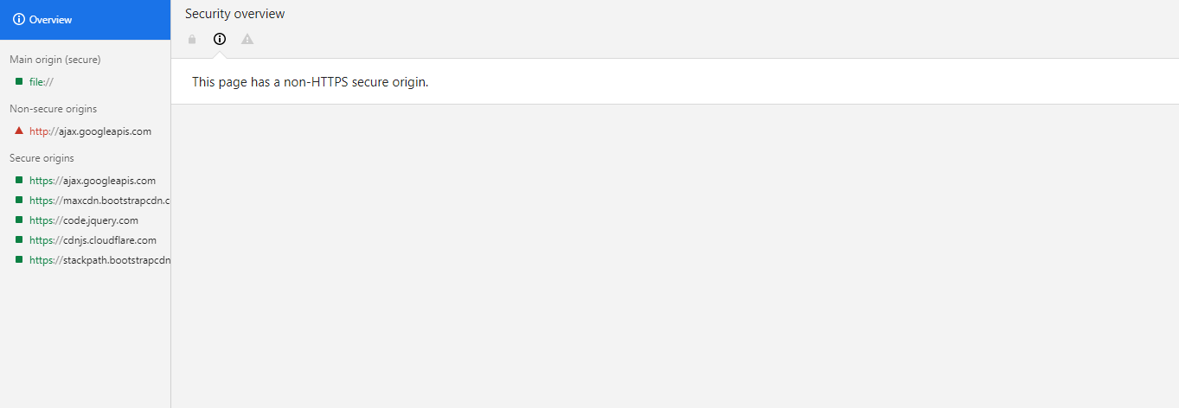

However, the site does use secure origins. So there’s that.

Audits: Because the site is not HTTPS as discussed under security, I was not able to perform any Audits, as auditing requires a secure site.