CSC472 Project Proposal

**Project Title:** Traveler’s note app

**Name:** Lanyixuan (Lanny) Xu

This is an **individual** project.

**Project Description:** The app will let users who likes to travel to find where to go, and after they have been there, they can use drawing and writing to capture the moment.

**Preliminary screen design:**

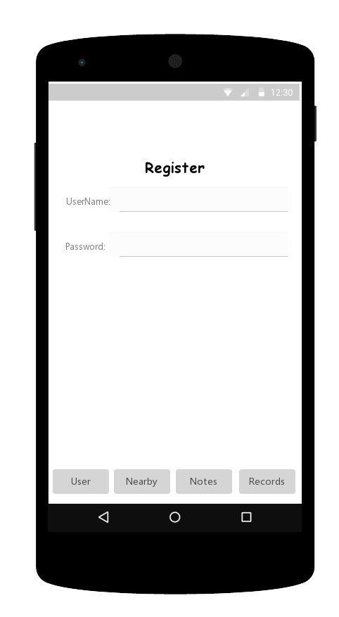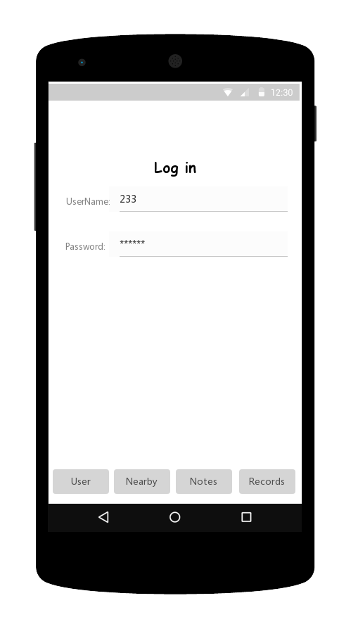1.user register/ login:

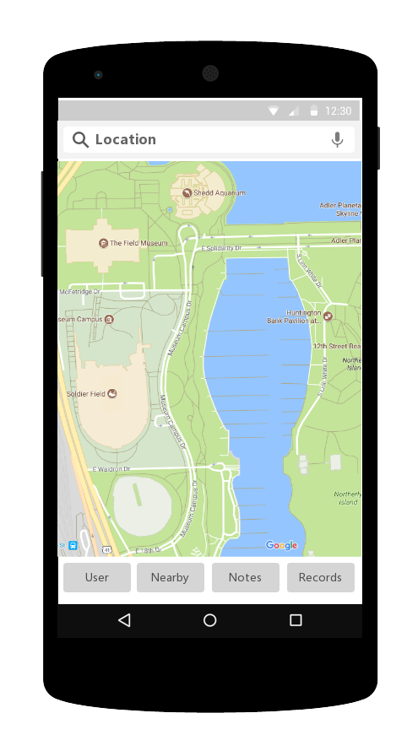

2. Let users to search the landmarks near them:

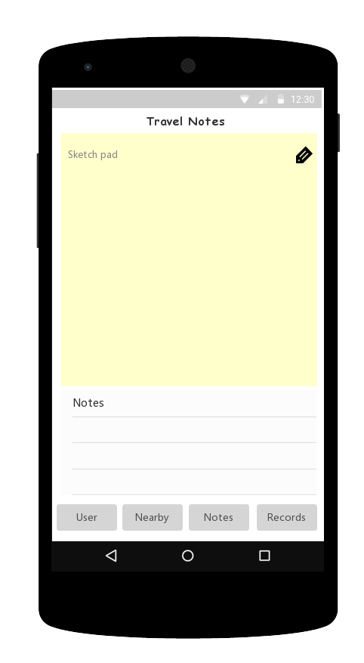

3. Travel Notes: Sketch Pad part: Use drawing to express themselves：like emoji, landmarks or just some words. Notes part: Use keyboard to type in.

They may also rate the place use stars.

Maybe take a picture, not sure yet…

And even share the notes to other social networking sites.

4. Records: All the notes are saved here. Users should have access to them.

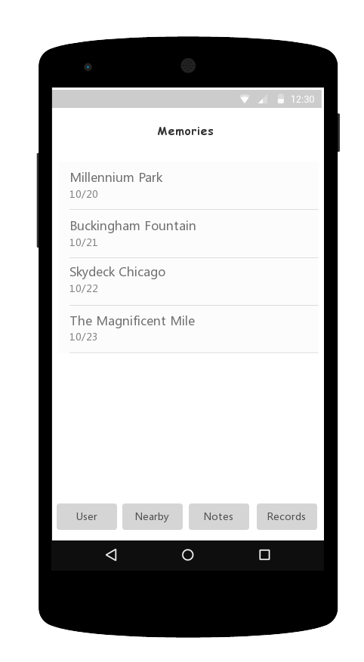

**API features:**

* 2D graphic drawing
* Multi-tough gesture
* Maybe other APIs, like pin, map, take photo, sharing etc.