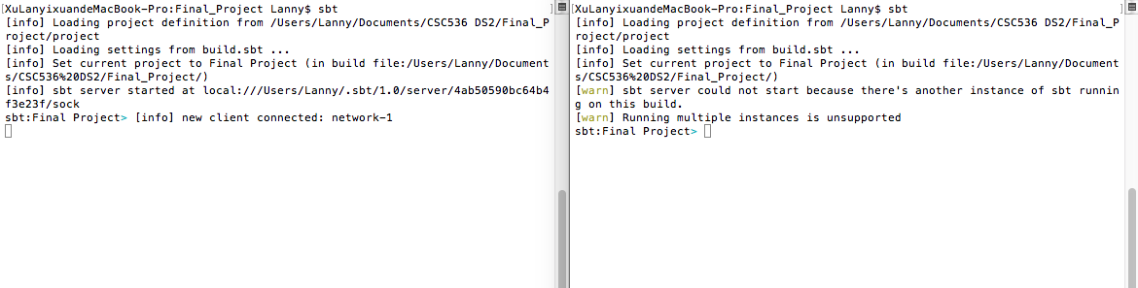

enter ‘sbt’

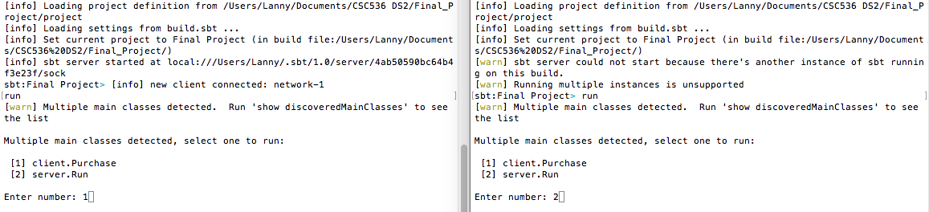

after entering ‘run’, you may choose to run either server or client.

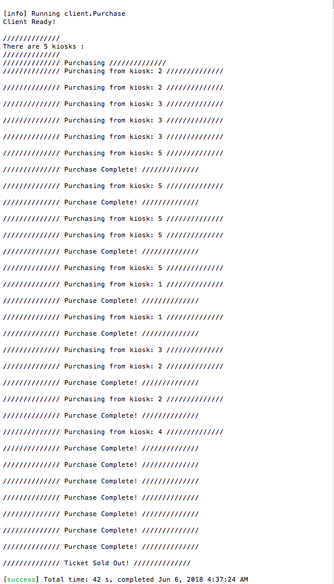client outputs:

server outputs: