PROG6212

ICE TASK 2

ST10258321

Screenshots of code:

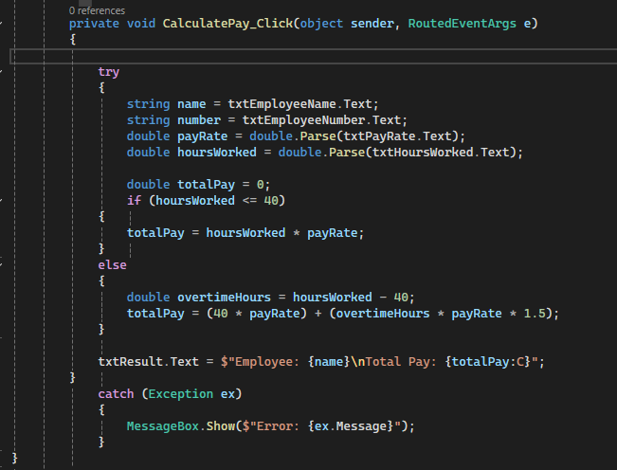

Final window:

Code:  
 private void CalculatePay_Click(object sender, RoutedEventArgs e)

{

try

{

string name = txtEmployeeName.Text;

string number = txtEmployeeNumber.Text;

double payRate = double.Parse(txtPayRate.Text);

double hoursWorked = double.Parse(txtHoursWorked.Text);

double totalPay = 0;

if (hoursWorked <= 40)

{

totalPay = hoursWorked * payRate;

}

else

{

double overtimeHours = hoursWorked - 40;

totalPay = (40 * payRate) + (overtimeHours * payRate * 1.5);

}

txtResult.Text = $"Employee: {name}\nTotal Pay: {totalPay:C}";

}

catch (Exception ex)

{

MessageBox.Show($"Error: {ex.Message}");

}

}

private void SaveToFile_Click(object sender, RoutedEventArgs e)

{

SaveFileDialog saveFileDialog = new SaveFileDialog

{

Filter = "Text file (*.txt)|*.txt"

};

if (saveFileDialog.ShowDialog() == true)

{

try

{

using (StreamWriter writer = new StreamWriter(saveFileDialog.FileName))

{

writer.WriteLine(txtEmployeeName.Text);

writer.WriteLine(txtEmployeeNumber.Text);

writer.WriteLine(txtResult.Text.Split('\n')[1].Split(':')[1].Trim());

}

MessageBox.Show("Employee data saved successfully.");

}

catch (Exception ex)

{

MessageBox.Show($"Error saving file: {ex.Message}");

}

}

}

private void LoadFromFile_Click(object sender, RoutedEventArgs e)

{

OpenFileDialog openFileDialog = new OpenFileDialog

{

Filter = "Text file (*.txt)|*.txt"

};

if (openFileDialog.ShowDialog() == true)

{

try

{

using (StreamReader reader = new StreamReader(openFileDialog.FileName))

{

string employeeName = reader.ReadLine();

string employeeNumber = reader.ReadLine();

string totalPay = reader.ReadLine();

txtResult.Text = $"Employee: {employeeName}\nTotal Pay: {totalPay:C}";

}

}

catch (Exception ex)

{

MessageBox.Show($"Error loading file: {ex.Message}");

}

}

}