The ERD of the database structure.

Here are pictures of the database deployment.

The content of the web app when the connection string is added.

The overall look of the web app.

Screenshots of Table Design:

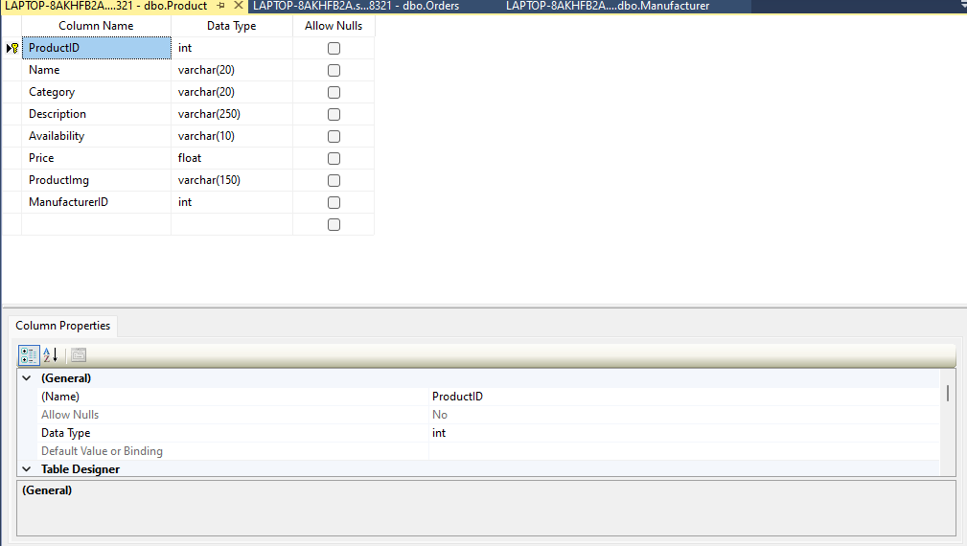

Screenshots of the deployment of the database created in SQL Server management Studio to Azure.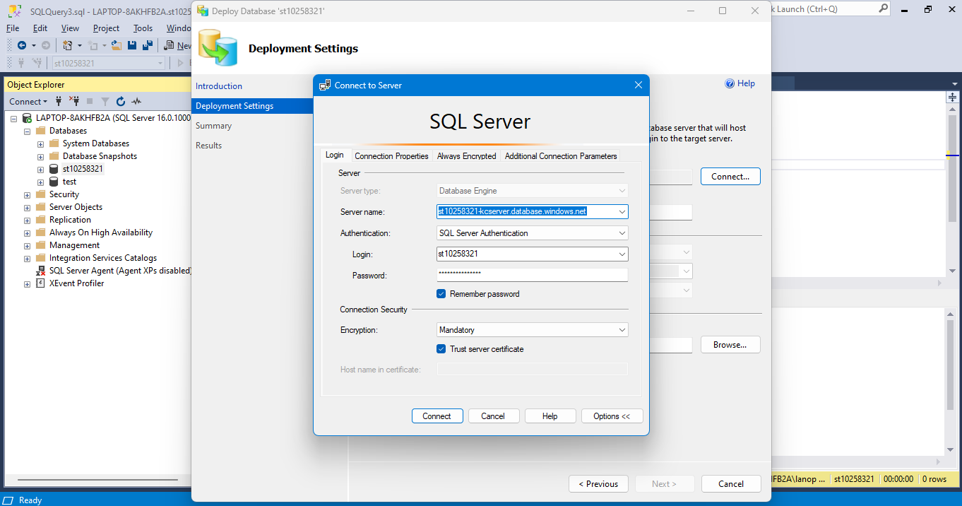 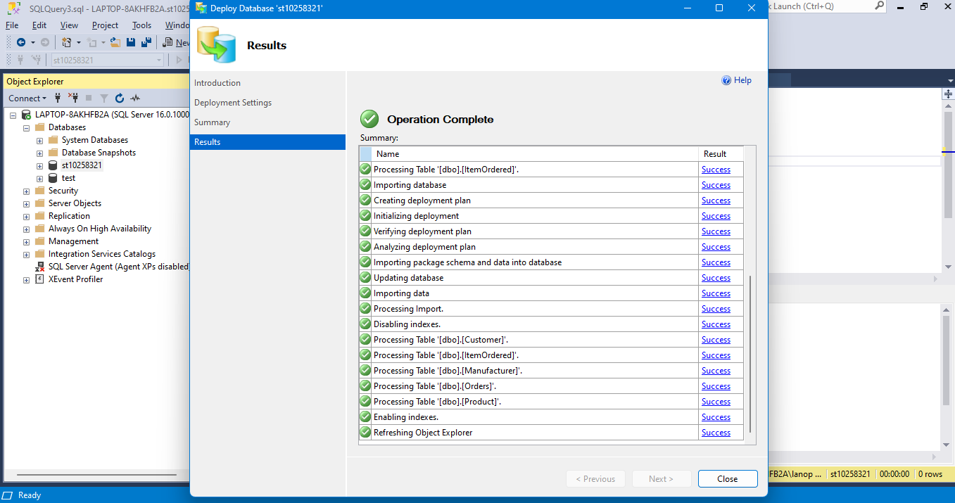

Screenshots of the user entering data/information from the website and it being in the Database:

Screenshots of the user ordering a product:

User views their order history:

User orders a product:



User Go back to their order history to an updated list:

