2020-10-25

Qian Zhang

CID: 01939418

Assignment 5

Fundamentals of Database Technologies

Question 1:

ORM(Object-relational mapper) is a programming technique which maps class to table in database. Specifically, it maps object from record, and maps attribute from field. ORM is useful in database programming because it provides a method for developers to interact with database using any language of choice, instead of writing SQL statements. It also provides a lot of advanced features, such as support for transactions, connection pooling, migrations, seeds, and streams.[1]

Question 2:

• The Flask server: flask is a python framework which is used to create web app. It is classified as a microframework because it does not require particular tools and libraries, so the code is simple while extensible. Flask supports extensions to add functionality to the application, including database integration, form validation, upload handling, various open authentication technologies, and more.[2] It is created by Armin Ronacher of Pocoo, an international group of Python enthusiasts formed in 2004. [3]

• The SQLAlchemy ORM: SQLAlchemy ORM is a python library which facilitates python program to communicate with relational databases. It is named as ORM because it could translates Python classes to tables on relational databases and automatically converts function calls to SQL statements. It is usually used to query data on Python applications.[4]It is a open-source SQL toolkit and is initially released on February 14, 2006. The original author is Michael Bayer.[5]

• The Heroku hosting platform: Heroku is a cloud platform as a service. It is a managed container system, with integrated data services and a powerful ecosystem, for deploying and running modern apps.[6] Heroku was initially developed by James Lindenbaum, Adam Wiggins, and Orion Henry for supporting projects that were compatible with the Ruby programming platform known as Rack. The name "Heroku" is a portmanteau of "heroic" and "haiku. It faced drawbacks after it is initially released because it lacked market, as many app developers used their own tools and environment.[7]

• The Git version control tool: Git is a modern version control system. It helps software developers to manage changes to source code over time. Git keeps track of every modification to the code in a special kind of database. If a mistake is made, developers can turn back the clock and compare earlier versions of the code to help fix the mistake while minimizing disruption to all team members. It is originally developed in 2005 by Linus Torvalds, the famous creator of the Linux operating system kernel.[8]

Question 3:

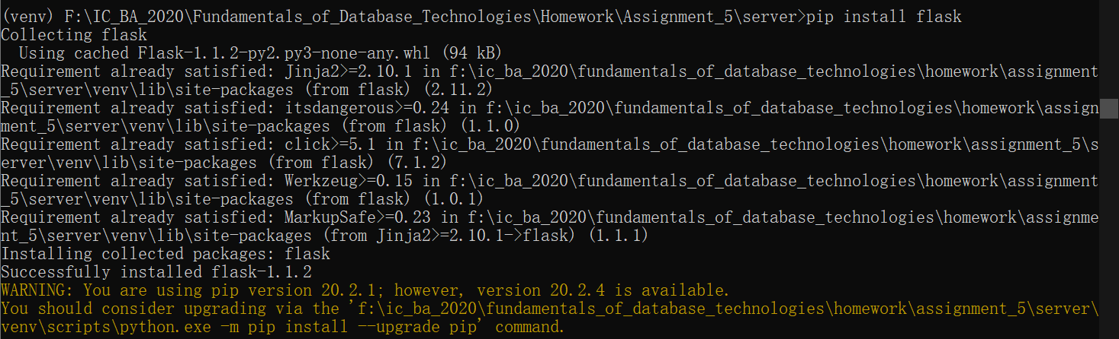

Question 4:



Question 5:

If I change the scripts in app.py to something else and refresh the web page, the new value is not shown. Therefore, I searched online for solution and found that I need to turn on the debug mode by setting FLASK_ENV the environment variable to development. After I done that, I reran the FLASK RUN command. Now if I change the scripts in app.py and save it, Flask will automatically reload the code.

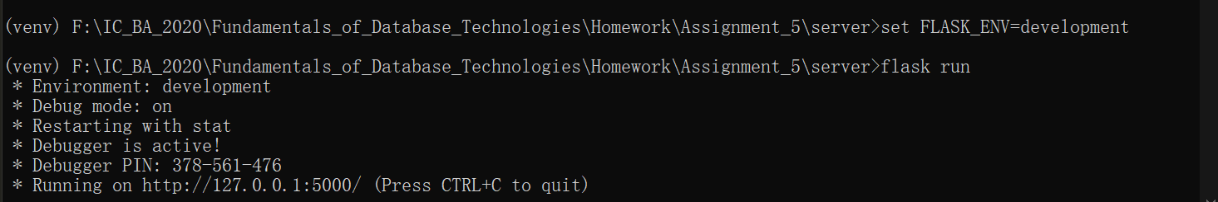

Question 6:

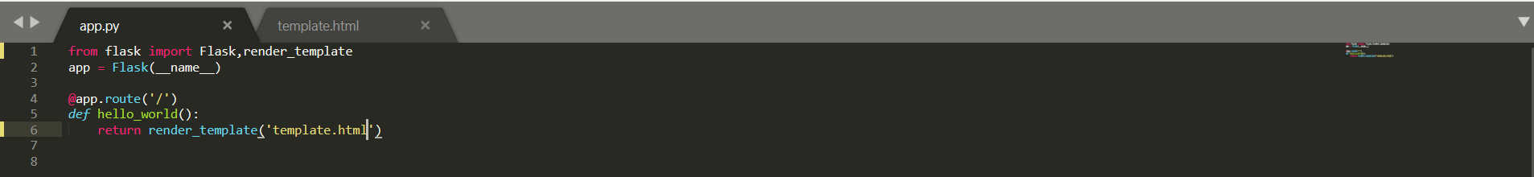



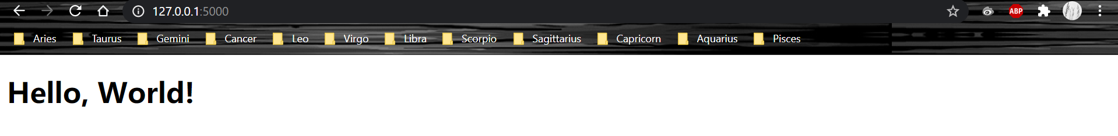

Question 7:



Question 8:

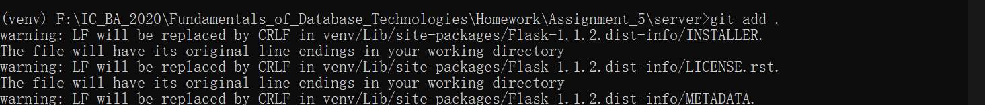

Question 9:

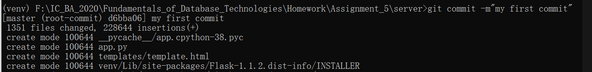

Question 10:

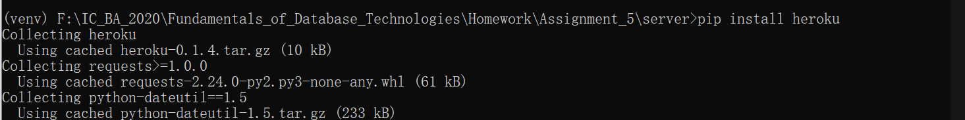

Question 11:

After I created an account on Heroku and downloaded the Heroku toolbelt, I first login into the account by using **Heroku login**, which brought me to a website.

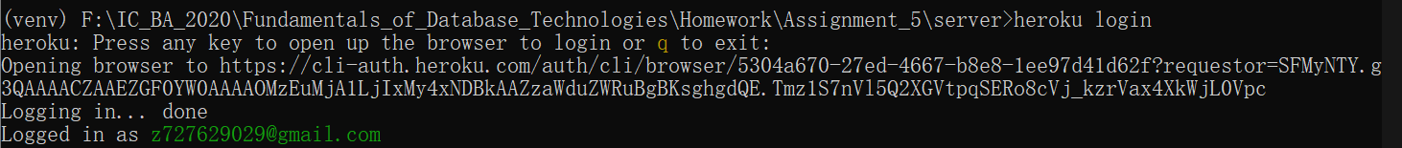

Then, I used **Heroku create** to create a app on Heroku, and deployed it with git.

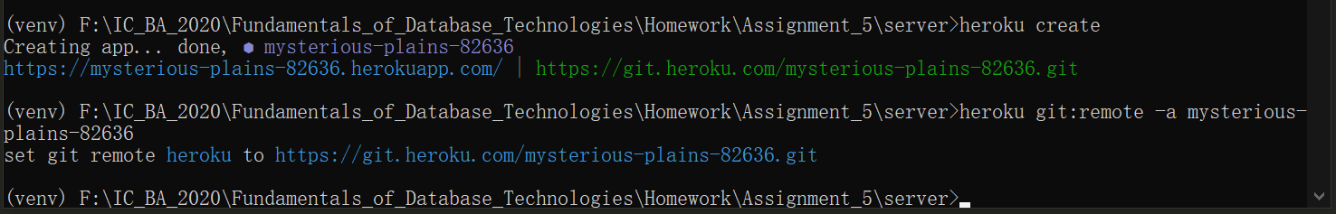

Then I used **pip freeze > requirements.txt** to generate a text file, which contains the Python libraries that Heroku needs to install to run the app.



I added a new line in app.py to tell Heroku that it should listen on port 5000, and created a Procfile to tell Heroku how to run my server.

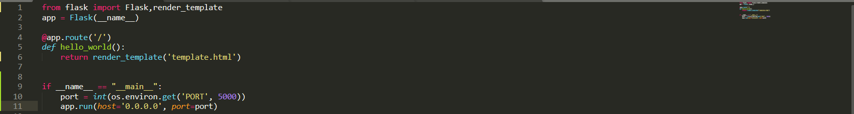



Now everything is set up, I used **git add .**, **git commit** and **git push heroku master** to deploy my app on Heroku. The website displays **Hello, World** successfully.

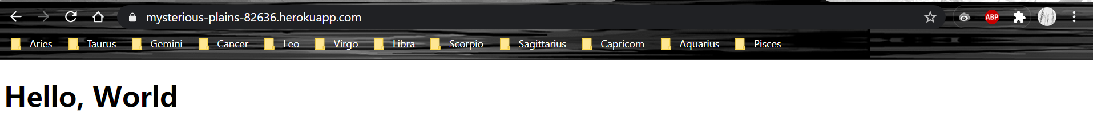

Question 12:

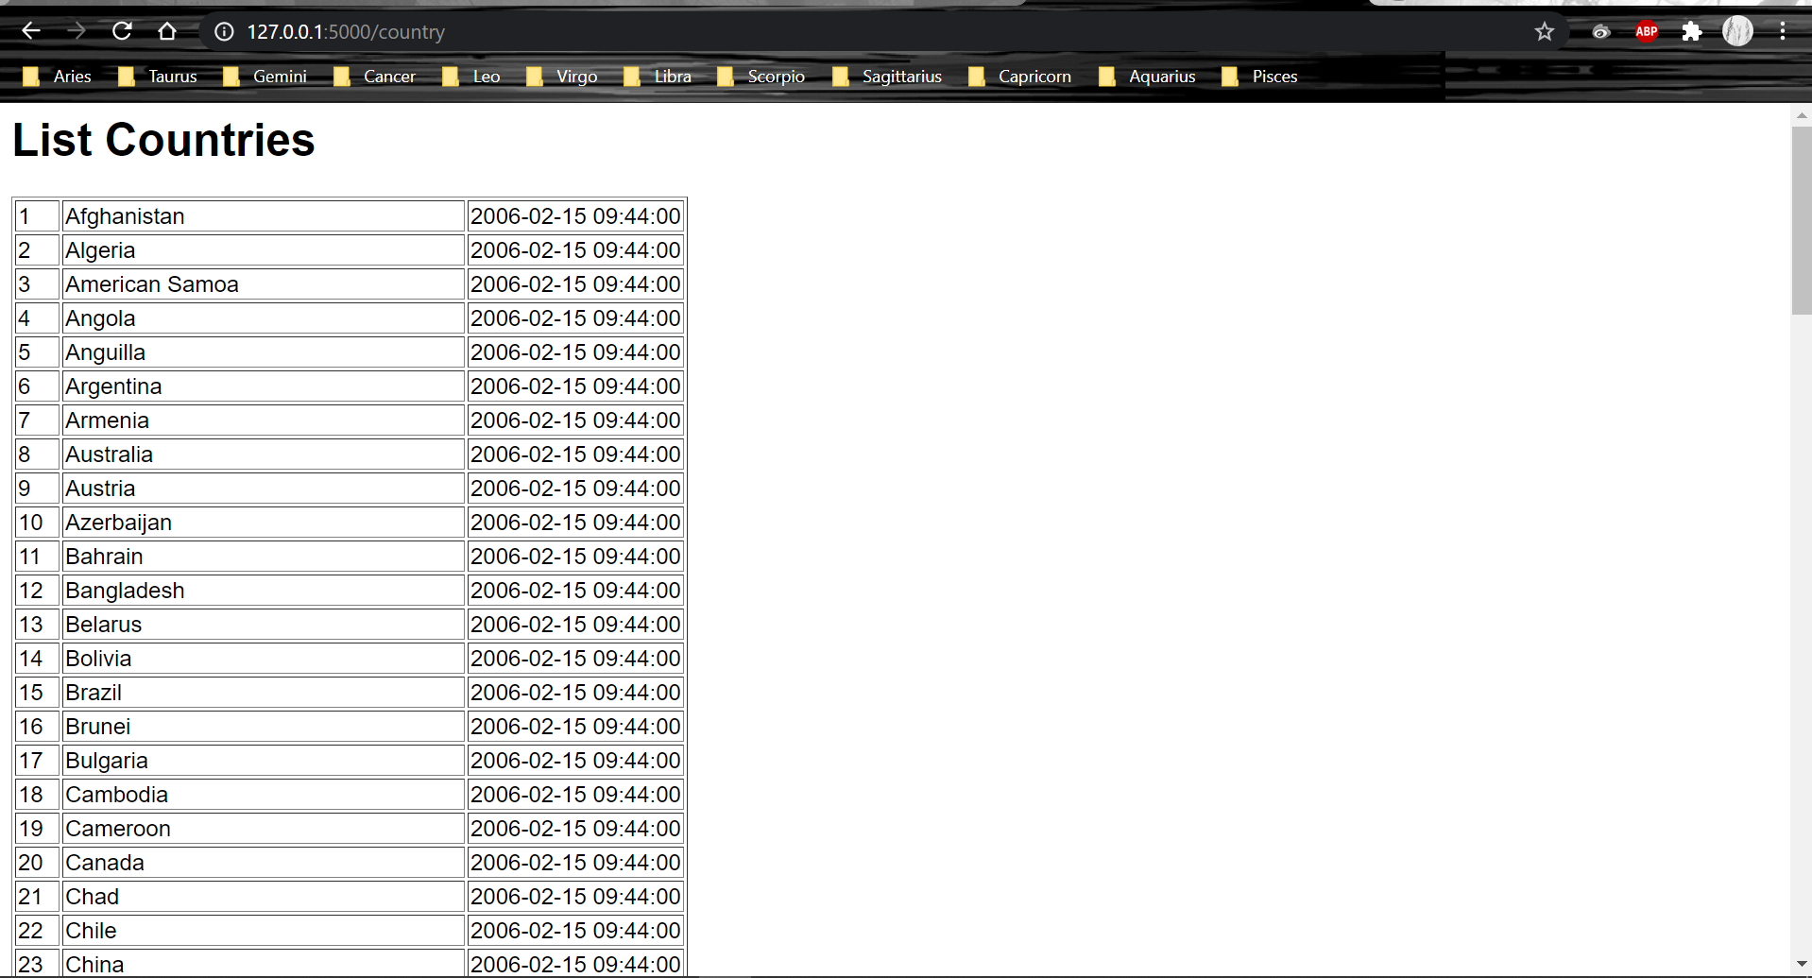

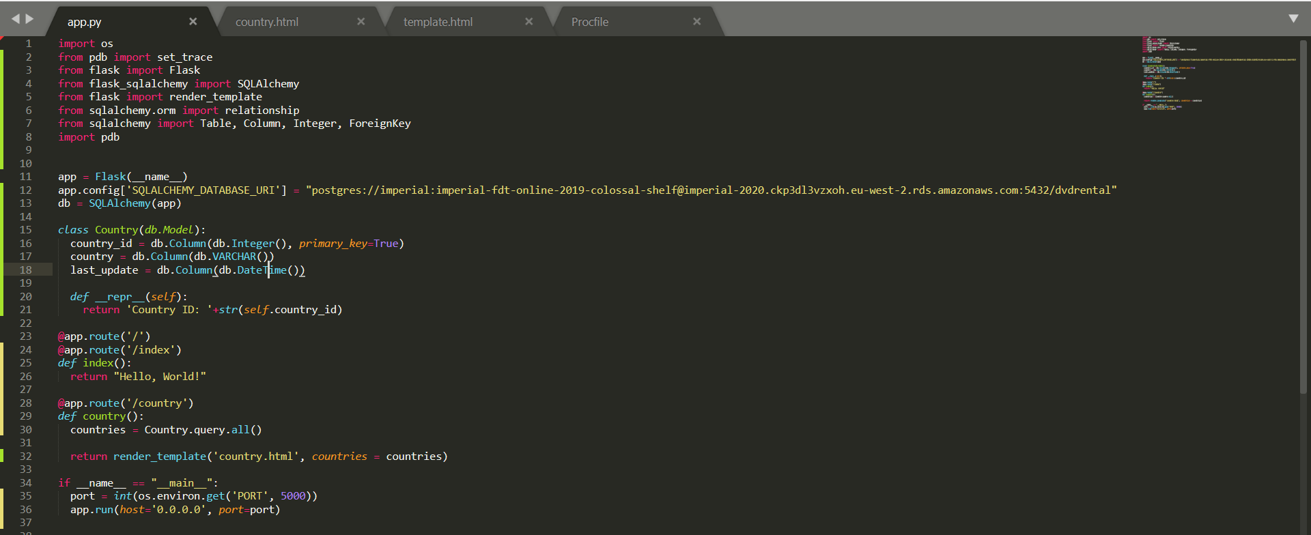

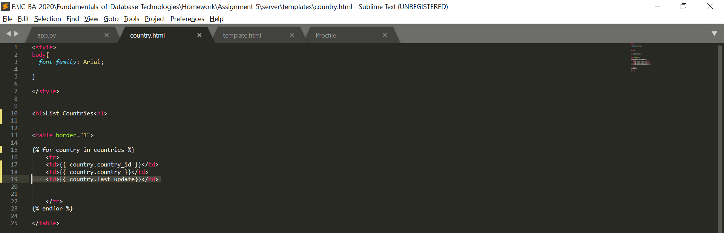

Question 13:

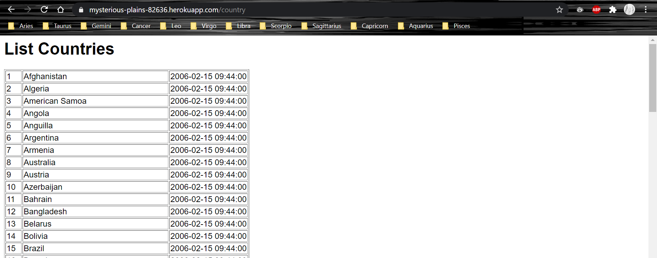

References

[1] https://blog.bitsrc.io/what-is-an-orm-and-why-you-should-use-it-b2b6f75f5e2a

[2] https://flask.palletsprojects.com/en/1.1.x/foreword/

[3] https://en.wikipedia.org/wiki/Flask_(web_framework)

[4] https://auth0.com/blog/sqlalchemy-orm-tutorial-for-python-developers/

[5] https://en.wikipedia.org/wiki/SQLAlchemy

[6] https://www.heroku.com/platform

[7] https://en.wikipedia.org/wiki/Heroku

[8] https://www.atlassian.com/git/tutorials/what-is-version-control