Chasing wind and sun narrows but does not close the data-centre clean-power gap

Junteng Liao¹, Jiefu Lu², Haoran Zhang^{1,*}

¹School of Urban Planning and Design, Peking University, Shenzhen, Guangdong, China
²School of Artificial Intelligence, Shenzhen Technology University, Shenzhen, Guangdong, China
*Corresponding author: Haoran Zhang (h.zhang@pku.edu.cn)

ABSTRACT
Data centres are a rapidly growing source of electricity demand, yet interactive computing follows local human routines whereas solar generation peaks near local noon. Here we combine hourly web traffic from 104 countries with station-level wind and solar output and network latencies to quantify the same-hour alignment between equal-energy clean supply and an interactive-demand proxy. Domestic wind and solar leave a median matching gap of 40.1%. Enabling cross-longitude workload routing reduces the median gap to approximately 12.7% under fully routable demand and global reach. The benefit rises strongly with routing distance but plateaus at a phase floor: even an unrestricted static combination of reachable wind-and-solar waveforms cannot synthesize the evening-peaked demand curve. Reshaping AI workloads has a smaller influence than expanding routing reach, and the residual floor requires storage, firm clean generation or cross-hour flexibility. These results establish temporal waveform synthesis as a distinct systems constraint on 24/7 carbon-free interactive computing.

Introduction
Artificial intelligence is turning electricity into a binding constraint on digital civilisation. The International Energy Agency projects that global data-centre electricity will rise from about 415 TWh in 2024 to about 945 TWh in 2030^{1,2}. That exceeds what Japan consumes today, and AI is the dominant driver. Over the same years, the 24/7 carbon-free energy compact led by Google, Microsoft and UN Energy has tightened the standard from annual net offsetting to hourly real-time matching³. The size of the hourly gap, the share that can be erased, and the share that must be bought back remain unknown. Yet they decide how trillions of dollars of compute and power investment are allocated. That account has not been settled.
Existing theory answers the spatiotemporal mismatch from the supply side. The spatial-aggregation hypothesis holds that wind and solar decorrelate across geography. Wide interconnection can therefore smooth their fluctuations and partly replace storage, which motivates supergrid and global-network designs^{4,5,6,7}. Integration-cost theory then prices the remaining mismatch as a firming premium, the extra cost of filling the gap with dispatchable power^{8,9}. The 24/7 carbon-free framework inherits this supply-side view^{3,10}. Demand enters as a fixed spatial boundary condition, and every degree of flexibility comes from generation, storage and transmission. Within this theory, how far geography can substitute for storage is an empirical curve of diminishing returns, with no limiting theorem.
AI load, however, dissolves an axiom of that theory. Supply-side models solve only over generation, storage and transmission because, for a century, demand had nowhere else to go. Factories, homes and cities were pinned in place. Computing is the first electricity demand that is mobile at scale^{11,12}. Data can cross continents in milliseconds, whereas power cannot. The spatial-aggregation hypothesis therefore gains a demand-side dual for the first time. Instead of moving power to the load, one moves the load to the power. Carbon-aware computing has produced scenario-specific estimates of this new degree of freedom^{13,14,15,16}. A more basic question remains: how far can space substitute for time? Our hypothesis is that geographic substitution has a phase floor. Once all useful longitudes are reachable, the remaining demand waveform lies outside the set that static non-negative wind-and-solar combinations can synthesize.
To test the hypothesis, we assemble an hourly generation-demand waveform dataset for 104 countries^{17,18}. On it we build an equal-energy waveform-matching framework that separates temporal shape from energy volume. Cross-longitude routing compresses the median gap from about 40% to about 13% and saturates within a few hundred milliseconds of latency¹⁶. The binding variable is the off-site share of load, not network physics. A metric-aligned linear programme proves that the global-reach residual remains positive in all 104 countries, with a median floor of 12.4%, close to the 12.7% NNLS estimate used for stable partner attribution. Uniform longitude coverage leaves the floor near 13%, and AI demand reshaping does not remove it. Follow-the-sun computing can therefore buy out about two-thirds of the domestic waveform gap, but the remaining phase floor requires temporal flexibility.

Normalised measures of temporal mismatch
Directly accounting for each country’s hourly carbon-free supply gap is not yet feasible. Independent estimates of its absolute energy differ several-fold. Yet the question posed here does not depend on absolute magnitude. Whether digital demand and clean supply align in time is a property fixed only by the phase relation between two within-day waveforms.
We therefore rescale each country’s digital-activity and clean-output series to the same annual total, discard the information on volume, and keep only temporal structure. We call this property phase-alignability, and quantify it with two measures. The hourly wind-and-solar matching gap $U_{c}$ is the share of demand that, under equal-energy normalisation, cannot be met by contemporaneous clean supply, and its complement, 1 − U, is provably identical to the hourly matching score of the 24/7 carbon-free energy (CFE) framework, now standard in corporate clean-power procurement and policy^{3,10}. The domestic residual phase-firming premium after waveform matching$Π_{c}$ is the increment, over pure wind-and-solar generation cost, of firming the residual gap with storage, the standard measure used in studies of variable-renewable integration cost^{8,9}. $U_{c}$ captures the physical share of the phase mismatch and $Π_{c}$ its economic cost, and the two are driven by the same mismatch. Their formal definitions are given in the Methods.
This construction is robust to uncertainty in volume. Wherever the absolute level of AI energy use falls within current projections, the normalised phase relation is unchanged. Demand volume depends on technological progress and adoption, whereas the phase structure is set by Earth’s rotation and human routines. The latter is what this study measures.
Two assumptions underlie this demand proxy, and we state them explicitly. First, the intraday shape of human request arrivals is taken to track the intraday shape of interactive electricity use, which holds when the within-day mix of request classes is approximately stationary; because equal-energy normalisation retains only shape, this is a statement about timing rather than about the several-orders-of-magnitude spread in per-request energy across classes, and it is corroborated against the BurstGPT and Azure inference-serving traces and stress-tested by compute-intensity weighting (Supplementary Section S17). Second, and more consequential for the projections, the results carried to 2050 (Figs 4 and 5) do not assume that the request-class composition is itself stationary — a mix that will certainly shift as inference and video generation grow — but only that human digital demand remains evening-peaked. That phase is set by human routines and Earth's rotation, not by the request mix, and the gap is correspondingly insensitive to demand shape: across six AI-reshaped 2025–2050 demand profiles the matching gap moves by only about one percentage point (Fig. 4), far less than the routing lever, and flattening the load if anything raises it slightly (Supplementary Section S17). The projections therefore rest on the persistence of the evening phase — an explicit and testable premise — rather than on a frozen composition.

Results

Domestic wind and solar alone leave the median country a 40.1% hourly wind-and-solar matching gap
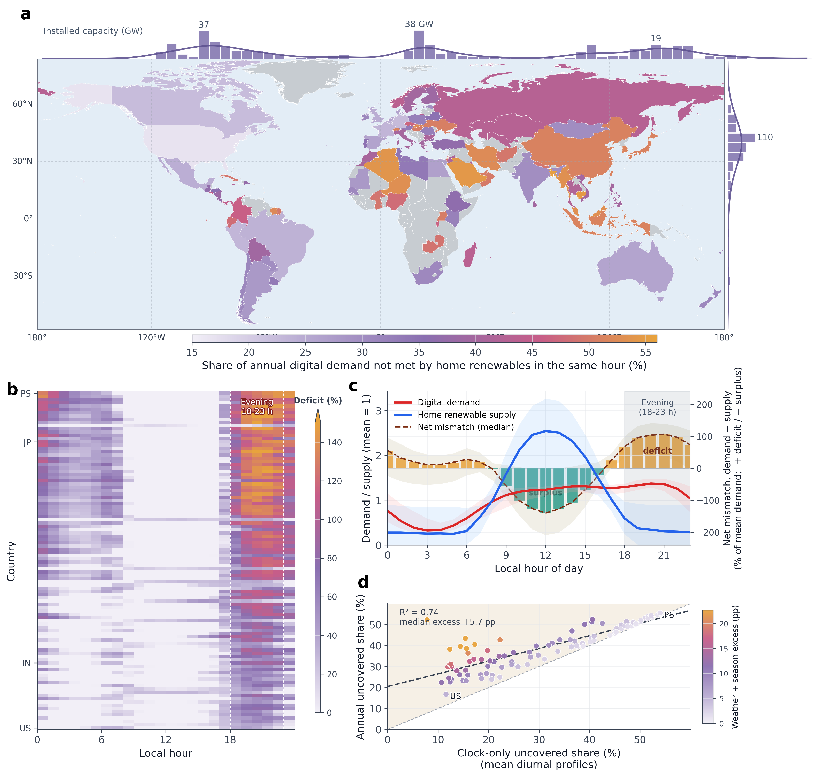
Figure 1 | Hourly mismatch between the interactive-demand proxy and domestic wind-plus-solar supply (n = 104 countries). (a) Per-country hourly wind-and-solar matching gap U (%, equal-energy basis; grey, countries outside the sample); marginal bars give the global wind-plus-solar installed capacity across 5° longitude and latitude bands (461 representative stations). (b) Local-hour × deficit-intensity matrix, one country per row, sorted by U; the dashed box marks the local 18:00–23:00 evening window. (c) Digital demand (red) and equal-energy-scaled domestic supply (blue) folded by local hour (medians and 10th–90th percentiles; mean = 1); the right axis gives the net mismatch, amber the evening deficit and cyan the midday surplus. (d) Matching gap U versus its clock-term share, recomputed from the 24-hour mean intraday profile alone (one point per country; linear fit R² = 0.74). Definitions and calibers are given in Methods.

The hourly match between the country-level interactive-demand proxy and domestic wind-plus-solar supply exhibits a consistent directional misalignment across all densely populated latitude bands, and no single country can absorb the resulting gap under equal-energy installed capacity. The median hourly wind-and-solar matching gap U across the 104 countries is 40.1%, reaching a maximum of 55.5% in Palestine and a minimum of 16.8% in the United States; 94 of the 104 countries exceed 25% and 22 exceed 50% (Fig. 1a). The Africa/MENA and Asia-Pacific regions concentrate most of the worst-mismatched countries, led by Bangladesh at 55%, Cambodia 55%, Saudi Arabia 54% and Algeria 54%, indicating that hourly mismatch is not a single climatic problem of high or equatorial latitudes but a structural tension between the temporal structure of digital society and the physical rhythm of renewables.
The direction of the mismatch is highly consistent and is driven primarily by the intraday temporal offset between demand and supply. Folded by local hour, human web-access traffic in almost every country forms a pronounced evening peak at local 18:00–22:00, whereas domestic renewable supply forms a midday peak at local 10:00–14:00 and falls sharply at 18:00–23:00; the demand–supply peak difference in the median country is about 8 hours (Fig. 1c). Solar PV locks the supply peak of most countries at 12:00–13:00, whereas the demand peak is broad and late, clustered at 18:00–22:00, and demand lags supply in 99 of 104 countries. These local evening peaks are strongly aligned in local solar time but staggered in UTC. Their similar local phase explains why nearby countries tend to enter the evening deficit together, limiting short-distance cancellation.
The evening is precisely where the gap lies. The difference between demand and supply (Fig. 1c, right axis) is pushed negative at midday by the solar surplus and, after 18:00–23:00, reverses into the largest deficit of the day; tiling the 104 countries into a matrix from bottom to top by matching gap U (Fig. 1b), the same evening bright band aligns horizontally across all countries, spanning every region and time zone, and in most countries the hourly deficit within this window reaches above 60% of annual mean demand, exceeding 100% in the worst-affected countries.
Differences among countries lie only in the magnitude of the deficit; its evening timing is shared across the sample—sorted in ascending order of matching gap U, the evening deficit merely deepens monotonically along the ordering, its position never shifting or disappearing, and all 104 countries concentrate the bulk of their all-day deficit in the evening (a median of 66.7% falling in 18:00–23:00, about 2.7 times the uniform baseline; Fig. 1b). Where a country sits along this gradient is set mainly by its domestic supply mix. The closer its supply is to pure solar, the higher its matching gap U, because solar output is locked at midday by astronomical geometry and its offset from evening-peaking demand cannot be evaded. Across the 104 countries the wind share of installed wind-plus-solar capacity is a strong descriptive correlate of this gradient (Spearman ρ = −0.61, p < 10⁻⁹), reflecting resource endowment; the load-bearing matching and routing gaps in the following sections are computed on a portfolio-optimised station basis that does not depend on this installed ratio (Methods). Wind-rich countries can soften this phase difference but cannot move where the gap falls—even in the United States, where the demand–supply phase difference is not pronounced, the deficit still concentrates in the evening window (Fig. 1b, leftmost column).
The clock-term gap, recomputed from each country’s 24-hour mean intraday profile alone, explains about three-quarters of the cross-country variation in the annual gap (R² = 0.74, Fig. 1d)—intraday temporal offset, not weather fluctuation, drives the divergence in magnitude among countries; weather and seasonal fluctuations only shift the overall level systematically upward, by a median of about 5.7 percentage points (IQR 2–12). Country-level detail on the matching gap U, the demand–supply peak phase difference and the 95th-percentile continuous gap duration is given in Supplementary Data 1.

Cross-longitude routing compresses the geometric waveform gap but leaves a phase floor
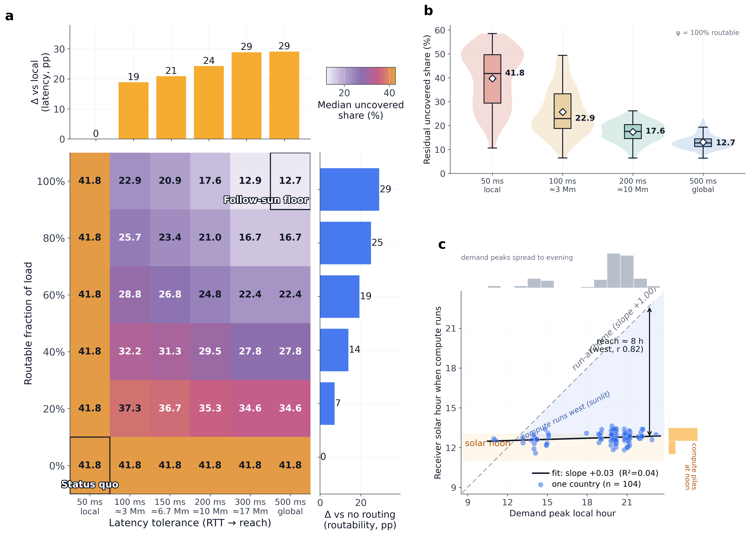
Figure 2 | Compression of the residual supply-demand gap by latency tolerance and routable share. (a) Cross-national median residual matching gap U across 104 countries for a 6 × 6 scenario matrix. Rows give the off-site-servable share and columns give routing reach under round-trip-time budgets from approximately 50 ms to 500 ms; marginal bars show reductions from expanding each lever. (b) Cross-national distributions of U as reach expands under fully routable demand; inset boxes show quartiles and white diamonds show means. (c) Energy-weighted mean solar time of the fitted receiving profiles at each country's demand-peak hour (n = 104). The grey dashed line is the domestic self-sufficiency counterfactual. The near-flat fit checks that routed load is matched to partner profiles near solar noon. U is the equal-energy share of demand not aligned with contemporaneous clean supply and equals one minus the 24/7 carbon-free energy matching score (Methods). Reachable supply is a static non-negative combination of partner generation shapes. The phase floor is defined in Methods and proved in Supplementary Section S24.

Migrating compute workloads to regions with contemporaneous clean generation can compress the hourly 24/7 CFE gap without relying on cross-border electricity transmission. Under fully on-site execution, the median matching gap U is about four-tenths, in line with the 40.1% installed-capacity headline of Result 1; the waveform routing analysis uses each country's optimised domestic wind-and-solar portfolio, whose no-routing baseline lies within 2 percentage points of that headline (Methods and Supplementary Section S10). As the routable share and latency tolerance increase, workloads gain access to a broader set of contemporaneous clean-generation waveforms and the residual gap declines. With fully routable demand and global reach under an approximately 500-ms round-trip-time budget, the residual gap reaches its phase floor at about 12.7% (Fig. 2a).
The modelled gain from relaxing the latency budget shows diminishing returns beyond a few hundred milliseconds. Inter-country round-trip time in the distance model reaches about 340 ms, so budgets of roughly 200–300 ms provide access to most longitudes and larger budgets add little within the scenario grid (Fig. 2a). When load is fully routable, expanding reach from local to about 3000 km lowers the median gap only to 22.9%; access across larger longitudinal spans then reduces it to about 12.7% (Fig. 2b). Nearby countries have similar diurnal phases and tend to enter night together, whereas far-side resources may remain in daylight. Workload placement also depends on the network budget left after on-server compute. Under the service-level and compute-time assignments used here, voice assistants, code completion and real-time retrieval-augmented generation generally remain in local or short-reach tiers, whereas image and video generation and batch inference are assigned broader reach. Supplementary Section S18 reports the measured inputs and the reasoned tier assignments.
Under the median-latency and workload-budget assumptions examined here, the routable share has a larger modelled influence than expanding the latency budget beyond a few hundred milliseconds. A substantial share of digital load remains local because of proximity access, session state and data-residency constraints. Under global reach, increasing the off-site-servable share lowers the median gap U nearly linearly, from 34.6% at one-fifth through 27.8%, 22.4% and 16.7% to 12.7% when fully open (Fig. 2a, right margin), and to about 27.8% at an illustrative routable share of four-tenths. Reaching the lowest modelled residual therefore requires highly routable service architectures; lower tail latency alone does not guarantee that these operational and regulatory constraints are removed.
The timing-complementarity network implied by the fitted basis weights is highly dispersed, and the gain comes overwhelmingly from crossing longitudes rather than from regional interconnection. About 38 waveform-matching partners carry non-zero aggregate weights, led chiefly by Mexico, Chile, Australia, Japan, South Africa, Spain and the United States; these partners span all longitude bands and are dominated by low-latitude, high-irradiance solar PV, with mid- and high-latitude wind secondary (Fig. 3g,h). The weights describe potential timing complementarity, not delivered compute or power. Regional reach captures only a small part of the gain. As the latency budget expands from about 3000 km (Fig. 3a,b) to trans-hemispheric and global reach (Fig. 3e–h), the waveform basis opens from nearby neighbours to partners across all longitudes, and the cross-national mean share of the routable shortfall matched in timing rises from about 14% to about 27%.
This dispersed timing basis lowers the modelled gap because partner clean-output shapes still near solar noon complement each country’s evening peak. Whatever the local hour at which the interactive-demand proxy peaks, the fitted waveform-matching weights concentrate around solar noon in partner countries, and their energy-weighted mean implied landing solar time clusters around 13:00 essentially regardless of the local demand-peak hour (Fig. 2c) — as expected once supply is noon-locked everywhere, confirming that routing reaches partners still in daylight rather than constituting a finding in itself. Countries peaking in the evening therefore reach back westward by about 8 solar hours on average to match the partner waveform, approximately offsetting the roughly 8-hour phase lag by which their demand peak trails the domestic wind-and-solar output peak.
Geographic routing compresses the gap but cannot close it. With fully routable load and global reach under a ~500 ms round-trip budget, the median NNLS residual is about 12.7%. A linear programme that minimises uncovered energy directly gives 12.4%, and its optimum is strictly positive in every country. This value is the phase floor of the equal-energy, static wind-and-solar waveform-synthesis problem. Closing the remaining gap requires firm clean generation, storage or cross-hour deferral (Methods and Supplementary Section S24).
The phase floor near one-eighth follows from separating availability from waveform synthesis. Routing first removes the availability limit by reaching partners whose clean output is still near solar noon, compressing the median gap from about four-tenths to about one-eighth (Fig. 2b). Once global reach is open, the residual is the total-variation distance between the routable demand shortfall and the convex hull of reachable wind-and-solar waveforms. That distance is zero if and only if the demand shortfall belongs to the convex hull; the metric-aligned LP and its dual certificate show that it remains positive for all 104 countries. Uniformly redistributing receiving partners in longitude leaves the median floor near 13%, whereas changing the supply dictionary moves its value because it changes the convex hull. The floor is therefore irreducible within the specified static same-hour wind-and-solar waveform space, rather than a consequence of missing longitudes.
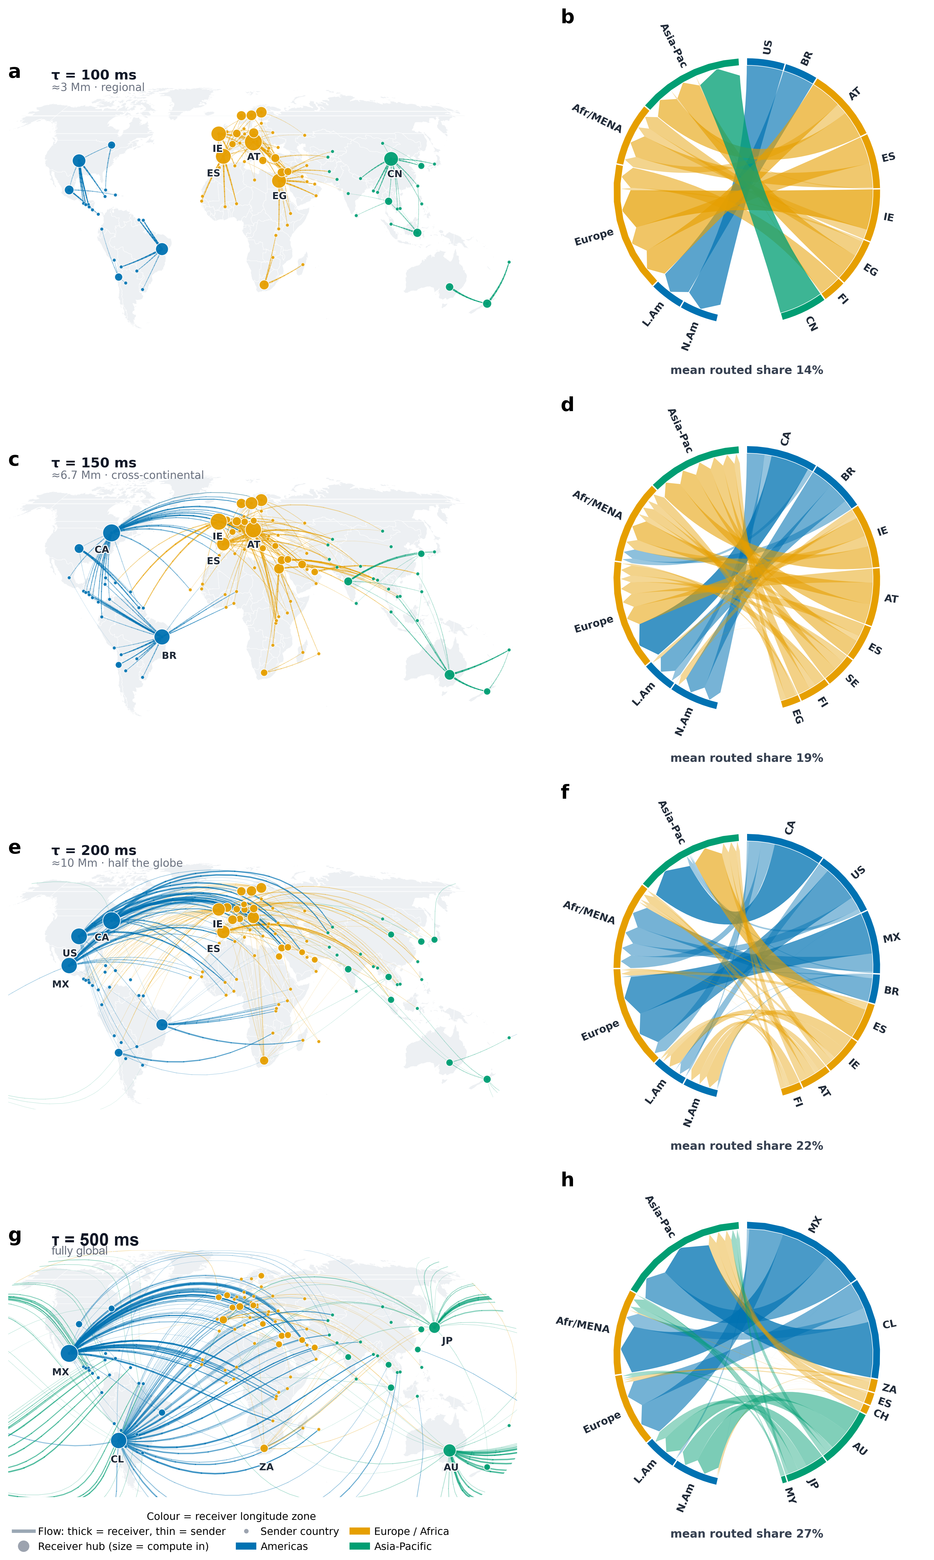
Figure 3 | Opening of waveform-matching partner weights with latency tolerance. The four rows correspond to latency tolerances τ = 100, 150, 200 and 500 ms (regional, cross-continental, cross-hemisphere and fully global reach under round-trip-time gating); within each row, the left panel is a geographic basis-weight map and the right panel a receiving-partner-to-sending-region chord diagram. (a, c, e, g) Arcs run from waveform-matching partners to sending countries; their width and opacity denote fitted NNLS routing-basis weight, colour denotes the partner’s longitude band, and dot size denotes cumulative receiving-partner weight. (b, d, f, h) Chords aggregate the same routing-basis weights between the highest-weight partners and sending regions. The value below each row is the cross-national mean share of the routable shortfall matched by partner waveforms. These graphics show an implied timing allocation, not physical compute flows or power transfers. As latency tolerance relaxes, the timing-complementarity basis opens from nearby partners (about 14%) to trans-hemispheric and global partners (about 27%).

The AI-reshaped demand shape matters little; the phase-firming premium is set by routing reach, falling to about 55% at the global tier
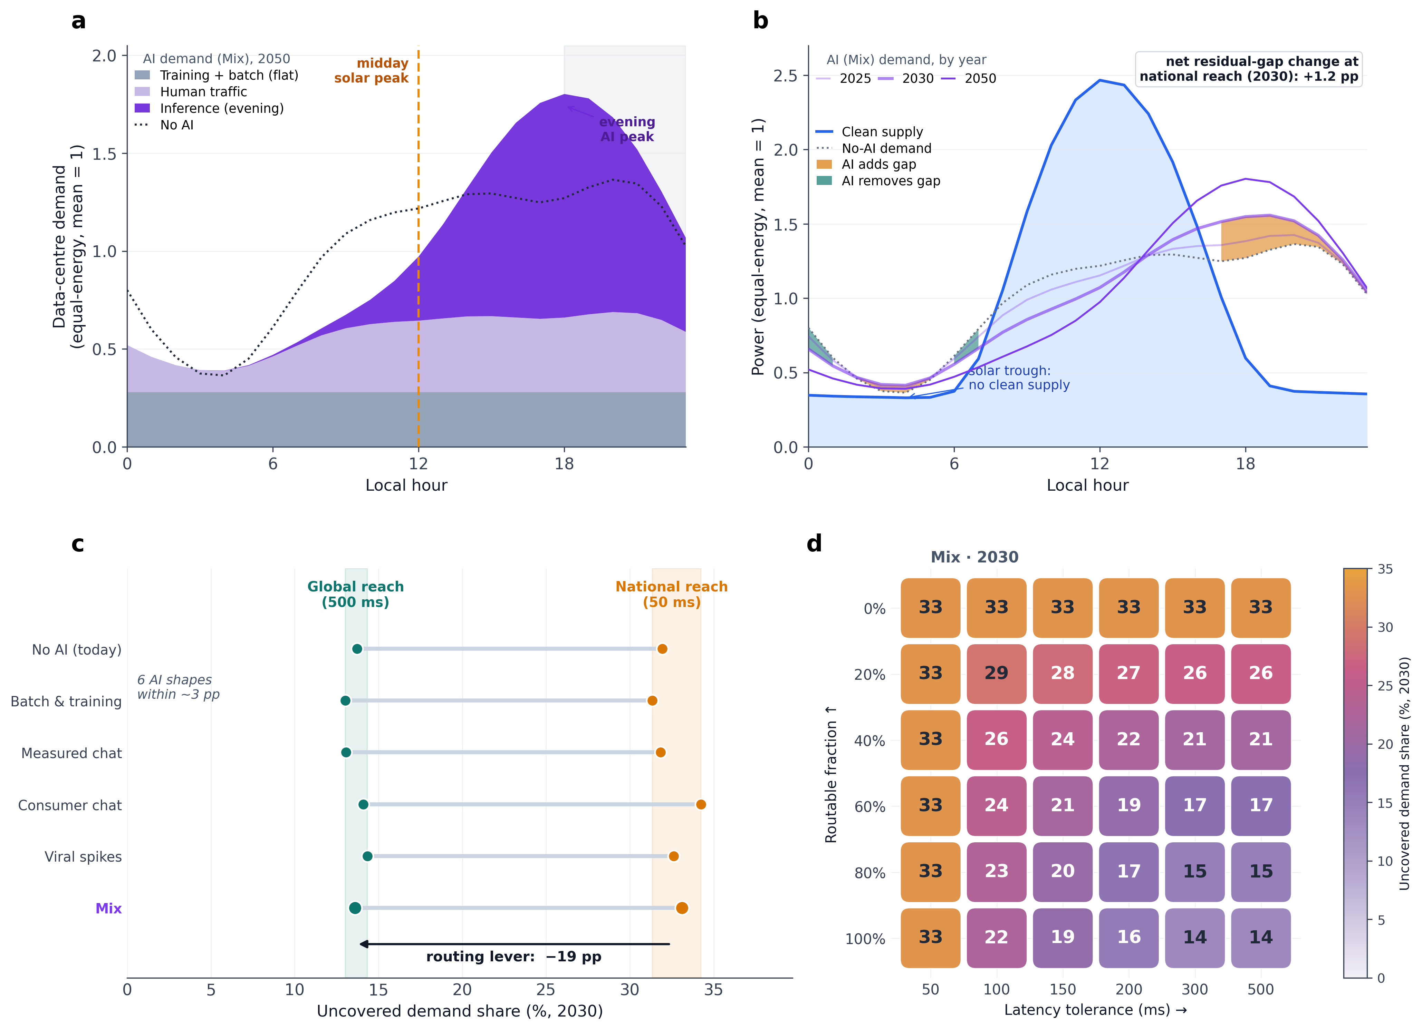
Figure 4 | AI reshapes the human-traffic demand proxy but changes the residual gap little. The expected mixed-AI profile combines an evening inference peak with flat training and batch load. (a) Local-hour decomposition of the 2050 mixed profile (mean = 1); the dotted line is AI-free demand, the orange line marks the solar-PV midday peak and the grey band marks 18:00–23:00 local time. (b) Mixed profiles for 2025, 2030 and 2050 and the AI-free profile against equal-energy domestic wind-and-solar supply. Orange and cyan mark hours in which the 2030 mixed profile respectively adds or removes uncovered demand; the inset gives the net change. (c) Median uncovered share across 104 countries for six 2030 demand profiles under domestic and fully routable global reach. The AI-free to Mix change is approximately 1 percentage point, while the full six-profile range is approximately 3 percentage points. (d) Median uncovered share for the 2030 mixed profile across the 6 × 6 routing matrix. Panels c and d use the country × technology capacity-weighted basis employed for the full AI scenario sweep. Their absolute levels are comparable within Figure 4 but not directly with the station-level values in Figure 2; see Methods and Supplementary Section S10.

The effect of AI load on 24/7 CFE lies not in the total energy it injects but in how it reshapes the within-day profile of the human-traffic demand proxy once a flat training baseload is superimposed. As the inference and training shares rise, the demand curve is partly flattened and an inference peak is added in the evening (Fig. 4a). Yet this shape effect in itself exerts little influence on the residual gap. Under fixed domestic supply, reshaped demand merely redistributes an equal amount of energy among hours, and both the night trough it fills and the evening peak it raises fall within the deficit window where there is no sunlight and clean supply is already near zero; against the supply trough dominated by solar PV, the gains and losses of peak-shaving and valley-filling nearly cancel (Fig. 4b). As a result, the matching gap U under the expected mixed-AI profile differs from the AI-free baseline by only about 1 percentage point, the six AI profiles lie close to one another, and this is far smaller than the routing drop between domestic and global reach (Fig. 4c; Supplementary Fig. S4). What determines the magnitude of the matching gap U and the phase-firming premium Π is therefore not the shape of the reshaped demand curve, but how far the compute load can be routed and what fraction of it can be taken up elsewhere (Fig. 4d). Within the country × technology basis used consistently across Figure 4, routing lowers the 2030 mixed-profile median from 33.3% to 13.9%. This same-basis 19.4-percentage-point contrast, rather than a cross-basis comparison with Figure 2, is the routing result that Figure 4 supports.
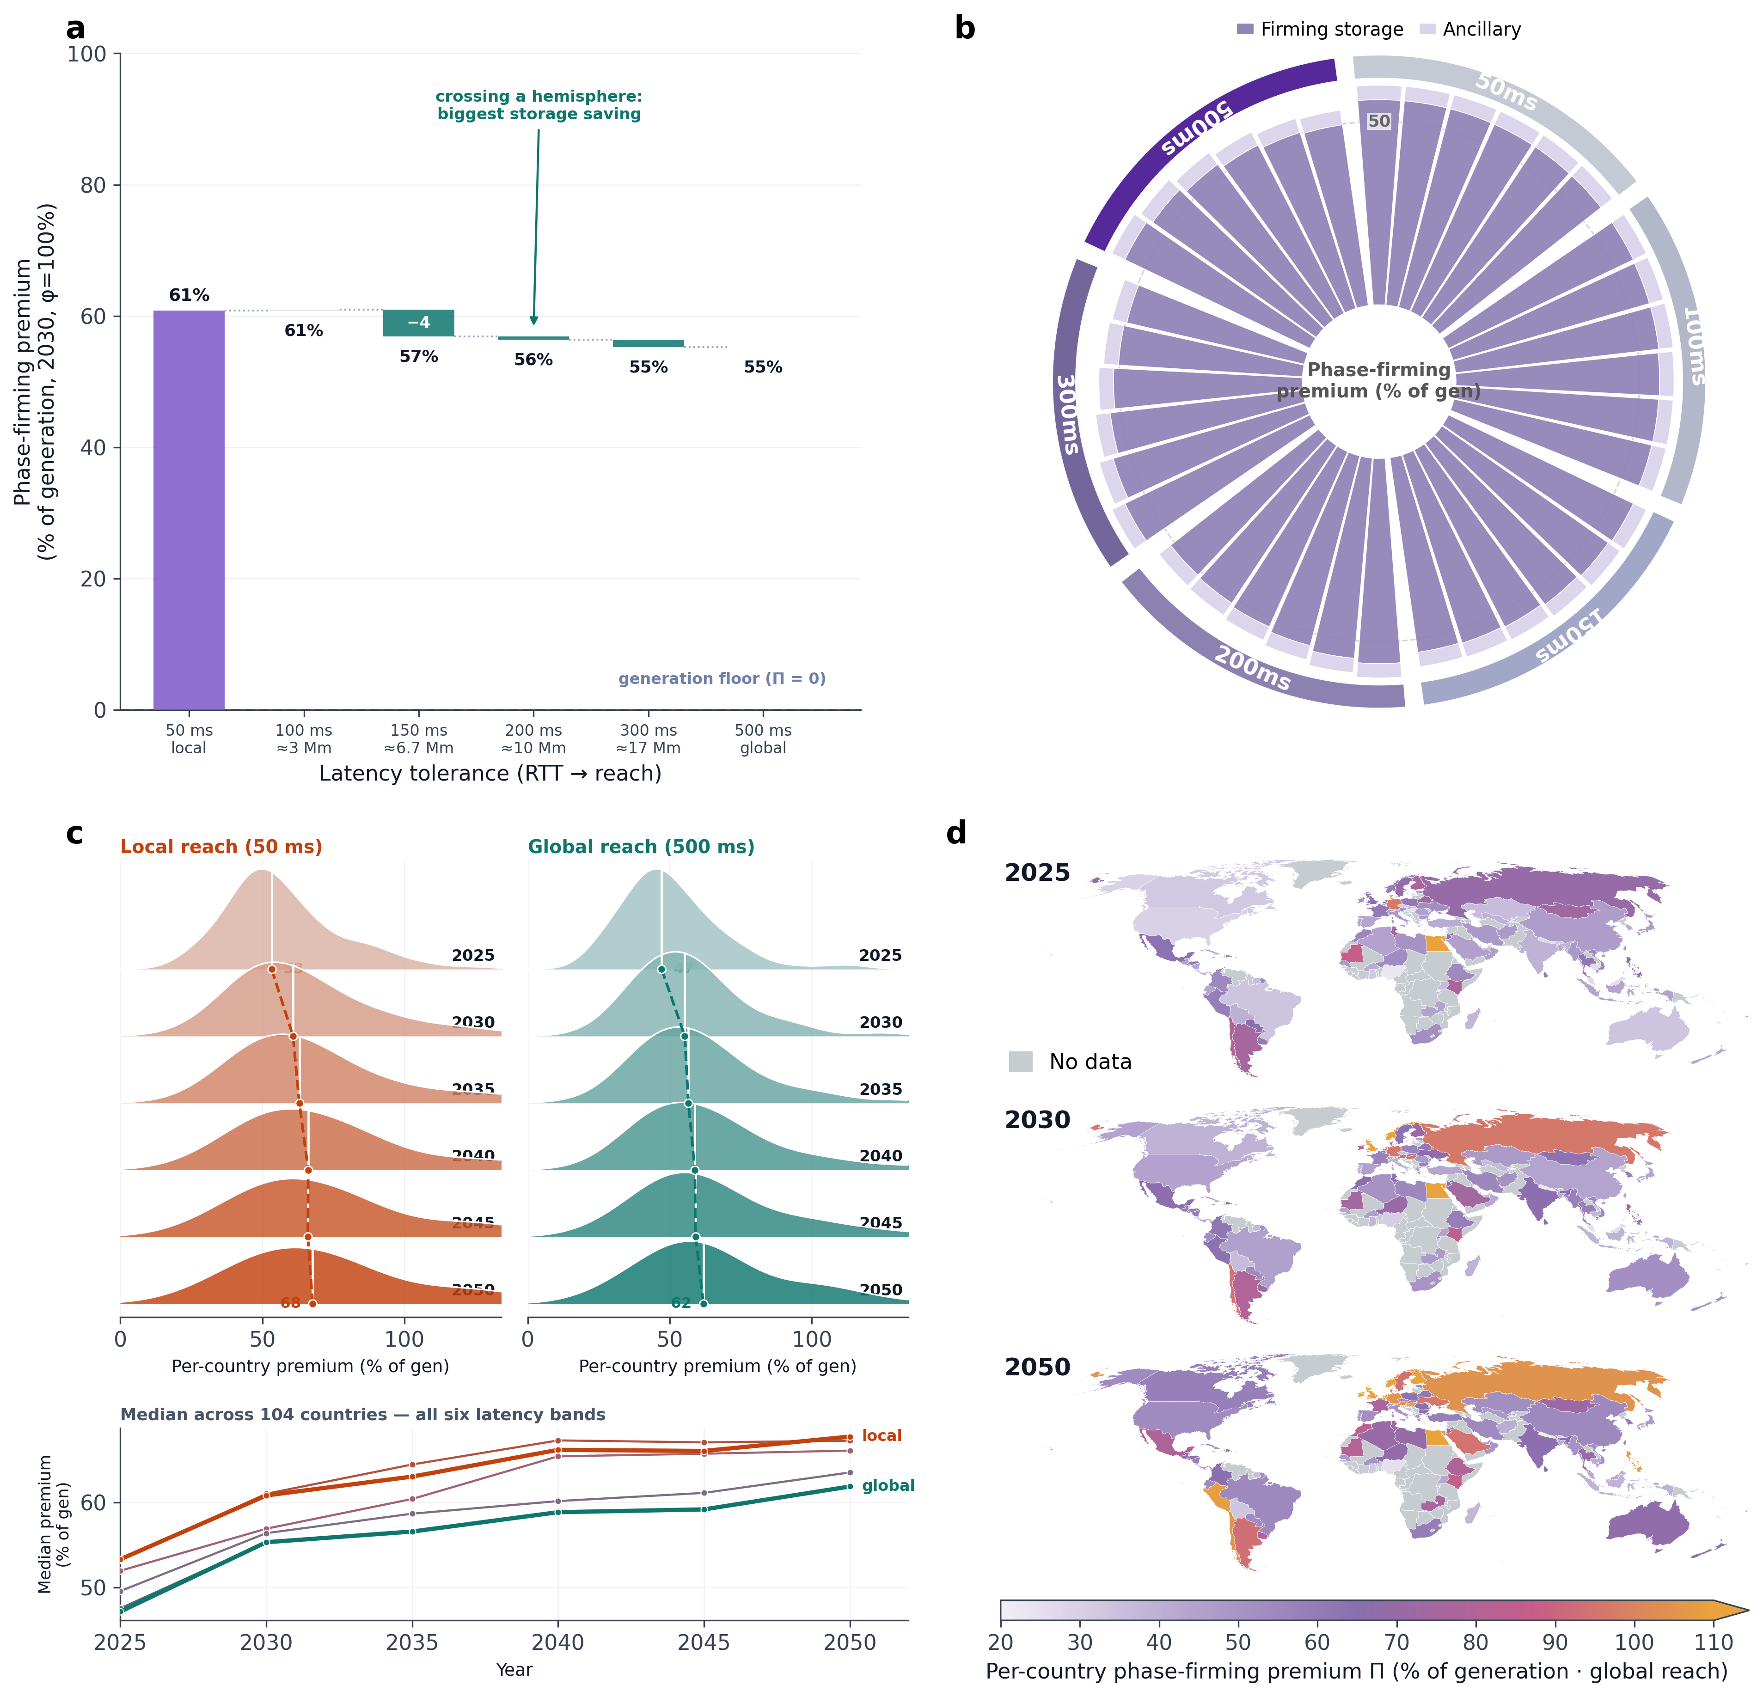
Figure 5 | Routing reach determines the domestic residual phase-firming premium. Throughout, the expected mixed-AI demand profile is used as representative. The domestic residual phase-firming premium after waveform matching, Π, is the dimensionless fraction, over pure wind-and-solar generation cost, needed to firm with domestic storage the residual phase gap that routing leaves (generation cost corresponds to Π = 0), made up of firming storage and ancillary services; it is the cost-language mirror of the matching gap U, computed per country on domestic supply, not a complete cross-national delivery cost. The corresponding absolute cost basis and its year-by-year conversion are given in Supplementary Section S22. (a) The waterfall plot gives the stepwise decline of Π under full routability in 2030 as latency tolerance is relaxed, from about 61% at the on-site tier, each downward step being the firming-storage premium saved, the cross-hemisphere hop giving the largest drop, to about 55% at the global tier. (b) The polar rose plot gives Π for 36 scenarios in 2030, each sector being one scenario and the radius the premium, stacked from inner to outer as firming storage and ancillary services, with the outer ring grouped by latency tolerance. (c) The ridgeline plot compares the year-by-year distribution of 104-country Π from 2025 to 2050 under the on-site tier (50 ms) and the global tier (500 ms), the white tick being each year’s median and the dashed line the median trajectory; the line below gives the median premium across all six latency tiers as a function of year—absolute levelised cost declines year by year, yet Π rises because generation cheapens faster than storage. (d) World maps of country-level Π under global reach and full routability for 2025/2030/2050 (shared colour scale; grey denotes countries not in the sample).

The reduction in the matching gap is accompanied by a smaller domestic residual firming burden. Under fully on-site execution, the median phase-firming premium is approximately 61% of wind-and-solar generation cost. The premium declines monotonically as routing reach expands, reaching about 55% under fully routable demand and global reach (Fig. 5a). The corresponding firming-cost share decreases from approximately 38% to 36%. Cross-longitude routing therefore lowers the cost of managing the residual mismatch, although the economic reduction is more modest than the compression in the hourly matching gap.
Most of this reduction comes from lower storage requirements. Routing workloads towards regions with contemporaneous clean generation reduces the domestic residual gap that must be bridged across hours by approximately one quarter. The storage component of the premium consequently falls from about 57% of generation cost under on-site execution to about 50% under global reach, whereas the ancillary-services component remains close to 4% (Fig. 5a,b). Improved phase alignment therefore reduces firming costs primarily by shortening and narrowing the residual intervals that storage must cover, rather than by materially changing ancillary-service requirements.
The relative and absolute cost trends diverge over time. Absolute levelised costs decline as solar, wind and battery technologies become cheaper, yet the phase-firming premium rises from approximately 47% in 2025 to 62% in 2050 under fully routable global reach and from approximately 53% to 68% under on-site execution (Fig. 5c,d). This increase reflects the faster decline in generation costs relative to residual firming costs, rather than a worsening of the underlying phase mismatch. Global routing remains less costly than on-site execution in every year, but its advantage is insufficient to offset the growing relative importance of firming as renewable generation becomes cheaper.

Discussion
The substitution of geography for storage is commonly described by a curve of diminishing returns^{4,5,6}. This study gives that substitution a boundary. In the limit of fully mobile load, the hourly gap has a two-part structure: cross-longitude access removes about two-thirds, while the final third is a phase floor set by the distance between evening-peaked demand and the feasible wind-and-solar waveform space. The metric-aligned linear programme makes this boundary exact within the model, and its dual supplies a separating certificate whenever demand lies outside the feasible convex hull. Geography can therefore substitute for storage only up to the boundary of the waveform space.
A two-part gap calls for two-part policy. The routable share is governed by software architecture, cross-border data rules and the fraction of services that can execute off-site^{19,20}. The phase floor is instead a temporal-capacity problem within wind-and-solar supply and must be met by storage, firm clean generation or genuinely deferrable workloads²¹. Hourly-matching frameworks should therefore distinguish certified geographic routing from the temporal resources used to cover the floor. Data-flow policy and capacity support address different components of the same decarbonisation problem.
Equal-energy normalisation is what makes the phase floor mathematically identifiable. Once demand and supply both sum to one, the uncovered share is exactly their total-variation distance, so multiplying installed capacity cannot erase the mismatch by changing scale alone. The floor can fall only when the feasible waveform set expands—for example through storage, firm generation or temporal deferral—or when the demand waveform itself changes. Absolute procurement, overbuilding and curtailment remain quantity questions and are deliberately separate from this waveform theorem.
The theorem has a precise scope. It applies to static, non-negative, same-hour combinations of the wind-and-solar waveforms and interactive-demand proxy used here; dynamic hydro, nuclear, storage and cross-hour execution enlarge the feasible set and can lower the floor. Off-site execution is also constrained by data sovereignty, privacy jurisdictions and market friction^{19,20}. These limitations do not weaken the convex-hull result within its stated space, but they delimit its translation into an operational grid optimum. Future work should estimate that enlarged feasible space and couple waveform synthesis to absolute compute, bandwidth and clean-capacity constraints.

Methods

Hourly demand-supply panel and equal-energy normalisation
The analysis sample is an hourly demand–supply panel for 104 countries spanning 2 May 2025 to 1 May 2026, at 8,760 integer hours per country and roughly 910,000 country–hour observations, with inclusion conditioned on having both Cloudflare human-user traffic and station-level renewable supply records. The raw input is not electricity but a request-rate observable: the country-level hourly volume of human web requests on Cloudflare Radar. We do not equate this traffic with electricity demand but pass it through an explicit demand-shape model²² whose output is the interactive-computing electricity-demand curve used throughout. Concretely, we model the intraday shape of interactive digital electricity use $d_{c}(t)$ as a linear functional of human request rates, dc(t)∝k​nk(t) ek, where $n_{k}(t)$ is the arrival rate of request class $k$ and $e_{k}$ its mean energy per request²³; provided the intraday composition of request classes is approximately stationary, the aggregate request rate Rc(t)=k​nk(t) is proportional to the use shape, so $R_{c}(t)$ serves as the shape proxy for $d_{c}(t)$. Because equal-energy normalisation retains only this shape and divides out the absolute magnitude, the model output captures the temporal structure of electricity use rather than absolute power; robustness to this stationary-composition assumption and to compute-intensity weighting is shown in Supplementary Section S17. Flat training and batch baseload has no intraday rhythm and is carried separately by the flat training share within the AI operator, never entering its intraday shape. This intraday shape is independently corroborated by the BurstGPT and Azure real-world inference-serving traces and is robust to the flat baseload share, as shown in Supplementary Sections S2, S4 and S17. The supply curve is taken from each country’s domestic wind and solar stations — the wind and solar units in the WRI Global Power Plant Database¹⁸ are aggregated on a 3° grid into 455 capacity-weighted representative stations, with one solar and one wind centroid proxy added for each of the three demand countries lacking domestic station records, giving 461 candidate stations in total; each station’s Open-Meteo ERA5 meteorology is converted to a station-level hourly capacity factor through the standard PVWatts solar model and IEC wind power curves^{24,25}, and these station-level shapes are combined into national solar and wind profiles, with the cross-country magnitude weighted by IRENA 2025 grid-connected installed capacity and the WRI database used only to locate stations and distribute capacity within each country; station aggregation, the capacity source and conversion parameters are given in Supplementary Section S9. Because the same station’s reanalysis meteorology yields both irradiance and wind speed, every country obtains both solar and wind resource shapes simultaneously²⁶. The headline waveform gaps combine the national solar and wind shapes by portfolio optimisation (Eq. (2)) rather than by a fixed installed ratio, so they do not inherit the wind–solar mix of any single capacity vintage; the installed-capacity simple mix enters only the Result-1 estimate. To separate temporal structure from the absolute magnitude of load, the demand and supply curves are each rescaled to the same annual total, so that any residual mismatch reflects only the difference in temporal shape between the two curves, not the absolute level of installed capacity or load. The matching gap is robust to interannual weather variability: recomputing each country's supply from seven years of reanalysis (2019–2026) for eight representative countries reproduces the headline per-country gap and shifts the median country's value by only about 1.3 percentage points across years, largest (about 2.7 points) for wind-heavy grids, with no change in the cross-country ranking (Supplementary Section S9).
Three provenance caveats attach to the human web-traffic input to this model. First, Cloudflare's market share, bot-filtering and cache-hit rates differ systematically across countries; because each country's series is equal-energy normalised, these differences rescale volume rather than the intraday phase that U measures, and the evening peak — a circadian feature rather than a coverage artefact — reproduces in the independent inference-serving traces. Second, the 'human' series on Cloudflare Radar separates human from automated traffic by construction, so the 2025 rise in AI-crawler activity, which is bot traffic, is excluded; any mid-period reclassification would shift levels or trends, which normalisation absorbs, rather than the diurnal shape. Third, China is included in the sample, but Cloudflare's limited and atypical presence in mainland China may make its traffic less representative of total national activity; because results are reported per country, a single-country data-quality issue does not propagate, and China's diurnal shape follows the global evening-peaked pattern. Country and territory names follow the source datasets (Cloudflare Radar, the WRI Global Power Plant Database and IRENA) and are used solely for identification, without implying any position on the legal or political status of any territory.

Phase, spectral and persistence metrics of domestic mismatch
Domestic hourly phase mismatch is captured primarily by the wind-and-solar matching gap $U_{c}$, the fraction of annual demand that exceeds contemporaneous supply under the equal-energy condition,
Uc=t​maxdc(t)-sc(t), 0t​dc(t)∈[0,1].​ (1)
Because the demand and supply curves are each rescaled to the same annual total, $U_{c}$ reflects only the difference in temporal shape between the two curves. Its complement 1-Uc=t​min(dc(t),sc(t))/t​dc(t) equals, hour by hour, the 24/7 carbon-free energy (CFE) matching score^{3,10}, and likewise the complement of the temporal self-sufficiency rate²⁷ and of the net-zero-energy-building load match index²⁸; under the same equal-energy condition, $U_{c}$ is furthermore the total-variation distance between the two normalised shape distributions and $1-U_{c}$ their overlap coefficient²⁹. These identities let the phase-alignability metric reported here be cross-checked against established procurement, policy and statistical metrics, with the full derivation and a de-normalisation counterexample in Supplementary Section S21. The same mismatch is further characterised from two complementary angles — phase offset, the difference between the intraday peak hours of demand and supply, and persistent deficit, the distribution of run lengths over which demand stays above supply, capturing temporal misalignment and exposure duration respectively. The cross-country variance in the annual gap is decomposed into a deterministic clock term — the gap recomputed from each country's 24-hour mean intraday profile, which averages out day-to-day and seasonal variation — and a weather-and-seasonal residual; because the clock term is a strict projection onto the mean diurnal cycle and the residual is its orthogonal complement, the R² between the clock term and the annual gap (Fig. 1d) measures the share of cross-country variance that is structurally diurnal rather than a self-correlation, and its value of 0.74 — below one — shows that weather contributes real, independent variance.

Domestic supply portfolio optimisation
The domestic supply portfolio is formulated as a non-negative investment problem targeting temporal complementarity^{26,30}. Each domestic wind or solar station contributes a capacity-factor basis function normalised to unit mean, stacked into a matrix $Φ_{c}$; the weights of the portfolio curve ${\tilde{s}}_{c}=Φ_{c}w_{c}$ are determined by non-negative least squares so that it tracks demand hour by hour,
$\min_{w_{c}≥0} ∥Φ_{c} w_{c}-d_{c}∥_{2}^{2}.​$ (2)
After solving, the weights are rescaled to equal energy, and the residual matching gap of each scenario follows the definition of $U_{c}$, with the portfolio curve ${\tilde{s}}_{c}$ substituted for $s_{c}$. The headline domestic matching gap is the 40.1% equal-energy installed-capacity mix of Result 1. The cross-longitude routing of Result 2 is solved on a domestic station-level portfolio, which lets the optimizer select the stations most temporally complementary to demand; its no-routing on-site baseline is 41.8%, and because non-negative least squares minimises the squared hourly demand–supply deviation rather than the uncovered energy itself, this is an upper bound. A linear program minimising uncovered energy directly under the same equal-energy constraint gives a floor of 40.8%. The installed-capacity mix, the non-negative-least-squares portfolio and the linear-program floor agree to within 2 percentage points, so the domestic baseline is robust both to how supply is constructed and to the choice of objective (Supplementary Section S10). NNLS is retained for the main waveform analysis because its quadratic fit provides comparatively stable, distributed basis weights as reach changes, supporting partner attribution and cross-tier comparisons. The linear program is used as the metric-aligned benchmark; equivalent optima can shift weight among alternative bases and need not provide stable partner attribution.
Figure 4 uses a third construction—a country × technology capacity-weighted basis—to make the full multi-year, multi-operator 6 × 6 sweep tractable. For the 2030 mixed profile it gives 33.3% under domestic reach and 13.9% under fully routable global reach. These absolute values are not compared with Figure 2's 41.8% and 12.7%; Figure 4 is used for AI-shape sensitivity and the routing contrast within its own basis. Station-level re-solves at the corner cases preserve the lever ordering (Supplementary Section S10).

Scenario design for compute-load routing
Sharing clean resources across borders can move either electricity or compute; this study characterises the latter—holding each country’s supply fixed domestically while routing relocatable compute load over the internet to regions that currently still have clean output^{16,5,31,32}. The scenarios are arranged as a two-dimensional matrix of latency tolerance $τ$ and routable share $φ$, with six levels on each axis for 36 combinations in total, $τ$ from about 50 ms local to about 500 ms global and $φ$ from non-routable to fully routable, solved independently for all 104 countries; its two corners range from the no-routing status-quo baseline to the fully open global waveform-matching scenario⁶.
Each country uses only its own wind-and-solar composite supply curve, whose station-level capacity factors are constructed as described above, and does not dispatch electricity across borders; cross-longitude geographic complementarity is realised entirely through the routing of compute load rather than by moving electricity itself.
The routable share $φ$ gives the fraction of load that can be served elsewhere, the remainder being locked locally by proximity access, stateful sessions or data residency^{16,33}; the latency tolerance $τ$ gates the reachable receiving countries through network round-trip time. The round-trip time between two countries is estimated from the great-circle distance between centroids as $RTT=2(l/v+δ) κ$, where the propagation speed, per-end switching overhead and wide-area detour factor are taken from existing measurements¹⁶, with values and validation in Supplementary Section S11. An eligible receiving country must simultaneously satisfy a round-trip time no greater than $τ$ and host a hyperscale cloud region, about 39 countries, the rest acting only as senders; cloud-region availability and the receiving-country grouping are given in Supplementary Section S12. Reachability in practice is also shaped by P95/P99 tail latency, cross-cloud egress cost, failover, spare GPU capacity and KV-cache or session-state constraints, which are not modelled individually. Against 136 measured Microsoft Azure inter-region P50 pairs, the distance model has Pearson r = 0.865, a median absolute error of 39 ms and a median signed error of +30 ms. It therefore overestimates P50 latency on average, but not uniformly: the BR–DE pair is underestimated by 10 ms. The routing results should consequently be interpreted under the modelled median-latency tiers rather than as a conservative bound on tail-latency feasibility (Supplementary Section S11 and Table S19).

Cross-longitude routing as waveform matching
Moving routable load to regions that currently still have clean output is equivalent to following renewable output and rearranging consumption in space to reduce storage^{13,14,34}. Routing is a pure same-hour spatial migration with no cross-hour deferral, because human web-access traffic cannot be delayed by hours. Here $τ$ is a network round-trip latency tolerance only and does not include the temporal deferrability of a task—the time window over which its execution may be postponed; interactive load cannot be pushed across hours, so the residual here refers specifically to the same-hour phase gap of interactive load; same-hour execution is a physical property of this load class, not a tunable setting. Genuinely deferrable training and batch jobs are a different load class that can move across time as well as space and would push the gap lower still; relaxing the same-hour convention therefore does not refine the same residual but defines a different question, and temporal deferrability is placed outside the scope of this study. The directional effect of each simplifying assumption on this residual is set out item by item in Supplementary Section S15. We model it as timing, or waveform, matching rather than quantity matching — the domestic portfolio is first fitted to demand to obtain the gap still uncovered after optimisation, and the routable part of that gap is then covered by the clean-generation shapes of reachable receiving countries. The routable shortfall is the smaller of the load corresponding to the routable share and the domestic gap, and the share of it that reachable partners’ clean shapes can cover is fixed by a non-negative least-squares fit,
rc(t)=min​φ dc(t), deficitc(t), coveredc(t)=min​rc(t), i∈Rc(τ)​wi si(t),​ (3)
where $R_{c}(τ)$ is the set of receiving countries reachable within $τ$ and hosting a cloud region, ${\hat{s}}_{i}$ is receiving country $i$’s clean-generation shape equal-energy-normalised to the routable-shortfall energy, and the weights $w_{i}≥0$ are found by fitting the time-series shape of $r_{c}$ by non-negative least squares; their static non-negative combination is the largest share of the shortfall’s timing that reachable partners’ clean generation can cover, magnitude being divided out at every step by the equal-energy normalisation. To ensure that routing never raises the gap, routing and portfolio optimisation are coupled in two steps — the domestic portfolio is first solved for the unrouted demand to obtain the gap, and after routing the portfolio is re-solved for the effective demand.

Mathematical characterization of the phase floor
Let the routable shortfall be normalised to the probability vector r̄c, and let each reachable partner's clean-generation profile be normalised to s̄i. Equal-energy, static and non-negative mixing makes the feasible routed-supply set the convex hull of those partner profiles. The phase floor is the total-variation distance from the shortfall to that convex hull:
$$C_{c}(τ)=conv\{{\overline{s}}_{i}:i∈R_{c}(τ)\},ρ_{c}(τ)=\min_{q∈C_{c}(τ)}\frac{1}{2}{\left\|{\overline{r}}_{c} − q\right\|}_{1}.$$ (4)
Because Eq. (1) is a total-variation distance under equal-energy normalisation, the minimum in Eq. (4) is zero if and only if r̄c belongs to the feasible convex hull. The dual representation in Eq. (5) supplies an hourly separating certificate h whenever the minimum is positive:
$$ρ_{c}(τ)=\max_{0≤h≤1}[h^{T}{\overline{r}}_{c}-\max_{i∈R_{c}(τ)}h^{T}{\overline{s}}_{i}].$$ (5)
The metric-aligned linear programme is the finite-dimensional primal form of this distance. Under fully routable global reach, all 104 country optima are strictly positive (minimum 5.54%, median 12.37%, maximum 22.04%). The reported NNLS median of 12.7% is retained because its quadratic objective gives stable, distributed partner weights for attribution; its median difference from the exact LP floor is 0.17 percentage points (90th percentile 0.50; maximum 0.95). The equivalence, dual proof and numerical certification are given in Supplementary Section S24.

AI workload perturbation
AI load is split into inference and training, and only the inference share $λ_{inf}$ with an intraday rhythm is reshaped by the shape operator, while the training share $λ_{train}$ acts as a flat baseload, so as not to peak the flat load along with it and overestimate cost. The shape operator redistributes the inference share according to its possible intraday morphology, and this study compares three treatments — spreading the share into a batch baseload at the annual mean, concentrating it into daytime and evening along an empirical intraday curve, and amplifying only the top 1% of intraday peak hours into a spiky burst. In the daytime-concentration scenario, the inference share is redistributed along the intraday shape curve $w(h(t))$,
$d_{c}^{(P_{2})}(t)=(1-λ_{inf}-λ_{train}) d_{c}(t)+λ_{inf} ⟨d_{c}⟩ w(h(t))+λ_{train} ⟨d_{c}⟩,​$ (6)
where $w(h(t))$ is normalised to unit mean and fitted from the public BurstGPT v2.0 trace³⁵—the inference peak is at about 18:00 local time with a width of about 9 h—and cross-validated against the independent Azure trace³⁶, with fitted values and confidence intervals in Supplementary Sections S2 and S4. The full definition of the spiky-burst scenario and its amplification factor, derived from the BurstGPT hourly burst ratio, are given in Supplementary Section S3, and the batch-flattened share is folded into the realistic-mix scenario of Supplementary Section S5. An empirical-shape scenario that adopts the measured intraday curve directly without a Gaussian assumption yields directionally consistent results and quantifies the bias of the Gaussian parameterization, as detailed in Supplementary Section S2.8; the main text reports the realistic-mix scenario, which linearly superposes the flat batch share and the smoothly daytime-shaped inference share by their literature weights so that the multiple load classes coexist, while the event-driven burst is treated separately and not folded into the main case, with shares and definitions given in Supplementary Section S5.
The AI energy share $λ$ is triangulated across multiple sources on a unified TWh basis and split by the inference fraction, with a median trajectory spanning 2025–2050 whose values are given in Supplementary Section S1. Every combination of year, operator and scenario re-solves the portfolio optimisation on the perturbed demand and is cross-checked against a station-level basis to confirm that the ordering of the tested levers does not depend on the basis functions; absolute uncovered-share levels are reported within, rather than across, the two bases.

Robustness, sensitivity and reproducibility
The main conclusions are robust to parameter choices — a one-factor sensitivity sweep of each parameter group on the supply, routing and AI-shape sides shows that relaxing latency tolerance and raising the routable share each monotonically lower the matching gap U and the phase-firming premium Π—neither alone is sufficient—while the dependence on AI demand shape remains small throughout, with the sweeps reported in Supplementary Sections S7 and S14. All analyses are implemented in Python, with the sample covering the full-year hourly series of all 104 countries and no observations removed; derived data and code are released under the corresponding statements.

Phase-firming premium and storage technology scenarios
We report the firming premium of the residual phase gap by the phase-firming premium $Π_{c}$, the increment over pure wind-and-solar generation cost of firming that gap with storage,
$Π_{c}=\frac{{LCOE}_{c}^{firm}-{LCOE}_{c}^{gen}}{{LCOE}_{c}^{gen}}∈[0,∞).​$ (7)
Its absolute basis is the full electricity-supply cost per MWh of digital demand served from each country’s own supply. The firming-storage component of that cost is determined by hourly storage-dispatch optimisation rather than by percentile sizing. For each country, a linear program co-optimises the generation overbuild factor, the power and energy capacities of lithium (Li) and long-duration energy storage (LDES) and their hourly charge/discharge, so that the hourly energy balance holds after accounting for round-trip efficiency, state-of-charge (SOC) recursion, annual SOC cycling and curtailment, with unserved load priced at the value of lost load (VOLL) to make reliability endogenous; the objective is minimum annualized full-system cost. The annualized firming-storage cost is the sum over the two technologies,
Storagec=tech∈{Li, LDES}​(CRFtech+FOM) ptech Ptech+etech Etech×103,​ (8)
where $P_{tech}$ and $E_{tech}$ are the dispatch-optimised power and energy capacities, and round-trip efficiency enters the physical balance through the SOC recursion; the power and energy costs, round-trip efficiency and lifetime of each technology are given in Supplementary Section S13. The per-kWh cost of the two technologies crosses at a gap duration of about 10 hours, consistent with the DOE definition of long-duration storage. The sensitivity of the full electricity-supply cost to the reliability target, annual cycling and storage-cost scenarios is given in Supplementary Section S16, and the cost advantage of global over local is robust.
Storage costs by year from 2025 to 2050 are taken, for lithium, from NREL utility-scale storage cost projections³⁷ and the Annual Technology Baseline³⁸, and from long-duration storage literature and policy targets^{39,40,41}, with conservative / central / optimistic scenarios whose cost-decline rates reference storage experience curves^{42,43}, the year-by-year series appearing in Supplementary Section S13. This component is sized endogenously by the dispatch optimisation above and constitutes the firming-storage term in the full electricity-supply cost; of the remaining two terms, generation is accounted using the capacity cost and fixed O&M of NREL ATB 2024 wind and solar (including the capacity built as firming overbuild), and ancillary services are accounted on a per-unit-energy cost of variable renewable generation. With each country’s supply fixed domestically and load routed over the internet, the sum of the three terms—generation, firming storage and ancillary services—is the full electricity-supply cost that serves as the absolute basis of each panel of Figure 5. On this basis, the domestic residual phase-firming premium after waveform matching,$Π_{c}$, defined in Eq. (7), normalises the firming-storage and ancillary terms to the deployed generation cost. This is the standard normalisation of variable-renewable integration cost to generation cost^{8,9}, which bare levelised generation cost systematically understates by ignoring the output timing profile⁴⁴. $Π=0$ corresponds to perfect phase alignment requiring no storage, so $Π_{c}$, like the matching gap $U_{c}$, is dimensionless and anchored at zero at perfect phase alignment; where a common $[0,1)$ scale with $U_{c}$ is wanted it can equivalently be written as the firming-cost share $σ_{c}=Π_{c}/(1+Π_{c})$. The resulting total firmed cost is approximately 1.61 and 1.55 times the generation cost locally and globally, respectively, corresponding to phase-firming premiums of 61% and 55%; these values sit within the range IRENA reports for comparable firmed wind-plus-solar delivery⁴⁵. Firming storage is sized by an hour-by-hour state-of-charge (SOC) dispatch optimisation that explicitly represents the state of charge, the charge–discharge sequence, annual energy cycling, curtailment and reliability under a value-of-lost-load penalty; the residual uncertainty is bounded by the reliability-target (99%–100%), annual-cycling and Li/LDES cost ±50% sensitivity ranges reported in Supplementary Section S16.

Data availability
All data used in this study derive from public third-party sources and can be obtained through their respective original channels — national hourly human-user traffic is from the Cloudflare Radar public API17; the locations and within-country capacity distribution of renewable stations are from the WRI Global Power Plant Database v1.3.0 (CC-BY-4.0 licence)18; hourly shortwave irradiance, 2 m air temperature and 100 m wind speed are from the Open-Meteo ERA5 archive API46,47 (window 2025-05-02 to 2026-05-01, aligned with the demand curves); cross-country capacity weighting uses IRENA grid-connected renewable installed-capacity statistics48; the fitting and independent cross-validation of the AI inference workload shape are based on the two public request traces BurstGPT v2.035 and Azure LLM Inference Trace 202436, respectively; the annual storage cost trajectories are taken from the NREL utility-scale storage cost projections (2025 update)37 and the NREL Annual Technology Baseline 2024 (v3.0.0)38; the projections used for the multi-source triangulation of the AI energy share are from the public reports cited in the main text, including McKinsey49 and IEA Energy and AI 20251. The source data required to reproduce the five main figures, together with the derived datasets supporting all conclusions of this paper, are deposited in the public repository https://github.com/Lantern567/earth-rotation-cfe/tree/v1.1.0-submission . For raw data that cannot be redistributed owing to third-party licence restrictions, this paper provides only the acquisition channels listed above.$λ$

Code availability
All custom analysis code supporting this study—covering data acquisition, station-level renewable capacity-factor construction, mismatch-metric computation, portfolio optimisation across the geographic and migration axes, parameter fitting and cross-validation of the AI workload operator, storage cost translation, and generation of all figures—is implemented in Python and deposited in the public repository https://github.com/Lantern567/earth-rotation-cfe/tree/v1.1.0-submission . The complete definitions of the parameter fitting, confidence intervals, independent cross-validation and composite workload operator, together with their parameter-determination procedures, are given in the Supplementary Information (Supplementary Sections S0–S24). Supplementary Table S0 summarizes the adopted AI-workload parameters and sources, while the repository’s REPRODUCIBILITY_INDEX.md maps reported results to their analysis scripts, principal inputs and frozen outputs.

Author contributions
Junteng Liao and Haoran Zhang conceived the study. Junteng Liao developed the methodology, curated the data, performed the analysis and drafted the manuscript. Jiefu Lu contributed to validation and manuscript revision. Haoran Zhang supervised the study and revised the manuscript. All authors reviewed and approved the final manuscript.

Competing interests
The authors declare no competing interests.

References
1. International Energy Agency. Energy and AI (IEA, 2025). https://www.iea.org/reports/energy-and-ai/executive-summary
2. International Energy Agency. Key Questions on Energy and AI (IEA, 2026). https://www.iea.org/reports/key-questions-on-energy-and-ai
3. Google. 24/7 by 2030: Realizing a Carbon-free Future (Google, 2020). https://www.gstatic.com/gumdrop/sustainability/247-carbon-free-energy.pdf
4. MacDonald, A. E., Clack, C. T. M., Alexander, A., Dunbar, A., Wilczak, J. & Xie, Y. Future cost-competitive electricity systems and their impact on US CO2 emissions. Nature Climate Change 6, 526-531 (2016). https://doi.org/10.1038/nclimate2921
5. Schlachtberger, D. P., Brown, T., Schramm, S. & Greiner, M. The benefits of cooperation in a highly renewable European electricity network. Energy 134, 469-481 (2017). https://doi.org/10.1016/j.energy.2017.06.004
6. Jiang, H. et al. Globally interconnected solar-wind system addresses future electricity demands. Nature Communications 16, 4523 (2025). https://doi.org/10.1038/s41467-025-59879-9
7. Chatzivasileiadis, S., Ernst, D. & Andersson, G. The Global Grid. Renewable Energy 57, 372-383 (2013). https://doi.org/10.1016/j.renene.2013.01.032
8. Ueckerdt, F., Hirth, L., Luderer, G. & Edenhofer, O. System LCOE: what are the costs of variable renewables? Energy 63, 61-75 (2013). https://doi.org/10.1016/j.energy.2013.10.072
9. Hirth, L., Ueckerdt, F. & Edenhofer, O. Integration costs revisited — an economic framework for wind and solar variability. Renewable Energy 74, 925-939 (2015). https://doi.org/10.1016/j.renene.2014.08.065
10. Riepin, I. & Brown, T. On the means, costs, and system-level impacts of 24/7 carbon-free energy procurement. Energy Strategy Reviews 54, 101488 (2024). https://doi.org/10.1016/j.esr.2024.101488
11. Qureshi, A., Weber, R., Balakrishnan, H., Guttag, J. & Maggs, B. Cutting the electric bill for internet-scale systems. In Proceedings of the ACM SIGCOMM 2009 Conference on Data Communication 123-134 (ACM, 2009). https://doi.org/10.1145/1592568.1592584
12. Liu, Z., Lin, M., Wierman, A., Low, S. H. & Andrew, L. L. H. Greening geographical load balancing. In Proceedings of the ACM SIGMETRICS Joint International Conference on Measurement and Modeling of Computer Systems 233-244 (ACM, 2011). https://doi.org/10.1145/1993744.1993767
13. Radovanović, A. et al. Carbon-aware computing for datacenters. IEEE Transactions on Power Systems 38, 1270-1280 (2023). https://doi.org/10.1109/TPWRS.2022.3173250
14. Wiesner, P., Behnke, I., Scheinert, D., Gontarska, K. & Thamsen, L. Let’s wait awhile: how temporal workload shifting can reduce carbon emissions in the cloud. In Proceedings of the 22nd International Middleware Conference (Middleware ’21) (ACM, 2021). https://doi.org/10.1145/3464298.3493399
15. Riepin, I., Brown, T. & Zavala, V. M. Spatio-temporal load shifting for truly clean computing. Advances in Applied Energy 17, 100202 (2025). https://doi.org/10.1016/j.adapen.2024.100202
16. Luo, X. & Yang, C. AI inference as relocatable electricity demand: a latency-constrained energy-geography framework. Preprint at arXiv https://arxiv.org/abs/2604.27855 (2026).
17. Cloudflare. Radar Documentation: HTTP Requests Timeseries (Cloudflare, 2025). https://developers.cloudflare.com/radar/
18. Global Energy Observatory, Google, KTH Royal Institute of Technology, Enipedia & World Resources Institute. Global Power Plant Database v1.3.0 (World Resources Institute, 2021). https://datasets.wri.org/datasets/global-power-plant-database
19. Aaronson, S. A. What are we talking about when we talk about digital protectionism? World Trade Review 18, 541-577 (2019). https://doi.org/10.1017/S1474745618000198
20. van der Marel, E. & Ferracane, M. F. Do data policy restrictions inhibit trade in services? Review of World Economics 157, 727-776 (2021). https://doi.org/10.1007/s10290-021-00417-2
21. Davis, S. J. et al. Net-zero emissions energy systems. Science 360, eaas9793 (2018). https://doi.org/10.1126/science.aas9793
22. Masanet, E., Shehabi, A., Lei, N., Smith, S. & Koomey, J. Recalibrating global data center energy-use estimates. Science 367, 984-986 (2020). https://doi.org/10.1126/science.aba3758
23. Luccioni, S., Jernite, Y. & Strubell, E. Power Hungry Processing: Watts Driving the Cost of AI Deployment? In The 2024 ACM Conference on Fairness, Accountability, and Transparency 85-99 (ACM, 2024). https://doi.org/10.1145/3630106.3658542
24. Pfenninger, S. & Staffell, I. Long-term patterns of European PV output using 30 years of validated hourly reanalysis and satellite data. Energy 114, 1251-1265 (2016). https://doi.org/10.1016/j.energy.2016.08.060
25. Tong, D. et al. Geophysical constraints on the reliability of solar and wind power worldwide. Nature Communications 12, 6146 (2021). https://doi.org/10.1038/s41467-021-26355-z
26. Sun, W. & Harrison, G. P. Wind-solar complementarity and effective use of distribution network capacity. Applied Energy 247, 89-101 (2019). https://doi.org/10.1016/j.apenergy.2019.04.042
27. Luthander, R., Widén, J., Nilsson, D. & Palm, J. Photovoltaic self-consumption in buildings: a review. Applied Energy 142, 80-94 (2015). https://doi.org/10.1016/j.apenergy.2014.12.028
28. Sartori, I., Napolitano, A. & Voss, K. Net zero energy buildings: a consistent definition framework. Energy and Buildings 48, 220-232 (2012). https://doi.org/10.1016/j.enbuild.2012.01.032
29. Weitzman, M. S. Measures of Overlap of Income Distributions of White and Negro Families in the United States Technical Paper No. 22 (U.S. Bureau of the Census, 1970).
30. López Prol, J., de Llano-Paz, F., Calvo-Silvosa, A., Pfenninger, S. & Staffell, I. Wind-solar technological, spatial and temporal complementarities in Europe: a portfolio approach. Energy 292, 130348 (2024). https://doi.org/10.1016/j.energy.2024.130348
31. Ajagekar, A. & You, F. Variational quantum circuit learning-enabled robust optimization for AI data center energy control and decarbonization. Advances in Applied Energy 14, 100179 (2024). https://doi.org/10.1016/j.adapen.2024.100179
32. Liu, H., Brown, T., Andresen, G. B., Schlachtberger, D. P. & Greiner, M. The role of hydro power, storage and transmission in the decarbonization of the Chinese power system. Applied Energy 239, 1308-1321 (2019). https://doi.org/10.1016/j.apenergy.2019.02.009
33. Xing, J. et al. Carbon Responder: coordinating demand response for the datacenter fleet. Preprint at arXiv https://arxiv.org/abs/2311.08589 (2023).
34. Wald, D., Johnson, K., King, J., Comden, J. & Bay, C. J. Shifting demand: reduction in necessary storage capacity through tracking of renewable energy generation. Advances in Applied Energy 10, 100131 (2023). https://doi.org/10.1016/j.adapen.2023.100131
35. Wang, Y. et al. BurstGPT: a real-world workload dataset to optimize LLM serving systems. Preprint at arXiv https://arxiv.org/abs/2401.17644 (2024).
36. Microsoft Azure. Azure LLM Inference Trace 2024, in AzurePublicDataset (Microsoft, 2024). https://github.com/Azure/AzurePublicDataset/blob/master/AzureLLMInferenceDataset2024.md
37. National Renewable Energy Laboratory. Cost Projections for Utility-Scale Battery Storage: 2025 Update (NREL, 2025). https://www.nrel.gov/docs/fy25osti/93281.pdf
38. National Renewable Energy Laboratory. 2024 Annual Technology Baseline (ATB): Utility-Scale Battery Storage (NREL, 2024). https://atb.nrel.gov/electricity/2024/utility-scale_battery_storage ; annual dataset at https://oedi-data-lake.s3.amazonaws.com/ATB/electricity/csv/2024/v3.0.0/ATBe.csv
39. Kittel, M., Roth, A. & Schill, W.-P. Long-duration electricity storage needs for coping with Dunkelflaute events in Europe. Nature Communications 17, 4210 (2026). https://doi.org/10.1038/s41467-026-72681-5
40. U.S. Department of Energy. Long Duration Storage Shot (DOE, 2021). https://www.energy.gov/eere/long-duration-storage-shot
41. Sepulveda, N. A., Jenkins, J. D., Edington, A., Mallapragada, D. S. & Lester, R. K. The design space for long-duration energy storage in decarbonized power systems. Nature Energy 6, 506-516 (2021). https://doi.org/10.1038/s41560-021-00796-8
42. Schmidt, O., Hawkes, A., Gambhir, A. & Staffell, I. The future cost of electrical energy storage based on experience rates. Nature Energy 2, 17110 (2017). https://doi.org/10.1038/nenergy.2017.110
43. Ziegler, M. S. & Trancik, J. E. Re-examining rates of lithium-ion battery technology improvement and cost decline. Energy & Environmental Science 14, 1635-1651 (2021). https://doi.org/10.1039/D0EE02681F
44. Joskow, P. L. Comparing the costs of intermittent and dispatchable electricity generating technologies. American Economic Review 101, 238-241 (2011). https://doi.org/10.1257/aer.101.3.238
45. International Renewable Energy Agency. 24/7 Renewables: The Economics of Firm Solar and Wind (IRENA, 2026). https://www.irena.org/Publications/2026/May/24-7-renewables-The-economics-of-firm-solar-and-wind
46. Zippenfenig, P. Open-Meteo.com Historical Weather API (ERA5 archive). Zenodo (2023). https://doi.org/10.5281/zenodo.7970649
47. Hersbach, H. et al. The ERA5 global reanalysis. Quarterly Journal of the Royal Meteorological Society 146, 1999-2049 (2020). https://doi.org/10.1002/qj.3803
48. International Renewable Energy Agency. IRENASTAT Online Data Query Tool (IRENA, 2025). https://www.irena.org/Data
49. McKinsey & Company. The Cost of Compute: A $7 Trillion Race to Scale Data Centers (McKinsey, 2025). https://www.mckinsey.com/industries/technology-media-and-telecommunications/our-insights/the-cost-of-compute-a-7-trillion-race-to-scale-data-centers

