Appendix for "Infrastructure incompatibility across synthetic aviation fuel pathways risks stranding decarbonization investments"
Junteng Liao¹, Haoran Zhang^{1,}*

¹School of Urban Planning and Design, Peking University, Shenzhen, Guangdong, China
*Corresponding author: Haoran Zhang (h.zhang@pku.edu.cn)

This appendix consolidates the data-processing steps, scenario definitions, methodological details, numerical validation results, and supplementary figures that support the findings reported in “Infrastructure incompatibility across synthetic aviation fuel pathways risks stranding decarbonization investments.” The companion Supplementary Figure Archive contains additional input summaries and pathway figures; figure numbers are shared across the two files.

1 Data Sources and Processing Methods
The input pipeline combines airport demand, renewable electricity, industrial hydrogen and carbon sources, and transport networks. Table S1 identifies their coverage and role. Additional inventory summaries are provided in the companion Supplementary Archive.

1.1 Overview of input data
The model combines airport demand, renewable electricity, industrial hydrogen, carbon or fossil feedstock sources, and transport or price information. The national inventories define the source search domain. The renewable-dependent instances use 109 candidate projects, comprising 65 solar and 44 wind projects, over 224 three-hour periods. Plant-level power defines electricity limits; source capacities, location coordinates and route costs define the corresponding network constraints.
Supply-side inventories cover mainland China, while the demand instance represents Beijing and Tianjin airports. Scenario-specific candidate filtering defines the sources available in each optimization network.
Point inventories, time series and transport records provide the spatial and temporal inputs summarized in Table S1.
Table S1 Overview of input datasets, coverage, and model role.
Dataset block | Raw source / scope | Model-ready representation | Role in optimization
Airport fuel demand | 2024 domestic flight schedule processed flight by flight with a pyBADA-based fuel model | 8 airport-week records for Beijing and Tianjin across 4 representative weeks | Weekly SAF demand at airport nodes
Renewable electricity | China-wide wind and solar plant inventories plus hourly output profiles | National inventory: 1,798 wind and 1,908 solar plants; electricity-dependent instances: 44 wind and 65 solar projects over 672 h | Unit-consistent available electricity shared by electrolysis and co-located synthesis
Industrial by-product hydrogen | Refinery and steel-plant geocoded inventories with daily hydrogen estimates | 180 refineries and 211 steel plants | Upper bounds for by-product hydrogen pathways
Industrial / atmospheric CO₂ | Industrial capture source metadata, CCUS references, and DAC siting rules | 3,445 industrial capture-source records plus DAC candidate locations generated from scenario configs | Upper bounds or siting candidates for CCU and DAC pathways
Transport network | Existing pipeline GIS layers, province-level gas/electricity price tables, and OpenStreetMap road network routed with GraphHopper/OSM tools | 436 pipeline polylines plus 30 provincial price surfaces | Constructs candidate logistics arcs and route-specific transport / energy costs
Techno-economic parameters | Scenario-specific YAML configuration files and harmonized literature inputs | Route-specific cost, emissions, efficiency, lifetime, and policy parameters | Objective coefficients and ex-post emissions accounting

1.2 Aviation fuel demand estimation
Airport synthetic aviation fuel demand is derived from the 2024 domestic flight schedule rather than from a fixed annual consumption scalar. Each flight record provides the operating airport, aircraft information, and route-distance context needed to estimate fuel use at the flight level. The workflow applies a pyBADA-based fuel-consumption model to these records and then aggregates the resulting fuel estimates to airport-week demand values.^{1,2,22,23}
This flight-level construction is important because airport fuel demand is affected by both traffic volume and aircraft mix. A simple average fuel-per-flight assumption would hide differences between short and long routes or between aircraft classes. The stored demand table therefore preserves the link between traffic composition, route structure, and weekly fuel requirements before the data are reduced for optimization.^{3,4,5}
To keep the optimization problem tractable, the full-year demand series was compressed from 52 calendar weeks to a smaller representative set. The stored reduction keeps four final representative weeks. In that reduced dataset, Beijing contributes 39.55 million kg across the four modeled weeks and Tianjin contributes 11.50 million kg. The selected weeks cover the high, low, and intermediate demand regimes observed for Beijing and the normal and low demand regimes observed for Tianjin.^{16,17,19,21}
The demand reduction retains weeks 1, 5, 14 and 44. Figures S3–S4 show the demand context; the joint demand–renewable diagnostic in Table S26 separately assesses the twelve-week candidate pool.
Table S2 Representative-week mapping used by the reduced demand model.
Model week index | Week in 12-week set | Calendar week | Calendar span | Beijing demand | Tianjin demand
1 | 1 | 1 | Jan 01, 2024 - Jan 07, 2024 | 11.51 million kg (High) | 3.29 million kg (Normal)
2 | 2 | 5 | Jan 29, 2024 - Feb 04, 2024 | 5.76 million kg (Low) | 3.29 million kg (Normal)
3 | 4 | 14 | Apr 01, 2024 - Apr 07, 2024 | 11.51 million kg (High) | 1.64 million kg (Low)
4 | 11 | 44 | Oct 28, 2024 - Nov 03, 2024 | 10.77 million kg (Medium) | 3.29 million kg (Normal)
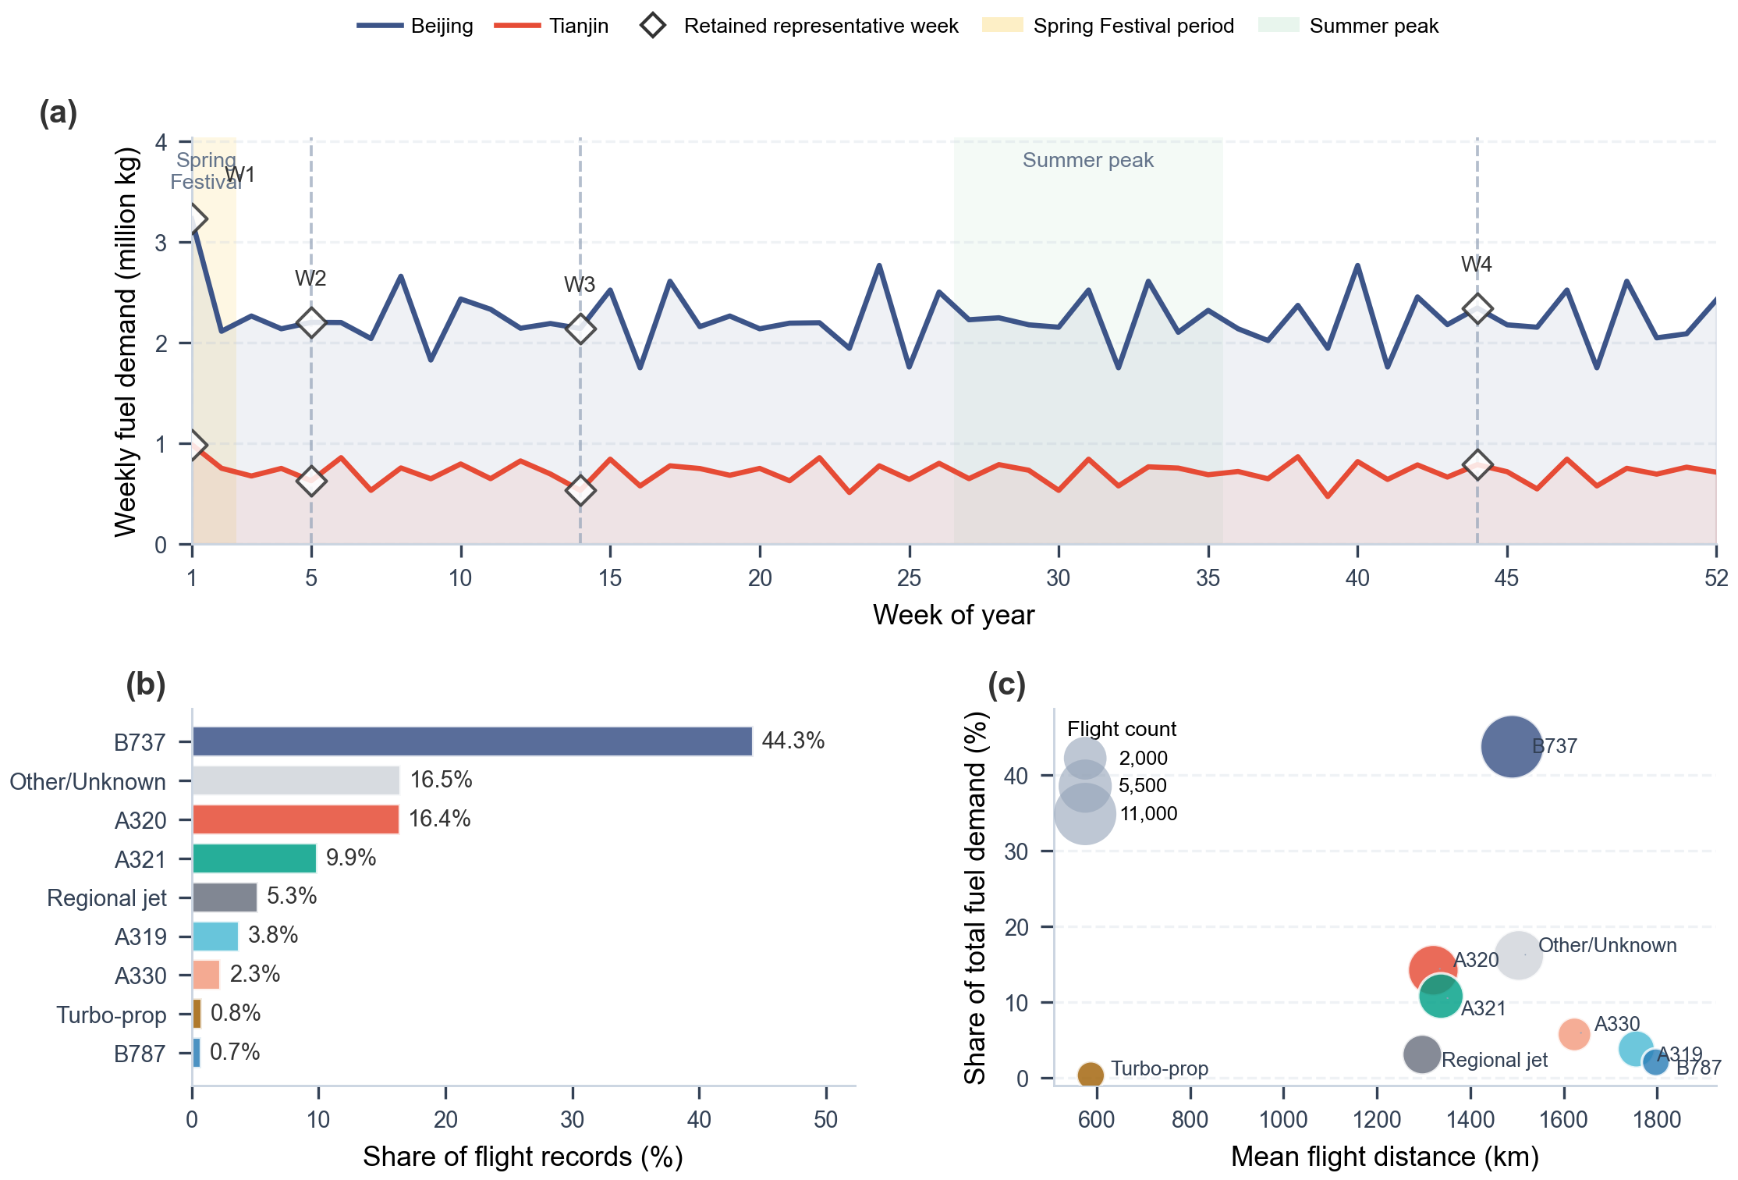
Figure S3. Full-year weekly airport demand, aircraft mix, and aircraft-distance structure for the Beijing-Tianjin demand instance.
Panel (a) shows the full-year demand context by plotting all 52 weekly fuel-demand observations and marking the retained original calendar weeks 1, 5, 14, and 44. Panels (b) and (c) summarize the aircraft heterogeneity embedded in the same flight schedule, which supports flight-level pyBADA fuel estimation instead of a single stylized aircraft.
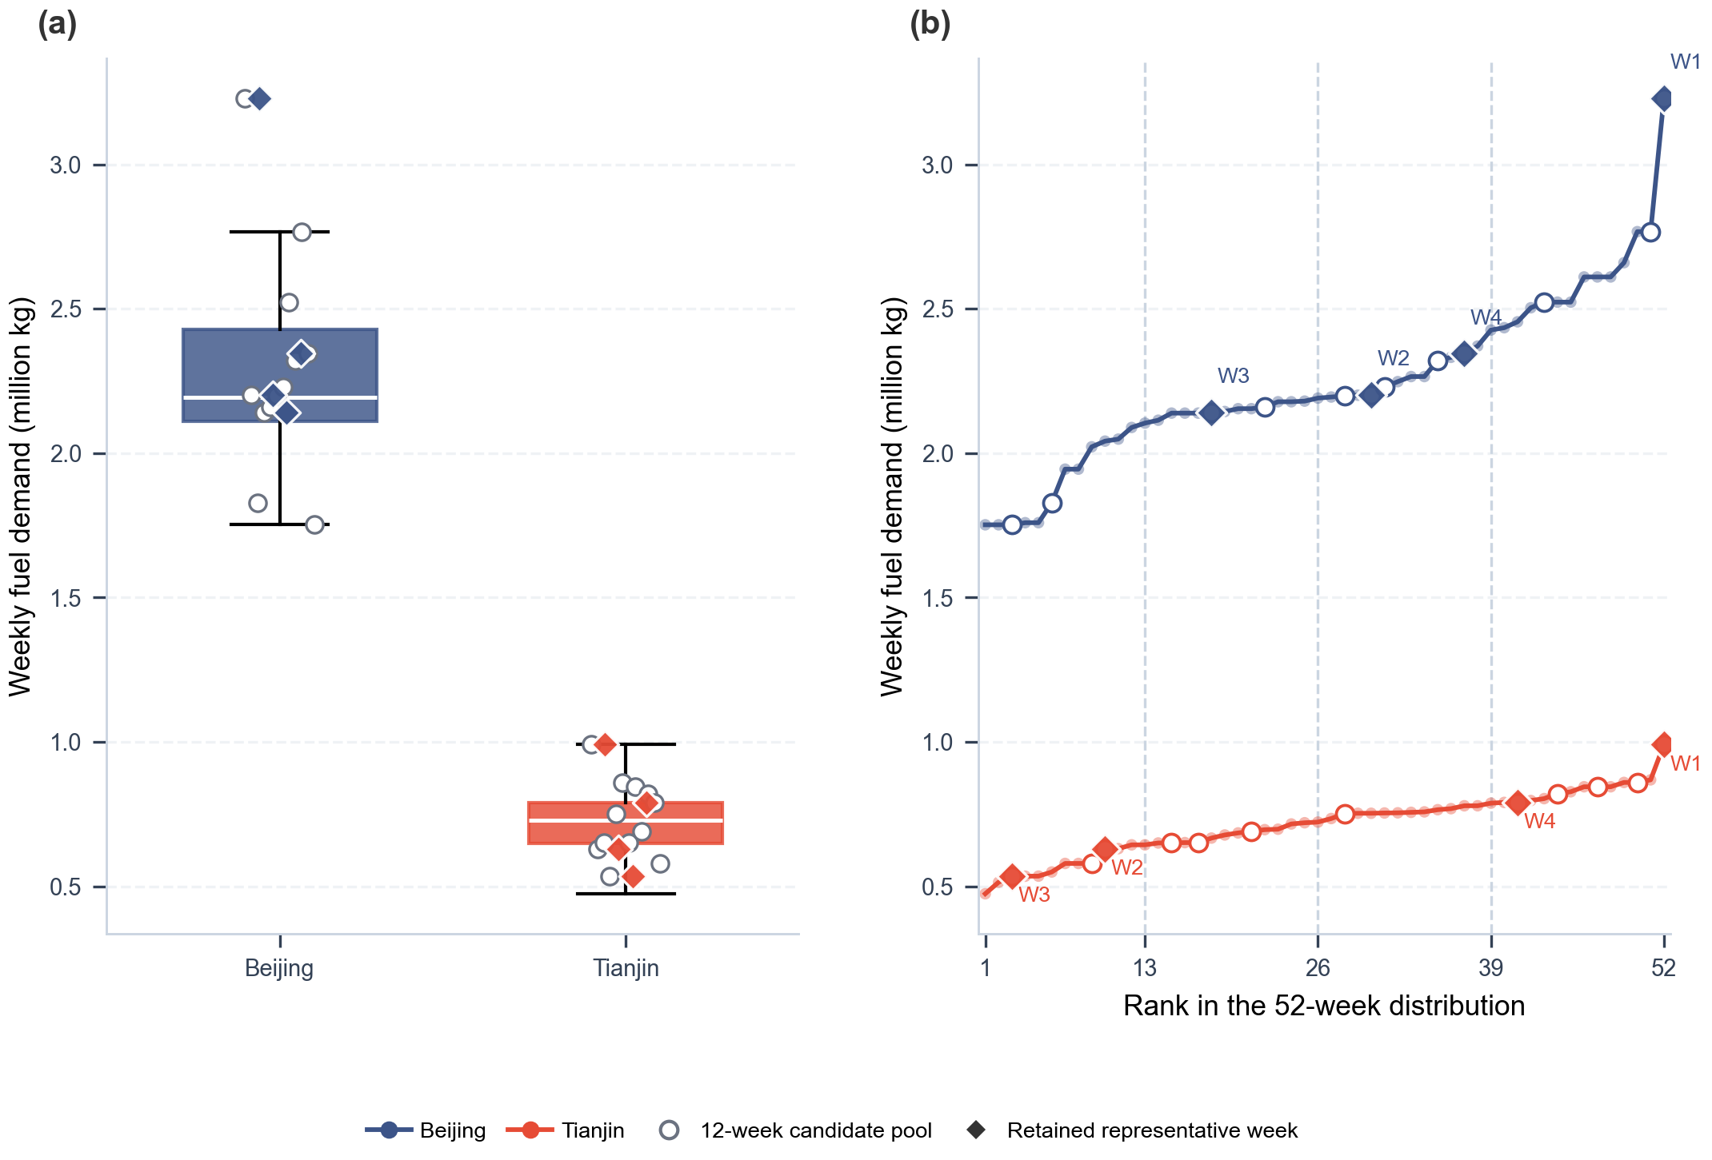
Figure S4. Distribution coverage of the 52-week demand series and positions of the retained weeks.
The boxplots summarize the full 52-week demand distribution for each airport. Open circles show the 12-week candidate pool extracted from the raw year, and filled diamonds show the four retained representative weeks. The ranked-distribution panel confirms that the screening pipeline spans low, medium, and upper-demand positions before reduction to the final 4-week set.

1.3 Renewable electricity data processing
Renewable electricity is constructed from the retained plant inventories and meteorological drivers. The 65 solar projects aggregate 66 distinct capacity phases with 748.6 MW installed capacity; the 44 wind projects aggregate 48 phases with 3,596.5 MW capacity. The inventory includes operating, construction and planned records and represents the specified candidate-resource scenario. Figures S9–S10 describe the data chain and selected profiles.
Solar irradiance is extracted from the source HDF5 grid at each plant coordinate, with the array indexed by longitude and latitude. Source values in 0.0001 MJ m−2 h−1 are converted to W m−2 by division by 36 before applying the retained effective photovoltaic factor of 0.1632 and phase capacity. Duplicate capacity phases are removed before project aggregation. Wind inputs retain the reconstructed three-hour mean power in MW. All profiles are aligned to UTC+8; multiplying mean power by the three-hour period gives energy in MWh. Source-weather sequences are cyclic at the year boundary to supply the first eight local hours. The wind archive contains 8,760 hours, with its labelled final timestamp on 30 December 2024; it is not a complete 366-day weather record. The two meteorological source series and 2024 demand form a representative-input scenario, rather than a contemporaneously observed operating year.^{24–31}
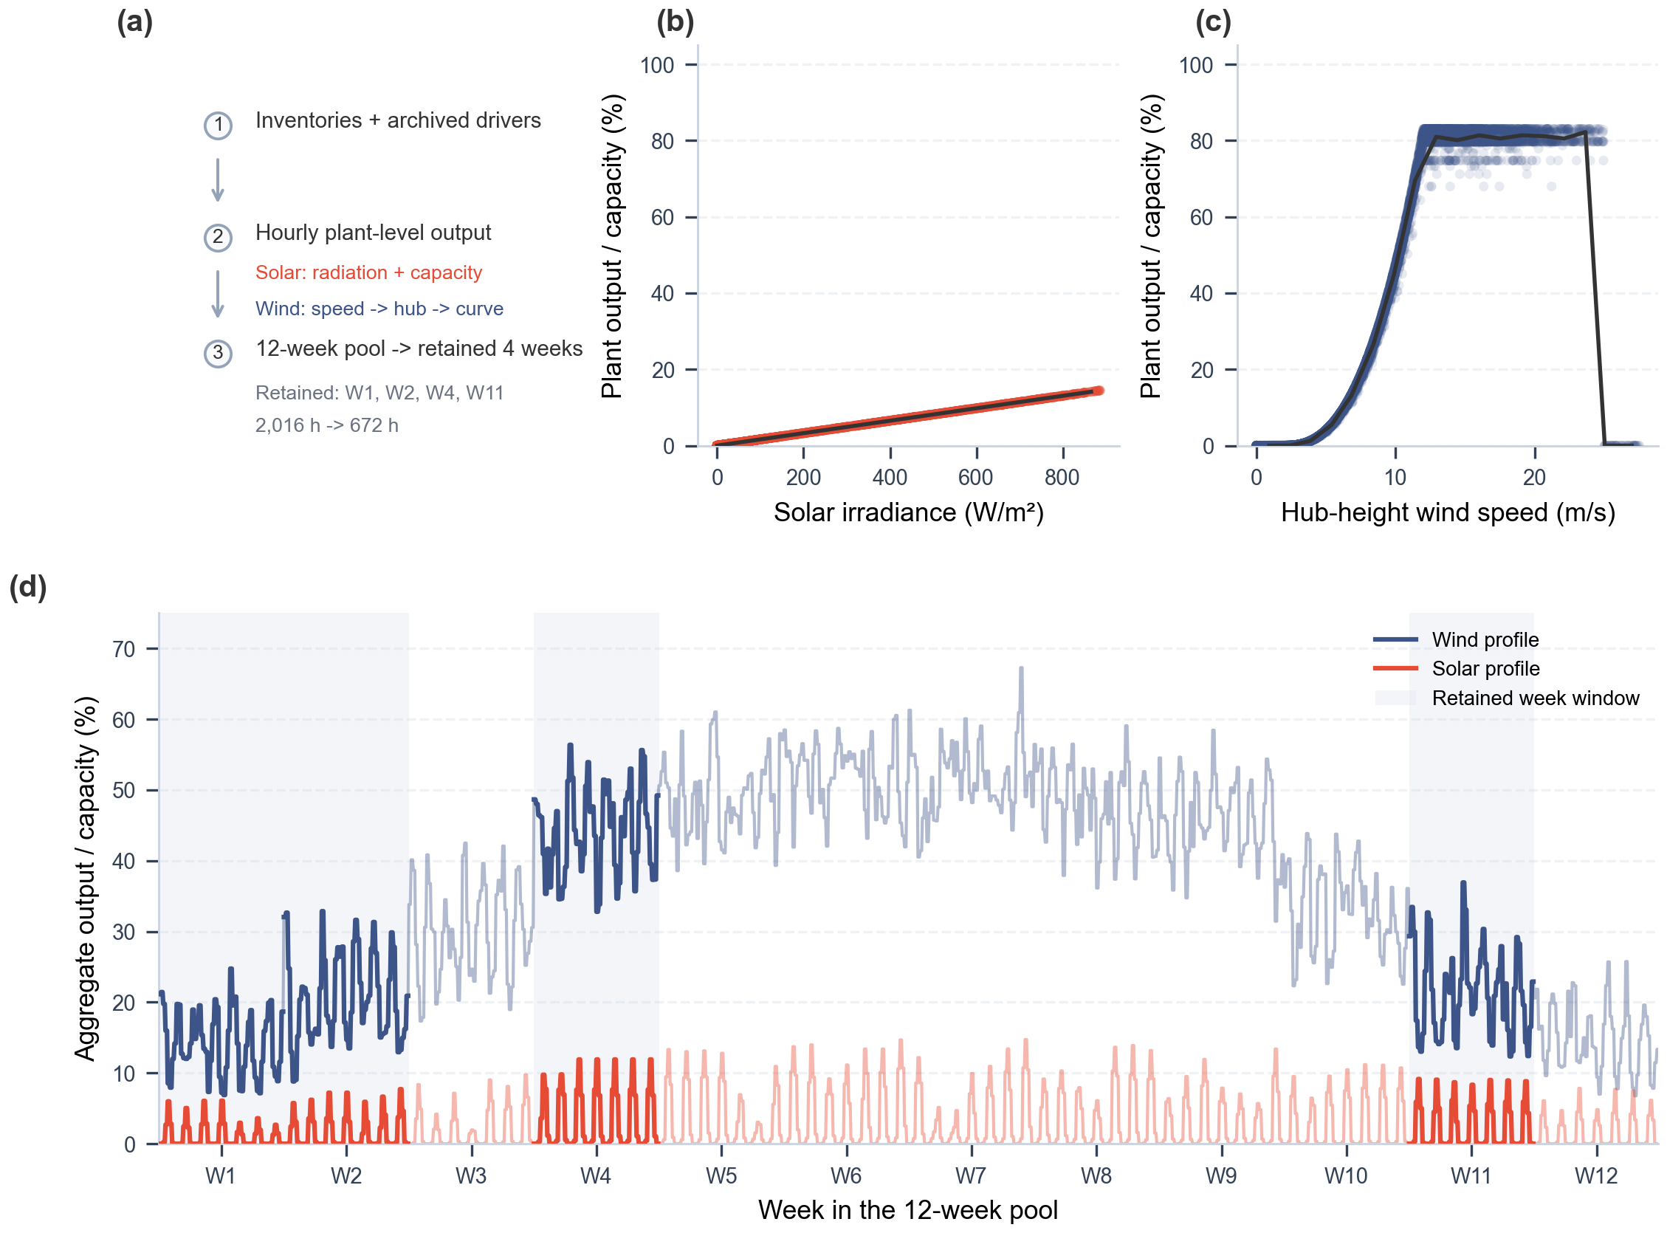
Figure S9. Resource-to-power relationships using solar irradiance units (W/m2) and three-hour mean wind-power observations.
Panel (a) shows the plant-inventory and meteorological-input workflow. Panels (b) and (c) show the radiation-to-solar-output and wind-driver-to-output relationships. Solar reconstruction uses an assumed effective photovoltaic factor of 0.1632; the input consistency checks do not independently calibrate this factor.
The baseline uses weeks 1, 5, 14 and 44, corresponding to entries 1, 2, 4 and 11 of the twelve-week candidate pool. Set B uses weeks 1, 14, 27 and 44. Each set contains 672 hours and 224 three-hour periods. Baseline solar and wind energy are 10,806.161 and 606,812.211 MWh; set B contains 12,654.216 and 794,254.948 MWh, respectively.
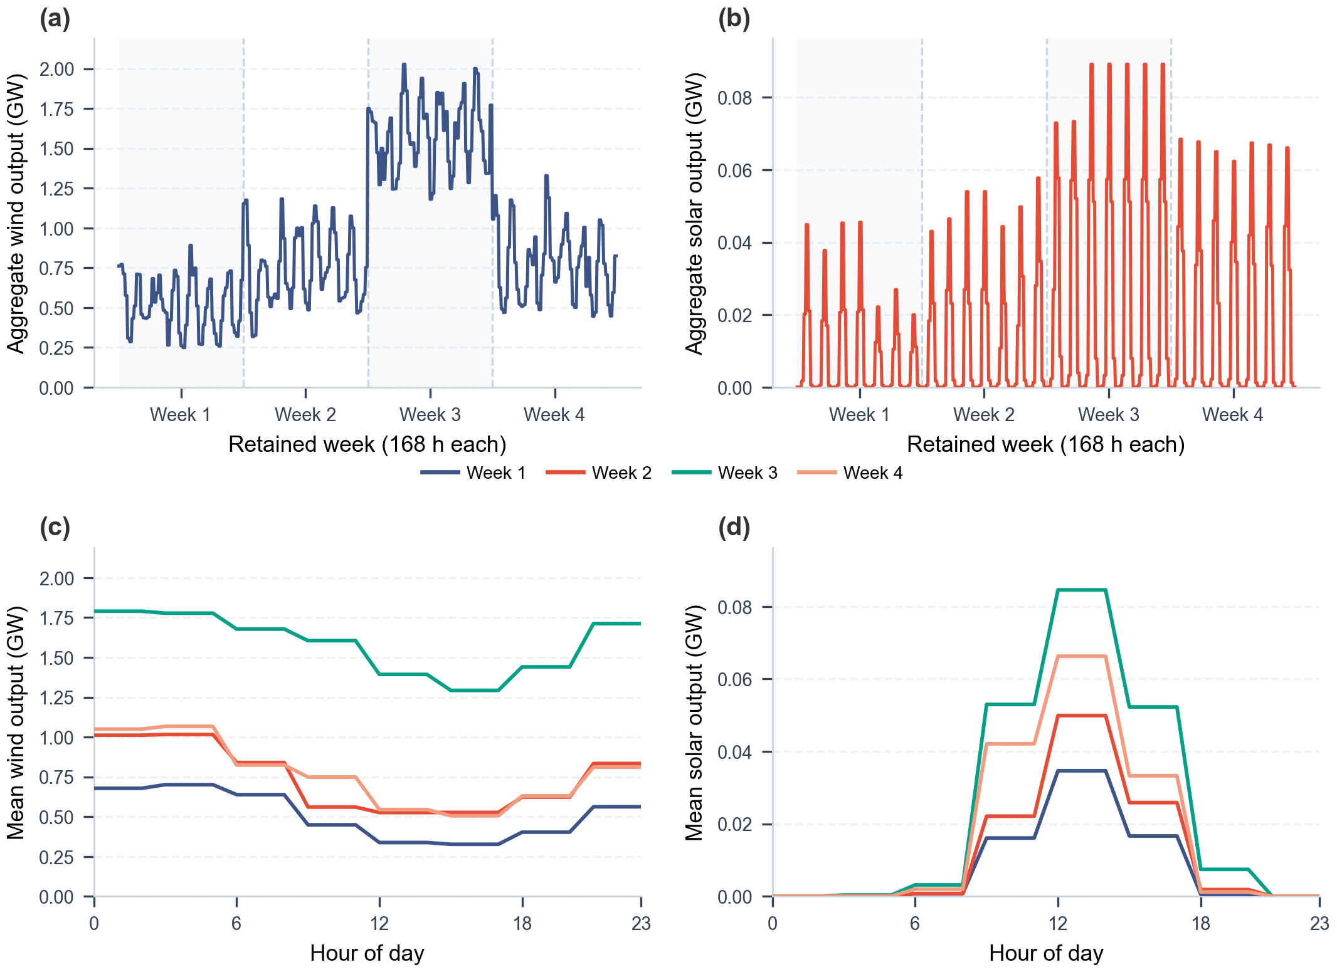
Figure S10. Wind and solar output in the twelve-week candidate pool and the four representative weeks. The three-hour means are displayed on an hourly axis without changing the represented energy.

1.4 Industrial by-product hydrogen and CO₂ data
Industrial by-product hydrogen is represented with two plant-level source layers: refinery-associated hydrogen and steel-sector by-product hydrogen. The refinery dataset contains 180 sites across 27 provinces with an aggregate estimated supply of 1412.56 t H₂/day. The steel dataset contains 211 sites across 28 provinces with an aggregate estimated supply of 150549.27 t H₂/day.^{37,38,39}
Industrial hydrogen availability is represented by source-specific upper bounds. The model selects supply from eligible nodes according to each scenario’s hydrogen-source definition.^{38,39}
Industrial carbon data enter the framework through point-source capture layers and through DAC siting logic. For CCU scenarios, the project stores 3,445 industrial capture-source records across 34 provinces and applies source-type-specific capture assumptions to represent point-source CO₂ availability. Coal-power sources dominate the archived table by record count and aggregate capture potential, while gas-power and refinery sources remain important because they differ in capture cost, geographic coverage, and technology assumptions.^{36,40}
The point-source CO₂ table is converted into weekly capture potential and unit capture-cost inputs. Aggregate weekly capture potentials are 179.3 Mt/week from coal power, 3.3 Mt/week from gas power, and 6.7 Mt/week from oil refineries. Median unit capture costs are 150, 180, and 120 yuan/t CO₂, respectively. These values enter CCU pathways as source-specific availability and cost coefficients.^{41,42,43,44,45}
For DAC scenarios, carbon is not drawn from the industrial point-source table. Instead, DAC supply is generated through an explicit DAC module whose siting candidates are attached to renewable or industrial nodes, depending on the scenario configuration. The supplementary metadata retained alongside the model also include 21 CCUS reference records, of which 15 are marked as operating in the source table. These CCUS records are used as contextual infrastructure metadata rather than as direct mandatory CO₂ supply in every pathway.^{46,47,48,49,50,51}

1.5 Transport network construction
Transport-network construction combines existing infrastructure metadata with newly generated candidate routes. The current GIS table contains 436 pipeline polylines, including 317 operating and 44 planned records, with a reported cumulative length of 116,204 km across records that include explicit length metadata. These corridors provide spatial anchors for candidate hydrogen or CO₂ pipeline links and for interpreting where existing rights-of-way may reduce new-build transport burdens.^{36,52,54}
Pipeline corridors anchor and screen candidate logistics arcs between source, conversion and demand nodes. The optimization selects pathway-specific flows and associated costs within this network representation. Detailed future pipeline design is outside the model boundary.^{52,54}
Downstream synthetic aviation fuel deliveries and other truck-based movements are routed over the road network. The implementation relies on OpenStreetMap-derived road graphs and GraphHopper or OSM shortest-path tools to convert origin-destination coordinate pairs into practical transport distances. This avoids using straight-line distances for truck transport, which would understate travel distance in regions where road geometry, terrain, or network connectivity makes direct routes unrealistic.^{53,57,58,55}
Candidate logistics arcs use the routing settings in Tables S3 and S10. Provincial energy-price records are summarized in the Supplementary Figure Archive (Fig. S16); Tables S8–S9 specify the model cost coefficients and units.

1.6 Data preprocessing workflow
The raw spatial source tables are much denser than the final optimization network can efficiently handle. Many plant or point-source records are close to one another and would create a large number of nearly redundant candidate arcs if passed directly into the network model. Spatial preprocessing therefore reduces the raw point layers to a smaller set of representative nodes while retaining the geographic structure needed for logistics and siting decisions.^{63,64,65}
The repository applies DBSCAN clustering to renewable-hydrogen, by-product-hydrogen, and CO₂ source layers before arc generation. In the archived renewable clustering run, 24 clusters and 13 direct-connection points were obtained with eps = 60 km and min_samples = 2. The by-product hydrogen clustering run stores 12 clusters and 23 noise points with eps = 15 km, while the stored CO₂ clustering run retains 4 clusters and 8 noise points.⁶²
Cluster-center selection is not based on geometric proximity alone. The center-optimization routine balances within-cluster travel and access to existing pipeline corridors with a pipeline-weight term of 0.3; shared pipeline use is further discounted by a factor of 0.65. This means a representative node can be favored not only because it is central to nearby source points, but also because it is better connected to the transport infrastructure layer.^{63,64}
After clustering, candidate logistics arcs are generated by connecting business nodes to the 10 nearest pipeline nodes in the precomputed super graph and by calculating shortest-path road distances for truck transport. The preprocessing outputs are therefore the bridge between the raw GIS and time-series data in Sections 1.1-1.5 and the scenario-specific optimization models described in the later sections of the appendix.^{52,54}
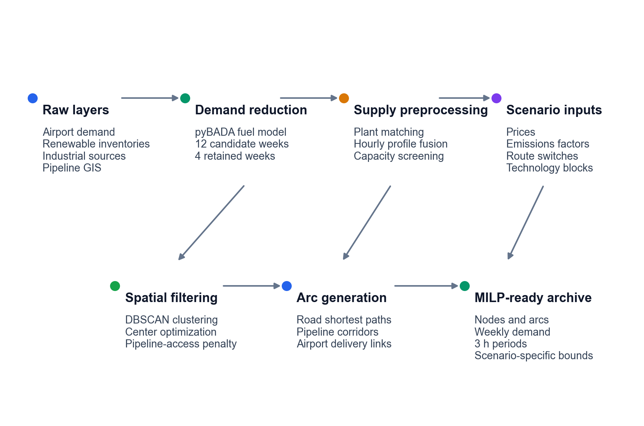
Figure S18. Preprocessing workflow from raw datasets to optimization-ready inputs.

2 Scenario Definition and Underlying Assumptions

2.1 Spatial and temporal boundary
The supply inventory search domain covers mainland China, and the demand instance covers Beijing and Tianjin airports. Scenario-specific candidate filtering defines the actual optimization network. Spatial resolution is a network of discrete geocoded source, candidate-facility and airport nodes connected by screened transport arcs. Facility siting selects among the locations eligible for the active conversion module; Sections 1.5–1.6 and Tables S3 and S10 describe route construction. Baseline airport demand is 51.051 million kg over weeks 1, 5, 14 and 44; the alternative sequence contains 56.807 million kg over weeks 1, 14, 27 and 44.
Production and inventory are represented in three-hour periods, giving 56 periods per week and 224 periods (672 h) across the four selected weeks. Hydrogen dispatch uses the same three-hour interval at origin and destination and is linked to the route-level weekly volume. The retained pipeline formulation uses the same route volume in each selected week. Airport demand and final-fuel delivery are weekly. GTL-GH natural-gas allocation uses 28 days, each containing eight production periods. The selected weeks are concatenated with inventory carryover; their intervening calendar weeks are not simulated.
Table S3 Spatial, temporal and routing boundaries. Scenario-specific route screening takes precedence over generic configuration defaults.
Parameter | Baseline value and unit | Scope | Model role
Supply-side search domain | Mainland China (categorical) | All scenarios | Defines the candidate region for energy, feedstock, synthesis, and infrastructure nodes.
Demand nodes | Beijing and Tianjin airports (categorical) | Beijing–Tianjin case | Defines the SAF sink nodes used in the four-week optimization runs.
Representative horizon | 4 weeks | All scenarios | Reduced annual horizon used for comparative optimization.
Production time step | 56 periods/week; 3 h/period | Production and inventory balances | Aggregates hourly renewable profiles into tractable production periods.
Demand and delivery time step | Weekly time step | Airport demand and final-fuel transport | Enforces airport demand and delivered SAF balances at the week level.
Candidate-arc distance screen | Commodity- and scenario-specific | Candidate transport arcs | Apply the actual configured route screens; no universal distance limit is assumed.
Road-routing engine | GraphHopper truck routing over the archived OpenStreetMap road graph | Truck-routing arcs | Provides routed road distances for short-distance truck transport.
Pipeline connector graph | k = 10; algorithm = johnson nearest connectors | Pipeline-enabled H₂/CO₂ cases | Restricts pipeline candidate generation to a sparse super-graph representation.
Hydrogen and natural-gas dispatch | H₂: 3 h; GTL-GH natural gas: 1 day = 8 periods | Six electricity-dependent configurations | Link three-hour H₂ flows to weekly route volumes and allocate daily natural gas by technology.

2.2 System boundary
The system boundary starts with carbon and hydrogen acquisition and ends with synthetic aviation fuel delivery to airport nodes. Upstream stages include renewable-power-driven electrolysis, industrial by-product hydrogen use, natural-gas- or coal-linked carbon supply, industrial capture, and DAC, depending on scenario definition. Midstream stages include route-specific conversion through FT or MTJ, inventory buffering, and interregional transport. Aircraft use, airport tank-farm operations, and detailed refueling logistics are outside the modeled system boundary.
Table S4 Physical system-boundary inclusions and simplifications.
System element | Included representation and model treatment | Explicit exclusions
Hydrogen supply | Green electrolysis, industrial by-product H₂, and fossil/process H₂ are activated by scenario. Hydrogen enters as source availability, conversion efficiency, transport, and capacity constraints. | A national hydrogen-market equilibrium and sub-3 h electrolyzer dispatch are not modeled.
Carbon supply | Industrial point-source CO₂, DAC CO₂, natural-gas carbon, and coal-derived carbon are represented by pathway. Carbon source class determines both feedstock logistics and carbon-accounting treatment. | Detailed plant-level capture retrofits and endogenous carbon-source expansion are not optimized.
Conversion facilities | FT/direct SAF, MTJ, and CTL/coal-gasification blocks are represented with route-specific capacity limits. Conversion choice is a scenario definition, not an endogenous route-selection decision. | Internal reactor scheduling and equipment sizing below the model time step are not represented.
Intermediate inventories | H₂, CO₂, methanol, and SAF inventories are included only where required by the pathway block. Inventory buffers connect the production time step to weekly delivery requirements. | Tank-farm design, boil-off, and safety-zone layout are outside the optimization boundary.
Transport system | H₂, CO₂, natural gas, methanol intermediate, and SAF logistics are modeled through candidate arcs. Transport modes impose distance screens, capacity factors, and cost coefficients. | Vehicle-count scheduling and pipe-diameter design are not optimized explicitly.
Demand and use | Weekly SAF demand is imposed at the Beijing and Tianjin airport nodes. Airport demand is a fixed sink for supply-chain optimization. | Aircraft assignment, refueling operations, and downstream combustion allocation are not modeled.
Emissions accounting | Lifecycle tracking, construction emissions, utilization credits, and benchmark conversion are configured by scenario. Ex-post carbon intensity and displacement metrics use the same accounting flags across scenario families. | Policy feedbacks and endogenous carbon-price responses are not represented.

2.3 Supply-chain structure assumptions
The implemented supply chain is abstracted as a production–transport–consumption network. Production nodes combine carbon sourcing, hydrogen sourcing, and synthetic aviation fuel synthesis; transport links move hydrogen, carbon dioxide, methanol intermediates where needed, and final synthetic aviation fuel; airport nodes absorb weekly demand. Nodes are treated as perfectly mixed. Internal plant scheduling is not modeled below the chosen time step, and transport capacity is represented with upper bounds rather than detailed vehicle-count or pipe-diameter design variables.
Scenario switches activate feedstock, conversion and inventory modules. Captured-CO₂ FT and MTJ cases consume external hydrogen according to route-specific yields; MTJ cases also represent the methanol intermediate. The retained CTL case supplies its external hydrogen through renewable electrolysis and should be interpreted as that modelled coal–hydrogen configuration. Natural-gas and coal carbon remain fossil feedstocks in the emissions accounting.
Table S5 Route-module and inventory activation assumptions.
Module | Active scenarios | Modeled state | Key parameterization and role
Direct FT / RWGS-FT | GTL, CCU-GH-FT, CCU-BH-FT, DAC-GH-FT, DAC-BH-FT | Direct SAF output; no methanol inventory. | RWGS energy coefficient = 2.5; FT energy coefficient = 3.5 for CCU-GH-FT; GTL FT energy coefficient = 5. Represents one-step/direct SAF synthesis scenarios.
MTJ | GTL-GH, GTL-BH, CCU-GH-MTJ, CCU-BH-MTJ, DAC-GH-MTJ, DAC-BH-MTJ | Methanol intermediate and methanol inventory active. | MTJ process-energy coefficient = 800 for CCU/DAC-style MTJ configs; 4,500 for natural-gas MTJ configs. Separates methanol production from final jet-fuel synthesis.
CTL / coal gasification | CTL, CTL-BH | Coal-derived carbon with the configured FT/SAF synthesis block; no methanol inventory. | Coal price 525 CNY/t; carbon content 0.75; gasification efficiency 0.75. CTL uses modelled electrolysis; CTL-BH uses industrial by-product H₂.
Industrial point-source CO₂ | CCU-GH-MTJ, CCU-GH-FT, CCU-BH-MTJ, CCU-BH-FT | Industrial capture-source layer active. | scenario_type = industrial_capture; utilization credit factor = -1.0. Credits captured industrial CO₂ fixed into SAF under the archived accounting convention.
DAC CO₂ | DAC-GH-MTJ, DAC-GH-FT, DAC-BH-MTJ, DAC-BH-FT | DAC module and DAC siting logic active. | Capture efficiency 0.95; capture energy 350 kWh/t CO₂. Atmospheric uptake attribution is reported separately from process burdens and fuel combustion.
By-product H₂ | CTL-BH, CCU-BH-MTJ, CCU-BH-FT, DAC-BH-MTJ, DAC-BH-FT, GTL-BH | Industrial by-product H₂ source layer active. | H₂ equipment lifetime convention = 20 yr; capacity factor = 0.9. Defines blue variants that replace green electrolysis with by-product H₂ supply.

2.4 Pathway screening and selection rationale
Tables S6–S7 define 13 carbon–hydrogen–conversion cases: six electricity-dependent configurations with baseline and alternative-week operating solutions, and seven archived baseline comparators. The CTL formulation with a 90% output floor is infeasible; CTL† denotes a partial-supply diagnostic with that floor removed. The case set is bounded by the represented modules. Cost and carbon intensity describe each configuration at its achieved demand-fulfillment level. Table S20 explains additional omitted combinations.
For the represented CO₂-to-fuel modules, hydrogen is an explicit consumed feedstock. Idealized balances illustrate the requirement: CO₂ + 3H₂ → CH₃OH + H₂O for methanol formation, and nCO₂ + (3n + 1)H₂ → CₙH₂ₙ₊₂ + 2nH₂O for an overall paraffin-forming balance. These relations illustrate material requirements rather than replacing the model yields. With both hydrogen input and alternative reducing pathways disabled, the existing conversion balances permit zero fuel output. A CO₂-only positive-output scenario is therefore unavailable within this formulation.
Other omissions reflect the comparison boundary. Supplementary hydrogen in a natural-gas FT chain, fossil-derived hydrogen for captured CO₂, coal-to-methanol upgrading, and other hybrid supply chains require explicit source, conversion and allocation choices. Their omission from Tables S6–S7 does not establish technical infeasibility or inferior performance. In particular, the retained natural-gas cases comprise an internally supplied FT reference and two externally supplied MTJ variants, so effects of hydrogen origin and conversion route cannot be isolated across that family.
Biomass-, lipid- and fermentation-based routes require feedstock collection, pretreatment, seasonal supply and conversion modules beyond the represented source network. HEFA, biomass FT and alcohol-to-jet are established comparison categories in ICAO documentation. Their exclusion is a modelling-scope choice and does not imply that these technologies cannot produce aviation fuel. The present model does not establish ASTM approval or CORSIA eligibility for any individual fuel batch.119,120
Table S20 separates combinations that cannot satisfy the represented conversion balances from technically possible routes outside the evaluated scenario set. This distinction defines the scope within which the retained pathways can be compared.
Table S6 Implemented pathway set used in the pathway comparison.
Class | Scenario | Pathway definition | Technical description
Coal-linked | CTL | Coal-derived carbon; modelled renewable electrolysis; coal-linked FT conversion | The original 90% minimum-output case is infeasible. CTL† denotes the separately reported partial-supply diagnostic.
Grey | CTL-BH | Carbon: coal; H₂: industrial by-product hydrogen; route: coal-linked FT module | Coal-derived carbon with industrial by-product hydrogen and the configured FT synthesis block.
Blue | CCU-BH-MTJ | Carbon: Industrial captured CO₂; H₂: By-product hydrogen; route: Methanol-to-Jet | Industrial captured CO₂ coupled with by-product hydrogen via Methanol-to-Jet synthesis.
Blue | CCU-BH-FT | Carbon: Industrial captured CO₂; H₂: By-product hydrogen; route: Fischer–Tropsch | Industrial captured CO₂ coupled with by-product hydrogen via Fischer–Tropsch synthesis.
Blue | DAC-BH-MTJ | Carbon: Direct air captured CO₂; H₂: By-product hydrogen; route: Methanol-to-Jet | Direct air captured CO₂ coupled with by-product hydrogen via Methanol-to-Jet synthesis.
Blue | DAC-BH-FT | Carbon: Direct air captured CO₂; H₂: By-product hydrogen; route: Fischer–Tropsch | Direct air captured CO₂ coupled with by-product hydrogen via Fischer–Tropsch synthesis.
Blue | GTL-BH | Carbon: Natural gas; H₂: By-product hydrogen; route: Methanol-to-Jet | Natural-gas-based pathway enhanced by industrial by-product hydrogen via Methanol-to-Jet synthesis.
Blue | GTL-GH | Carbon: Natural gas; H₂: Green hydrogen; route: Methanol-to-Jet | Natural-gas-based pathway integrated with green hydrogen via Methanol-to-Jet synthesis.
Blue | GTL | Carbon: Natural gas; H₂: In situ process hydrogen / no external H₂ input; route: Fischer–Tropsch | Conventional natural-gas-to-liquids pathway via Fischer–Tropsch without external hydrogen input.
Green | DAC-GH-MTJ | Carbon: Direct air captured CO₂; H₂: Green hydrogen; route: Methanol-to-Jet | Direct air captured CO₂ coupled with green hydrogen via Methanol-to-Jet synthesis.
Green | DAC-GH-FT | Carbon: Direct air captured CO₂; H₂: Green hydrogen; route: Fischer–Tropsch | Direct air captured CO₂ coupled with green hydrogen via Fischer–Tropsch synthesis.
Green | CCU-GH-MTJ | Carbon: Industrial captured CO₂; H₂: Green hydrogen; route: Methanol-to-Jet | Industrial captured CO₂ coupled with green hydrogen via Methanol-to-Jet synthesis.
Green | CCU-GH-FT | Carbon: Industrial captured CO₂; H₂: Green hydrogen; route: Fischer–Tropsch | Industrial captured CO₂ coupled with green hydrogen via Fischer–Tropsch synthesis.
For reproducibility, the pathway names are complemented by an activation matrix. The matrix reports which conversion block, hydrogen module, carbon module, inventory treatment, and carbon-accounting rule is active in each retained scenario, for each pathway.
Table S7 Scenario activation matrix for the retained pathway definitions.
Scenario | Source modules | Conversion and inventory | Carbon-accounting treatment
CTL | Renewable electrolysis; coal-derived carbon | Coal-derived carbon and FT synthesis; methanol inventory inactive | Fossil feedstock; utilization credit disabled
CTL-BH | Industrial by-product H₂; Coal-derived carbon | Coal-derived carbon and FT synthesis; methanol inventory inactive | Fossil feedstock; utilization credit disabled
CCU-BH-MTJ | Industrial by-product H₂; Industrial point-source CO₂ | MTJ; methanol inventory: active | Industrial CO₂ utilization credit enabled; credit factor = -1.0
CCU-BH-FT | Industrial by-product H₂; Industrial point-source CO₂ | Direct FT; methanol inventory: not active | Industrial CO₂ utilization credit enabled; credit factor = -1.0
DAC-BH-MTJ | Industrial by-product H₂; Direct air capture CO₂ | MTJ; methanol inventory: active | Atmospheric CO₂ removal credit enabled; credit factor = -1.0
DAC-BH-FT | Industrial by-product H₂; Direct air capture CO₂ | Direct FT; methanol inventory: not active | Atmospheric CO₂ removal credit enabled; credit factor = -1.0
GTL-BH | Industrial by-product H₂; Natural-gas carbon | MTJ; methanol inventory: active | Fossil feedstock; utilization credit disabled
GTL-GH | Green electrolysis; Natural-gas carbon | MTJ; methanol inventory: active | Fossil feedstock; utilization credit disabled
GTL | No external H₂ input; Natural-gas carbon | Direct FT; methanol inventory: not active | Fossil feedstock; utilization credit disabled
DAC-GH-MTJ | Green electrolysis; Direct air capture CO₂ | MTJ; methanol inventory: active | Atmospheric CO₂ removal credit enabled; credit factor = -1.0
DAC-GH-FT | Green electrolysis; Direct air capture CO₂ | Direct FT; methanol inventory: not active | Atmospheric CO₂ removal credit enabled; credit factor = -1.0
CCU-GH-MTJ | Green electrolysis; Industrial point-source CO₂ | MTJ; methanol inventory: active | Industrial CO₂ utilization credit enabled; credit factor = -1.0
CCU-GH-FT | Green electrolysis; Industrial point-source CO₂ | Direct FT; methanol inventory: not active | Industrial CO₂ utilization credit enabled; credit factor = -1.0

2.5 Economic, policy, and lifecycle assumptions
Economic coefficients, project life and discount rate retain the scenario inputs. The optimization objective includes the shortage penalty of 2,500 CNY/kg, while reported fuel costs exclude this penalty and use actual output as the denominator. Grid electricity is available only to the process blocks specified in each scenario. No financial carbon-credit revenue is included in the DAC cost objective. Capture attribution in emissions accounting is reported separately from revenue.
Table S8 Economic, policy, and lifecycle assumptions used in scenario definitions.
Parameter | Baseline value and unit | Scenario scope | Model role
Project evaluation life | 20 yr | All scenarios | Defines the present-value horizon for cost and levelized-cost calculations.
Discount rate | 8% annual fraction | All scenarios | Annualizes and discounts capital and operating cost streams.
Unserved-demand penalty | 2,500 yuan/kg SAF | All scenarios | Discourages unmet airport demand while preserving model feasibility.
LCO-SAF screening threshold | 20 for GTL/GTL-GH/GTL-BH; 50 for CTL/CTL-BH; 1000 for most CCU/DAC cases; 1200 for CCU-GH-FT yuan/kg SAF | Scenario-specific | Used as a configuration-level filter and plausibility screen, not as an endogenous policy target.
Electrolyzer lifetime | 15 for green-H₂ cases; 20 for by-product-H₂ and CTL-BH cases yr | H₂-supply scenarios with an H₂ capacity block | Sets capital recovery for the H₂ supply block.
Synthesis and logistics lifetimes | MTJ/RWGS 20; FT/SAF reactor 25; pipeline 30; storage 25; transport vehicle 20 yr | Route-specific | Sets annualized capital recovery for route and transport assets.
Capacity factors | Electrolyzer 0.75 for green-H₂ cases and 0.90 for by-product-H₂/CTL-BH cases; synthesis 0.85; pipeline 0.95; storage 0.90; transport 0.75 fraction | Scenario-family-specific | Translates installed capacity into available production, storage, and transport service.
Electricity prices | Wind 0.35; solar 0.4; grid 0.6 yuan/kWh | Pathways using renewable or grid electricity | Exogenous operating-cost inputs for electricity-consuming steps.
Natural-gas price | 4.2 yuan/m3 | GTL, GTL-GH, GTL-BH | Feedstock price for natural-gas-based SAF pathways.
Coal price | 525 yuan/t | CTL, CTL-BH | Feedstock price for coal-linked CTL pathways.
DAC capture cost | 4,500 CNY/t CO₂ (baseline) | DAC-GH-MTJ, DAC-GH-FT, DAC-BH-MTJ, DAC-BH-FT | Exogenous cost for atmospheric CO₂ capture.

2.6 Feedstock, process, and capture assumptions
Feedstock and process parameters define the physical conversion assumptions that differ across pathway families. The table separates hydrogen production, fossil feedstock use, coal gasification, DAC capture, and route-specific process coefficients so that each parameter block can be traced to the scenarios in which it is active.
Table S9 Feedstock, process, and capture assumptions used in pathway definitions.
Parameter block | Baseline value and unit | Scenario scope | Model role
Electrolysis efficiency | 0.7 fraction | CCU/DAC/CTL-style configs with electrolysis blocks | Configuration metadata; the six electricity-dependent configurations use the explicit 55 kWh/kg intensity below.
Electrolysis efficiency, natural-gas MTJ | 0.8 fraction | GTL-GH, GTL-BH | Configuration metadata; the six electricity-dependent configurations use the explicit 55 kWh/kg intensity below.
Electrolysis electricity intensity | 55 kWh/kg H₂ in all six electricity-dependent configurations | H₂-producing pathway blocks | Electricity input per kilogram of hydrogen, including electrolysis conversion losses.
Hydrogen market-price proxy | 25; natural-gas MTJ configs = 30 yuan/kg H₂ | H₂ supply and transport cost blocks | Provides the exogenous H₂ price level used in scenario cost terms.
Natural-gas feedstock | Price 4.2; extraction intensity 0.25; pipeline-transport coefficient 0.01 (mixed) | GTL, GTL-GH, GTL-BH | Defines natural-gas feedstock cost and upstream-emissions coefficients.
Coal feedstock | Type bituminous; carbon content 0.75; CO₂ yield 2.44; coal-to-SAF use 1 fraction; kg CO₂/kg coal; kg coal/kg SAF | CTL, CTL-BH | Defines coal material input and carbon yield for the coal-linked scenarios.
Coal gasification | Efficiency 0.75; energy 8 MJ/kg (2.22 kWh/kg); energy cost 0.05 fraction; MJ/kg; kWh/kg; yuan/MJ | CTL, CTL-BH | Defines gasification energy use before CTL/SAF conversion.
DAC capture module | Capture efficiency 0.95; CO₂ purity 0.995; energy 350; module capacity 2,000; availability 0.9 fraction; kWh/t CO₂; t/yr | DAC-GH-MTJ, DAC-GH-FT, DAC-BH-MTJ, DAC-BH-FT | Defines the DAC supply block and modular deployment constraint.
GTL direct FT process | NG upstream emission 0.5; NG process emission 0.8; FT process emission 1.5; FT process-energy coefficient 5 (configuration coefficients) | GTL | Provides process-emissions and energy coefficients for the direct gas-to-liquids route.
Natural-gas MTJ process | NG-to-methanol rate 1.2; H₂ addition rate 40; MTJ process-energy coefficient 4,500 (configuration coefficients) | GTL-GH, GTL-BH | Defines the methanol-intermediate step for natural-gas MTJ routes.

2.7 Transport and routing assumptions
Transport assumptions define which candidate arcs can enter the network and how their cost and capacity are represented. Distance limits are screening parameters, while truck capacities, cost curves, capacity factors, and routing-cache settings determine the attributes assigned to feasible arcs before optimization.
Table S10 Transport and routing assumptions used to construct candidate logistics arcs.
Commodity / mode | Transport limit | Capacity or cost parameter | Scenario scope
H₂ pipeline | 500 km | CAPEX 5,000,000 yuan/km; cost curve 25 km: 1.91; 50 km: 1.04; 100 km: 0.56; 200 km: 0.3; 300 km: 0.21; 400 km: 0.16; 500 km: 0.13 yuan/(kg H₂ per 100 km) | H₂-pipeline-enabled green, DAC, CCU, CTL, and gas-MTJ cases
H₂ truck | 200 km | Truck capacity 500 kg; max 15 trucks/day; cost 2 yuan/(kg km); capacity factor 0.8 | Green, DAC, CCU, and CTL H₂ logistics
CO₂ pipeline | 500 km | Capacity factor 0.95; DAC cost curve 25 km: 150; 50 km: 80; 100 km: 45; 200 km: 25; 300 km: 18 yuan/(t CO₂ per 100 km) | CCU and DAC carbon logistics where CO₂ pipeline distance is enabled
CO₂ truck | 300 km | Truck capacity 20 t; max 25 trucks/day; cost 0.8 yuan/(t km); capacity factor 0.85 | CCU, DAC, and CTL carbon logistics
Natural-gas pipeline direct | 1,500 km | Capacity factor 0.95 | GTL direct FT configuration
LNG terminal supply | 800 km | Capacity factor 0.92 | GTL direct FT configuration
Natural-gas truck constraint | n/a m3; trucks/day | Truck capacity 1,200 m3; max 20 trucks/day | Natural-gas logistics constraints in GTL-family configs
Airport-integrated option | 100 for CO₂/H₂ cases; 500 for GTL km | Cost 5 yuan/kg in CO₂/H₂ cases; capacity factor 0.9 | Local production or delivery option around airport demand nodes
Routing cache | 168 h | GraphHopper routing enabled; pipeline super graph k = 10; CO₂ super graph k = 10 | Repeated scenario runs and candidate-arc preprocessing

2.8 Capacity, solver, and carbon-accounting assumptions
Capacity bounds, production requirements and scenario activation rules determine feasible scale. The CTL implementation includes a 90% minimum-production requirement; the available renewable energy places a lower upper bound on production in both week sets, so this model is infeasible. Its partial-supply diagnostic removes only that minimum requirement. The COPT calculations target a 1% gap for the full objective, including shortage penalties. Unit production cost is reported separately and has no corresponding 1% error guarantee.
Table S11 Configuration bounds and solver settings in the source archive. Table S27 reports COPT model dimensions, certified objective gaps and final-dispatch runtimes for the six electricity-dependent configurations.
Scenario | Route | Capacity bounds | Output and cost screen | Source-archive MILP settings
CTL | CTL | CTL/SAF reactor: 0.01-1,000,000 kg/h; H₂ capacity: 100-100,000 kg/h | Original output ≥90% of demand: infeasible in A and B; CTL† removes only this floor; LCO screen 50 CNY/kg | 3,600 s; gap 1%; 100 threads
CTL-BH | CTL | CTL/SAF reactor: 0.01-1,000,000 kg/h; H₂ capacity: 100-100,000 kg/h | Minimum output: n/a; LCO screen: 50 yuan/kg | 3,600 s; gap 1%; 100 threads
CCU-BH-MTJ | MTJ | SAF reactor: 0-1,000,000 kg/h; H₂ capacity: 100-100,000 kg/h | Minimum output: SAF: 100 kg/yr; LCO screen: 1,000 yuan/kg | 3,600 s; gap 1%; 100 threads
CCU-BH-FT | FT | SAF reactor: 0.01-1,000,000 kg/h; H₂ capacity: 100-100,000 kg/h | Minimum output: SAF: 100 kg/yr; LCO screen: 1,000 yuan/kg | 3,600 s; gap 1%; 100 threads
DAC-BH-MTJ | MTJ | SAF reactor: 0.01-1,000,000 kg/h; H₂ capacity: 100-100,000 kg/h | Minimum output: SAF: 100 kg/yr; LCO screen: 1,000 yuan/kg | 3,600 s; gap 1%; 100 threads
DAC-BH-FT | FT | SAF reactor: 0.01-1,000,000 kg/h; H₂ capacity: 100-100,000 kg/h | Minimum output: SAF: 100 kg/yr; LCO screen: 1,000 yuan/kg | 3,600 s; gap 1%; 100 threads
GTL-BH | MTJ | MTJ plant: 0.01-100,000 kg/h; H₂ capacity: 100-100,000 kg/h | Minimum output: MTJ: 100 kg/yr; LCO screen: 20 yuan/kg | 3,600 s; gap 1%; 100 threads
GTL-GH | MTJ | MTJ plant: 0.01-100,000 kg/h; H₂ capacity: 100-100,000 kg/h | Minimum output: MTJ: 100 kg/yr; LCO screen: 20 yuan/kg | 3,600 s; gap 1%; 100 threads
GTL | FT | FT reactor: 0-1,000,000 kg/h; H₂ capacity: not active | Minimum output: SAF: 100 kg/yr; LCO screen: 20 yuan/kg | 3,600 s; gap 1%; 100 threads
DAC-GH-MTJ | MTJ | SAF reactor: 0-1,000,000 kg/h; H₂ capacity: 100-100,000 kg/h | Minimum output: SAF: 100 kg/yr; LCO screen: 1,000 yuan/kg | 3,600 s; gap 3%; 192 threads
DAC-GH-FT | FT | SAF reactor: 0.01-1,000,000 kg/h; H₂ capacity: 100-100,000 kg/h | Minimum output: SAF: 100 kg/yr; LCO screen: 1,000 yuan/kg | 3,600 s; gap 3%; 192 threads
CCU-GH-MTJ | MTJ | SAF reactor: 0-1,000,000 kg/h; H₂ capacity: 100-100,000 kg/h | Minimum output: SAF: 100 kg/yr; LCO screen: 1,000 yuan/kg | 3,600 s; gap 1%; 100 threads
CCU-GH-FT | FT | RWGS-FT reactor: 0-1,000,000 kg/h; H₂ capacity: 100-100,000 kg/h | Minimum output: SAF: 100 kg/yr; LCO screen: 1,200 yuan/kg | 10,800 s; gap 1%; 100 threads
Table S12 Carbon-accounting assumptions and emissions benchmark parameters.
Accounting assumption | Baseline value and unit | Scenario scope | Interpretation
Conventional jet benchmark | 89 gCO2e/MJ | All scenarios | Well-to-wake reference; compare with combustion-inclusive intensities.
SAF energy-content conversion | 43.15 MJ/kg | All scenarios | Converts mass-based SAF output to energy-basis carbon intensity.
Illustrative intensity threshold | 30 g CO₂e/MJ | Retained plotting/configuration value | Not used here as a certification or CORSIA eligibility determination.
Lifecycle tracking flags | Enabled; facility construction included; lifecycle amortization enabled (categorical) | All scenarios | Keeps construction and lifecycle allocation inside ex-post emissions reporting.
Industrial CO₂ utilization credit | -1.0 dimensionless credit factor | CCU-GH-MTJ, CCU-GH-FT, CCU-BH-MTJ, CCU-BH-FT | Credits industrial point-source CO₂ fixed into SAF according to the archived accounting switch.
DAC removal credit | -1.0; DAC capture emission 7; DAC capture energy 350 credit factor; configuration coefficients | DAC-GH-MTJ, DAC-GH-FT, DAC-BH-MTJ, DAC-BH-FT | Atmospheric uptake attribution, with process burdens retained; combustion-inclusive fuel recycling does not constitute permanent carbon removal.
Natural-gas fossil-feedstock treatment | Utilization credit disabled; NG extraction 0.25; NG transport 0.01 (configuration coefficients) | GTL-GH, GTL, GTL-BH | Counts natural-gas-derived carbon as fossil feedstock rather than carbon removal.
Coal fossil-feedstock treatment | Utilization credit disabled; mining 0.04; transport 0.05; gasification direct 0.15; capture efficiency 0.85 configuration coefficients; fraction | CTL, CTL-BH | Counts coal-derived carbon as fossil feedstock.
Transport-emission coefficients | H₂ truck 0.15; CO₂ truck 0.08; SAF truck 0.12; H₂ pipeline 0.02; CO₂ pipeline 0.01; NG truck 0.1 (configuration coefficients) | Relevant transport arcs | Applied in ex-post transport-emissions accounting.

3 Methodological Supplement
Figure S19 summarizes the cost-minimizing network model for the 13 pathway cases. The resource candidate domain is mainland China and the demand instance covers Beijing and Tianjin airports.
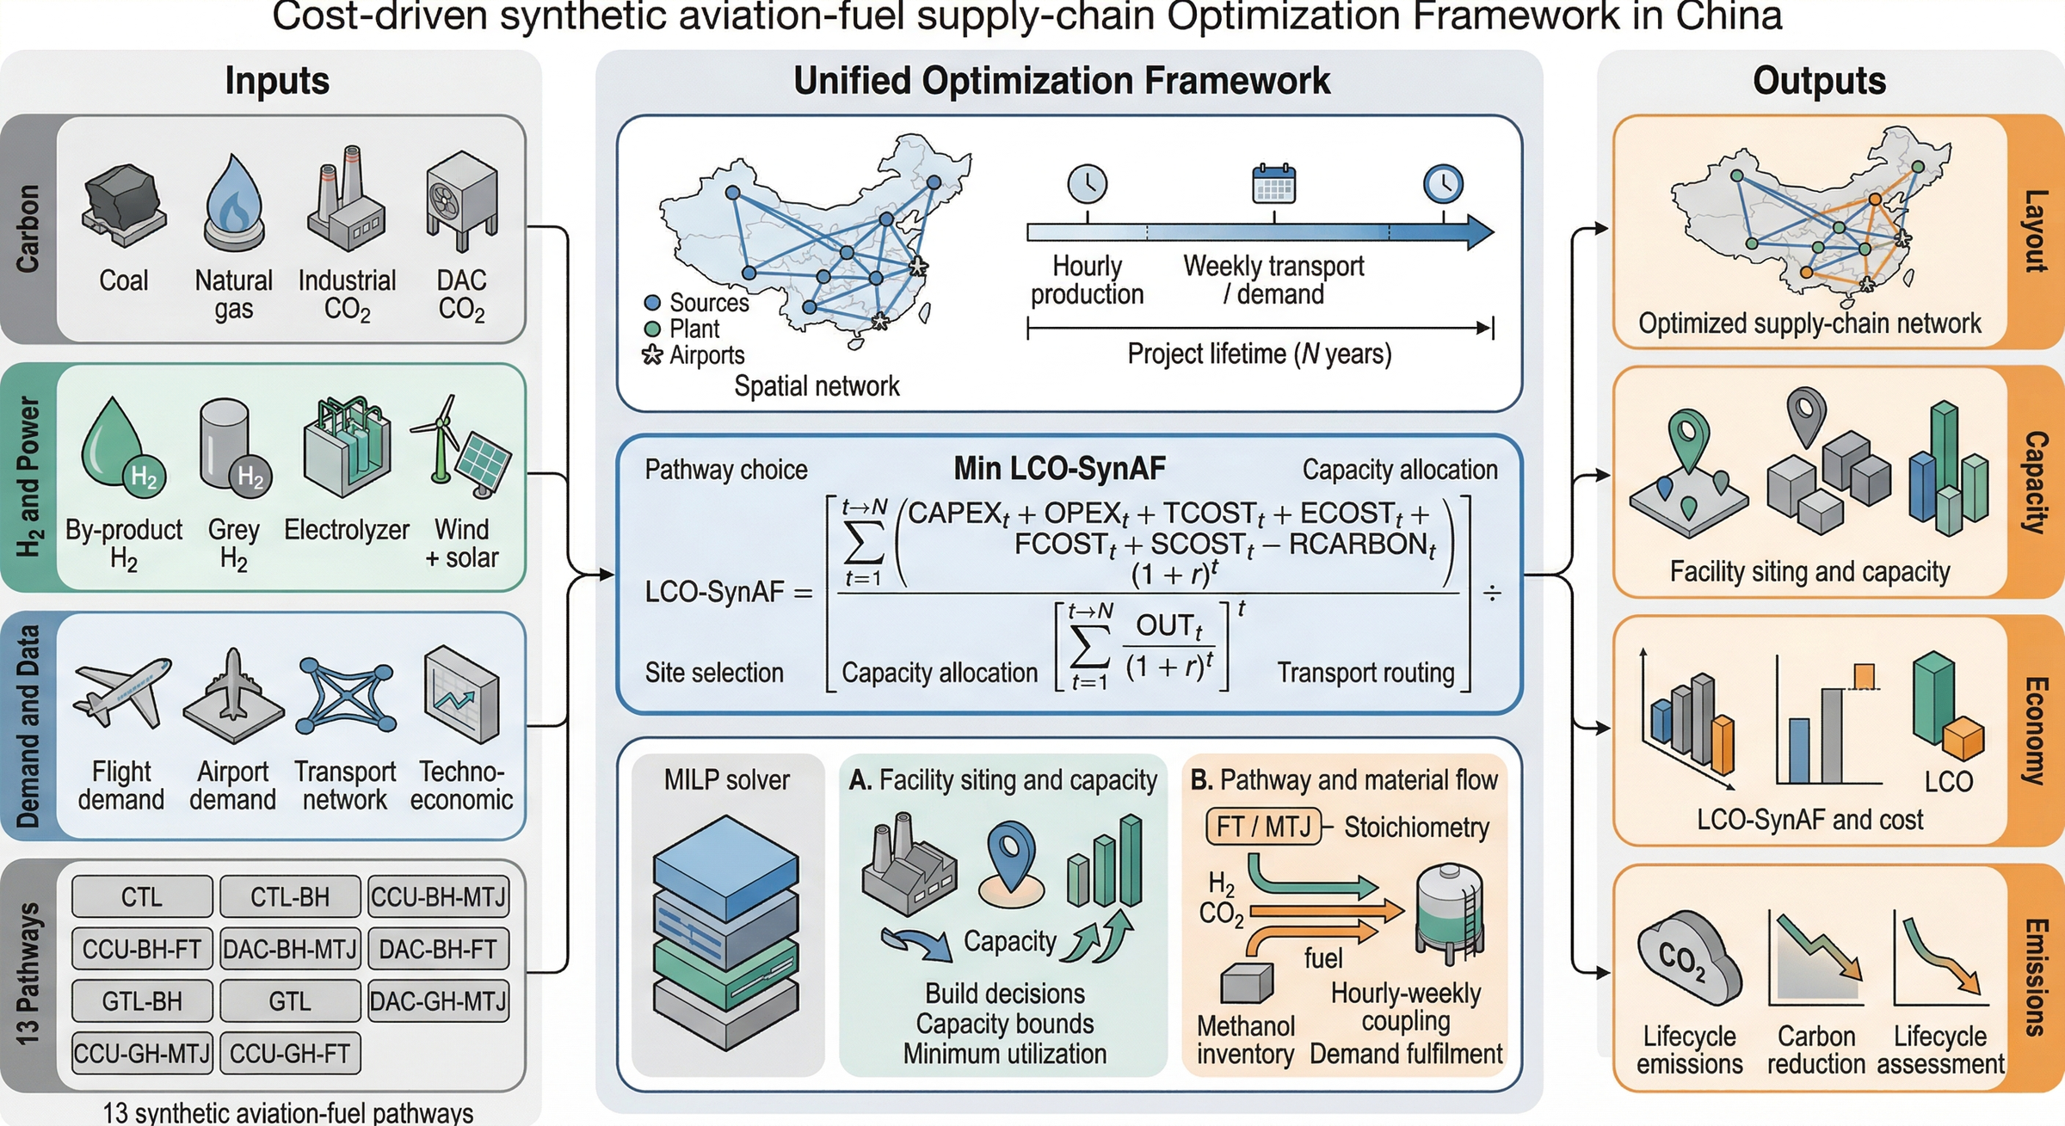
Figure S19. Overview of the cost-driven synthetic aviation-fuel supply-chain optimisation framework in China. Inputs (left) span carbon feedstocks, hydrogen and power sources, demand data, and techno-economic parameters for all 13 pathways. The unified MILP (centre) simultaneously determines facility siting and capacity, pathway and material flow, and transport routing. Outputs (right) include the optimised supply-chain network layout, facility capacities, LCO-SynAF estimates, and production and supply-chain emissions.

3.1 Unified scenario-indexed formulation
The 13 pathway definitions form scenario-indexed instances of one mixed-integer linear framework. Each case activates cost, capacity, transport, demand and reporting blocks together with its specified hydrogen, carbon/feedstock, conversion and inventory modules. Resource units and temporal balances are consistent across the active blocks. Each instance uses one pathway configuration.^{89,90,91,92,94}
Eq. (S1) $\min_{x_{s}} Z_{s} s.t. x_{s} ∈ X_{s}^{core} ∩ X_{s}^{H} ∩ X_{s}^{C} ∩ X_{s}^{P} ∩ X_{s}^{I} ∩ X_{s}^{N} ∩ X_{s}^{D}, s ∈ S$
Table S13 Unified constraint and accounting blocks used to express the 13 scenario-specific MILP instances. XE denotes ex-post accounting and is not a feasibility constraint; the remaining blocks define the feasible set in Eq. (S1). Section 5.1 and Tables S27–S29 identify the implementations and result provenance for the six electricity-dependent configurations and seven archived comparators.
Block | Mathematical role | Scenario scope | Implementation meaning
X_{core} | Facility siting, installed capacity, production variables, and total-cost objective. | All 13 scenarios | Binary facility activation permits installed capacity at eligible geocoded nodes. Three-hour output is bounded by hourly capacity multiplied by three hours; scenario-specific capacity bounds apply (Section 3.5; Table S11).
X_{H}(s) | Green electrolysis, industrial by-product H₂, fossil/process H₂, or no-external-H₂ supply block. | Scenario-specific | By-product hydrogen has source-specific availability bounds. In the six electricity-dependent configurations, electrolysis uses 55 kWh/kg H₂ and installed-capacity limits; electrolysis and co-located synthesis share period renewable energy, with grid access defined by process (Section 3.6).
X_{C}(s) | Industrial CO₂ capture, DAC capture, natural gas, or coal feedstock block. | Scenario-specific | Point-source CO₂ has capture-availability bounds; DAC links capture to capacity and energy; coal enters its feedstock balance. GTL-GH allocates natural gas by technology and day, subject to source and delivery limits (Section 3.6).
X_{P}(s) | Conversion route equations for FT/RWGS-FT, MTJ, GTL, or CTL. | Scenario-specific | Route-specific coefficients link feedstock consumption to fuel output. MTJ additionally balances methanol production, consumption and inventory; FT and coal/natural-gas blocks use their activated balances (Section 3.7; Table S15).
X_{I}(s) | Inventory balances for H₂, CO₂, methanol, and SAF. | Only commodities active in each scenario | Three-hour stock balances link production, arrivals, dispatch and consumption under storage bounds. In the six electricity-dependent configurations, initial H₂ and fuel stocks are zero; stocks can carry between the concatenated selected weeks (Section 3.8).
X_{N}(s) | Candidate truck, pipeline, LNG, natural-gas, H₂, CO₂, methanol, and SAF transport arcs. | Mode-specific | Screened arcs have route-capacity limits. H₂ period flows sum to the common weekly route contract; fuel delivery is weekly; GTL-GH natural-gas allocation is daily (Sections 2.1 and 3.8; Tables S3 and S10).
X_{D} | Weekly airport demand, delivered SAF, and shortage slack constraints. | All 13 scenarios | Delivered fuel plus nonnegative shortage covers each airport-week demand. Shortage enters the cost objective and defines reported service coverage; separate minimum-production restrictions remain scenario-specific (Section 3.9; Table S11).
X_{E} | Ex-post supply-chain emissions accounting and boundary comparisons. | All 13 scenarios | Postprocessing applies source, process, storage, transport and facility factors and the active capture attribution. Baseline intensity excludes aircraft combustion and divides by actual fuel energy (Section 3.10; Table S21).

3.2 Objective function and cost accounting
The optimization minimizes discounted system cost over twenty years, including unmet-demand penalties. In Eq. (S2), initial capital expenditure is paid at year zero; annual operating and transport costs and actual fuel output are discounted over years 1–20 at 8%. Operating expenditure includes energy and feedstock purchases and excludes separately listed transport charges. The representative four-week operations and output are expanded by 52/4 before discounting. Reported levelized cost excludes shortage penalties and uses actual output; it is not a full-demand supply cost where shortage remains. Emissions are evaluated separately.^{95,17,74} For GTL-BH, inventory holding charges for the retained facility configuration and dispatch use half the sum of site-specific peak stocks as the average-inventory proxy for each commodity, multiplied by its hourly holding-charge coefficient and 672 h (224 three-hour periods). Inventory equipment costs use the corresponding peak stocks.
Eq. (S2) ${LCO}_{SynAF} = \frac{C_{CAPEX,0} + \sum_{y=1}^{N}{\frac{C_{OPEX,y} + C_{TRANS,y}}{{(1+r)}^{y}}}}{\sum_{y=1}^{N}{\frac{Q_{SynAF,y}}{{(1+r)}^{y}}}}$
Eq. (S3) $Z = Z_{CAPEX} + Z_{OPEX} + Z_{Transport} + Z_{Energy} + Z_{Material} + Z_{Shortage} - Z_{Credit}$
Each point in the cost–emissions comparison comes from a separate pathway-specific cost-minimization problem; emissions intensity is calculated after optimization using Eq. (S11). The cost denominator in Eq. (S2) is actual synthesis output. Demand fulfilment is reported separately as one minus total airport-week shortage divided by total demand across the four selected weeks. The nondominated points are identified by comparing the resulting cost–intensity pairs across the finite scenario set. These configurations share the demand definition and selected weeks, while resource availability, active process modules and achieved supply differ. Their two-dimensional envelope therefore describes production configurations at their respective output levels, rather than an equal-service frontier generated by varying an emissions constraint. Tables S21–S22 give the corresponding demand coverage and accounting variants.

3.3 Sets, indices, and decision variables
The model indexes hydrogen and carbon sources, synthesis locations and demand airports separately. Time indices include three-hour production and inventory periods, representative weeks for airport delivery and route-volume accounting, and days for GTL-GH natural-gas allocation. Route and conversion families are selected by the scenario configuration.^{89,92}
Table S14 Representative sets, indices, and decision-variable groups used in the scenario-specific optimization models.
Category | Symbol / group | Meaning in implementation
Sets | S | Retained scenario set containing the 13 pathway models
Sets | I | Hydrogen supply nodes, including electrolysis, by-product, or fossil-linked supply depending on scenario
Sets | J | Carbon-source or feedstock nodes, including industrial capture, DAC, natural gas, or coal
Sets | K | Candidate synthesis-facility locations
Sets | A | Airport demand nodes
Sets | T | 3-hour production periods in the representative-year reduction
Sets | W | Representative weeks used for transport and demand aggregation
Sets | M_{s} | Active commodity set for scenario s, e.g., H₂, CO₂, methanol, natural gas, coal, and SAF
Binary variables | z_{k}^{p} | Facility construction / activation decisions for route-specific process block p
Binary variables | y_{u,v}^{m} | Transport arc or mode activation decisions for commodity m where a fixed decision is represented
Continuous variables | Q_{k}^{p} | Installed capacity for the active process block p
Continuous variables | q_{k,t}^{p} | Route-specific production quantities, including methanol or SAF depending on block p
Continuous variables | f_{i,k,t}^{H2}, f_{j,k,t}^{CO2},  f_{k,a,w}^{SAF} | Material flows between supply, plant, and airport nodes
Continuous variables | I_{k,t}^{H2}, I_{k,t}^{CO2},  I_{k,t}^{MeOH}, I_{k,t}^{SAF} | Inventory states that bridge production variability and weekly shipment timing
Continuous variables | s_{a,w} | Airport shortage slack variables used to preserve feasibility

3.4 Scenario-specific model composition
The following matrix spells out the complete model composition for each retained scenario. The notation should be read as a modular MILP definition: X_{core}, X_{D}, and X_{E} are always present, while X_{H}(s), X_{C}(s), X_{P}(s), X_{I}(s), and X_{N}(s) are populated by the hydrogen, carbon/feedstock, conversion, inventory, and network modules indicated in the row. This avoids duplicating the same demand and capacity equations 13 times while still identifying the exact pathway-specific model for each scenario.
Table S15 Complete scenario-level model composition for the 13 retained pathway models.
Scenario | Mathematical instance | Feedstock and capture constraints | Conversion, temporal, and accounting constraints
CTL | X_{core} + X_{H}(renewable electrolysis) + X_{C}(coal) + X_{P}(CTL) + X_{I}(s) + X_{N}(s) + X_{D} + X_{E} | Electrolysis capacity, renewable electricity, H₂ storage and logistics; coal purchase, gasification and carbon balances. | Coal-linked FT production; H₂, carbon and SAF balances. Original 90% output floor infeasible; CTL† removes only this floor. Fossil-carbon accounting; no capture attribution.
CTL-BH | X_{core} +  X_{H}(by-product H₂) +  X_{C}(coal) + X_{P}(CTL) +  X_{I}(s) + X_{N}(s) +  X_{D} + X_{E} | plant-level by-product H₂ availability, H₂ storage and logistics; coal purchase, coal-gasification and coal-derived CO₂ inventory constraints. | Coal-linked FT production with by-product H₂; carbon and SAF balances; airport delivery. Fossil-carbon accounting; no capture attribution.
CCU-BH-MTJ | X_{core} +  X_{H}(by-product H₂) +  X_{C}(industrial CO₂) + X_{P}(MTJ) +  X_{I}(s) + X_{N}(s) +  X_{D} + X_{E} | plant-level by-product H₂ availability, H₂ storage and logistics; industrial point-source CO₂ capture capacity and CO₂ logistics. | Two-step MTJ block; methanol production and methanol inventory active; final SAF conversion and weekly delivery balance. Industrial CO₂ utilization credit active under the archived accounting switch.
CCU-BH-FT | X_{core} +  X_{H}(by-product H₂) +  X_{C}(industrial CO₂) + X_{P}(RWGS-FT) +  X_{I}(s) + X_{N}(s) +  X_{D} + X_{E} | plant-level by-product H₂ availability, H₂ storage and logistics; industrial point-source CO₂ capture capacity and CO₂ logistics. | One-step RWGS-FT/direct-FT block; methanol inventory inactive; H₂/CO₂ and SAF temporal balances. Industrial CO₂ utilization credit active under the archived accounting switch.
DAC-BH-MTJ | X_{core} +  X_{H}(by-product H₂) +  X_{C}(DAC CO₂) + X_{P}(MTJ) +  X_{I}(s) + X_{N}(s) +  X_{D} + X_{E} | plant-level by-product H₂ availability, H₂ storage and logistics; DAC siting, capture-rate, energy-use and CO₂ logistics constraints. | Two-step MTJ block; methanol production and methanol inventory active; final SAF conversion and weekly delivery balance. DAC removal credit active with DAC process burdens retained.
DAC-BH-FT | X_{core} +  X_{H}(by-product H₂) +  X_{C}(DAC CO₂) + X_{P}(RWGS-FT) +  X_{I}(s) + X_{N}(s) +  X_{D} + X_{E} | plant-level by-product H₂ availability, H₂ storage and logistics; DAC siting, capture-rate, energy-use and CO₂ logistics constraints. | One-step RWGS-FT/direct-FT block; methanol inventory inactive; H₂/CO₂ and SAF temporal balances. DAC removal credit active with DAC process burdens retained.
GTL-BH | X_{core} +  X_{H}(by-product H₂) +  X_{C}(natural gas) + X_{P}(MTJ) +  X_{I}(s) + X_{N}(s) +  X_{D} + X_{E} | plant-level by-product H₂ availability, H₂ storage and logistics; natural-gas feedstock supply and logistics constraints. | Two-step MTJ block; methanol production and methanol inventory active; final SAF conversion and weekly delivery balance. Natural-gas carbon counted as fossil feedstock; utilization credit inactive.
GTL-GH | X_{core} +  X_{H}(green electrolysis) +  X_{C}(natural gas) + X_{P}(MTJ) +  X_{I}(s) + X_{N}(s) +  X_{D} + X_{E} | Renewable electrolysis; explicit renewable/grid allocation for MTJ energy; H₂ capacity and logistics; daily source-specific NG allocation and limits. | Two-step MTJ block; methanol production and methanol inventory active; final SAF conversion and weekly delivery balance. Natural-gas carbon counted as fossil feedstock; utilization credit inactive.
GTL | X_{core} +  X_{H}(no external H₂) +  X_{C}(natural gas) + X_{P}(GTL-FT) +  X_{I}(s) + X_{N}(s) +  X_{D} + X_{E} | Natural-gas pipeline/LNG availability and price surfaces; no external H₂ balance. | Direct GTL/FT block with natural-gas feedstock; methanol inventory inactive; SAF delivery and shortage balance. Natural-gas carbon counted as fossil feedstock; utilization credit inactive.
DAC-GH-MTJ | X_{core} +  X_{H}(green electrolysis) +  X_{C}(DAC CO₂) + X_{P}(MTJ) +  X_{I}(s) + X_{N}(s) +  X_{D} + X_{E} | Renewable electrolysis and co-located synthesis share available power; DAC grid purchases serve DAC only; H₂ and CO₂ balances, capacity and logistics. | Two-step MTJ block; methanol production and methanol inventory active; final SAF conversion and weekly delivery balance. DAC removal credit active with DAC process burdens retained.
DAC-GH-FT | X_{core} +  X_{H}(green electrolysis) +  X_{C}(DAC CO₂) + X_{P}(RWGS-FT) +  X_{I}(s) + X_{N}(s) +  X_{D} + X_{E} | Renewable electrolysis and co-located synthesis share available power; DAC grid purchases serve DAC only; H₂ and CO₂ balances, capacity and logistics. | One-step RWGS-FT/direct-FT block; methanol inventory inactive; H₂/CO₂ and SAF temporal balances. DAC removal credit active with DAC process burdens retained.
CCU-GH-MTJ | X_{core} +  X_{H}(green electrolysis) +  X_{C}(industrial CO₂) + X_{P}(MTJ) +  X_{I}(s) + X_{N}(s) +  X_{D} + X_{E} | Renewable electrolysis and co-located synthesis share available power; H₂ capacity, storage and logistics; industrial capture capacity and CO₂ logistics. | Two-step MTJ block; methanol production and methanol inventory active; final SAF conversion and weekly delivery balance. Industrial CO₂ utilization credit active under the archived accounting switch.
CCU-GH-FT | X_{core} +  X_{H}(green electrolysis) +  X_{C}(industrial CO₂) + X_{P}(RWGS-FT) +  X_{I}(s) + X_{N}(s) +  X_{D} + X_{E} | Renewable electrolysis and co-located synthesis share available power; H₂ capacity, storage and logistics; industrial capture capacity and CO₂ logistics. | One-step RWGS-FT/direct-FT block; methanol inventory inactive; H₂/CO₂ and SAF temporal balances. Industrial CO₂ utilization credit active under the archived accounting switch.

3.5 Facility siting and capacity constraints
Binary siting decisions activate continuous capacity. In Eq. (S4), q is fuel output during one three-hour period in kg, Q is hourly capacity in kg/h, and Δt = 3 h. Capacity bounds apply when the corresponding facility is built. Synthesis, hydrogen and DAC modules retain their scenario-specific activation rules.^{89,90}
Eq. (S4) $0 ≤ q_{k,t}^{p} ≤ Q_{k}^{p} · Δt; Q_{k}^{p,min}z_{k}^{p} ≤ Q_{k}^{p} ≤ Q_{k}^{p,max}z_{k}^{p}$

3.6 Feedstock and carbon-source availability
Green-hydrogen output consumes 55 kWh/kg and is limited by electrolyzer capacity multiplied by three hours. At each renewable site and period, hydrogen electricity and co-located synthesis electricity share the same available energy, including periods with zero supply. CCU-GH synthesis at renewable sites uses this shared supply. DAC grid purchases supply the DAC module; GTL-GH retains explicit renewable and grid allocations for methanol-to-jet process energy while its electrolysis uses renewable electricity. Nonrenewable synthesis locations retain their configured grid supply. By-product hydrogen, point-source capture and fossil feedstocks retain their source-specific limits.
Eq. (S5) $∑_{k}f_{i,k,t}^{m} ≤ A_{i,t}^{m}, m ∈ M_{s}$
DAC capture is linked to its electricity requirement and allowed grid allocation. Coal purchase supplies the coal-derived carbon balance. For GTL-GH, daily natural-gas deliveries are allocated by conversion technology and source type; the same delivery cannot satisfy two co-located technology balances. Daily truck and LNG-terminal limits apply to eight three-hour periods. Natural-gas transport cost is counted once per flow, and extraction emissions include all natural gas consumed, including the airport-integrated supply option. The configured airport-integrated pipeline supply remains implicit.
Eq. (S6) $e_{k,t}^{DAC} = ε^{DAC}c_{k,t}^{DAC}; c_{k,t}^{coal} = γ^{coal}b_{k,t}^{coal}; g_{k,t}^{NG} = α^{NG}q_{k,t}^{SAF}$

3.7 Conversion-route balances
The active conversion block maps feedstocks to final synthetic aviation fuel output. FT and RWGS-FT routes connect hydrogen and carbon inputs directly to synthetic aviation fuel production through route-specific coefficients. MTJ routes add methanol production and methanol inventory before final synthetic aviation fuel conversion. GTL and CTL routes replace the generic CO₂ input with natural-gas or coal-derived feedstock balances while retaining the same facility, production, and delivery accounting structure.^{73,75,117}
Eq. (S7) $f_{k,t}^{m} = α_{m}^{p}q_{k,t}^{SAF}; q_{k,t}^{SAF} = β^{MTJ}q_{k,t}^{MeOH,cons}, p ∈ \{FT, MTJ, CTL, GTL\}$

3.8 Inventory and transport constraints
Inventories connect three-hour production and dispatch. Initial hydrogen and fuel stocks are zero in the six electricity-dependent configurations. Hydrogen leaves and arrives within the same three-hour period; the sum of period flows equals the route volume in each representative week, subject to route capacity. Final-fuel shipments satisfy weekly airport balances. GTL-GH separately allocates natural-gas flows by day and conversion technology. These balances retain inventory carryover between the four concatenated weeks.^{110,112,16}
Eq. (S8) $I_{n,t} = I_{n,t-1} + F_{n,t}^{in} - F_{n,t}^{out}, n ∈ \{H₂, CO₂, MeOH, SAF\}$
Eq. (S9) $0 ≤ f_{u,v,τ}^{m} ≤ F_{u,v}^{m,max}y_{u,v}^{m}, m ∈ M_{s}$

3.9 Demand fulfillment constraints
Delivered fuel plus explicit shortage covers each airport-week demand. Shortage is penalized in the objective and reported in the results. This slack preserves feasibility only when the other production and resource restrictions are compatible. In particular, the CTL model with a 90% production floor is infeasible under both renewable-input sets; Table S32 labels the separate calculation that removes this floor.
Eq. (S10) $∑_{k}f_{k,a,w}^{SAF} + s_{a,w} ≥ D_{a,w}, ∀ a ∈ A, w ∈ W$

3.10 Emissions accounting method
Baseline carbon intensities cover configured upstream supply, production, storage, transport and facility contributions, with capture attribution where enabled, and exclude aircraft combustion. In Eq. (S11), the numerator terms are kg CO₂e over the reported horizon, the credited quantity is positive and subtracted, and the denominator is actual fuel energy in MJ; multiplication by 1,000 gives g CO₂e/MJ. Fuel energy content is 43.15 MJ/kg. In Eq. (S12), Q is annual supplied fuel energy in MJ and R is tonnes CO₂e/year, requiring the factor 10⁻⁶ when intensities are in g/MJ. Comparisons with the 89 g CO₂e/MJ conventional-jet benchmark require a common combustion-inclusive boundary. Captured fuel carbon does not constitute permanent removal.^{9,87,106} Storage electricity is integrated over the three-hour periods. SAF storage intensities expressed in kWh/(t·day) use inventory in tonnes and 3/24 day per period; hydrogen storage intensities expressed in kWh/(kg·day) use inventory in kilograms and the same duration. Storage electricity emissions use the configured electricity-emissions coefficients and wind–solar weighting rule. In the archived BH comparators, hydrogen-storage emissions cover source-location storage represented in the saved ledger; the electricity-dependent configurations include hydrogen inventories at both supply and receiving locations.
Eq. (S11) $E_{s}^{SAF} = 1000 · \frac{E_{s}^{feed} + E_{s}^{process} + E_{s}^{transport} + E_{s}^{storage} + E_{s}^{capex} − C_{s}^{credit}}{Q_{s}^{SAF,E}}$
Eq. (S12) $R_{CO₂} = {10}^{−6} · Q_{SAF}^{E} · (E_{JetA} − E_{SAF})$

3.11 Solver settings and implementation
The seven archived comparators use Gurobi 12.0.3 source results. The six electricity-dependent configurations use COPT 8.0.7. A routing projection provides a global lower bound, candidate facility decisions are fixed, and the full model is solved for period dispatch. Each accepted solution is feasible for the full model and within 1% of the global lower bound for its complete objective. Table S27 reports the objective gaps, full-model sizes and final-dispatch runtimes; Tables S28–S29 report input, algebraic and independent physical checks.

4 Sensitivity and Uncertainty Assessment

4.1 Analysis design and parameter overview
Table S16 describes the fixed-design parameter changes used for the supplementary cost comparisons. Figures S22–S24 recalculate cost coefficients on the identified baseline designs, dispatch and output; they do not reoptimize facilities, routes or demand coverage. Figures S20–S21 show parameter comparisons for the archived GTL/GTL-BH configurations. Tables S21–S29 cover carbon accounting, utilization, site matching, week omission, joint input coverage and numerical validation. Alternative-week operating reoptimization is reported separately in Section 7.10.
For CCU-GH-MTJ, varying grid price from 0.25 to 0.80 CNY/kWh and electrolyzer capital cost from 200,000 to 1,000,000 CNY/(kg H₂/h) gives 36.55–55.79 CNY/kg at fixed production (Fig. S22). Grid price affects synthesis at nonrenewable locations; 60.78% of fuel output occurs at those locations in this solution. Changing DAC capture operating cost from 300 to 4,500 CNY/t gives 37.29–39.97 CNY/kg for DAC-GH-FT and 53.70–56.64 for DAC-GH-MTJ; the retained BH comparators give 16.02–18.72 and 21.81–24.78, respectively (Fig. S23). None reaches 8 CNY/kg over this range. Figure S24 varies individual non-overlapping cost coefficients by ±20% and displays each pathway’s largest cost response. These conditional responses hold facility siting, dispatch and production fixed.
Table S16 Fixed-design sensitivity and conditional learning assumptions. The retained design, dispatch, output and demand coverage remain fixed in these cost calculations.
Parameter | Baseline | Range or assumption | Cases | Calculation scope
Natural-gas price | 4.2 CNY/m³ | 2.5–7.0 CNY/m³ | GTL*, GTL-BH* | Parameter comparison for archived configurations, Fig. S20.
By-product hydrogen purification capital | Steel 280,000; refinery 224,000 CNY/(kg H₂/h) | 140,000–400,000 CNY/(kg H₂/h) | GTL-BH* | Parameter comparison for archived configurations, Fig. S21.
Grid electricity price | 0.60 CNY/kWh | 0.25, 0.35, 0.50, 0.60, 0.80 CNY/kWh | CCU-GH-MTJ | Fixed design and dispatch, jointly with capital cost, Fig. S22.
Electrolyzer capital coefficient | 360,000 CNY/(kg H₂/h) | 200,000; 360,000; 500,000; 700,000; 1,000,000 CNY/(kg H₂/h) | CCU-GH-MTJ | Raw equipment coefficient in the investment expression; fixed design and dispatch, Fig. S22.
DAC capture operating cost | 4,500 CNY/t CO₂ | 300–4,500 CNY/t CO₂ | DAC-GH-FT/MTJ and archived DAC-BH-FT/MTJ* | Fixed output and capture activity; Fig. S23.
Individual leaf cost coefficient | Identified baseline component | −20% to +20%, one coefficient at a time | All 13 records; CTL† diagnostic | Fixed design, dispatch and service level; largest driver shown in Fig. S24.
Learning illustration | 2026 scenario baseline | Per-doubling assumptions: electrolyzer 21%, FT 18%, MTJ 15%, DAC 12%, coal 10%, industrial capture 6%; electricity −4%/yr | All 13 records | Common category mapping and specified deployment trajectories; fixed design/output, 2026–2036.

5 Model Verification and Result Validation

5.1 Internal consistency checks
Tables S27–S29 document numerical validation of the twelve COPT solutions for the six electricity-dependent configurations, including two CTL partial-supply diagnostics. The checks cover objective gaps, all exported constraints and variables, independent physical balances, input provenance and six baseline-to-alternative fixed-asset comparisons. Validation applies to these model solutions and their stated input assumptions; experimental process validation and annual plant reliability are outside this scope.

5.2 Benchmark comparison with literature
Table S17 positions the supply-chain framework relative to representative published studies.
Table S17 Scope and contribution of selected related studies. Bracketed numbers refer to Supplementary References.
Study | Evidence scale | Pathway scope | Method or focus | Relation to this comparison
Martinez-Valencia et al. [14] | Published supply-chain literature | Sustainable aviation fuels | Review of supply-chain design and value creation | Provides supply-chain concepts; the present study compares explicit retained configurations.
Wassermann et al. [13] | Germany | Electricity-based jet fuel | Joint site and technology selection | Establishes spatial PtL supply-chain optimization; the present study compares a carbon–hydrogen–conversion matrix for regional demand.
Eyberg et al. [12] | Plant-level processes | FT and methanol-to-jet PtL | Process simulation and techno-economic assessment | Details conversion processes; the present study adds regional siting, logistics and selected-week schedules.
Bianco et al. [123] | 1000 candidate U.S. sites | Cellulosic ethanol and alcohol-to-jet | Stochastic siting and refinery co-location assessment | Demonstrates conditional co-location opportunities; the present study concerns different carbon and hydrogen supply configurations.

5.3 Worst-week descriptive checks
Over the baseline weeks, the retained GTL-BH and GTL comparators have worst-week retention of 89.11% and 70.85%, respectively. GTL meets each week’s airport demand; its 70.85% retention follows the lower demand in calendar week 5. CCU-GH-FT retains 62.49%. These values describe each selected schedule at its achieved output. The model does not simulate equipment failure or repair, and low-load duration does not measure outage recovery time.
Tables S23 and S25 report utilization metrics and static week-omission ranges. Section 7.10 evaluates all six electricity-dependent configurations with the baseline production assets fixed under the summer-inclusive input sequence. Seven archived comparators contribute only their retained baseline schedules to the 13-pathway descriptive comparisons.

5.4 Interpretation of pathway comparisons
The retained GTL-BH and GTL costs are 5.29 and 6.50 CNY/kg at full demand coverage. CCU-GH-FT costs 26.06 CNY/kg at 43.84% coverage. These costs describe configurations with different delivered quantities. Tables S21–S22 show the costs, service levels and accounting boundaries for the reported configurations.
Utilization-based capacity premiums describe the nameplate capacity implied by an observed operating profile. They are schedule-based capacity ratios, reported separately from optimized fuel costs.

6 Supplementary Results

6.1 Additional pathway comparison results
Figure S25 compares the six electricity-dependent baseline configurations and seven archived comparators, with CTL identified as a partial-supply diagnostic. The plotted cost and carbon intensity are per unit of actual output and must be interpreted alongside demand coverage. Tables S21–S22 supply the carbon-accounting variants and comparison scope.
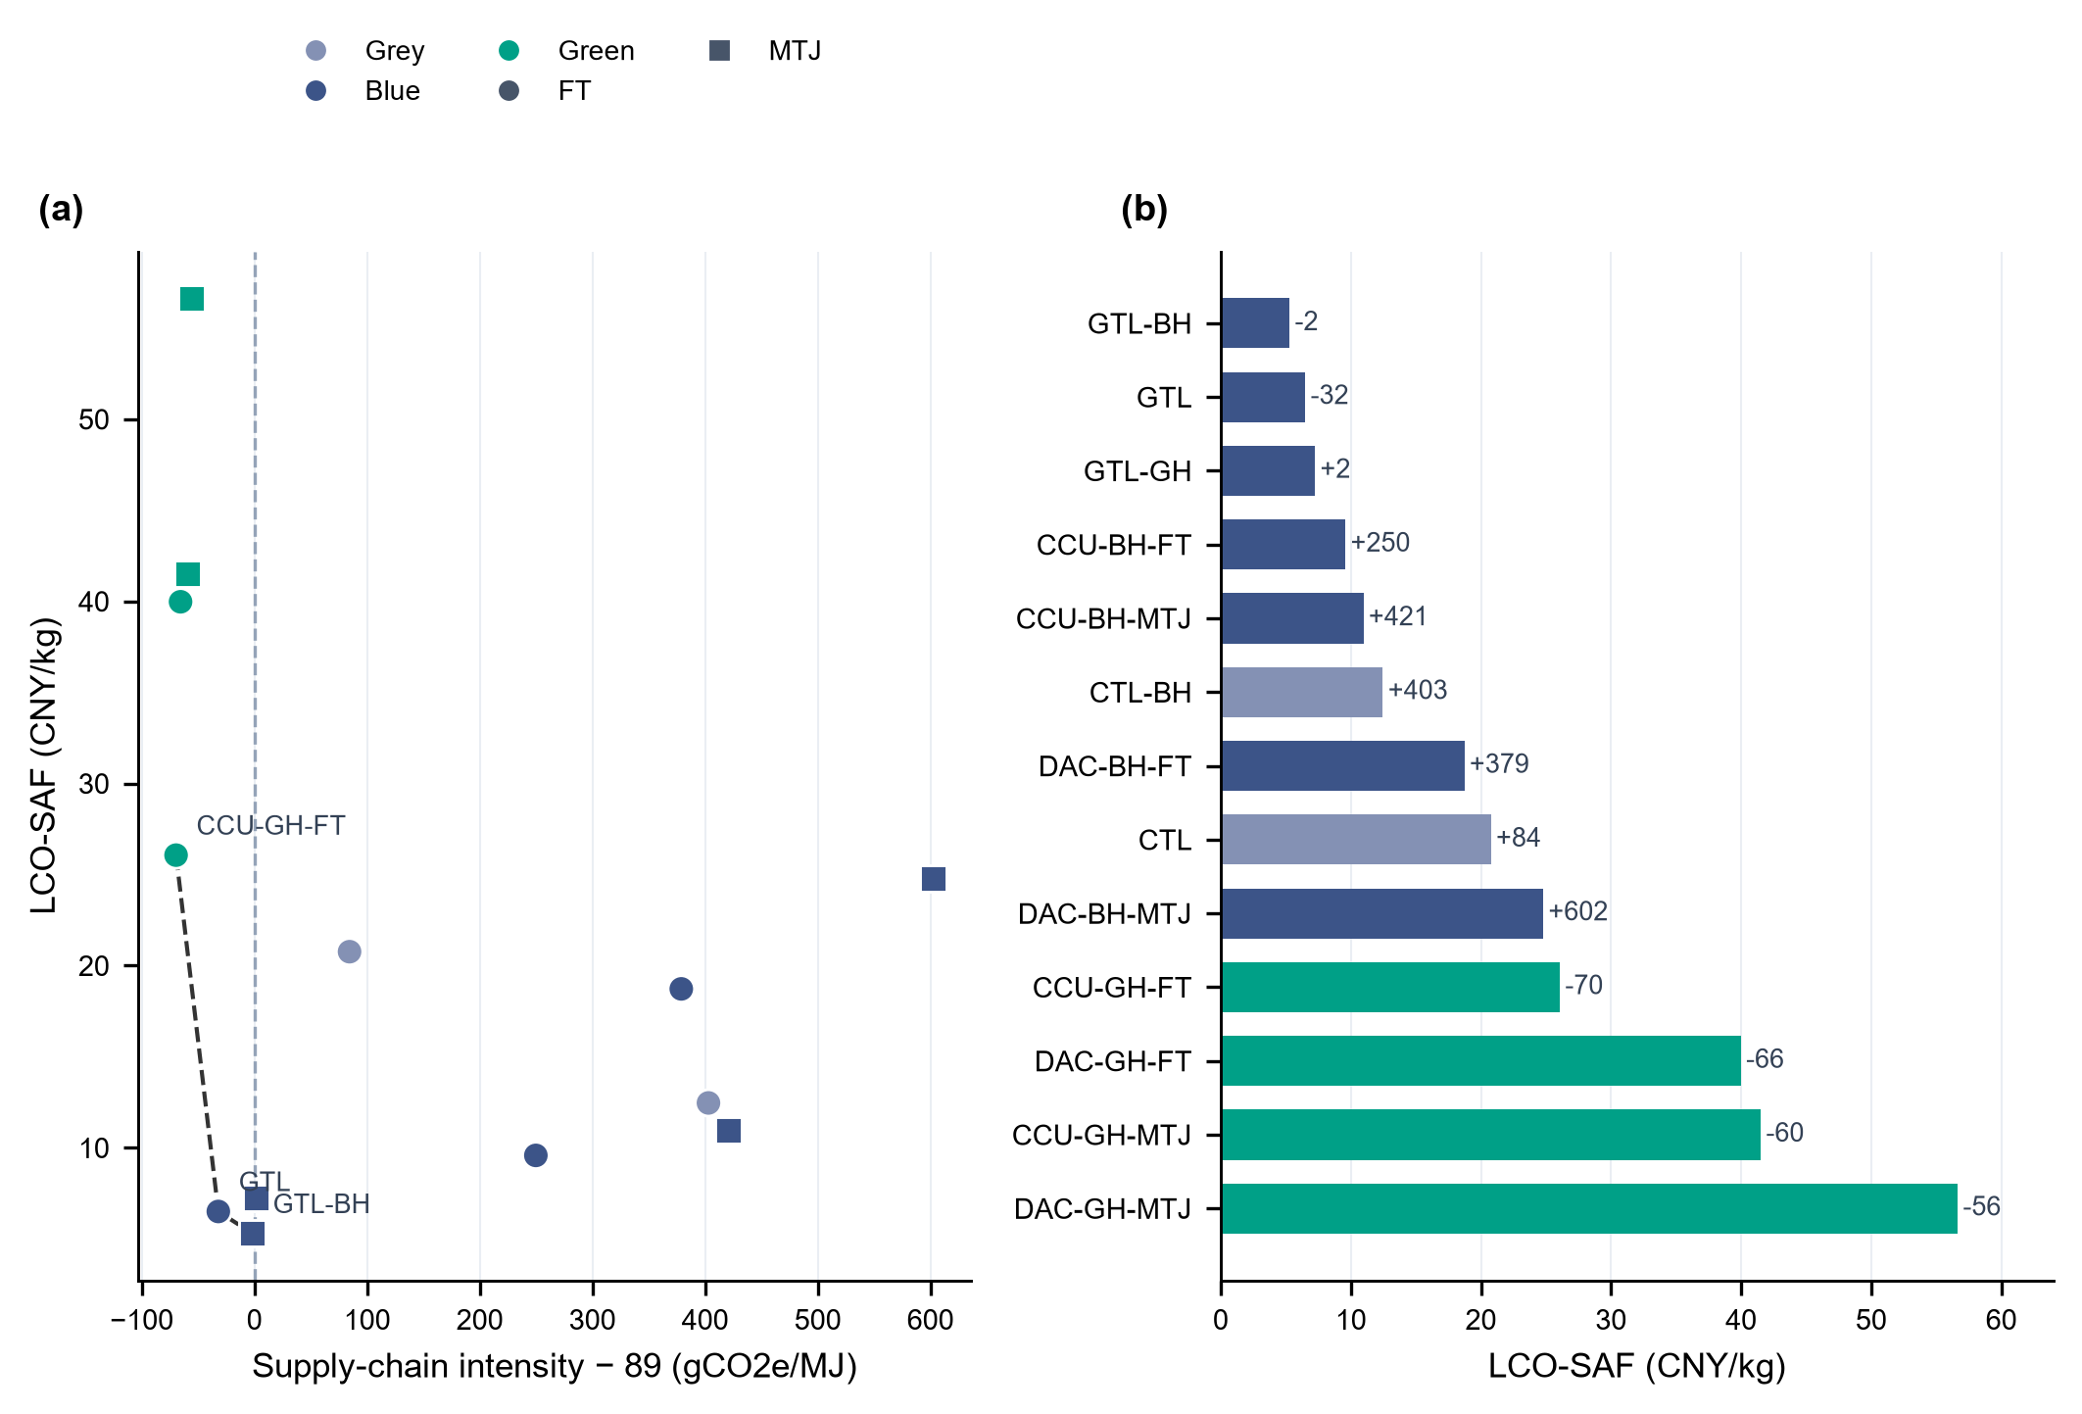
Figure S25. Extended cost and supply-chain carbon comparison across 13 pathway configurations. (a) Points retain the pathway-family colors and FT/MTJ markers; the dashed line connects nondominated points in the displayed two-dimensional projection only. (b) Bars show baseline costs excluding shortage penalties; end labels show supply-chain carbon intensity minus the 89 gCO2e/MJ reference. Baselines have different service fractions and therefore do not define a common full-service Pareto frontier. The carbon ledger excludes aircraft combustion; Table S21 reports the accounting sensitivity and service fractions. The comparison combines six electricity-dependent configurations, including the CTL partial-supply diagnostic, with seven archived comparators.

6.2 Additional spatial network maps
Figure S27 and Table S18 describe the selected networks using positive transport records. Model identifiers and physical coordinates are counted separately; co-located equipment records are aggregated only for site counts and matching. H₂ facility records in the by-product cases are supply or purification records and are not counts of physical electrolyzers. Distances are quantity weighted separately by commodity. Aggregate mass-flow metrics use H₂, CO₂ and fuel; natural-gas volumes are reported separately. Top-node concentration is the outflow share of the largest 10% of source identifiers, and top-route concentration is the share on the three largest aggregated routes. The more-than-100-km fraction describes long-distance flows; it is not an administrative-border measure. The largest-source share is a concentration proxy, not a simulated outage loss. Comparison groups are retained labels and do not assert a new clustering result. Table S24 measures physical synthesis-site correspondence without inferring equipment reuse.
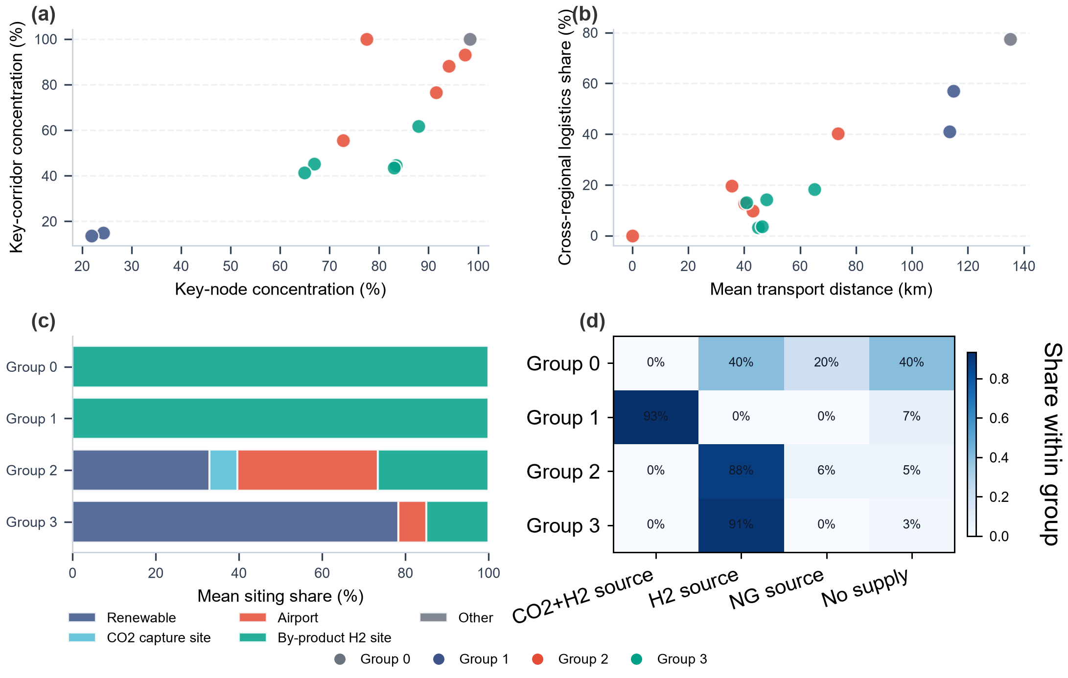
Figure S27. Network and siting profiles within the retained pathway comparison groups. Group membership is retained for comparison and does not assert a new clustering result. Active network nodes refer to positive mass-flow endpoints; siting counts include selected facilities. Six electricity-dependent configurations and seven archived comparators are shown; CTL is a partial-supply diagnostic. Reported values describe these solved configurations and service levels.
Table S18 Network descriptors calculated from the identified baseline transport records. An asterisk denotes an archived comparator and CTL† the partial-supply diagnostic. Positive-flow identifiers, H₂ facility records, synthesis modules and physical synthesis coordinates have distinct counting rules. Concentration metrics use mass flows; natural-gas volume is excluded.
Pathway | Network  IDs | H₂ facility records | SAF modules / sites | H₂ distance (km) | SAF distance (km) | Top-node share (%) | Top-route share (%) | Flow  >100 km  (%) | Largest-source share (%)
GTL-BH* | 4 | 0 | 3 / 2 | — | 135.25 | 98.32 | 100.00 | 77.47 | 98.32
GTL* | 4 | 0 | 2 / 2 | — | 0.00 | 77.47 | 100.00 | 0.00 | 77.47
CTL-BH* | 35 | 0 | 3 / 3 | 156.93 | 62.37 | 94.10 | 88.08 | 40.30 | 39.73
CTL† | 113 | 109 | 111 / 59 | 84.31 | 30.26 | 72.78 | 55.57 | 12.72 | 48.54
GTL-GH | 112 | 109 | 3 / 3 | 97.02 | 32.63 | 97.40 | 93.08 | 19.50 | 89.36
CCU-BH-MTJ* | 62 | 55 | 4 / 4 | 199.22 | 20.41 | 87.97 | 61.75 | 18.22 | 38.30
CCU-BH-FT* | 51 | 45 | 3 / 3 | 196.78 | 45.52 | 91.56 | 76.63 | 9.69 | 67.65
CCU-GH-MTJ | 130 | 109 | 111 / 59 | 67.28 | 34.02 | 83.04 | 43.38 | 3.59 | 41.26
CCU-GH-FT | 129 | 109 | 71 / 57 | 63.51 | 32.22 | 83.43 | 44.59 | 3.23 | 40.67
DAC-BH-MTJ* | 32 | 30 | 28 / 28 | — | 165.66 | 21.88 | 13.75 | 41.01 | 7.66
DAC-BH-FT* | 28 | 26 | 26 / 26 | — | 150.85 | 24.29 | 14.84 | 56.94 | 8.40
DAC-GH-MTJ | 113 | 109 | 111 / 59 | 72.92 | 34.02 | 64.90 | 41.26 | 14.20 | 34.80
DAC-GH-FT | 113 | 109 | 111 / 59 | 60.14 | 32.22 | 66.87 | 45.21 | 12.94 | 39.86

6.3 Additional cost decomposition results
The cost-decomposition panel compares CCU-GH-FT, GTL and GTL-BH by cost category. Costs are normalized by actual fuel output and exclude shortage penalties. CCU-GH-FT serves 43.84% of baseline demand, whereas the retained GTL and GTL-BH cases serve all demand. The decomposition therefore describes their reported configurations and does not establish incremental costs for supplying a common total quantity.
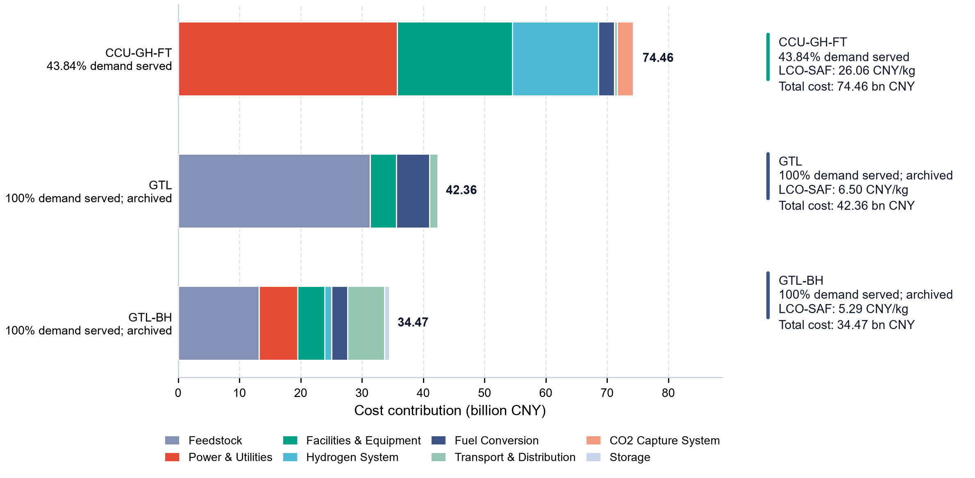
Figure S28. Cost composition of three selected pathway configurations. Stacked bars partition the reported discounted cost, excluding shortage penalties, into nonoverlapping categories. Cards give the cost per kilogram of actual output and the service fraction: 43.84% for CCU-GH-FT and 100% for retained GTL and GTL-BH controls. Total expenditures correspond to different production quantities and are not equal-service transition costs. Aggregated cost totals are excluded from component shares to prevent double counting.

6.4 Additional emissions decomposition results
The emissions decomposition uses the same three pathway configurations. Positive contributions and capture attribution are accounted for separately without counting both component transport terms and their aggregate totals. Baseline values exclude aircraft combustion; Table S21 reports combustion-inclusive and capture-attribution variants on the same fixed production schedules.^{9,87,106}
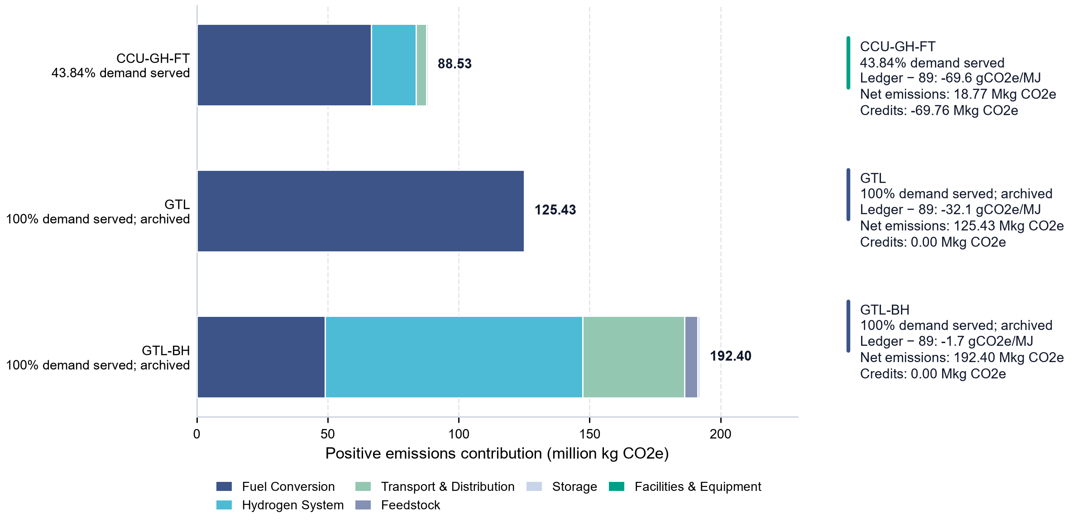
Figure S29. Positive production and supply-chain emissions of three selected pathway configurations. Stacked bars show positive emissions over the four representative weeks; cards report the ledger total after credits, the credit amount and the difference from the 89 gCO2e/MJ reference. CCU-GH-FT supplies 43.84% of demand, while the retained GTL and GTL-BH controls supply 100%, so total emissions reflect different output quantities. Hydrogen and CO2 transport subtotals are counted once. Aircraft combustion is excluded; the plotted ledger and reference difference do not establish harmonized lifecycle reductions or fuel-standard eligibility.

6.5 Temporal-operational profile and production-stability analysis
This section describes utilization over the baseline four-week sequence for six electricity-dependent configurations, including the CTL partial-supply diagnostic, and seven archived comparators. Utilization and worst-week retention characterize each schedule at its achieved output; demand coverage is reported separately.

6.5.1 Facility-utilization efficiency across pathways
Facility utilization is computed at the 3-hour production-period level for both the hydrogen supply stage and the synthetic aviation fuel synthesis stage. For each period the utilization rate is the ratio of actual production (kg) to the maximum achievable output given installed capacity and period length. Hydrogen utilization uses installed production or purification capacity where available. For integrated routes without a separate hydrogen module, peak hourly supply over the selected horizon is used as the denominator. GTL-BH follows this peak-supply convention; its hydrogen curve describes a normalized supply profile rather than installed-equipment utilization.^{111,112}
Eq. (S13) $U_{w,k} = \frac{q_{w,k}}{{Cap}_{k} · T_{w}}, U_{w,k} ∈ [0, 1]$
Here q is period production, Cap is installed hourly capacity and T is the three-hour duration. Utilization distributions and aggregate metrics are computed from the same identified schedules.
Figure S30. H2 production and SAF factory utilization distributions, grouped by feedstock category, across 224 three-hour periods in four representative weeks. Capacity denominators use selected H2 production or purification capacity where available, and peak supply for integrated routes without a separate H2 module. Six electricity-dependent configurations and seven archived comparators are shown; CTL is a partial-supply diagnostic. Reported values describe these solved configurations and service levels.
The plotted distributions describe the selected four-week schedules. Low-load episodes are detected within each 56-period week, with episode boundaries reset between nonconsecutive calendar weeks. An episode lasting more than 12 h must contain at least five three-hour periods. These durations describe within-week dispatch and do not measure equipment outage or recovery. Extension to other weeks requires separate operating calculations.
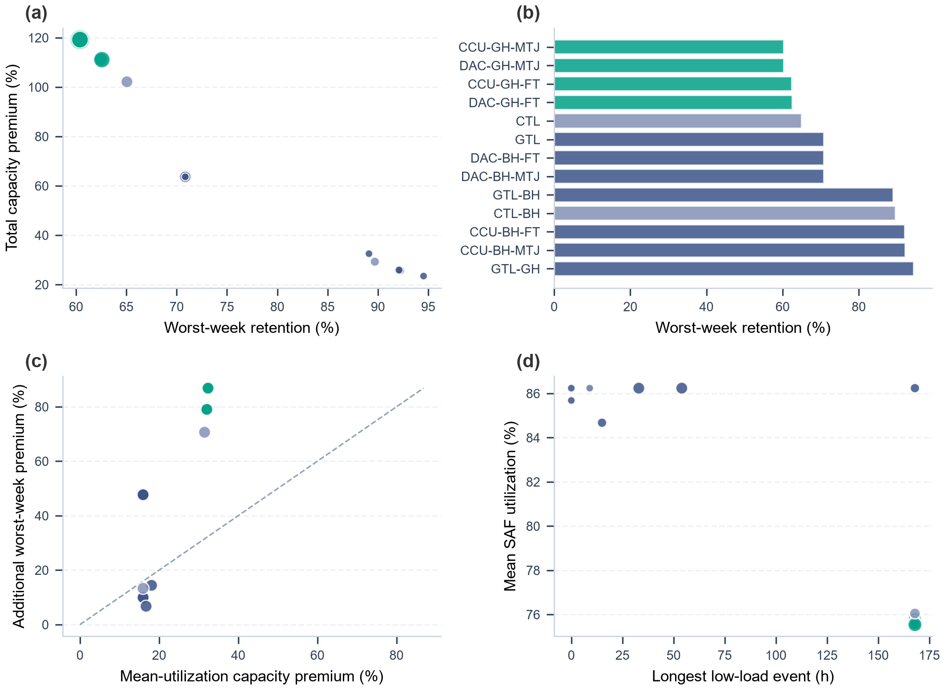
Figure S31. Temporal comparisons for all pathways: (a) worst-week retention versus total capacity premium, (b) worst-week-retention ranking, (c) mean-utilization and additional worst-week capacity premiums, and (d) longest low-load episode versus mean SAF utilization. Low-load episodes are counted within individual representative weeks. Six electricity-dependent configurations and seven archived comparators are shown; CTL is a partial-supply diagnostic. Reported values describe these solved configurations and service levels.

6.5.2 Temporal robustness penalty framework
The capacity-premium framework translates utilization into the additional nameplate capacity implied by producing a fixed output at that utilization rather than at full utilization. It comprises a mean-utilization component and an additional worst-week component. It is not a measured financial penalty or a failure-probability model.
The chronic low-utilization penalty reflects the gap between mean synthetic aviation fuel utilization and the full-capacity benchmark:
Eq. (S14) $P_{chronic} = (\frac{1}{Ū_{SAF}} − 1) × 100\%$
The robustness penalty reflects the additional shortfall associated with the single worst representative week, capturing inter-week variability rather than the average level:
Eq. (S15) $P_{robust} = (\frac{1}{Ū_{worst}} − \frac{1}{Ū_{SAF}}) × 100\%$
In Eqs. (S14)–(S15), mean synthesis utilization and worst-week mean utilization are fractions between zero and one. The total implied capacity premium is the sum of the mean-utilization and additional worst-week components. Figure S32 reports the components for three representative configurations; Table S23 gives all thirteen baseline records.
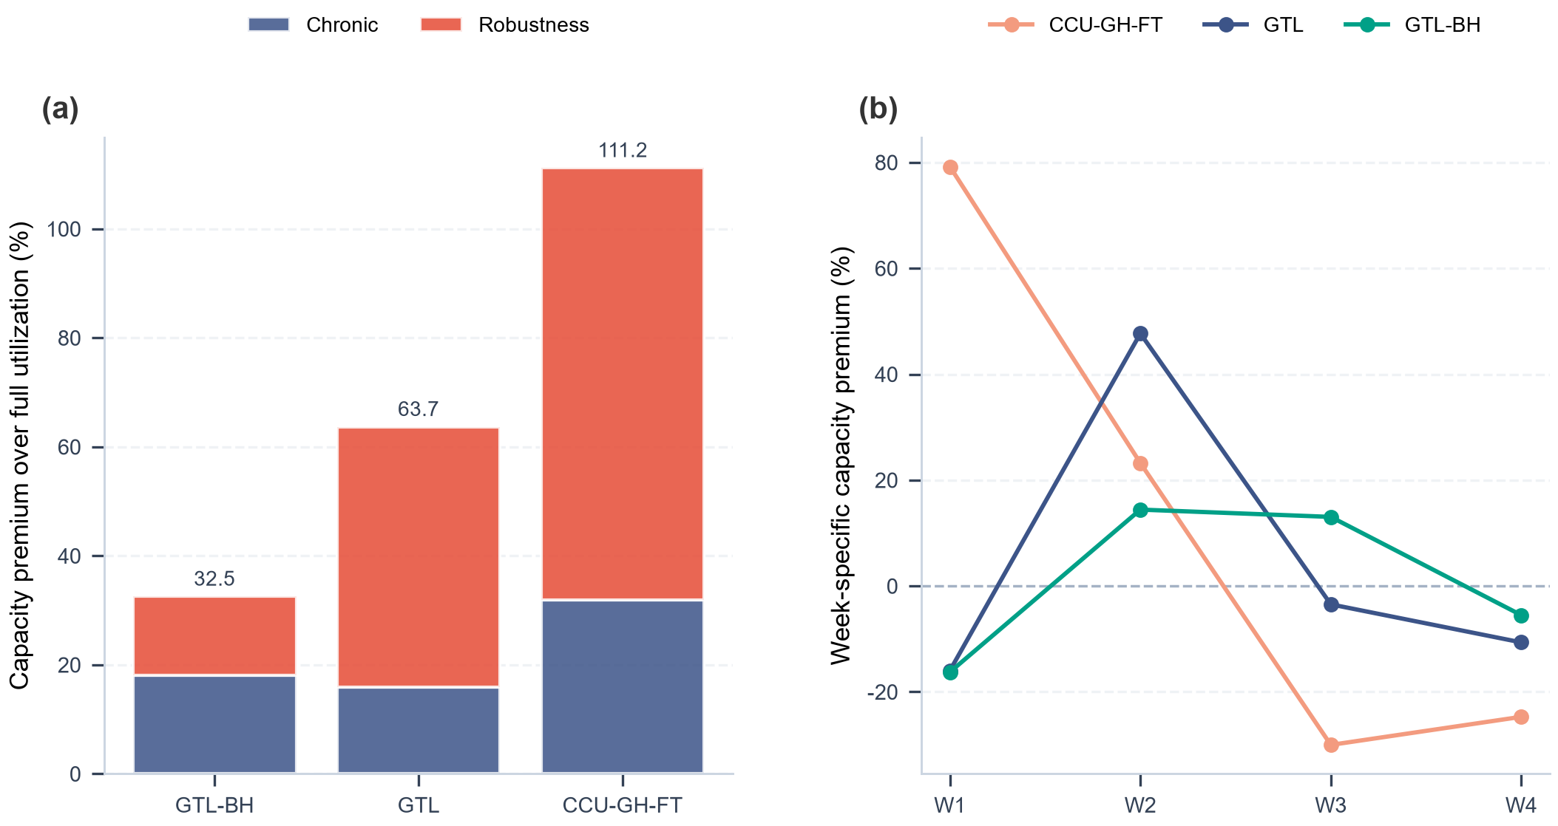
Figure S32. Capacity-premium decomposition for three representative pathways. (a) Mean-utilization and additional worst-week capacity premiums; (b) week-specific capacity premium relative to the mean-utilization requirement. Values are capacity ratios rather than recalculated monetary costs.

6.5.3 Capacity-premium decomposition for three reference pathways
The retained GTL-BH configuration has 84.68% mean utilization and 89.11% worst-week retention. GTL has 86.24% mean utilization and 70.85% retention. CCU-GH-FT has 75.78% mean utilization and 62.49% retention, corresponding to a 31.95% mean-utilization premium and a 79.21% additional worst-week premium. Its baseline demand coverage is 43.84%. Tables S19 and S23 quantify these distinct properties, and Tables S25 and S32 describe sensitivity to week selection.
Table S19 Utilization and implied capacity premiums for the three reference pathways.
Pathway | Mean SAF util. (%) | Worst-week util. (%) | Chronic penalty (%) | Robustness penalty (%) | Total penalty (%)
GTL-BH* | 84.68 | 75.46 | 18.10 | 14.43 | 32.53
GTL* | 86.24 | 61.10 | 15.96 | 47.70 | 63.66
CCU-GH-FT | 75.78 | 47.36 | 31.95 | 79.21 | 111.17
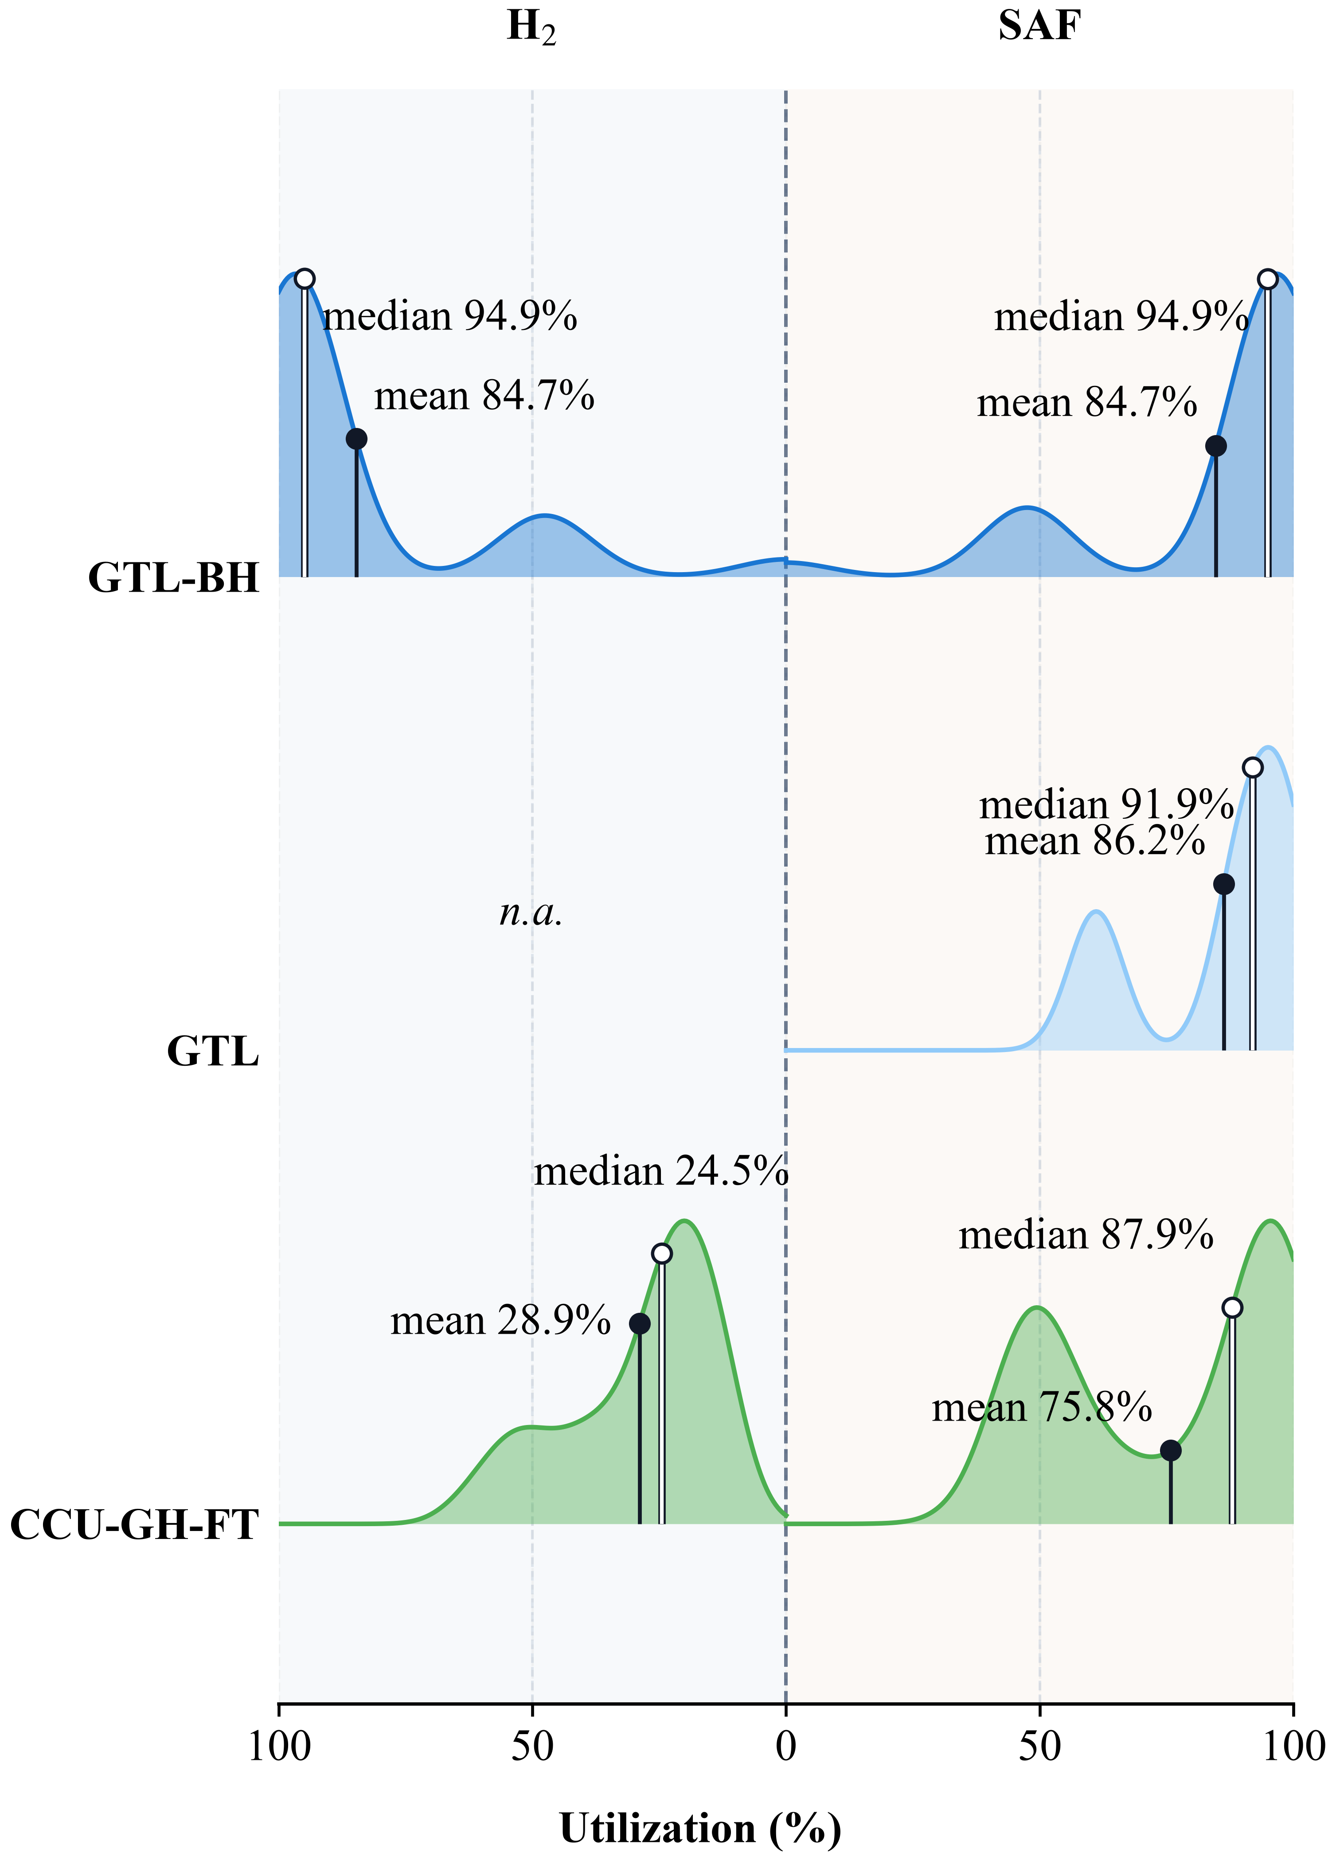
Figure S33. Utilization distributions for GTL-BH, GTL and CCU-GH-FT. H2 production is shown at left and SAF factory utilization at right, with means and medians annotated. The selected configurations have different fulfilled-demand levels. GTL-BH H₂ supply is normalized to peak hourly supply; CCU-GH-FT H₂ utilization uses installed electrolyzer capacity.
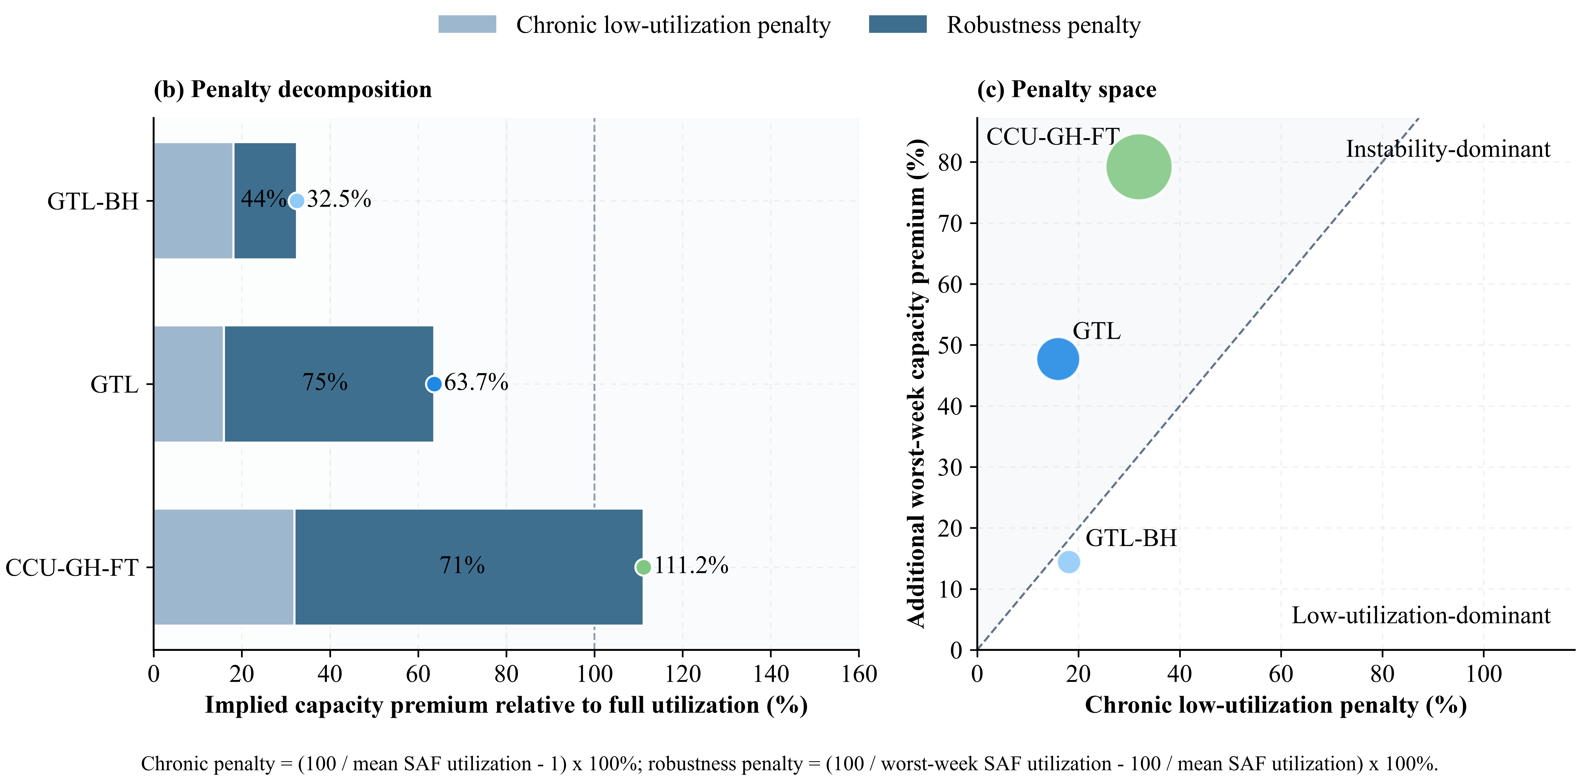
Figure S34. Capacity-premium decomposition for GTL-BH, GTL and CCU-GH-FT. The mean-utilization and additional worst-week components sum to the total premium; bubble size encodes this sum and the diagonal denotes equal contributions. Percentages inside the stacked bars give the additional worst-week component as a share of the total premium.

6.5.4 Penalty-driver fingerprint
The twelve-driver fingerprint describes mean fuel utilization, within-week low-load frequency and duration, worst-week retention, interweek variability, renewable variability and capacity-premium components. Low-load events do not continue across the boundaries between nonconsecutive representative weeks; the more-than-12-hour count uses a strict duration threshold. Each value is standardized across the identified 13-pathway baseline records. The records cover six electricity-dependent configurations, including the CTL partial-supply diagnostic, and seven archived comparators. The heatmap is descriptive; achieved output and demand coverage remain relevant to interpretation.^{111,112,107}
Figure S35 compares standardized utilization, low-load, renewable-availability and capacity-premium measures for GTL-BH, GTL and CCU-GH-FT. The associations describe the selected production schedules.
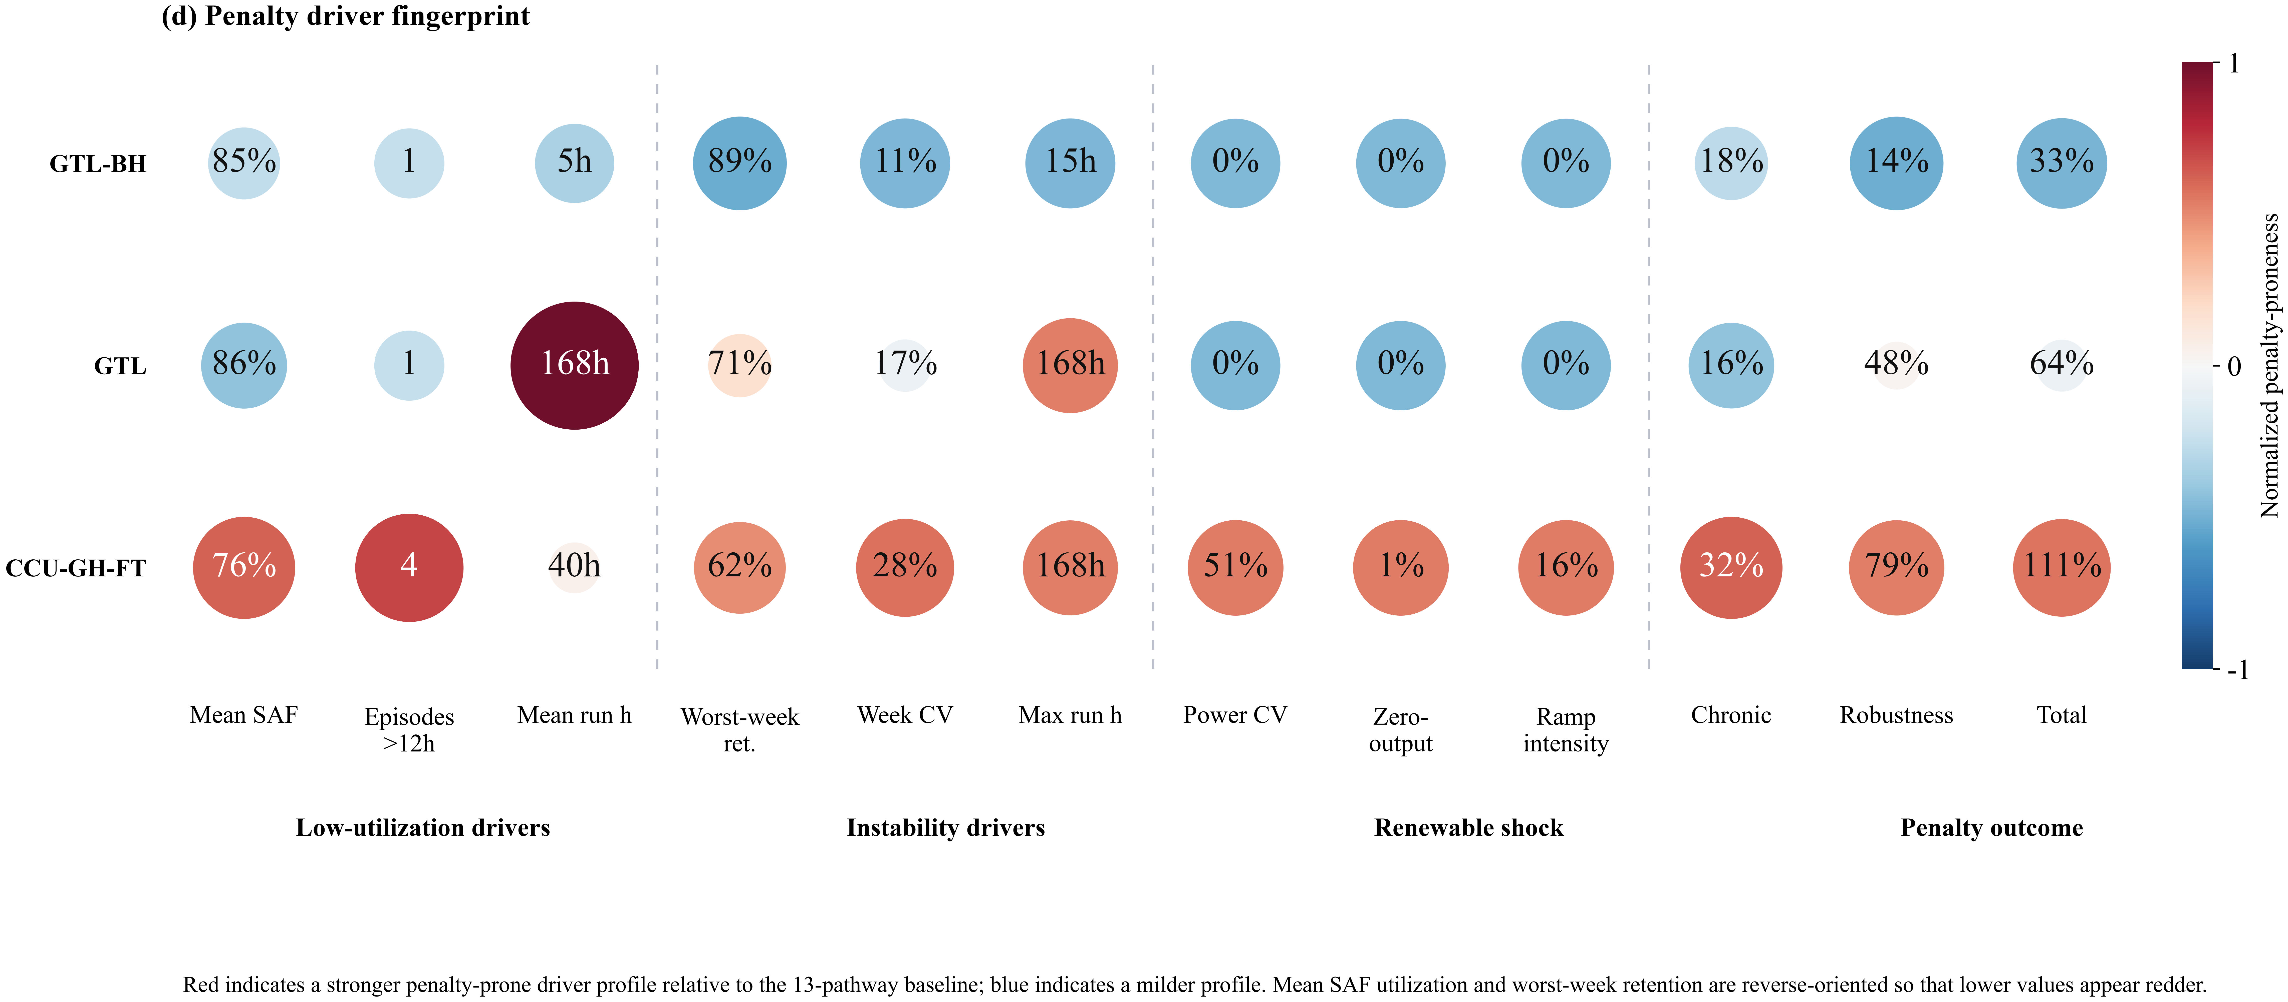
Figure S35. Twelve-driver fingerprint for GTL-BH, GTL and CCU-GH-FT, normalized against the thirteen-configuration distribution. Four groups separate utilization, within-week low-load episodes, renewable variability and capacity-premium outcomes. This is a descriptive comparison of configurations with different fulfilled-demand levels.

6.6 Per-pathway cost–emission decomposition
Figures S36–S48 show conditional 2026–2036 cost projections for the identified baseline designs. Illustrative learning rates per cumulative-capacity doubling are 21% for electrolyzer-related capital, 18% for FT synthesis, 15% for MTJ synthesis, 12% for DAC, 10% for the coal-gasification category and 6% for industrial capture. For each component, the baseline cost is multiplied by [X(y)/X(2026)] raised to the power ln(1 − LR)/ln(2), where LR is its learning rate and X is its deployment index. Each index starts at 1 in 2026. Its 2036 value is 11.875 for electrolysis and synthesis, 30 for DAC, 18.75 for coal processing and 13.846 for point-source capture. The supplied learning_deployment_indices.csv gives every annual index; these trajectories define the illustrative deployment scenario. Electricity uses the factor 0.96 raised to the power (y − 2026). The FT group includes CTL, CTL-BH and GTL as well as the captured-carbon FT cases; GTL-GH and GTL-BH use the MTJ group. Other cost categories retain their coefficients. Costs use actual baseline output and exclude shortage penalties; capacity, dispatch, carbon intensity and demand coverage are held fixed. The projections therefore describe cost changes for the specified baseline output and resource configuration.

6.7 Transport network route maps
Clustered and pathway-specific route maps are provided in the Supplementary Archive (Figs. S49–S63), including the representative topology comparison in Fig. S50 and CCU-GH-FT in Fig. S57. Table S18 and the physical-site matching in Table S24 provide the core numerical comparisons.

7 Additional quantitative analyses

7.1 Scope of additional source and conversion combinations
Table S20 defines the represented model boundary and the process information required to evaluate additional combinations. Section 2.4 gives the stoichiometric reasoning and distinguishes internally and externally supplied hydrogen.
Table S20 Reasons for excluding additional source and conversion combinations.
Combination | Treatment | Reason and required extension
CCU or DAC CO₂ with no hydrogen input, using the represented FT or MTJ block | Cannot sustain positive output within the represented balances | Both conversion blocks consume hydrogen. With hydrogen and alternative reducing routes disabled, positive fuel output violates the model material balance. A different reduction or co-electrolysis process would require its own energy, material and cost formulation.
CCU or DAC CO₂ with dedicated fossil-derived hydrogen | Technically possible; outside the evaluated hydrogen-source cases | The retained CCU/DAC comparisons use green or industrial by-product H₂. A dedicated reforming or gasification supply case requires an explicit hydrogen-production configuration, fuel use, upstream emissions and optional carbon-capture allocation. No such independently evaluated case is included in Tables S6–S7.
Natural gas with supplemental GH or BH through FT | Not evaluated in the retained 13-scenario comparison | The FT gas reference uses internally supplied hydrogen; the external-H₂ gas cases use MTJ. Supplemental-H₂ FT requires a separate configuration of reforming, syngas conditioning and hydrogen balances.
Natural-gas MTJ without external hydrogen | Not represented by the retained MTJ hydrogen boundary | The retained gas-to-MTJ cases supply external GH or BH. An internally hydrogen-balanced reforming-to-methanol variant requires its own integrated syngas, energy and cost accounting; setting the existing external-H₂ input to zero is not an equivalent process substitution.
Additional coal and hydrogen combinations or coal-to-methanol-to-jet variants | Outside the two retained coal configurations | Tables S6–S7 contain the CTL reference and its BH variant, without a full coal × hydrogen-source × synthesis-route matrix. Other variants require separate conversion yields, hydrogen requirements and process costs. No physical-infeasibility or cost-dominance claim is made for the omitted variants.
Lipids to HEFA; fermentation alcohols to ATJ; biomass or waste to FT or hydrothermal products | Outside the represented feedstock and conversion network | These routes require lipid or biomass inventories, collection and pretreatment, seasonal availability, conversion yields and lifecycle allocation. The current source network represents coal, natural gas, industrial CO₂ and DAC. ICAO lists HEFA, ATJ and biomass FT as distinct conversion categories (Refs. 119–120); exclusion here is a scope choice.
Additional synthesis technologies or multi-source hybrid configurations | Outside the activated process modules | The finite scenario set does not include every compatible carbon, hydrogen and conversion combination. Additional technology modules or simultaneous source mixing require calibrated yields, capacity and operating constraints and consistent lifecycle accounting before inclusion in the comparison.

7.2 Carbon accounting sensitivity on fixed configurations
The combustion addition is 0.85 × (44/12) × 1000 / 43.15 = 72.228660 g CO₂/MJ. Table S21 holds each reported configuration, output and cost fixed. One variant adds combustion while retaining capture attribution; another also removes that attribution as an accounting diagnostic. For DAC, the latter is an accounting bound and does not imply that atmospheric uptake should generally receive no credit. Recycled fuel carbon is distinguished from permanent removal. None of these fixed-schedule accounting variants is a new optimization.
Table S21 Delivered-output costs, demand coverage and fixed-configuration carbon-accounting sensitivities. Carbon intensity is in g CO₂e/MJ. An asterisk identifies a retained archived comparator; CTL† is the partial-supply diagnostic.
Pathway | Demand met (%) | CNY/kg | Baseline CI | With combustion | With combustion; no capture attribution
CTL† | 63.24 | 20.76 | 173.402 | 245.631 | 245.631
CTL-BH* | 100.00 | 12.46 | 491.952 | 564.180 | 564.180
GTL-GH | 100.00 | 7.24 | 90.605 | 162.833 | 162.833
GTL* | 100.00 | 6.50 | 56.940 | 129.169 | 129.169
GTL-BH* | 100.00 | 5.29 | 87.342 | 159.570 | 159.570
CCU-GH-MTJ | 29.17 | 41.51 | 29.282 | 101.510 | 173.739
CCU-GH-FT | 43.84 | 26.06 | 19.436 | 91.665 | 163.894
CCU-BH-MTJ* | 100.00 | 10.96 | 509.656 | 581.884 | 654.113
CCU-BH-FT* | 100.00 | 9.58 | 338.753 | 410.981 | 483.210
DAC-GH-MTJ | 29.17 | 56.64 | 33.240 | 105.468 | 177.697
DAC-GH-FT | 43.88 | 39.97 | 23.411 | 95.640 | 167.869
DAC-BH-MTJ* | 100.00 | 24.78 | 691.299 | 763.527 | 835.756
DAC-BH-FT* | 100.00 | 18.72 | 467.826 | 540.055 | 612.283

Table S22 Comparison scope for GTL-BH, GTL and CCU-GH-FT at their reported baseline service levels.
Comparison | Service level | Interpretation
GTL-BH* → GTL* | 100% → 100% | Archived configurations: 5.291 → 6.502 CNY/kg; conversion and hydrogen-source modules differ.
GTL* → CCU-GH-FT | 100% → 43.84% | 6.502 → 26.064 CNY/kg of actual output; not a full-demand marginal-cost comparison.
Equal-service interpretation | Unequal service levels | These configurations describe their achieved supply quantities; an equal-service comparison requires a common-demand constraint.
Uniform combustion addition | Same output as each baseline | Adds 72.229 g CO₂/MJ; preserves pairwise differences but changes absolute intensities.
Capture-attribution sensitivity | Same output as each baseline | Removing capture attribution adds a further 72.229 g CO₂/MJ to the CCU/DAC cases.

A common combustion addition cancels from pairwise intensity differences but changes comparison with a combustion-inclusive fossil benchmark. It does not resolve unequal service levels. CCU-GH-FT has a baseline intensity of 19.436 g CO₂e/MJ, increasing to 91.665 with combustion and to 163.894 when capture attribution is also removed. Its positive carbon intensity under all three conventions does not support a negative-emissions interpretation.

7.3 Utilization and implied capacity premiums
Aggregate utilization is total fuel output divided by installed synthesis capacity and modelled duration. With mean utilization Ū and the smallest weekly mean Umin expressed as fractions, the mean-utilization capacity premium is 100(1/Ū − 1), the additional worst-week premium is 100(1/Umin − 1/Ū), and retention is 100Umin/Ū. These are capacity proxies for the reported schedules, not financial losses, failure probabilities or repair times. The existing chronic and robustness or instability labels denote the two premium components. Demand coverage is reported separately.
Table S23 Baseline utilization and implied capacity premiums. All numeric entries are percentages. Asterisks identify archived comparators; CTL† denotes the partial-supply diagnostic.
Pathway | Mean utilization | Worst-week utilization | Retained (%) | Mean premium | Additional premium
CTL† | 76.05 | 49.47 | 65.05 | 31.50 | 70.64
CTL-BH* | 86.24 | 77.35 | 89.70 | 15.96 | 13.32
GTL-GH | 85.68 | 81.00 | 94.54 | 16.71 | 6.74
GTL* | 86.24 | 61.10 | 70.85 | 15.96 | 47.70
GTL-BH* | 84.68 | 75.46 | 89.11 | 18.10 | 14.43
CCU-GH-MTJ | 75.55 | 45.62 | 60.38 | 32.37 | 86.84
CCU-GH-FT | 75.78 | 47.36 | 62.49 | 31.95 | 79.21
CCU-BH-MTJ* | 86.24 | 79.54 | 92.23 | 15.96 | 9.77
CCU-BH-FT* | 86.24 | 79.43 | 92.10 | 15.96 | 9.95
DAC-GH-MTJ | 75.55 | 45.62 | 60.38 | 32.36 | 86.84
DAC-GH-FT | 75.71 | 47.37 | 62.56 | 32.08 | 79.03
DAC-BH-MTJ* | 86.24 | 61.10 | 70.85 | 15.96 | 47.70
DAC-BH-FT* | 86.24 | 61.10 | 70.85 | 15.96 | 47.70

7.4 Capacity-weighted synthesis-site matching
Synthesis records with identical latitude and longitude are aggregated before matching. The retained GTL and GTL-BH cases each occupy two synthesis coordinates; CCU-GH-FT occupies 57 coordinates. Candidate pairs are selected by great-circle distance. A maximum-weight one-to-one assignment credits the smaller installed capacity in each pair, and each coordinate may be used once. Dividing matched capacity by each pathway total gives the two directional shares. Airport demand nodes are excluded unless the same coordinate hosts an actual synthesis facility.
At 25 km, GTL and CCU-GH-FT share 20,995.20 kg/h of matched synthesis capacity: 23.83% of GTL capacity and 47.77% of CCU-GH-FT capacity. These shares are unchanged over the tested 1–100 km thresholds for this pair. They measure geographic correspondence between the selected configurations and do not establish equipment reuse or retrofit cost.
Table S24 Physical-coordinate matching after co-located capacity aggregation.
Source → target | Radius  (km) | Source capacity % | Target capacity %
GTL-BH* → GTL* | 1 | 0.00 | 0.00
GTL-BH* → GTL* | 10 | 0.00 | 0.00
GTL-BH* → GTL* | 25 | 21.81 | 22.21
GTL-BH* → GTL* | 50 | 21.81 | 22.21
GTL-BH* → GTL* | 100 | 21.81 | 22.21
GTL-BH* → CCU-GH-FT | 1 | 0.00 | 0.00
GTL-BH* → CCU-GH-FT | 10 | 0.00 | 0.00
GTL-BH* → CCU-GH-FT | 25 | 2.55 | 5.21
GTL-BH* → CCU-GH-FT | 50 | 4.49 | 9.17
GTL-BH* → CCU-GH-FT | 100 | 4.49 | 9.17
GTL* → CCU-GH-FT | 1 | 23.83 | 47.77
GTL* → CCU-GH-FT | 10 | 23.83 | 47.77
GTL* → CCU-GH-FT | 25 | 23.83 | 47.77
GTL* → CCU-GH-FT | 50 | 23.83 | 47.77
GTL* → CCU-GH-FT | 100 | 23.83 | 47.77

7.5 Dependence on representative-week selection
Each baseline week is omitted once while the other three weeks retain their installed capacity and dispatch. Thirteen cases × four omissions give 52 descriptive calculations: 24 use the six electricity-dependent baseline schedules, including the labelled CTL diagnostic, and 28 use the seven archived comparators. Table S25 reports ranges with equal weighting of retained weeks. These ranges are not confidence intervals, reoptimized omissions or full-year reliability measures.
Table S25 Ranges across the four fixed-schedule week-omission calculations. All ranges are percentages.
Pathway | Mean utilization | Mean premium | Additional premium | Retention
CCU-BH-FT* | 81.65–88.51 | 12.98–22.47 | 3.43–12.74 | 89.88–97.27
CCU-BH-MTJ* | 81.65–88.47 | 13.03–22.47 | 3.26–11.45 | 90.89–97.41
CCU-GH-FT | 68.35–85.26 | 17.29–46.31 | 37.89–85.48 | 59.52–75.58
CCU-GH-MTJ | 67.92–85.52 | 16.93–47.23 | 40.34–93.48 | 57.36–74.35
CTL† | 68.89–84.91 | 17.78–45.16 | 35.07–76.49 | 62.16–77.06
CTL-BH* | 81.65–89.20 | 12.10–22.47 | 6.81–16.48 | 87.25–94.73
DAC-BH-FT* | 81.65–94.62 | 5.69–22.47 | 6.80–46.50 | 71.59–93.95
DAC-BH-MTJ* | 81.65–94.62 | 5.69–22.47 | 6.80–46.50 | 71.59–93.95
DAC-GH-FT | 68.28–85.16 | 17.42–46.45 | 38.01–85.33 | 59.58–75.54
DAC-GH-MTJ | 67.93–85.53 | 16.92–47.22 | 40.34–93.47 | 57.36–74.35
GTL* | 81.65–94.62 | 5.69–22.47 | 6.80–46.50 | 71.59–93.95
GTL-BH* | 80.17–87.75 | 13.96–24.73 | 7.80–18.22 | 86.25–94.12
GTL-GH | 81.13–87.24 | 14.62–23.26 | 0.19–8.82 | 92.86–99.85

The week-omission ranges show how utilization and additional worst-week capacity requirements depend on the selected subset. The separate reoptimization in Table S32 evaluates a summer-inclusive demand–resource sequence with each baseline production design fixed.
For the 109 retained resource projects, weekly airport demand, solar energy and wind energy are normalized by their respective twelve-week means. The baseline four weeks define marginal minimum–maximum ranges. 7 of the twelve candidate weeks lie inside all three ranges; weeks 18, 22, 27, 31, 35 fall outside. This rectangular-range diagnostic identifies omitted demand–resource states and does not establish coverage of the full joint distribution or of an operating year.
Table S26 Joint demand–renewable range diagnostic for the twelve candidate weeks. Relative values are dimensionless.
Calendar week | Demand | Solar | Wind | Selected | Inside all ranges
1 | 1.080 | 0.432 | 0.402 | Yes | Yes
5 | 0.660 | 0.632 | 0.584 | Yes | Yes
9 | 1.080 | 0.722 | 0.847 | No | Yes
14 | 0.960 | 1.262 | 1.248 | Yes | Yes
18 | 1.080 | 1.251 | 1.383 | No | No
22 | 1.080 | 1.534 | 1.467 | No | No
27 | 1.080 | 1.185 | 1.461 | No | No
31 | 1.080 | 1.297 | 1.357 | No | No
35 | 1.080 | 1.044 | 1.292 | No | No
40 | 1.080 | 1.093 | 0.931 | No | Yes
44 | 1.026 | 0.911 | 0.608 | Yes | Yes
48 | 0.714 | 0.637 | 0.420 | No | Yes

7.6 Solver certificates and validation checks
Table S27 reports COPT 8.0.7 calculations for the six electricity-dependent configurations and two input sequences. Each feasible full-model dispatch is compared with a valid global lower bound from the routing projection. The relative gap applies to the complete objective, including shortage penalties. Fixed candidate binaries and route volumes are re-evaluated in the full model. Model dimensions are before presolve. Times refer only to the final full-model dispatch solve; the accompanying timing records separately document design searches, projection solves and model export.
Table S27 COPT 8.0.7 certificates for the twelve reported solutions. A and B denote baseline and summer-inclusive weeks. CTL† removes the infeasible 90% output floor. Reported seconds cover final dispatch only.
Pathway / set | Rows | Columns | Final dispatch (s) | Certified gap (%) | Result scope
CCU-GH-FT / A | 375508 | 3704823 | 92.46 | 0.2008 | Full-model feasible; global bound certificate
CCU-GH-FT / B | 376010 | 3704823 | 35.37 | 0.0690 | Full-model feasible; global bound certificate
CCU-GH-MTJ / A | 375508 | 3704823 | 76.90 | 0.2027 | Full-model feasible; global bound certificate
CCU-GH-MTJ / B | 376010 | 3704823 | 39.21 | 0.0341 | Full-model feasible; global bound certificate
DAC-GH-FT / A | 385612 | 2984901 | 61.70 | 0.2633 | Full-model feasible; global bound certificate
DAC-GH-FT / B | 386163 | 2984901 | 49.57 | 0.0427 | Full-model feasible; global bound certificate
DAC-GH-MTJ / A | 385612 | 2984901 | 28.01 | 0.2103 | Full-model feasible; global bound certificate
DAC-GH-MTJ / B | 386163 | 2984901 | 27.83 | 0.0340 | Full-model feasible; global bound certificate
GTL-GH / A | 1094075 | 1474176 | 15.90 | 0.7284 | Full-model feasible; global bound certificate
GTL-GH / B | 1096413 | 1474176 | 9.59 | 0.0000 | Full-model feasible; global bound certificate
CTL† / A | 260404 | 2848482 | 72.46 | 0.3461 | Full-model feasible; global bound certificate
CTL† / B | 260844 | 2848482 | 26.91 | 0.0955 | Full-model feasible; global bound certificate

Table S28 Numerical and independent physical checks of the twelve accepted solutions. Constraint and variable residuals use the exported model units; electricity is in MWh and hydrogen balance residuals are in kg.
Pathway / set | Max row residual | Max bound residual | Max electricity deficit (MWh) | Max H₂ balance residual (kg) | Checks
CCU-GH-FT / A | 4.95e-09 | 3.78e-10 | 1.14e-13 | 4.95e-09 | Passed
CCU-GH-FT / B | 3.73e-09 | 1.31e-11 | 1.14e-13 | 7.64e-11 | Passed
CCU-GH-MTJ / A | 5.59e-09 | 5.24e-10 | 1.14e-13 | 1.66e-09 | Passed
CCU-GH-MTJ / B | 9.31e-09 | 3.21e-11 | 1.14e-13 | 1.53e-10 | Passed
DAC-GH-FT / A | 5.11e-08 | 3.13e-10 | 2.27e-13 | 5.11e-08 | Passed
DAC-GH-FT / B | 3.35e-08 | 7.86e-10 | 2.27e-13 | 1.31e-09 | Passed
DAC-GH-MTJ / A | 1.86e-09 | 1.37e-11 | 1.14e-13 | 3.77e-11 | Passed
DAC-GH-MTJ / B | 2.14e-08 | 2.33e-09 | 2.27e-13 | 8.48e-10 | Passed
GTL-GH / A | 6.34e-08 | 3.17e-08 | 1.10e-12 | 3.15e-10 | Passed
GTL-GH / B | 1.49e-08 | 4.89e-09 | 3.41e-13 | 1.64e-11 | Passed
CTL† / A | 9.78e-09 | 9.43e-09 | 1.14e-13 | 4.28e-09 | Passed
CTL† / B | 7.45e-09 | 1.86e-09 | 5.80e-12 | 1.68e-10 | Passed

Every exported linear constraint, variable bound and integer decision is checked. Independent calculations reconstruct electricity use, hydrogen and fuel balances, capacity limits, initial inventories, weekly demand and hydrogen-route volumes. GTL-GH additionally checks 28 daily natural-gas allocations, source compatibility, truck and LNG-terminal capacities, transport costs and extraction emissions. Checks use the saved solution and source profiles.
Table S29 records the independent input and fixed-asset checks. All twelve reported solutions meet the stated numerical tolerances. The certified gap applies to the full objective, including shortage penalties. Unit fuel cost excludes shortage penalties and is reported separately; the objective gap does not provide a unit-cost error bound.
Table S29 Input provenance, physical-accounting scope and fixed-asset checks.
Check | Recorded outcome | Validation scope
Solar source reconstruction | 2,016 HDF5 files; 66 phases; 43,680 project-period records checked | Source grid, coordinates, raw units, deduplicated capacities and UTC+8 alignment; retained effective PV factor 0.1632.
Wind aggregation | 48 phases; 29,568 project-period records; 0.0 MWh maximum aggregation error | Mean MW and three-hour energy; cyclic 8,760-hour source sequence.
Selected profiles and demand | A: weeks 1, 5, 14, 44; B: weeks 1, 14, 27, 44; 224 periods each | Inputs selected together; source files and solution summaries linked by hashes.
Full-model and physical checks | Twelve accepted solutions pass; CTL† is a diagnostic variant | All algebraic rows, bounds and integers; independent supply, stock, capacity, transport and demand checks.
Fixed production assets | Six A/B pathway pairs pass | SAF and electrolyzer build/capacity; DAC build where present. Inventory and routes reoptimized.
GTL-GH natural-gas checks | 28 days × 8 periods; daily technology allocation, source types and capacities pass | Single allocation and charging of delivery flows; extraction emissions include all consumed natural gas.
CTL with a 90% minimum-output requirement | Infeasible in A and B; renewable-energy upper bounds 73.32% and 86.09% | Both upper bounds are below the required 90%, even without other operating restrictions.
For each renewable site and period, available energy equals three-hour mean power multiplied by 3 h. Electrolysis requires 0.055 MWh/kg H₂, and co-located synthesis energy is included in the same limit. The acceptance tolerances are 10⁻³ in the full constraint row units, 10⁻⁵ for variable bounds, 10⁻⁶ for integer variables, and 10⁻⁵ MWh for electricity deficits. Input hashes and validation records link every certificate to its exported solution.

7.7 Data files supporting the supplementary tables
The fixed archive nexus-r1-20261015 (https://github.com/Lantern567/synthetic-aviation-fuel-pathways-risks/releases/tag/nexus-r1-20261015) contains the model code and environment records, 36 per-run execution source files and twelve run configurations, selected inputs and computed routing caches, complete saved schedules and inventories, independent physical checks, six fixed-production-asset comparisons, and the final accompanying data and accounting scripts. The data retain the 52 static week-omission calculations, synthesis-site matching and final cost and emissions tables. archive_tools/verify_archive.py verifies file integrity; archive_tools/prepare_execution.py --verify-all checks all twelve saved schedules; postprocess_source/verify_postprocess.py verifies the cost and emissions accounting. New optimization requires a COPT licence. These entry points use the supplied selected inputs and routes, with full-domain HDF5/OSM reconstruction and one-command portable figure rendering outside their scope. The seven comparison configurations retain historical source provenance in nexus-r1-20260930 (commit d20ad94).

7.8 Currency and cost-input basis
Costs use the scenario-input CNY coefficients for electricity, fossil feedstocks, hydrogen, capture and equipment, with the units summarized in Table S30. These inputs have no harmonized price base year or common inflation adjustment. In the learning scenarios, 2026 denotes the baseline and 2036 the projection year. USD equivalents divide CNY by the 2025 annual-average exchange rate of 7.1429 CNY/USD. Cost comparisons are conditional on these input assumptions.
Table S30 Cost-input currency and year basis.
Input class | Reported basis | Price-year basis
Electricity and fossil feedstocks | Scenario CNY/kWh, CNY/m³ and CNY/t coefficients in Tables S8–S9 | No common price-year declaration in retained parameter metadata.
Hydrogen and carbon capture | Scenario CNY/kg H₂ and CNY/t CO₂ coefficients | Scenario inputs; source or access year does not establish a common price year.
Equipment, storage and transport | Scenario capital and operating coefficients, lifetimes and discount rate | No documented common inflation-normalization procedure.
Learning projection | 2026 baseline and 2036 projected scenario | Scenario years; they do not establish constant-price currency years.
USD presentation | CNY divided by 7.1429; 2025 annual-average exchange rate | Currency conversion using the scenario cost inputs.

7.9 Engineering scope of infrastructure reuse
Table S24 quantifies geographic correspondence under distance and capacity rules. Table S31 identifies asset classes, relevant reuse evidence and the project information needed for engineering assessment. The U.S. Department of Energy describes the use of existing distribution and airport facilities by qualified fuel blends.¹²¹ Its SAF implementation framework identifies opportunities for existing hydrotreating capacity subject to compatibility tests for emerging intermediates.¹²² These sources support conditional reuse opportunities. Quantifying direct reuse, retrofit fractions or stranded value for the modelled configurations would additionally require asset inventories, process designs and cost estimates; the quantified results here concern site correspondence.
GTL and CCU-GH-FT both use Fischer–Tropsch conversion. Their matched synthesis capacity at 25, 50 and 100 km is 23.83% of GTL capacity and 47.77% of CCU-GH-FT capacity at each threshold (Table S24). These shares describe geographic screening within the same broad conversion family. Reactor, catalyst and feed-conditioning compatibility still require equipment-specific information. GTL-BH uses methanol-to-jet, so comparison with an FT route additionally requires assessment of conversion-process changes. Downstream storage and delivery require separate assessment under the asset-specific criteria in Table S31.
Table S31 Engineering interpretation of potential asset reuse.
Asset class | Evidence-based interpretation | Information needed for a reuse decision
Certified final-fuel storage and delivery | Qualified fuel blends can use existing distribution and airport systems [121]. | Fuel certification, blending location, material compatibility, capacity and local approvals.
Refinery site and shared services | Existing refinery locations can host PtL synthesis [13]; site availability does not certify every installed unit. | Site rights, utility capacities, plot space, integration design and remaining service life.
Synthesis and upgrading equipment | FT and methanol-to-jet have different process arrangements [12]. Reuse is conditional on equipment-specific design. | Reactor and catalyst design, feed composition, pressure, temperature, throughput and retrofit estimate.
Hydrotreating equipment | Existing capacity may offer integration opportunities, with intermediate-specific compatibility testing [122]. | Feed-contaminant limits, pilot tests, hydrogen supply and product-quality qualification.
Hydrogen and carbon supply facilities | The compared pathways activate different source modules; location matching alone does not establish their transferability. | An asset inventory, commodity specifications, materials assessment, capacity and replacement or retrofit costs.

7.10 Operating sensitivity to alternative representative weeks
Set A uses calendar weeks 1, 5, 14 and 44 and determines the baseline design for CCU-GH-FT, CCU-GH-MTJ, DAC-GH-FT, DAC-GH-MTJ, GTL-GH and the separately labelled CTL partial-supply diagnostic. Set B uses weeks 1, 14, 27 and 44 and fixes each case’s set-A synthesis and electrolyzer build decisions and capacities, together with DAC build decisions where applicable. Demand and renewable profiles change together. Inventories and transport are reoptimized under the stated model rules. Both sets contain 224 three-hour periods with zero initial hydrogen and fuel inventories and interweek carryover; they are not a continuous annual simulation.
Table S32 Demand coverage and operating metrics for the six electricity-dependent configurations. Set B fixes the production assets selected in set A. CTL† denotes the partial-supply diagnostic.
Pathway | Week  set | Demand  met (%) | Mean  util. (%) | Worst-week  retention (%) | Mean  premium (%) | Additional  premium (%)
CCU-GH-FT | A | 43.84 | 75.78 | 62.49 | 31.95 | 79.21
CCU-GH-FT | B | 43.81 | 84.27 | 56.29 | 18.67 | 92.16
CCU-GH-MTJ | A | 29.17 | 75.55 | 60.38 | 32.37 | 86.84
CCU-GH-MTJ | B | 29.25 | 84.30 | 54.21 | 18.62 | 100.21
DAC-GH-FT | A | 43.88 | 75.71 | 62.56 | 32.08 | 79.03
DAC-GH-FT | B | 43.86 | 84.21 | 56.34 | 18.75 | 92.01
DAC-GH-MTJ | A | 29.17 | 75.55 | 60.38 | 32.36 | 86.84
DAC-GH-MTJ | B | 29.25 | 84.30 | 54.22 | 18.62 | 100.17
GTL-GH | A | 100.00 | 85.68 | 94.54 | 16.71 | 6.74
GTL-GH | B | 100.00 | 95.34 | 97.58 | 4.88 | 2.60
CTL† | A | 63.24 | 76.05 | 65.05 | 31.50 | 70.64
CTL† | B | 62.93 | 84.21 | 58.88 | 18.75 | 82.94
A: weeks 1, 5, 14 and 44. B: weeks 1, 14, 27 and 44. Utilization and premiums follow Section 7.3. Demand coverage is delivered fuel divided by selected demand. The CTL diagnostic removes the 90% minimum-production constraint; the original CTL formulation is infeasible in both sets.
Selected demand increases by 11.28%, from 51.051 to 56.807 million kg. GTL-GH supplies 100% in both sets. CCU-GH-FT supplies 43.84% and 43.81%, CCU-GH-MTJ 29.17% and 29.25%, DAC-GH-FT 43.88% and 43.86%, and DAC-GH-MTJ 29.17% and 29.25%. The CTL partial-supply diagnostic supplies 63.24% and 62.93%. Costs exclude shortage penalties and describe actual production; they do not represent a common fully served demand comparison.
CCU-GH-FT mean utilization rises from 75.78% to 84.27% in set B, while worst-week retention falls from 62.49% to 56.29%. Its mean-utilization capacity premium decreases from 31.95% to 18.67%, and its additional worst-week premium increases from 79.21% to 92.16%. GTL-GH retains full demand coverage and its worst-week retention increases from 94.54% to 97.58%. These calculations quantify selected-week operating sensitivity within the six fixed production designs. The seven archived comparators contribute baseline schedules only.
CTL’s renewable-energy-only production upper bounds are 73.32% and 86.09% of demand for sets A and B. Both are below the 90% production floor, even before synthesis electricity, logistics or installed-capacity restrictions are imposed. This provides an independent infeasibility certificate. The CTL† results in Table S32 use a diagnostic formulation that omits this floor and retains all remaining constraints.
All twelve reported solutions pass the full-model algebraic and independent physical checks, and all six set-A/set-B pairs pass the fixed-production-asset comparison. Table S27 reports model dimensions, final-dispatch solve times and certified objective gaps. Both week sets use the same shortage coefficient and process cost assumptions. Validation covers these model solutions under the input assumptions and scope defined in Section 5.1.

Supplementary References
1. Nuić, A., Poleš, D. & Mouillet, V. BADA: an advanced aircraft performance model for present and future ATM systems. Int. J. Adapt. Control Signal Process. 24, 850–866 (2010).
2. Seymour, K., Held, M., Georges, G. & Boulouchos, K. Fuel estimation in air transportation: modeling global fuel consumption for commercial aviation. Transp. Res. D 88, 102528 (2020).
3. Sun, J., Hoekstra, J. M. & Ellerbroek, J. OpenAP: an open-source aircraft performance model for air transportation studies and simulations. Aerospace 7, 104 (2020).
4. Wasiuk, D. K., Khan, M. A. H. & Shallcross, D. E. A commercial aircraft fuel burn and emissions inventory for 2005–2011. Atmosphere 7, 78 (2016).
5. Teoh, R., Engberg, Z., Shapiro, M., Dray, L. & Stettler, M. E. J. The high-resolution Global Aviation emissions Inventory based on ADS-B (GAIA) for 2019–2021. Atmospheric Chemistry and Physics 24, 725–744 (2024). https://doi.org/10.5194/acp-24-725-2024.
6. Grobler, C., Wolfe, P. J., Dasadhikari, K., Dedoussi, I. C., Allroggen, F., Speth, R. L., et al. Marginal climate and air quality costs of aviation emissions. Environmental Research Letters 14, 114031 (2019). https://doi.org/10.1088/1748-9326/ab4942.
7. Dray, L., Schäfer, A. W., Grobler, C., Falter, C., Allroggen, F., Stettler, M. E. J., et al. Cost and emissions pathways towards net-zero climate impacts in aviation. Nature Climate Change 12, 956–962 (2022). https://doi.org/10.1038/s41558-022-01485-4.
8. Abrantes, I., Ferreira, A. F., Silva, A. & Costa, M. Sustainable aviation fuels and imminent technologies — CO2 emissions evolution towards 2050. J. Clean. Prod. 313, 127937 (2021).
9. de Jong, S., Antonissen, K., Hoefnagels, R., Lonza, L., Wang, M., Faaij, A., et al. Life-cycle analysis of greenhouse gas emissions from renewable jet fuel production. Biotechnology for Biofuels 10, 64 (2017). https://doi.org/10.1186/s13068-017-0739-7.
10. Gray, N., McDonagh, S., O'Shea, R., Smyth, B. & Murphy, J. D. Decarbonising ships, planes and trucks: an analysis of suitable low-carbon fuels for the maritime, aviation and haulage sectors. Adv. Appl. Energy 1, 100008 (2021).
11. Märkl, R. S., Voigt, C., Sauer, D., Dischl, R. K., Kaufmann, S., Harlaß, T., et al. Powering aircraft with 100 % sustainable aviation fuel reduces ice crystals in contrails. Atmospheric Chemistry and Physics 24, 3813–3837 (2024). https://doi.org/10.5194/acp-24-3813-2024.
12. Eyberg, V., Dieterich, V., Bastek, S., Dossow, M., Spliethoff, H. & Fendt, S. Techno-economic assessment and comparison of Fischer–Tropsch and methanol-to-jet processes to produce sustainable aviation fuel via power-to-liquid. Energy Convers. Manage. 315, 118728 (2024). https://doi.org/10.1016/j.enconman.2024.118728
13. Wassermann, T., Muehlenbrock, H., Kenkel, P. & Zondervan, E. Supply chain optimization for electricity-based jet fuel: The case study Germany. Applied Energy 307, 117683 (2022). https://doi.org/10.1016/j.apenergy.2021.117683.
14. Martínez-Valencia, L., García-Pérez, M. & Wolcott, M. P. Supply chain configuration of sustainable aviation fuel: review, challenges, and pathways for including environmental and social benefits. Renew. Sustain. Energy Rev. 152, 111680 (2021). https://doi.org/10.1016/j.rser.2021.111680
15. Woeldgen, E., Teoh, R., Stettler, M. E. J. & Malina, R. Sustainable aviation fuel deployment strategies in Europe: supply chain implications and climate benefits. Environ. Sci. Technol. 59, 12447–12457 (2025). https://doi.org/10.1021/acs.est.5c02364
16. Kotzur, L., Markewitz, P., Robinius, M. & Stolten, D. Time series aggregation for energy system design: modeling seasonal storage. Appl. Energy 213, 123–135 (2018).
17. Kotzur, L., Markewitz, P., Robinius, M. & Stolten, D. Impact of different time series aggregation methods on optimal energy system design. Renew. Energy 117, 474–487 (2018).
18. Hoffmann, M., Kotzur, L., Stolten, D. & Robinius, M. A review on time series aggregation methods for energy system models. Energies 13, 641 (2020).
19. Nahmmacher, P., Schmid, E., Hirth, L. & Knopf, B. Carpe diem: a novel approach to select representative days for long-term power system modelling. Energy 112, 430–442 (2016).
20. Teichgraeber, H. & Brandt, A. R. Time-series aggregation for the optimization of energy systems: goals, challenges, approaches and opportunities. Renew. Sustain. Energy Rev. 157, 111984 (2022).
21. Poncelet, K., Höschle, H., Delarue, E., Virag, A. & D'haeseleer, W. Selecting representative days for capturing the implications of integrating intermittent renewables in generation expansion planning problems. IEEE Trans. Power Syst. 32, 1936–1948 (2017).
22. Flightera GmbH. Flight schedules and historical operational data. Flightera commercial aviation dataset (accessed 2024). https://www.flightera.net
23. EUROCONTROL. Base of Aircraft Data (BADA), Family 3 release (accessed through the pyBADA-based fuel-consumption calculator of the current project).
24. Gelaro, R., McCarty, W., Suárez, M. J., Todling, R., Molod, A., Takacs, L., et al. The Modern-Era Retrospective Analysis for Research and Applications, Version 2 (MERRA-2). Journal of Climate 30, 5419–5454 (2017). https://doi.org/10.1175/jcli-d-16-0758.1.
25. Jiang, H. & Lu, N. High-resolution surface global solar radiation and the diffuse component dataset over China (2020). PANGAEA https://doi.org/10.1594/PANGAEA.955967 (2023).
26. Jiang, H., Yang, Y., Wang, H., Bai, Y. & Bai, Y. Surface diffuse solar radiation determined by reanalysis and satellite over East Asia: evaluation and comparison. Remote Sens. 12, 1387 (2020).
27. Staffell, I. & Pfenninger, S. Using bias-corrected reanalysis to simulate current and future wind power output. Energy 114, 1224–1239 (2016).
28. Pfenninger, S. & Staffell, I. Long-term patterns of European PV output using 30 years of validated hourly reanalysis and satellite data. Energy 114, 1251–1265 (2016).
29. Gualtieri, G. & Secci, S. Methods to extrapolate wind resource to the turbine hub height based on power law: a 1-h wind speed vs. Weibull distribution extrapolation comparison. Renew. Energy 43, 183–200 (2012).
30. Şen, Z., Altunkaynak, A. & Erdik, T. Wind velocity vertical extrapolation by extended power law. Adv. Meteorol. 2012, 178623 (2012).
31. Liu, B., Ma, X., Guo, J., Li, H., Jin, S., Ma, Y., et al. Estimating hub-height wind speed based on a machine learning algorithm: implications for wind energy assessment. Atmospheric Chemistry and Physics 23, 3181–3193 (2023). https://doi.org/10.5194/acp-23-3181-2023.
32. Wang, Y., Chao, Q., Zhao, L. & Chang, R. Assessment of wind and photovoltaic power potential in China. Carbon Neutrality 1, 15 (2022).
33. Fan, J.-L., Huang, X., Shi, J., Li, K., Cai, J. & Zhang, X. Complementary potential of wind-solar-hydro power in Chinese provinces: Based on a high temporal resolution multi-objective optimization model. Renewable and Sustainable Energy Reviews 184, 113566 (2023). https://doi.org/10.1016/j.rser.2023.113566.
34. Tong, D., Farnham, D. J., Duan, L., Zhang, Q., Lewis, N. S., Caldeira, K., et al. Geophysical constraints on the reliability of solar and wind power worldwide. Nature Communications 12, 6146 (2021). https://doi.org/10.1038/s41467-021-26355-z.
35. Global Energy Monitor. Global Wind Power Tracker and Global Solar Power Tracker (China Wind/Solar Power Plants, GEM 202406 release). https://globalenergymonitor.org
36. Baker Institute for Public Policy, Rice University. China Energy Map — ArcGIS Feature Services (services.arcgis.com/lqRTrQp2HrfnJt8U) providing plant-level coal, gas, oil-refinery, hydrogen-pipeline and CO2 capture inventories (accessed 2024–2025). https://www.bakerinstitute.org/china-energy-map
37. Global Energy Monitor. Global Iron and Steel Tracker, September 2025 V1 release; plant-level capacity data used for steel-sector by-product hydrogen estimation. https://globalenergymonitor.org/projects/global-iron-and-steel-tracker
38. Luberti, M. & Ahn, H. Review of Polybed pressure swing adsorption for hydrogen purification. Int. J. Hydrogen Energy 47, 10911–10933 (2022).
39. Abdin, Z., Zafaranloo, A., Rafiee, A., Mérida, W., Lipiński, W. & Khalilpour, K. R. Hydrogen as an energy vector. Renewable and Sustainable Energy Reviews 120, 109620 (2020). https://doi.org/10.1016/j.rser.2019.109620.
40. Bui, M., Adjiman, C. S., Bardow, A., Anthony, E. J., Boston, A., Brown, S., et al. Carbon capture and storage (CCS): the way forward. Energy & Environmental Science 11, 1062–1176 (2018). https://doi.org/10.1039/c7ee02342a.
41. Fan, J.-L., Li, Z., Huang, X., Li, K., Zhang, X., Lu, X., et al. A net-zero emissions strategy for China’s power sector using carbon-capture utilization and storage. Nature Communications 14, 5972 (2023). https://doi.org/10.1038/s41467-023-41548-4.
42. Fan, J.-L., Fu, J. & Zhang, X. Co-firing plants with retrofitted carbon capture and storage for power-sector emissions mitigation. Nat. Clim. Change 13, 807–815 (2023).
43. Jiutian, Z., Zhiyong, W., Jia-Ning, K., Xiangjing, S. & Dong, X. Several key issues for CCUS development in China targeting carbon neutrality. Carbon Neutrality 1, 17 (2022). https://doi.org/10.1007/s43979-022-00019-3.
44. Yang, L., Xu, M. & Fan, J.-L. Financing coal-fired power plant to demonstrate CCS (carbon capture and storage) through an innovative policy. Energy Policy 156, 112562 (2021).
45. Roussanaly, S., Berghout, N., Fout, T., Garcia, M., Gardarsdottir, S., Nazir, S. M., et al. Towards improved cost evaluation of Carbon Capture and Storage from industry. International Journal of Greenhouse Gas Control 106, 103263 (2021). https://doi.org/10.1016/j.ijggc.2021.103263.
46. Keith, D. W., Holmes, G., St. Angelo, D. & Heidel, K. A process for capturing CO2 from the atmosphere. Joule 2, 1573–1594 (2018).
47. Fasihi, M., Efimova, O. & Breyer, C. Techno-economic assessment of CO2 direct air capture plants. J. Clean. Prod. 224, 957–980 (2019).
48. Küng, L., Aeschlimann, S., Charalambous, C., McIlwaine, F., Young, J., Shannon, N., et al. A roadmap for achieving scalable, safe, and low-cost direct air carbon capture and storage. Energy & Environmental Science 16, 4280–4304 (2023). https://doi.org/10.1039/d3ee01008b.
49. Erans, M., Sanz-Pérez, E. S., Hanak, D. P., Clulow, Z., Reiner, D. M. & Mutch, G. A. Direct air capture: process technology, techno-economic and socio-political challenges. Energy & Environmental Science 15, 1360–1405 (2022). https://doi.org/10.1039/d1ee03523a.
50. Breyer, C., Fasihi, M., Bajamundi, C. & Creutzig, F. Direct air capture of CO2: a key technology for ambitious climate change mitigation. Joule 3, 2053–2057 (2019).
51. Global CCS Institute. CO2RE Facilities Database (Global Status of CCS annual reports); CCUS project inventory used as contextual infrastructure metadata. https://co2re.co/FacilityData (accessed 2024–2025).
52. Reuß, M., Grube, T., Robinius, M. & Stolten, D. A hydrogen supply chain with spatial resolution: comparative analysis of infrastructure technologies in Germany. Appl. Energy 247, 438–453 (2019).
53. Haklay, M. & Weber, P. OpenStreetMap: user-generated street maps. IEEE Pervasive Comput. 7, 12–18 (2008).
54. Neumann, F., Zeyen, E., Victoria, M. & Brown, T. The potential role of a hydrogen network in Europe. Joule 7, 1793–1817 (2023).
55. Doliente, S. S., Narayan, A., Tapia, J. F. D., Samsatli, N. J., Zhao, Y. & Samsatli, S. Bio-aviation Fuel: A Comprehensive Review and Analysis of the Supply Chain Components. Frontiers in Energy Research 8, 110 (2020). https://doi.org/10.3389/fenrg.2020.00110.
56. Rissman, J., Bataille, C., Masanet, E., Aden, N., Morrow, W. R., Zhou, N., et al. Technologies and policies to decarbonize global industry: Review and assessment of mitigation drivers through 2070. Applied Energy 266, 114848 (2020). https://doi.org/10.1016/j.apenergy.2020.114848.
57. GraphHopper GmbH. Open-source routing engine used to compute shortest-path road distances from OpenStreetMap road-network data (accessed 2024). https://www.graphhopper.com
58. OpenStreetMap contributors. OpenStreetMap geographic database (china-latest.osm.pbf extract used for truck-distance routing, accessed 2024). https://www.openstreetmap.org
59. National Development and Reform Commission (NDRC), People's Republic of China. Official notices on provincial natural-gas city-gate benchmark prices and industrial/retail electricity tariffs; price data aggregated into the project price table (archived in the repository as 主要能源价格.xlsx).
60. National Bureau of Statistics of China (NBS). China Energy Statistical Yearbook (annual editions, used as cross-check for provincial energy prices).
61. Chen, M. The development of Chinese gas pricing: drivers, challenges and implications for demand. OIES Paper NG 89, Oxford Institute for Energy Studies https://doi.org/10.26889/9781784670078 (2014).
62. Ester, M., Kriegel, H.-P., Sander, J. & Xu, X. A density-based algorithm for discovering clusters in large spatial databases with noise. Proc. 2nd Int. Conf. Knowl. Discov. Data Min. 226–231 (1996).
63. Brown, T., Schlachtberger, D., Kies, A., Schramm, S. & Greiner, M. Synergies of sector coupling and transmission reinforcement in a cost-optimised, highly renewable European energy system. Energy 160, 720–739 (2018).
64. Blanco, H., Nijs, W., Ruf, J. & Faaij, A. Potential of Power-to-Methane in the EU energy transition to a low carbon system using cost optimization. Appl. Energy 232, 323–340 (2018).
65. Pfenninger, S., Hirth, L., Schlecht, I., Schmid, E., Wiese, F., Brown, T., et al. Opening the black box of energy modelling: Strategies and lessons learned. Energy Strategy Reviews 19, 63–71 (2018). https://doi.org/10.1016/j.esr.2017.12.002.
66. Su-Ungkavatin, P., Tiruta-Barna, L. & Hamelin, L. Biofuels, electrofuels, electric or hydrogen? A review of current and emerging sustainable aviation systems. Prog. Energy Combust. Sci. 96, 101073 (2023).
67. Braun, M., Grimme, W. & Oesingmann, K. Pathway to net zero: Reviewing sustainable aviation fuels, environmental impacts and pricing. Journal of Air Transport Management 117, 102580 (2024). https://doi.org/10.1016/j.jairtraman.2024.102580.
68. Detsios, N., Theodoraki, S., Maragoudaki, L., Atsonios, K., Grammelis, P. & Orfanoudakis, N. G. Recent Advances on Alternative Aviation Fuels/Pathways: A Critical Review. Energies 16, 1904 (2023). https://doi.org/10.3390/en16041904.
69. Okolie, J. A., Awotoye, D., Tabat, M. E., Okoye, P. U., Epelle, E. I., Ogbaga, C. C., et al. Multi-criteria decision analysis for the evaluation and screening of sustainable aviation fuel production pathways. iScience 26, 106944 (2023). https://doi.org/10.1016/j.isci.2023.106944.
70. Bergero, C., Gosnell, G., Gielen, D., Kang, S., Bazilian, M. & Davis, S. J. Pathways to net-zero emissions from aviation. Nature Sustainability 6, 404–414 (2023). https://doi.org/10.1038/s41893-022-01046-9.
71. Cabrera, E. & Sousa, J. M. M. Use of sustainable fuels in aviation — a review. Energies 15, 2440 (2022).
72. Mannion, L. A., Bell, A., Watson-Murphy, T., Kelly, M., Ghaani, M. R. & Dooley, S. A physics constrained methodology for the life cycle assessment of sustainable aviation fuel production. Biomass and Bioenergy 185, 107169 (2024). https://doi.org/10.1016/j.biombioe.2024.107169.
73. Dieterich, V., Buttler, A., Hänel, A., Spliethoff, H. & Fendt, S. Power-to-liquid via synthesis of methanol, DME or Fischer–Tropsch fuels: a review. Energy Environ. Sci. 13, 3207–3252 (2020).
74. Rojas-Michaga, M. F., Michailos, S., Cardozo, E., Akram, M., Hughes, K. J., Ingham, D., et al. Sustainable aviation fuel (SAF) production through power-to-liquid (PtL): A combined techno-economic and life cycle assessment. Energy Conversion and Management 292, 117427 (2023). https://doi.org/10.1016/j.enconman.2023.117427.
75. Colelli, L., Segneri, V., Bassano, C. & Vilardi, G. E-fuels, technical and economic analysis of the production of synthetic kerosene precursor as sustainable aviation fuel. Energy Convers. Manage. 288, 117165 (2023).
76. Dell’Aversano, S., Villante, C., Gallucci, K., Vanga, G. & Di Giuliano, A. E-Fuels: A Comprehensive Review of the Most Promising Technological Alternatives towards an Energy Transition. Energies 17, 3995 (2024). https://doi.org/10.3390/en17163995.
77. Seymour, K., Held, M., Stolz, B. M., Georges, G. & Boulouchos, K. Future costs of power-to-liquid sustainable aviation fuels produced from hybrid solar PV-wind plants in Europe. Sustain. Energy Fuels 8, 811–825 (2024).
78. Ozkan, M., Narappa, A. B., Namboodiri, T., Chai, Y., Babu, M., Jennings, J. S., et al. Forging a sustainable sky: Unveiling the pillars of aviation e-fuel production for carbon emission circularity. iScience 27, 109154 (2024). https://doi.org/10.1016/j.isci.2024.109154.
79. Hepburn, C., Adlen, E., Beddington, J., Carter, E. A., Fuss, S., Mac Dowell, N., et al. The technological and economic prospects for CO2 utilization and removal. Nature 575, 87–97 (2019). https://doi.org/10.1038/s41586-019-1681-6.
80. Davis, S. J., Lewis, N. S., Shaner, M., Aggarwal, S., Arent, D., Azevedo, I. L., et al. Net-zero emissions energy systems. Science 360, eaas9793 (2018). https://doi.org/10.1126/science.aas9793.
81. Dimitriou, I., García-Gutiérrez, P., Elder, R. H., Cuéllar-Franca, R. M., Azapagic, A. & Allen, R. W. K. Carbon dioxide utilisation for production of transport fuels: process and economic analysis. Energy & Environmental Science 8, 1775–1789 (2015). https://doi.org/10.1039/c4ee04117h.
82. Mertens, J., Breyer, C., Arning, K., Bardow, A., Belmans, R., Dibenedetto, A., et al. Carbon capture and utilization: More than hiding CO2 for some time. Joule 7, 442–449 (2023). https://doi.org/10.1016/j.joule.2023.01.005.
83. Elwalily, A., Verkama, E., Mantei, F., Kaliyeva, A., Pounder, A., Sauer, J., et al. Sustainable aviation fuel production via the methanol pathway: a technical review. Sustainable Energy & Fuels 9, 5151–5180 (2025). https://doi.org/10.1039/d5se00231a.
84. Lee, J.-K., Shin, S., Kwak, G.-J., Lee, M.-K., Lee, I.-B. & Yoon, Y.-S. Techno-economic evaluation of polygeneration system for olefins and power by using steel-mill off-gases. Energy Conversion and Management 224, 113316 (2020). https://doi.org/10.1016/j.enconman.2020.113316.
85. de Klerk, A. Fischer-Tropsch Refining (Wiley-VCH, Weinheim, 2011).
86. Glebova, O. Gas to Liquids — Historical Development and Future Prospects. OIES Paper NG 80, Oxford Institute for Energy Studies (2013).
87. Jing, L., El-Houjeiri, H. M., Monfort, J.-C., Littlefield, J., Al-Qahtani, A., Dixit, Y., et al. Understanding variability in petroleum jet fuel life cycle greenhouse gas emissions to inform aviation decarbonization. Nature Communications 13, 7853 (2022). https://doi.org/10.1038/s41467-022-35392-1.
88. de Jong, S., Hoefnagels, R., Faaij, A., Slade, R., Mawhood, R. & Junginger, M. The feasibility of short-term production strategies for renewable jet fuels — a comprehensive techno-economic comparison. Biofuels Bioprod. Biorefin. 9, 778–800 (2015).
89. Dal-Mas, M., Giarola, S., Zamboni, A. & Bezzo, F. Strategic design and investment capacity planning of the ethanol supply chain under price uncertainty. Biomass Bioenergy 35, 2059–2071 (2011).
90. Akgul, O., Zamboni, A., Bezzo, F., Shah, N. & Papageorgiou, L. G. Optimization-based approaches for bioethanol supply chains. Ind. Eng. Chem. Res. 50, 4927–4938 (2011).
91. Ibagon, N., Muñoz, P., Díaz, V. & Curbelo, A. Techno-economic analysis for off-grid green hydrogen production in Uruguay. J. Energy Storage 67, 107604 (2023).
92. Müller, L. A., Leonard, A., Trotter, P. A. & Hirmer, S. A. Green hydrogen production and use in low- and middle-income countries: a least-cost geospatial modelling approach. Appl. Energy 343, 121219 (2023).
93. Kronqvist, J., Bernal, D. E., Lundell, A. & Grossmann, I. E. A review and comparison of solvers for convex MINLP. Optim. Eng. 20, 397–455 (2019).
94. Mancarella, P. MES (multi-energy systems): an overview of concepts and evaluation models. Energy 65, 1–17 (2014).
95. Staffell, I., Scamman, D., Velazquez Abad, A., Balcombe, P., Dodds, P. E., Ekins, P., et al. The role of hydrogen and fuel cells in the global energy system. Energy & Environmental Science 12, 463–491 (2019). https://doi.org/10.1039/c8ee01157e.
96. Zhang, S. & Chen, W. Assessing the energy transition in China towards carbon neutrality with a probabilistic framework. Nat. Commun. 13, 87 (2022).
97. Mayyas, A., Ruth, M., Pivovar, B., Bender, G. & Wipke, K. Manufacturing cost analysis for proton exchange membrane water electrolyzers. NREL Technical Report NREL/TP-6A20-72740 https://doi.org/10.2172/1557965 (2019).
98. He, X., Lei, L., Dai, Z. & Hägg, M.-B. Green hydrogen enrichment with carbon membrane processes: techno-economic feasibility and sensitivity analysis. Sep. Purif. Technol. 276, 119346 (2021).
99. International Energy Agency. Global Hydrogen Review 2024 (IEA, Paris, 2024). https://www.iea.org/reports/global-hydrogen-review-2024
100. International Renewable Energy Agency. Making the breakthrough: green hydrogen policies and technology costs (IRENA, Abu Dhabi, 2021).
101. Saltelli, A., Ratto, M., Andres, T., Campolongo, F., Cariboni, J., Gatelli, D., et al. Global Sensitivity Analysis. The Primer. (2007). https://doi.org/10.1002/9780470725184.
102. Noussan, M., Raimondi, P. P., Scita, R. & Hafner, M. The role of green and blue hydrogen in the energy transition — a technological and geopolitical perspective. Sustainability 13, 298 (2020).
103. Chireshe, F., Petersen, A. M., Ravinath, A., Mnyakeni, L., Ellis, G., Viljoen, H., et al. Cost-effective sustainable aviation fuel: Insights from a techno-economic and logistics analysis. Renewable and Sustainable Energy Reviews 210, 115157 (2025). https://doi.org/10.1016/j.rser.2024.115157.
104. International Air Transport Association. Net Zero Roadmaps (IATA, Montreal, 2023). https://www.iata.org/en/programs/environment/net-zero-2050
105. Boulouchos, K., Bach, C., Bauer, C., Bucher, D., Cerruti, D., Dehdarian, A., et al. Pathways to a net zero CO₂ Swiss mobility system: SCCER Mobility Whitepaper. ETH Zurich (2021). https://doi.org/10.3929/ethz-b-000481510.
106. Jing, L., El-Houjeiri, H. M., Monfort, J.-C., Littlefield, J., Al-Qahtani, A., Dixit, Y., et al. Understanding variability in petroleum jet fuel life cycle greenhouse gas emissions to inform aviation decarbonization. Nature Communications 13, 7853 (2022). https://doi.org/10.1038/s41467-022-35392-1.
107. Bardon, P. & Massol, O. Decarbonizing aviation with sustainable aviation fuels: myths and realities of the roadmaps to net zero by 2050. Renew. Sustain. Energy Rev. 200, 115279 (2024).
108. Rezaei, S., Alsamri, K., Simeoni, E., Huynh, J. & Brouwer, J. Techno-economic and environmental analysis of clean hydrogen deployment: A case study of Los Angeles International Airport. Energy Conversion and Management 340, 119946 (2025). https://doi.org/10.1016/j.enconman.2025.119946.
109. Liu, Z., Terlouw, T., Frey, P., Bauer, C. & Hirschberg, S. Global cost drivers and regional trade-offs for low-carbon fuels: a prospective techno-economic assessment. Energy Environ. Sci. (2026).
110. Brown, T. & Hampp, J. Ultra-long-duration energy storage anywhere: methanol with carbon cycling. Joule 7, 2414–2420 (2023).
111. Mac Dowell, N., Fennell, P. S., Shah, N. & Maitland, G. C. The role of CO2 capture and utilization in mitigating climate change. Nat. Clim. Change 7, 243–249 (2017).
112. Blanco, H. & Faaij, A. A review at the role of storage in energy systems with a focus on Power to Gas and long-term storage. Renew. Sustain. Energy Rev. 81, 1049–1086 (2018).
113. Smith, C., Hill, A. K. & Torrente-Murciano, L. Current and future role of Haber–Bosch ammonia in a carbon-free energy landscape. Energy Environ. Sci. 13, 331–344 (2020).
114. Odenweller, A. & Ueckerdt, F. The green hydrogen ambition and implementation gap. Nat. Energy 10, 101–114 (2025).
115. Hoelzen, J., Silberhorn, D., Schenke, F., Stabenow, E., Zill, T., Bensmann, A., et al. H2-powered aviation – Optimized aircraft and green LH2 supply in air transport networks. Applied Energy 380, 124999 (2025). https://doi.org/10.1016/j.apenergy.2024.124999.
116. MacFarlane, D. R., Cherepanov, P. V., Choi, J., Suryanto, B. H., Hodgetts, R. Y., Bakker, J. M., et al. A Roadmap to the Ammonia Economy. Joule 4, 1186–1205 (2020). https://doi.org/10.1016/j.joule.2020.04.004.
117. Adelung, S., Maier, S. & Dietrich, R.-U. Impact of the reverse water-gas shift operating conditions on the Power-to-Liquid process efficiency. Sustain. Energy Technol. Assess. 43, 100897 (2021).
118. Welsby, D., Price, J., Pye, S. & Ekins, P. Unextractable fossil fuels in a 1.5 °C world. Nature 597, 230–234 (2021).
119. International Civil Aviation Organization. SAF conversion processes. https://www.icao.int/SAF/saf-conversion-processes (accessed 29 September 2026).
120. International Civil Aviation Organization. SAF Rules of Thumb. https://www.icao.int/SAF/saf-rules-of-thumb (accessed 29 September 2026).
121. U.S. Department of Energy. Sustainable Aviation Fuel. Alternative Fuels Data Center. https://afdc.energy.gov/fuels/sustainable-aviation-fuel (accessed 30 September 2026).
122. U.S. Department of Energy, U.S. Department of Transportation & U.S. Department of Agriculture. Sustainable Aviation Fuel Grand Challenge Roadmap Implementation Framework (2024), pp. 22–23 and 51. https://www.energy.gov/sites/default/files/2024-11/SAF-Implementation-Framework-Nov-2024.pdf.
123. Bianco, M. F., Guo, W., Khanna, M. & Guest, J. S. Co-Location of Cellulosic Bioethanol and Alcohol-to-Jet (ATJ) Production Facilities for Targeted Scale-Up of Sustainable Aviation Fuel (SAF) Production. Environmental Science & Technology 60, 5505–5517 (2026). https://doi.org/10.1021/acs.est.5c17460.

