Supplementary Archive
Junteng Liao¹, Haoran Zhang^{1,}*
¹School of Urban Planning and Design, Peking University, Shenzhen, Guangdong, China
*Corresponding authors: Haoran Zhang (h.zhang@pku.edu.cn)
This companion archive contains additional input diagnostics, exploratory parameter sweeps, learning projections and pathway-specific maps. Figure identifiers correspond to citations in the main text and the core Supplementary Information. These are archived model outputs, subject to the operating-feasibility limitations in core Section 5.1 and Table S28. They do not constitute a corrected-results release. Physical input units and aggregation require validation. The core supplement contains the methods, parameters, primary comparisons and quantitative revision tables.
Figure S1. Raw-data scale and temporal compression.
Figure S2. Representative-week airport-demand descriptors.
Figure S5. Candidate 12-week airport-demand pool and retained representative weeks.
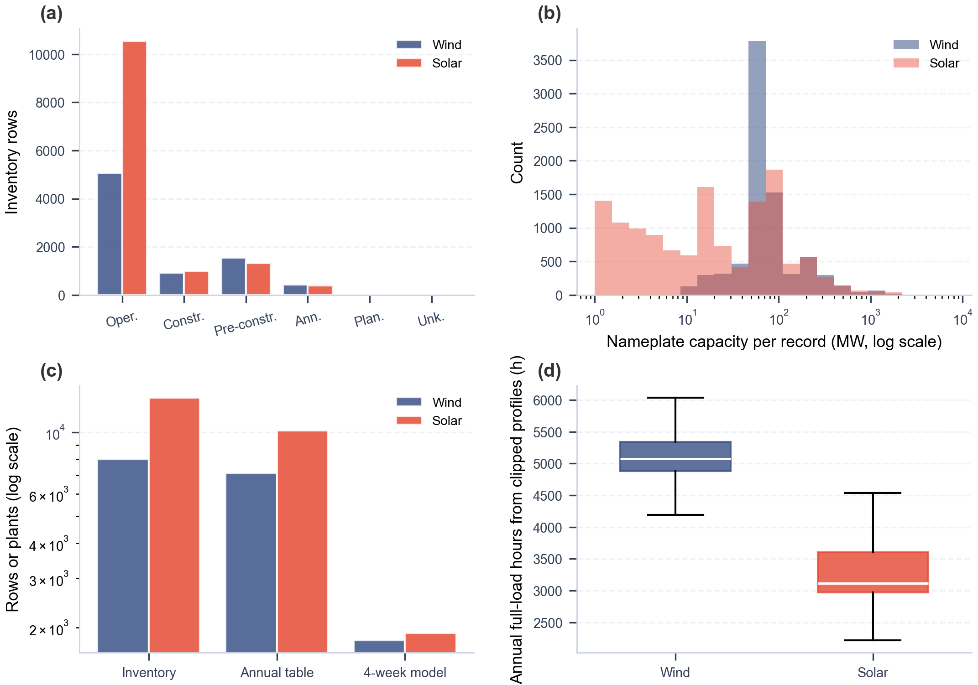
Figure S6. Renewable inventory descriptors and annual resource summaries.
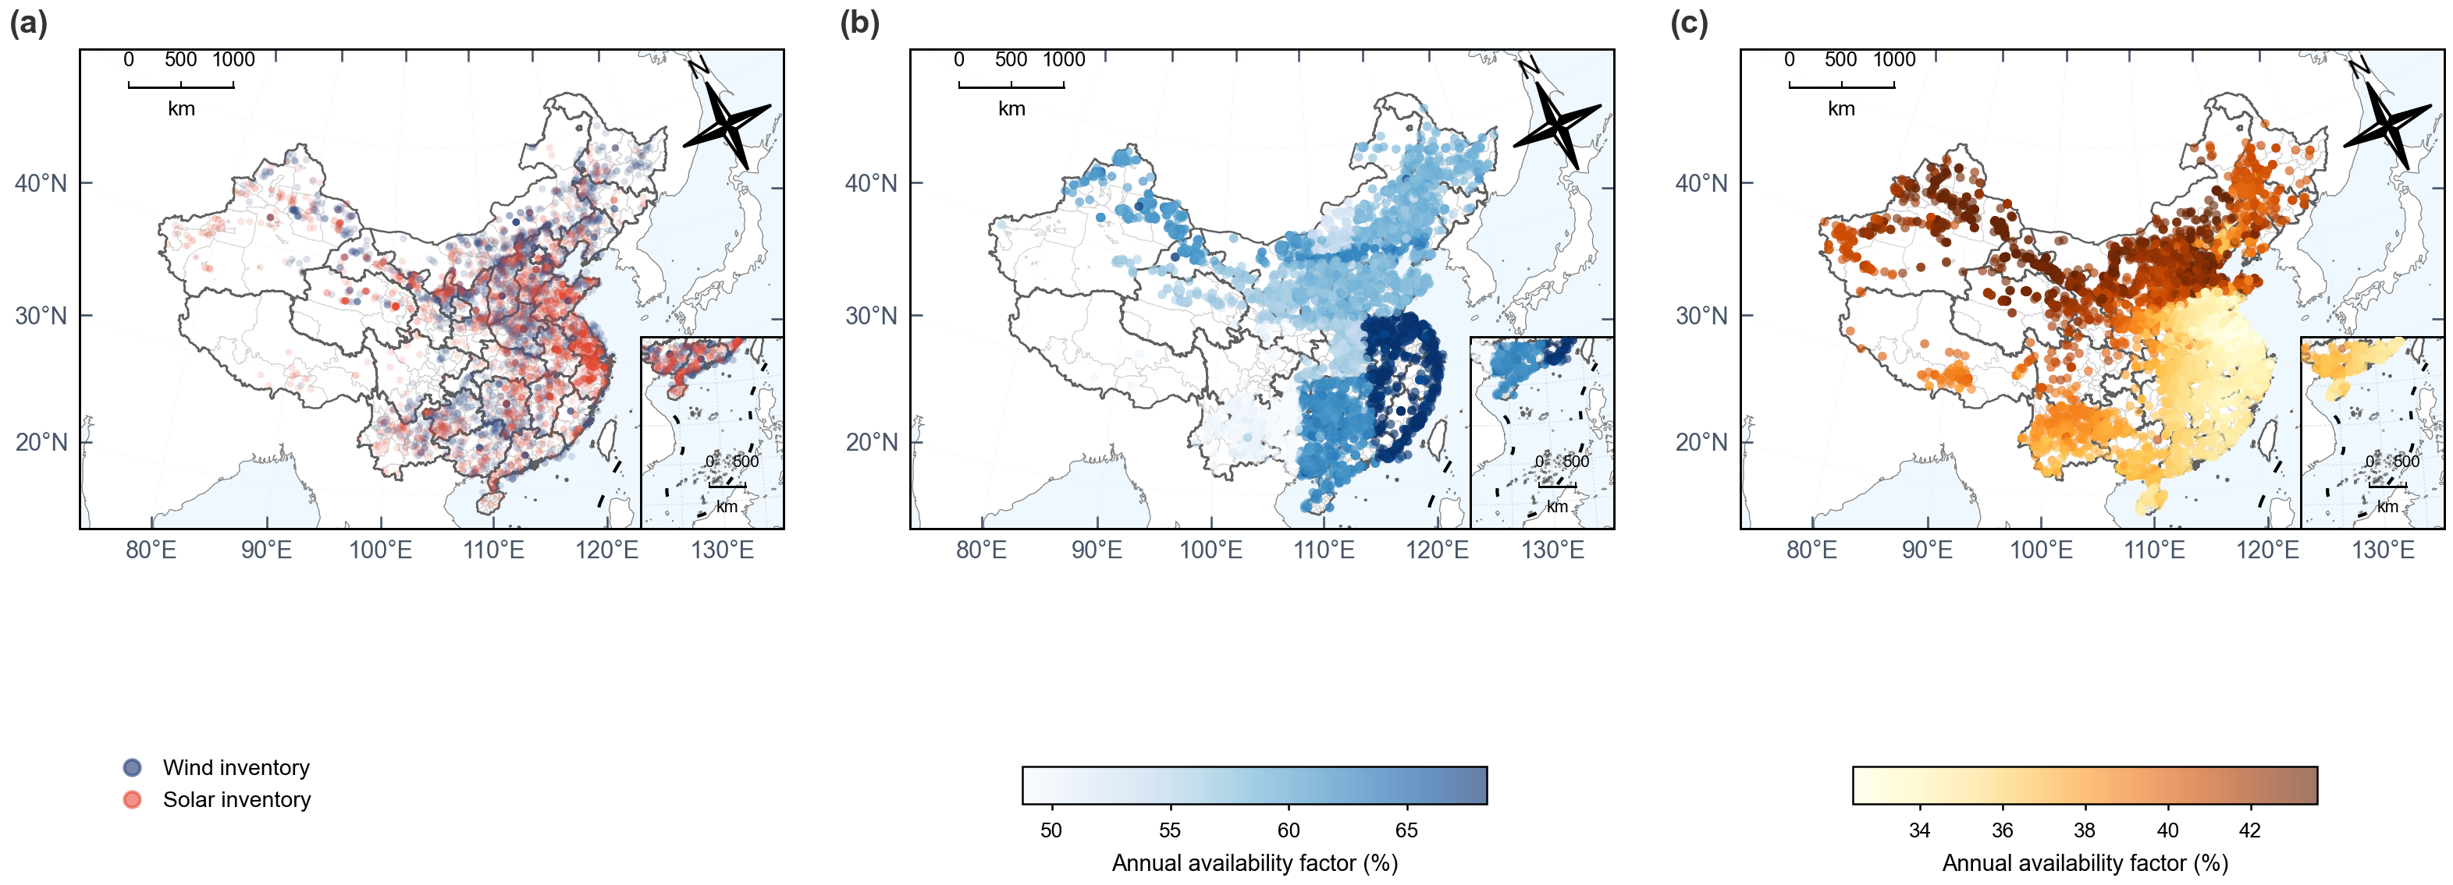
Figure S7. National renewable resource maps.
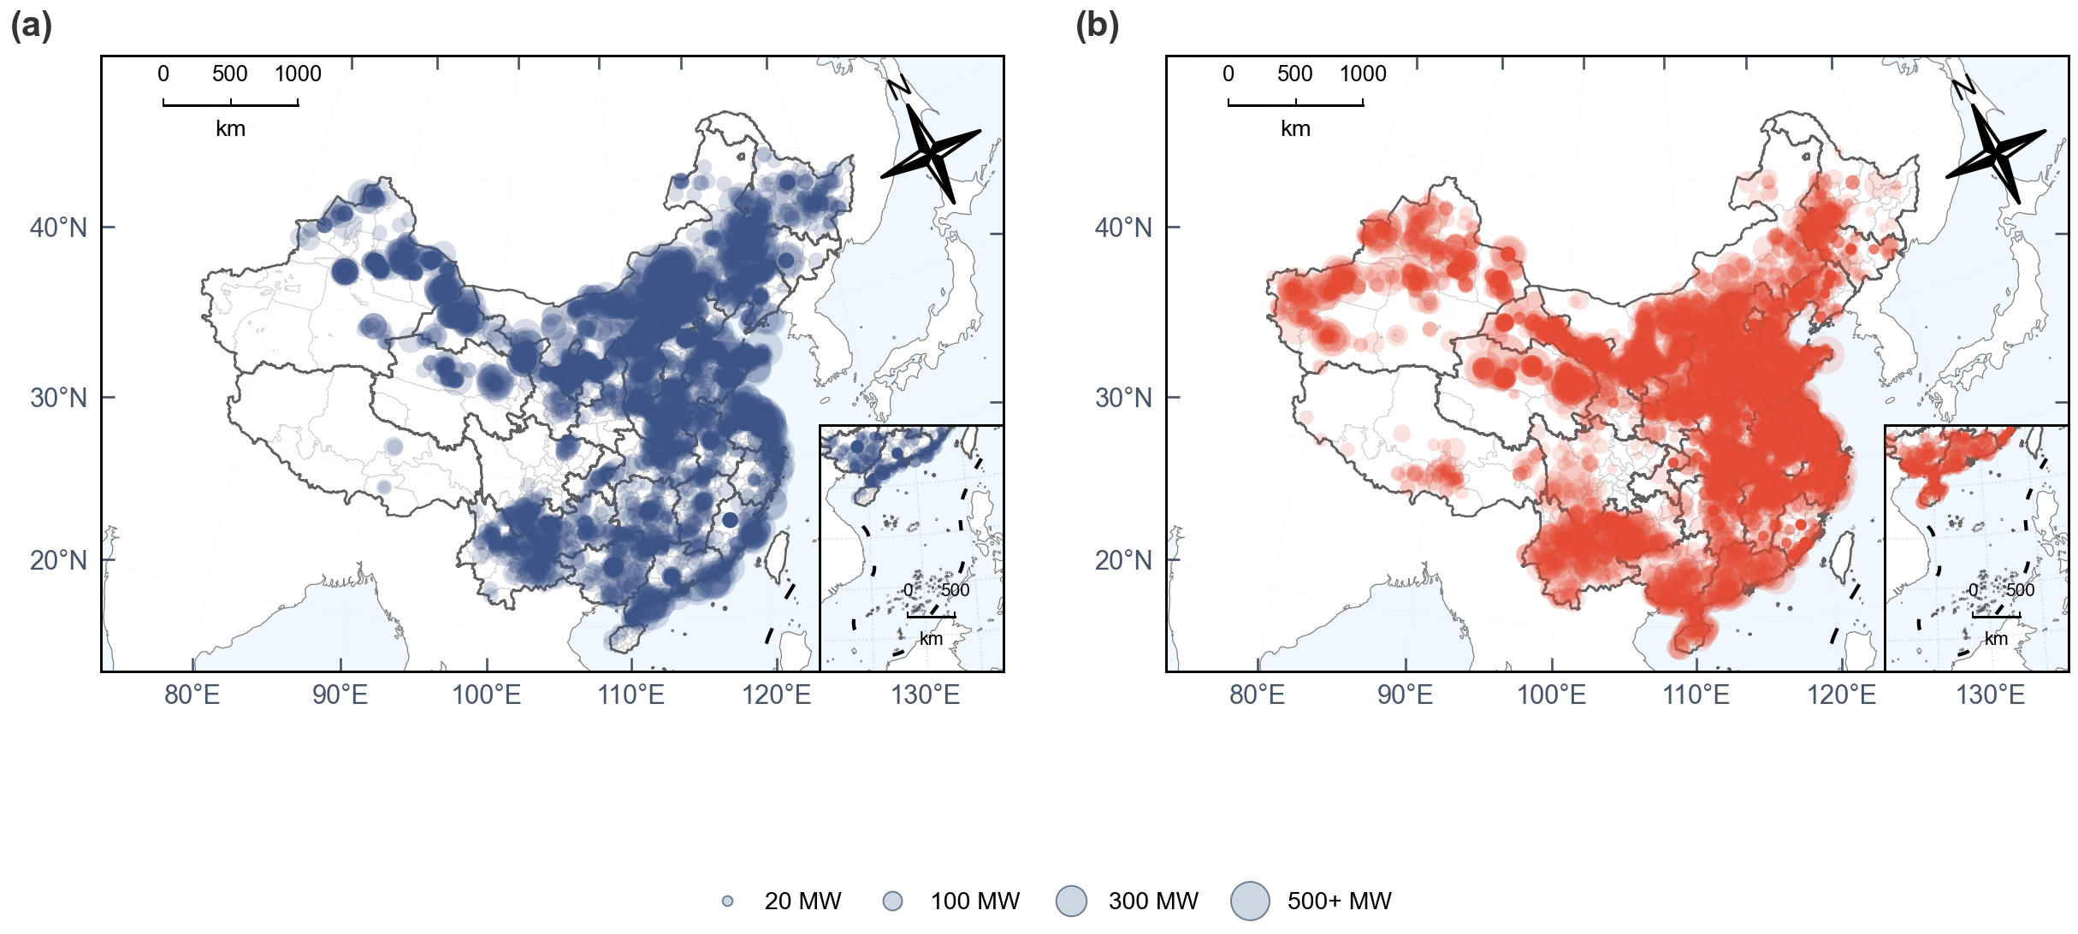
Figure S8. National operating renewable plant inventories used as spatial anchors for hourly renewable-power reconstruction.
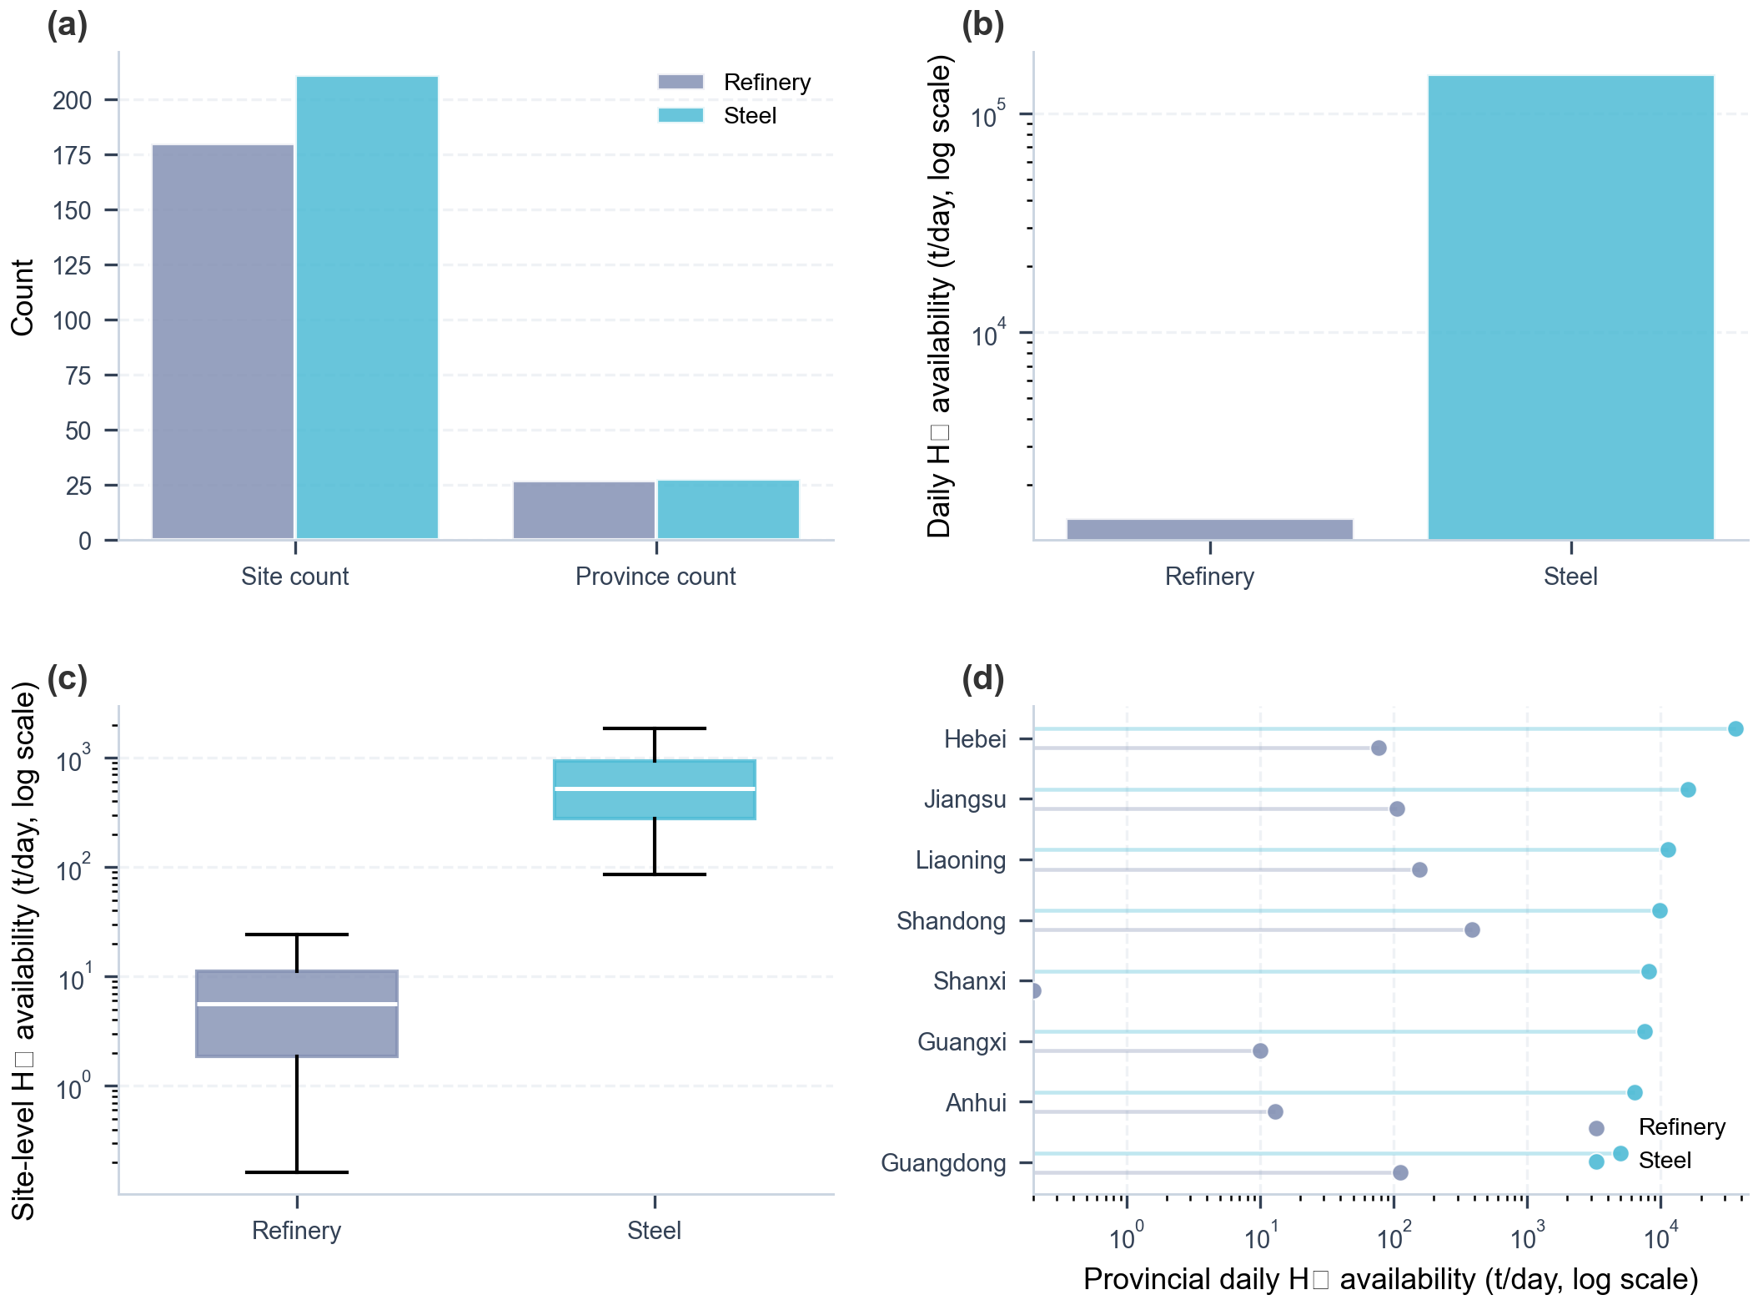
Figure S11. Industrial by-product hydrogen summary statistics.
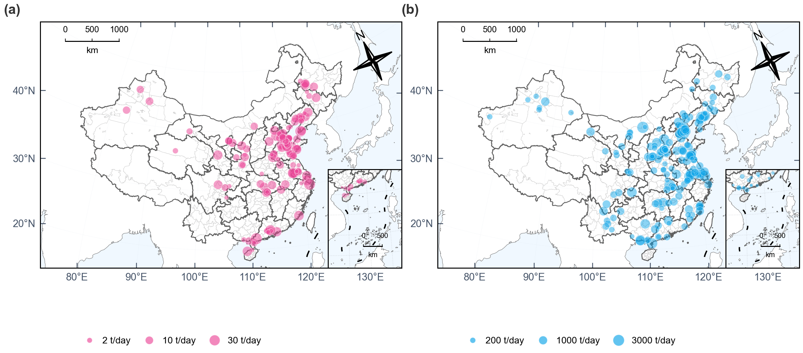
Figure S12. National maps of industrial by-product hydrogen sources.
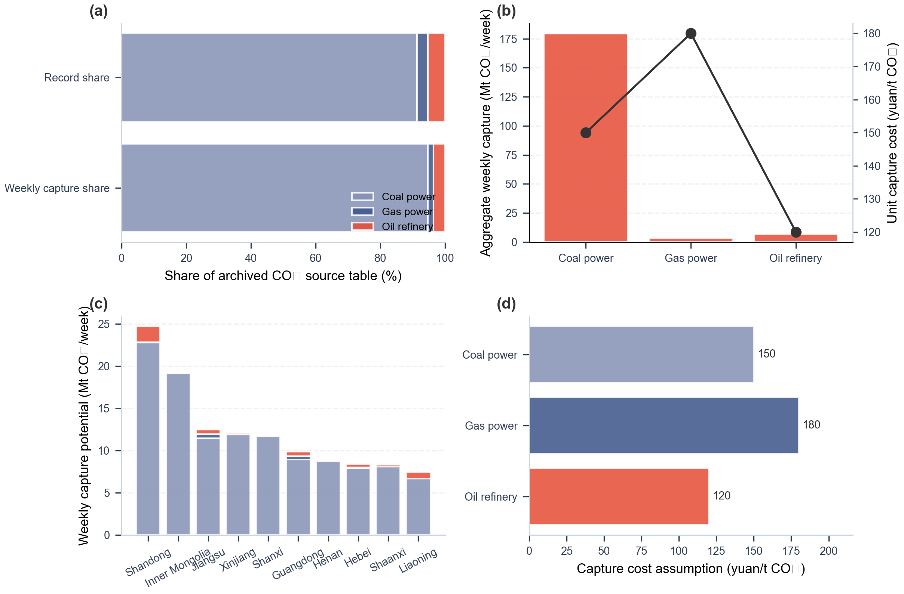
Figure S13. Industrial CO₂ capture-source summary statistics.
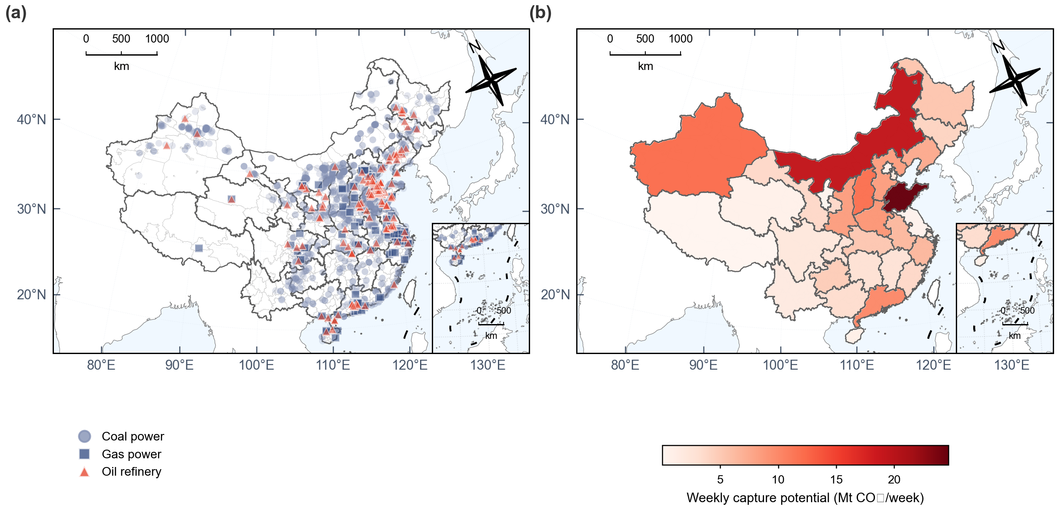
Figure S14. National maps of industrial CO₂ capture sources.
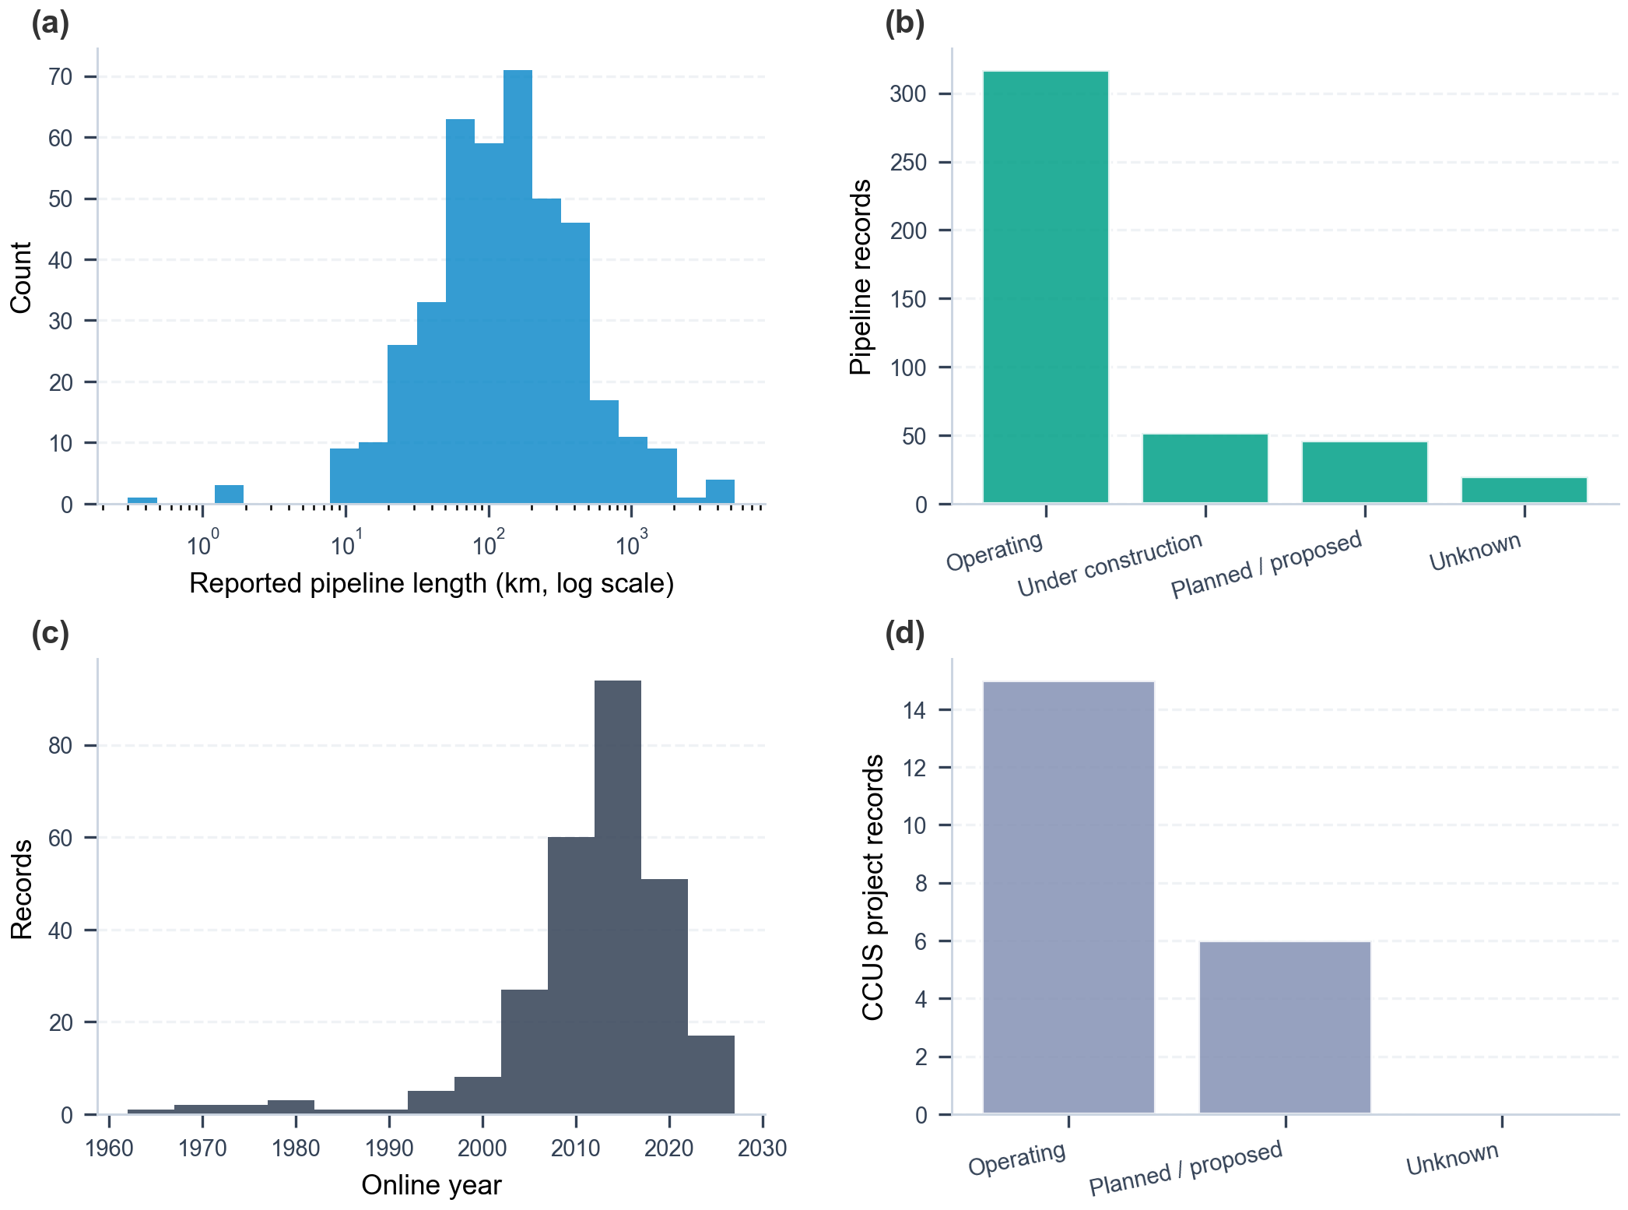
Figure S15. Transport-network and CCUS metadata summaries.
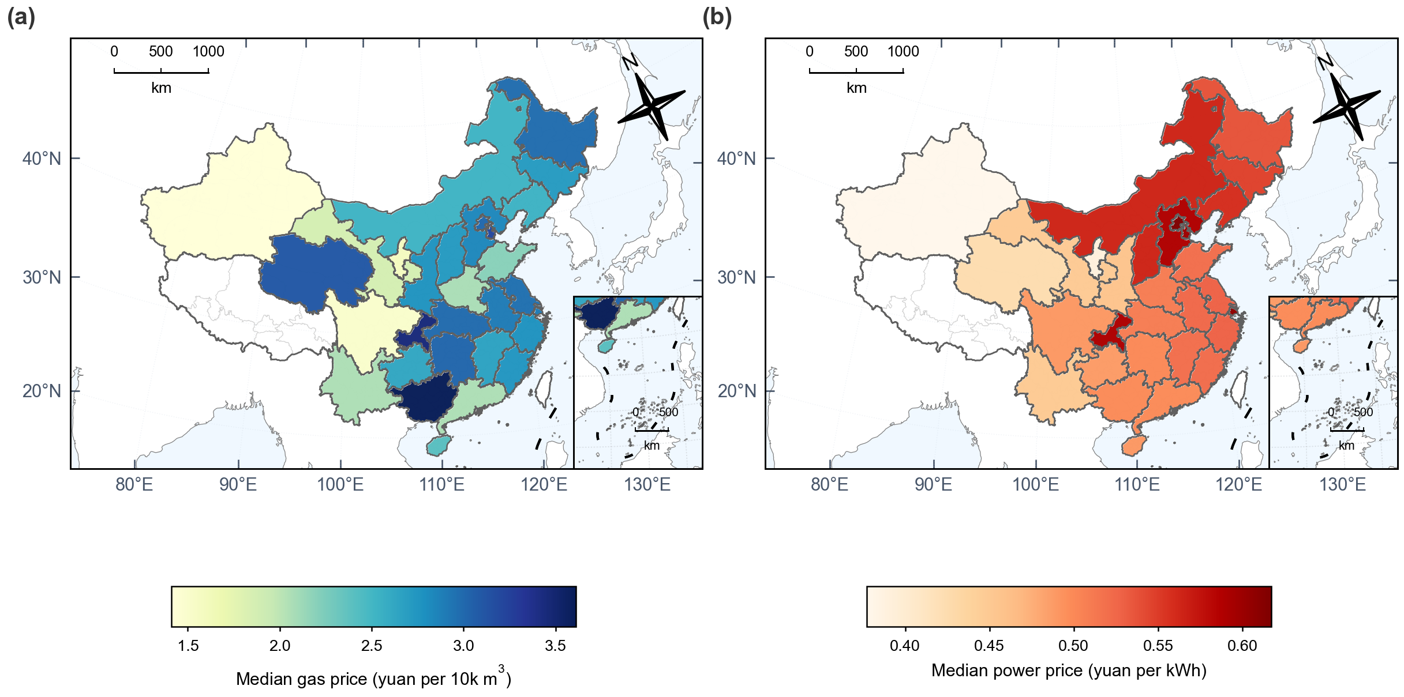
Figure S16. Province-level energy price maps.
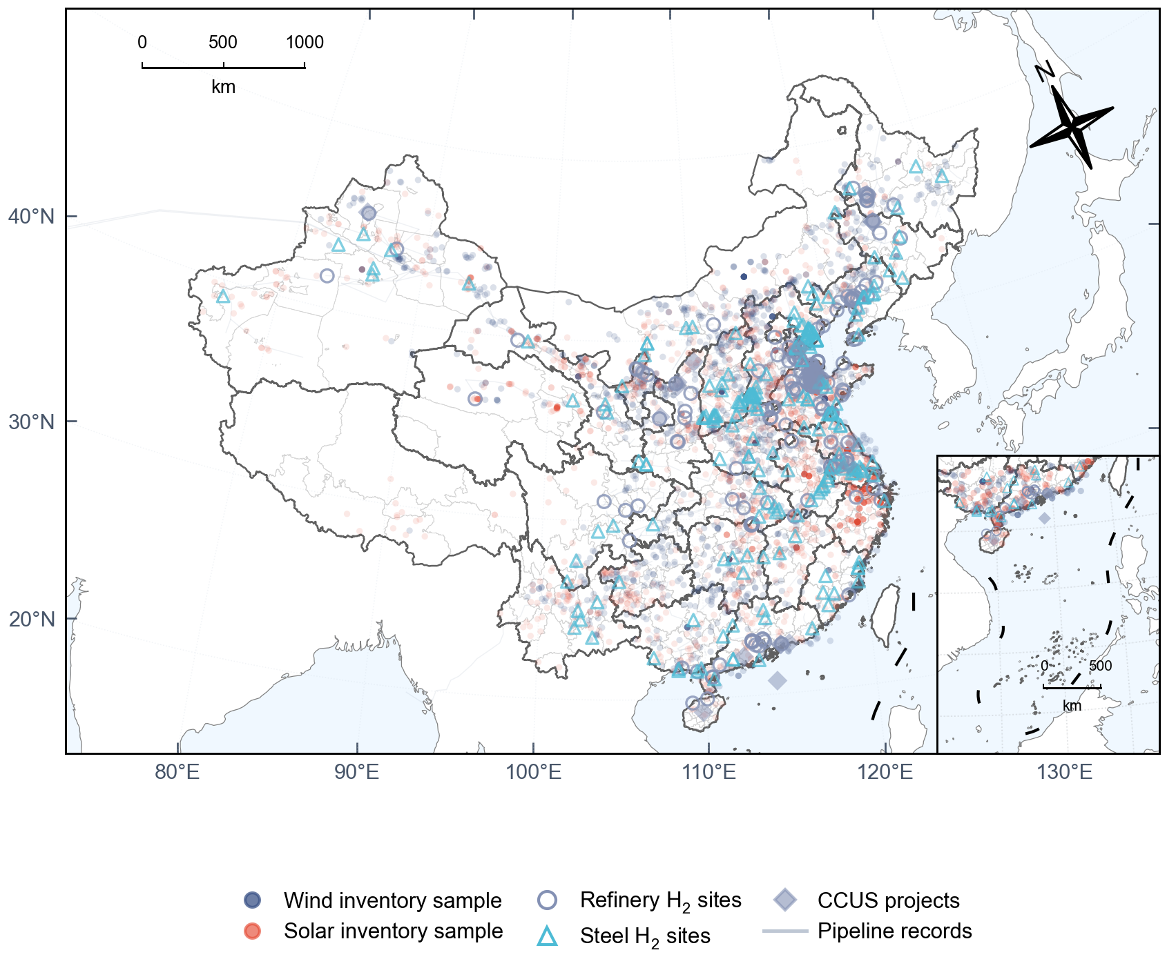
Figure S17. Repository-level national infrastructure overview.
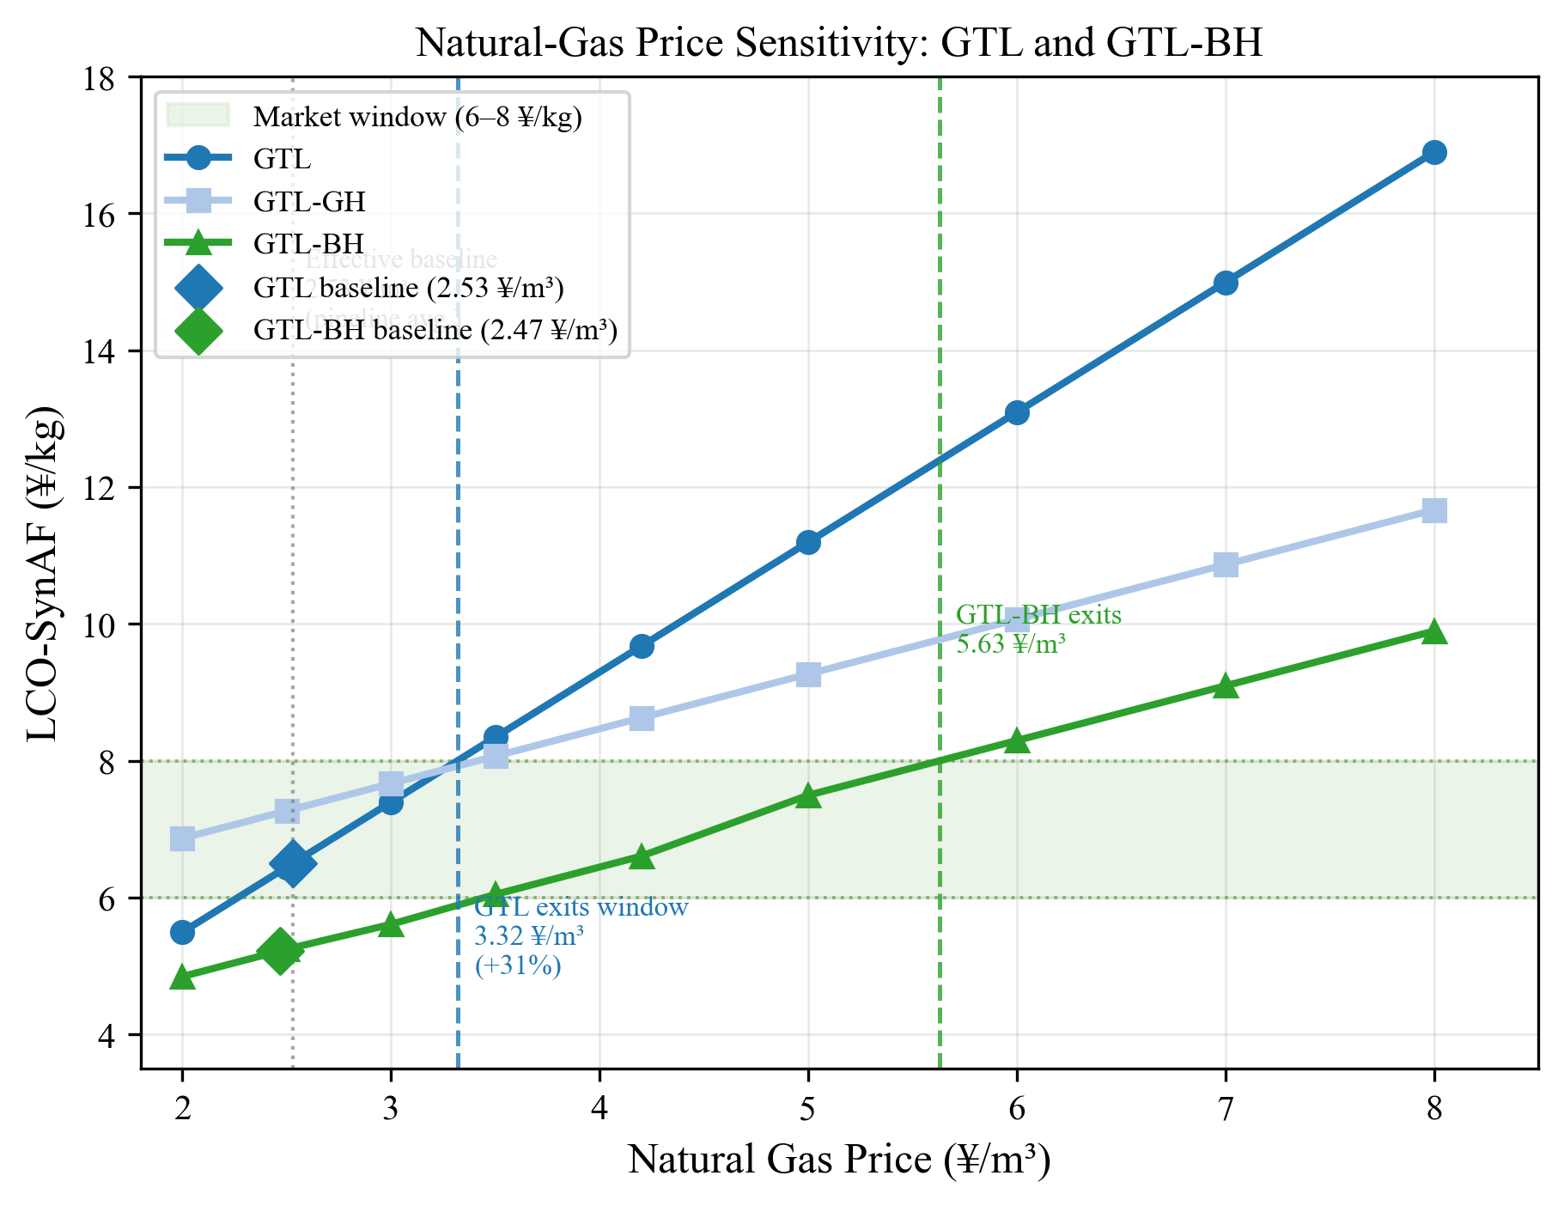
Figure S20. Natural-gas price sensitivity of GTL and GTL-BH. The shaded band marks the 6–8 yuan/kg market-price window.
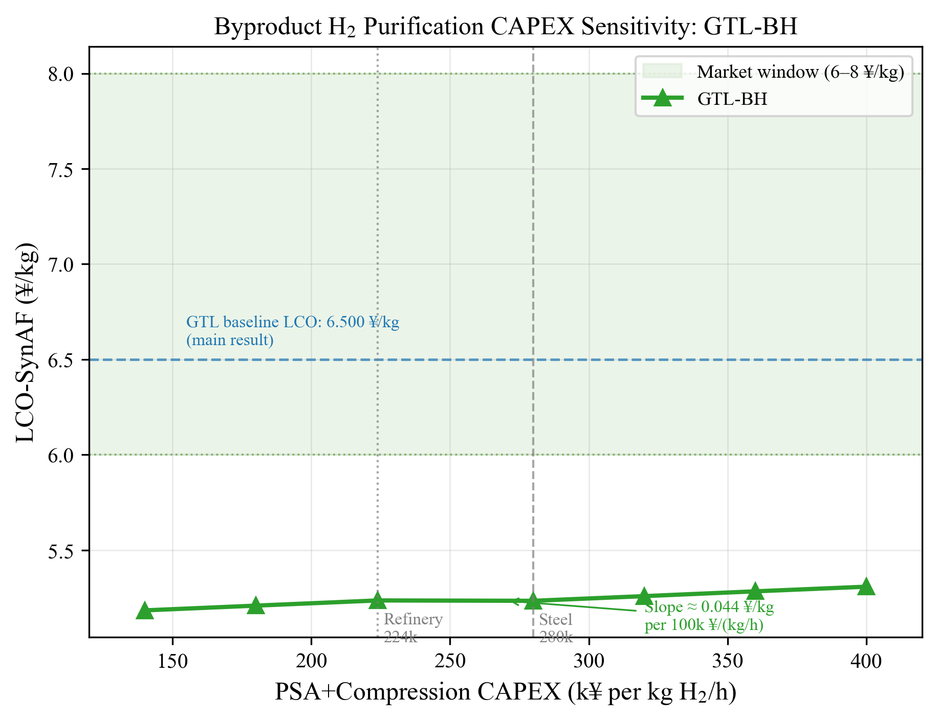
Figure S21. Byproduct hydrogen purification CAPEX sensitivity for GTL-BH. The panel shows LCO-SynAF (yuan/kg) as a function of PSA-plus-compression equipment CAPEX [yuan per kg H₂/h of capacity]. The shaded horizontal band marks the 6–8 yuan/kg market-price window. The vertical dashed lines mark the archived baseline values for steel-mill (280,000) and refinery (224,000) sites. No cost crossover with GTL occurs within the surveyed range.
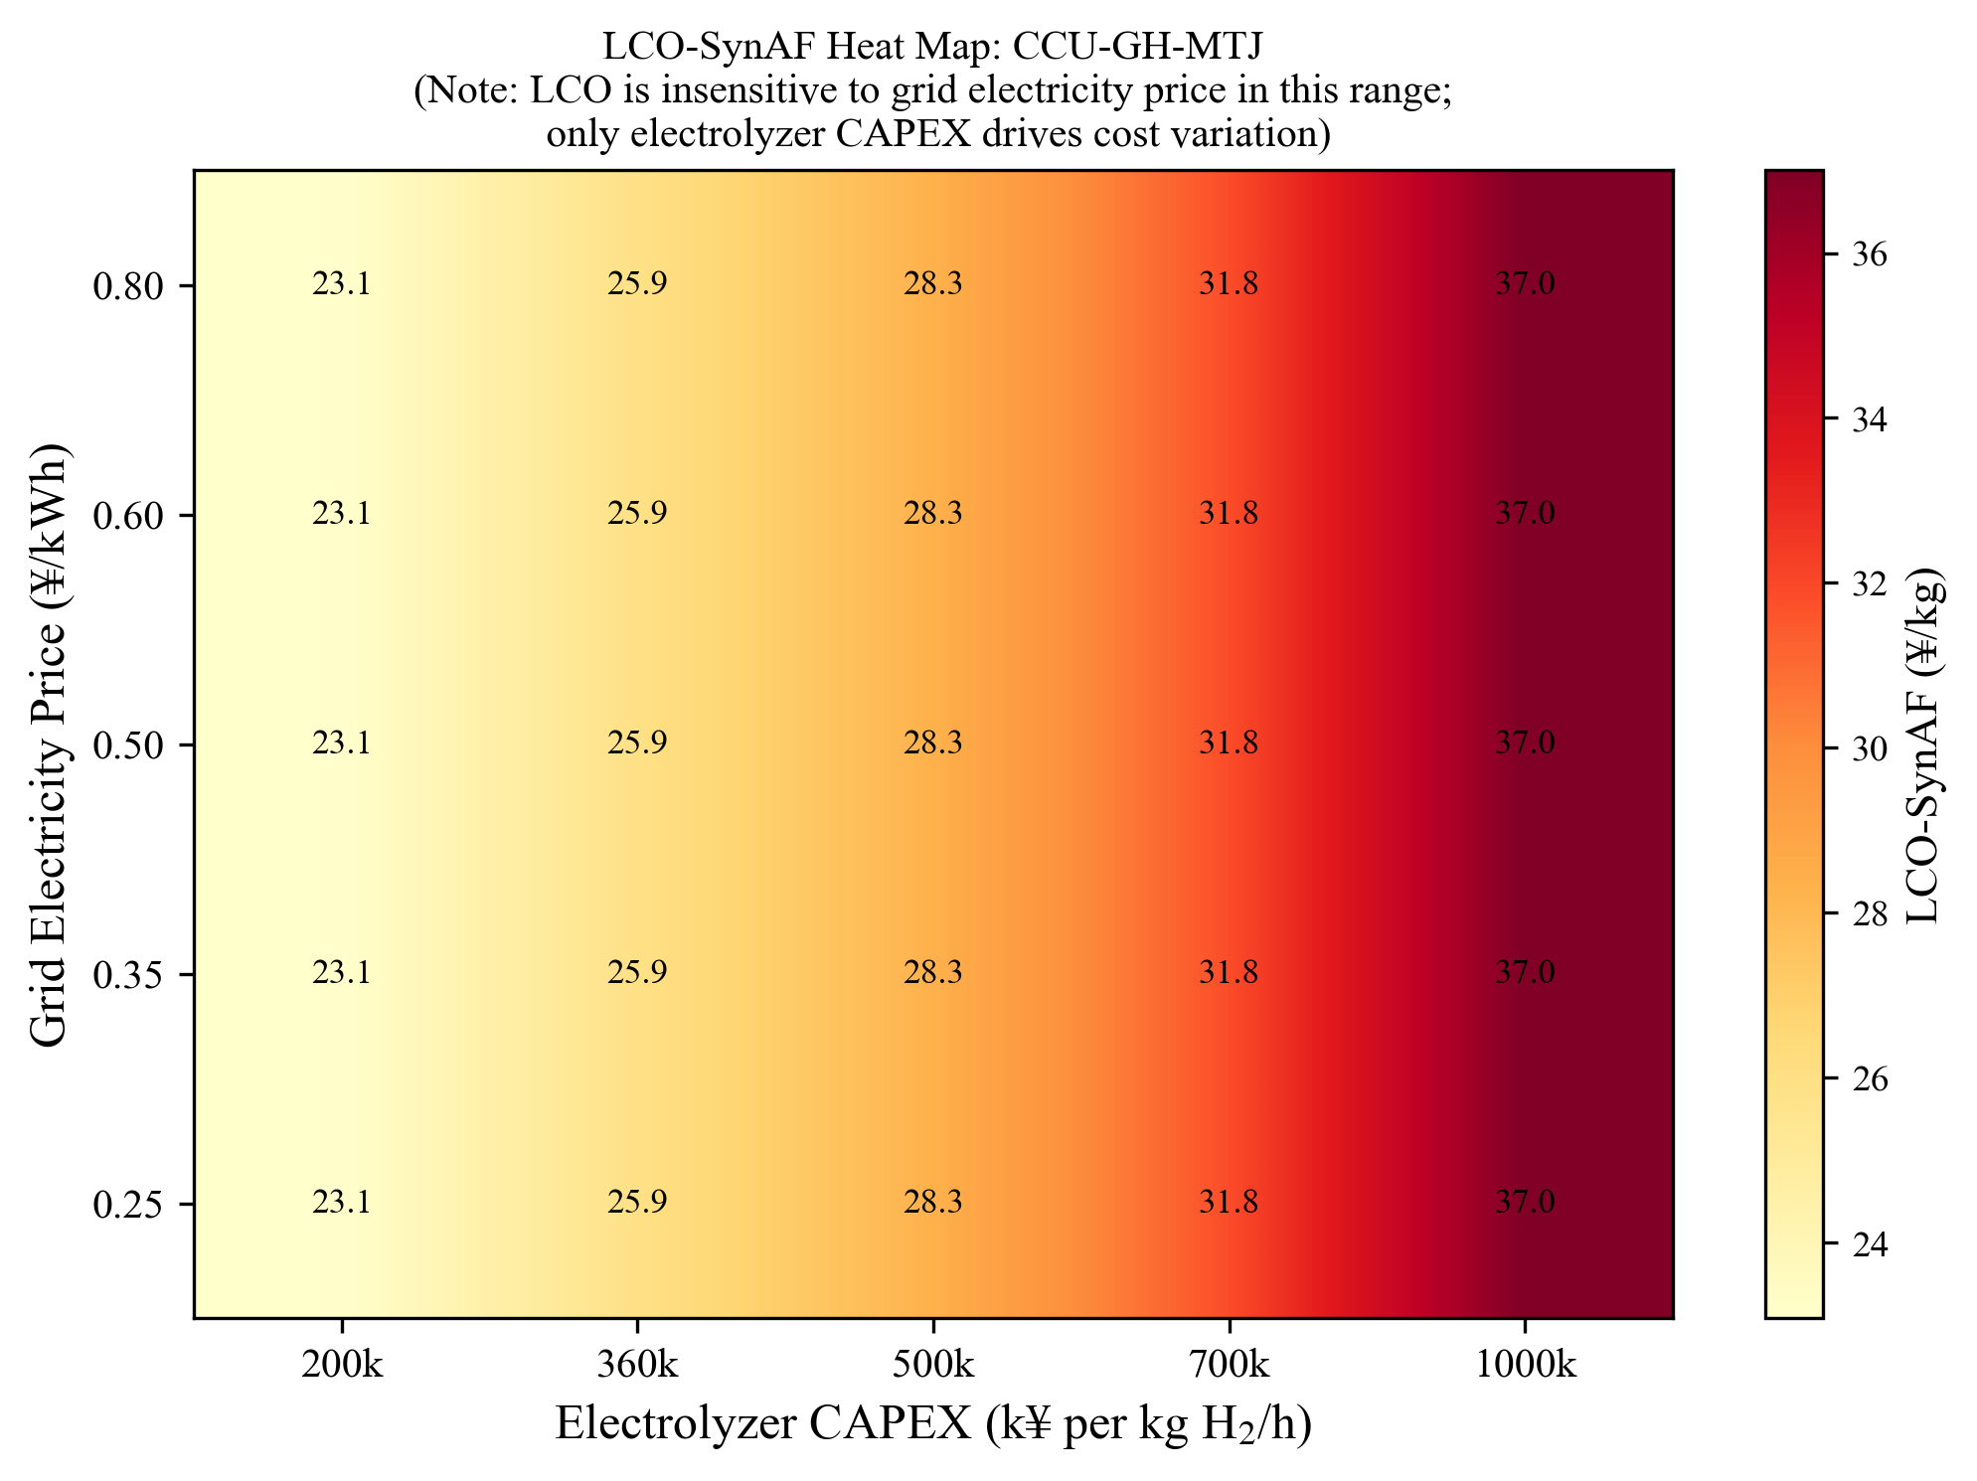
Figure S22. Joint sensitivity of CCU-GH-MTJ LCO-SynAF to electricity price and electrolyzer capital cost. Colour encodes LCO-SynAF (yuan/kg). LCO ranges from approximately 23.1 to 37.0 yuan/kg and is driven entirely by electrolyzer CAPEX; grid electricity price has no discernible effect. The 8 yuan/kg market threshold is not reached within the surveyed space.
Figure S23. DAC unit cost versus LCO-SynAF for the DAC-GH-FT pathway. The horizontal dashed line marks the 8 yuan/kg market-window upper bound. The vertical dashed line at the intersection marks the break-even DAC cost. The IEA 2030 target is annotated for reference. [Figure to be populated from batch runs.]
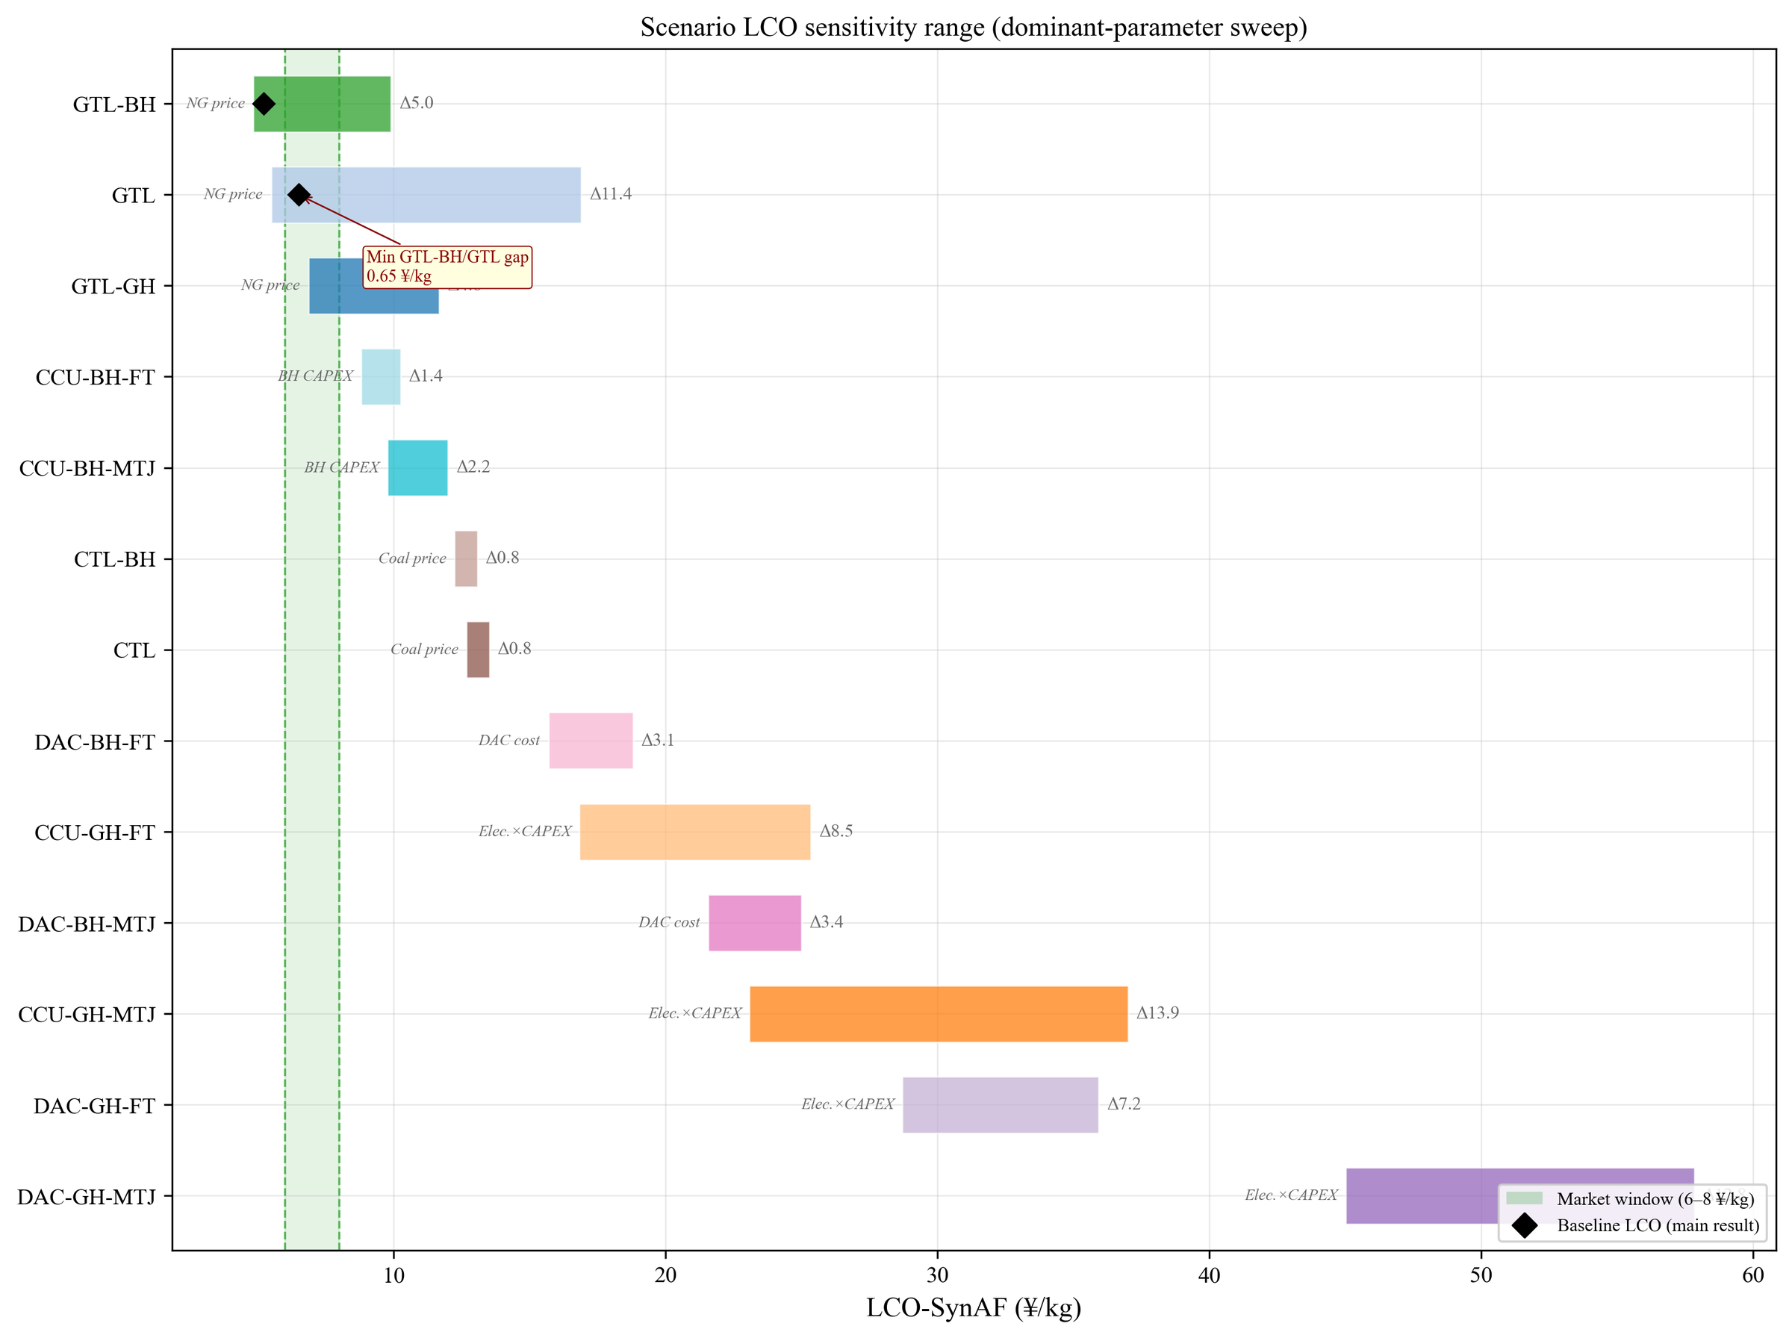
Figure S24. Cross-scenario LCO-SynAF sensitivity range chart for all 13 archived pathways. Each bar spans the minimum-to-maximum LCO-SynAF range produced by varying the dominant cost driver for that pathway. The shaded green band marks the 6–8 yuan/kg market-price window.
Figure S26. Additional pathway-efficiency and deployability comparisons.
Figure S36. Cost–emission decomposition for pathway CTL: polar stacked-area learning-curve trajectory (2026–2036), with stacked cost categories and outer carbon-intensity ring.
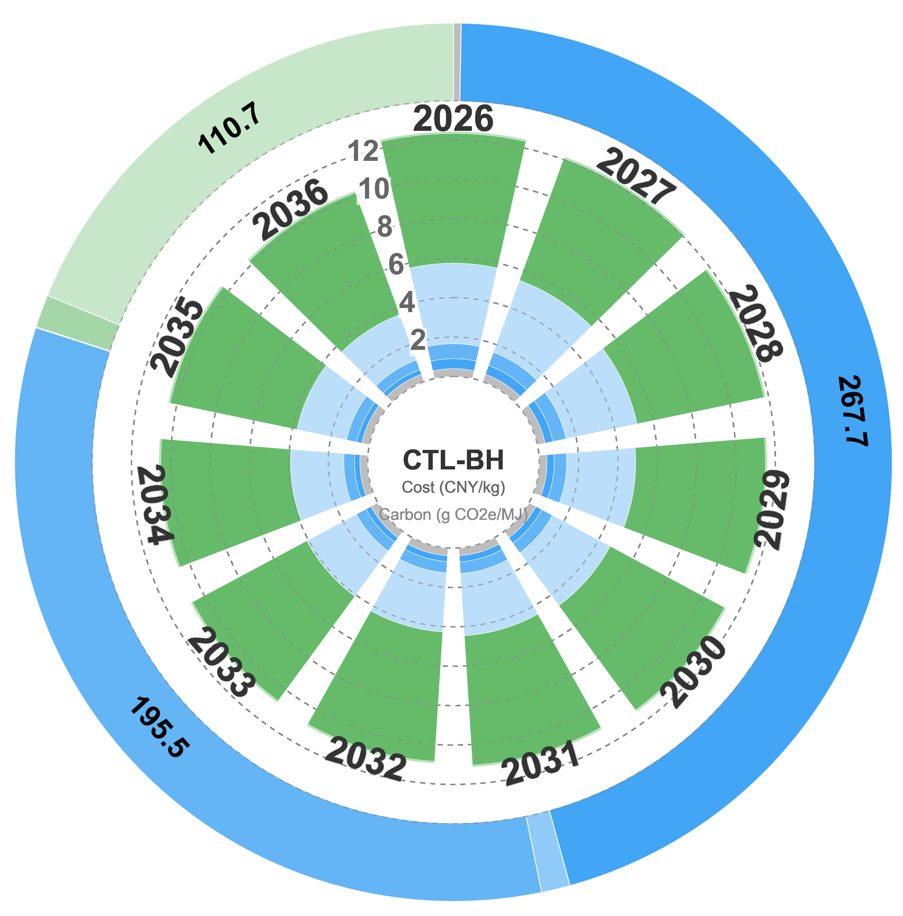
Figure S37. Cost–emission decomposition for pathway CTL-BH: polar stacked-area learning-curve trajectory (2026–2036), with stacked cost categories and outer carbon-intensity ring.
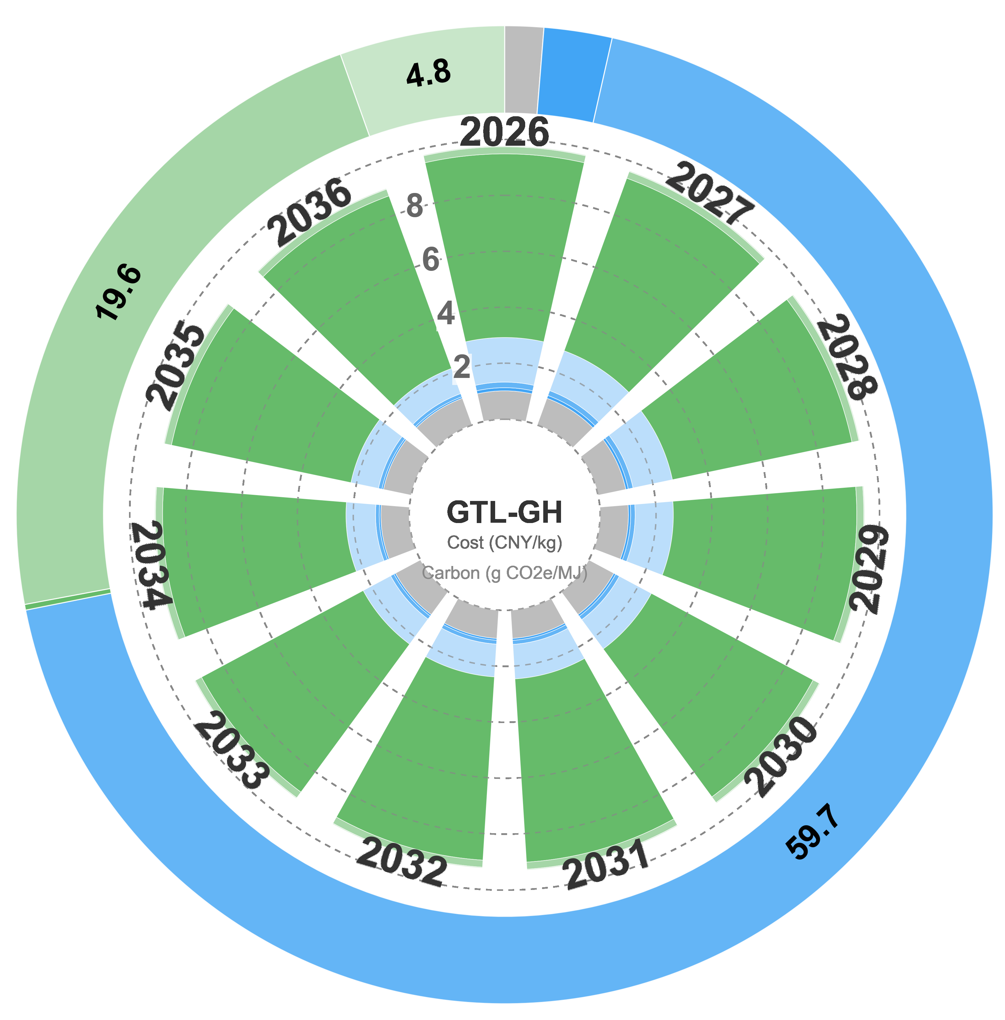
Figure S38. Cost–emission decomposition for pathway GTL-GH: polar stacked-area learning-curve trajectory (2026–2036), with stacked cost categories and outer carbon-intensity ring.
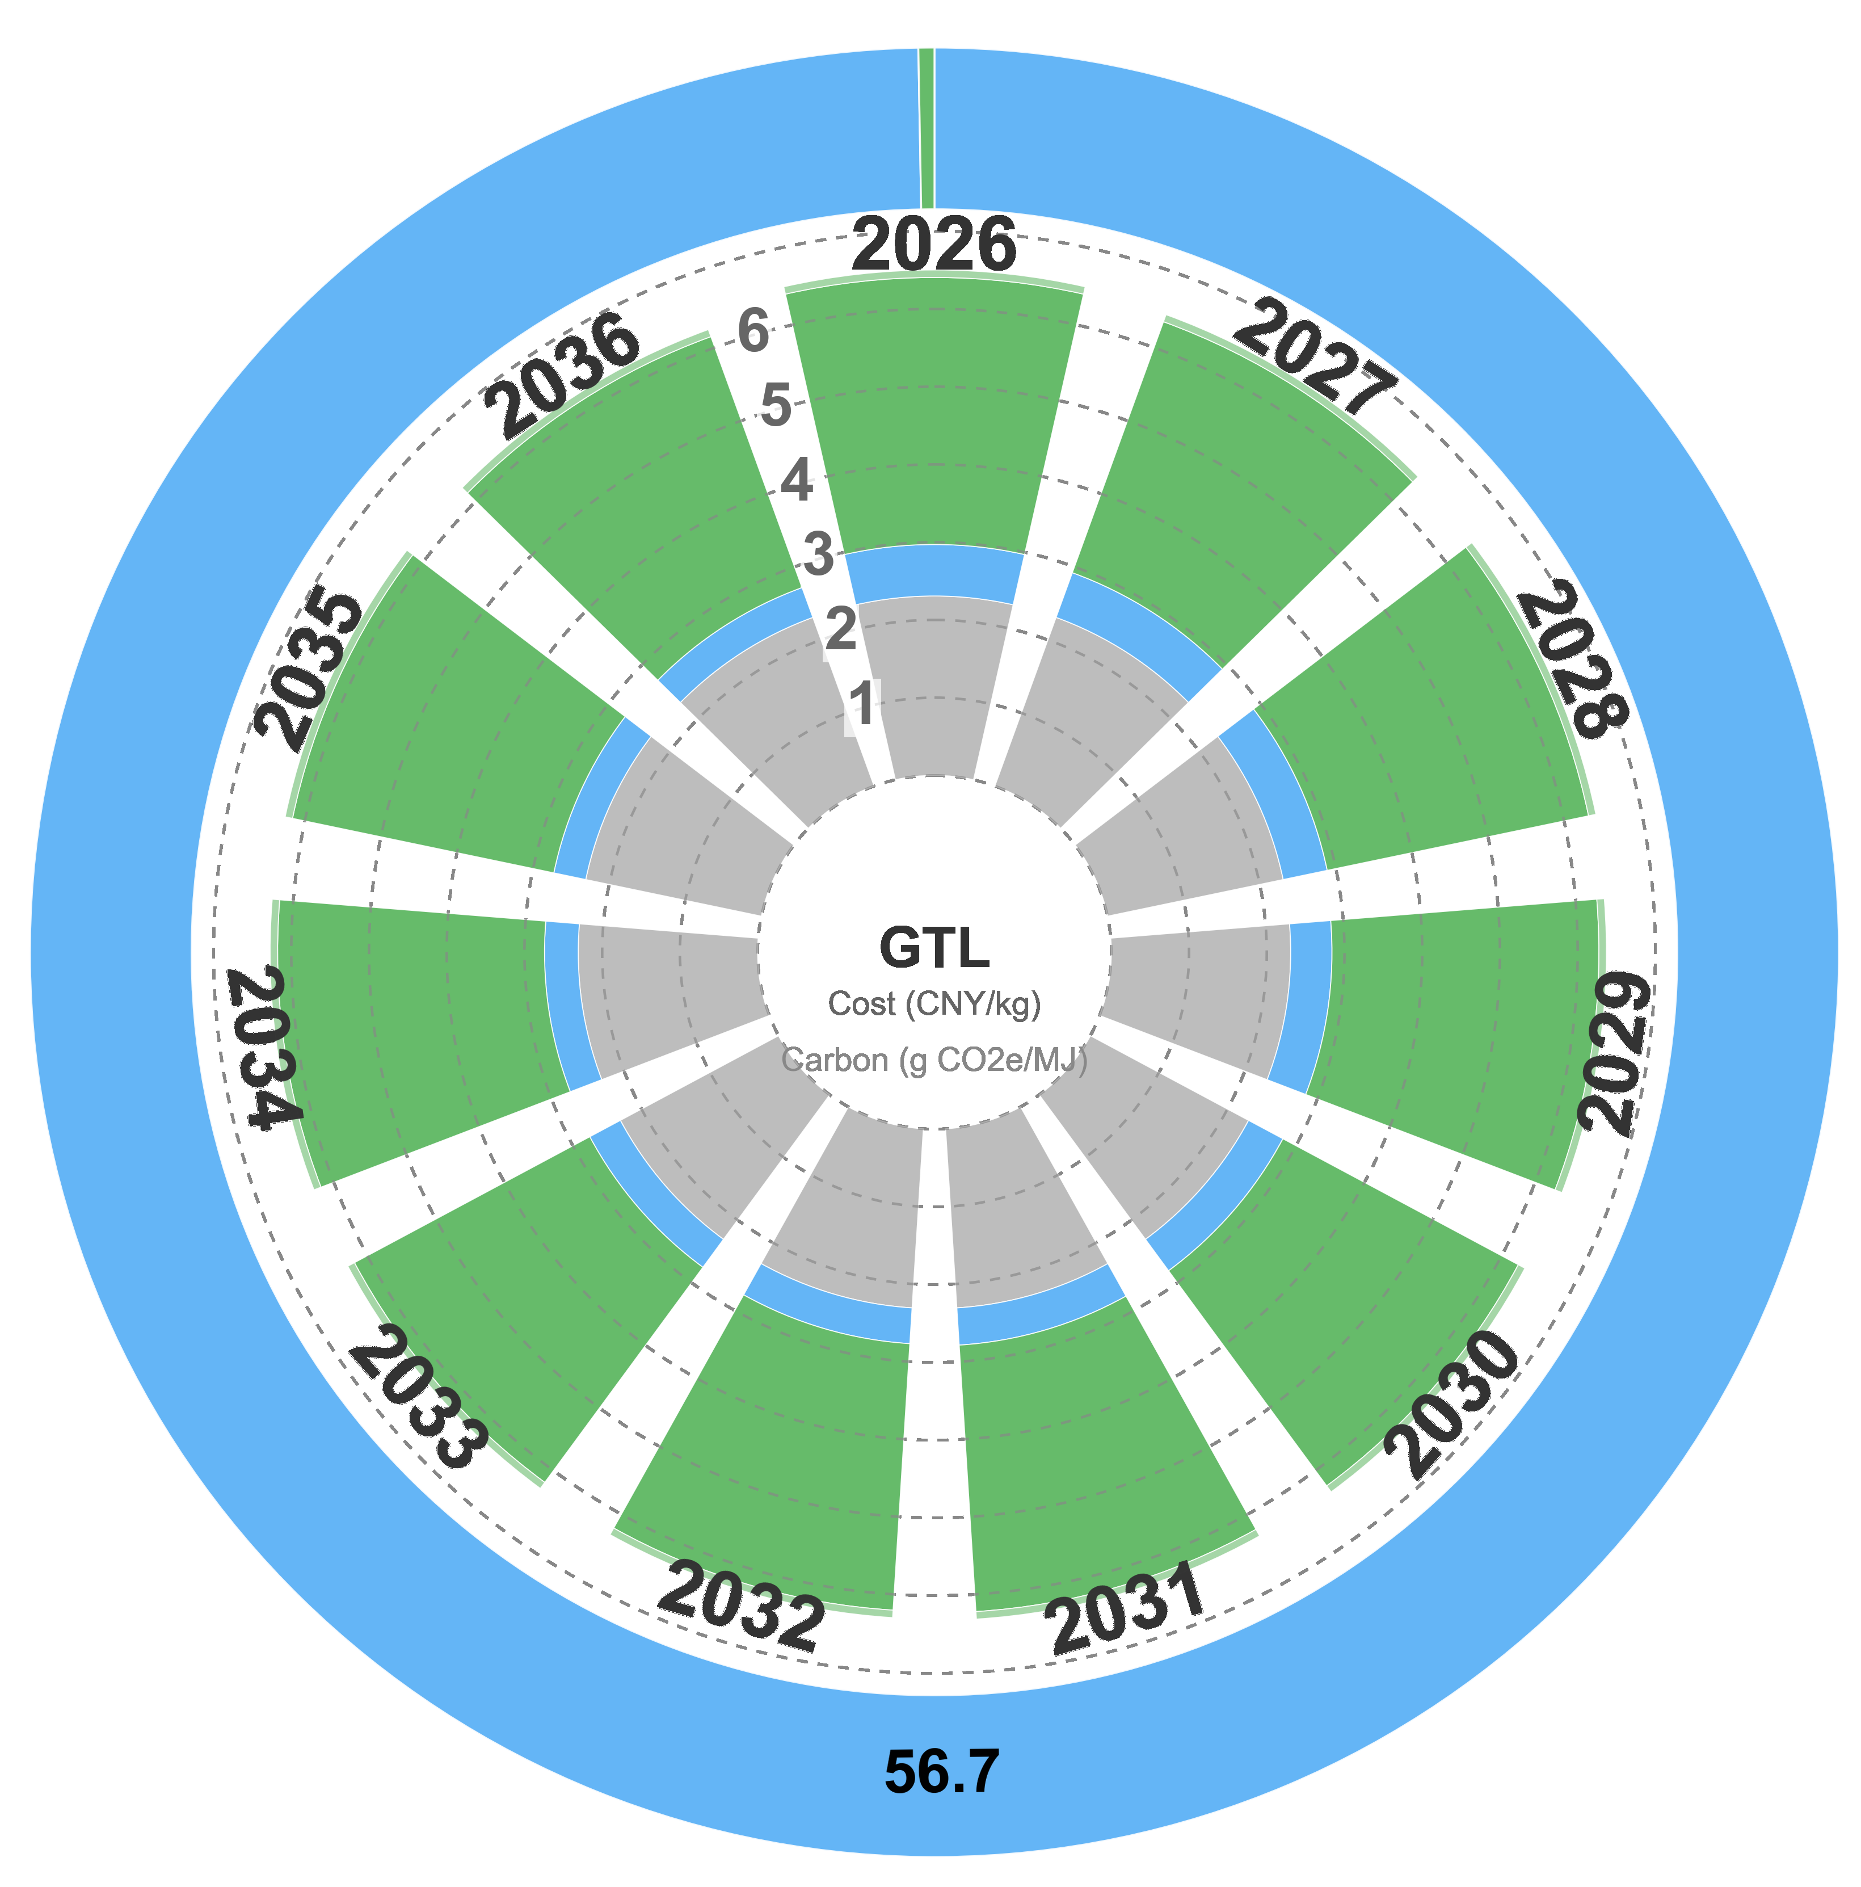
Figure S39. Cost–emission decomposition for pathway GTL: polar stacked-area learning-curve trajectory (2026–2036), with stacked cost categories and outer carbon-intensity ring.
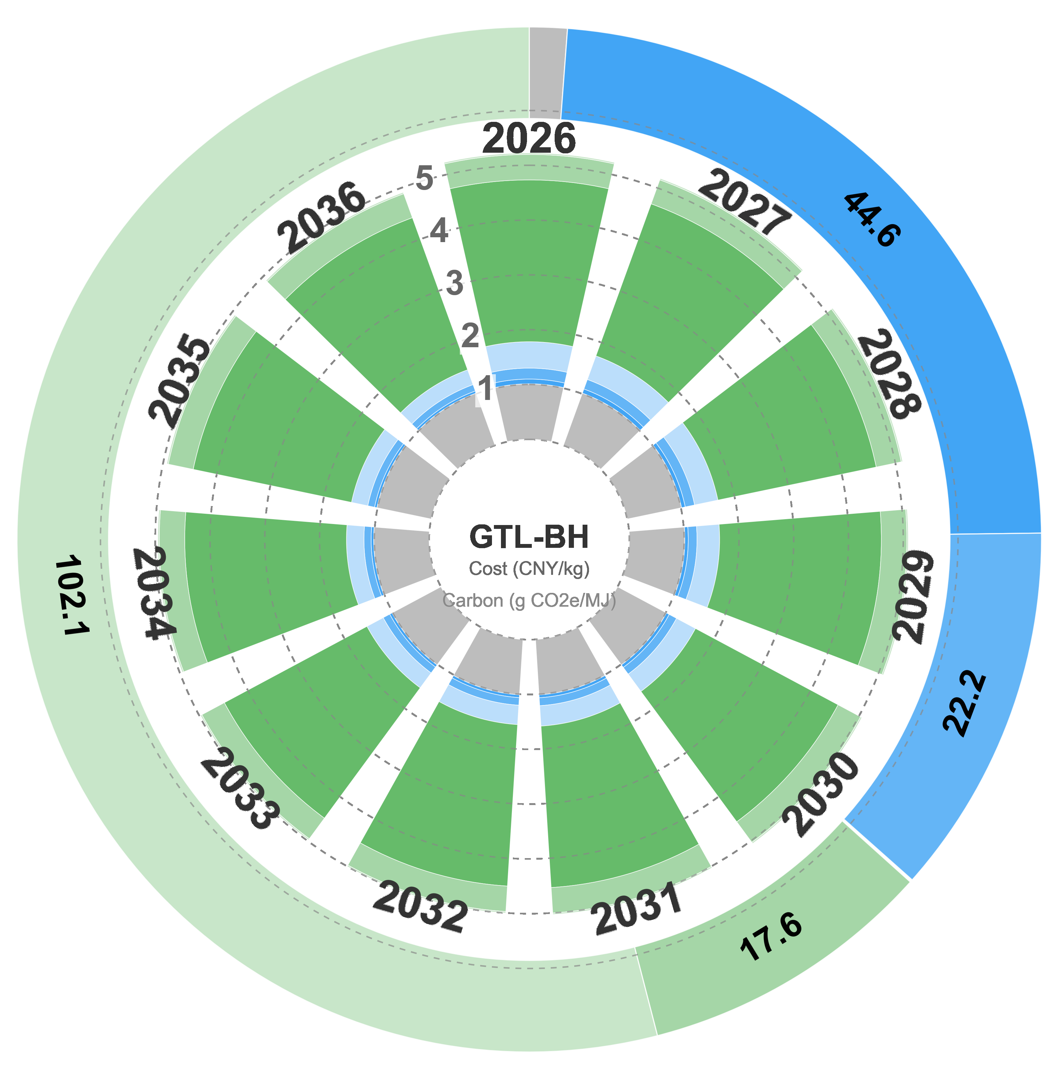
Figure S40. Cost–emission decomposition for pathway GTL-BH: polar stacked-area learning-curve trajectory (2026–2036), with stacked cost categories and outer carbon-intensity ring.
Figure S41. Cost–emission decomposition for pathway CCU-GH-MTJ: polar stacked-area learning-curve trajectory (2026–2036), with stacked cost categories and outer carbon-intensity ring.
Figure S42. Cost–emission decomposition for pathway CCU-GH-FT: polar stacked-area learning-curve trajectory (2026–2036), with stacked cost categories and outer carbon-intensity ring.
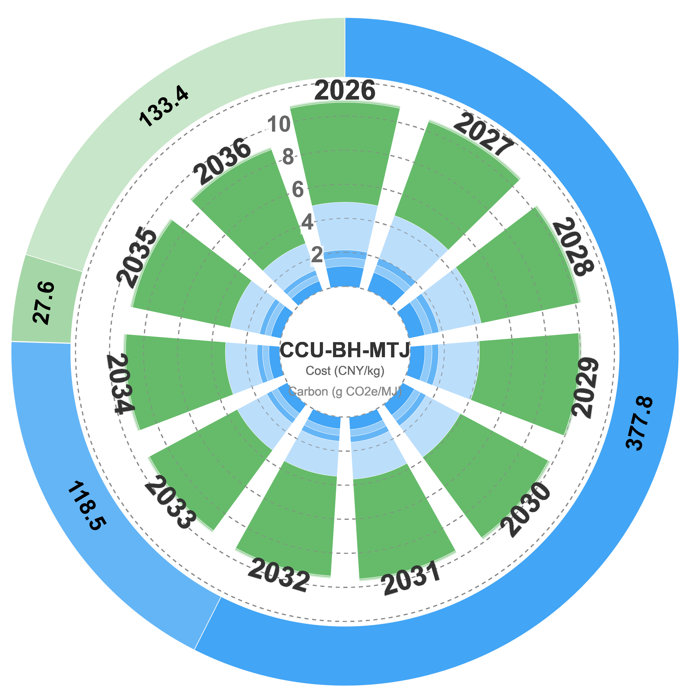
Figure S43. Cost–emission decomposition for pathway CCU-BH-MTJ: polar stacked-area learning-curve trajectory (2026–2036), with stacked cost categories and outer carbon-intensity ring.
Figure S44. Cost–emission decomposition for pathway CCU-BH-FT: polar stacked-area learning-curve trajectory (2026–2036), with stacked cost categories and outer carbon-intensity ring.
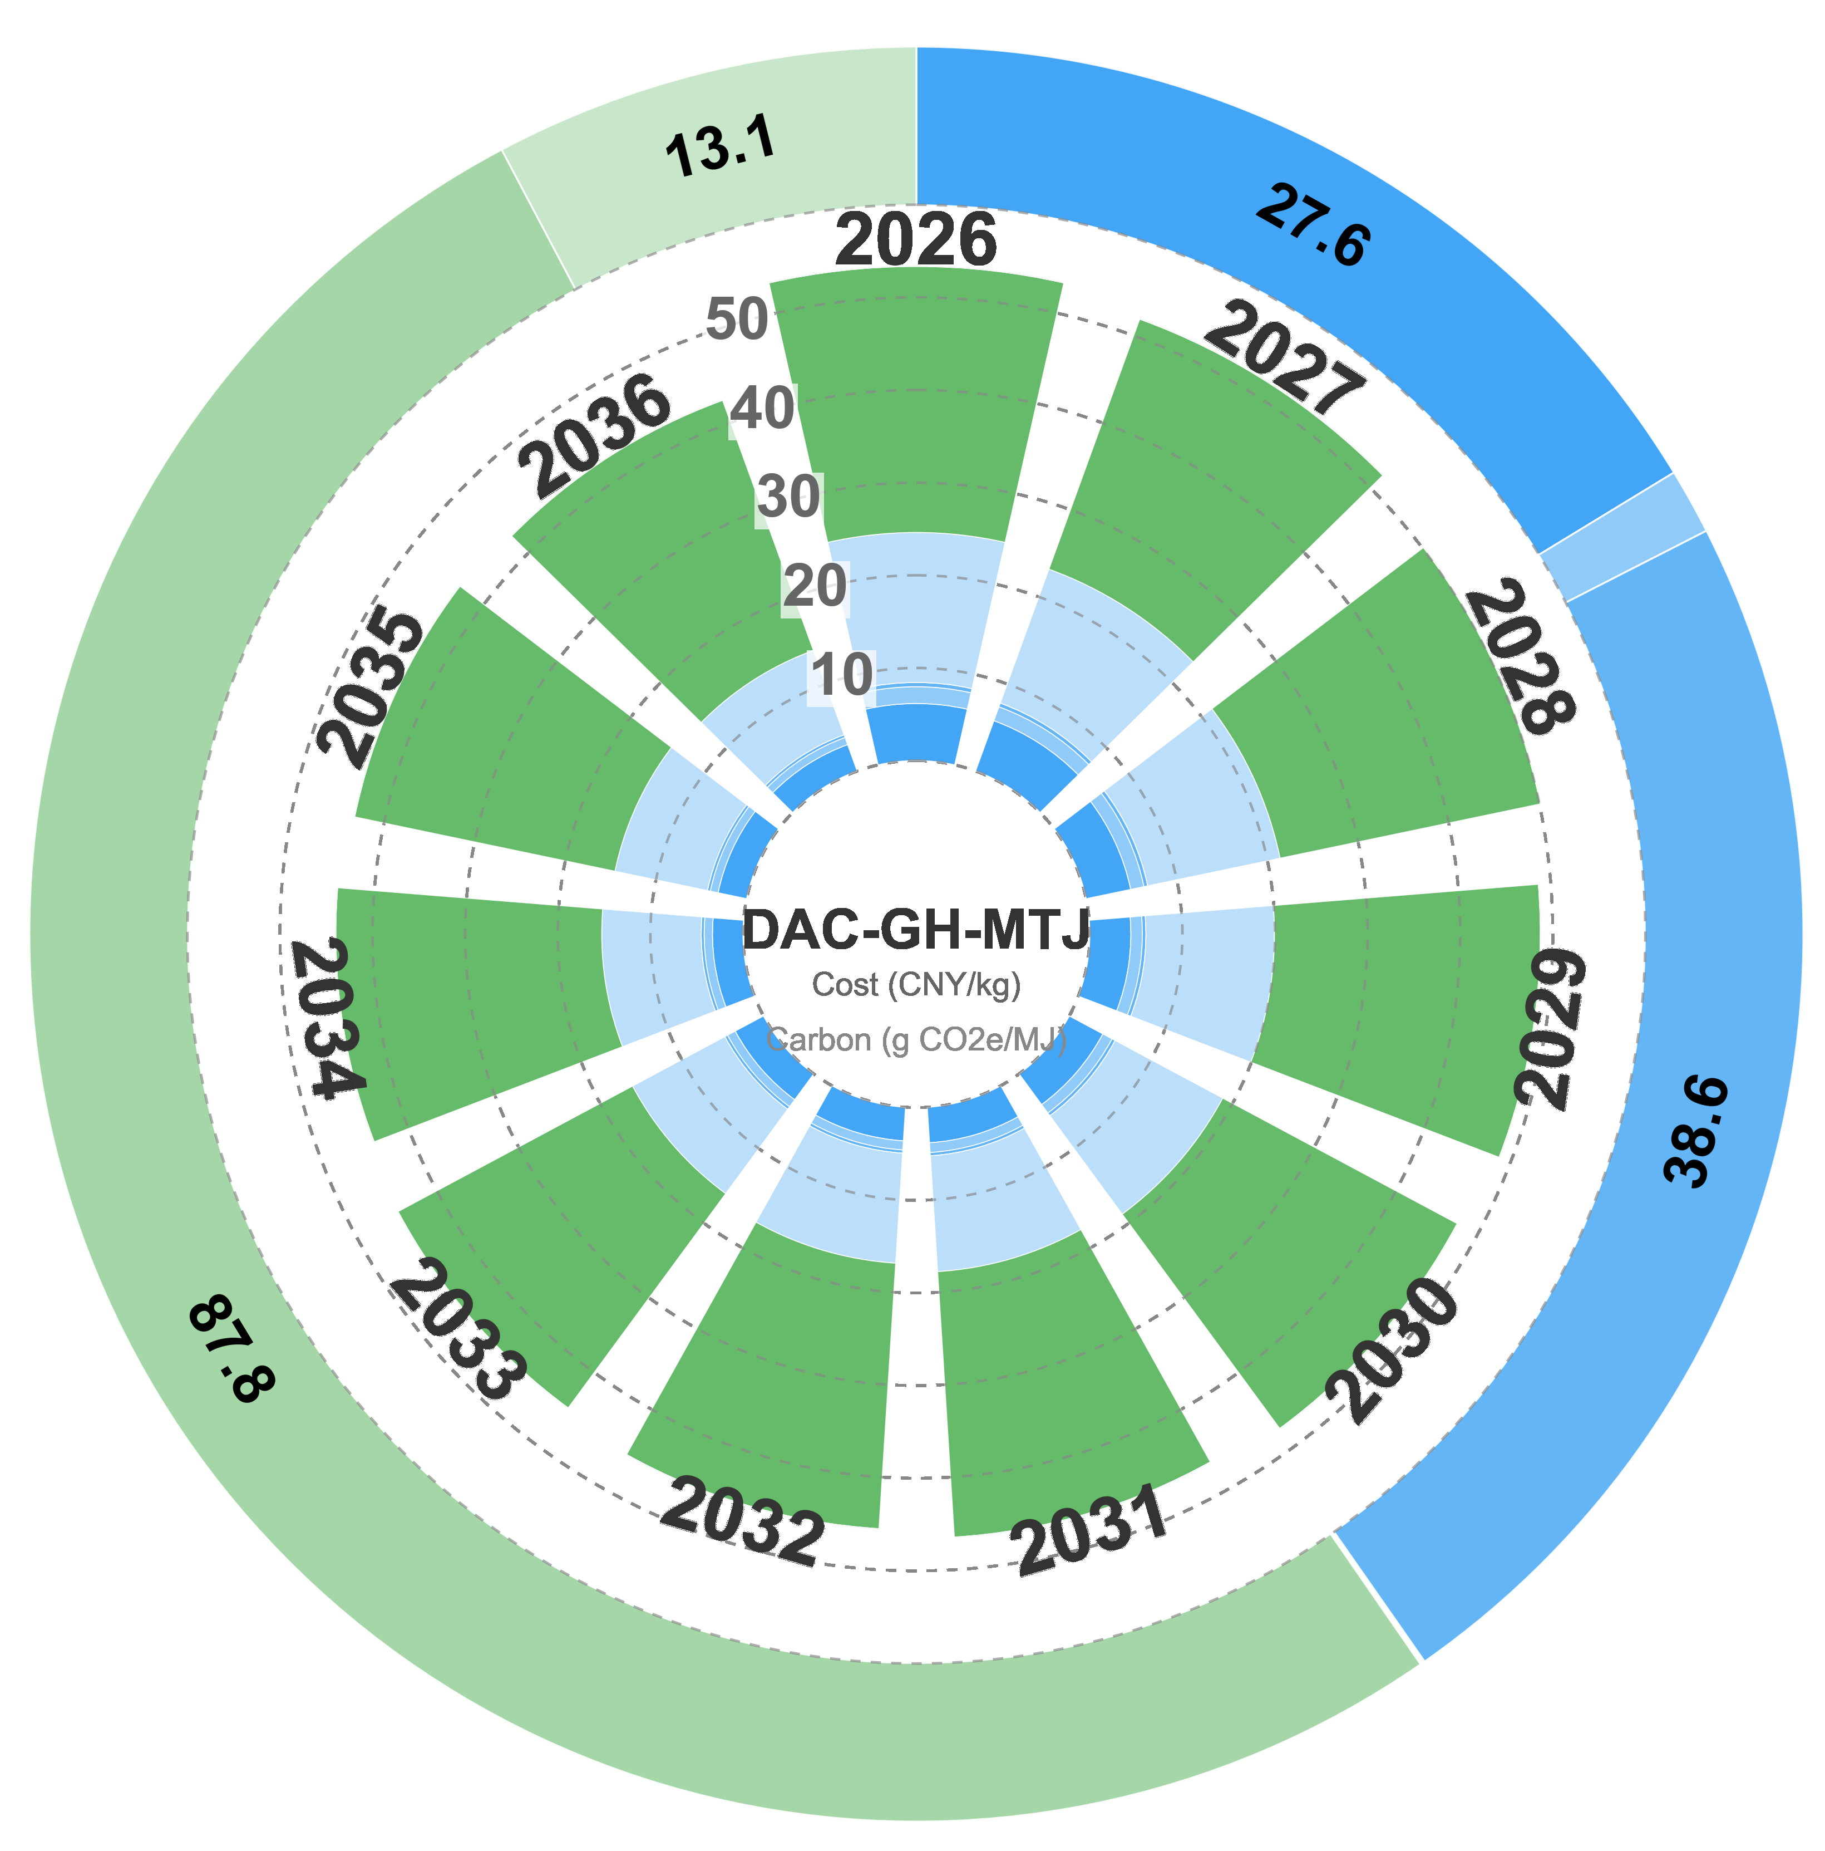
Figure S45. Cost–emission decomposition for pathway DAC-GH-MTJ: polar stacked-area learning-curve trajectory (2026–2036), with stacked cost categories and outer carbon-intensity ring.
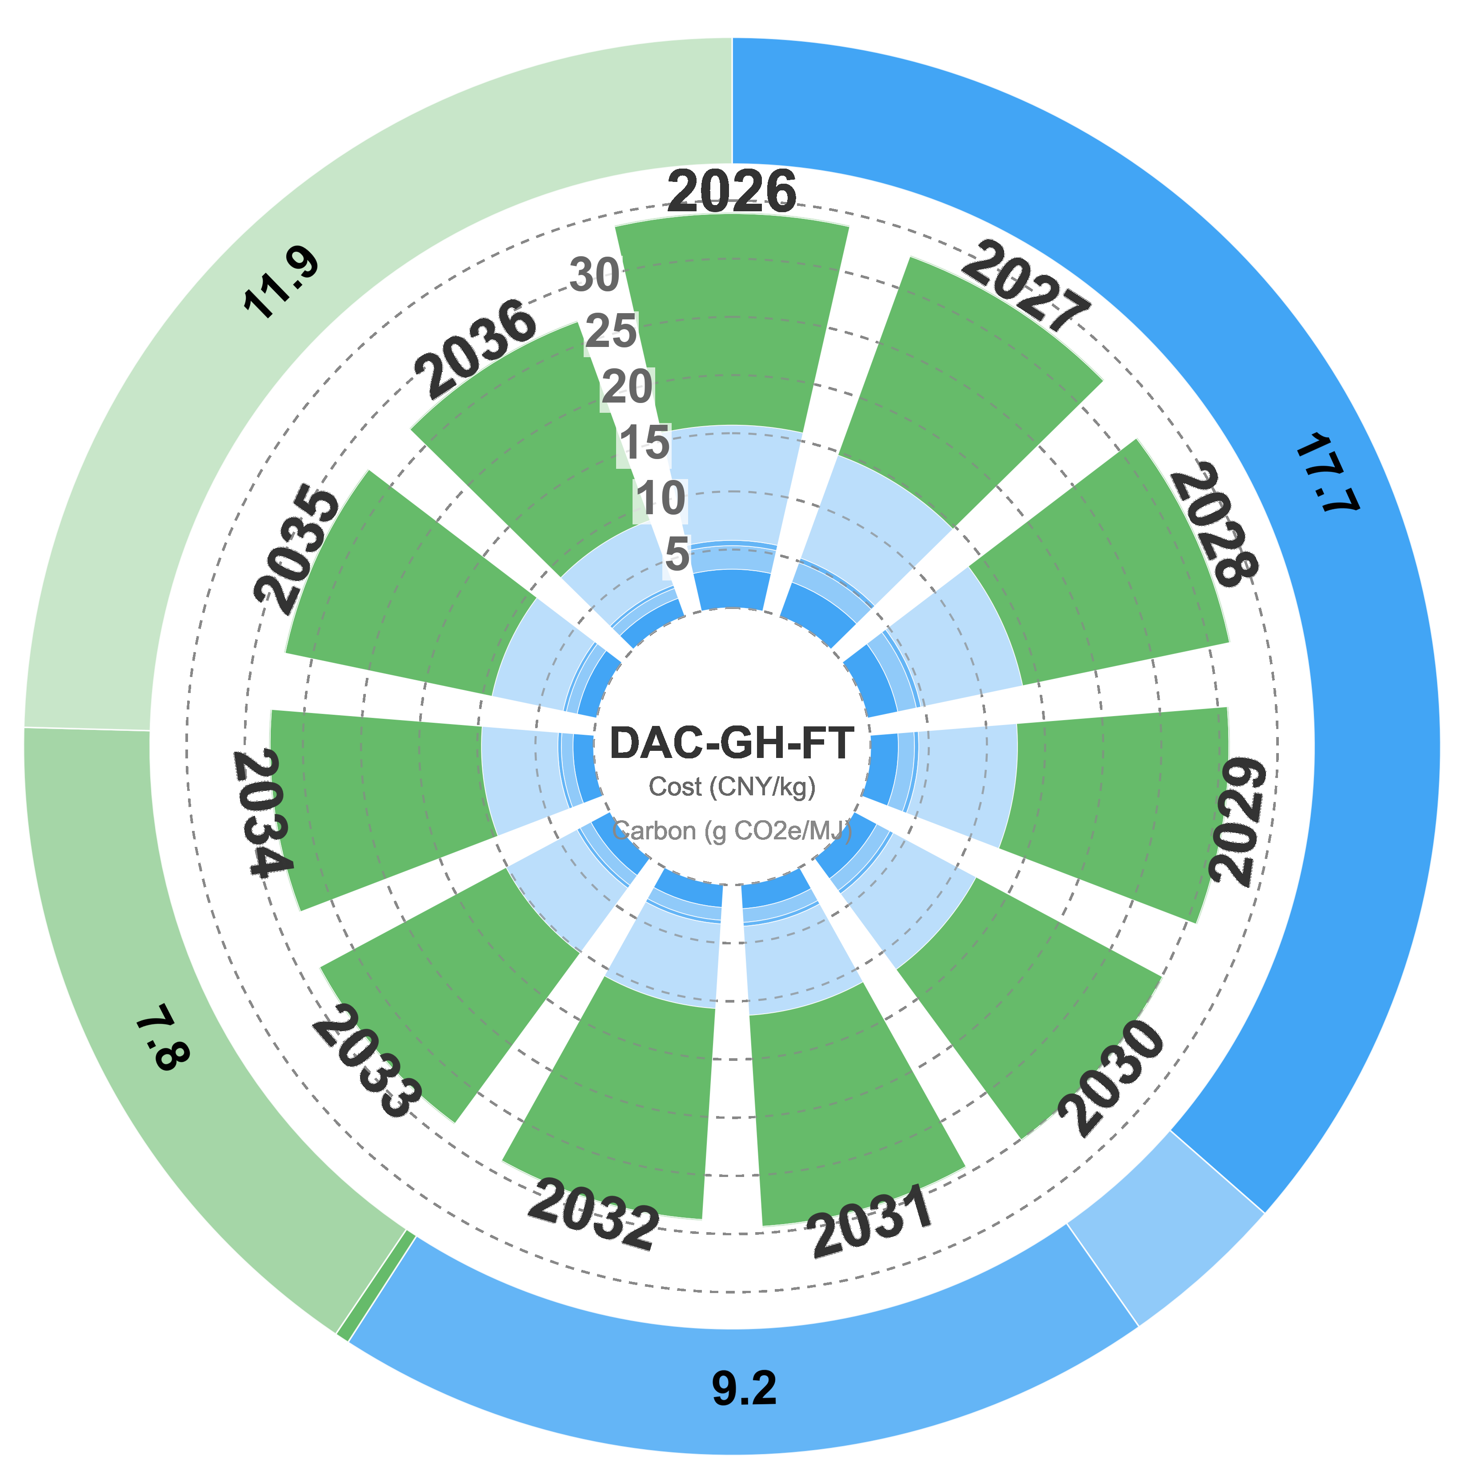
Figure S46. Cost–emission decomposition for pathway DAC-GH-FT: polar stacked-area learning-curve trajectory (2026–2036), with stacked cost categories and outer carbon-intensity ring.
Figure S47. Cost–emission decomposition for pathway DAC-BH-MTJ: polar stacked-area learning-curve trajectory (2026–2036), with stacked cost categories and outer carbon-intensity ring.
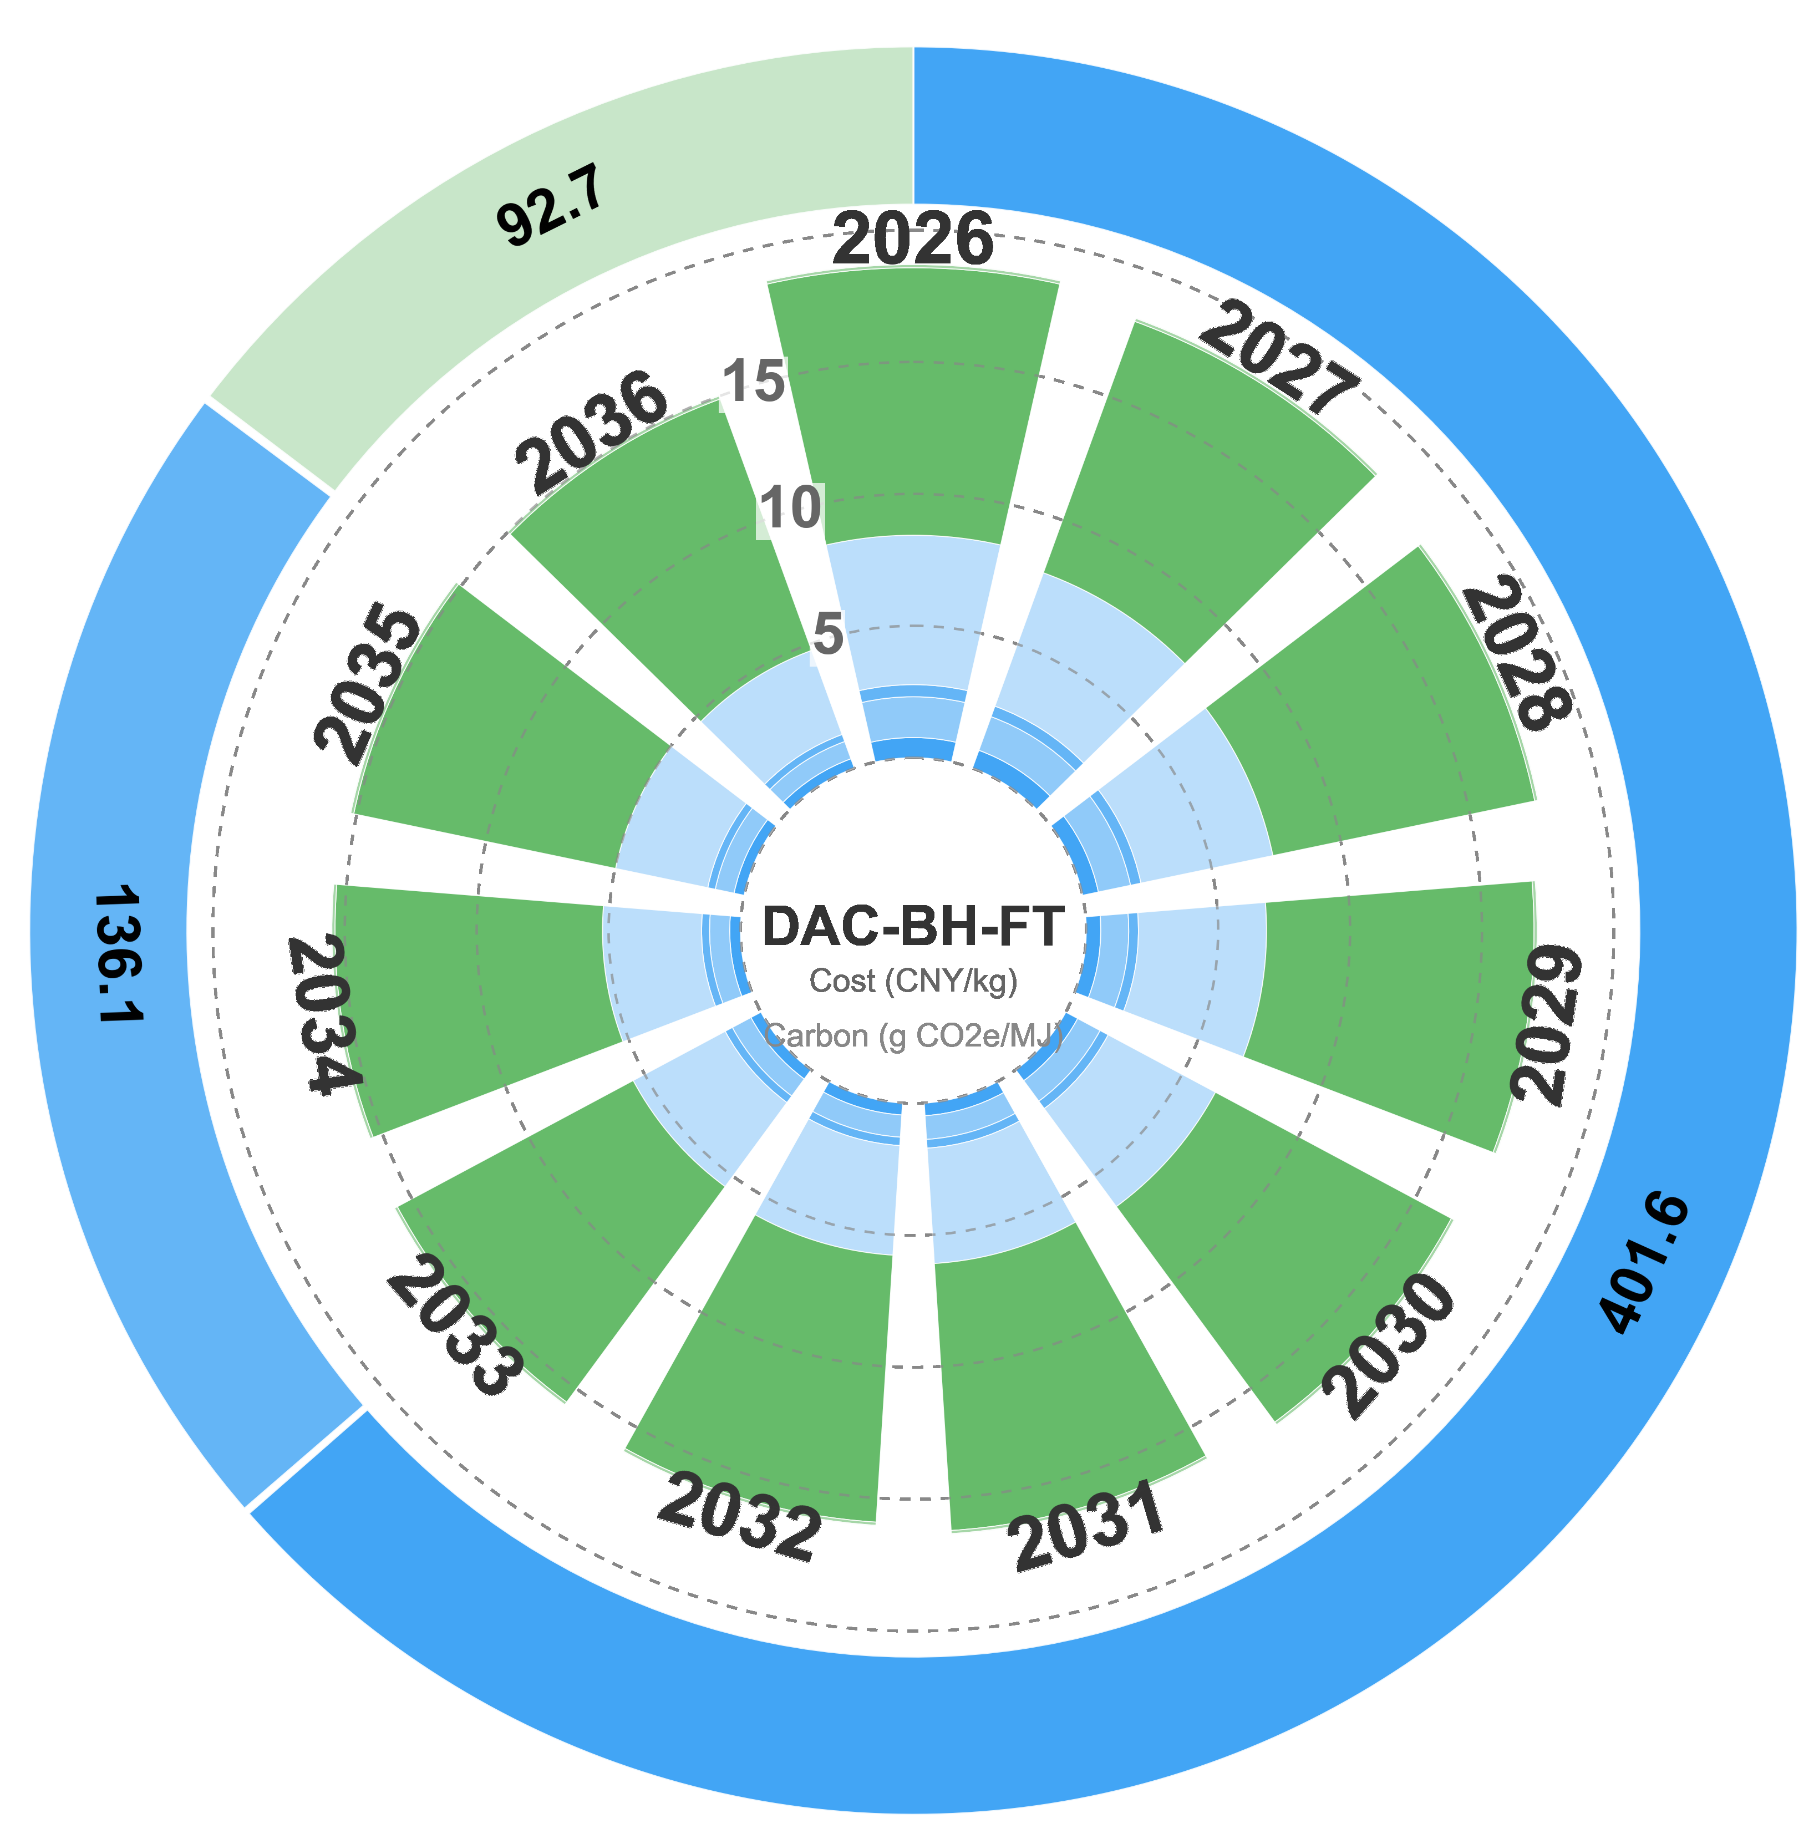
Figure S48. Cost–emission decomposition for pathway DAC-BH-FT: polar stacked-area learning-curve trajectory (2026–2036), with stacked cost categories and outer carbon-intensity ring.
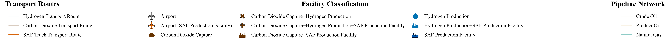
Figure S49. Shared legend for the transport network route maps (all 13 pathways).
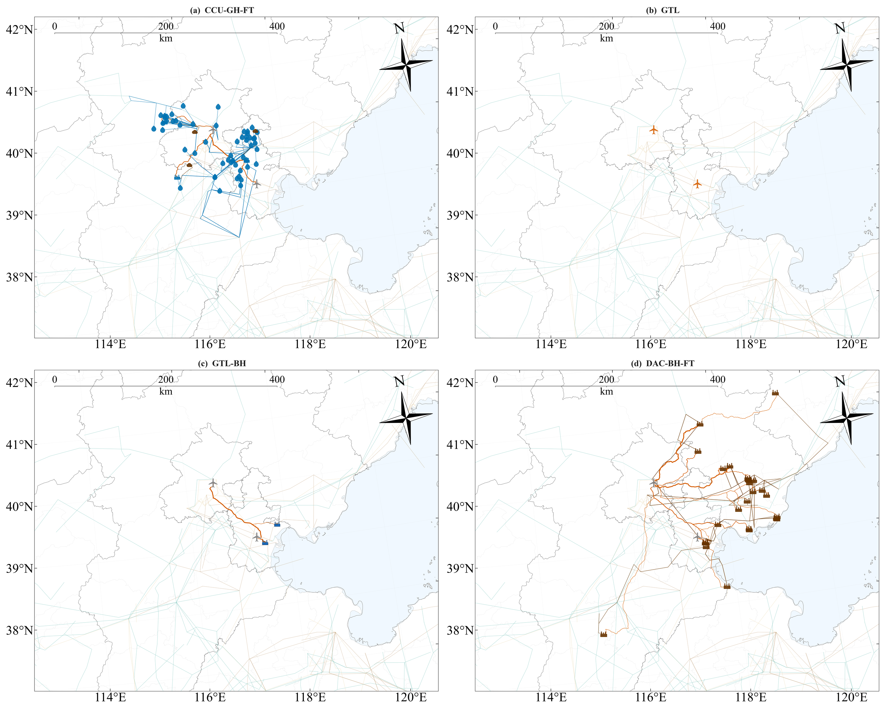
Figure S50. Side-by-side comparison of four representative pathways: CCU-GH-FT (deep decarbonisation), GTL (transition), GTL-BH (lowest-cost frontier), and DAC-BH-FT.
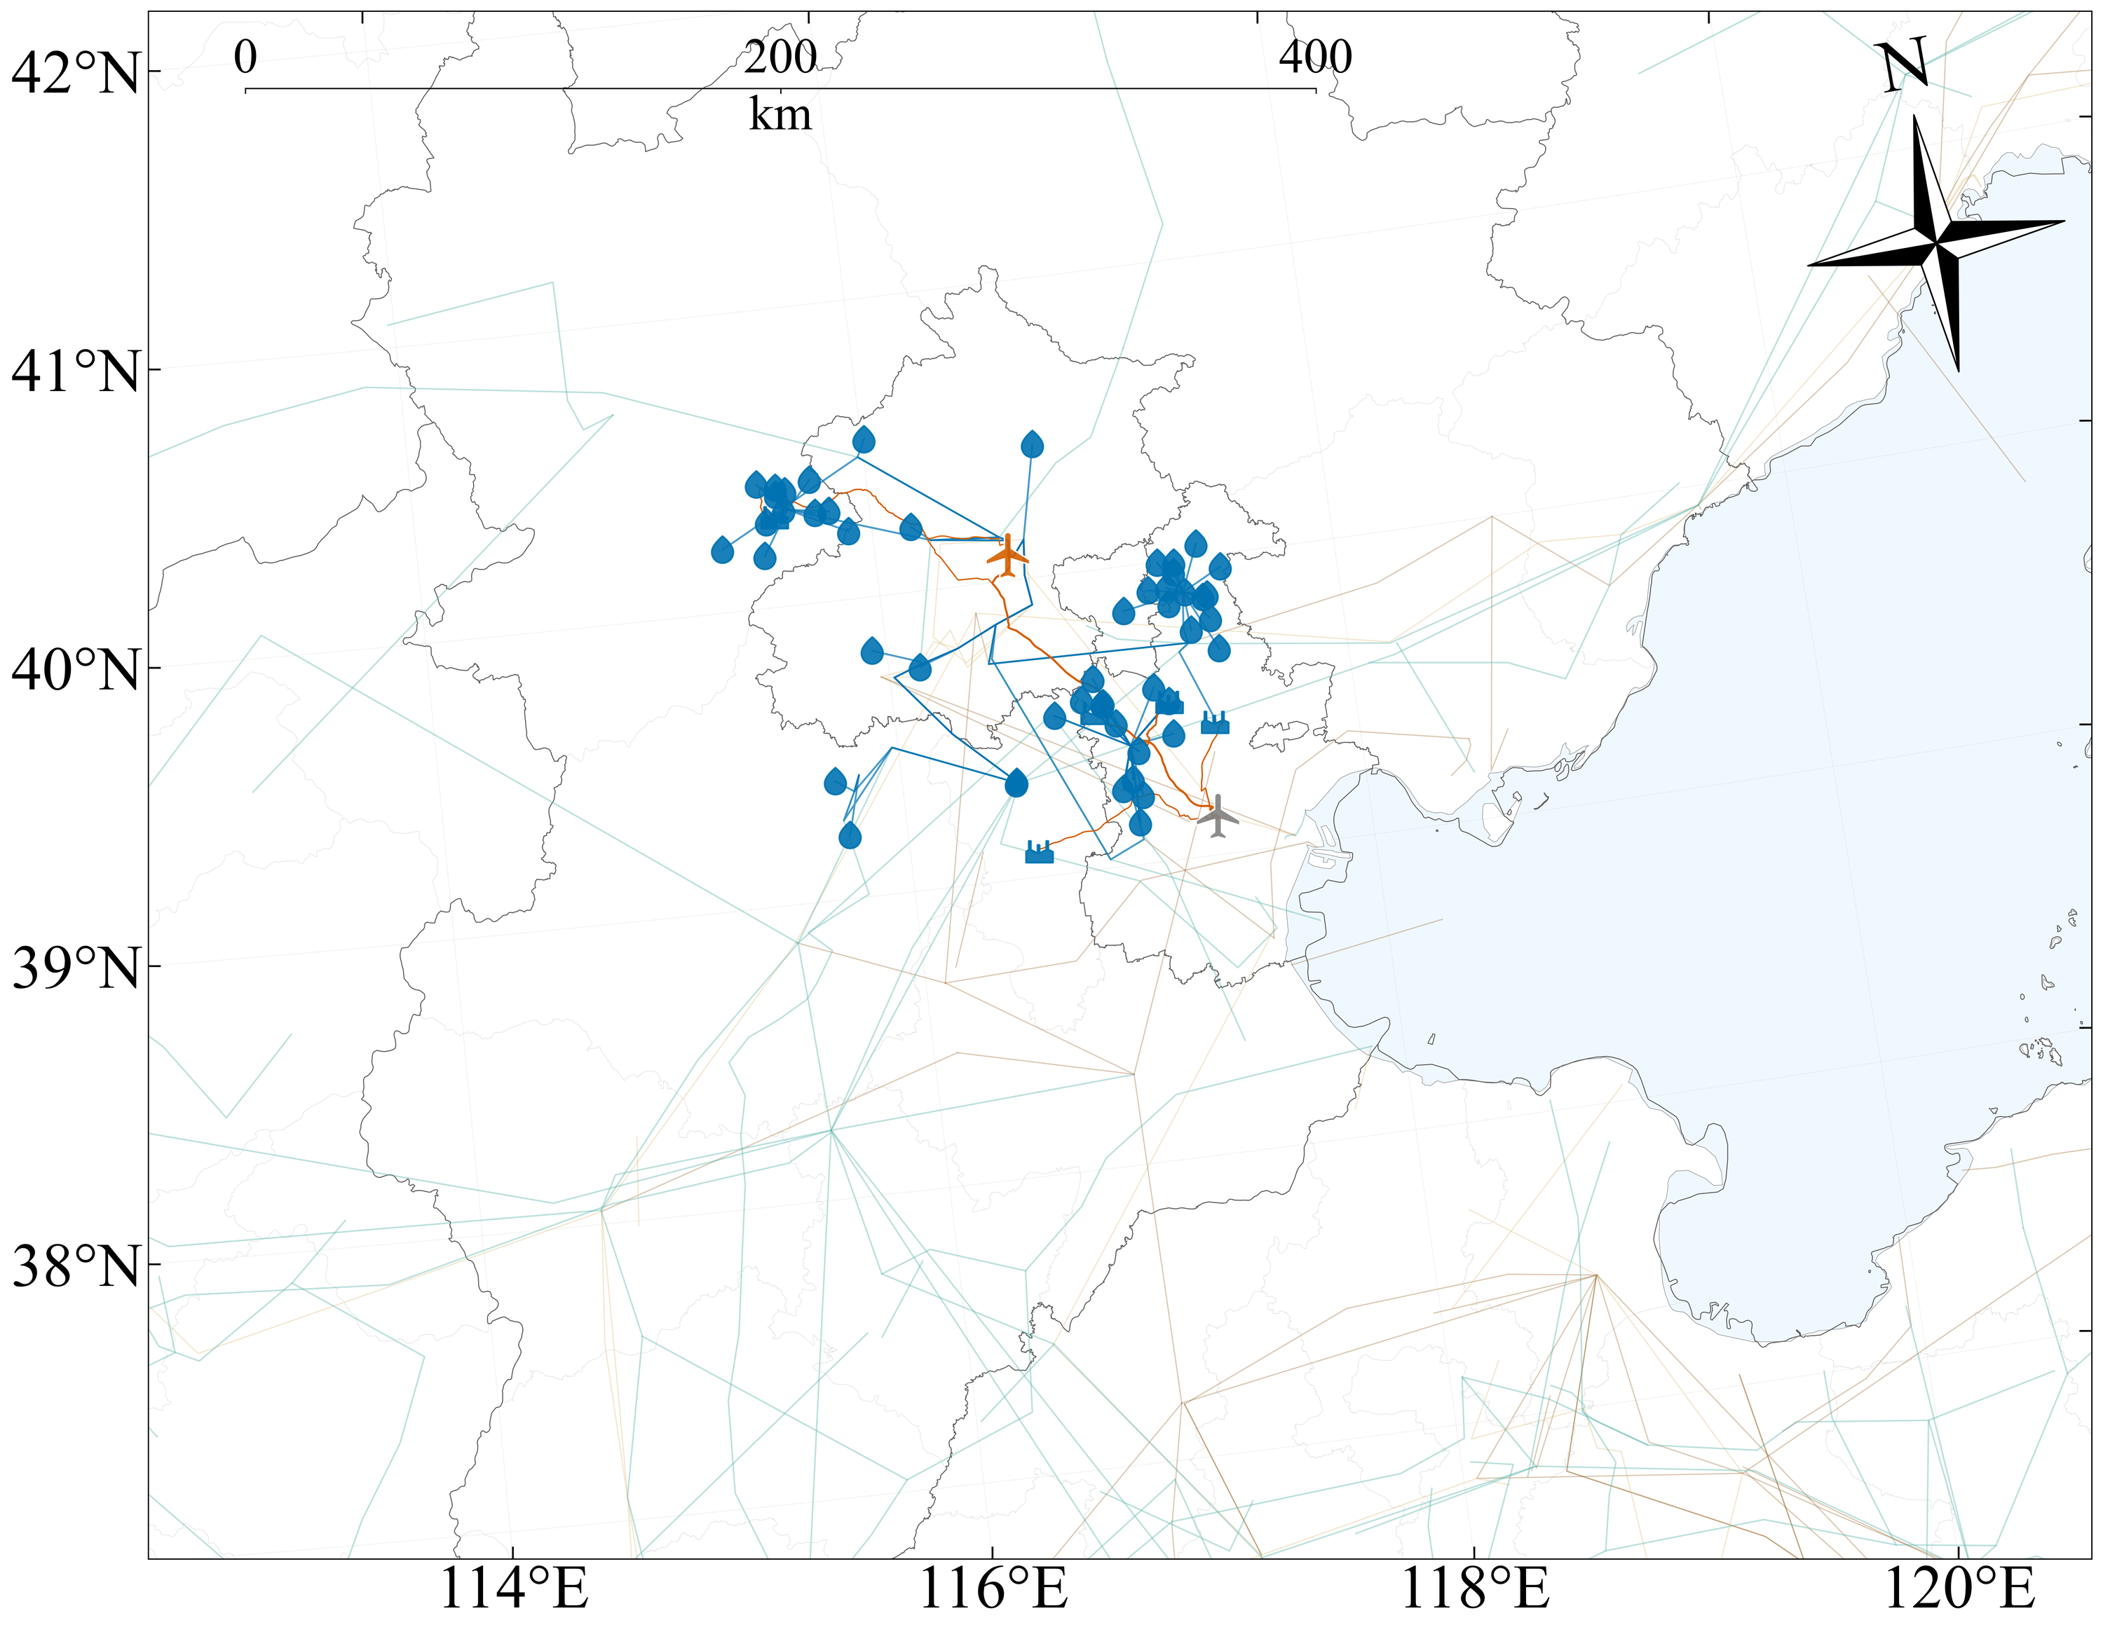
Figure S51. Optimised clustered transport route map for pathway CTL.
Figure S52. Optimised clustered transport route map for pathway CTL-BH.
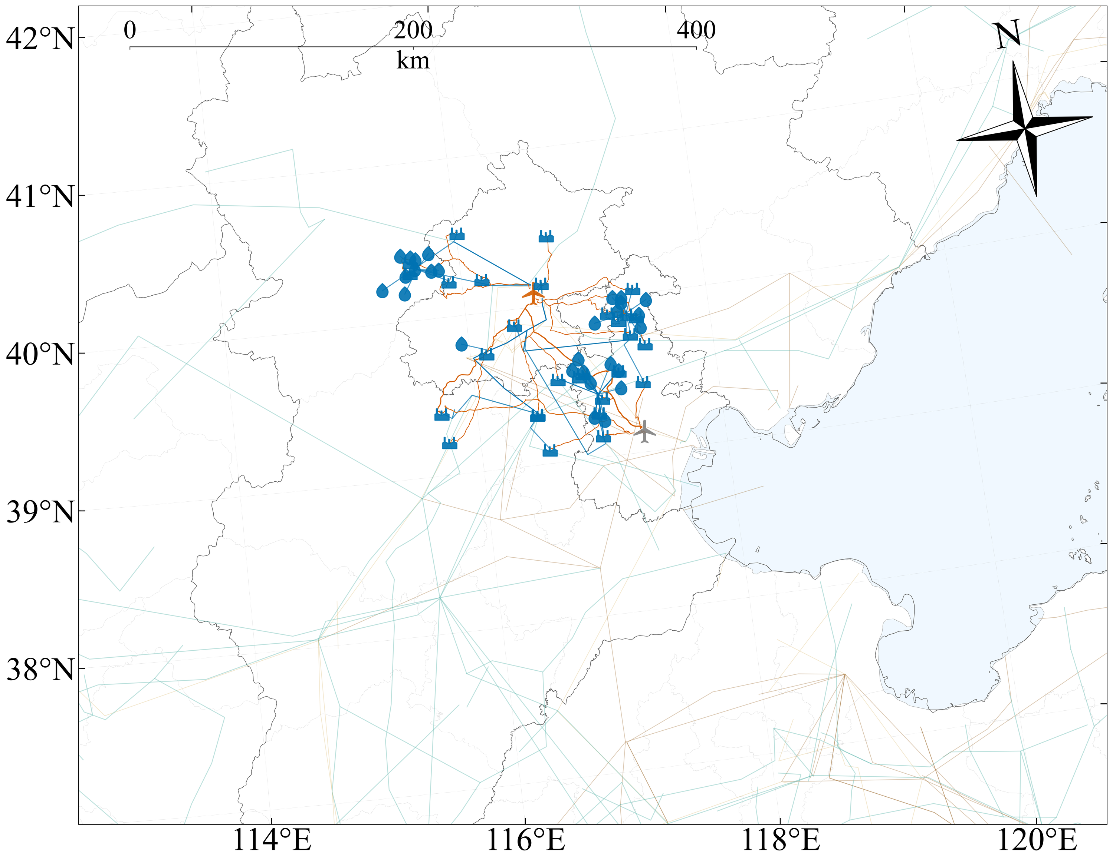
Figure S53. Optimised clustered transport route map for pathway GTL-GH.
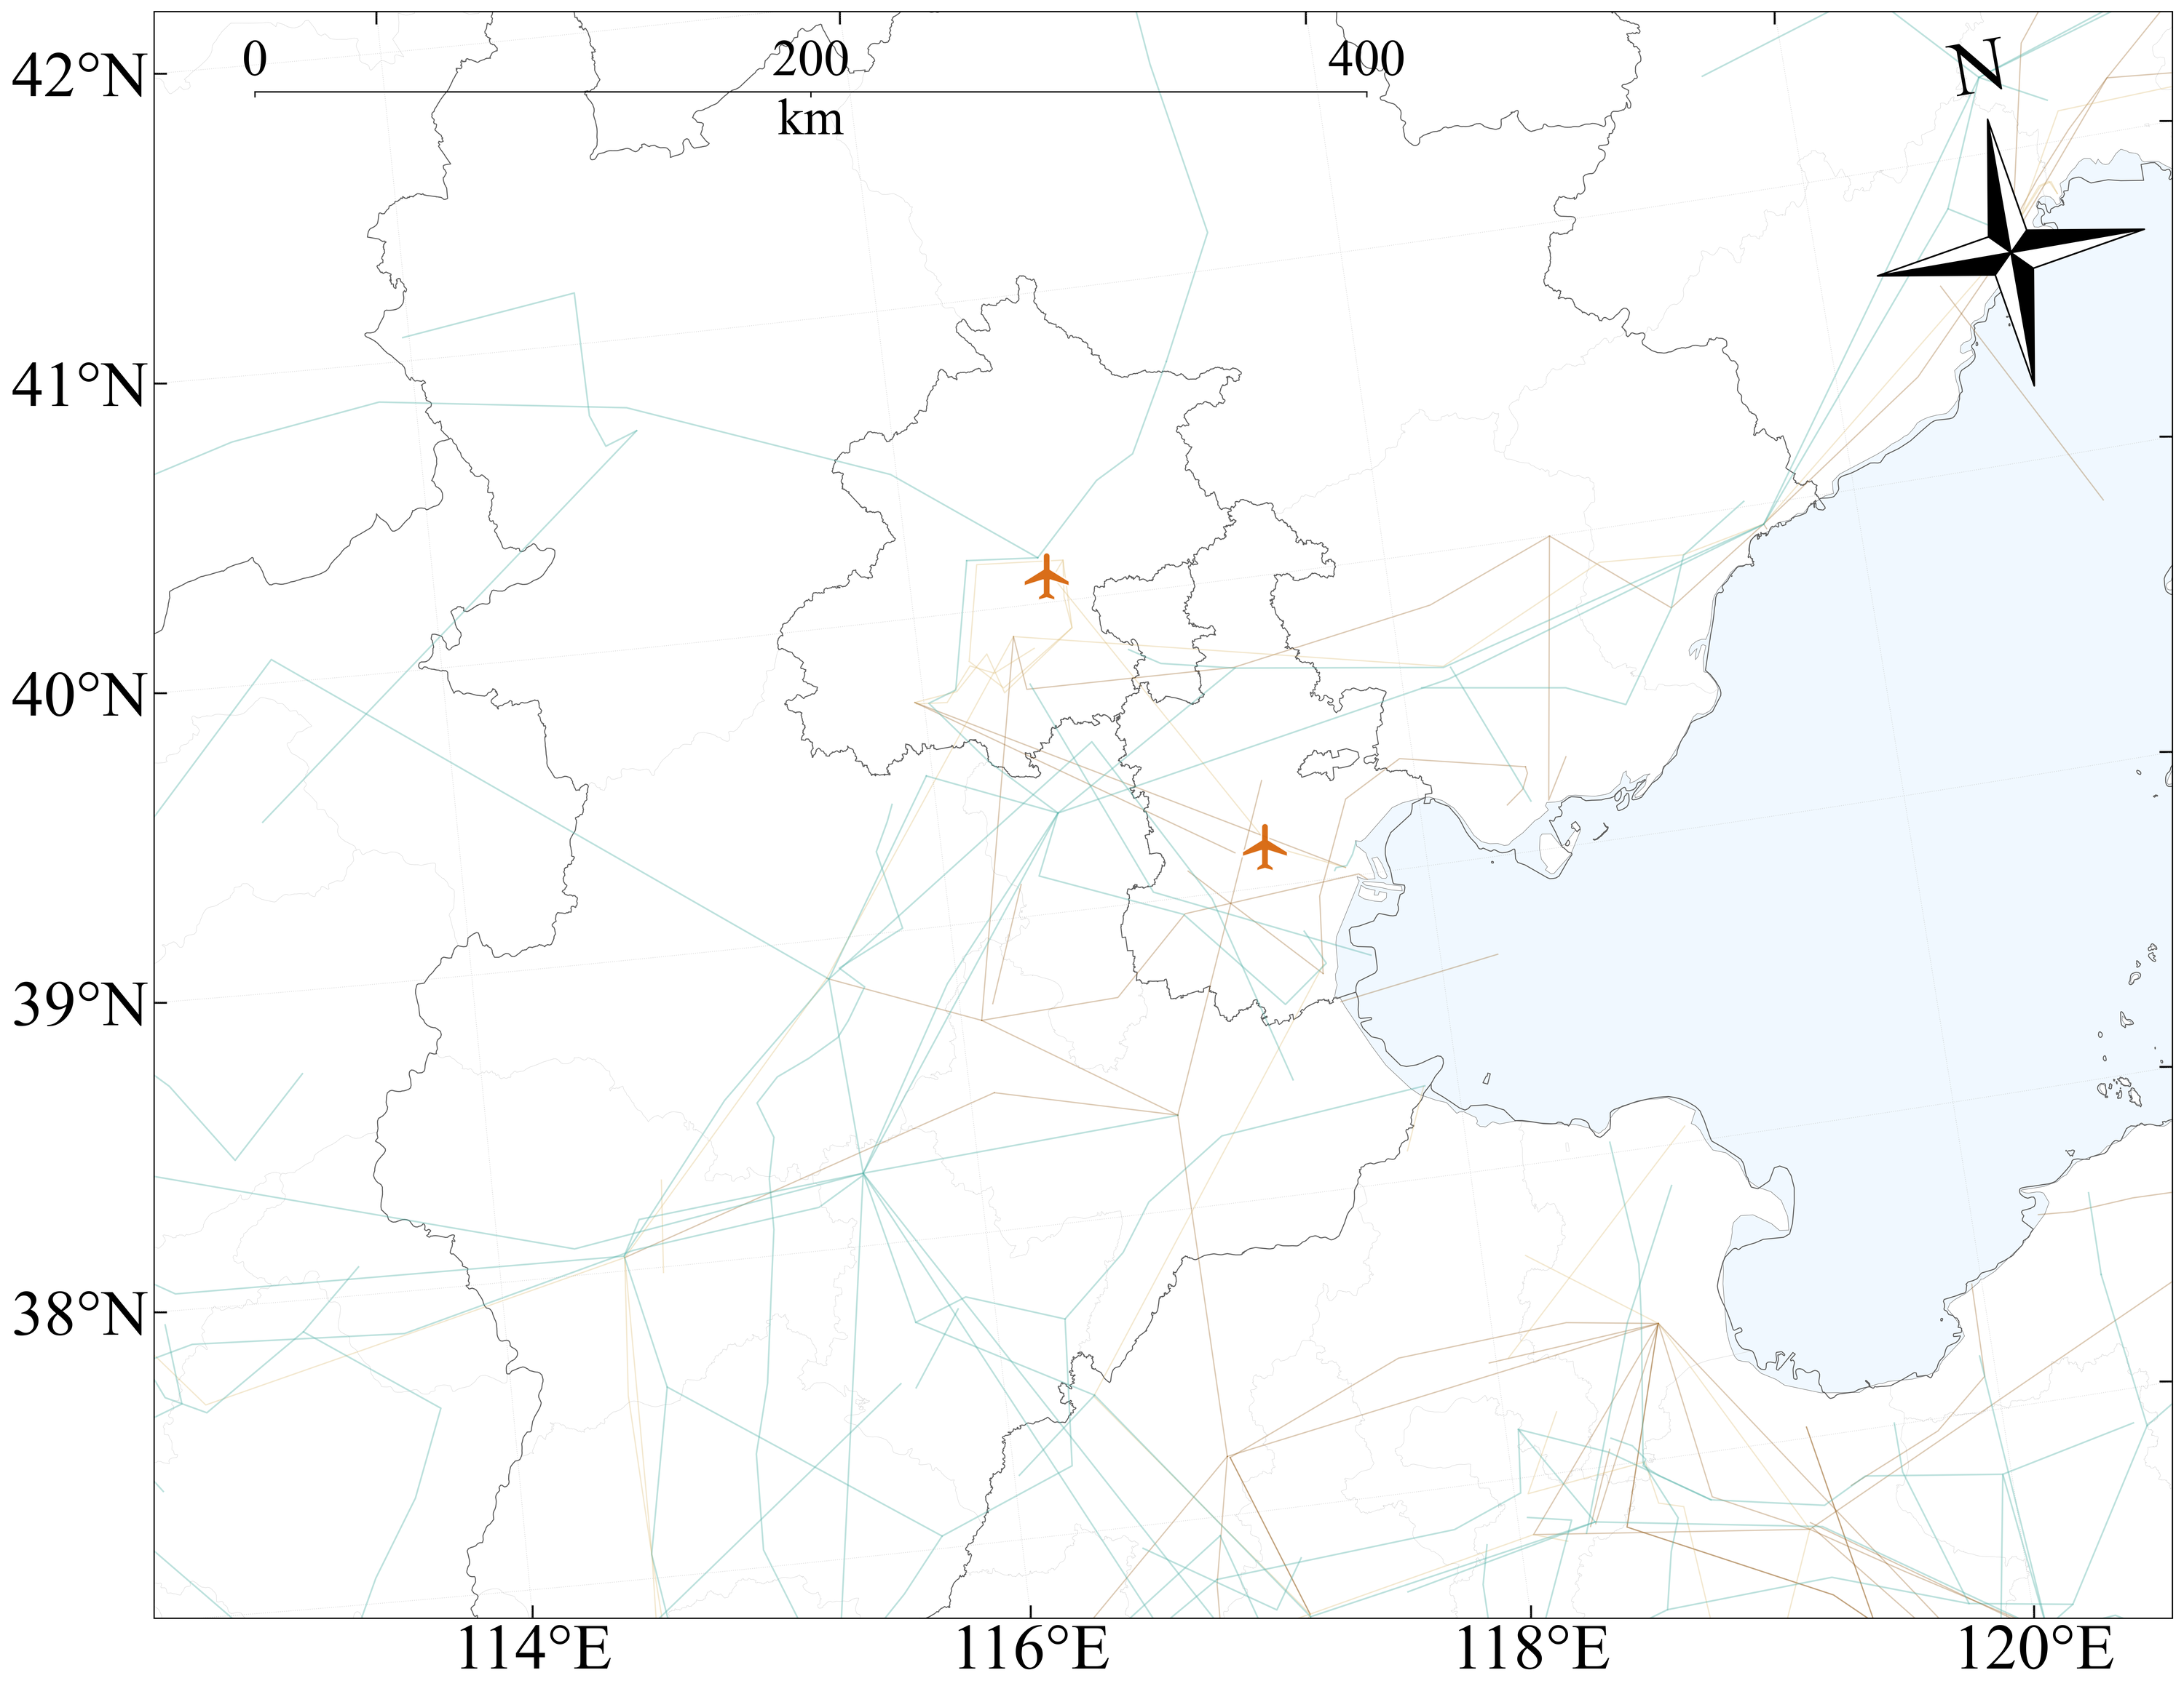
Figure S54. Optimised clustered transport route map for pathway GTL.
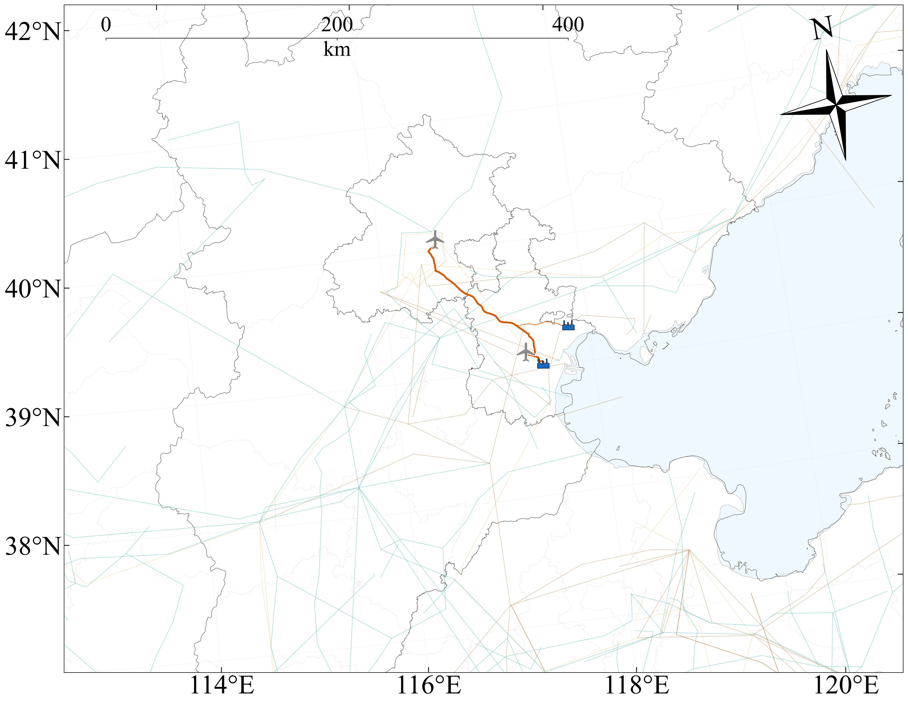
Figure S55. Optimised clustered transport route map for pathway GTL-BH.
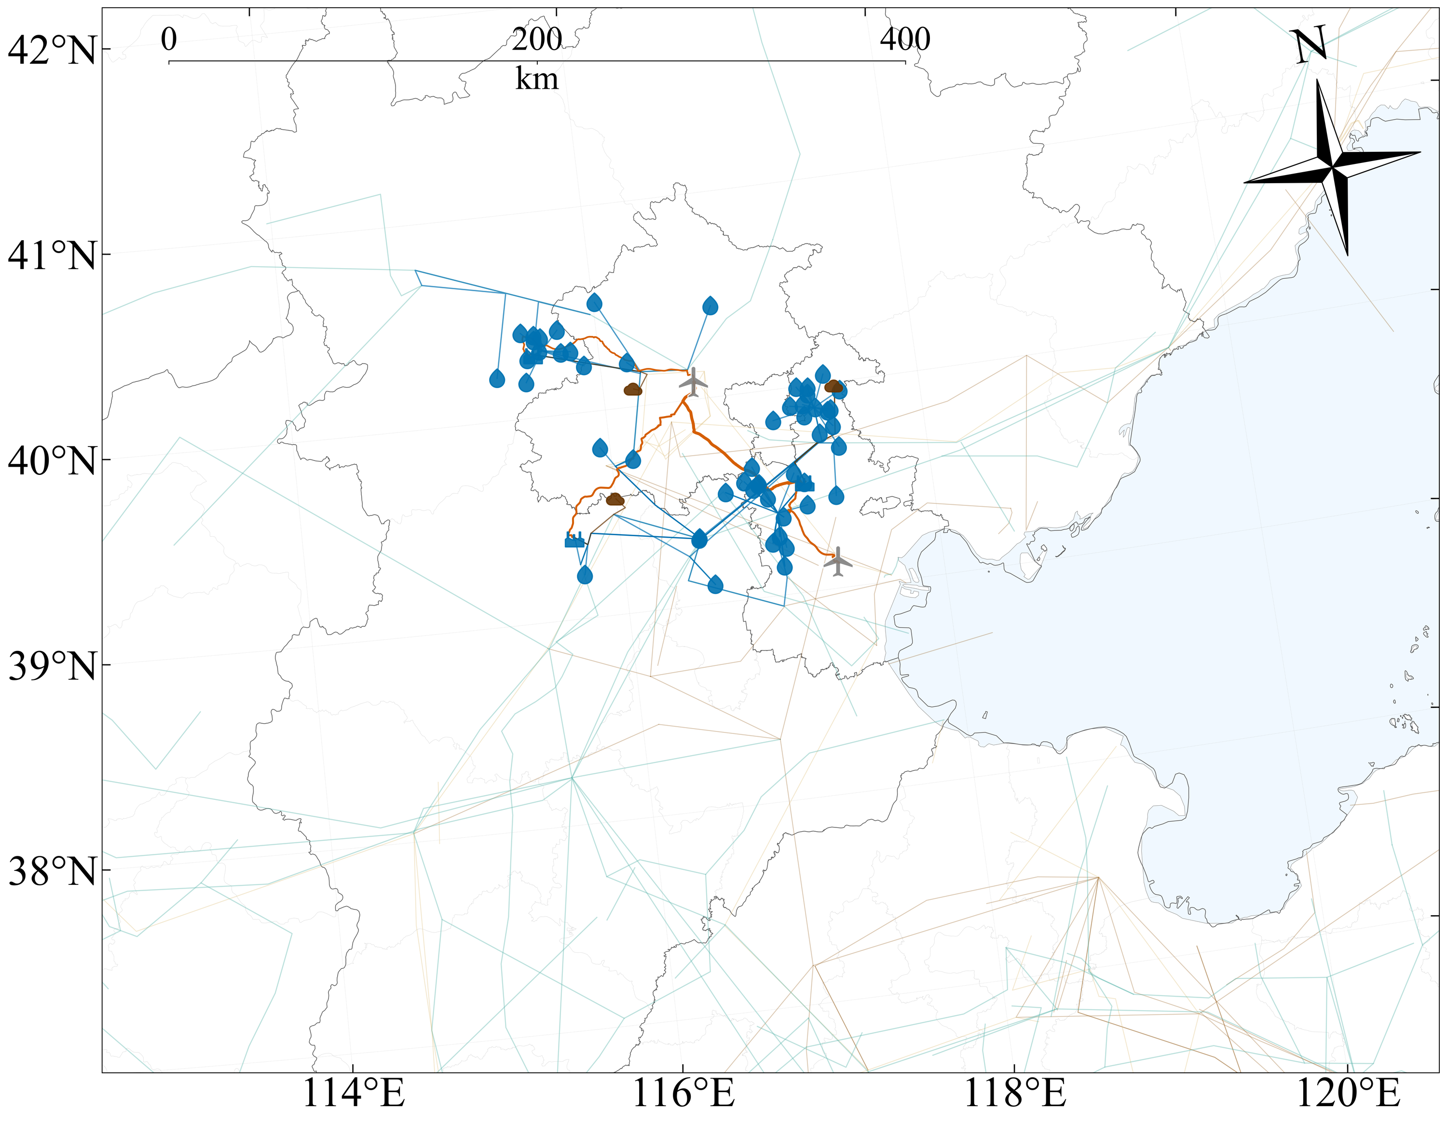
Figure S56. Optimised clustered transport route map for pathway CCU-GH-MTJ.
Figure S57. Optimised clustered transport route map for pathway CCU-GH-FT.
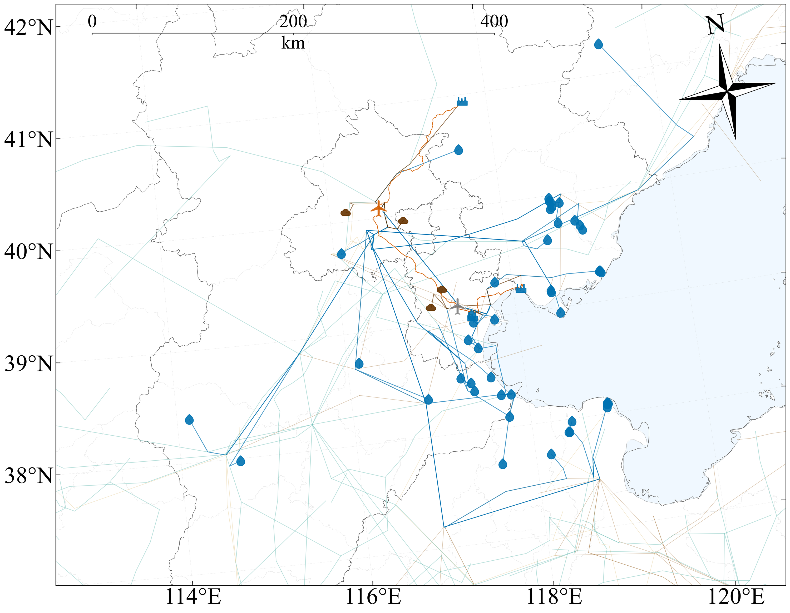
Figure S58. Optimised clustered transport route map for pathway CCU-BH-MTJ.
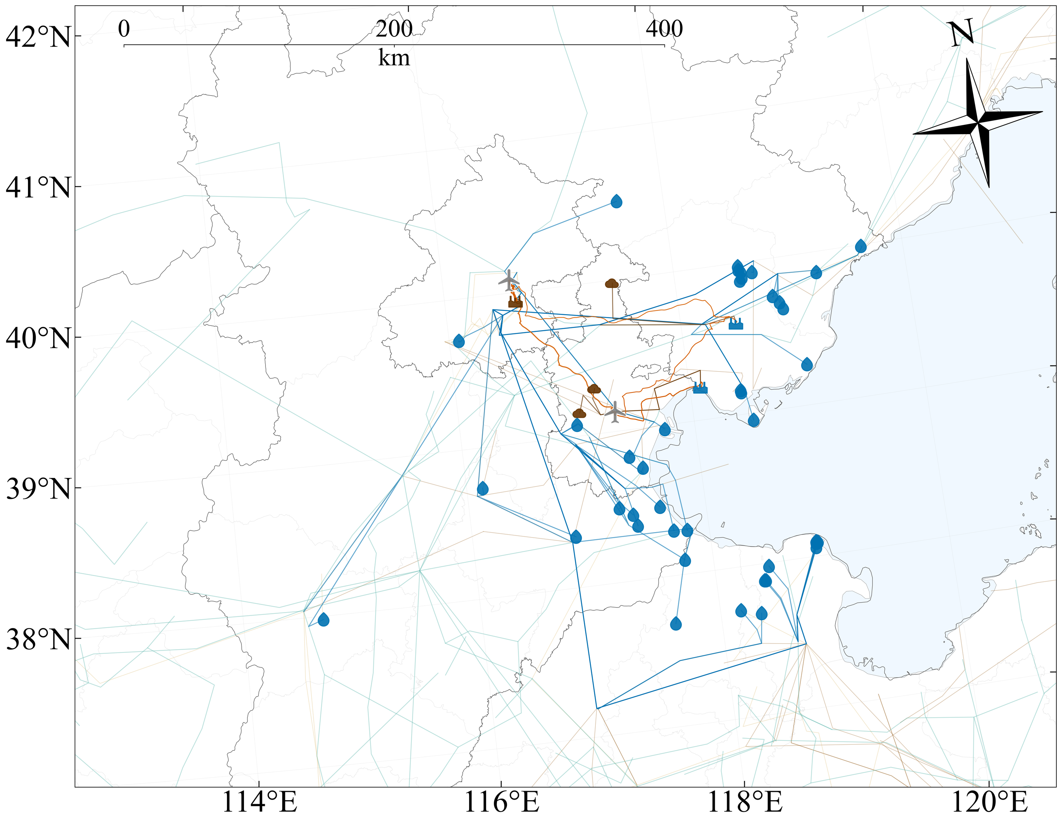
Figure S59. Optimised clustered transport route map for pathway CCU-BH-FT.
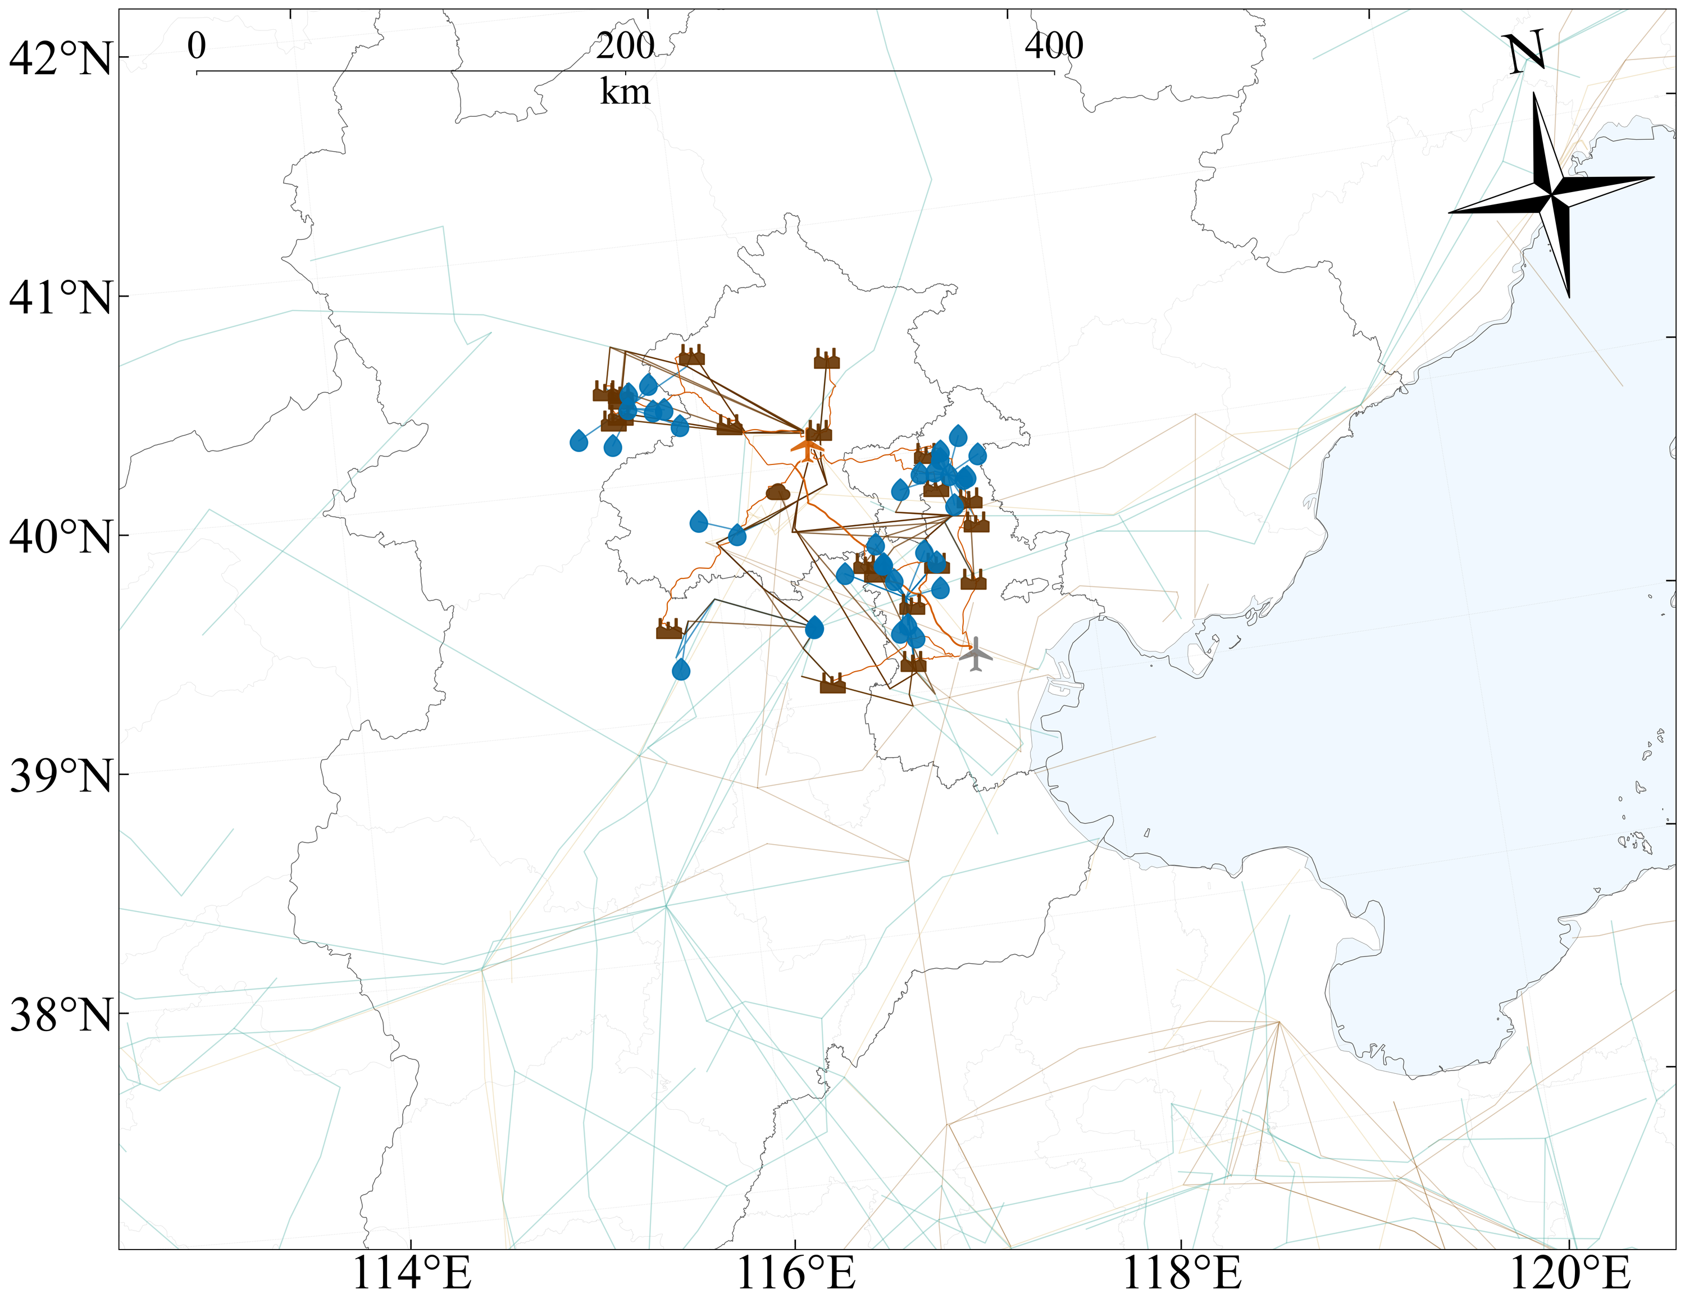
Figure S60. Optimised clustered transport route map for pathway DAC-GH-MTJ.
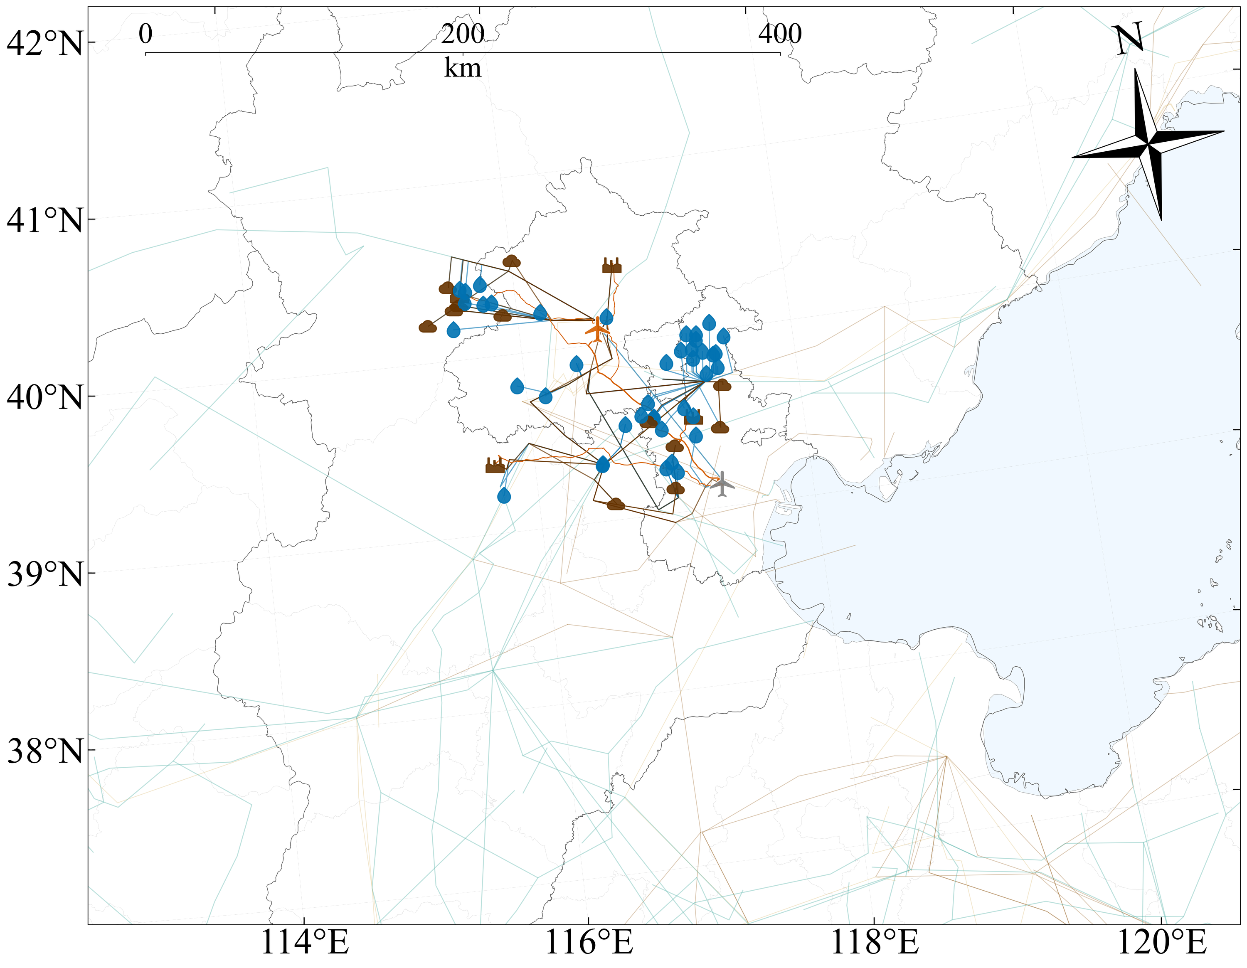
Figure S61. Optimised clustered transport route map for pathway DAC-GH-FT.
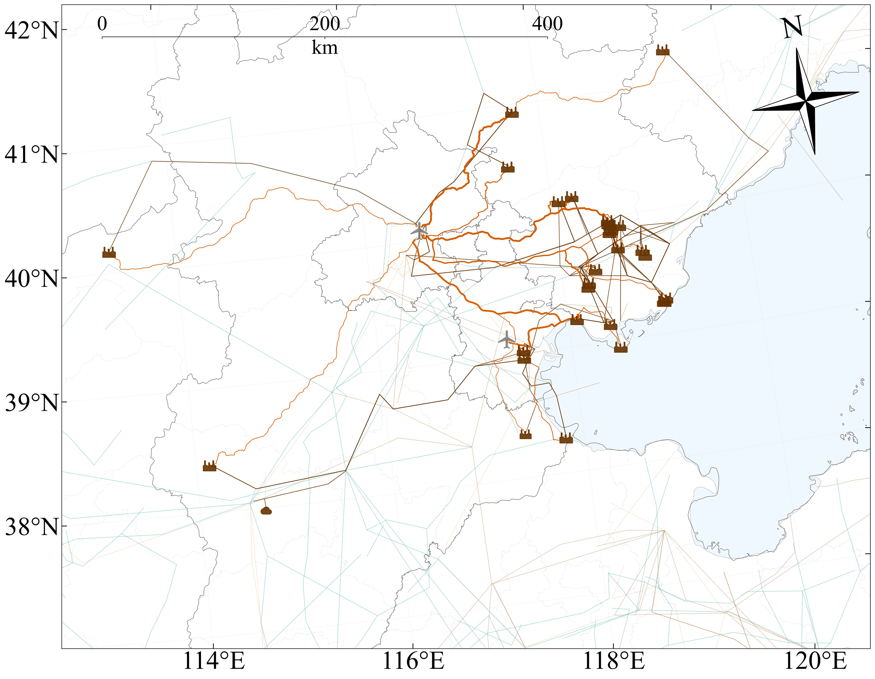
Figure S62. Optimised clustered transport route map for pathway DAC-BH-MTJ.
Figure S63. Optimised clustered transport route map for pathway DAC-BH-FT.

