Appendix for "Infrastructure incompatibility across synthetic aviation fuel pathways risks stranding decarbonization investments"
Junteng Liao¹, Haoran Zhang^{1,}*

¹School of Urban Planning and Design, Peking University, Shenzhen, Guangdong, China
*Corresponding authors: Haoran Zhang (h.zhang@pku.edu.cn)

This Supplementary Information contains the data definitions, scenario boundaries, model equations, parameter tables and selected comparisons for the Beijing–Tianjin airport-demand case. Sections 2.4 and 7 document scenario exclusions and quantitative revision calculations. Companion Supplementary Archive contains additional input diagnostics and per-pathway figures. Figure numbers are shared across the two files. Numerical comparisons describe archived solutions; the operating-feasibility limits are stated in Section 5.1 and Table S28.

1 Data Sources and Processing Methods
The input pipeline combines airport demand, renewable electricity, industrial hydrogen and carbon sources, and transport networks. Table S1 identifies their coverage and role. Additional inventory diagnostics are provided in the companion Supplementary Archive.

1.1 Overview of input data
The archived model instance combines five major data blocks: aviation fuel demand, renewable-electricity availability, industrial hydrogen sources, industrial or atmospheric carbon sources, and transport or price-network information. These data blocks are not used as isolated descriptive layers. Each one is converted into a specific model role, such as weekly airport demand, plant-level renewable generation limits, source-node capacity upper bounds, route-specific cost coefficients, or candidate transport arcs.
The spatial boundary is deliberately asymmetric. Supply-side candidate nodes are screened at the national scale because green hydrogen, by-product hydrogen, industrial CO₂, DAC siting, and pipeline corridors may all be located far from the final demand nodes. The demand side is narrower in the current archived instance and is represented by the Beijing-Tianjin airport system. This design keeps the aviation demand case concrete while preserving a national search space for upstream supply, conversion, and logistics options.
Point inventories, time series and transport records provide the spatial and temporal inputs summarized in Table S1. Their physical units and aggregation require the validation described in Section 5.1.
Table S1 Overview of input datasets, coverage, and model role.
Dataset block | Raw source / scope | Model-ready representation | Role in optimization
Airport fuel demand | 2024 domestic flight schedule processed flight by flight with a pyBADA-based fuel model | 8 airport-week records for Beijing and Tianjin across 4 representative weeks | Weekly SAF demand at airport nodes
Renewable electricity | China-wide wind and solar plant inventories plus hourly output profiles | 1,798 wind plants and 1,908 solar plants over 672 hours | Limits green-hydrogen production and defines renewable spatial opportunity
Industrial by-product hydrogen | Refinery and steel-plant geocoded inventories with daily hydrogen estimates | 180 refineries and 211 steel plants | Upper bounds for by-product hydrogen pathways
Industrial / atmospheric CO₂ | Industrial capture source metadata, CCUS references, and DAC siting rules | 3,445 industrial capture-source records plus DAC candidate locations generated from scenario configs | Upper bounds or siting candidates for CCU and DAC pathways
Transport network | Existing pipeline GIS layers, province-level gas/electricity price tables, and OpenStreetMap road network routed with GraphHopper/OSM tools | 436 pipeline polylines plus 30 provincial price surfaces | Constructs candidate logistics arcs and route-specific transport / energy costs
Techno-economic parameters | Scenario-specific YAML configuration files and harmonized literature inputs | Route-specific cost, emissions, efficiency, lifetime, and policy parameters | Objective coefficients and ex-post emissions accounting

1.2 Aviation fuel demand estimation
Airport synthetic aviation fuel demand is derived from the 2024 domestic flight schedule rather than from a fixed annual consumption scalar. Each flight record provides the operating airport, aircraft information, and route-distance context needed to estimate fuel use at the flight level. The workflow applies a pyBADA-based fuel-consumption model to these records and then aggregates the resulting fuel estimates to airport-week demand values.^{1,2,22,23}
This flight-level construction is important because airport fuel demand is affected by both traffic volume and aircraft mix. A simple average fuel-per-flight assumption would hide differences between short and long routes or between aircraft classes. The stored demand table therefore preserves the link between traffic composition, route structure, and weekly fuel requirements before the data are reduced for optimization.^{3,4,5}
To keep the optimization problem tractable, the full-year demand series was compressed from 52 calendar weeks to a smaller representative set. The stored reduction keeps four final representative weeks. In that reduced dataset, Beijing contributes 39.55 million kg across the four modeled weeks and Tianjin contributes 11.50 million kg. The selected weeks cover the high, low, and intermediate demand regimes observed for Beijing and the normal and low demand regimes observed for Tianjin.^{16,17,19,21}
The demand reduction retains weeks 1, 5, 14 and 44. Figures S3–S4 show the demand context; the joint demand–renewable diagnostic in Table S26 separately assesses the twelve-week candidate pool.
Table S2 Representative-week mapping used by the reduced demand model.
New week | Week in 12-week set | Original week in year | Calendar span | Beijing demand | Tianjin demand
1 | 1 | 1 | Jan 01, 2024 - Jan 07, 2024 | 11.51 million kg (High) | 3.29 million kg (Normal)
2 | 2 | 5 | Jan 29, 2024 - Feb 04, 2024 | 5.76 million kg (Low) | 3.29 million kg (Normal)
3 | 4 | 14 | Apr 01, 2024 - Apr 07, 2024 | 11.51 million kg (High) | 1.64 million kg (Low)
4 | 11 | 44 | Oct 28, 2024 - Nov 03, 2024 | 10.77 million kg (Medium) | 3.29 million kg (Normal)
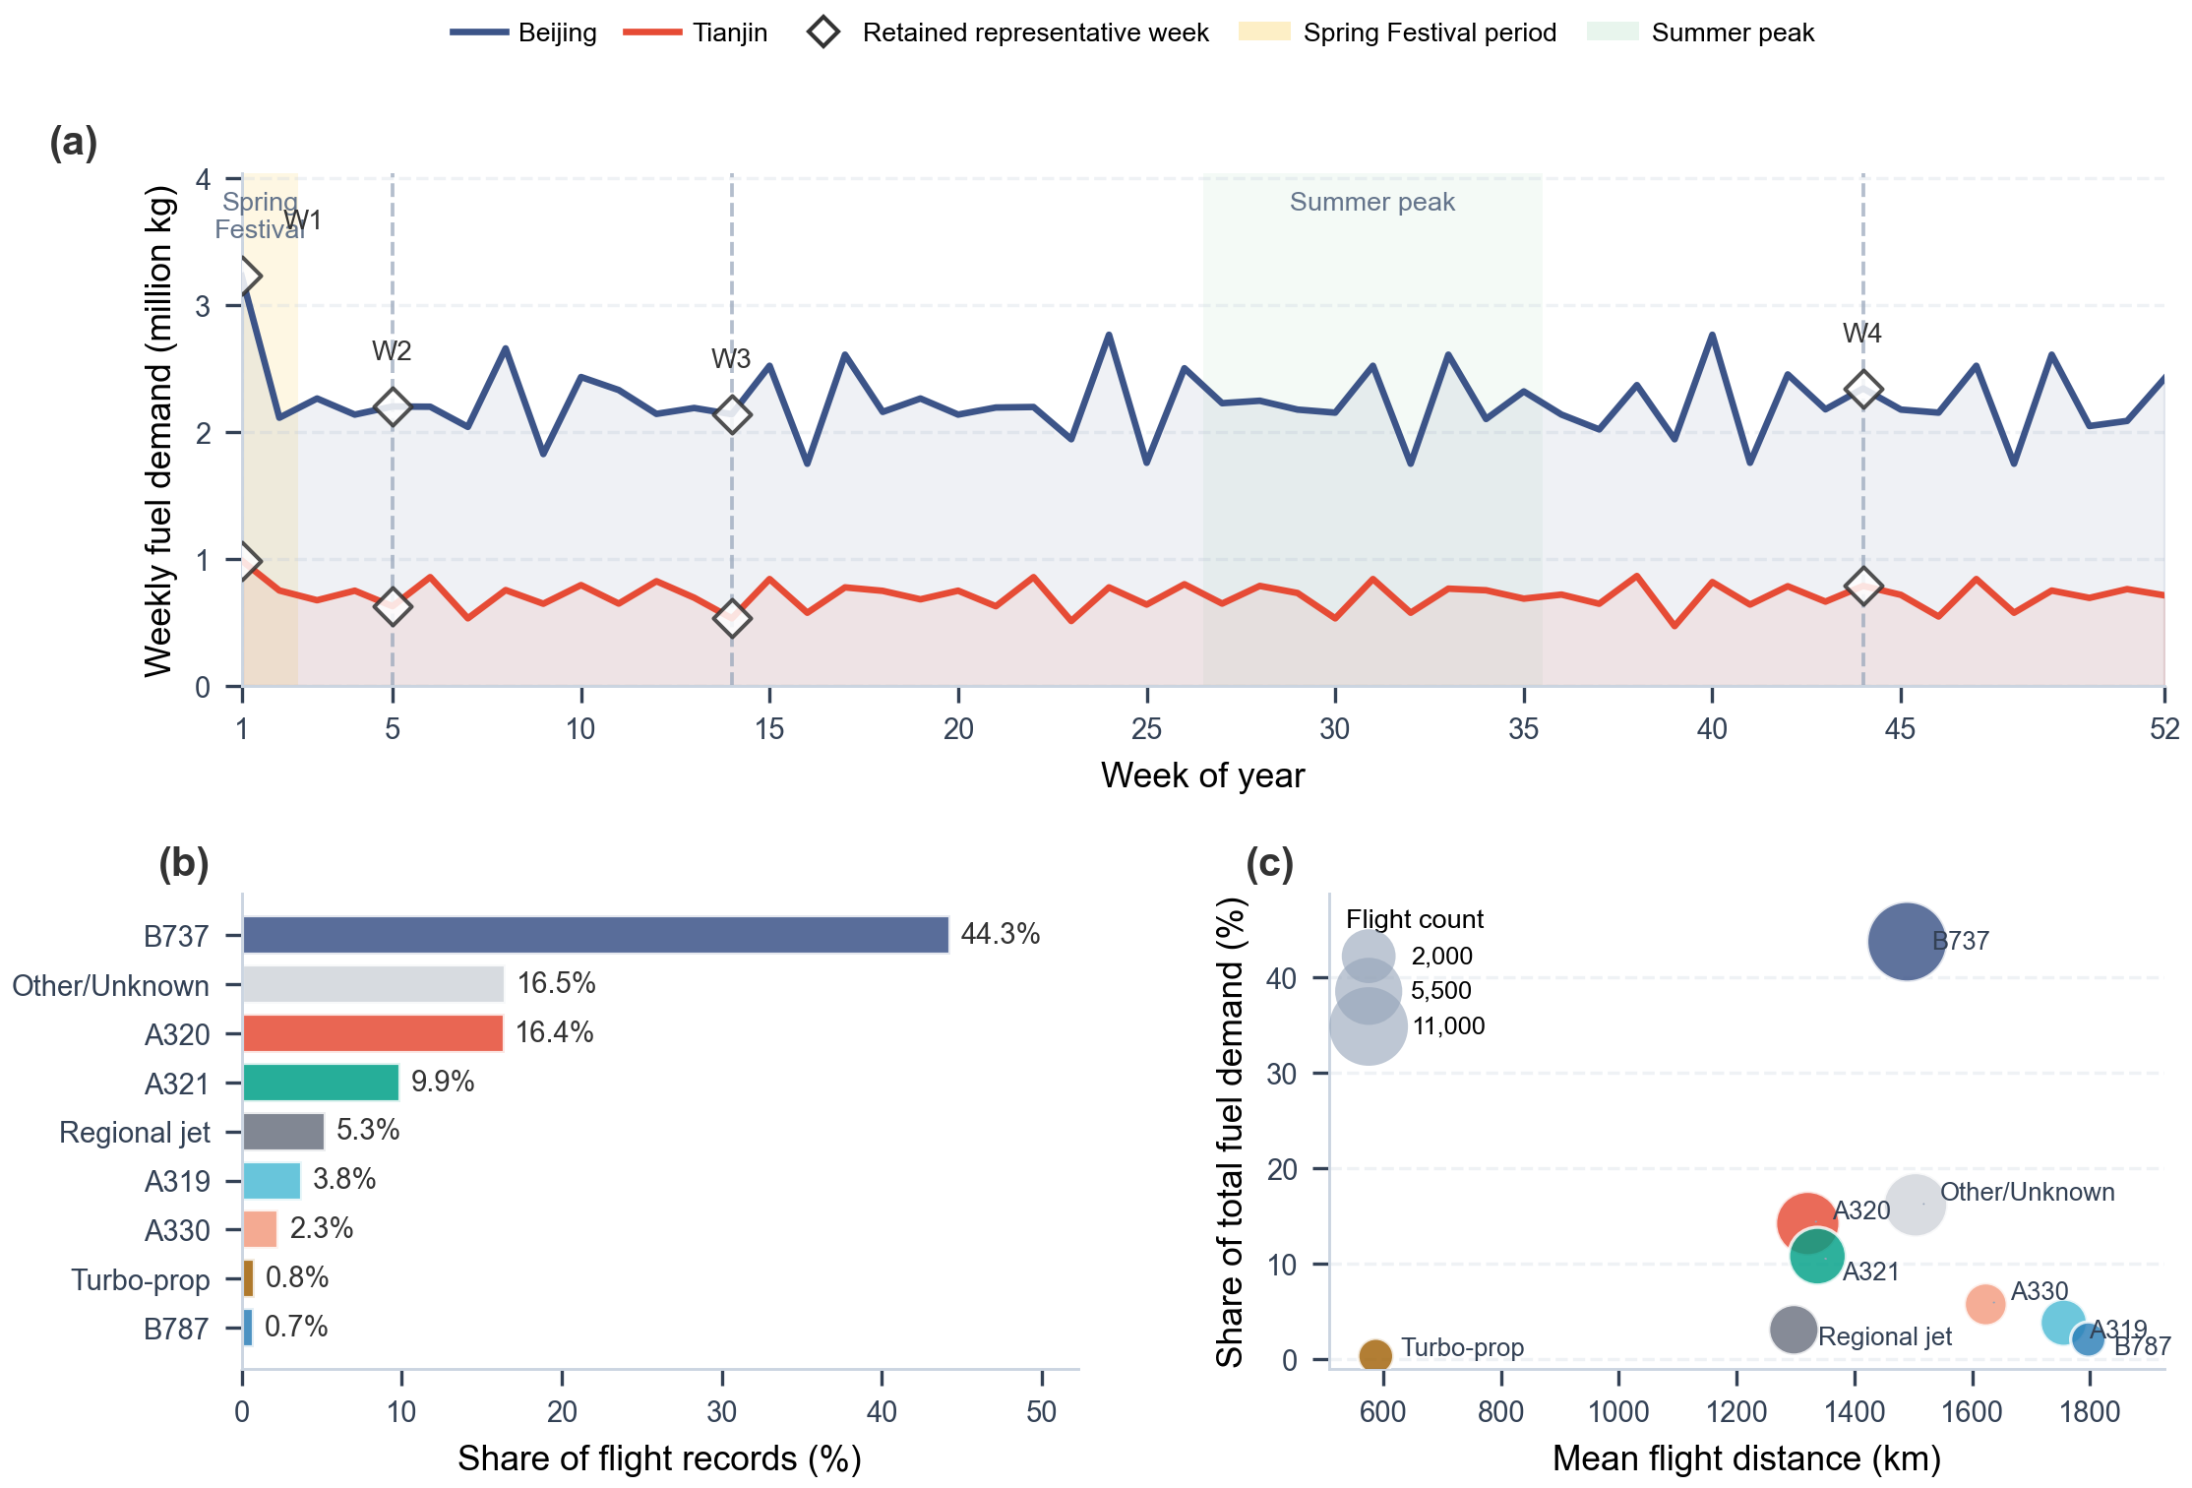
Figure S3. Full-year weekly airport demand, aircraft mix, and aircraft-distance structure for the Beijing-Tianjin demand instance.
Panel (a) restores the omitted raw-year context by plotting all 52 weekly fuel-demand observations and marking the retained original calendar weeks 1, 5, 14, and 44. Panels (b) and (c) summarize the aircraft heterogeneity embedded in the same flight schedule, which supports flight-level pyBADA fuel estimation instead of a single stylized aircraft.
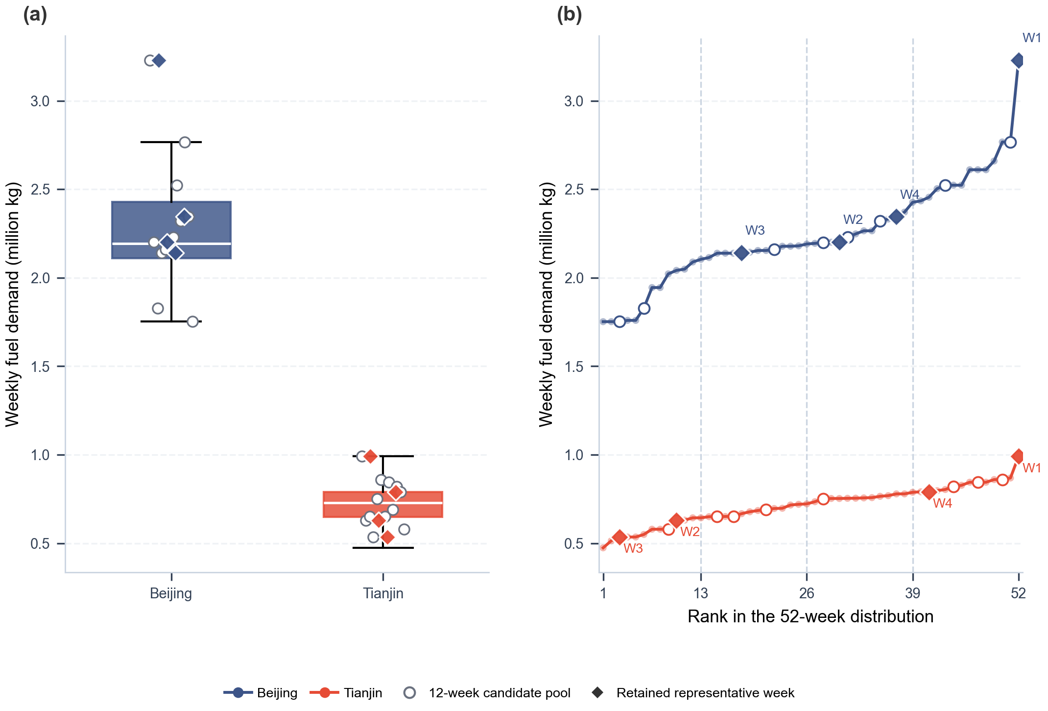
Figure S4. Distribution coverage of the 52-week demand series and positions of the retained weeks.
The boxplots summarize the full 52-week demand distribution for each airport. Open circles show the 12-week candidate pool extracted from the raw year, and filled diamonds show the four retained representative weeks. The ranked-distribution panel confirms that the screening pipeline spans low, medium, and upper-demand positions before reduction to the final 4-week set.

1.3 Renewable electricity data processing
Renewable electricity inputs are reconstructed from plant inventories and meteorological drivers. Plant coordinates define candidate resource locations and hourly reconstructed output supplies the representative-week series. Figures S9–S10 document this data chain. The reconstruction-unit and aggregation limitations are reported in Section 5.1.
For solar generation, the processing chain links plant coordinates and installed capacities to the stored radiation-related drivers used by the solar-generation workflow. For wind generation, nationwide wind-farm coordinates are combined with MERRA-2-based wind-speed fields, hub-height adjustment, and turbine power conversion. The resulting hourly output profiles are therefore generated from physical resource drivers and plant attributes rather than being treated as exogenous electricity-supply records.^{24,25,26,27,28,29,30,31}
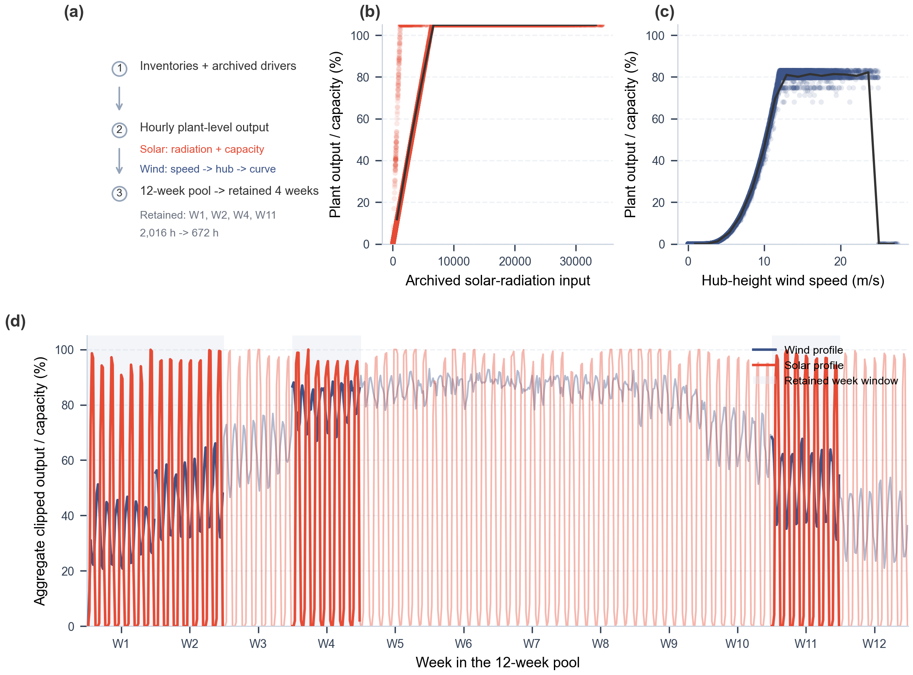
Figure S9. Renewable-data construction from archived meteorological drivers to representative-week optimization inputs.
Panel (a) summarizes the renewable-data chain from plant inventories and archived weather drivers to plant-level hourly output, the 12-week candidate pool, and the retained 4-week optimization horizon. Panels (b) and (c) visualize the stored raw driver-to-output relationships from the archived solar and wind generation tables, confirming that the renewable traces are calculated from radiation or wind-speed inputs rather than used as direct exogenous power records.
The retained calendar weeks are 1, 5, 14 and 44, corresponding to entries 1, 2, 4 and 11 of the twelve-week candidate pool. Production and inventory use 224 three-hour periods across the selected 672 hours.
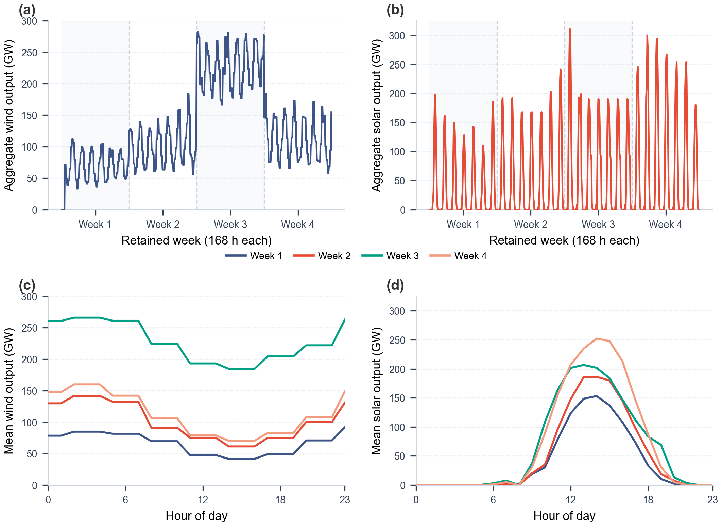
Figure S10. Aggregate renewable production profiles for the four representative weeks.

1.4 Industrial by-product hydrogen and CO₂ data
Industrial by-product hydrogen is represented with two plant-level source layers: refinery-associated hydrogen and steel-sector by-product hydrogen. The refinery dataset contains 180 sites across 27 provinces with an aggregate estimated supply of 1412.56 t H₂/day. The steel dataset contains 211 sites across 28 provinces with an aggregate estimated supply of 150549.27 t H₂/day.^{37,38,39}
These industrial hydrogen values are used as availability upper bounds rather than as forced production levels. In other words, the optimization model may use hydrogen from these nodes when a scenario allows by-product hydrogen, but it is not required to consume all reported by-product supply. This treatment avoids interpreting the inventory as a mandatory dispatch profile and instead uses it as a spatially explicit supply opportunity set.^{38,39}
Industrial carbon data enter the framework through point-source capture layers and through DAC siting logic. For CCU scenarios, the project stores 3,445 industrial capture-source records across 34 provinces and applies source-type-specific capture assumptions to represent point-source CO₂ availability. Coal-power sources dominate the archived table by record count and aggregate capture potential, while gas-power and refinery sources remain important because they differ in capture cost, geographic coverage, and technology assumptions.^{36,40}
The point-source CO₂ table is converted into weekly capture potential and unit capture-cost inputs. Aggregate weekly capture potentials are 179.3 Mt/week from coal power, 3.3 Mt/week from gas power, and 6.7 Mt/week from oil refineries. Median unit capture costs are 150, 180, and 120 yuan/t CO₂, respectively. These values enter CCU pathways as source-specific availability and cost coefficients.^{41,42,43,44,45}
For DAC scenarios, carbon is not drawn from the industrial point-source table. Instead, DAC supply is generated through an explicit DAC module whose siting candidates are attached to renewable or industrial nodes, depending on the scenario configuration. The supplementary metadata retained alongside the model also include 21 CCUS reference records, of which 15 are marked as operating in the source table. These CCUS records are used as contextual infrastructure metadata rather than as direct mandatory CO₂ supply in every pathway.^{46,47,48,49,50,51}

1.5 Transport network construction
Transport-network construction combines existing infrastructure metadata with newly generated candidate routes. The current GIS table contains 436 pipeline polylines, including 317 operating and 44 planned records, with a reported cumulative length of 116,204 km across records that include explicit length metadata. These corridors provide spatial anchors for candidate hydrogen or CO₂ pipeline links and for interpreting where existing rights-of-way may reduce new-build transport burdens.^{36,52,54}
The pipeline layer is not treated as a fully designed future network. Instead, it is used to construct and screen candidate logistics arcs between source, conversion, and demand nodes. The model still decides whether to use available pathway-specific transport options under the scenario assumptions. This distinction is important because the map data describe corridors and reference infrastructure, while the optimization variables represent selected flows and costs within the simplified network.^{52,54}
Downstream synthetic aviation fuel deliveries and other truck-based movements are routed over the road network. The implementation relies on OpenStreetMap-derived road graphs and GraphHopper or OSM shortest-path tools to convert origin-destination coordinate pairs into practical transport distances. This avoids using straight-line distances for truck transport, which would understate travel distance in regions where road geometry, terrain, or network connectivity makes direct routes unrealistic.^{53,57,58,55}
Candidate logistics arcs use the routing settings in Tables S3 and S10. Provincial price maps are retained as input diagnostics in the Supplementary Archive (Fig. S16); their unit metadata require checking before using them as an independent price-validation source.

1.6 Data preprocessing workflow
The raw spatial source tables are much denser than the final optimization network can efficiently handle. Many plant or point-source records are close to one another and would create a large number of nearly redundant candidate arcs if passed directly into the network model. Spatial preprocessing therefore reduces the raw point layers to a smaller set of representative nodes while retaining the geographic structure needed for logistics and siting decisions.^{63,64,65}
The repository applies DBSCAN clustering to renewable-hydrogen, by-product-hydrogen, and CO₂ source layers before arc generation. In the archived renewable clustering run, 24 clusters and 13 direct-connection points were obtained with eps = 60 km and min_samples = 2. The by-product hydrogen clustering run stores 12 clusters and 23 noise points with eps = 15 km, while the stored CO₂ clustering run retains 4 clusters and 8 noise points.⁶²
Cluster-center selection is not based on geometric proximity alone. The center-optimization routine balances within-cluster travel and access to existing pipeline corridors with a pipeline-weight term of 0.3; shared pipeline use is further discounted by a factor of 0.65. This means a representative node can be favored not only because it is central to nearby source points, but also because it is better connected to the transport infrastructure layer.^{63,64}
After clustering, candidate logistics arcs are generated by connecting business nodes to the 10 nearest pipeline nodes in the precomputed super graph and by calculating shortest-path road distances for truck transport. The preprocessing outputs are therefore the bridge between the raw GIS and time-series data in Sections 1.1-1.5 and the scenario-specific optimization models described in the later sections of the appendix.^{52,54}
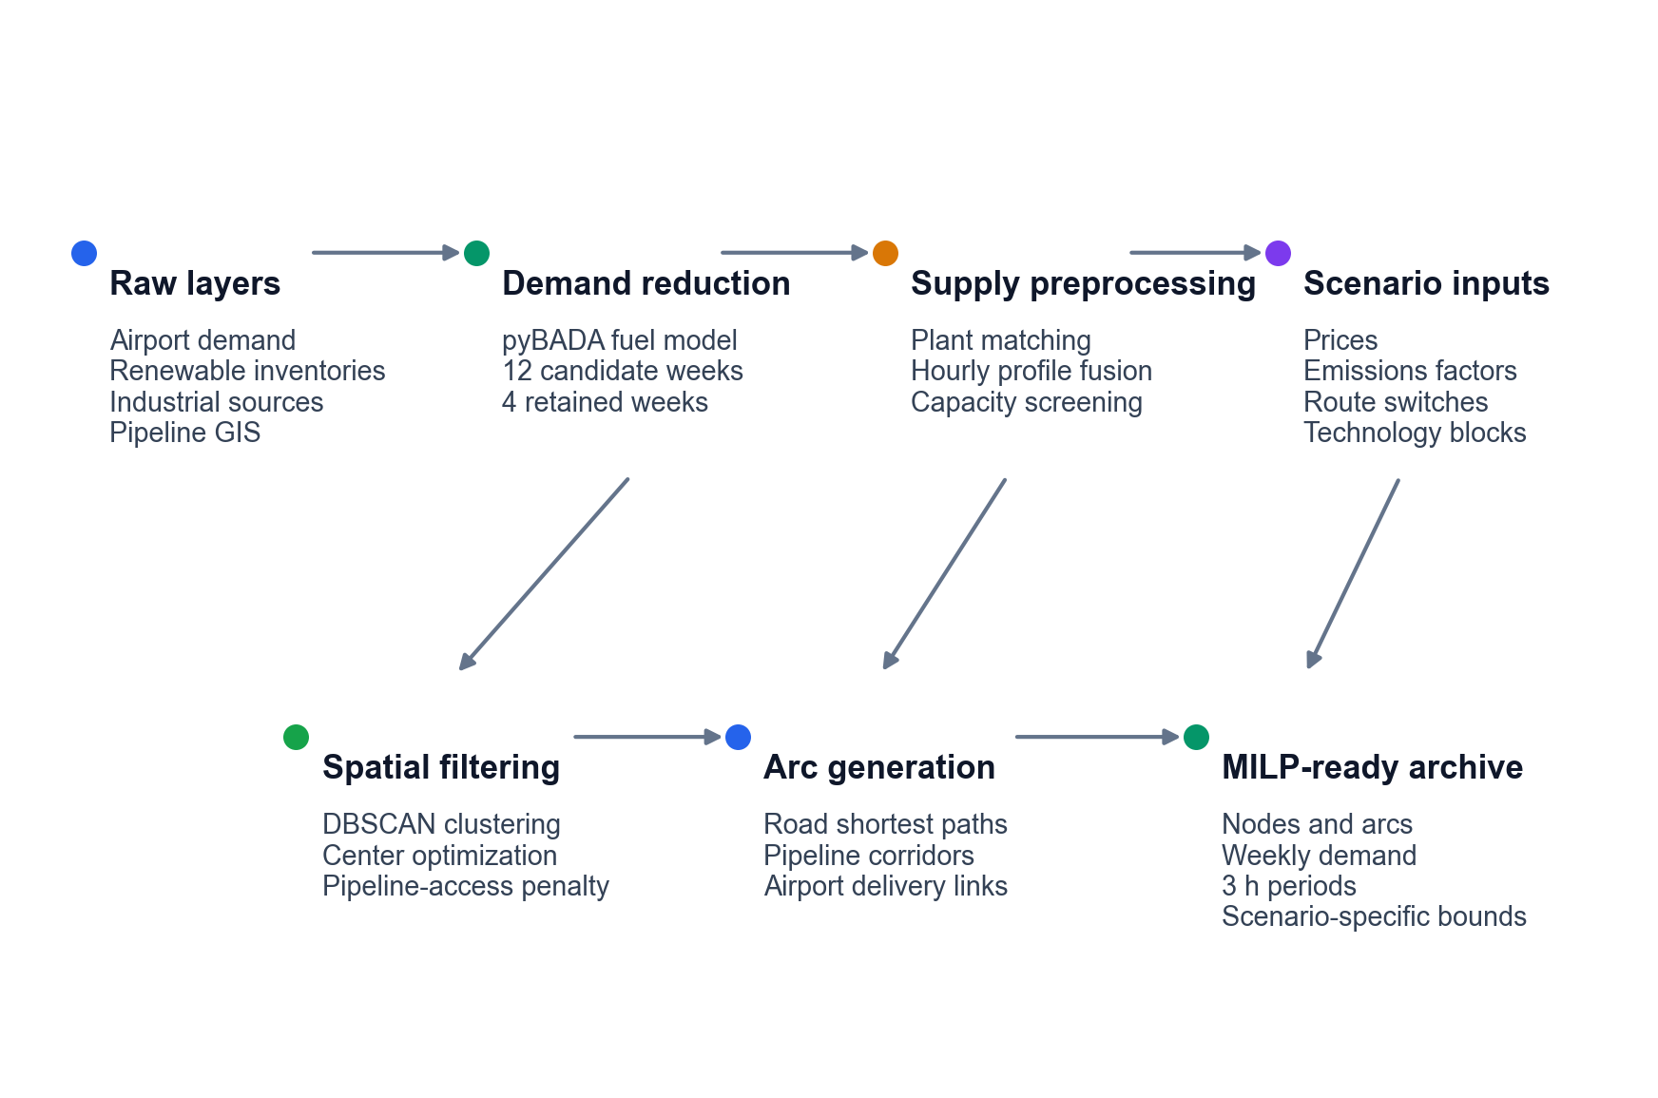
Figure S18. Preprocessing workflow from raw datasets to optimization-ready inputs.

2 Scenario Definition and Underlying Assumptions

2.1 Spatial and temporal boundary
The optimization domain spans mainland China on the supply side: renewable plants, industrial hydrogen sources, carbon sources, candidate synthesis nodes, and infrastructure corridors are all screened nationally. The current demand instance is narrower. In the archived four-week runs, weekly airport demand is represented by Beijing and Tianjin as a northern-China test system, which keeps the demand side concrete while preserving a national supply search space.
Time is represented on two linked layers. Raw renewable profiles are available hourly, but the optimization model aggregates production and inventory decisions into 3-hour periods, giving 56 periods per representative week. Transport flows and airport demand are enforced at the weekly level. This combination retains operational variability while keeping the problem size manageable for repeated scenario comparisons.
Table S3 Spatial, temporal, and routing boundary parameters for the archived optimization instance.
Parameter | Baseline value and unit | Scope | Model role
Supply-side search domain | Mainland China (categorical) | All scenarios | Defines the candidate region for energy, feedstock, synthesis, and infrastructure nodes.
Demand nodes | Beijing and Tianjin airports (categorical) | Archived demand instance | Defines the SAF sink nodes used in the four-week optimization runs.
Representative horizon | 4 weeks | All scenarios | Reduced annual horizon used for comparative optimization.
Production time step | 56 periods/week; 3 h/period periods; hours | Production and inventory balances | Aggregates hourly renewable profiles into tractable production periods.
Demand and delivery time step | Weekly time step | Airport demand and final-fuel transport | Enforces airport demand and delivered SAF balances at the week level.
Candidate-arc distance screen | 1,000 km | All transport candidate generation | Removes infeasible long-distance candidate arcs before optimization.
Road-routing engine | GraphHopper at localhost:8989; cache expiry 168 h engine; hours | Truck-routing arcs | Provides routed road distances for short-distance truck transport.
Pipeline connector graph | k = 10; algorithm = johnson nearest connectors | Pipeline-enabled H₂/CO₂ cases | Restricts pipeline candidate generation to a sparse super-graph representation.

2.2 System boundary
The system boundary starts with carbon and hydrogen acquisition and ends with synthetic aviation fuel delivery to airport nodes. Upstream stages include renewable-power-driven electrolysis, industrial by-product hydrogen use, natural-gas- or coal-linked carbon supply, industrial capture, and DAC, depending on scenario definition. Midstream stages include route-specific conversion through FT or MTJ, inventory buffering, and interregional transport. Aircraft use, airport tank-farm operations, and detailed refueling logistics are outside the modeled system boundary.
Table S4 Physical system-boundary inclusions and simplifications.
System element | Included representation and model treatment | Explicit exclusions
Hydrogen supply | Green electrolysis, industrial by-product H₂, and fossil/process H₂ are activated by scenario. Hydrogen enters as source availability, conversion efficiency, transport, and capacity constraints. | A national hydrogen-market equilibrium and sub-3 h electrolyzer dispatch are not modeled.
Carbon supply | Industrial point-source CO₂, DAC CO₂, natural-gas carbon, and coal-derived carbon are represented by pathway. Carbon source class determines both feedstock logistics and carbon-accounting treatment. | Detailed plant-level capture retrofits and endogenous carbon-source expansion are not optimized.
Conversion facilities | FT/direct SAF, MTJ, and CTL/coal-gasification blocks are represented with route-specific capacity limits. Conversion choice is a scenario definition, not an endogenous route-selection decision. | Internal reactor scheduling and equipment sizing below the model time step are not represented.
Intermediate inventories | H₂, CO₂, methanol, and SAF inventories are included only where required by the pathway block. Inventory buffers connect the production time step to weekly delivery requirements. | Tank-farm design, boil-off, and safety-zone layout are outside the optimization boundary.
Transport system | H₂, CO₂, natural gas, methanol intermediate, and SAF logistics are modeled through candidate arcs. Transport modes impose distance screens, capacity factors, and cost coefficients. | Vehicle-count scheduling and pipe-diameter design are not optimized explicitly.
Demand and use | Weekly SAF demand is imposed at the Beijing and Tianjin airport nodes. Airport demand is a fixed sink for supply-chain optimization. | Aircraft assignment, refueling operations, and downstream combustion allocation are not modeled.
Emissions accounting | Lifecycle tracking, construction emissions, utilization credits, and benchmark conversion are configured by scenario. Ex-post carbon intensity and displacement metrics use the same accounting flags across scenario families. | Policy feedbacks and endogenous carbon-price responses are not represented.

2.3 Supply-chain structure assumptions
The implemented supply chain is abstracted as a production–transport–consumption network. Production nodes combine carbon sourcing, hydrogen sourcing, and synthetic aviation fuel synthesis; transport links move hydrogen, carbon dioxide, methanol intermediates where needed, and final synthetic aviation fuel; airport nodes absorb weekly demand. Nodes are treated as perfectly mixed. Internal plant scheduling is not modeled below the chosen time step, and transport capacity is represented with upper bounds rather than detailed vehicle-count or pipe-diameter design variables.
Scenario-specific pathway structure is represented through activation switches. FT routes link carbon and hydrogen consumption directly to synthetic aviation fuel output. MTJ routes add an explicit methanol intermediate together with methanol inventory. DAC and industrial-capture pathways keep their own carbon-accounting rules, whereas natural-gas and coal pathways treat carbon as fossil feedstock in ex-post emissions accounting.
Table S5 Route-module and inventory activation assumptions.
Module | Active scenarios | Modeled state | Key parameterization and role
Direct FT / RWGS-FT | GTL, CCU-GH-FT, CCU-BH-FT, DAC-GH-FT, DAC-BH-FT | Direct SAF output; no methanol inventory. | RWGS energy coefficient = 2.5; FT energy coefficient = 3.5 for CCU-GH-FT; GTL FT energy coefficient = 5. Represents one-step/direct SAF synthesis scenarios.
MTJ | GTL-GH, GTL-BH, CCU-GH-MTJ, CCU-BH-MTJ, DAC-GH-MTJ, DAC-BH-MTJ | Methanol intermediate and methanol inventory active. | MTJ process-energy coefficient = 800 for CCU/DAC-style MTJ configs; 4,500 for natural-gas MTJ configs. Separates methanol production from final jet-fuel synthesis.
CTL / coal gasification | CTL, CTL-BH | Coal-derived carbon and CTL/SAF reactor block active. | Coal price = 525 yuan/t; carbon content = 0.75; gasification efficiency = 0.75. Provides the grey coal-linked baseline and by-product-H₂ variant.
Industrial point-source CO₂ | CCU-GH-MTJ, CCU-GH-FT, CCU-BH-MTJ, CCU-BH-FT | Industrial capture-source layer active. | scenario_type = industrial_capture; utilization credit factor = -1.0. Credits captured industrial CO₂ fixed into SAF under the archived accounting convention.
DAC CO₂ | DAC-GH-MTJ, DAC-GH-FT, DAC-BH-MTJ, DAC-BH-FT | DAC module and DAC siting logic active. | Capture efficiency = 0.95; capture energy = 350 kWh/t CO₂. Treats atmospheric CO₂ fixed into SAF as a carbon-removal credit.
By-product H₂ | CTL-BH, CCU-BH-MTJ, CCU-BH-FT, DAC-BH-MTJ, DAC-BH-FT, GTL-BH | Industrial by-product H₂ source layer active. | H₂ equipment lifetime convention = 20 yr; capacity factor = 0.9. Defines blue variants that replace green electrolysis with by-product H₂ supply.

2.4 Pathway screening and selection rationale
The 13 scenarios in Tables S6–S7 compare the specified coal and natural-gas reference configurations with captured-CO₂ pathways using green or industrial by-product hydrogen. The scenario set follows the source and conversion modules represented in the model. It is a bounded comparison set: pathway-level nondominance applies to these scenarios, and does not establish optimality over every technically possible SAF route. Table S20 gives the reasons for excluding additional combinations and the model additions each would require.
For the represented CO₂-to-fuel modules, hydrogen is an explicit consumed feedstock. Idealized balances illustrate the requirement: CO₂ + 3H₂ → CH₃OH + H₂O for methanol formation, and nCO₂ + (3n + 1)H₂ → CₙH₂ₙ₊₂ + 2nH₂O for an overall paraffin-forming balance. These relations illustrate material requirements rather than replacing the model yields. With both hydrogen input and alternative reducing pathways disabled, the existing conversion balances permit zero fuel output. A CO₂-only positive-output scenario is therefore unavailable within this formulation.
Other omissions reflect the comparison boundary. Supplementary hydrogen in a natural-gas FT chain, fossil-derived hydrogen for captured CO₂, coal-to-methanol upgrading, and other hybrid supply chains require explicit source, conversion and allocation choices. Their omission from Tables S6–S7 does not establish technical infeasibility or inferior performance. In particular, the retained natural-gas cases comprise an internally supplied FT reference and two externally supplied MTJ variants, so effects of hydrogen origin and conversion route cannot be isolated across that family.
Biomass-, lipid- and fermentation-based routes require feedstock collection, pretreatment, seasonal supply and conversion modules beyond the represented source network. HEFA, biomass FT and alcohol-to-jet are established comparison categories in ICAO documentation. Their exclusion is a modelling-scope choice and does not imply that these technologies cannot produce aviation fuel. The present model does not establish ASTM approval or CORSIA eligibility for any individual fuel batch.119,120
Table S20 separates combinations that cannot satisfy the represented conversion balances from technically possible routes outside the evaluated scenario set. This distinction limits interpretation of the retained pathways without inventing a universal feasibility screen.
Table S6 Implemented pathway set retained for appendix reporting.
Class | Scenario | Pathway definition | Technical description
Grey | CTL | Carbon: Coal; H₂: Fossil-based hydrogen; route: Direct liquefaction / CTL | Conventional coal-to-liquids pathway using fossil-based hydrogen.
Grey | CTL-BH | Carbon: Coal; H₂: By-product hydrogen; route: Direct liquefaction / CTL | Coal-to-liquids pathway integrated with industrial by-product hydrogen.
Blue | CCU-BH-MTJ | Carbon: Industrial captured CO₂; H₂: By-product hydrogen; route: Methanol-to-Jet | Industrial captured CO₂ coupled with by-product hydrogen via Methanol-to-Jet synthesis.
Blue | CCU-BH-FT | Carbon: Industrial captured CO₂; H₂: By-product hydrogen; route: Fischer–Tropsch | Industrial captured CO₂ coupled with by-product hydrogen via Fischer–Tropsch synthesis.
Blue | DAC-BH-MTJ | Carbon: Direct air captured CO₂; H₂: By-product hydrogen; route: Methanol-to-Jet | Direct air captured CO₂ coupled with by-product hydrogen via Methanol-to-Jet synthesis.
Blue | DAC-BH-FT | Carbon: Direct air captured CO₂; H₂: By-product hydrogen; route: Fischer–Tropsch | Direct air captured CO₂ coupled with by-product hydrogen via Fischer–Tropsch synthesis.
Blue | GTL-BH | Carbon: Natural gas; H₂: By-product hydrogen; route: Methanol-to-Jet | Natural-gas-based pathway enhanced by industrial by-product hydrogen via Methanol-to-Jet synthesis.
Blue | GTL-GH | Carbon: Natural gas; H₂: Green hydrogen; route: Methanol-to-Jet | Natural-gas-based pathway integrated with green hydrogen via Methanol-to-Jet synthesis.
Blue | GTL | Carbon: Natural gas; H₂: In situ process hydrogen / no external H₂ input; route: Fischer–Tropsch | Conventional natural-gas-to-liquids pathway via Fischer–Tropsch without external hydrogen input.
Green | DAC-GH-MTJ | Carbon: Direct air captured CO₂; H₂: Green hydrogen; route: Methanol-to-Jet | Direct air captured CO₂ coupled with green hydrogen via Methanol-to-Jet synthesis.
Green | DAC-GH-FT | Carbon: Direct air captured CO₂; H₂: Green hydrogen; route: Fischer–Tropsch | Direct air captured CO₂ coupled with green hydrogen via Fischer–Tropsch synthesis.
Green | CCU-GH-MTJ | Carbon: Industrial captured CO₂; H₂: Green hydrogen; route: Methanol-to-Jet | Industrial captured CO₂ coupled with green hydrogen via Methanol-to-Jet synthesis.
Green | CCU-GH-FT | Carbon: Industrial captured CO₂; H₂: Green hydrogen; route: Fischer–Tropsch | Industrial captured CO₂ coupled with green hydrogen via Fischer–Tropsch synthesis.
For reproducibility, the pathway names are complemented by an activation matrix. The matrix reports which conversion block, hydrogen module, carbon module, inventory treatment, and carbon-accounting rule is active in each retained scenario, without exposing repository file paths as scientific content.
Table S7 Scenario activation matrix for the retained pathway definitions.
Scenario | Source modules | Conversion and inventory | Carbon-accounting treatment
CTL | Fossil-based H₂ baseline; Coal-derived carbon | CTL / coal gasification; methanol inventory: not active | Fossil feedstock; utilization credit disabled
CTL-BH | Industrial by-product H₂; Coal-derived carbon | CTL / coal gasification; methanol inventory: not active | Fossil feedstock; utilization credit disabled
CCU-BH-MTJ | Industrial by-product H₂; Industrial point-source CO₂ | MTJ; methanol inventory: active | Industrial CO₂ utilization credit enabled; credit factor = -1.0
CCU-BH-FT | Industrial by-product H₂; Industrial point-source CO₂ | Direct FT; methanol inventory: not active | Industrial CO₂ utilization credit enabled; credit factor = -1.0
DAC-BH-MTJ | Industrial by-product H₂; Direct air capture CO₂ | MTJ; methanol inventory: active | Atmospheric CO₂ removal credit enabled; credit factor = -1.0
DAC-BH-FT | Industrial by-product H₂; Direct air capture CO₂ | Direct FT; methanol inventory: not active | Atmospheric CO₂ removal credit enabled; credit factor = -1.0
GTL-BH | Industrial by-product H₂; Natural-gas carbon | MTJ; methanol inventory: active | Fossil feedstock; utilization credit disabled
GTL-GH | Green electrolysis; Natural-gas carbon | MTJ; methanol inventory: active | Fossil feedstock; utilization credit disabled
GTL | No external H₂ input; Natural-gas carbon | Direct FT; methanol inventory: not active | Fossil feedstock; utilization credit disabled
DAC-GH-MTJ | Green electrolysis; Direct air capture CO₂ | MTJ; methanol inventory: active | Atmospheric CO₂ removal credit enabled; credit factor = -1.0
DAC-GH-FT | Green electrolysis; Direct air capture CO₂ | Direct FT; methanol inventory: not active | Atmospheric CO₂ removal credit enabled; credit factor = -1.0
CCU-GH-MTJ | Green electrolysis; Industrial point-source CO₂ | MTJ; methanol inventory: active | Industrial CO₂ utilization credit enabled; credit factor = -1.0
CCU-GH-FT | Green electrolysis; Industrial point-source CO₂ | Direct FT; methanol inventory: not active | Industrial CO₂ utilization credit enabled; credit factor = -1.0

2.5 Economic, policy, and lifecycle assumptions
Economic inputs are treated as exogenous over the representative year. The scenario parameter sets define the project life, discount rate, shortage penalty, technology lifetimes, power prices, fuel prices, and solver tolerances before each pathway is optimized. Electricity tariffs, fuel feedstock prices, DAC costs, and carbon-accounting switches therefore enter as scenario assumptions rather than as endogenous market outcomes. Carbon price and subsidy effects, when considered, enter the model as cost terms rather than through endogenous policy-response loops.
Table S8 Economic, policy, and lifecycle assumptions used in scenario definitions.
Parameter | Baseline value and unit | Scenario scope | Model role
Project evaluation life | 20 yr | All scenarios | Defines the present-value horizon for cost and levelized-cost calculations.
Discount rate | 8% annual fraction | All scenarios | Annualizes and discounts capital and operating cost streams.
Unserved-demand penalty | 2,500 yuan/kg SAF | All scenarios | Discourages unmet airport demand while preserving model feasibility.
LCO-SAF screening threshold | 20 for GTL/GTL-GH/GTL-BH; 50 for CTL/CTL-BH; 1000 for most CCU/DAC cases; 1200 for CCU-GH-FT yuan/kg SAF | Scenario-specific | Used as a configuration-level filter and plausibility screen, not as an endogenous policy target.
Electrolyzer lifetime | 15 for green-H₂ cases; 20 for by-product-H₂ and CTL-BH cases yr | H₂-supply scenarios with an H₂ capacity block | Sets capital recovery for the H₂ supply block.
Synthesis and logistics lifetimes | MTJ/RWGS 20; FT/SAF reactor 25; pipeline 30; storage 25; transport vehicle 20 yr | Route-specific | Sets annualized capital recovery for route and transport assets.
Capacity factors | Electrolyzer 0.75 for green-H₂ cases and 0.90 for by-product-H₂/CTL-BH cases; synthesis 0.85; pipeline 0.95; storage 0.90; transport 0.75 fraction | Scenario-family-specific | Translates installed capacity into available production, storage, and transport service.
Electricity prices | Wind 0.35; solar 0.4; grid 0.6 yuan/kWh | Pathways using renewable or grid electricity | Exogenous operating-cost inputs for electricity-consuming steps.
Natural-gas price | 4.2 yuan/m3 | GTL, GTL-GH, GTL-BH | Feedstock price for natural-gas-based SAF pathways.
Coal price | 525 yuan/t | CTL, CTL-BH | Feedstock price for coal-linked CTL pathways.
DAC capture cost | 4,500; 2030 reference = 2,500 yuan/t CO₂ | DAC-GH-MTJ, DAC-GH-FT, DAC-BH-MTJ, DAC-BH-FT | Exogenous cost for atmospheric CO₂ capture.

2.6 Feedstock, process, and capture assumptions
Feedstock and process parameters define the physical conversion assumptions that differ across pathway families. The table separates hydrogen production, fossil feedstock use, coal gasification, DAC capture, and route-specific process coefficients so that each parameter block can be traced to the scenarios in which it is active.
Table S9 Feedstock, process, and capture assumptions used in pathway definitions.
Parameter block | Baseline value and unit | Scenario scope | Model role
Electrolysis efficiency | 0.7 fraction | CCU/DAC/CTL-style configs with electrolysis blocks | Converts electricity input into H₂ production.
Electrolysis efficiency, natural-gas MTJ | 0.8 fraction | GTL-GH, GTL-BH | Applies to the H₂ addition block used in natural-gas MTJ configurations.
Electrolysis electricity intensity | 55; CCU-GH-FT = 50 kWh/kg H₂ | H₂-producing pathway blocks | Links H₂ production to electricity demand.
Hydrogen market-price proxy | 25; natural-gas MTJ configs = 30 yuan/kg H₂ | H₂ supply and transport cost blocks | Provides the exogenous H₂ price level used in scenario cost terms.
Natural-gas feedstock | Price 4.2; extraction intensity 0.25; pipeline-transport coefficient 0.01 (mixed) | GTL, GTL-GH, GTL-BH | Defines natural-gas feedstock cost and upstream-emissions coefficients.
Coal feedstock | Type bituminous; carbon content 0.75; CO₂ yield 2.44; coal-to-SAF use 1 fraction; kg CO₂/kg coal; kg coal/kg SAF | CTL, CTL-BH | Defines coal material input and carbon yield for the coal-linked scenarios.
Coal gasification | Efficiency 0.75; energy 8 MJ/kg (2.22 kWh/kg); energy cost 0.05 fraction; MJ/kg; kWh/kg; yuan/MJ | CTL, CTL-BH | Defines gasification energy use before CTL/SAF conversion.
DAC capture module | Capture efficiency 0.95; CO₂ purity 0.995; energy 350; module capacity 2,000; availability 0.9 fraction; kWh/t CO₂; t/yr | DAC-GH-MTJ, DAC-GH-FT, DAC-BH-MTJ, DAC-BH-FT | Defines the DAC supply block and modular deployment constraint.
GTL direct FT process | NG upstream emission 0.5; NG process emission 0.8; FT process emission 1.5; FT process-energy coefficient 5 (configuration coefficients) | GTL | Provides process-emissions and energy coefficients for the direct gas-to-liquids route.
Natural-gas MTJ process | NG-to-methanol rate 1.2; H₂ addition rate 40; MTJ process-energy coefficient 4,500 (configuration coefficients) | GTL-GH, GTL-BH | Defines the methanol-intermediate step for natural-gas MTJ routes.

2.7 Transport and routing assumptions
Transport assumptions define which candidate arcs can enter the network and how their cost and capacity are represented. Distance limits are screening parameters, while truck capacities, cost curves, capacity factors, and routing-cache settings determine the attributes assigned to feasible arcs before optimization.
Table S10 Transport and routing assumptions used to construct candidate logistics arcs.
Commodity / mode | Transport limit | Capacity or cost parameter | Scenario scope
H₂ pipeline | 500 km | CAPEX 5,000,000 yuan/km; cost curve 25 km: 1.91; 50 km: 1.04; 100 km: 0.56; 200 km: 0.3; 300 km: 0.21; 400 km: 0.16; 500 km: 0.13 yuan/(kg H₂ per 100 km) | H₂-pipeline-enabled green, DAC, CCU, CTL, and gas-MTJ cases
H₂ truck | 200 km | Truck capacity 500 kg; max 15 trucks/day; cost 2 yuan/(kg km); capacity factor 0.8 | Green, DAC, CCU, and CTL H₂ logistics
CO₂ pipeline | 500 km | Capacity factor 0.95; DAC cost curve 25 km: 150; 50 km: 80; 100 km: 45; 200 km: 25; 300 km: 18 yuan/(t CO₂ per 100 km) | CCU and DAC carbon logistics where CO₂ pipeline distance is enabled
CO₂ truck | 300 km | Truck capacity 20 t; max 25 trucks/day; cost 0.8 yuan/(t km); capacity factor 0.85 | CCU, DAC, and CTL carbon logistics
Natural-gas pipeline direct | 1,500 km | Capacity factor 0.95 | GTL direct FT configuration
LNG terminal supply | 800 km | Capacity factor 0.92 | GTL direct FT configuration
Natural-gas truck constraint | n/a m3; trucks/day | Truck capacity 1,200 m3; max 20 trucks/day | Natural-gas logistics constraints in GTL-family configs
Airport-integrated option | 100 for CO₂/H₂ cases; 500 for GTL km | Cost 5 yuan/kg in CO₂/H₂ cases; capacity factor 0.9 | Local production or delivery option around airport demand nodes
Routing cache | 168 h | GraphHopper routing enabled; pipeline super graph k = 10; CO₂ super graph k = 10 | Repeated scenario runs and candidate-arc preprocessing

2.8 Capacity, solver, and carbon-accounting assumptions
The final scenario-assumption layer defines capacity bounds, minimum-output constraints, MILP tolerances, and carbon-accounting switches. These parameters do not change the pathway identity, but they determine the feasible scale of each scenario and the way cost and emissions are reported after optimization.
Table S11 Capacity bounds and MILP settings used by scenario.
Scenario | Route | Capacity bounds | Output and cost screen | MILP settings
CTL | CTL | CTL/SAF reactor: 0.01-1,000,000 kg/h; H₂ capacity: 100-100,000 kg/h | Minimum output: n/a; LCO screen: 50 yuan/kg | 3,600 s; gap 1%; 100 threads
CTL-BH | CTL | CTL/SAF reactor: 0.01-1,000,000 kg/h; H₂ capacity: 100-100,000 kg/h | Minimum output: n/a; LCO screen: 50 yuan/kg | 3,600 s; gap 1%; 100 threads
CCU-BH-MTJ | MTJ | SAF reactor: 0-1,000,000 kg/h; H₂ capacity: 100-100,000 kg/h | Minimum output: SAF: 100 kg/yr; LCO screen: 1,000 yuan/kg | 3,600 s; gap 1%; 100 threads
CCU-BH-FT | FT | SAF reactor: 0.01-1,000,000 kg/h; H₂ capacity: 100-100,000 kg/h | Minimum output: SAF: 100 kg/yr; LCO screen: 1,000 yuan/kg | 3,600 s; gap 1%; 100 threads
DAC-BH-MTJ | MTJ | SAF reactor: 0.01-1,000,000 kg/h; H₂ capacity: 100-100,000 kg/h | Minimum output: SAF: 100 kg/yr; LCO screen: 1,000 yuan/kg | 3,600 s; gap 1%; 100 threads
DAC-BH-FT | FT | SAF reactor: 0.01-1,000,000 kg/h; H₂ capacity: 100-100,000 kg/h | Minimum output: SAF: 100 kg/yr; LCO screen: 1,000 yuan/kg | 3,600 s; gap 1%; 100 threads
GTL-BH | MTJ | MTJ plant: 0.01-100,000 kg/h; H₂ capacity: 100-100,000 kg/h | Minimum output: MTJ: 100 kg/yr; LCO screen: 20 yuan/kg | 3,600 s; gap 1%; 100 threads
GTL-GH | MTJ | MTJ plant: 0.01-100,000 kg/h; H₂ capacity: 100-100,000 kg/h | Minimum output: MTJ: 100 kg/yr; LCO screen: 20 yuan/kg | 3,600 s; gap 1%; 100 threads
GTL | FT | FT reactor: 0-1,000,000 kg/h; H₂ capacity: not active | Minimum output: SAF: 100 kg/yr; LCO screen: 20 yuan/kg | 3,600 s; gap 1%; 100 threads
DAC-GH-MTJ | MTJ | SAF reactor: 0-1,000,000 kg/h; H₂ capacity: 100-100,000 kg/h | Minimum output: SAF: 100 kg/yr; LCO screen: 1,000 yuan/kg | 3,600 s; gap 3%; 192 threads
DAC-GH-FT | FT | SAF reactor: 0.01-1,000,000 kg/h; H₂ capacity: 100-100,000 kg/h | Minimum output: SAF: 100 kg/yr; LCO screen: 1,000 yuan/kg | 3,600 s; gap 3%; 192 threads
CCU-GH-MTJ | MTJ | SAF reactor: 0-1,000,000 kg/h; H₂ capacity: 100-100,000 kg/h | Minimum output: SAF: 100 kg/yr; LCO screen: 1,000 yuan/kg | 3,600 s; gap 1%; 100 threads
CCU-GH-FT | FT | RWGS-FT reactor: 0-1,000,000 kg/h; H₂ capacity: 100-100,000 kg/h | Minimum output: SAF: 100 kg/yr; LCO screen: 1,200 yuan/kg | 10,800 s; gap 1%; 100 threads
Table S12 Carbon-accounting assumptions and emissions benchmark parameters.
Accounting assumption | Baseline value and unit | Scenario scope | Interpretation
Conventional jet benchmark | 89 gCO2e/MJ | All scenarios | Reference value for carbon-intensity comparison.
SAF energy-content conversion | 43.15 MJ/kg | All scenarios | Converts mass-based SAF output to energy-basis carbon intensity.
CORSIA benchmark limit | 30 gCO2e/MJ | All scenarios | Reference policy benchmark retained in the archived configuration.
Lifecycle tracking flags | Enabled; facility construction included; lifecycle amortization enabled (categorical) | All scenarios | Keeps construction and lifecycle allocation inside ex-post emissions reporting.
Industrial CO₂ utilization credit | -1.0 dimensionless credit factor | CCU-GH-MTJ, CCU-GH-FT, CCU-BH-MTJ, CCU-BH-FT | Credits industrial point-source CO₂ fixed into SAF according to the archived accounting switch.
DAC removal credit | -1.0; DAC capture emission 7; DAC capture energy 350 credit factor; configuration coefficients | DAC-GH-MTJ, DAC-GH-FT, DAC-BH-MTJ, DAC-BH-FT | Treats atmospheric CO₂ fixed into SAF as carbon removal while retaining DAC process burdens.
Natural-gas fossil-feedstock treatment | Utilization credit disabled; NG extraction 0.25; NG transport 0.01 (configuration coefficients) | GTL-GH, GTL, GTL-BH | Counts natural-gas-derived carbon as fossil feedstock rather than carbon removal.
Coal fossil-feedstock treatment | Utilization credit disabled; mining 0.04; transport 0.05; gasification direct 0.15; capture efficiency 0.85 configuration coefficients; fraction | CTL, CTL-BH | Counts coal-derived carbon as fossil feedstock.
Transport-emission coefficients | H₂ truck 0.15; CO₂ truck 0.08; SAF truck 0.12; H₂ pipeline 0.02; CO₂ pipeline 0.01; NG truck 0.1 (configuration coefficients) | Relevant transport arcs | Applied in ex-post transport-emissions accounting.

3 Methodological Supplement
Figure S19 summarizes the cost-minimizing network model for the 13 pathway cases. The resource candidate domain is mainland China and the demand instance covers Beijing and Tianjin airports.
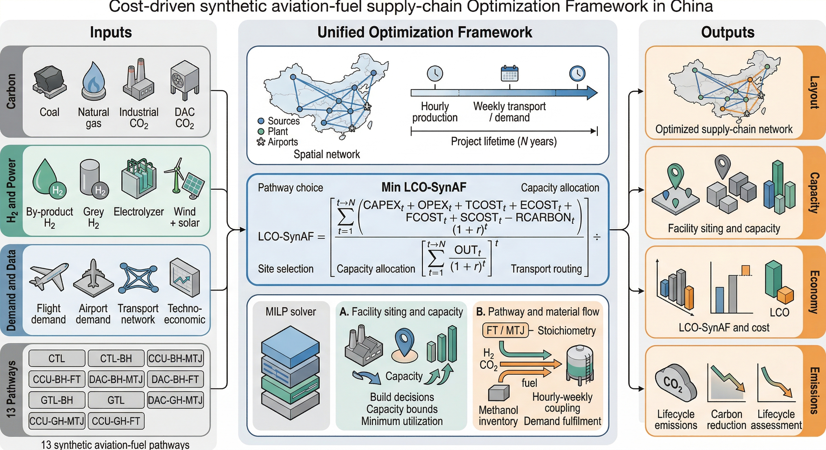
Figure S19. Overview of the cost-driven synthetic aviation-fuel supply-chain optimisation framework in China. Inputs (left) span carbon feedstocks, hydrogen and power sources, demand data, and techno-economic parameters for all 13 pathways. The unified MILP (centre) simultaneously determines facility siting and capacity, pathway and material flow, and transport routing. Outputs (right) include the optimised supply-chain network layout, facility capacities, LCO-SynAF estimates, and lifecycle emissions.

3.1 Unified scenario-indexed formulation
The 13 archived pathway models are written here as scenario-indexed instances of one mixed-integer linear optimization framework. Each scenario activates the same core cost, capacity, transport, demand, and reporting blocks, but uses a different combination of hydrogen-supply, carbon/feedstock, conversion, inventory, and accounting blocks. This is consistent with the repository implementation: the runner selects one scenario configuration at a time, while the core optimizer instantiates only the variables and constraints required by that configuration.^{89,90,91,92,94}
Eq. (S1) $\min_{x_{s}} Z_{s} s.t. x_{s} ∈ X_{s}^{core} ∩ X_{s}^{H} ∩ X_{s}^{C} ∩ X_{s}^{P} ∩ X_{s}^{I} ∩ X_{s}^{N} ∩ X_{s}^{D}, s ∈ S$
Table S13 Unified constraint blocks used to express the 13 scenario-specific MILP instances.
Block | Mathematical role | Scenario scope | Implementation meaning
X_{core} | Facility siting, installed capacity, production variables, and total-cost objective. | All 13 scenarios | Links binary activation decisions to continuous production and capacity variables.
X_{H}(s) | Green electrolysis, industrial by-product H₂, fossil/process H₂, or no-external-H₂ supply block. | Scenario-specific | Selects the H₂ availability, storage, and logistics equations implied by the pathway name.
X_{C}(s) | Industrial CO₂ capture, DAC capture, natural gas, or coal feedstock block. | Scenario-specific | Defines carbon/feedstock availability, capture energy, and upstream logistics.
X_{P}(s) | Conversion route equations for FT/RWGS-FT, MTJ, GTL, or CTL. | Scenario-specific | Maps H₂, CO₂, natural gas, or coal-derived carbon into SAF output.
X_{I}(s) | Inventory balances for H₂, CO₂, methanol, and SAF. | Only commodities active in each scenario | Couples the 3-hour production step with weekly logistics and demand.
X_{N}(s) | Candidate truck, pipeline, LNG, natural-gas, H₂, CO₂, methanol, and SAF transport arcs. | Mode-specific | Applies distance screens, routing-cache distances, and arc-capacity limits.
X_{D} | Weekly airport demand, delivered SAF, and shortage slack constraints. | All 13 scenarios | Ensures Beijing and Tianjin demand coverage while preserving feasibility under stressed cases.
X_{E} | Ex-post lifecycle accounting and benchmark comparison. | All 13 scenarios | Uses pathway-specific credit switches and process/transport emissions coefficients.

3.2 Objective function and cost accounting
The core optimization objective minimizes annualized total system cost for a selected scenario. levelized cost of synthetic aviation fuel (LCO-SAF; labeled as LCOE in several archived result files) is evaluated ex post by dividing the discounted cost stream by discounted synthetic aviation fuel output. The archived result files store lifecycle and annualized cost measures; the frontier comparison uses the lifecycle value excluding shortage cost unless otherwise noted, while shortage penalties remain in the optimization objective to discourage unmet airport demand.^{95,17,74}
Eq. (S2) $LCO-SAF = \frac{∑_{y}\frac{C_{CAPEX,y} + C_{OPEX,y} + C_{TRANS,y}}{{(1 + r)}^{y}}}{∑_{y}\frac{Q_{SAF,y}}{{(1 + r)}^{y}}}$
Eq. (S3) $Z = Z_{CAPEX} + Z_{OPEX} + Z_{Transport} + Z_{Energy} + Z_{Material} + Z_{Shortage} - Z_{Credit}$

3.3 Sets, indices, and decision variables
The MILP uses a compact multi-commodity flow notation. Candidate hydrogen or carbon sources are indexed separately from candidate synthesis locations and airport nodes. Time is indexed on two layers: 3-hour production periods and representative weeks. Route-selection logic is scenario-indexed rather than endogenized inside one super-model, which matches the codebase workflow and keeps comparisons reproducible.^{89,92}
Table S14 Representative sets, indices, and decision-variable groups used in the archived optimization models.
Category | Symbol / group | Meaning in implementation
Sets | S | Retained scenario set containing the 13 pathway models
Sets | I | Hydrogen supply nodes, including electrolysis, by-product, or fossil-linked supply depending on scenario
Sets | J | Carbon-source or feedstock nodes, including industrial capture, DAC, natural gas, or coal
Sets | K | Candidate synthesis-facility locations
Sets | A | Airport demand nodes
Sets | T | 3-hour production periods in the representative-year reduction
Sets | W | Representative weeks used for transport and demand aggregation
Sets | M_{s} | Active commodity set for scenario s, e.g., H₂, CO₂, methanol, natural gas, coal, and SAF
Binary variables | z_{k}^{p} | Facility construction / activation decisions for route-specific process block p
Binary variables | y_{u,v}^{m} | Transport arc or mode activation decisions for commodity m where a fixed decision is represented
Continuous variables | Q_{k}^{p} | Installed capacity for the active process block p
Continuous variables | q_{k,t}^{p} | Route-specific production quantities, including methanol or SAF depending on block p
Continuous variables | f_{i,k,t}^{H2}, f_{j,k,t}^{CO2},  f_{k,a,w}^{SAF} | Material flows between supply, plant, and airport nodes
Continuous variables | I_{k,t}^{H2}, I_{k,t}^{CO2},  I_{k,t}^{MeOH}, I_{k,t}^{SAF} | Inventory states that bridge production variability and weekly shipment timing
Continuous variables | s_{a,w} | Airport shortage slack variables used to preserve feasibility

3.4 Scenario-specific model composition
The following matrix spells out the complete model composition for each retained scenario. The notation should be read as a modular MILP definition: X_{core}, X_{D}, and X_{E} are always present, while X_{H}(s), X_{C}(s), X_{P}(s), X_{I}(s), and X_{N}(s) are populated by the hydrogen, carbon/feedstock, conversion, inventory, and network modules indicated in the row. This avoids duplicating the same demand and capacity equations 13 times while still identifying the exact pathway-specific model for each scenario.
Table S15 Complete scenario-level model composition for the 13 retained pathway models.
Scenario | Mathematical instance | Feedstock and capture constraints | Conversion, temporal, and accounting constraints
CTL | X_{core} +  X_{H}(fossil/process H₂) +  X_{C}(coal) + X_{P}(CTL) +  X_{I}(s) + X_{N}(s) +  X_{D} + X_{E} | fossil/process H₂ baseline availability; coal purchase, coal-gasification and coal-derived CO₂ inventory constraints. | CTL/direct-liquefaction production block; CO₂ and SAF temporal balances; airport-delivery balance. Coal-derived carbon counted as fossil feedstock; utilization credit inactive.
CTL-BH | X_{core} +  X_{H}(by-product H₂) +  X_{C}(coal) + X_{P}(CTL) +  X_{I}(s) + X_{N}(s) +  X_{D} + X_{E} | plant-level by-product H₂ availability, H₂ storage and logistics; coal purchase, coal-gasification and coal-derived CO₂ inventory constraints. | CTL/direct-liquefaction production block; CO₂ and SAF temporal balances; airport-delivery balance. Coal-derived carbon counted as fossil feedstock; utilization credit inactive.
CCU-BH-MTJ | X_{core} +  X_{H}(by-product H₂) +  X_{C}(industrial CO₂) + X_{P}(MTJ) +  X_{I}(s) + X_{N}(s) +  X_{D} + X_{E} | plant-level by-product H₂ availability, H₂ storage and logistics; industrial point-source CO₂ capture capacity and CO₂ logistics. | Two-step MTJ block; methanol production and methanol inventory active; final SAF conversion and weekly delivery balance. Industrial CO₂ utilization credit active under the archived accounting switch.
CCU-BH-FT | X_{core} +  X_{H}(by-product H₂) +  X_{C}(industrial CO₂) + X_{P}(RWGS-FT) +  X_{I}(s) + X_{N}(s) +  X_{D} + X_{E} | plant-level by-product H₂ availability, H₂ storage and logistics; industrial point-source CO₂ capture capacity and CO₂ logistics. | One-step RWGS-FT/direct-FT block; methanol inventory inactive; H₂/CO₂ and SAF temporal balances. Industrial CO₂ utilization credit active under the archived accounting switch.
DAC-BH-MTJ | X_{core} +  X_{H}(by-product H₂) +  X_{C}(DAC CO₂) + X_{P}(MTJ) +  X_{I}(s) + X_{N}(s) +  X_{D} + X_{E} | plant-level by-product H₂ availability, H₂ storage and logistics; DAC siting, capture-rate, energy-use and CO₂ logistics constraints. | Two-step MTJ block; methanol production and methanol inventory active; final SAF conversion and weekly delivery balance. DAC removal credit active with DAC process burdens retained.
DAC-BH-FT | X_{core} +  X_{H}(by-product H₂) +  X_{C}(DAC CO₂) + X_{P}(RWGS-FT) +  X_{I}(s) + X_{N}(s) +  X_{D} + X_{E} | plant-level by-product H₂ availability, H₂ storage and logistics; DAC siting, capture-rate, energy-use and CO₂ logistics constraints. | One-step RWGS-FT/direct-FT block; methanol inventory inactive; H₂/CO₂ and SAF temporal balances. DAC removal credit active with DAC process burdens retained.
GTL-BH | X_{core} +  X_{H}(by-product H₂) +  X_{C}(natural gas) + X_{P}(MTJ) +  X_{I}(s) + X_{N}(s) +  X_{D} + X_{E} | plant-level by-product H₂ availability, H₂ storage and logistics; natural-gas feedstock supply and logistics constraints. | Two-step MTJ block; methanol production and methanol inventory active; final SAF conversion and weekly delivery balance. Natural-gas carbon counted as fossil feedstock; utilization credit inactive.
GTL-GH | X_{core} +  X_{H}(green electrolysis) +  X_{C}(natural gas) + X_{P}(MTJ) +  X_{I}(s) + X_{N}(s) +  X_{D} + X_{E} | green-H₂ electrolysis capacity, renewable/grid electricity use, H₂ storage and logistics; natural-gas feedstock supply and logistics constraints. | Two-step MTJ block; methanol production and methanol inventory active; final SAF conversion and weekly delivery balance. Natural-gas carbon counted as fossil feedstock; utilization credit inactive.
GTL | X_{core} +  X_{H}(no external H₂) +  X_{C}(natural gas) + X_{P}(GTL-FT) +  X_{I}(s) + X_{N}(s) +  X_{D} + X_{E} | Natural-gas pipeline/LNG availability and price surfaces; no external H₂ balance. | Direct GTL/FT block with natural-gas feedstock; methanol inventory inactive; SAF delivery and shortage balance. Natural-gas carbon counted as fossil feedstock; utilization credit inactive.
DAC-GH-MTJ | X_{core} +  X_{H}(green electrolysis) +  X_{C}(DAC CO₂) + X_{P}(MTJ) +  X_{I}(s) + X_{N}(s) +  X_{D} + X_{E} | green-H₂ electrolysis capacity, renewable/grid electricity use, H₂ storage and logistics; DAC siting, capture-rate, energy-use and CO₂ logistics constraints. | Two-step MTJ block; methanol production and methanol inventory active; final SAF conversion and weekly delivery balance. DAC removal credit active with DAC process burdens retained.
DAC-GH-FT | X_{core} +  X_{H}(green electrolysis) +  X_{C}(DAC CO₂) + X_{P}(RWGS-FT) +  X_{I}(s) + X_{N}(s) +  X_{D} + X_{E} | green-H₂ electrolysis capacity, renewable/grid electricity use, H₂ storage and logistics; DAC siting, capture-rate, energy-use and CO₂ logistics constraints. | One-step RWGS-FT/direct-FT block; methanol inventory inactive; H₂/CO₂ and SAF temporal balances. DAC removal credit active with DAC process burdens retained.
CCU-GH-MTJ | X_{core} +  X_{H}(green electrolysis) +  X_{C}(industrial CO₂) + X_{P}(MTJ) +  X_{I}(s) + X_{N}(s) +  X_{D} + X_{E} | green-H₂ electrolysis capacity, renewable/grid electricity use, H₂ storage and logistics; industrial point-source CO₂ capture capacity and CO₂ logistics. | Two-step MTJ block; methanol production and methanol inventory active; final SAF conversion and weekly delivery balance. Industrial CO₂ utilization credit active under the archived accounting switch.
CCU-GH-FT | X_{core} +  X_{H}(green electrolysis) +  X_{C}(industrial CO₂) + X_{P}(RWGS-FT) +  X_{I}(s) + X_{N}(s) +  X_{D} + X_{E} | green-H₂ electrolysis capacity, renewable/grid electricity use, H₂ storage and logistics; industrial point-source CO₂ capture capacity and CO₂ logistics. | One-step RWGS-FT/direct-FT block; methanol inventory inactive; H₂/CO₂ and SAF temporal balances. Industrial CO₂ utilization credit active under the archived accounting switch.

3.5 Facility siting and capacity constraints
Binary siting variables are linked to continuous capacity and production variables through standard activation constraints. These constraints prevent nonzero production at unbuilt plants and ensure that installed capacity remains within the scenario-specific lower and upper bounds stored in the configuration files. The same block covers synthesis facilities, DAC units, electrolyzer or by-product-H₂ supply blocks, and route-specific upstream feedstock blocks when they are active.^{89,90}
Eq. (S4) $0 ≤ q_{k,t}^{p} ≤ Q_{k}^{p}; Q_{k}^{p,min}z_{k}^{p} ≤ Q_{k}^{p} ≤ Q_{k}^{p,max}z_{k}^{p}$

3.6 Feedstock and carbon-source availability
Feedstock availability is enforced before conversion. Green-hydrogen supply is bounded by renewable output, grid-electricity purchases, and electrolyzer capacity; by-product hydrogen is capped by plant-level availability from steel and refinery sources; industrial CO₂ is bounded by point-source capture capacity; DAC CO₂ is bounded by DAC siting and energy-use constraints; natural-gas and coal routes use their own feedstock-capacity and price layers. The generic availability expression is specialized by the active commodity set in each scenario.^{95,102}
Eq. (S5) $∑_{k}f_{i,k,t}^{m} ≤ A_{i,t}^{m}, m ∈ M_{s}$
Scenario-family feedstock equations then map atmospheric capture, coal purchase, or natural-gas feedstock into usable carbon supply. The DAC term links captured CO₂ to electricity consumption; the coal term links coal purchase to coal-derived CO₂ yield; and the natural-gas term links GTL feedstock consumption to synthetic aviation fuel output.
Eq. (S6) $e_{k,t}^{DAC} = ε^{DAC}c_{k,t}^{DAC}; c_{k,t}^{coal} = γ^{coal}b_{k,t}^{coal}; g_{k,t}^{NG} = α^{NG}q_{k,t}^{SAF}$

3.7 Conversion-route balances
The active conversion block maps feedstocks to final synthetic aviation fuel output. FT and RWGS-FT routes connect hydrogen and carbon inputs directly to synthetic aviation fuel production through route-specific coefficients. MTJ routes add methanol production and methanol inventory before final synthetic aviation fuel conversion. GTL and CTL routes replace the generic CO₂ input with natural-gas or coal-derived feedstock balances while retaining the same facility, production, and delivery accounting structure.^{73,75,117}
Eq. (S7) $f_{k,t}^{m} = α_{m}^{p}q_{k,t}^{SAF}; q_{k,t}^{SAF} = β^{MTJ}q_{k,t}^{MeOH,cons}, p ∈ \{FT, MTJ, CTL, GTL\}$

3.8 Inventory and transport constraints
Inventory states bridge variable production and scheduled logistics. Hydrogen, carbon dioxide, methanol, natural-gas-linked feedstock intermediates, and final synthetic aviation fuel appear only when the relevant scenario block activates them. Weekly transport variables move final synthetic aviation fuel to airports and move gaseous intermediates through candidate pipeline, truck, LNG, or natural-gas logistics arcs depending on the scenario and arc availability.^{110,112,16}
Eq. (S8) $I_{n,t} = I_{n,t-1} + F_{n,t}^{in} - F_{n,t}^{out}, n ∈ \{H₂, CO₂, MeOH, SAF\}$
Eq. (S9) $0 ≤ f_{u,v,τ}^{m} ≤ F_{u,v}^{m,max}y_{u,v}^{m}, m ∈ M_{s}$

3.9 Demand fulfillment constraints
Airport demand is enforced on a weekly basis. For each airport-week pair, the sum of delivered synthetic aviation fuel and the shortage slack variable must cover the required weekly demand. The shortage variable enters the objective with a high unit penalty, allowing the model to stay feasible under stressed cases while still reporting unmet demand explicitly in archived outputs.⁹²
Eq. (S10) $∑_{k}f_{k,a,w}^{SAF} + s_{a,w} ≥ D_{a,w}, ∀ a ∈ A, w ∈ W$

3.10 Emissions accounting method
Emissions are calculated ex post on a well-to-wake basis. The repository uses a conventional-jet benchmark of 89 gCO2e/MJ and an synthetic aviation fuel energy content of 43.15 MJ/kg. Pathway-specific carbon intensity combines feedstock acquisition or capture, upstream and downstream transport, process emissions, storage losses where relevant, facility lifecycle allocation, and route-specific credit treatment.^{9,87,106}
Eq. (S11) $E_{s}^{SAF} = \frac{E_{s}^{feed} + E_{s}^{process} + E_{s}^{transport} + E_{s}^{storage} + E_{s}^{capex} - C_{s}^{credit}}{Q_{s}^{SAF,E}}$
Eq. (S12) $R_{CO₂} = Q_{E}^{SAF} · (E^{JetA} - E^{SAF})$

3.11 Solver settings and implementation
The 13 archived runs used Gurobi 12.0.3 with a 1% relative-gap target. Eight reached this tolerance and five stopped at the time limit. Table S27 reports the pre-presolve model dimensions, elapsed solve times and achieved gaps matched to each archived result. Time-limited outputs are incumbent solutions. Historical solver termination and physical input or constraint validation are reported separately in Section 5.1.

4 Sensitivity and Uncertainty Assessment

4.1 Analysis design and parameter overview
Table S16 records the archived parameter-sweep design. Its supporting plots are retained in the Supplementary Archive (Figs. S20–S24) as exploratory model outputs. The quantitative revision checks are provided in Tables S21–S26: fixed-configuration carbon accounting, utilization and site matching, leave-one-week-out metrics, and joint demand–renewable coverage. These exercises have distinct boundaries and do not establish corrected full-year operating feasibility.
Cost-parameter sweeps describe outcomes under their specified model and inputs. They do not validate electricity units, establish year-round renewable coverage, or prove that site and operating configurations are invariant to parameter changes. The limitations in Section 5.1 apply to use of the archived sensitivity plots.
Table S16 Parameter sweep design for sensitivity and uncertainty assessment.
Parameter | Baseline value | Sweep range | Range basis | Pathways affected | Tests main-text result
Natural-gas price | 4.2 yuan/m³ | 2.5–7.0 yuan/m³ | Provincial price surface + medium-term trajectory | GTL, GTL-BH | Result 1 cost ranking
Byproduct H₂ purification CAPEX | Steel: 280,000; Refinery: 224,000 yuan/(kg/h) | 140,000–400,000 yuan/(kg/h) | PSA+compression literature range | GTL-BH | Result 1 cost ranking
Renewable electricity price | 0.35–0.40 yuan/kWh | 0.377–0.617 yuan/kWh | Full observed provincial retail tariff distribution | CCU-GH-FT, DAC-GH series | Result 1 cost ranking
Electrolyzer CAPEX | Current market value | Current → IEA 2030 target (~2,000 yuan/kW) | IEA hydrogen technology roadmap | All PtL pathways | Result 1 cost ranking
DAC unit cost | Archived scenario value | Current → competitive-entry threshold | Technology learning trajectories | DAC-GH-FT, DAC-BH series | Result 1 Pareto inclusion
Discount rate | 8% | 5%–12% | Infrastructure financing convention range | All pathways (differential) | Result 1 cost structure
Demand scale | Beijing–Tianjin (baseline) | 0.5×–3× baseline | Representativeness across Chinese airport clusters | All pathways | Result 2 spatial configuration

5 Model Verification and Result Validation

5.1 Internal consistency checks
Independent checks recovered the historical solver records and examined the archived CCU-GH-FT electricity balance. Hydrogen-production electricity requirements exceed recorded renewable-electricity availability in 63 of 224 periods when the three-hour mean-power series is converted to energy. Two periods record zero available renewable supply and positive hydrogen production. Tables S28 and S29 summarize the diagnostics and their validation scope. A fully passing physical-feasibility report and corrected optimization results are not yet available.
The affected constraints were revised in a separate source copy to impose bounds at zero availability and consistently convert power to period energy. Validation of radiation units and resource aggregation remains outstanding. These implementation changes and static checks do not establish that archived costs, capacities or network choices will be unchanged after re-optimization.

5.2 Benchmark comparison with literature
Table S17 positions the supply-chain framework relative to representative published studies. Literature benchmarking provides context for model scope; it does not substitute for validation of the archived input data and operating constraints.
Table S17 Comparison with representative synthetic aviation fuel supply-chain studies summarized in the project materials.
Study | Data / resolution | Pathway scope | Method | Main gap relative to this study
Masum et al. | County-level, annual, 20-year horizon | Biomass only | MILP | Does not resolve renewable-power variability or multi-source PtL coupling
Bianco et al. | Sampled siting with uncertain parameters | Cellulosic ethanol / ATJ | Monte Carlo | Focuses on siting and policy sensitivity rather than integrated upstream energy supply
Akter et al. | State-level, annual, 10-year horizon | Forest residues / ETJ | MILP | Does not include variable renewable-power-driven PtL pathways
Pin et al. | National, multiple demand cases | Oilseed-based SAF | MILP | Excludes downstream airport allocation and non-biogenic alternatives
Wassermann et al. | National-scale Germany case | PtL with industrial CO₂ | Supply-chain optimization | Limited treatment of multi-source H₂/CO₂ matrices and hourly variability
Martinez-Valencia et al. | Regional annual life-cycle case | Gasification / FT | Financial analysis + system dynamics | No high-resolution siting and logistics optimization
Woeldgen et al. | Flight-schedule-linked airport allocation | Airport-side SAF allocation | Distribution optimization | Does not optimize the full upstream source-to-airport supply chain
Eyberg et al. | Plant-level TEA | PtL via FT and MTJ | Process simulation + TEA | Strong process detail but no macro-spatial siting model

5.3 Worst-week descriptive checks
Over the four archived weeks, GTL-BH retains 89.11% of mean utilization in its worst week, GTL retains 70.85%, and CCU-GH-FT retains 83.18%. These metrics characterize the optimized schedules. The model does not simulate equipment failure or repair; low-load episode duration therefore does not measure outage recovery time.
Tables S23 and S25 report the utilization definitions and fixed-schedule week-omission sensitivity. Full-year or alternative-week dispatch has not been completed.

5.4 Interpretation of archived pathway comparisons
The archived comparison assigns costs of 5.23, 6.50 and 18.56 CNY/kg to GTL-BH, GTL and CCU-GH-FT, respectively. Carbon-accounting sensitivities in Tables S21–S22 change their absolute emissions and, for changes in capture attribution, the incremental abatement comparison. The operating-feasibility findings in Table S28 limit interpretation of the archived green-hydrogen results.
Utilization-based capacity premiums describe the capacity implied by an observed operating profile. They are not additional cost charges to be added to optimized fuel costs, and they do not independently validate pathway rankings.

6 Supplementary Results

6.1 Additional pathway comparison results
Figure S25 provides the archived pathway comparison. The supplementary efficiency and deployability diagnostics are supplied in the Supplementary Archive (Fig. S26). The carbon-accounting variants in Tables S21–S22 state the sensitivity of the numerical interpretation to the treatment of combustion and capture attribution.
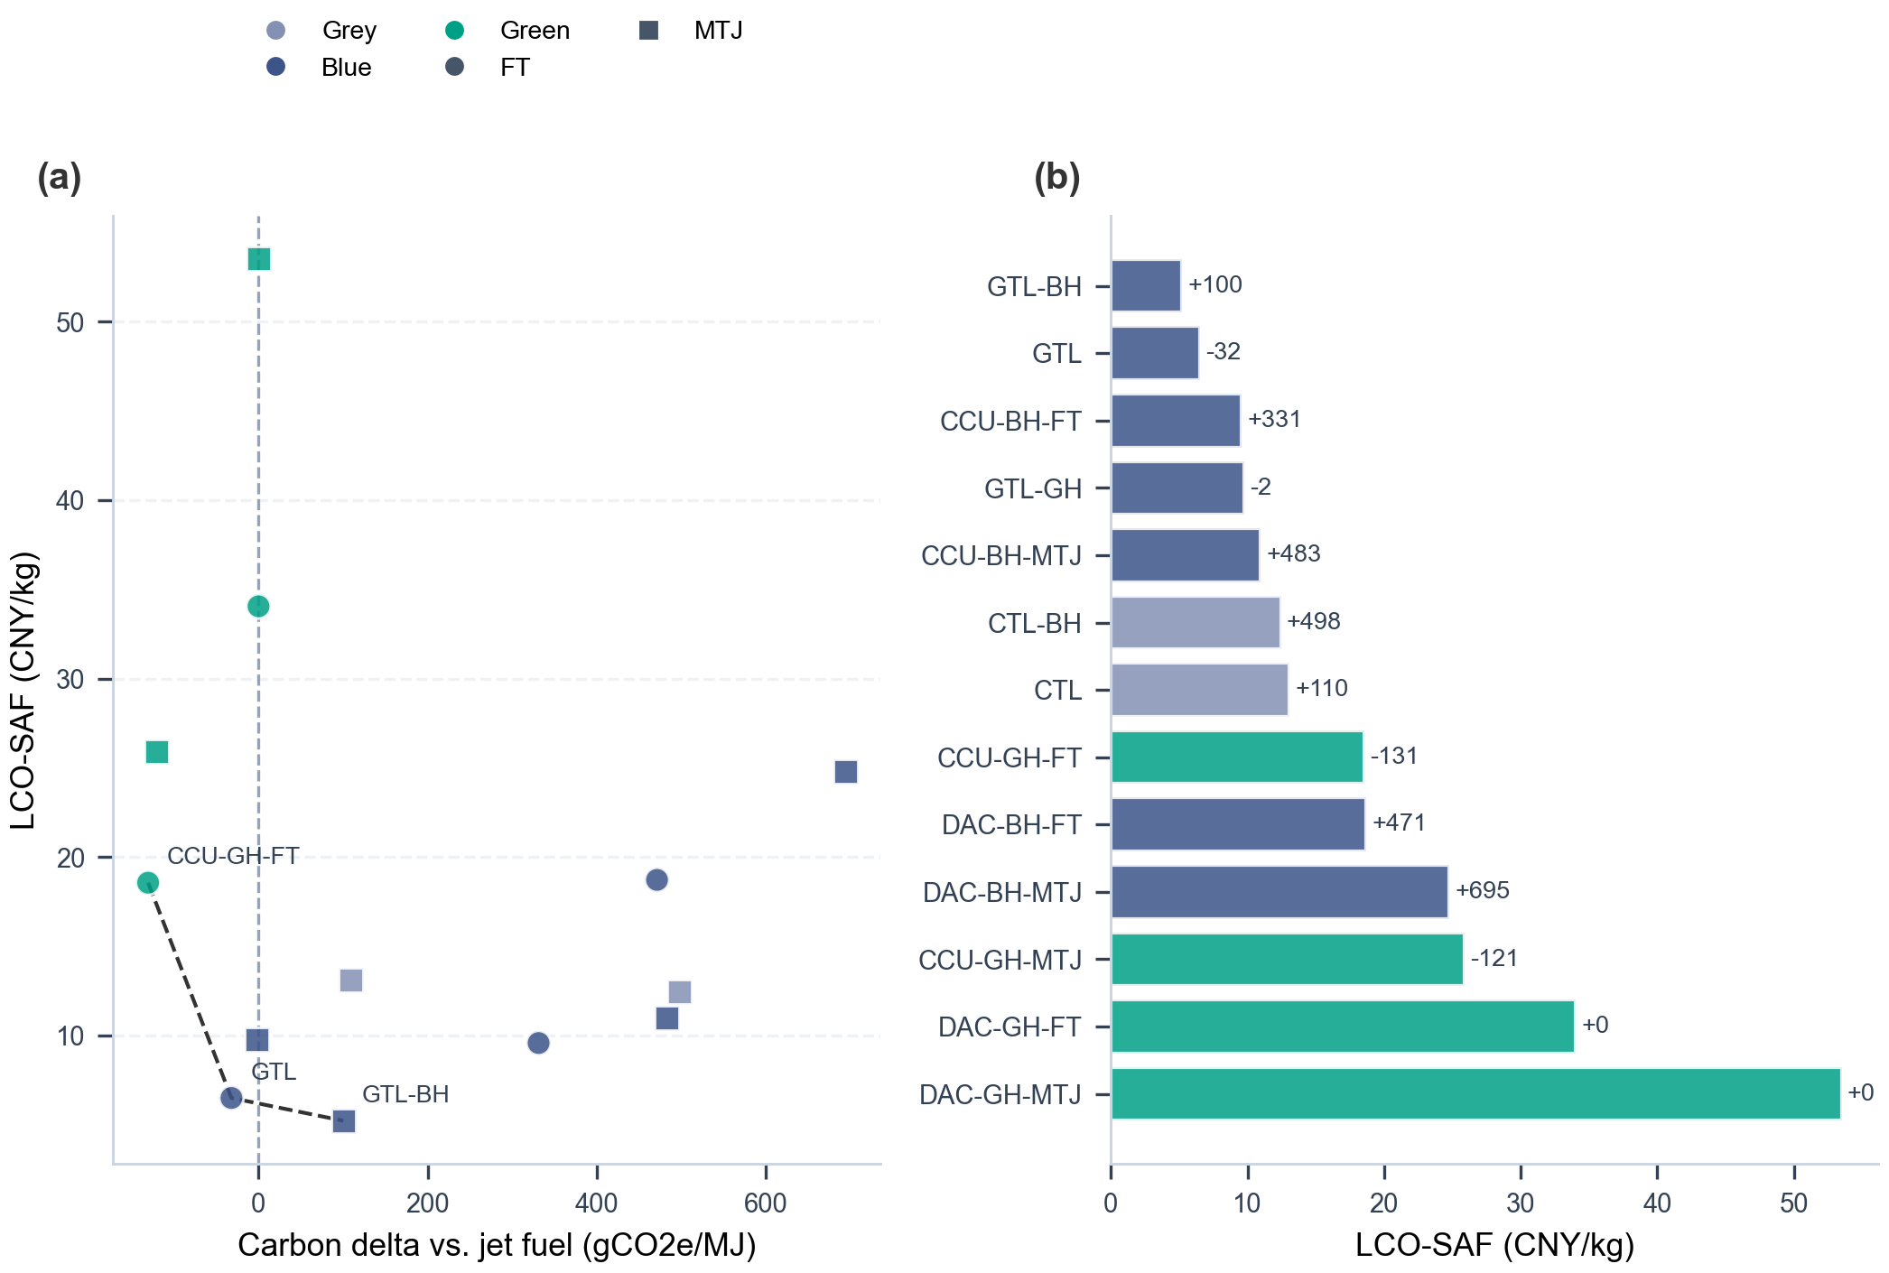
Figure S25. Extended cost-emissions comparison across the 13 archived pathways.

6.2 Additional spatial network maps
Figure S27 summarizes network archetypes, and Table S18 lists the archived network descriptors. Network identifiers, synthesis-equipment records and distinct coordinates are separate counts. Capacity-weighted matching in Table S24 compares physical synthesis coordinates after aggregating co-located records. It assesses geographic correspondence and does not quantify equipment reuse or retrofit cost. Additional individual route maps are provided in the Supplementary Archive (Figs. S49–S63).
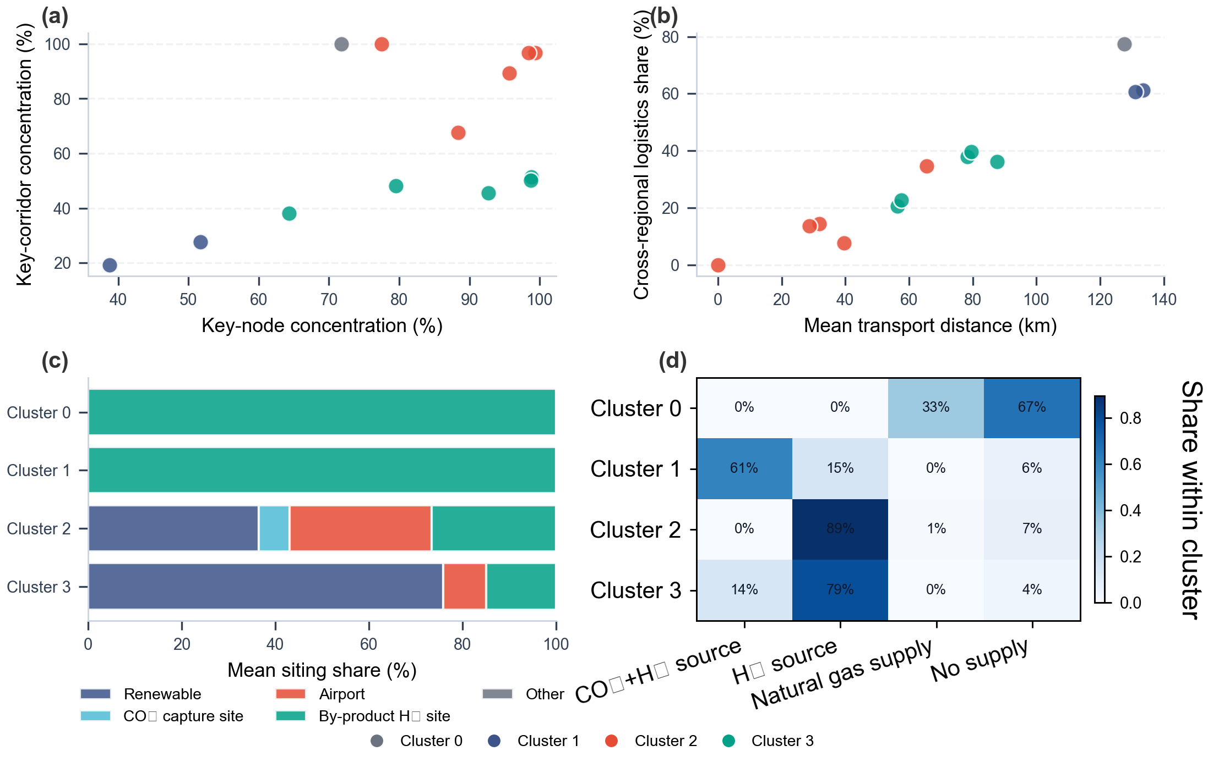
Figure S27. Clustered network and siting archetypes across archived synthetic aviation fuel pathways.
Table S18 Scenario-level spatial and network indicators for the 13 archived synthetic aviation fuel pathways. Columns are aggregated from the clustered transport-route summary files; em dash (—) denotes pathways without installed electrolysers, for which no weighted H₂ transport distance is defined.
Pathway | Nodes | Electro-  lyzers | SAF  plants | Avg H₂ dist  (km) | Avg SAF dist  (km) | Critical-node  conc. (%) | Critical-route  conc. (%) | Cross-regional  logistics (%) | SPOF  (%)
GTL-BH | 4 | 0 | 2 | — | 127.52 | 71.80 | 100.00 | 77.47 | 71.80
GTL | 4 | 0 | 2 | — | 0.00 | 77.47 | 100.00 | 0.00 | 77.47
CTL-BH | 37 | 0 | 3 | 156.93 | 62.37 | 98.38 | 96.73 | 34.54 | 43.63
CTL | 112 | 109 | 6 | 89.20 | 28.11 | 95.67 | 89.41 | 14.30 | 82.10
GTL-GH | 116 | 109 | 76 | 92.02 | 28.02 | 99.31 | 96.83 | 13.51 | 87.15
CCU-BH-MTJ | 73 | 64 | 4 | 90.94 | 139.64 | 92.69 | 45.61 | 36.12 | 28.06
CCU-BH-FT | 60 | 64 | 3 | 199.70 | 17.54 | 88.39 | 67.72 | 7.54 | 38.54
CCU-GH-MTJ | 120 | 109 | 4 | 71.52 | 105.47 | 98.78 | 51.28 | 37.87 | 31.59
CCU-GH-FT | 120 | 109 | 4 | 77.91 | 105.26 | 98.73 | 50.18 | 39.70 | 30.19
DAC-BH-MTJ | 50 | 64 | 28 | 257.49 | 168.52 | 38.78 | 19.36 | 61.18 | 9.48
DAC-BH-FT | 45 | 64 | 26 | 79.11 | 152.02 | 51.69 | 27.74 | 60.66 | 12.47
DAC-GH-MTJ | 113 | 109 | 25 | 80.70 | 42.53 | 64.34 | 38.17 | 20.59 | 34.70
DAC-GH-FT | 113 | 109 | 6 | 91.72 | 28.93 | 79.55 | 48.26 | 22.58 | 47.48

6.3 Additional cost decomposition results
The appendix cost-decomposition panel focuses on the same three representative Pareto pathways discussed above: CCU-GH-FT, GTL, and GTL-BH. A shared eight-category mapping makes it clear that electricity and hydrogen dominate the deep-decarbonization route, whereas feedstock-linked categories remain the main reason that gas-based pathways stay closer to the cost frontier.^{73,74,75}
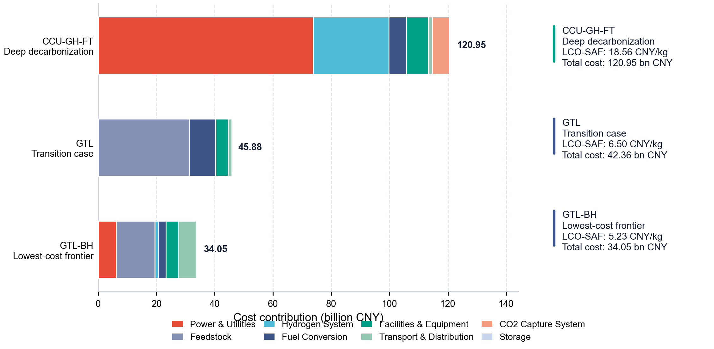
Figure S28. Cost composition of the three representative Pareto pathways.

6.4 Additional emissions decomposition results
The emissions-decomposition panel uses the same representative pathways and the same component mapping. Positive lifecycle burdens are shown as stacked contributions, while negative credit terms are kept outside the stacks and reported separately as net deltas relative to conventional jet fuel so that the comparison remains visually comparable across pathways.^{9,87,106}
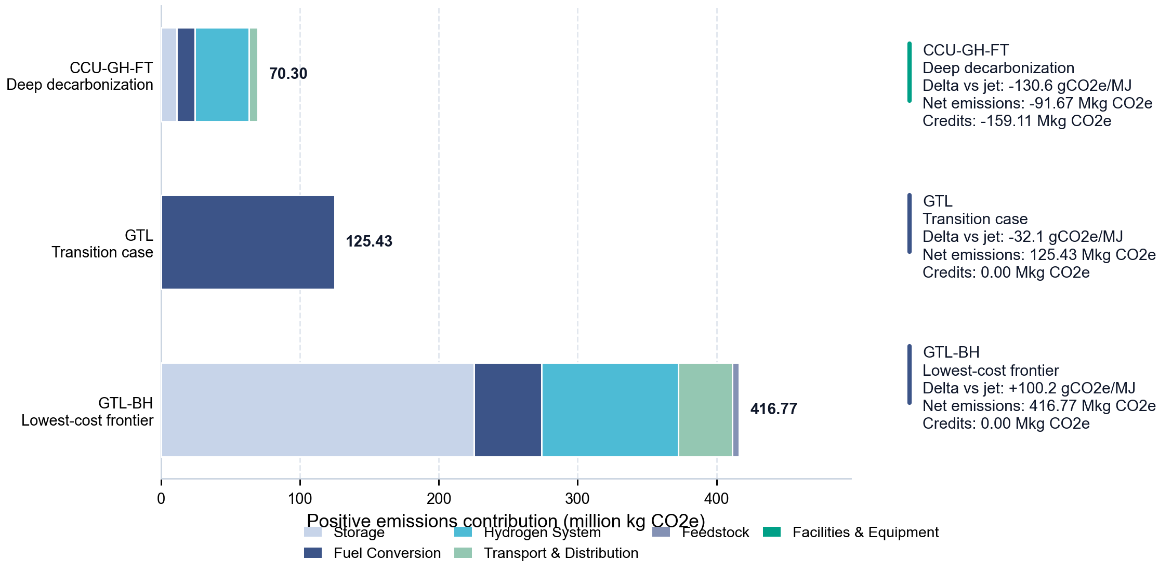
Figure S29. Positive emissions composition of the three representative Pareto pathways.

6.5 Temporal-operational profile and production-stability analysis
This section describes facility utilization within the four archived representative weeks. Utilization-based capacity premiums and worst-week retention quantify differences in the stored schedules. The definitions and additional checks appear in Tables S23 and S25; the physical-feasibility limitation remains as stated in Section 5.1.

6.5.1 Facility-utilization efficiency across pathways
Facility utilization is computed at the 3-hour production-period level for both the hydrogen supply stage and the synthetic aviation fuel synthesis stage. For each period the utilization rate is the ratio of actual production (kg) to the maximum achievable output given installed capacity and period length. By-product hydrogen pathways use the peak hourly supply observed over the four-week horizon as the capacity denominator because no electrolyzer nameplate capacity is installed.^{111,112}
Eq. (S13) $U_{w,k} = \frac{q_{w,k}}{{Cap}_{k} · T_{w}}, U_{w,k} ∈ [0, 1]$
Here q denotes period production, Cap denotes installed hourly capacity, and T denotes period duration. The archived distribution plots cap displayed utilization at 1.0. That plotting convention does not constitute a capacity-feasibility check; Table S23 uses the independently recomputed aggregate metrics.
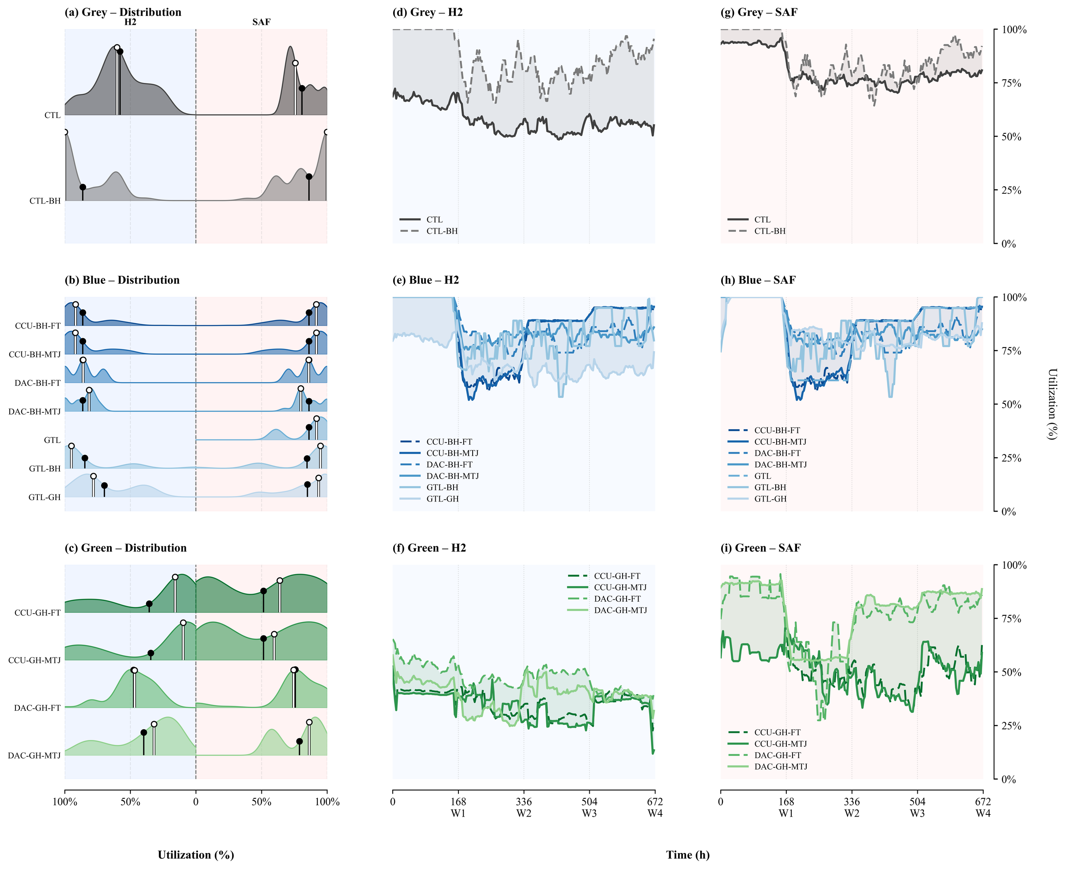
Figure S30. H₂ production and synthetic aviation fuel factory utilization distributions for all 13 pathways, grouped by feedstock category. Each panel shows the distribution of 3-hour period utilization rates across the four representative weeks. Pathways without an electrolyzer (GTL-BH, CTL-BH, GTL, and related by-product-H₂ routes) use peak supply as the capacity denominator.
The plotted distributions describe the selected four-week schedules. They support comparison of utilization profiles under those inputs; extension to unmodelled weeks requires additional dispatch calculations.
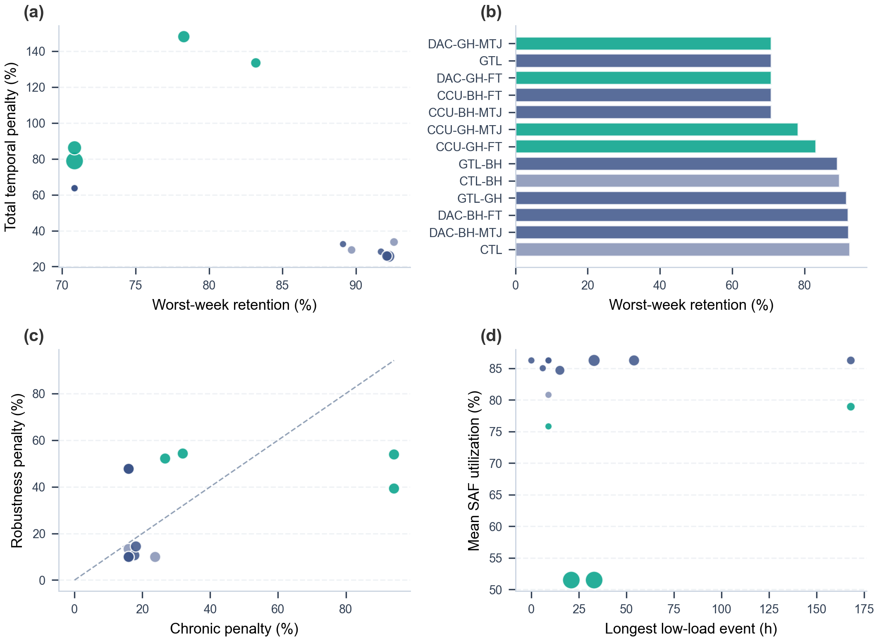
Figure S31. Four-panel temporal-robustness overview for all 13 pathways: (A) worst-week retention rate versus mean synthetic aviation fuel utilization, (B) pathways ranked by worst-week retention, (C) chronic versus robustness penalty scatter, (D) longest low-load episode versus mean synthetic aviation fuel utilization.

6.5.2 Temporal robustness penalty framework
The capacity-premium framework translates utilization into the additional nameplate capacity implied by producing a fixed output at that utilization rather than at full utilization. It comprises a mean-utilization component and an additional worst-week component. It is not a measured financial penalty or a failure-probability model.
The chronic low-utilization penalty reflects the gap between mean synthetic aviation fuel utilization and the full-capacity benchmark:
Eq. (S14) $P_{chronic} = (\frac{100}{Ū_{SAF}} - 1) × 100 \%$
The robustness penalty reflects the additional shortfall associated with the single worst representative week, capturing inter-week variability rather than the average level:
Eq. (S15) $P_{robust} = (\frac{100}{Ū_{worst}} - \frac{100}{Ū_{SAF}}) × 100 \%$
where Ū_SAF is the mean synthetic aviation fuel utilization across all four representative weeks and Ū_worst is the mean synthetic aviation fuel utilization in the worst-performing week. The total penalty P_total = P_chronic + P_robust quantifies the combined implied capacity premium. Fig. S32 shows the penalty decomposition across all 13 pathways.
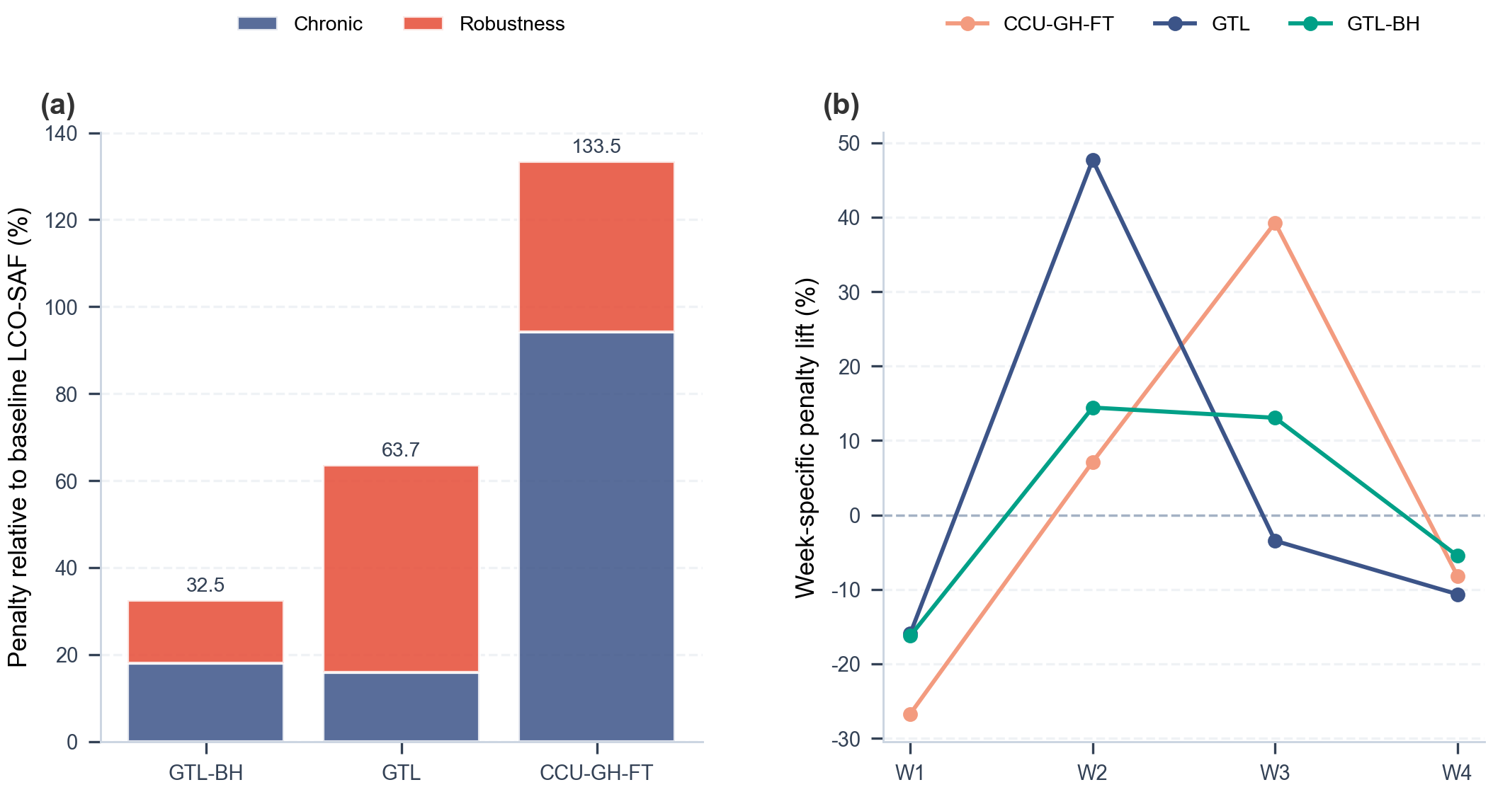
Figure S32. Chronic and robustness penalty decomposition across all pathways. Each horizontal bar shows the chronic component (darker) and robustness component (lighter) of the implied cost penalty. Pathways are ordered by total penalty.

6.5.3 Penalty decomposition for the three Pareto-representative pathways
For GTL-BH, the archived mean and worst-week synthesis utilizations are approximately 84.7% and 75.5%, giving 89.11% retention. GTL has 86.24% mean utilization and 70.85% worst-week retention; CCU-GH-FT has approximately 51.5% mean utilization and 83.18% retention. Table S19 gives the corresponding capacity-premium components, and Table S23 reports independently recomputed values. Lower mean utilization and greater relative worst-week retention describe different properties. The dependence on the selected weeks is reported in Table S25.
Table S19 Temporal robustness summary for the three Pareto-representative pathways.
Pathway | Mean SAF util. (%) | Worst-week util. (%) | Chronic penalty (%) | Robustness penalty (%) | Total penalty (%)
GTL-BH | 84.7 | 75.5 | 18.1 | 14.4 | 32.5
GTL | 86.2 | 61.1 | 16.0 | 47.7 | 63.7
CCU-GH-FT | 51.5 | 42.8 | 94.2 | 39.3 | 133.5
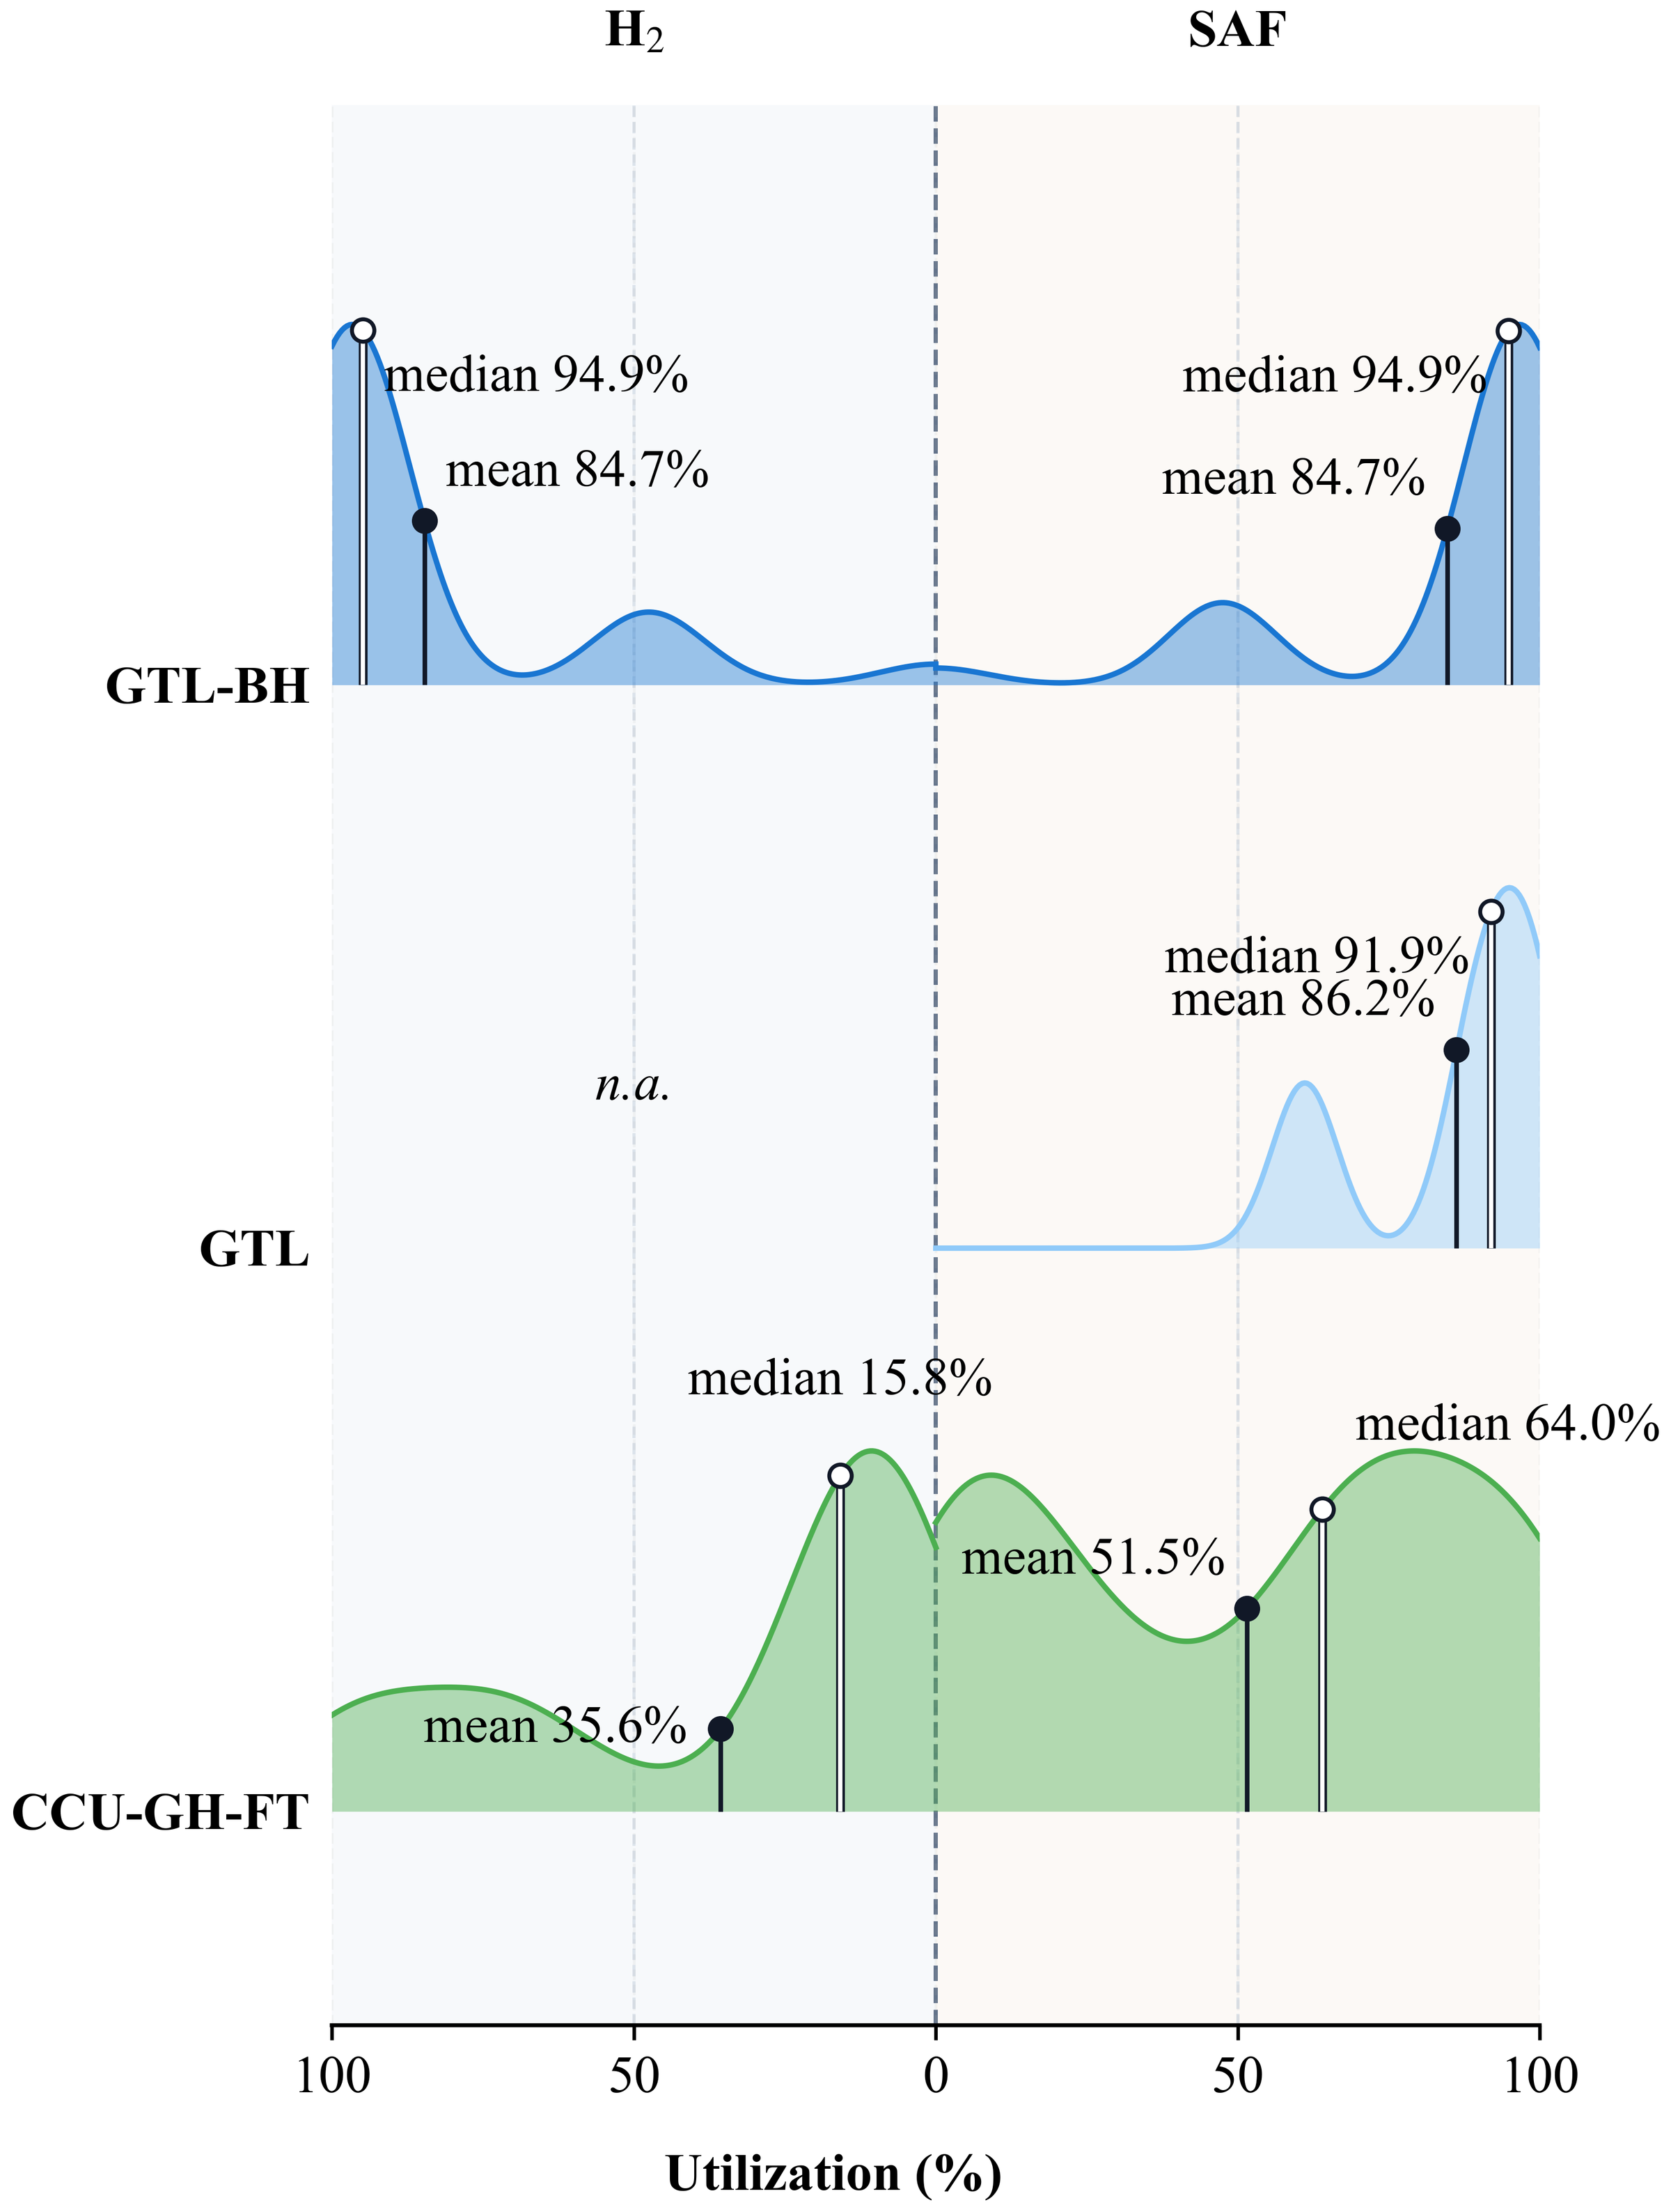
Figure S33. Utilization distributions for the three Pareto-representative pathways (GTL-BH, GTL, CCU-GH-FT). Left column: H₂ production utilization; right column: synthetic aviation fuel factory utilization. Mean and median are annotated.
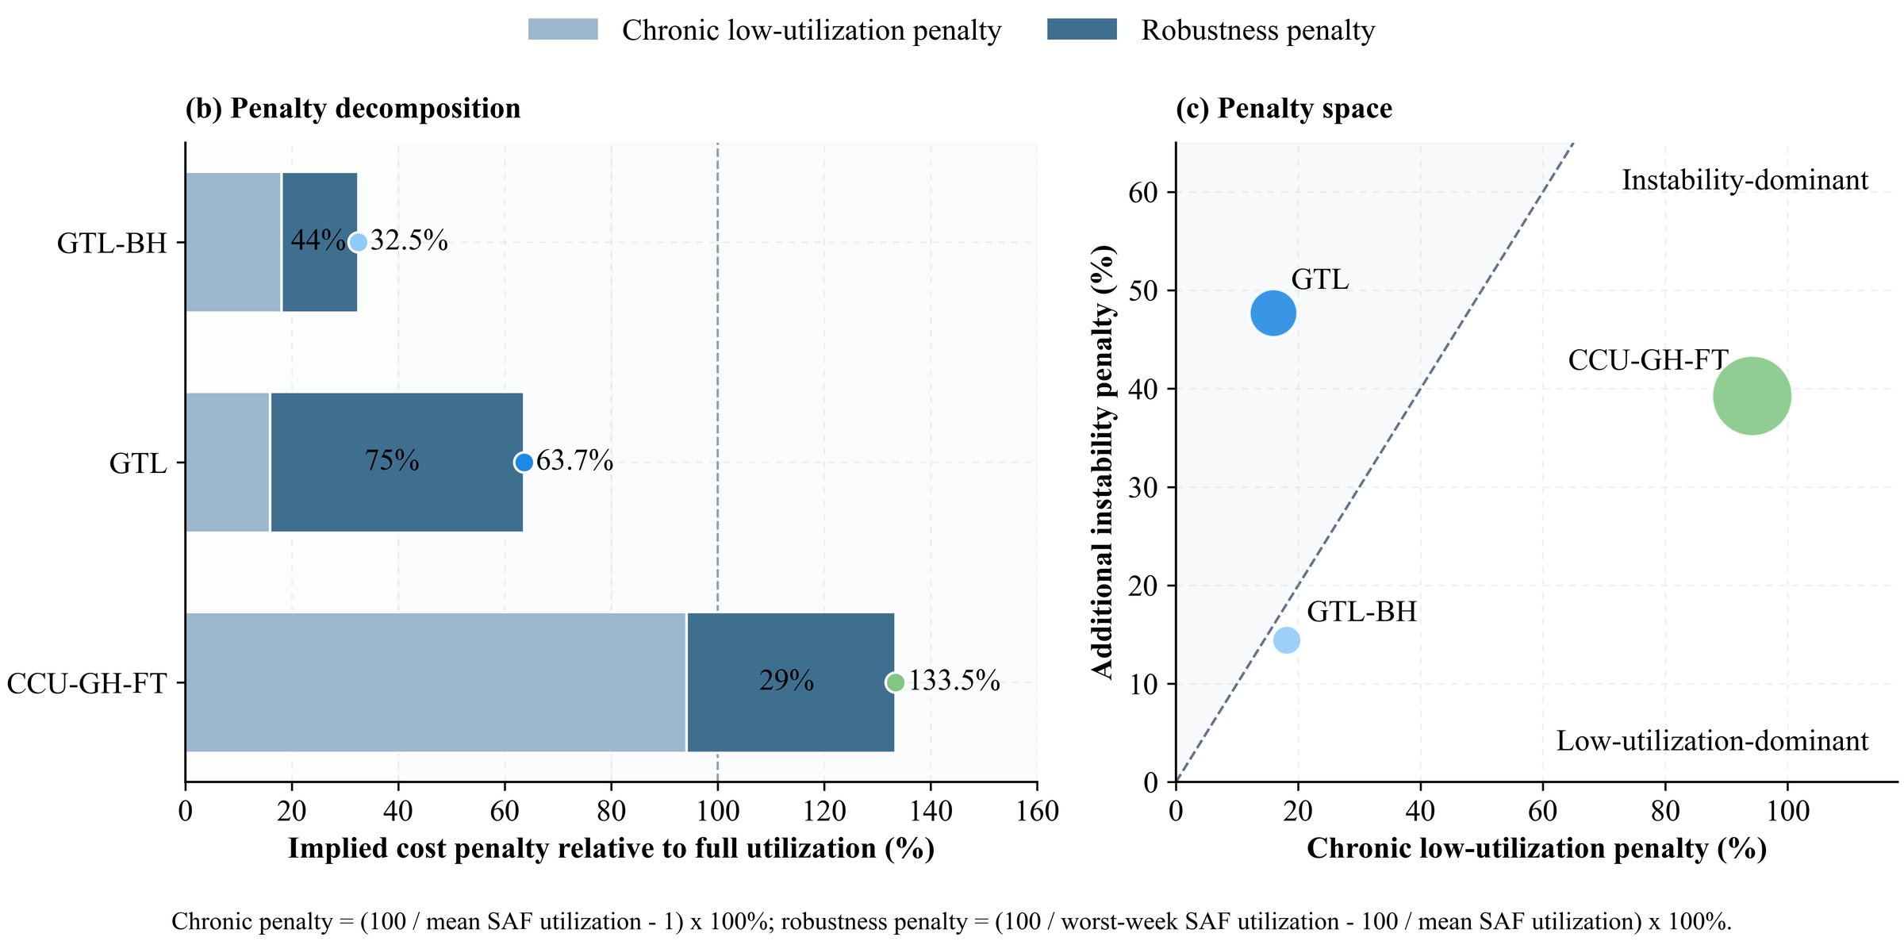
Figure S34. Capacity-premium decomposition for the three representative pathways. Panel (b) separates the mean-utilization and additional worst-week components. Panel (c) compares these two components; bubble area represents their sum. The diagonal denotes equal contributions. The archived instability label refers to the additional worst-week capacity premium.

6.5.4 Penalty-driver fingerprint
To attribute penalty differences among the three Pareto pathways to underlying operational factors, a twelve-driver fingerprint is constructed. The drivers are organized into four groups: low-utilization drivers (mean synthetic aviation fuel utilization, frequency and duration of episodes below 10% capacity), instability drivers (worst-week retention, week-to-week coefficient of variation, maximum single low-load event), renewable shock drivers (renewable power variability, zero-output fraction, ramp intensity), and penalty outcomes (chronic, robustness, and total penalty). Each driver value is standardized against the distribution across all 13 archived pathways using z-score normalization, so that the heatmap identifies which factors deviate from the all-pathway baseline for each of the three representative routes.^{111,112,107}
Figure S35 describes standardized utilization, low-load, renewable-availability and capacity-premium metrics for the three representative archived solutions. The fingerprint is descriptive and does not identify failure causes or quantify the transferability of operating knowledge.
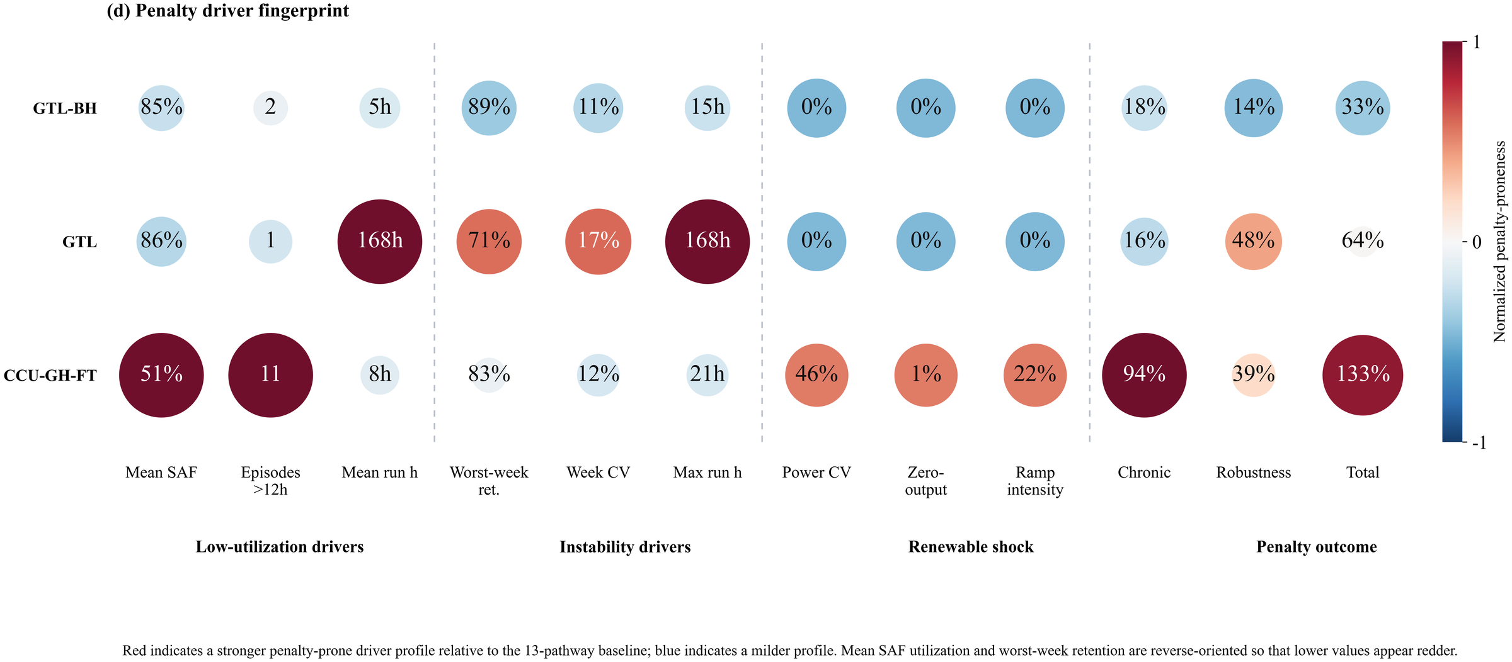
Figure S35. Twelve-driver penalty fingerprint for the three Pareto-representative pathways, normalized against the all-pathway distribution. Red cells indicate values elevated above the baseline; blue cells indicate suppressed values. The four driver groups (low-utilization drivers, instability drivers, renewable shock, penalty outcomes) are separated by horizontal dividers.

6.6 Per-pathway decomposition archive
The individual pathway cost–emission learning projections are provided in the Supplementary Archive (Figs. S36–S48). These figures retain their original identifiers for traceability. They use archived pathway configurations and do not represent corrected or independently validated future operating outcomes.

6.7 Transport network archive
Clustered and pathway-specific route maps are provided in the Supplementary Archive (Figs. S49–S63), including the representative topology comparison in Fig. S50 and CCU-GH-FT in Fig. S57. Table S18 and the physical-site matching in Table S24 provide the core numerical comparisons.

7 Quantitative revision calculations

7.1 Scope of additional source and conversion combinations
The exclusions below describe the represented model boundary and the additional process information required to expand it. They do not rank omitted feasible technologies or establish a universal feasibility catalogue. Section 2.4 gives the stoichiometric reasoning and the distinction between internally and externally supplied hydrogen.
Table S20 Reasons for excluding additional source and conversion combinations.
Combination | Treatment | Reason and required extension
CCU or DAC CO₂ with no hydrogen input, using the represented FT or MTJ block | Cannot sustain positive output within the represented balances | Both conversion blocks consume hydrogen. With hydrogen and alternative reducing routes disabled, positive fuel output violates the model material balance. A different reduction or co-electrolysis process would require its own energy, material and cost formulation.
CCU or DAC CO₂ with dedicated fossil-derived hydrogen | Technically possible; outside the evaluated hydrogen-source cases | The retained CCU/DAC comparisons use green or industrial by-product H₂. A dedicated reforming or gasification supply case requires an explicit hydrogen-production configuration, fuel use, upstream emissions and optional carbon-capture allocation. No such independently evaluated case is included in Tables S6–S7.
Natural gas with supplemental GH or BH through FT | Not evaluated in the retained 13-scenario comparison | The retained FT gas reference has no external H₂ input; external-H₂ gas cases use MTJ. Supplemental-H₂ FT would change reforming, syngas conditioning and hydrogen balances and requires a separately evaluated configuration. An additional FT runner exists in the code archive, so absence from the comparison is not evidence of technical impossibility.
Natural-gas MTJ without external hydrogen | Not represented by the retained MTJ hydrogen boundary | The retained gas-to-MTJ cases supply external GH or BH. An internally hydrogen-balanced reforming-to-methanol variant requires its own integrated syngas, energy and cost accounting; setting the existing external-H₂ input to zero is not an equivalent process substitution.
Additional coal and hydrogen combinations or coal-to-methanol-to-jet variants | Outside the two retained coal configurations | Tables S6–S7 contain the CTL reference and its BH variant, without a full coal × hydrogen-source × synthesis-route matrix. Other variants require separate conversion yields, hydrogen requirements and process costs. No physical-infeasibility or cost-dominance claim is made for the omitted variants.
Lipids to HEFA; fermentation alcohols to ATJ; biomass or waste to FT or hydrothermal products | Outside the represented feedstock and conversion network | These routes require lipid or biomass inventories, collection and pretreatment, seasonal availability, conversion yields and lifecycle allocation. The current source network represents coal, natural gas, industrial CO₂ and DAC. ICAO lists HEFA, ATJ and biomass FT as distinct conversion categories (Refs. 119–120); exclusion here is a scope choice.
Additional synthesis technologies or multi-source hybrid configurations | Outside the activated process modules | The finite scenario set does not include every compatible carbon, hydrogen and conversion combination. Additional technology modules or simultaneous source mixing require calibrated yields, capacity and operating constraints and consistent lifecycle accounting before inclusion in the comparison.

7.2 Carbon accounting sensitivity on fixed configurations
The combustion increment is 0.85 × (44/12) × 1000 / 43.15 = 72.228660 g CO₂/MJ. Costs, capacities and dispatch are held fixed. The first case adds combustion while retaining archived capture attribution. The second removes the capture credit as an attribution diagnostic; for DAC this is an accounting bound and does not imply that atmospheric uptake should generally receive no credit. Carbon recycling and permanent removal have different lifecycle meanings.
Table S21 Fixed-configuration costs and carbon intensities. CI is in g CO₂e/MJ.
Pathway | CNY/kg | Archived CI | With combustion | With combustion and no capture credit
CTL | 13.10 | 198.526 | 270.755 | 270.755
CTL-BH | 12.46 | 587.412 | 659.641 | 659.641
GTL-GH | 9.77 | 87.392 | 159.621 | 159.621
GTL | 6.50 | 56.940 | 129.169 | 129.169
GTL-BH | 5.23 | 189.195 | 261.424 | 261.424
CCU-GH-MTJ | 25.89 | -31.550 | 40.678 | 112.907
CCU-GH-FT | 18.56 | -41.613 | 30.615 | 102.844
CCU-BH-MTJ | 10.96 | 572.340 | 644.569 | 716.797
CCU-BH-FT | 9.58 | 420.268 | 492.496 | 564.725
DAC-GH-MTJ | 53.52 | 386.024 | 458.253 | 530.481
DAC-GH-FT | 34.05 | 207.990 | 280.219 | 352.447
DAC-BH-MTJ | 24.78 | 783.634 | 855.862 | 928.091
DAC-BH-FT | 18.72 | 560.337 | 632.565 | 704.794

Table S22 Increment ratios for GTL-BH to GTL and GTL to CCU-GH-FT.
Accounting | Cost increment ratio | Abatement increment ratio | Abatement per cost ratio
Archived accounting | 9.451 | 0.745 | 0.0788
Combustion counted with existing capture attribution | 9.451 | 0.745 | 0.0788
Combustion counted without point-source capture attribution | 9.451 | 0.199 | 0.0211

Uniform combustion addition cancels in differences between pathways. The absolute-intensity and fossil-benchmark interpretations still change. The 0.745 ratio compares absolute abatement increments; the corresponding baseline abatement-per-cost ratio is 0.0788.

7.3 Utilization and implied capacity premiums
Aggregate utilization is total fuel output divided by total installed synthesis capacity and modelled duration. With mean utilization Ū and the smallest weekly mean Umin expressed as fractions, the mean-utilization capacity premium is 100(1/Ū − 1), the additional worst-week premium is 100(1/Umin − 1/Ū), and retention is 100 Umin/Ū. These proxies use fixed archived schedules and do not measure monetary losses, failure probability or repair time.
Table S23 Independently recomputed archived utilization metrics. All entries after pathway are percentages.
Pathway | Mean utilization | Worst-week utilization | Retention | Mean premium | Additional premium
CTL | 80.80 | 74.80 | 92.58 | 23.77 | 9.92
CTL-BH | 86.24 | 77.35 | 89.70 | 15.96 | 13.32
GTL-GH | 85.01 | 77.95 | 91.70 | 17.63 | 10.65
GTL | 86.24 | 61.10 | 70.85 | 15.96 | 47.70
GTL-BH | 84.68 | 75.46 | 89.11 | 18.10 | 14.43
CCU-GH-MTJ | 51.49 | 40.31 | 78.28 | 94.20 | 53.87
CCU-GH-FT | 51.49 | 42.83 | 83.18 | 94.20 | 39.26
CCU-BH-MTJ | 86.24 | 79.54 | 92.23 | 15.96 | 9.77
CCU-BH-FT | 86.24 | 79.43 | 92.10 | 15.96 | 9.95
DAC-GH-MTJ | 78.92 | 55.92 | 70.85 | 26.71 | 52.12
DAC-GH-FT | 75.81 | 53.71 | 70.85 | 31.91 | 54.26
DAC-BH-MTJ | 86.24 | 61.10 | 70.85 | 15.96 | 47.70
DAC-BH-FT | 86.24 | 61.10 | 70.85 | 15.96 | 47.70

7.4 Capacity-weighted synthesis-site matching
All synthesis records with identical latitude and longitude are aggregated before matching. GTL and GTL-BH each occupy two distinct synthesis coordinates. CCU-GH-FT contains four synthesis records at three distinct coordinates. Candidate pairs lie within the stated great-circle distance. The maximum-weight one-to-one assignment credits the smaller installed capacity in each pair. Matched capacity divided by each pathway total gives the directional shares in Table S24. A physical-site coordinate may be used at most once in a matching.
The two GTL sites are 80.06 and 47.47 km from their nearest CCU-GH-FT synthesis coordinate. GTL-to-CCU-GH-FT correspondence is zero within 25 km and 22.21% of GTL capacity within 50 km. Distances quantify geographic correspondence; process compatibility, reusable equipment and retrofit costs are outside this calculation.
Table S24 Physical-coordinate matching after co-located capacity aggregation.
Source → target | Radius km | Source capacity % | Target capacity %
GTL-BH → GTL | 1 | 0.00 | 0.00
GTL-BH → GTL | 10 | 0.00 | 0.00
GTL-BH → GTL | 25 | 21.81 | 22.21
GTL-BH → GTL | 50 | 21.81 | 22.21
GTL-BH → GTL | 100 | 21.81 | 22.21
GTL-BH → CCU-GH-FT | 1 | 0.00 | 0.00
GTL-BH → CCU-GH-FT | 10 | 0.00 | 0.00
GTL-BH → CCU-GH-FT | 25 | 0.00 | 0.00
GTL-BH → CCU-GH-FT | 50 | 0.00 | 0.00
GTL-BH → CCU-GH-FT | 100 | 94.89 | 57.70
GTL → CCU-GH-FT | 1 | 0.00 | 0.00
GTL → CCU-GH-FT | 10 | 0.00 | 0.00
GTL → CCU-GH-FT | 25 | 0.00 | 0.00
GTL → CCU-GH-FT | 50 | 22.21 | 13.26
GTL → CCU-GH-FT | 100 | 77.79 | 46.45

7.5 Dependence on representative-week selection
Each of weeks 1, 5, 14 and 44 is omitted once while retaining installed capacity and the schedules of the other three weeks. Thirteen pathways × four omissions give 52 calculations, with equal weighting of retained weeks. Table S25 reports their ranges. These are descriptive sensitivity ranges, not confidence intervals or alternative-week dispatch results.
Table S25 Ranges across the four fixed-schedule week-omission calculations. All ranges are percentages.
Pathway | Mean utilization | Mean premium | Additional premium | Retention
CCU-BH-FT | 81.65–88.51 | 12.98–22.47 | 3.43–12.74 | 89.88–97.27
CCU-BH-MTJ | 81.65–88.47 | 13.03–22.47 | 3.26–11.45 | 90.89–97.41
CCU-GH-FT | 48.76–54.38 | 83.89–105.10 | 17.44–41.53 | 82.21–91.34
CCU-GH-MTJ | 48.76–55.22 | 81.09–105.10 | 10.60–53.02 | 78.63–94.47
CTL | 76.50–82.79 | 20.78–30.72 | 2.97–12.44 | 90.70–97.78
CTL-BH | 81.65–89.20 | 12.10–22.47 | 6.81–16.48 | 87.25–94.73
DAC-BH-FT | 81.65–94.62 | 5.69–22.47 | 6.80–46.50 | 71.59–93.95
DAC-BH-MTJ | 81.65–94.62 | 5.69–22.47 | 6.80–46.50 | 71.59–93.95
DAC-GH-FT | 71.78–83.17 | 20.23–39.32 | 7.74–52.90 | 71.59–93.95
DAC-GH-MTJ | 74.73–86.59 | 15.49–33.82 | 7.43–50.81 | 71.59–93.95
GTL | 81.65–94.62 | 5.69–22.47 | 6.80–46.50 | 71.59–93.95
GTL-BH | 80.17–87.75 | 13.96–24.73 | 7.80–18.22 | 86.25–94.12
GTL-GH | 80.49–87.36 | 14.47–24.24 | 4.05–12.27 | 90.43–96.85

The mean-utilization premium remains larger for CCU-GH-FT than GTL in these subsets. Their additional worst-week premium ranking depends on which week is omitted. Thus the four-week classification cannot establish a general operating-reliability ranking.
For the 109 resource records associated with archived CCU-GH-FT, weekly demand, solar and wind values are each divided by their twelve-week mean. The selected four weeks define a minimum-to-maximum range for each variable. Seven of twelve candidate weeks fall within all three marginal ranges; weeks 18, 22, 27, 31 and 35 fall outside. This rectangular-range diagnostic does not establish coverage of the full joint distribution or the year, and remains conditional on input units and aggregation.
Table S26 Joint demand–renewable range diagnostic for the twelve candidate weeks. Relative values are dimensionless.
Calendar week | Demand | Solar | Wind | Selected | Inside all ranges
1 | 1.080 | 0.561 | 0.370 | Yes | Yes
5 | 0.660 | 0.798 | 0.581 | Yes | Yes
9 | 1.080 | 0.898 | 0.850 | No | Yes
14 | 0.960 | 0.996 | 1.251 | Yes | Yes
18 | 1.080 | 1.078 | 1.388 | No | No
22 | 1.080 | 0.967 | 1.475 | No | No
27 | 1.080 | 1.073 | 1.471 | No | No
31 | 1.080 | 1.134 | 1.366 | No | No
35 | 1.080 | 1.320 | 1.297 | No | No
40 | 1.080 | 1.103 | 0.930 | No | Yes
44 | 1.026 | 1.191 | 0.601 | Yes | Yes
48 | 0.714 | 0.880 | 0.421 | No | Yes

7.6 Solver records and operating-feasibility diagnostics
The records below are matched to the archived solutions by objective, termination time and elapsed solve time. Model dimensions are before presolve. All entries use Gurobi 12.0.3. A tolerance-qualified solution is not asserted to be an exact mathematical optimum.
Table S27 Historical solver records for the thirteen archived runs.
Pathway | Rows | Columns | Seconds | Gap % | Termination
CTL | 206605 | 138306 | 524.8 | 0.9807 | 1% tolerance
CTL-BH | 137065 | 79086 | 23.2 | 0.5662 | 1% tolerance
GTL-GH | 537560 | 472775 | 3601.9 | 27.2950 | Time limit
GTL | 60768 | 49845 | 0.4 | 0.3280 | 1% tolerance
GTL-BH | 400022 | 352940 | 65.0 | 0.9087 | 1% tolerance
CCU-GH-MTJ | 327204 | 237751 | 92.0 | 0.2252 | 1% tolerance
CCU-GH-FT | 327204 | 237751 | 104.1 | 0.3246 | 1% tolerance
CCU-BH-MTJ | 217142 | 155671 | 395.0 | 0.8579 | 1% tolerance
CCU-BH-FT | 217142 | 155671 | 82.1 | 0.8932 | 1% tolerance
DAC-GH-MTJ | 325960 | 274725 | 3601.5 | 1.3769 | Time limit
DAC-GH-FT | 325960 | 274725 | 3602.6 | 3.5338 | Time limit
DAC-BH-MTJ | 196728 | 157230 | 3600.7 | 3.3594 | Time limit
DAC-BH-FT | 196728 | 157230 | 3600.4 | 4.1714 | Time limit

Table S28 Necessary electricity-balance checks for archived CCU-GH-FT.
Diagnostic | Result | Interpretation
Periods with H₂-only electricity shortfall | 63 of 224 | The archived schedule fails this necessary condition under the recorded supply.
Aggregate H₂-only electricity shortfall | 384035.9 MWh | This excludes synthesis electricity and retains the archived wind input.
Share of recorded H₂-production electricity | 30.39% | This is not a fuel-cost change or a predicted production reduction.
H₂ production in two zero-supply periods | 575712.7 kg | A zero-availability production bound is required.
Corrected optimization and full feasibility report | Pending | Solar input units and aggregation and the affected electricity constraints require validated operating results.

The check uses 55 kWh/kg H₂ and three-hour mean renewable power multiplied by three hours. It omits synthesis electricity and does not reduce the wind input, so it is a relaxed necessary condition. Existing costs, capacities and route choices cannot be certified by this diagnostic. The source corrections are held in a separate copy; a release of replacement numerical results requires validation of the corresponding calculations.
Table S29 separates checks of archived records and the revised source implementation from validation of a newly solved operating schedule. The 1% MIP gap in Table S27 measures the incumbent objective relative to the solver bound for the implemented model. It does not measure electricity-balance error or establish the physical adequacy of the model formulation.
Table S29 Validation scope and recorded outcomes.
Check | Recorded outcome | Validation scope
Representative-week mapping | 109/109 resource records match weeks 1, 5, 14 and 44 (672 hours). | Archived time mapping verified; annual representativeness is assessed separately in Table S26.
Exported electricity units | 224/224 values match three-hour mean power; energy requires multiplication by 3 h. | Export-unit interpretation verified; raw radiation units remain unresolved.
Historical solver records | 13 matched runs; 8 reached the 1% target and 5 reached the time limit. | Termination and reported gaps documented in Table S27; physical feasibility is assessed separately.
Revised constraint structure | Syntax checks passed; hydrogen and joint energy bounds include zero availability. | Source structure checked in the separate revision copy; no complete solver execution.
Conversion checks on actual records | 24,416 resource-period conversions, including 5,404 zero-supply periods and 2,784 wind records, checked. | Conversion-helper checks passed; these do not validate the complete optimized solution.
Archived hydrogen electricity balance | Necessary condition failed in 63/224 periods; aggregate shortfall 384,035.9 MWh (30.39%). | Table S28 and the period-level CSV report the shortfall against recorded supply.
Input units and aggregation | Radiation units and resource/nameplate-capacity aggregation remain unresolved. | Physical input validation remains incomplete.
Corrected solution and full feasibility | Re-optimization and a fully passing constraint-residual report remain outstanding. | Effects on costs, capacities and pathway rankings have not been established.
For each three-hour period, the necessary hydrogen-only condition is 0.055 MWh/kg multiplied by hydrogen output (kg) less than or equal to mean available renewable power (MW) multiplied by 3 h. The positive deficits are summed over periods; 30.39% uses total recorded hydrogen-production electricity as its denominator. This quantity is neither a solver optimality gap nor an estimated change in fuel cost. The observed balance violations cannot currently be attributed to numerical rounding. A complete operating validation requires consistent input units and a corrected solution checked for energy and material balances, capacity bounds, storage transitions and demand satisfaction, including zero-supply periods.

7.7 Data files supporting the supplementary tables
Supplementary data files contain the 52 individual week-omission calculations, the twelve-week normalized input records, physical-coordinate synthesis capacities and matching results, carbon-accounting tables, historical solver records and period-level electricity checks. The fixed revision archive is available as nexus-r1-20260930 at https://github.com/Lantern567/synthetic-aviation-fuel-pathways-risks/releases/tag/nexus-r1-20260930. It contains the original results, model sources, supplementary documents, file hashes and the archive_tools/reproduce.py entry point for archive and summary checks. These checks cover file integrity, solver-record association and temporal indexing; complete physical feasibility is not certified.

Supplementary References
1. Nuić, A., Poleš, D. & Mouillet, V. BADA: an advanced aircraft performance model for present and future ATM systems. Int. J. Adapt. Control Signal Process. 24, 850–866 (2010).
2. Seymour, K., Held, M., Georges, G. & Boulouchos, K. Fuel estimation in air transportation: modeling global fuel consumption for commercial aviation. Transp. Res. D 88, 102528 (2020).
3. Sun, J., Hoekstra, J. M. & Ellerbroek, J. OpenAP: an open-source aircraft performance model for air transportation studies and simulations. Aerospace 7, 104 (2020).
4. Wasiuk, D. K., Khan, M. A. H. & Shallcross, D. E. A commercial aircraft fuel burn and emissions inventory for 2005–2011. Atmosphere 7, 78 (2016).
5. Teoh, R. et al. The high-resolution Global Aviation emissions Inventory based on ADS-B (GAIA) for 2019–2021. Atmos. Chem. Phys. 24, 725–744 (2024).
6. Grobler, C. et al. Marginal climate and air quality costs of aviation emissions. Environ. Res. Lett. 14, 114031 (2019).
7. Dray, L. et al. Cost and emissions pathways towards net-zero climate impacts in aviation. Nat. Clim. Change 12, 956–962 (2022).
8. Abrantes, I., Ferreira, A. F., Silva, A. & Costa, M. Sustainable aviation fuels and imminent technologies — CO2 emissions evolution towards 2050. J. Clean. Prod. 313, 127937 (2021).
9. de Jong, S. et al. Life-cycle analysis of greenhouse gas emissions from renewable jet fuel production. Biotechnol. Biofuels 10, 64 (2017).
10. Gray, N., McDonagh, S., O'Shea, R., Smyth, B. & Murphy, J. D. Decarbonising ships, planes and trucks: an analysis of suitable low-carbon fuels for the maritime, aviation and haulage sectors. Adv. Appl. Energy 1, 100008 (2021).
11. Märkl, R. S. et al. Powering aircraft with 100% sustainable aviation fuel reduces ice crystals in contrails. Atmos. Chem. Phys. 24, 3813–3837 (2024).
12. Eyberg, V., Dieterich, V., Bastek, S., Dossow, M., Spliethoff, H. & Fendt, S. Techno-economic assessment and comparison of Fischer–Tropsch and methanol-to-jet processes to produce sustainable aviation fuel via power-to-liquid. Energy Convers. Manage. 315, 118728 (2024). https://doi.org/10.1016/j.enconman.2024.118728
13. Wassermann, T., Muehlenbrock, H., Kenkel, P. & Zondervan, E. Supply chain optimization for electricity-based jet fuel: the case study Germany. Appl. Energy 307, 117683 (2022).
14. Martínez-Valencia, L., García-Pérez, M. & Wolcott, M. P. Supply chain configuration of sustainable aviation fuel: review, challenges, and pathways for including environmental and social benefits. Renew. Sustain. Energy Rev. 152, 111680 (2021). https://doi.org/10.1016/j.rser.2021.111680
15. Woeldgen, E., Teoh, R., Stettler, M. E. J. & Malina, R. Sustainable aviation fuel deployment strategies in Europe: supply chain implications and climate benefits. Environ. Sci. Technol. 59, 12447–12457 (2025). https://doi.org/10.1021/acs.est.5c02364
16. Kotzur, L., Markewitz, P., Robinius, M. & Stolten, D. Time series aggregation for energy system design: modeling seasonal storage. Appl. Energy 213, 123–135 (2018).
17. Kotzur, L., Markewitz, P., Robinius, M. & Stolten, D. Impact of different time series aggregation methods on optimal energy system design. Renew. Energy 117, 474–487 (2018).
18. Hoffmann, M., Kotzur, L., Stolten, D. & Robinius, M. A review on time series aggregation methods for energy system models. Energies 13, 641 (2020).
19. Nahmmacher, P., Schmid, E., Hirth, L. & Knopf, B. Carpe diem: a novel approach to select representative days for long-term power system modelling. Energy 112, 430–442 (2016).
20. Teichgraeber, H. & Brandt, A. R. Time-series aggregation for the optimization of energy systems: goals, challenges, approaches and opportunities. Renew. Sustain. Energy Rev. 157, 111984 (2022).
21. Poncelet, K., Höschle, H., Delarue, E., Virag, A. & D'haeseleer, W. Selecting representative days for capturing the implications of integrating intermittent renewables in generation expansion planning problems. IEEE Trans. Power Syst. 32, 1936–1948 (2017).
22. Flightera GmbH. Flight schedules and historical operational data. Flightera commercial aviation dataset (accessed 2024). https://www.flightera.net
23. EUROCONTROL. Base of Aircraft Data (BADA), Family 3 release (accessed through the pyBADA-based fuel-consumption calculator of the current project).
24. Gelaro, R. et al. The Modern-Era Retrospective Analysis for Research and Applications, version 2 (MERRA-2). J. Clim. 30, 5419–5454 (2017).
25. Jiang, H. & Lu, N. High-resolution surface global solar radiation and the diffuse component dataset over China. PANGAEA https://doi.org/10.1594/PANGAEA.904136 (2019).
26. Jiang, H., Yang, Y., Wang, H., Bai, Y. & Bai, Y. Surface diffuse solar radiation determined by reanalysis and satellite over East Asia: evaluation and comparison. Remote Sens. 12, 1387 (2020).
27. Staffell, I. & Pfenninger, S. Using bias-corrected reanalysis to simulate current and future wind power output. Energy 114, 1224–1239 (2016).
28. Pfenninger, S. & Staffell, I. Long-term patterns of European PV output using 30 years of validated hourly reanalysis and satellite data. Energy 114, 1251–1265 (2016).
29. Gualtieri, G. & Secci, S. Methods to extrapolate wind resource to the turbine hub height based on power law: a 1-h wind speed vs. Weibull distribution extrapolation comparison. Renew. Energy 43, 183–200 (2012).
30. Şen, Z., Altunkaynak, A. & Erdik, T. Wind velocity vertical extrapolation by extended power law. Adv. Meteorol. 2012, 178623 (2012).
31. Liu, B. et al. Estimating hub-height wind speed based on a machine learning algorithm: implications for wind energy assessment. Atmos. Chem. Phys. 23, 3181–3195 (2023).
32. Wang, Y., Chao, Q., Zhao, L. & Chang, R. Assessment of wind and photovoltaic power potential in China. Carbon Neutrality 1, 15 (2022).
33. Fan, J.-L. et al. Complementary potential of wind-solar-hydro power in Chinese provinces: based on a high temporal resolution multi-objective optimization. Renew. Sustain. Energy Rev. 184, 113566 (2023).
34. Tong, D. et al. Geophysical constraints on the reliability of solar and wind power worldwide. Nat. Commun. 12, 6146 (2021).
35. Global Energy Monitor. Global Wind Power Tracker and Global Solar Power Tracker (China Wind/Solar Power Plants, GEM 202406 release). https://globalenergymonitor.org
36. Baker Institute for Public Policy, Rice University. China Energy Map — ArcGIS Feature Services (services.arcgis.com/lqRTrQp2HrfnJt8U) providing plant-level coal, gas, oil-refinery, hydrogen-pipeline and CO2 capture inventories (accessed 2024–2025). https://www.bakerinstitute.org/china-energy-map
37. Global Energy Monitor. Global Iron and Steel Tracker, September 2025 V1 release; plant-level capacity data used for steel-sector by-product hydrogen estimation. https://globalenergymonitor.org/projects/global-iron-and-steel-tracker
38. Luberti, M. & Ahn, H. Review of Polybed pressure swing adsorption for hydrogen purification. Int. J. Hydrogen Energy 47, 10911–10933 (2022).
39. Abdin, Z. et al. Hydrogen as an energy vector. Renew. Sustain. Energy Rev. 120, 109620 (2020).
40. Bui, M. et al. Carbon capture and storage (CCS): the way forward. Energy Environ. Sci. 11, 1062–1176 (2018).
41. Fan, J.-L. et al. A net-zero emissions strategy for China's power sector using carbon-capture utilization and storage. Nat. Commun. 14, 5972 (2023).
42. Fan, J.-L., Fu, J. & Zhang, X. Co-firing plants with retrofitted carbon capture and storage for power-sector emissions mitigation. Nat. Clim. Change 13, 807–815 (2023).
43. Zhang, J. et al. Several key issues for CCUS development in China targeting carbon neutrality. Carbon Neutrality 1, 17 (2022).
44. Yang, L., Xu, M. & Fan, J.-L. Financing coal-fired power plant to demonstrate CCS (carbon capture and storage) through an innovative policy. Energy Policy 156, 112562 (2021).
45. Roussanaly, S., Berghout, N., Fout, T. et al. Towards improved cost evaluation of carbon capture and storage from industry. Int. J. Greenh. Gas Control 106, 103263 (2021).
46. Keith, D. W., Holmes, G., St. Angelo, D. & Heidel, K. A process for capturing CO2 from the atmosphere. Joule 2, 1573–1594 (2018).
47. Fasihi, M., Efimova, O. & Breyer, C. Techno-economic assessment of CO2 direct air capture plants. J. Clean. Prod. 224, 957–980 (2019).
48. Küng, L. et al. A roadmap for achieving scalable, safe, and low-cost direct air carbon capture and storage. Energy Environ. Sci. 16, 4281–4303 (2023).
49. Erans, M. et al. Direct air capture: process technology, techno-economic and socio-political challenges. Energy Environ. Sci. 15, 1360–1405 (2022).
50. Breyer, C., Fasihi, M., Bajamundi, C. & Creutzig, F. Direct air capture of CO2: a key technology for ambitious climate change mitigation. Joule 3, 2053–2057 (2019).
51. Global CCS Institute. CO2RE Facilities Database (Global Status of CCS annual reports); CCUS project inventory used as contextual infrastructure metadata. https://co2re.co/FacilityData (accessed 2024–2025).
52. Reuß, M., Grube, T., Robinius, M. & Stolten, D. A hydrogen supply chain with spatial resolution: comparative analysis of infrastructure technologies in Germany. Appl. Energy 247, 438–453 (2019).
53. Haklay, M. & Weber, P. OpenStreetMap: user-generated street maps. IEEE Pervasive Comput. 7, 12–18 (2008).
54. Neumann, F., Zeyen, E., Victoria, M. & Brown, T. The potential role of a hydrogen network in Europe. Joule 7, 1793–1817 (2023).
55. Doliente, S. S. et al. Bio-aviation fuel: a comprehensive review and analysis of the supply chain components. Front. Energy Res. 8, 110 (2020).
56. Rissman, J. et al. Technologies and policies to decarbonize global industry: review and assessment of mitigation drivers through 2070. Appl. Energy 266, 114848 (2020).
57. GraphHopper GmbH. Open-source routing engine used to compute shortest-path road distances from OpenStreetMap road-network data (accessed 2024). https://www.graphhopper.com
58. OpenStreetMap contributors. OpenStreetMap geographic database (china-latest.osm.pbf extract used for truck-distance routing, accessed 2024). https://www.openstreetmap.org
59. National Development and Reform Commission (NDRC), People's Republic of China. Official notices on provincial natural-gas city-gate benchmark prices and industrial/retail electricity tariffs; price data aggregated into the project price table (archived in the repository as 主要能源价格.xlsx).
60. National Bureau of Statistics of China (NBS). China Energy Statistical Yearbook (annual editions, used as cross-check for provincial energy prices).
61. Chen, M. The development of Chinese gas pricing: drivers, challenges and implications for demand. OIES Paper NG 89, Oxford Institute for Energy Studies https://doi.org/10.26889/9781784670078 (2014).
62. Ester, M., Kriegel, H.-P., Sander, J. & Xu, X. A density-based algorithm for discovering clusters in large spatial databases with noise. Proc. 2nd Int. Conf. Knowl. Discov. Data Min. 226–231 (1996).
63. Brown, T., Schlachtberger, D., Kies, A., Schramm, S. & Greiner, M. Synergies of sector coupling and transmission reinforcement in a cost-optimised, highly renewable European energy system. Energy 160, 720–739 (2018).
64. Blanco, H., Nijs, W., Ruf, J. & Faaij, A. Potential of Power-to-Methane in the EU energy transition to a low carbon system using cost optimization. Appl. Energy 232, 323–340 (2018).
65. Pfenninger, S. et al. Opening the black box of energy modelling: strategies and lessons learned. Energy Strategy Rev. 19, 63–71 (2018).
66. Su-Ungkavatin, P., Tiruta-Barna, L. & Hamelin, L. Biofuels, electrofuels, electric or hydrogen? A review of current and emerging sustainable aviation systems. Prog. Energy Combust. Sci. 96, 101073 (2023).
67. Braun, M., Grimme, W. & Oesingmann, K. Pathway to net zero: reviewing sustainable aviation fuels, environmental impacts and pricing. J. Air Transp. Manag. 117, 102580 (2024).
68. Detsios, N. et al. Recent advances on alternative aviation fuels/pathways: a critical review. Energies 16, 1904 (2023).
69. Okolie, J. A. et al. Multi-criteria decision analysis for the evaluation and screening of sustainable aviation fuel production pathways. iScience 26, 106944 (2023).
70. Bergero, C. et al. Pathways to net-zero emissions from aviation. Nat. Sustain. 6, 404–414 (2023).
71. Cabrera, E. & Sousa, J. M. M. Use of sustainable fuels in aviation — a review. Energies 15, 2440 (2022).
72. Mannion, L. A. et al. A physics-constrained methodology for the life cycle assessment of sustainable aviation fuel production. Biomass Bioenergy 184, 107169 (2024).
73. Dieterich, V., Buttler, A., Hänel, A., Spliethoff, H. & Fendt, S. Power-to-liquid via synthesis of methanol, DME or Fischer–Tropsch fuels: a review. Energy Environ. Sci. 13, 3207–3252 (2020).
74. Rojas Michaga, M. F. et al. Sustainable aviation fuel (SAF) production through power-to-liquid (PtL): a combined techno-economic and life cycle assessment. Energy Convers. Manage. 292, 117427 (2023).
75. Colelli, L., Segneri, V., Bassano, C. & Vilardi, G. E-fuels, technical and economic analysis of the production of synthetic kerosene precursor as sustainable aviation fuel. Energy Convers. Manage. 288, 117165 (2023).
76. Dell'Aversano, S. et al. E-fuels: a comprehensive review of the most promising technological alternatives towards an energy transition. Energies 17, 3995 (2024).
77. Seymour, K., Held, M., Stolz, B. M., Georges, G. & Boulouchos, K. Future costs of power-to-liquid sustainable aviation fuels produced from hybrid solar PV-wind plants in Europe. Sustain. Energy Fuels 8, 811–825 (2024).
78. Ozkan, M. et al. Forging a sustainable sky: unveiling the pillars of aviation e-fuel production for carbon emission circularity. iScience 27, 109154 (2024).
79. Hepburn, C. et al. The technological and economic prospects for CO2 utilization and removal. Nature 575, 87–97 (2019).
80. Davis, S. J. et al. Net-zero emissions energy systems. Science 360, eaas9793 (2018).
81. Dimitriou, I. et al. Carbon dioxide utilisation for production of transport fuels: process and economic analysis. Energy Environ. Sci. 8, 1775–1789 (2015).
82. Mertens, J. et al. Carbon capture and utilization: more than hiding CO2 for some time. Joule 7, 442–449 (2023).
83. Elwalily, A. et al. Sustainable aviation fuel production via the methanol pathway: a technical review. Sustain. Energy Fuels 9, 1234–1260 (2025).
84. Lee, J. K. et al. Techno-economic evaluation of polygeneration system for olefins and power by using steel-mill off-gases. Energy Convers. Manage. 224, 113316 (2020).
85. de Klerk, A. Fischer-Tropsch Refining (Wiley-VCH, Weinheim, 2011).
86. Glebova, O. Gas to Liquids — Historical Development and Future Prospects. OIES Paper NG 80, Oxford Institute for Energy Studies (2013).
87. Jing, L. et al. Understanding variability in petroleum jet fuel life cycle greenhouse gas emissions to inform aviation decarbonization. Nat. Commun. 13, 7853 (2022).
88. de Jong, S., Hoefnagels, R., Faaij, A., Slade, R., Mawhood, R. & Junginger, M. The feasibility of short-term production strategies for renewable jet fuels — a comprehensive techno-economic comparison. Biofuels Bioprod. Biorefin. 9, 778–800 (2015).
89. Dal-Mas, M., Giarola, S., Zamboni, A. & Bezzo, F. Strategic design and investment capacity planning of the ethanol supply chain under price uncertainty. Biomass Bioenergy 35, 2059–2071 (2011).
90. Akgul, O., Zamboni, A., Bezzo, F., Shah, N. & Papageorgiou, L. G. Optimization-based approaches for bioethanol supply chains. Ind. Eng. Chem. Res. 50, 4927–4938 (2011).
91. Ibagon, N., Muñoz, P., Díaz, V. & Curbelo, A. Techno-economic analysis for off-grid green hydrogen production in Uruguay. J. Energy Storage 67, 107604 (2023).
92. Müller, L. A., Leonard, A., Trotter, P. A. & Hirmer, S. A. Green hydrogen production and use in low- and middle-income countries: a least-cost geospatial modelling approach. Appl. Energy 343, 121219 (2023).
93. Kronqvist, J., Bernal, D. E., Lundell, A. & Grossmann, I. E. A review and comparison of solvers for convex MINLP. Optim. Eng. 20, 397–455 (2019).
94. Mancarella, P. MES (multi-energy systems): an overview of concepts and evaluation models. Energy 65, 1–17 (2014).
95. Staffell, I. et al. The role of hydrogen and fuel cells in the global energy system. Energy Environ. Sci. 12, 463–491 (2019).
96. Zhang, S. & Chen, W. Assessing the energy transition in China towards carbon neutrality with a probabilistic framework. Nat. Commun. 13, 87 (2022).
97. Mayyas, A., Ruth, M., Pivovar, B., Bender, G. & Wipke, K. Manufacturing cost analysis for proton exchange membrane water electrolyzers. NREL Technical Report NREL/TP-6A20-72740 https://doi.org/10.2172/1557965 (2019).
98. He, X., Lei, L., Dai, Z. & Hägg, M.-B. Green hydrogen enrichment with carbon membrane processes: techno-economic feasibility and sensitivity analysis. Sep. Purif. Technol. 276, 119346 (2021).
99. International Energy Agency. Global Hydrogen Review 2024 (IEA, Paris, 2024). https://www.iea.org/reports/global-hydrogen-review-2024
100. International Renewable Energy Agency. Making the breakthrough: green hydrogen policies and technology costs (IRENA, Abu Dhabi, 2021).
101. Saltelli, A. et al. Global Sensitivity Analysis: The Primer (Wiley, 2008).
102. Noussan, M., Raimondi, P. P., Scita, R. & Hafner, M. The role of green and blue hydrogen in the energy transition — a technological and geopolitical perspective. Sustainability 13, 298 (2020).
103. Chireshe, F. et al. Cost-effective sustainable aviation fuel: insights from a techno-economic and logistics analysis. Renew. Sustain. Energy Rev. 194, 115157 (2024).
104. International Air Transport Association. Net Zero Roadmaps (IATA, Montreal, 2023). https://www.iata.org/en/programs/environment/net-zero-2050
105. Boulouchos, K., Bach, C., Bauer, C. et al. Pathways to a net-zero CO2 Swiss mobility system. SCCER Mobility Whitepaper, ETH Zurich https://doi.org/10.3929/ethz-b-000481510 (2021).
106. Jing, L. et al. Understanding variability in petroleum jet fuel life cycle greenhouse gas emissions to inform aviation decarbonization. Nat. Commun. 13, 7853 (2022).
107. Bardon, P. & Massol, O. Decarbonizing aviation with sustainable aviation fuels: myths and realities of the roadmaps to net zero by 2050. Renew. Sustain. Energy Rev. 200, 115279 (2024).
108. Rezaei, S. et al. Techno-economic and environmental analysis of clean hydrogen deployment: a case study of Los Angeles International Airport. Energy Convers. Manage. 327, 119946 (2025).
109. Liu, Z., Terlouw, T., Frey, P., Bauer, C. & Hirschberg, S. Global cost drivers and regional trade-offs for low-carbon fuels: a prospective techno-economic assessment. Energy Environ. Sci. (2026).
110. Brown, T. & Hampp, J. Ultra-long-duration energy storage anywhere: methanol with carbon cycling. Joule 7, 2414–2420 (2023).
111. Mac Dowell, N., Fennell, P. S., Shah, N. & Maitland, G. C. The role of CO2 capture and utilization in mitigating climate change. Nat. Clim. Change 7, 243–249 (2017).
112. Blanco, H. & Faaij, A. A review at the role of storage in energy systems with a focus on Power to Gas and long-term storage. Renew. Sustain. Energy Rev. 81, 1049–1086 (2018).
113. Smith, C., Hill, A. K. & Torrente-Murciano, L. Current and future role of Haber–Bosch ammonia in a carbon-free energy landscape. Energy Environ. Sci. 13, 331–344 (2020).
114. Odenweller, A. & Ueckerdt, F. The green hydrogen ambition and implementation gap. Nat. Energy 10, 101–114 (2025).
115. Hoelzen, J., Silberhorn, D., Schenke, F. et al. H2-powered aviation — optimized aircraft and green LH2 supply in air transport networks. Appl. Energy 372, 124999 (2024).
116. MacFarlane, D. R. et al. A roadmap to the ammonia economy. Joule 4, 1186–1205 (2020).
117. Adelung, S., Maier, S. & Dietrich, R.-U. Impact of the reverse water-gas shift operating conditions on the Power-to-Liquid process efficiency. Sustain. Energy Technol. Assess. 43, 100897 (2021).
118. Welsby, D., Price, J., Pye, S. & Ekins, P. Unextractable fossil fuels in a 1.5 °C world. Nature 597, 230–234 (2021).
119. International Civil Aviation Organization. SAF conversion processes. https://www.icao.int/SAF/saf-conversion-processes (accessed 29 September 2026).
120. International Civil Aviation Organization. SAF Rules of Thumb. https://www.icao.int/SAF/saf-rules-of-thumb (accessed 29 September 2026).

