**应豪超 Haochao Ying**

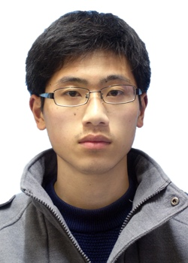

Mobile No.: +(86) 18767122656

Email: [haochaoying@zju.edu.cn](mailto:haochaoying@zju.edu.cn)

Room: Rm. 422, Cao Guang Biao Main Building Office

**Biography**

Mr. Haochao Ying is currently a second-year Ph.D. student under the supervision of Prof. Jian Wu, in the College of Computer Science and Technology of Zhejiang University. He received his Bachelor’s degree in College of Computer Science majoring in Computer Science and Technology, and Automation from Zhejiang University of Technology in 2014. His research area includes Service Oriented Computing, Recommendation System. His research focuses on implicit and hybrid recommendation, Point-of-Interest (POI) recommendation, and Quality of Services (QoS) prediction.

**In the submission of Papers**

[ICSE’15] **Haochao Ying**, Liang Chen, Tingting Liang, Jian Wu, EARec: Leveraging Expertise and Authority for Pull-Request Reviewer Recommendation in GitHub.

[PAKDD’15] **Haochao Ying**, Liang Chen, Yuwen Xiong, and Jian Wu, Collaborative Deep Ranking: a Hybrid Pair-wise Recommendation Algorithm with Implicit Feedback.

**Publication**

[SOCA’14] Liang, Tingting, Liang Chen, **Haochao Ying**, and Jian Wu. "Co-Clustering WSDL Documents to Bootstrap Service Discovery." In Service-Oriented Computing and Applications (SOCA), 2014 IEEE 7th International Conference on, pp. 215-222. IEEE, 2014.

**Education**

* Zhejiang University – Hangzhou, China, Sep.2014 – present

*Pursuing Ph.D degree in Computer and Technology*

* Zhejiang University of Technology – Hangzhou, China, Sep.2010 – July.2014

*B.S. in Computer and Technology, and Automation*

**Miscellaneous**

* Love playing basketball, traveling, taking photos, etc