Using particles swarm Optimization (PSO) for the optimal positioning of Wind Farm Layout for the reduction of wake loss

# Introduction

Due to the need to maintain consistent, environment-friendly, and economic power sources, wind power energy has become popular. A wind turbine is a mechanical device that converts wind kinetic energy into electrical energy. Wind turbines are combined to produce in the wind farm to produce a larger amount of electrical energy. The design of the placement of the individual wind turbine within the farm has been a major challenge in wind energy production. This project presents an optimization method using the particle swarm optimization (PSO) for the optimal design of farm layout for the optimization of power output.

# Farm Layout Design Problem

The optimal wind turbine positioning is a 2D problem that involves determining the (x,y) coordinate of each turbine in the farm for optimal power production and minimum wake losses (Charhouni, Sallaou, and Mansouri, 2019).

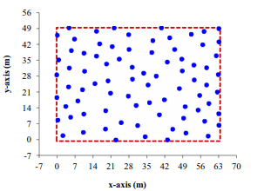

# Power model

To formulate the ppower production in a wind farm under the wake efectf, there is need to determine the power generated by each of the turbine. According to Charhouni, Sallaou, and Mansouri, (2019), the power produced by a wind turbine is estimated using equation 1.

$$P_{t}=η\frac{1}{2}ρAu^{3}C_{p}---(1)$$

**Where, $η=wind efficiency$**

$$ρ=Air density$$

$$u=Air stream velocity$$ $C_{p}=$ Power coefficient / efficiencyfactor

$$C_{p}=\frac{P_{A}}{\left(\frac{1}{2}\right)ρAu^{3}}---(2)$$

Given, $η=40\%, ρ=1.2, r=20m$

$$P_{t}=\frac{40}{100}×\frac{1}{2}×1.2×Π×u^{3}$$

$$P_{t}=301 u^{3} Watts$$

Hence, the power production by a wind turbine is given by:

$$P=0.3×u_{o}^{3}---(3)$$

Equation 3 shows that the power produced by a wind turbine on the farm is directly proportional to the cube of available free stream velocity. However, it is important to note that this is an ideal situation, the wake effect makes the equation to change to equation 4.

$$P=0.3×{(u_{o}-u_{d})}^{3}---(4)$$

Where, $u_{d}=velocity deficit$

# Wake Effect

The wind speed passing through the wind farm is reduced due to the wake effect which is based on the principle of conservation of momentum. Wake effect is the phenomenon that occurs when a wind turbine casts a wind shade resulting in less turbulent and slow wind speed behind the wind turbine when compared with the wind at the from of the turbine.

The placement of wind turbines in the wind farm is primarily dependent on the wake effects within the farm and between the turbines. Wind turbines are spaced vertically and horizontally in the farm to avoid velocity deficit due to the wake effect.

The pictorial view of the wake effect is described as described by Charhouni, Sallaou, and Mansouri, (2019) is shown in figure 1.

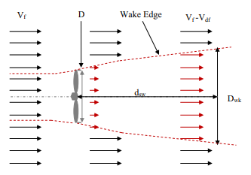

Figure 1:Illustration of wake effect

The reduction in the speed of the air stream is described given the velocity deficit factor ($u_{d}$) is described in equation 4

$$u=u˳\left(1-\frac{2a}{1+({\frac{ax}{r_{i}})}^{2}}\right)--(5)$$

Where $a=induction factor$. which is given by:

$$a=\frac{0.5}{\ln{(\frac{H}{z_{o}})}}--(6)$$

$$H=hub height, z_{o}=surface roughness$$

$$r_{i}=vertical spacing=r_{d}+ax--(6)$$

The wake effect due to the vertical spacing of the wind turbine is described in figure 2

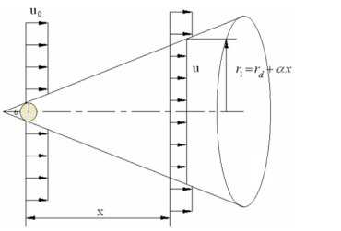

Figure 2: Illustration of the vertical spacing

# Cost model

The main goal of this optimization is to ensure maximum energy is generated within the wind farm at the lowest possible cost. Hence, cost modeling is essential, the cost modeling is the process of estimating the total value of cost needed to run the turbine for a particular period. The cost equation defines the total cost of running N turbines per unit time. The cost model was obtained from Shakoor et al., (2015), which is given the equation below

$$Cost= N_{t}\left[\frac{2}{3}+ \frac{1}{3}e^{-0.00174Nt2}\right]---(6)$$

Where *Nt* =Number of a wind turbine in the farm

The cost model can be used for the optimization problem by incorporating it with the power model as shown in equation 7. Hence, the optimization problem is aimed at minimizing the objective function.

$$objective=minimize\left(\frac{cost}{total power}\right)--(7)$$

**Assumptions**

The following assumptions are made for the simplicity of the model:

1. The freestream velocity for the farm, $u_{o}$ is 12 m/s
2. The air density is constant and it's equal to 1.2253 kg/m3
3. The farm layout is running for a known number of turbines

# Constraint

The minimum distance between any two turbines is assumed to be 200m

# Optimization

The particle swarm optimization (PSO) algorithm is proposed for the optimization problem. Particle swarm optimization is a global optimization algorithm that uses evolutionary computation problem to search for the best solution iteratively (El-Shorbagy and Hassanien, 2018). PSO has been applied to many optimization problems which include the constraint optimization problem, multi objective optimization, and stochastic optimization problem.

PSO search algorithm is insipired by the behavior of bees in search of food in an open field. The algorithm search for the best solution within a search space by observing the best result from individual solutions.

The mathematical formulation of the PSO is described below:

**parameters**

$$x_{i}^{t}=particle i at iteration t$$

$$v_{i}^{t}=velocity of particle i at iteration t$$

$${xc}_{i}^{t}=the cost of particle i at iteration t$$

$${bx}_{i}^{t}=the best position of particle i at iteration t$$

$${gx}^{t}=the global best position for all particles at iteration t$$

$$w=damping coefficient$$

$$c_{1},c_{2}=learning factor$$

$$r_{1},r_{2}=random number$$

Updating velocity

$$v_{i}^{t+1}=w×v_{i}^{t}+c_{1}×r_{1}\left(bx_{i}^{t}-x_{i}^{t}\right)+c_{2}×r_{2}×({gx}^{t}-x_{i}^{t})$$

Updating position

$$x_{i}^{t+1}=x_{i}^{t}+v_{i}^{t+1}$$

The flow chart for the PSO algorithm is described in the figure below

The optimization procedure is designed to compute the optimal coordinate point for each of the wind turbines in the wind farm for the minimization of cost and maximization of power. Equation 7 is used the objective function. The expected optimization result is the coordinate values for x and y for each of the turbines on the farm.

Setting bound for decision variables and optimization parameters

Create random population for optimization

Compute the current cost for each individual inn the population and determine the global best position and cost

Update the velocity and position of each of the individual in the population

Compute the current cost for each individual in the population and determine it’s the best cost for the individual and if it’s the global best cost for all individual.

If iteration is complete

No

yes

Parameters and characteristics of the wind farm

Table 1: Farm layout parameters

|  |  |
| --- | --- |
| Number of turbines | 20 |
| Hub height | 60m |
| Rotor radius(rd) | 40m |
| Wind farm area(km2) | 2km x 2km |
| Length of surface roughness(m) | 0.3 |
| Free stream velocity(m/s) | 12 |
| Air density(kg/m2) | 1.2253 |

# PSO parameter values

The simulation was carried out with a population of 50 for 100 iterations. The constraint tolerance and functional tolerance was set to 1e-100 for better optimization. The simulation was carried out on the Matlab Software.

# Optimization Results

The simulation was carried in the Matlab software using the farm layout parameters and the PSO parameter values discussed above. Table 2 shows the optimization results showing that the cost value is constant all through the optimization because the cost model only depends on the number of the turbine which is constant. However, the result was able to obtain an increment in the total power all during the iterations.

Table 2: Optimization Result

|  |  |  |
| --- | --- | --- |
| Iteration | Power (Watts) | Cost |
| 1 | 8.1353 $×{10}^{7}$ | 16.657 |
| 20 | 1.4860 $×{10}^{12}$ | 16.657 |
| 40 | 1.4860 $×{10}^{12}$ | 16.657 |
| 60 | 2.2842 $×{10}^{12}$ | 16.657 |
| 80 | 2.2842 $×{10}^{12}$ | 16.657 |
| 100 | 2.2842 $×{10}^{12}$ | 16.657 |
| 120 | 2.2842 $×{10}^{12}$ | 16.657 |
| 140 | 2.2842 $×{10}^{12}$ | 16.657 |
| 160 | 2.2842 $×{10}^{12}$ | 16.657 |
| 180 | 2.2917 $×{10}^{12}$ | 16.657 |
| 200 | 3.1923 $×{10}^{12}$ | 16.657 |

The optimum farm layout is shown in figure 3 resulting in an optimum cost of 16.732 and total power production of $2.3081 ×{10}^{12}$

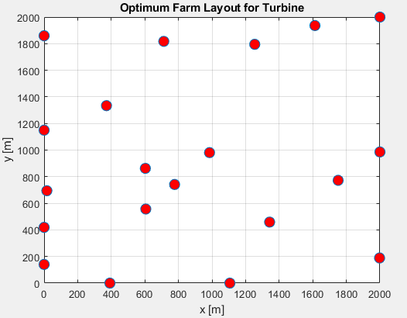

Figure 3: Optimum farm layout

# References

M.A. El-Shorbagy;Aboul Ella Hassanien. (2018). Particle Swarm Optimization from Theory to Applications. *International Journal of Rough Sets and Data Analysis, 5*(2).

Naima Charhouni;Mohammed Sallaou;Khalifa Mansouri. (2019). Realistic wind farm design layout optimization with diferent wind turbines types. *International Journal of Energy and Environmental Engineering*.

Nicholas F. Baker;1 Andrew P.J. Stanley;Jared J. Thomas;1 Andrew Ning;Katherine Dykes. (2019). *Best Practices for Wake Model and Optimization Algorithm Selection in Wind Farm Layout Optimization.* California.

Rabia Shakoor;Mohammad Yusri Hassan;Abdur Raheem;Nadia Rasheed. (2015). The Modelling of Wind Farm Layout Optimization for the Reduction of Wake Losses. *Indian Journal of Science and Technology, 8*(17).