* **Initial Steps:**

**Step 1:** Create your **GitHub** account.

**Step 2:** Click on the link [apriya-ram/manipal_assignments (github.com)](https://github.com/apriya-ram/manipal_assignments)

* **Fork:**

**Step 3:** Click on **Fork** at the top right to get that code in your Repositories.

* **Create Directory:**

**Step 4:** Now in your putty or unix terminal (Vnc Viewer), follow the below commands.

Create your directory in below path

**cd /fetools/work_area/frontend/**

**mkdir apriya (your login name for example priya’s name given)**

* **Configuration:**

**Step 5:** In putty/unix configure your mirafra user_name and email id as shown

**cd apriya/**

**git config --global user.name "apriya-ram"**

**git config --global user.email** [**apriyaram05@gmail.com**](mailto:apriyaram05@gmail.com)

* **SSH key in Linux:**

**Step 6:** Create ssh key,

**ssh-keygen -t ed25519 -C "**[**apriyaram05@gmail.com**](mailto:apriyaram05@gmail.com)**"**

Now press **Yes** and Press **Enter** until it gets added and your path is obtained and give below command

**gvim ~/.ssh/id_ed25519.pub**

**below image is an example given for reference**

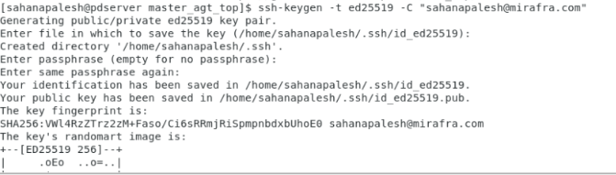

**Step 7:** Now ssh key will be generated and copy the file contents.

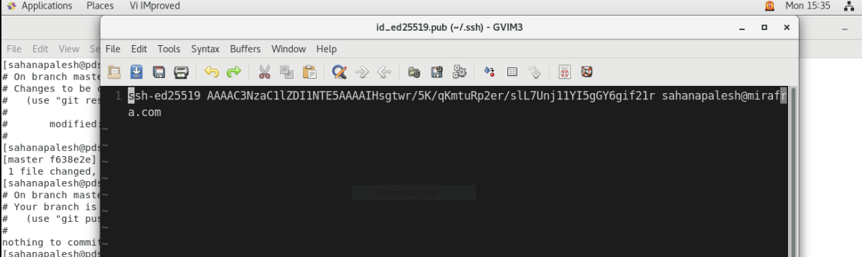

* **SSH key in GitHub:**

**Step 8:** Go to GitHub → Settings(of your account) → Account Settings → SSH and GPG keys → New SSH key

Title: **mirafra_server**

Key: (Paste the copied SSH key from putty/unix)

Now click on Add SSH keys

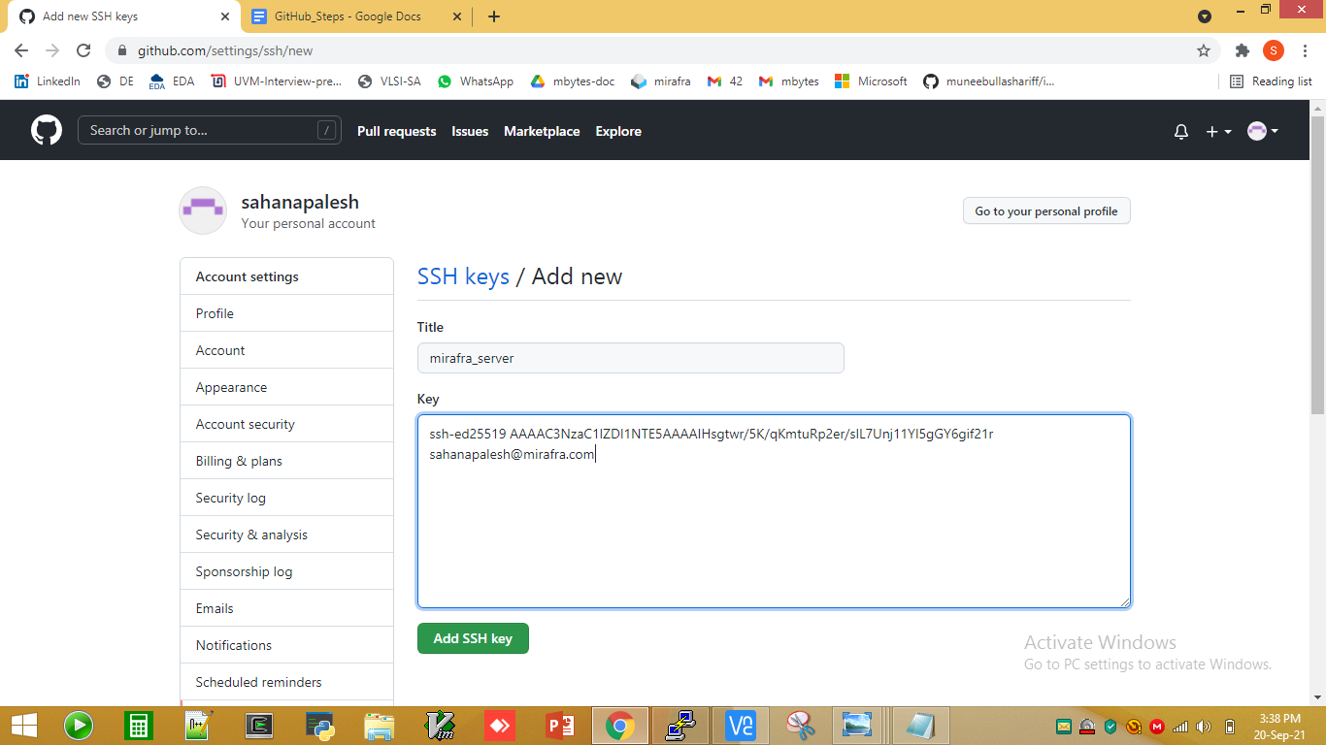

**Step 9:** Now you can use the SSH link from GitHub → Repository (particular folder- manipal_assignments) → code → Copy SSH link.

* **Git Clone:**

**Step 10:** Go to putty/unix terminal and clone the path as following command

**git clone** [**git@github.com:apriya-ram/manipal_assignments.git**](mailto:git@github.com:apriya-ram/manipal_assignments.git)

**Below image is given for reference for you here name of clone directory will be manipal_assignments instead of i2c_vip.**

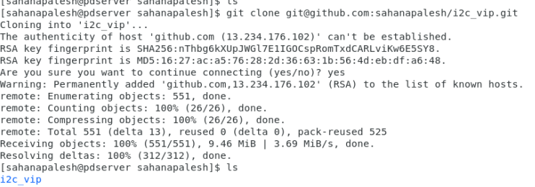

**Step 11:** Go to the master folder and check for git status

**cd /manipal_assignments/system_verilog/data_types_assignment**

**git status**

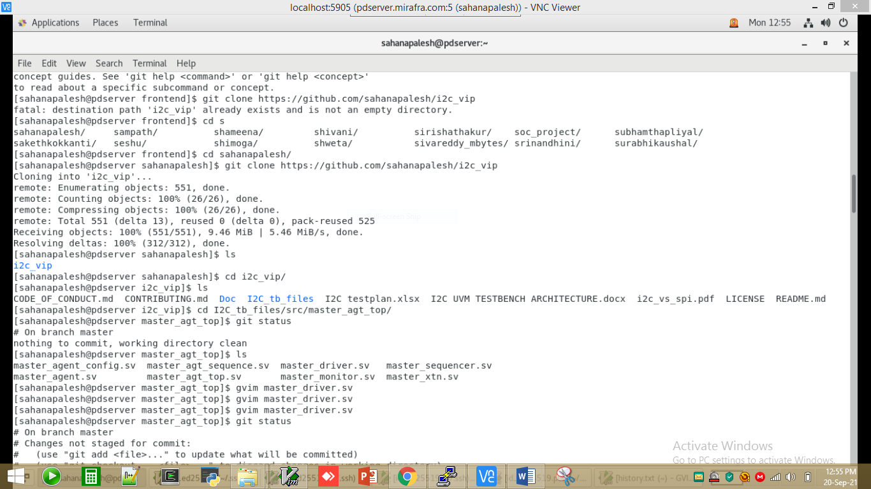

**Step 12:** Edit a file in gvim as shown and check status

**gvim data_assign1.sv**

**git status**

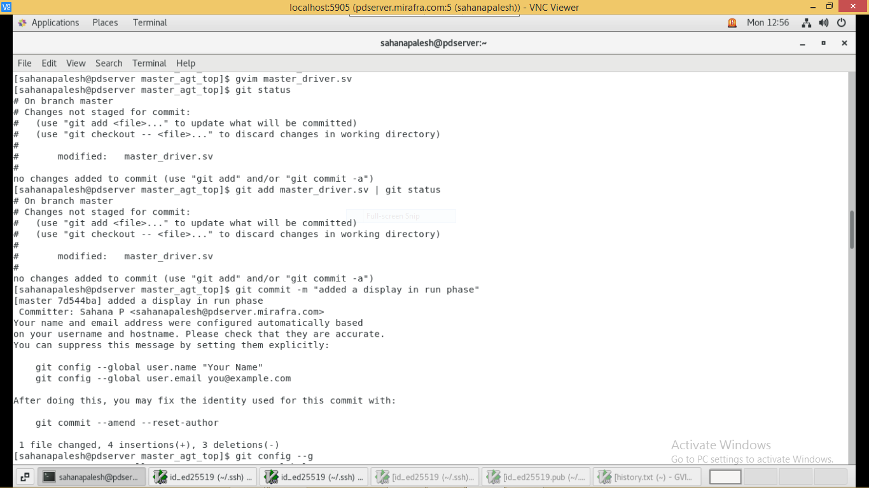

**Step13:**

**After editing the code save your code into your own work area and then copy same code to following path with your name as given in example below:**

**/**fetools/work_area/frontend/assignments_batch9/sv_assignments/data_types

**For ex: /fetools/work_area/frontend/assignments_batch9/sv_assignments/data_types/data_assign1_apriya.sv**