**Task 1: Print Sum, Difference, Product, and Quotient from user input**

import java.util.Scanner; *// Program import the Scanner class*

public class Week1 {

    public static void **main**(String[] *args*) {

        Scanner userInput1 = new Scanner(System.in); *// Scanner userInput = new Scanner(System.in);*

        System.out.print("Enter the first number: "); *// Program ask for First number*

        int firstNumber = userInput1.nextInt();

        System.out.print("Enter the second number: "); *// Program ask for Second number*

        int secondNumber = userInput1.nextInt();

        userInput1.close();

        int sum = firstNumber + secondNumber; *// Program calculate the sum of the two numbers*

        int product = firstNumber * secondNumber; *// Program calculate the product of the two numbers*

        int difference = firstNumber - secondNumber; *// Program calculate the difference of the two numbers*

        int quotient = firstNumber / secondNumber; *// Program calculate the quotient of the two numbers*

*// Program display the answers of the two numbers*

        System.out.println("The sum of the two numbers is: " + sum);

        System.out.println("The product of the two numbers is: " + product);

        System.out.println("The difference of the two numbers is: " + difference);

        System.out.println("The quotient of the two numbers is: " + quotient);

    }

}

* I import first the ***Scanner*** class from java for user input
* In the ***main*** method, I create a ***Scanner*** object to read user input
* The program will prompt the user to input two numbers and stores them as int.
* After storing the user input on variables, the program will perform two basic arithmetic: ***addition, multiplication, subtraction, and division.***
* The program will print the results of the operations to the console and close the Scanner.

The program demonstrates basic input and output operations and simple arithmetic calculations in Java.

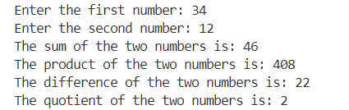

**Task 2: Check the user input number if it is odd or even**

import java.util.Scanner; *// Program import the Scanner class*

public class OddEven {

    public static void **main**(String[] *args*) {

        Scanner userInput = new Scanner(System.in);

        System.out.print("Enter a number: "); *// Program ask for a number*

        int number = userInput.nextInt();

        if (number % 2 == 0) { *// Program determine if the number is odd or even*

            System.out.println("The number is even.");

        } else {

            System.out.println("The number is odd.");

        }

        userInput.close(); *// Program close the scanner*

    }

}

* Same with the first problem, I import ***Scanner*** to get the user input
* The program will prompt the user to enter a number.
* After that, the program will read the input as ***integer***.
* I user if-else statement to check if the number is even or add.
* If the number if divisible by 2 { ***number % 2 == 0*** }, the number if ***even***.
* Otherwise, the number is ***odd.***
* The program will print whether the number is ***even*** or ***odd.***
* Finally, I close the Scanner to prevent resources leaks.

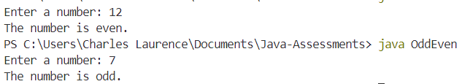 The program demonstrates basic input handling, conditional statements, and the modulus operator in Java to determine if a number is odd or even.

**Task 3: Factorial of the given number**

import java.util.Scanner; *// Program import the Scanner class*

import java.math.BigInteger; *// Program import the BigInteger class*

public class Factorial {

    public static void **main**(String[] *args*) {

        Scanner userInput = new Scanner(System.in); *// Program ask for a number*

        System.out.print("Enter a number: "); *// Program ask for a number*

        int number = userInput.nextInt();

        BigInteger factorial = BigInteger.ONE;

        for (int i = 1; i <= number; i++) {

            factorial = factorial.multiply(BigInteger.valueOf(i)); *// Program calculate the factorial of the number*

        }

        System.out.println("The factorial of " + number + " is " + factorial); *// Program display the factorial of the number*

        userInput.close();

    }

}

* Same with the first and second problem, I also input ***Scanner*** for user input and ***BigInteger*** Classes.
* The program prompts the user to enter a number and reads it as an integer.
* The program uses ***BigInteger*** for the factorial calculation.
* I use a ***for loop*** to calculate the factorial.
* Iterates from 1 to the input number.
* Multiplies each number in this range to the factorial.
* The program will print the calculated factorial of the input number.

 The program demonstrates user input handling loop usage, and basic arithmetic operations to compute the factorial of a number.