

**CS 1632 Software Quality Assurance**

**Deliverable 4**

Member 1 Name: Lanyi Wang

Member 2 Name: Tinglu Ren

1. **Optimized Feature 1**
   1. Write the name of the feature optimized (the label on the button)  
      write
   2. Write the name(s) of the method(s) you refactored to optimize this feature  
      Cell.toString()
   3. Insert a screenshot of VisualVM CPU profiling ***after*** optimizing Feature 1. Please include only the “Hot spots” window in the screenshot.   
      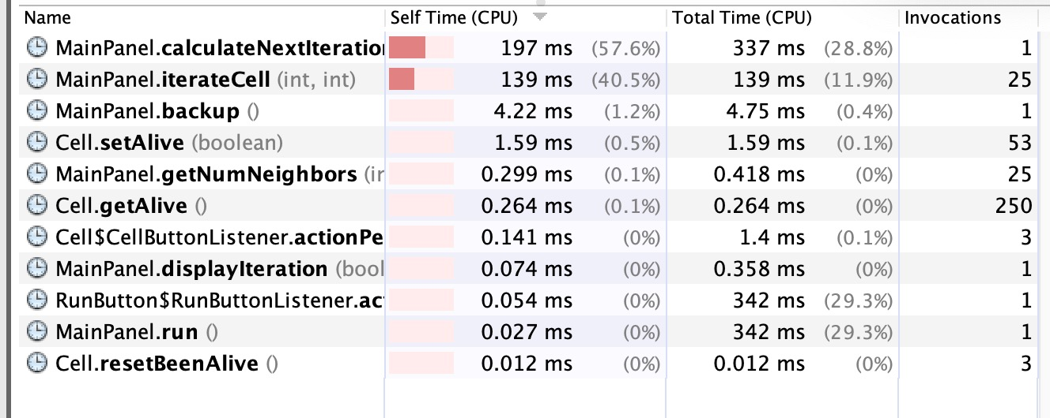
2. **Optimized Feature 2**
   1. Write the name of the feature optimized (the label on the button)  
      Run Continuous
   2. Write the name(s) of the method(s) you refactored to optimize this feature  
      MainPanel.calculateNextIteration()

MainPanel.iterateCell()

* 1. Insert a screenshot of VisualVM CPU profiling ***after*** optimizing Feature 2. Please show only the profile for Feature 2 (do not invoke Feature 1 while profiling). Please include only the “Hot spots” window in the screenshot, as before.

