**Problem 2 (MATLAB Solution)**

1. **Working Code**

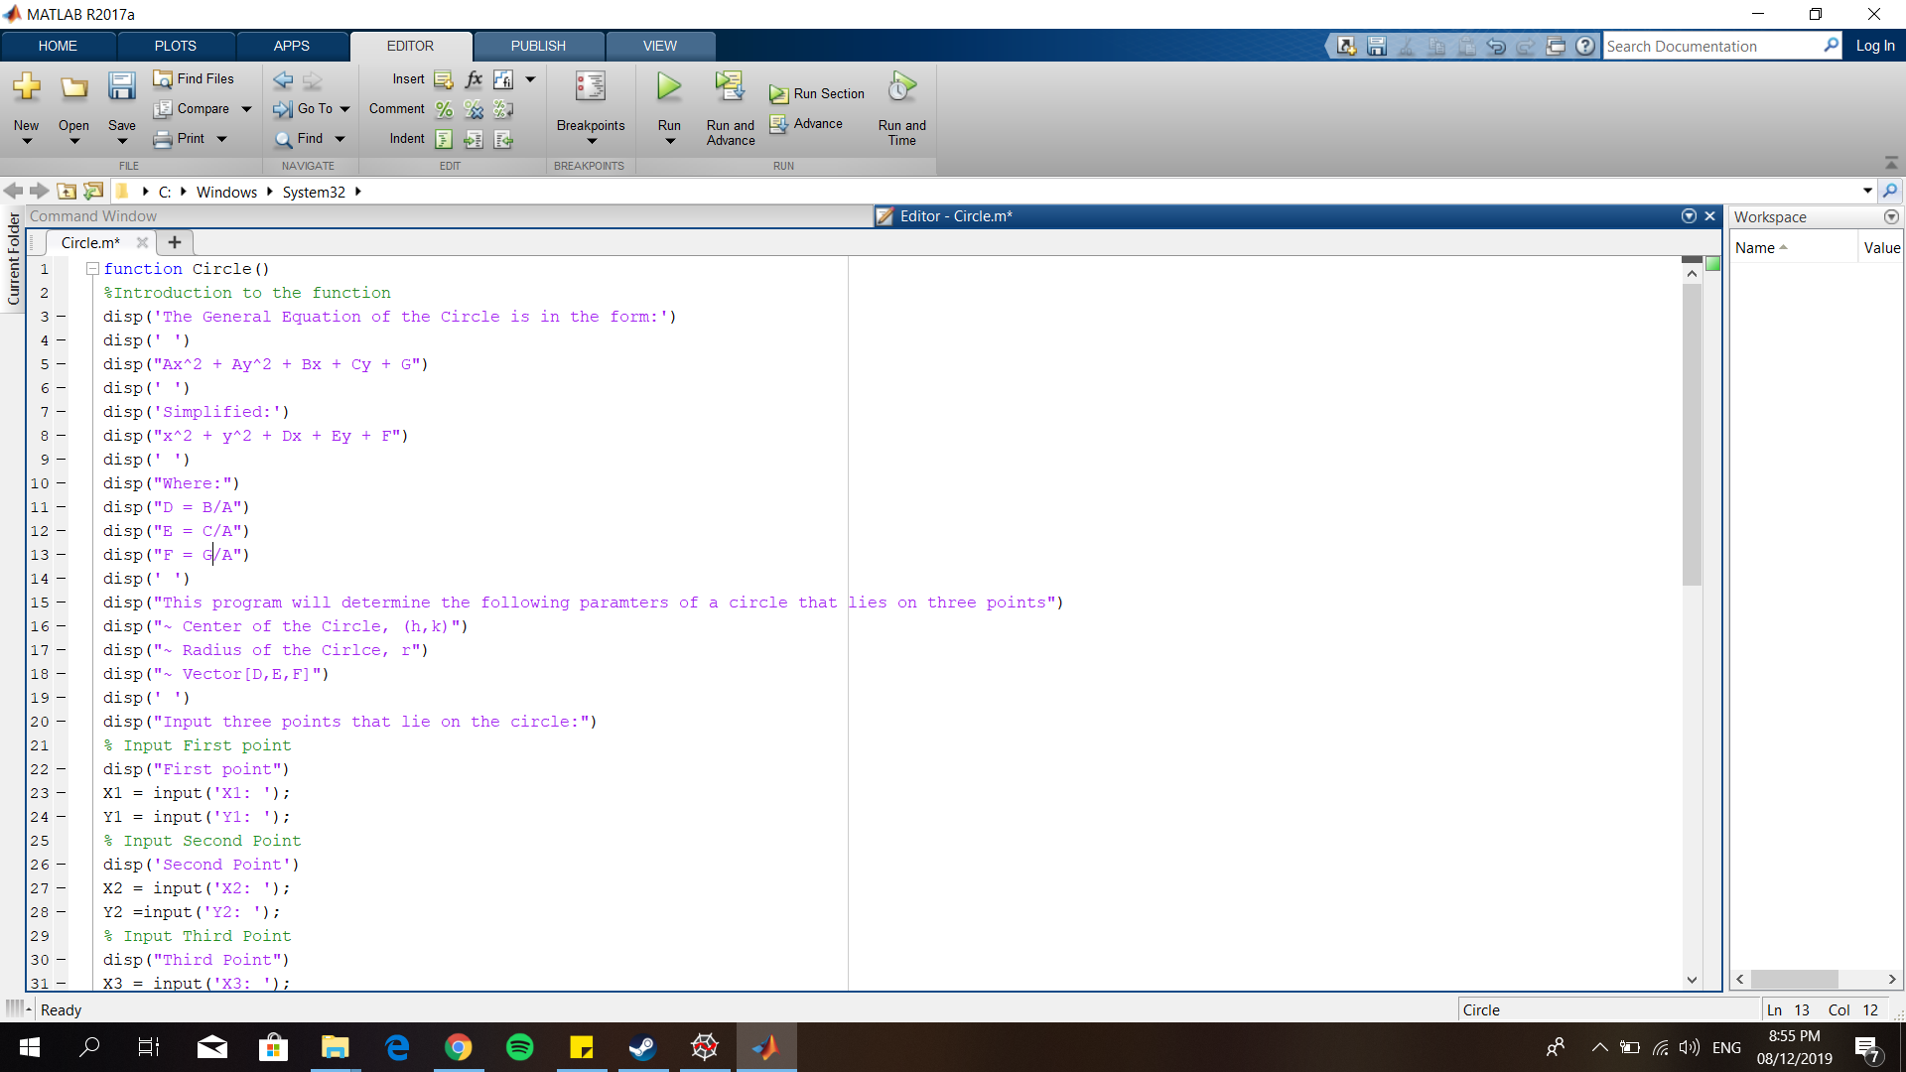

1. **Execution of Program**

B.1. Run the program.

B.2 After encoding the first point, the program then asks for the second point

B.3 After encoding the second point, the program then asks for the third and last point

B.4 After all the points are encoded, the program then displays the solved parameters of circle that lie on the points

For this, the points encoded are (-3,4), (4,5), and (1,-4). The parameters of the circle solved given those three points are: Center = (1,1), Radius = 5, and vector [D,E,F] = [-2,-2,-23].

