Problem 3 (Matlab)

1. **Working Code**

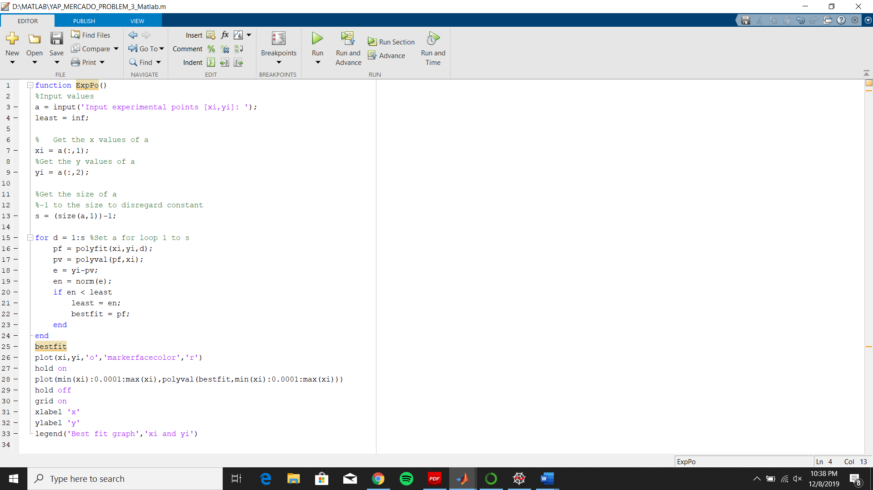

1. **Execution of Program**

B.1. Run the program. Input the desire experimental points of [xi,yi]

Experimental points: [1,2;3,4;5,6;7,8]

It will display the computed bestfit values. The graph is also displayed. Red dots are xi and yi points and the black line is the computed bestfit values.

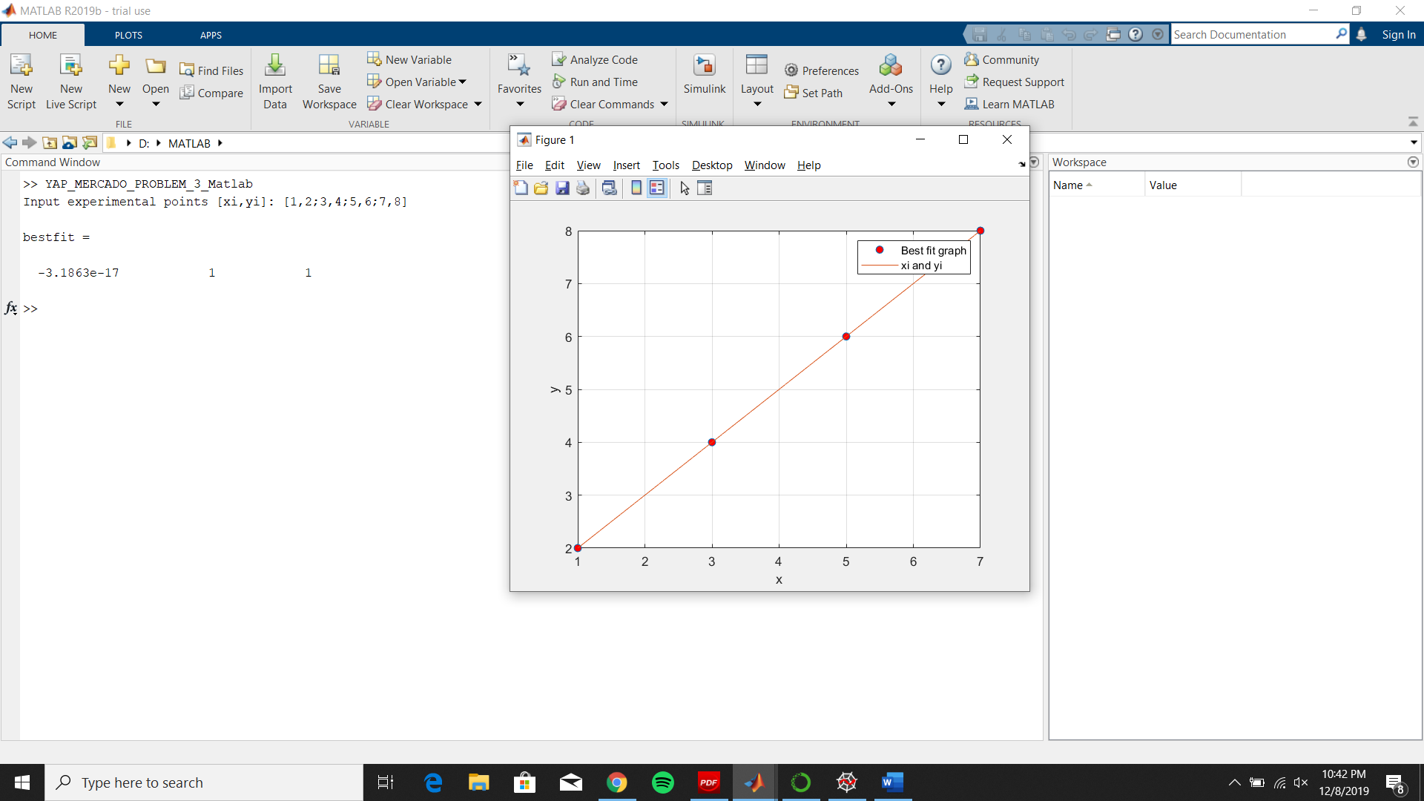

B.2. Rerun the program and test another experimental points.

Experimental points: [2,-1;3,4;-4,2;6,4]

