**Problem 1 (Python Solution)**

1. **Working Code**

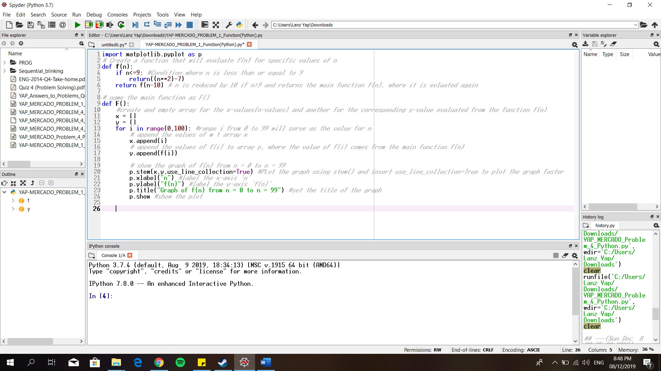

1. **Execution of Program**

B.1. Run the program. Then enter the name of the function, which is F()

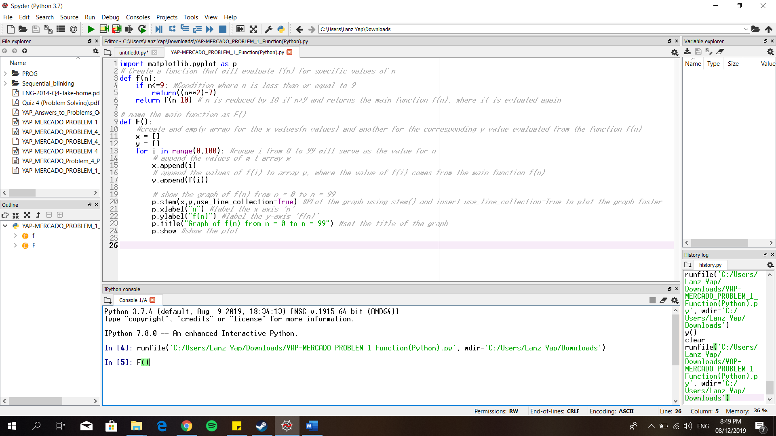

B.2 The graph is now shown in the iPhyton Console

