**Problem 4 (Python Solution)**

1. **Working Code**

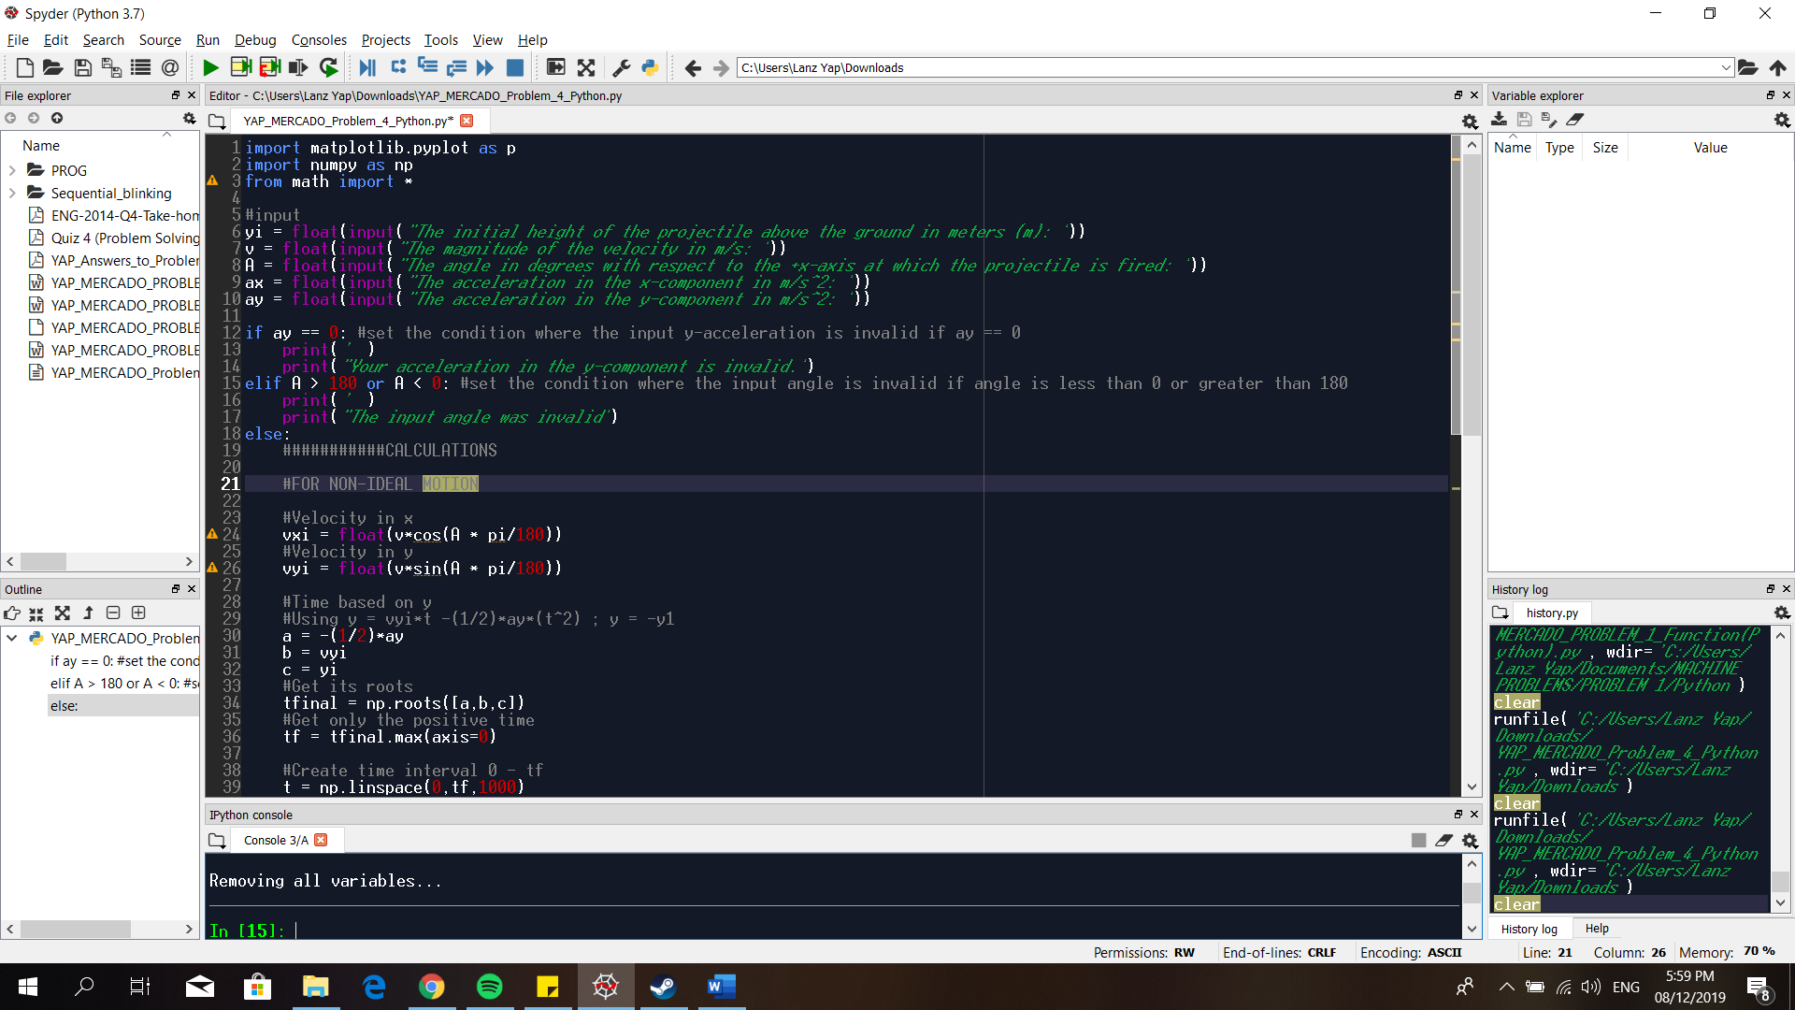

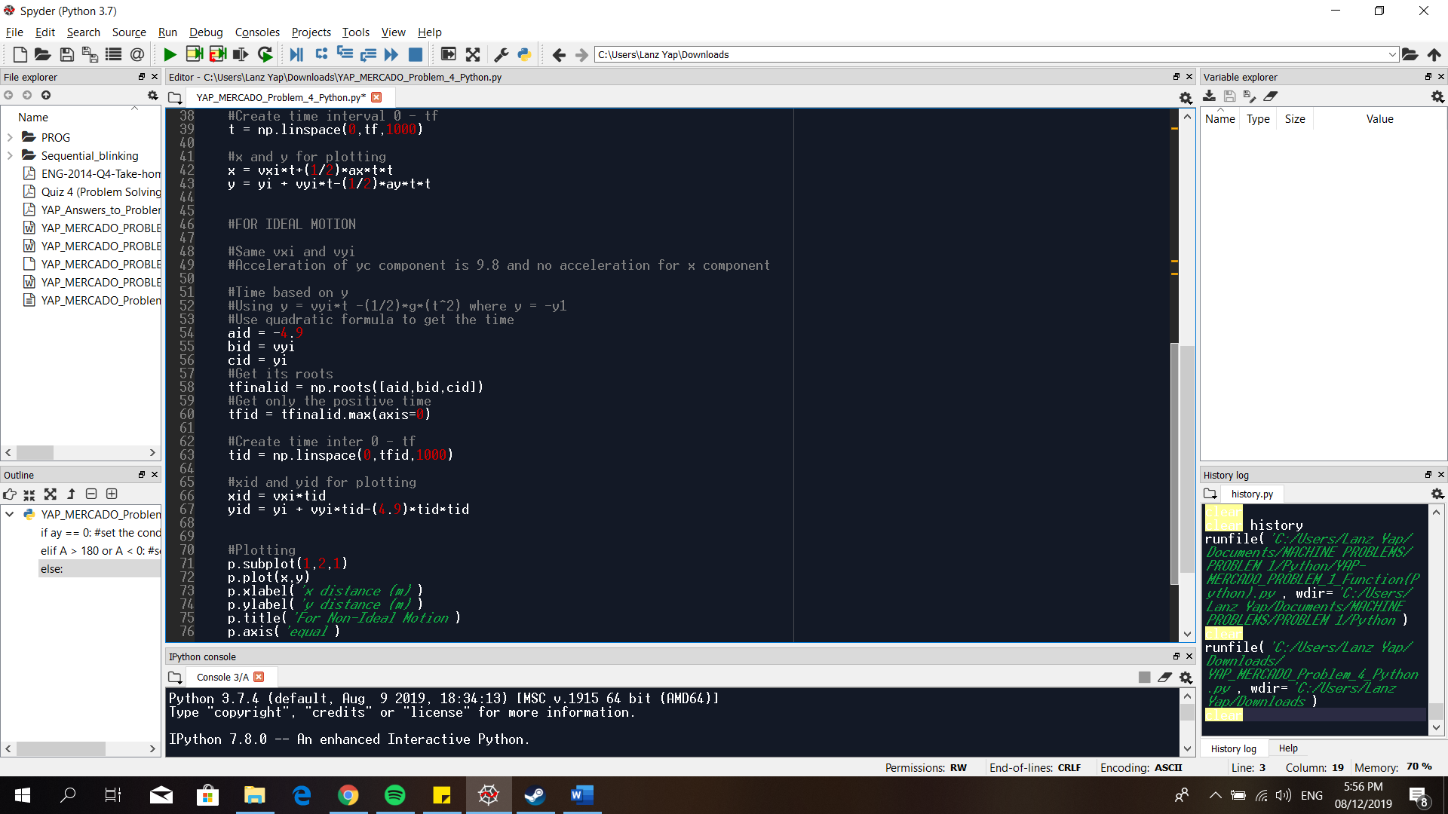

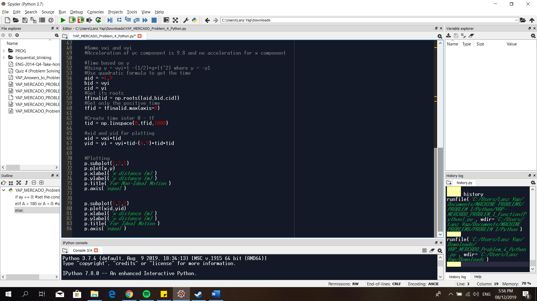

1. **Execution of Program**

B.1. Run the program. The program will ask values that are needed in graphing the projectile motion for ideal and non-ideal motions. Input the desired values.

Values: initial height = 3, velocity = 20, angle = 30, acceleration in x = 2, acceleration in y =2.

The graph of the projectile motion for ideal and non-ideal motions are displayed

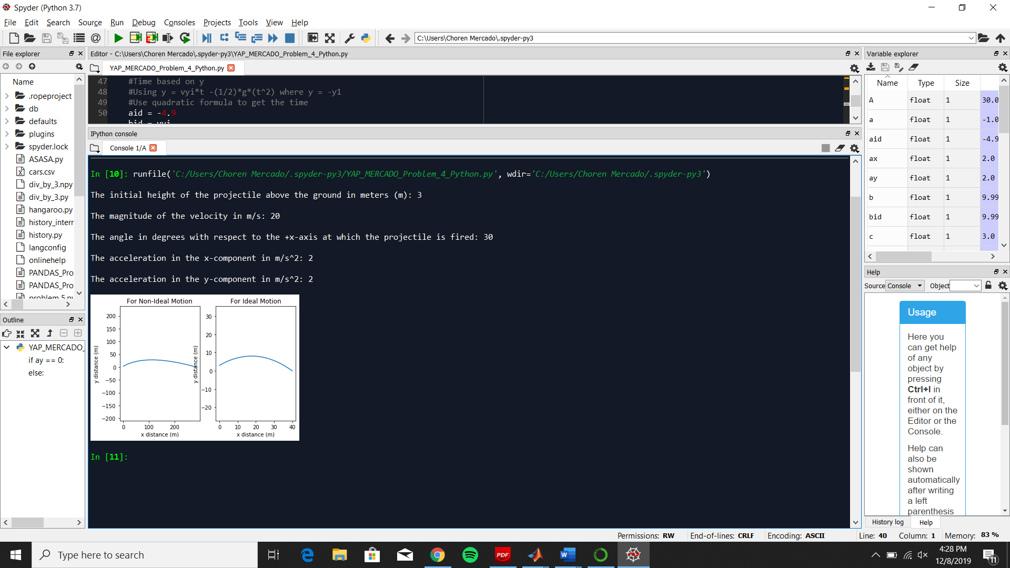

B.2. Run the program again and change the values.

Values: initial height = 45, velocity = 20, angle = 60, acceleration in x = 1, acceleration in y =8

The graph of the projectile motion for ideal and non-ideal motions are displayed.

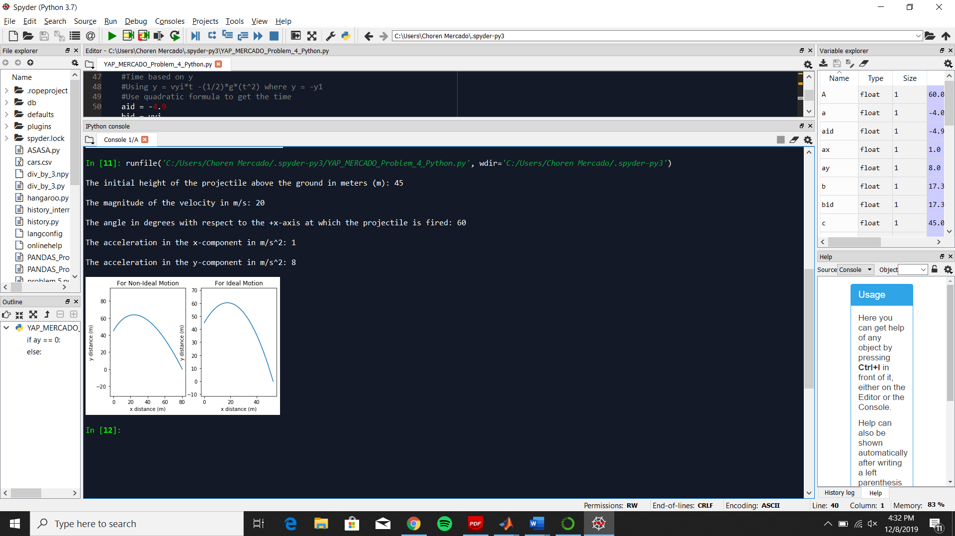

B.3. Run the program again and change its values.

Values: initial height = 25, velocity = 40, angle = 70, acceleration in x = 0, acceleration in y = 9.8

The graph of the projectile motion for ideal and non-ideal motions are displayed.

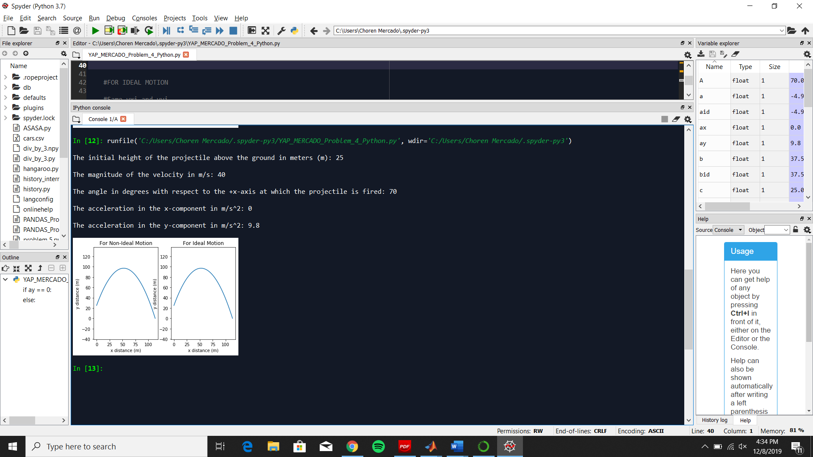

B.4. Run the program again and input invalid acceleration in y, ay= 0.

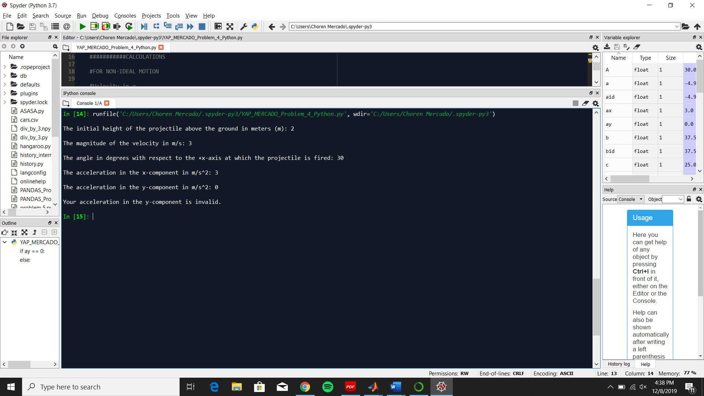

B.5 Run the program again and input invalid angle, A =181

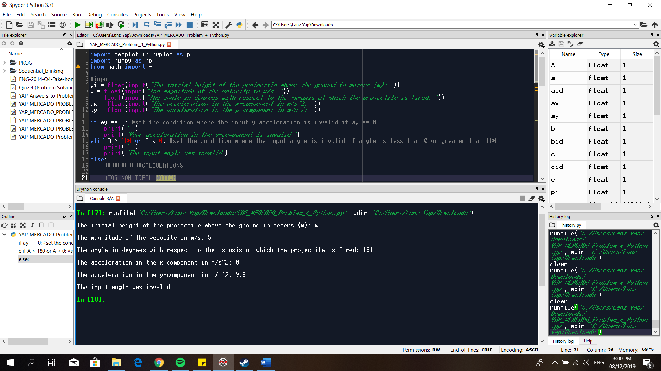

B.6 Run the program again and input invalid angle, A = -45

