**PROBLEM 1: We Bare Bears**

1. **Working Code**

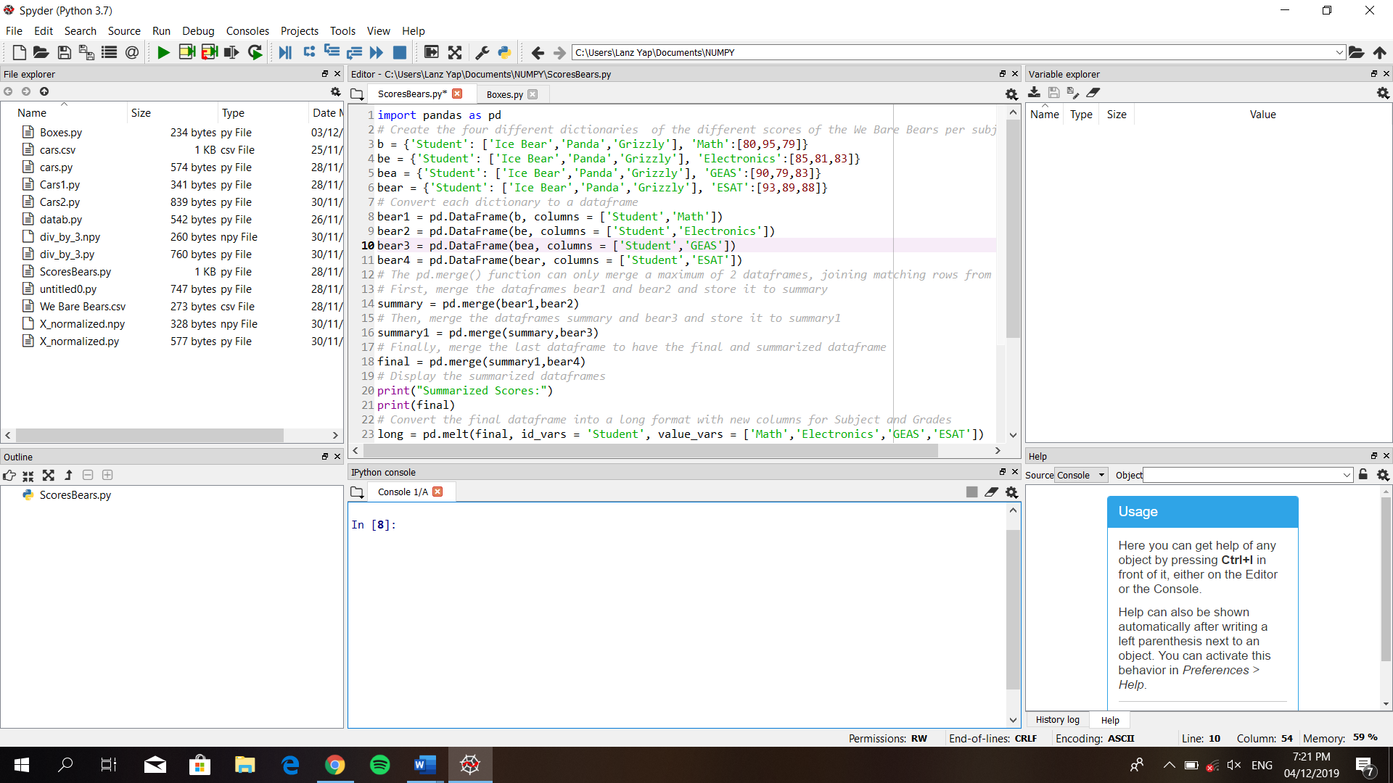

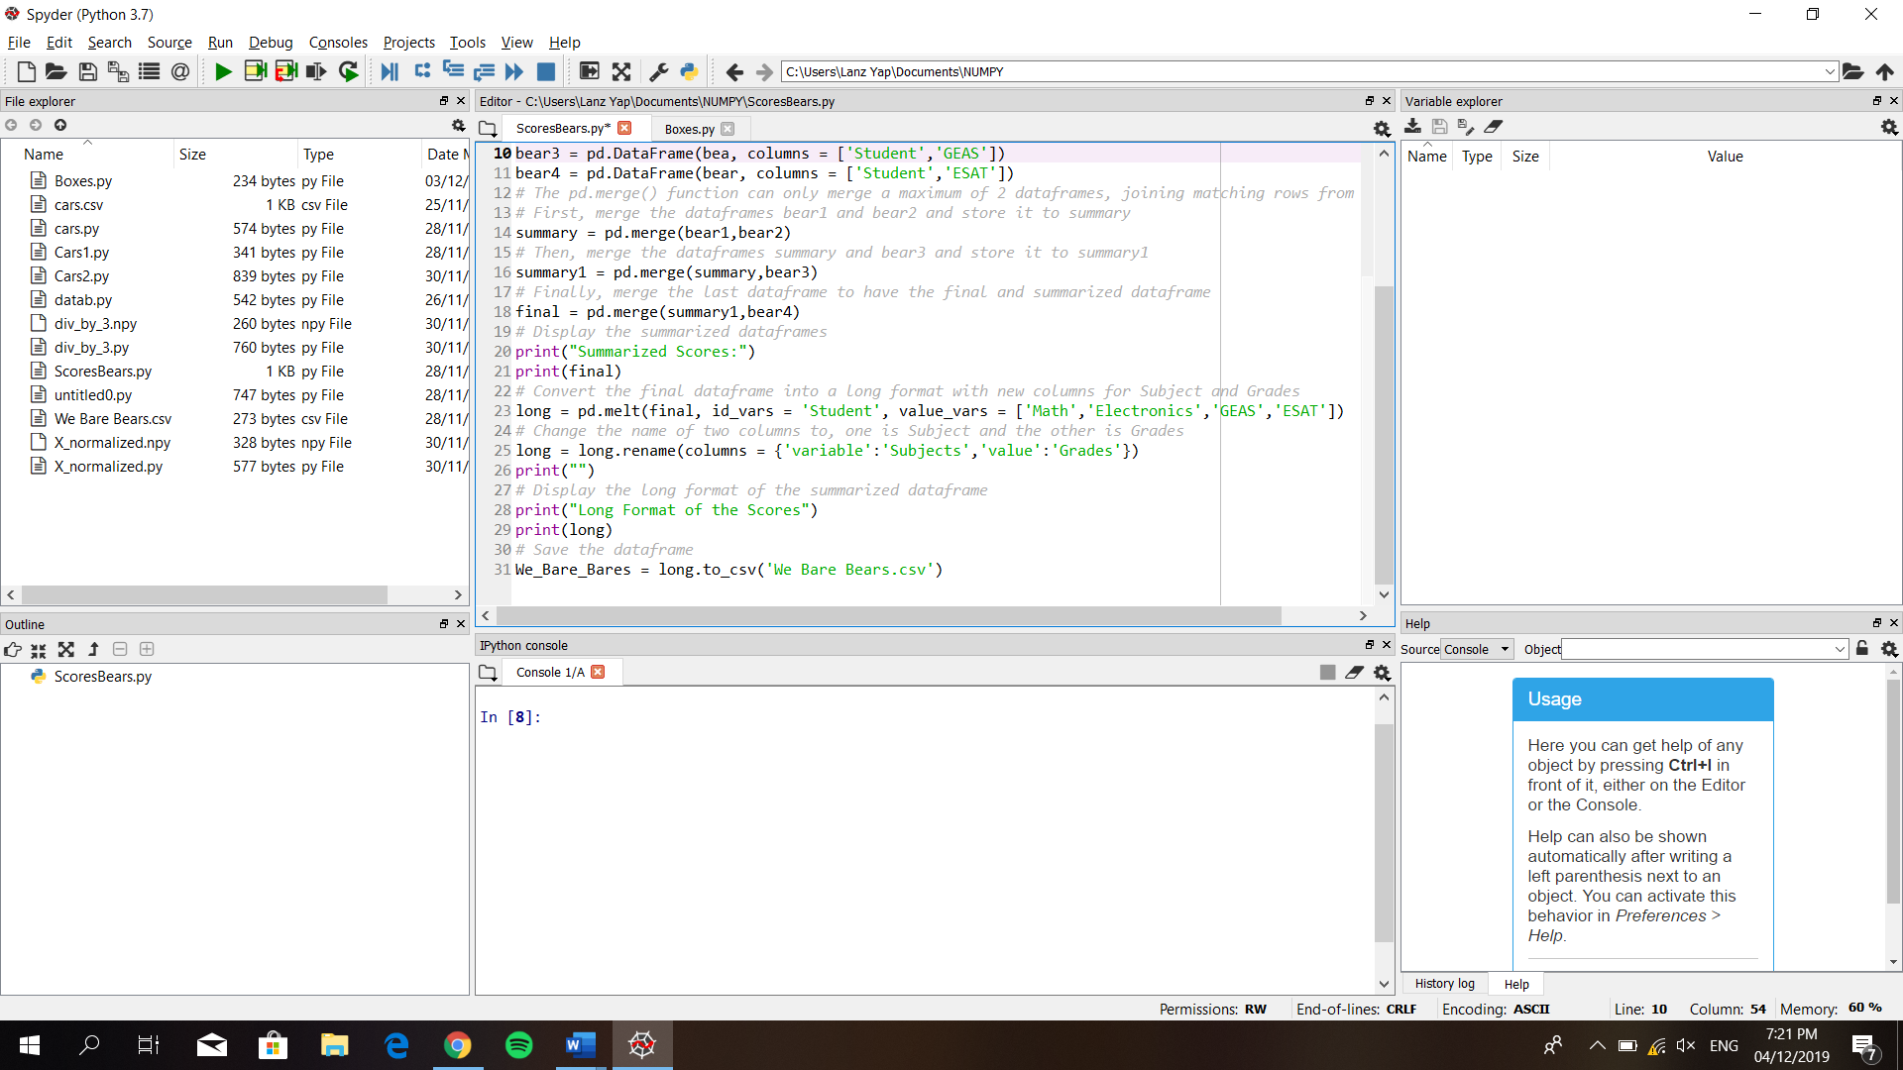

1. **Output (Tidy Data)**

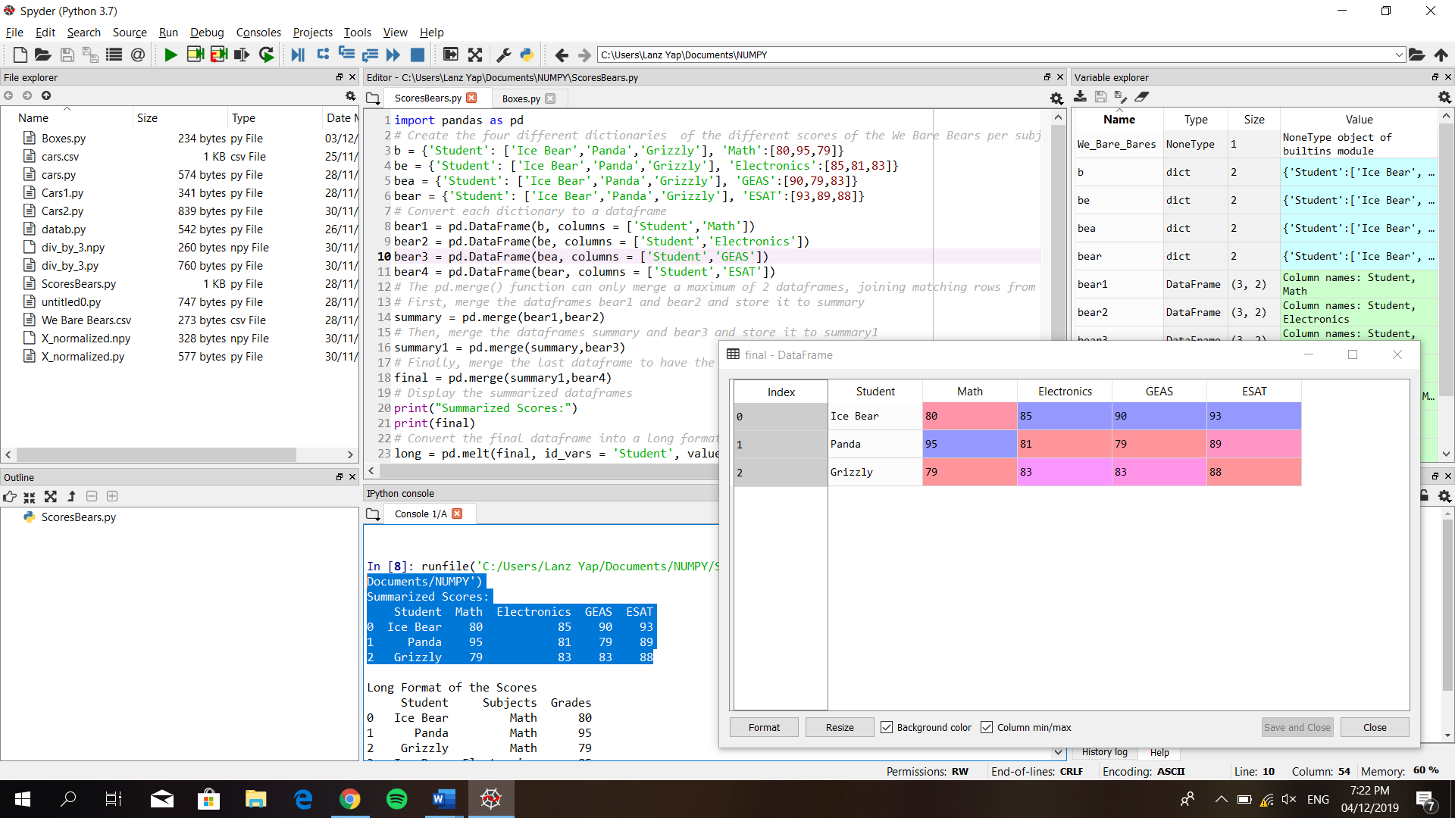

1. **Output (Long Format)**

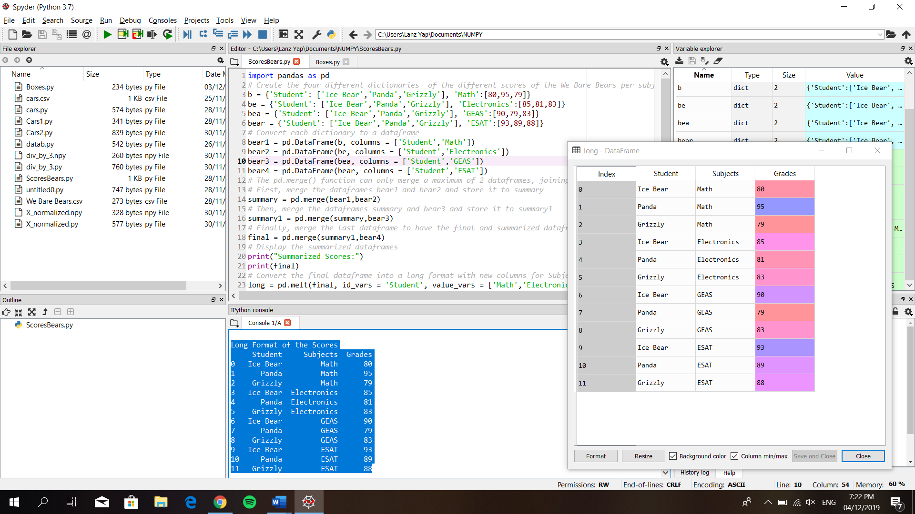

**Problem 2: Boxes**

1. **Working Code**

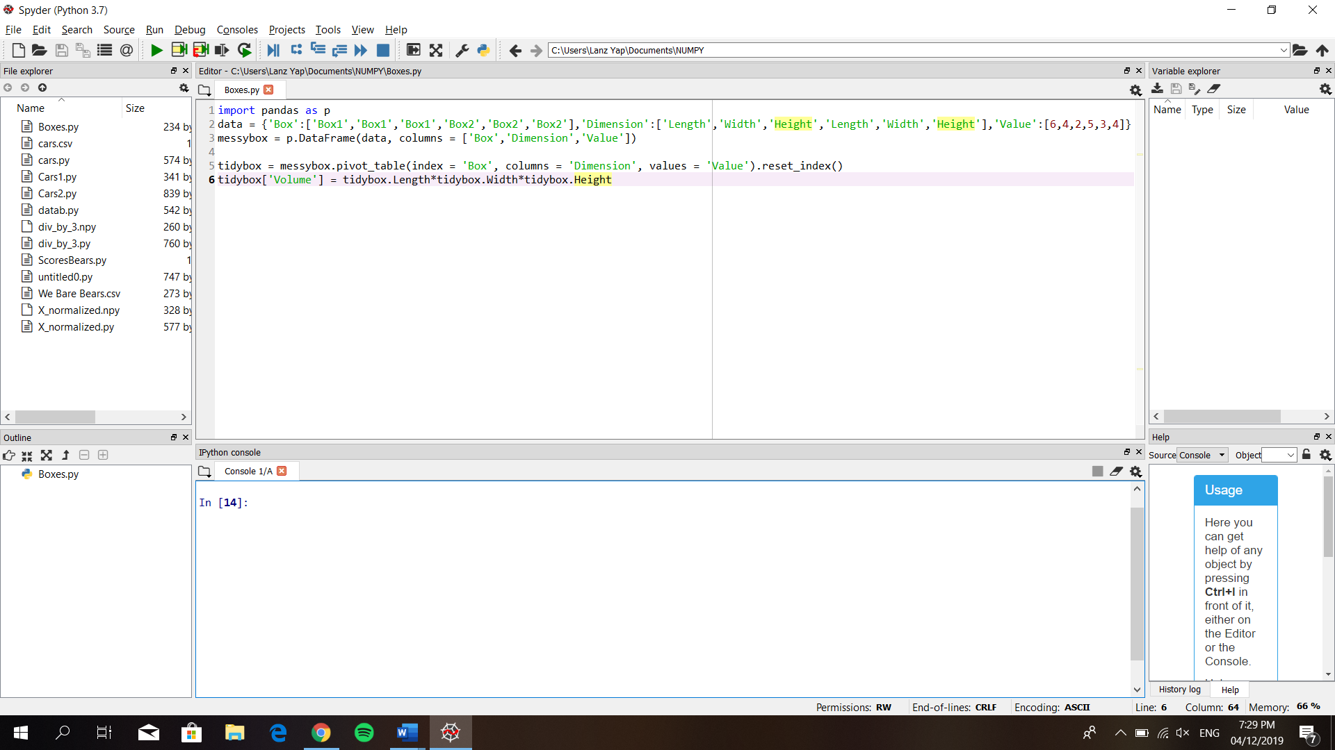

1. **Messy Data**

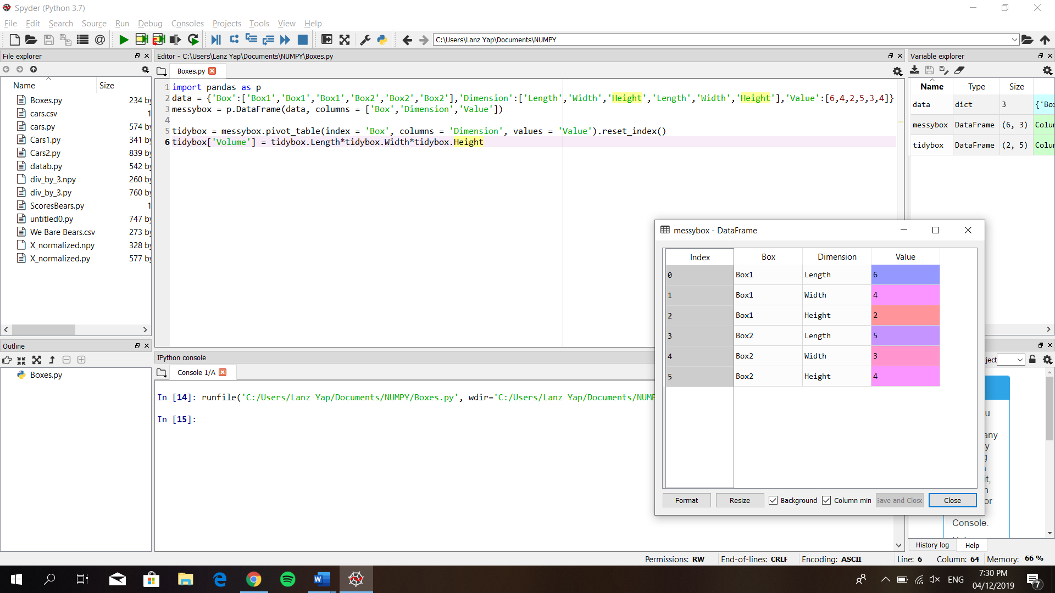

1. **Tidy Data with new column, Volume**