






GOVERNMENT
Chapter 1: Introduction to Accounting
(FAR by: Millan)

ACCOUNTING
Chapter 2: The Unified Accounts Code Structure (UACS)

Unified Accounts Code Structure

(UACS)
- It was jointly developed by the DBM, COA, DOF AND BTr.

- A government-wide coding framework, to provide a harmonized budgetary and accounting code classification that will facilitate the efficient and accurate financial reporting of actual revenue collections and expenditures compared with programmed revenues and expenditures, respectively, starting Fiscal Year (FY) 2014.

- On November 7, 2014, through JC No. 2014-1, the UACS per Joint Circular No. 2013-1 dated August 6, 2013 was enhanced amending the Funding Source Code and MFO/PAP Code.
- Validation and assignment of new Program, Activity and Project Codes shall be decided jointly by the proponent agency and DBM.

- Consistency of account classification and coding structure with the Revised Chart of Accounts shall be the responsibility of COA.

- Consistency of account classification and coding standards with the Government Finance Statistics shall be the responsibility of DOF-BTr.

Purpose of UACS
- It is a government-wide harmonized budgetary, treasury and accounting code classification that will facilitate reporting of all financial transactions of government agencies.

- Its objective is to establish the accounts and coded needed in reporting the financial transactions of the NGAs; and therefore, will be used by all departments and agencies of the National Government and GOCCs with Budgetary Support from National Government including those maintaining Special Accounts in the GF.
Reporting requirements that will be
best served by the UACS include:
- Financial reports as required by the DBM and COA.
- Financial statements as required by the Public Sector Accounting Standards Board of the Philippines.
- Management reports as required by the executive officials/heads of departments and agencies; and
- Economic statistics consistent with the Government Finance Statistics (GFS) Manual 2001.
Elements: The key elements of the
coding framework are:
  - Funding Source (8 digits)
    - Fund Cluster (2-digit code)
    - Financing Source (1-digit code)
    - Authorization Code(2-digit code)
    - Fund Category (3-digit code)
  - Organization Code (12 digits)
    - Department Code (2-digit code)
    - Agency Code(3-digit code)
    - Operating Unit Classification (2-digit code)
    - Lower Level Operating Unit(5-digit code)
Elements: The key elements of the
coding framework are:
  - Location Code (9 digits)
    - Region (2-digit code)
    - Province (2-digit code)
    - City/Municipality(2-digit code)
    - Barangay(3-digit code)
  - MFO/PAP (15 digits)
    - Sector/Horizontal Outcome (5-digit code)
    - Program/Project (1-digit code)
    - MFO/Project Category (2-digit code)
    - Activity Level 1/Project Sub-category (2-digit code)
    - Activity Level 2/Project title (5-digit code)
Elements: The key elements of the
coding framework are:
- Object Code (10 digits)
- Revised Chart of Accounts (8-digit code)
- Sub-Object Code (2-digit code)

Key Elements of UACS
- Funding Source Codes
  - It is a six-digit code to reflect the financing source, authorization and fund category. However, per JC No. 2014-1 dated November 7, 2014, the 6-digit funding source code was enhanced by adding another two digits code for the fund cluster for purposes of accounting, banking and reporting; thus, it becomes eight digits.
Funding Source Codes
Chapter 1:
Introduction to Accounting
(FAR by: Millan)
- Fund Cluster Code Values

FUND CLUSTER CODE | FUND CLUSTER DEFINITION
01 | Regular Agency Fund
02 | Foreign Assisted Project Fund
03 | Special Accounts-Locally Funded/Domestic Grants Fund
04 | Special Accounts-Foreign Assisted/Foreign Grants Fund
05 | Internally Generated Funds
06 | Business Related Funds
07 | Trust Receipts

Funding Source Codes
- Financing Source Code

Particulars | UACS
General Funds | 1
Off-Budgetary Funds | 2
Custodial Funds | 3

Funding Source Codes
b. Financing Source Code
-General Funds are funds available for any purpose that Congress may choose to apply, and is composed of all receipts or revenues that do not otherwise accrue to other funds.

-Off-Budgetary Funds refer to receipts for expenditure items that are not part of the National Expenditure Program, and which are authorized for depositing in government financial institutions. These are categorized into: · Retained Income/Receipts, and · Revolving Funds

Funding Source Codes
b. Financing Source Code
-Custodial Funds refer to receipts or cash received by any government agency—whether from a private source or another government agency—to fulfill a specific purpose. Custodial receipts include receipts collected as an agent for another entity. These include trust receipts—both from an individual or corporation—that are required to be held by government until the outcome of a court’s case or procurement activity is determined, as well as cases where a department or agency holds receipts as a trustee for the fulfillment of some obligations.

Funding Source Codes
c. Authorization Code

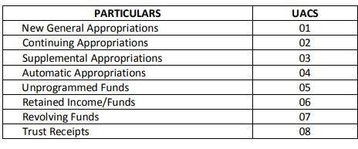

Funding Source Codes
c. Authorization Code
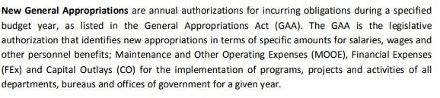

Funding Source Codes
c. Authorization Code

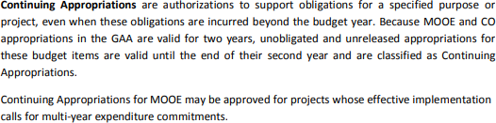

Funding Source Codes
c. Authorization Code
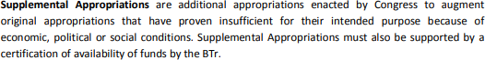

Funding Source Codes
c. Authorization Code

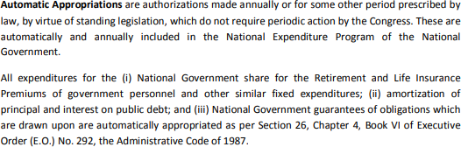

Funding Source Codes
c. Authorization Code

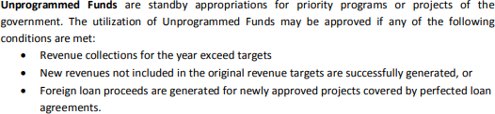

Funding Source Codes
c. Authorization Code

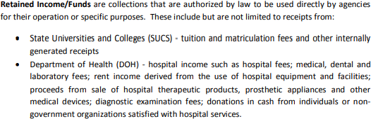

Funding Source Codes
c. Authorization Code
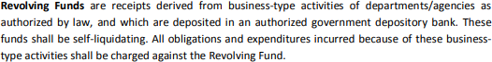

Funding Source Codes
c. Authorization Code

Funding Source Codes
d. Fund Category Code

-It identifies specific funds maintained by the agency for accounting purposes, as well as for recording and reporting financial transactions.
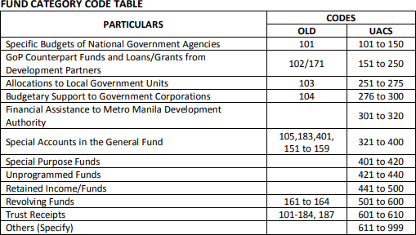

Fund Category Code
- Specific Budgets of National Government Agencies

- This refers to the budgets appropriated for a specific department or agency of the National Government.

Fund Category Code
- GoP Counterpart Funds and Loans/Grants from Development Partners

- It refers to the Multilateral/Bilateral Assistance.
- The fund category for counterpart funds, loan proceeds and grants proceeds will be selected according to the name of the institution providing funds from the list provided by UACS manual. The authorization code—which precedes the fund category code—will vary depending on whether funds were loans or grants, as well as if they were unprogrammed or included in the regular budget.
Appropriated loan proceeds will use authorization code 01, grant
proceeds will use authorization code 04 and unprogrammed loan proceeds will use authorization code 05.

Fund Category Code
- Allocation to Local Government Units (ALGU)

- It refers to the share of Local Government Units (LGUs) from the revenue collections of the National Government. The total ALGU is based on a sharing scheme computed for each LGU, as provided for under the Local Government Code and other special laws.

Fund Category Code
- Budgetary Support to Government Corporations

- It refers to either subsidies for operations or projects, equity contributions, and net lending and/or advances to Government-Owned or Controlled Corporations (GOCC) for loan repayments.

Fund Category Code
- Financial Assistance to Metropolitan Manila Development Authority

- It refers to national government subsidy in the form of regular appropriations as provided in the GAA which shall only be used to augment any deficiency in the consolidated funds of the MMDA to cover valid and authorized expenditures.

Fund Category Code
- Special Account in the General Fund (SAGF)

- It is a fund where proceeds from specific revenue measures and grants earmarked by law for priority projects are recorded. These sources are automatically appropriated

Fund Category Code
- Special Purpose Funds

-These are lump-sum funds included in the GAA which are not within the approved appropriations of Departments/Agencies/Lower Level Operating Units, and which are available for allocation to any Department/Agency/Lower Level Operating Unit or Local Government Unit for a specific purpose, as may be duly approved in accordance with special provisions on the use of these funds.

Key Elements of UACS
- Organization Codes

-It is a twelve-digit code to reflect the Department, Agency and Sub-Agency or Operating Unit/Revenue Collecting Unit.

Organization Codes
- Department Codes

- the primary subdivision of the Executive Branch responsible for the overall management of a sector or a permanent national concern with nationwide or international impact1 . A department is headed by a Secretary or an official with an equivalent position level.
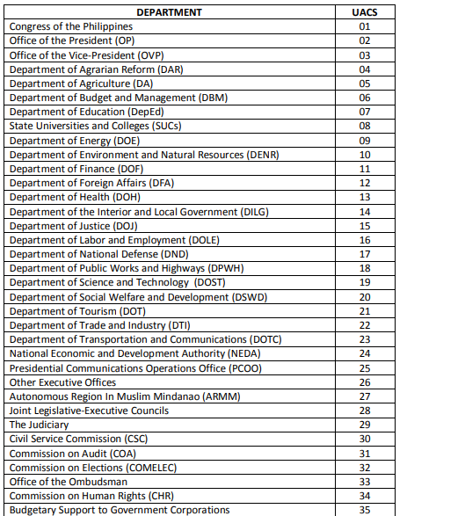
Department Codes

Organization Codes
- Agency Codes
Agency – refers to any of the various units of the government, including an office, instrumentality or Government-Owned and/or Controlled Corporation (GOCC)2 that may not approximate the size of a Department, but which nevertheless performs tasks that are equally important and whose area of concern is nationwide in scope (e.g., Other Executive Offices [OEOs]).
For purposes of the UACS, an agency is an entity under a department whose budget is directly released to the latter, and may include the summation of all budgets of sub-agencies listed under it, if any.

Organization Codes
- Operating Unit Classification Code
Operating Units – organizational entities charged with carrying out specific substantive functions or with directly implementing programs/projects of a department or agency, such as line bureaus and field units.

For the purposes of the UACS, these are organizational units under a Department or an Agency which may be:
- directly receiving budgets from DBM, including SUCs
- recipients of fund transfers from higher level OUs, and/or
- authorized to collect revenues

Organization Codes
c. Operating Unit Classification Code
The first two digits of operating unit codes will be used to indicate the classification of an operating unit, as follows
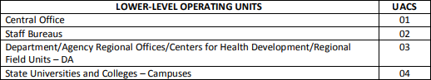
Operating Unit Classification Code
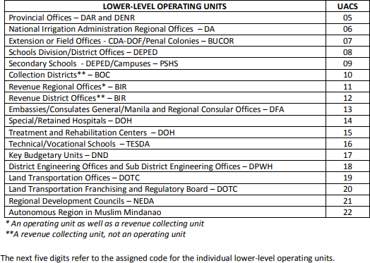
Operating Unit Classification Code

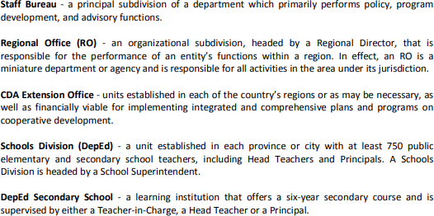
Operating Unit Classification Code
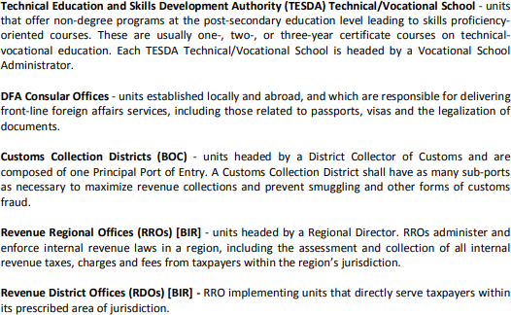
Operating Unit Classification Code

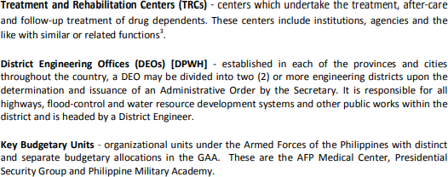

Organization Codes
d. Lower Level Operating Units

-As a general rule, the last five digits here refers to the assigned code for the individual operating units without reference to the Region Code.

Key Elements of UACS
- Location Codes
To facilitate central agency analysis across the National Government, location coding should first enable the analysis of data by region, and then by province, municipality/city and barangay. The coding structure here relies upon the codes used by the National Statistical Coordination Board (NSCB) only.

Location Codes
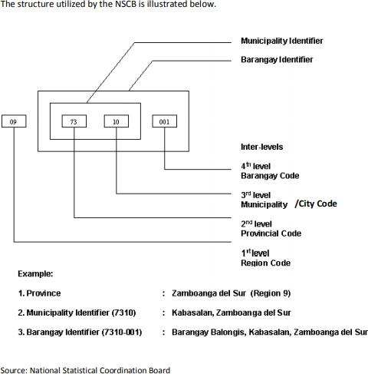
Key Elements of UACS
- Major Final Output (MFO)/Program, Activity, Project (PAP) Codes

-An MFO is defined as a good or service that a department or agency is mandated to deliver to external clients through the implementation of programs, activities and projects.

-It should be within the department or agency’s control and be measurable, manageable and auditable. Examples of MFOs include regulatory services, health services, education services and agricultural support services.

Key Elements of UACS
- Major Final Output (MFO)/Program, Activity, Project (PAP) Codes

-A program is an integrated group of activities that contributes to an agency or department’s continuing objective. Examples include General Administration and Support, Support to Operations, and Operations.

-An activity is defined as a work process that contributes to the fulfillment of a program or project. Each activity shall be attributed to only one MFO. Activities are to be assigned to General Administration and Support, or Support to Operations if they benefit internal clients. On the other hand, an activity that benefits external clients shall be attributed to an MFO.

  - Projects are special department/agency undertakings carried out within a definite timeframe, and which are designed to produce a pre-determined measure of goods or services (MFOs). A project is considered an investment toward expanding the capacity of a department/agency to deliver MFOs.
Key Elements of UACS
- Object Codes
-The object classification covers all financial transactions of the government such as, but not limited to, goods or services acquired, transfer payments made, the source of revenue or the cause of increases or decreases in assets and liabilities.

-The basis for coding the object classification in the COA Revised Chart of Accounts is accrual accounting, which requires transactions to be recorded in the period when they occur (and not only when cash or its equivalent is received or paid). Therefore, the transactions and events are recorded in the accounting records and recognized in the financial statements of the periods to which they relate. The elements recognized under accrual accounting are assets, liabilities, equity, income and expenses.
Object Codes
The classification coding framework is as follows
for Object Coding, as provided for by COA in the Revised Chart of Accounts.

PARTICULARS | UACS
Assets | 1
Liabilities | 2
Equity | 3
Income | 4
Expenses | 5

Object Codes
- Assets refer to the economic resources of an agency that are recognized and measured in conformity with generally accepted accounting principles. An asset is any owned physical object (tangible) or right (intangibles) with economic value that is expressed, for accounting purposes, in terms of its cost or some other value. These other values include revalued amounts, current cost, net realizable value, fair value and recoverable amounts.
Object Codes
- Liabilities refer to the economic obligations of an agency that are recognized and measured in conformity with accounting principles. Liabilities include certain deferred credits that are not obligations, but which are nonetheless recognized and measured according to accounting principles as outlined in Philippines Public Sector Accounting Standards.
Object Codes
- Equity refers to the residual interest of the government in an agency, which is the excess of the agency assets over its liabilities.
- Income refers to the gross inflow of economic benefits or service potential during the reporting period, when those inflows result in an increase in net assets/equity, other than increases relating to contributions from owners. The term “income” is broader than revenue and includes gains in addition to revenue.
Object Codes
- Expenses refer to decrease in economic benefits or service potential during the reporting period in the form of outflows or consumption of assets or incurrence of liabilities that result in decrease in net assets/equity, other than those relating to the distribution to owners.

Object Codes

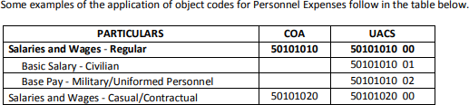
Object Codes

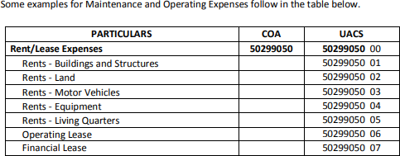




🞂​QUESTIONS????



🞂​REACTIONS!!!!!
END



