Macapagal, Lanz Ezekiel T.
BSCpE 3A

Company Background
Global Techno Hub Learning Center is a Technical Education and Skills Development Authority (TESDA)-accredited training institution founded in 2022 by its Founder and Chief Executive Officer, Sir Jasper Carl C. David. The institution was established to provide accessible, high-quality technical and vocational education, with a strong emphasis on Information and Communications Technology (ICT). Its mission is to equip learners with industry-relevant knowledge, practical competencies, and nationally recognized certifications that enhance their employability and support long-term career growth.
The learning center follows a competency-based and hands-on approach to education, allowing students to develop their technical skills through laboratory activities, practical exercises, and performance-based assessments. This training methodology enables learners to gain valuable real-world experience while building the confidence needed to perform effectively in professional work environments.
To ensure the quality and relevance of its programs, Global Techno Hub Learning Center works closely with CulayIT Pampanga to continuously update its training courses in line with current industry trends and technological developments. Through this partnership, the institution provides learners with modern tools, practical learning experiences, and opportunities that prepare them to meet the evolving demands of the ICT industry.

Location - 400 Gen Hizon Avenue, San Fernando, Philippines, 2000
Department Assigned – Technical/Maintenance and Full-Stack Developer (IT Department)
Contacts - 0917 160 6329 and globaltechnohublc@gmail.com

Problem 1 - Classroom-Based Inventory Storage Issues
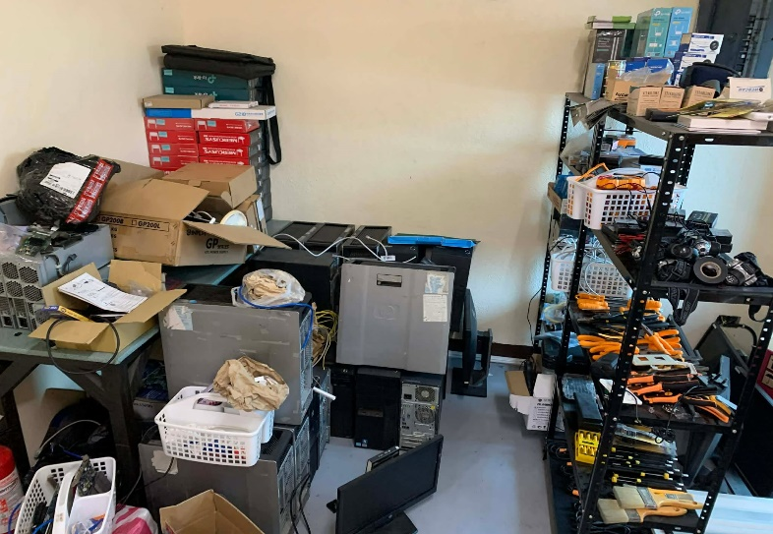
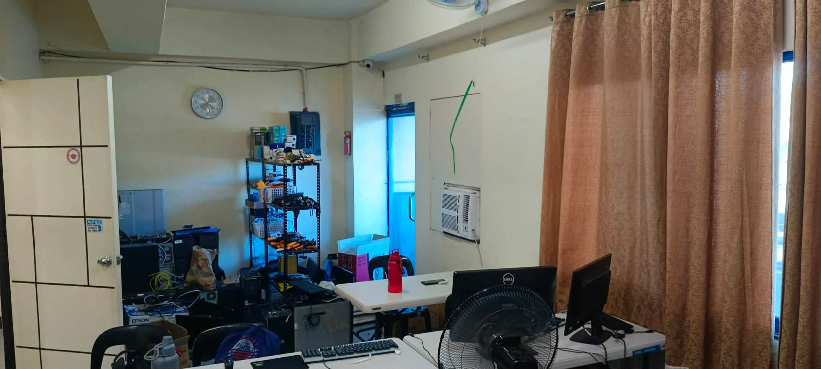

During my On-the-Job Training (OJT) at Global Techno Hub Learning Center, I observed a concern regarding the current inventory management setup. The institution's inventory, which consists of computer hardware, electronic components, peripherals, and other ICT-related equipment, is currently stored inside one of the classrooms used for training sessions. While this arrangement provides easy access to the materials, it also creates several operational challenges that affect both instructors and students.
Since the classroom serves as both a learning environment and a storage area, retrieving or returning inventory items often interrupts ongoing discussions, laboratory activities, or practical exercises. This can distract both the instructor and the students, reducing the overall effectiveness of the learning process. Frequent movement in and out of the classroom to access inventory also creates unnecessary disruptions during class hours.

Problem 2 - Outdated Computer Laboratory Equipment

