Use Case ID | G2-M1-F2
Use Case Name | User Searches Jobs Via Movable Map
Created By | Samuel Duckworth-Lanzo
Actor | User
Description and  Event flow | A user wants to do a search by location.  - User checks 'Redo Search When Map Moved' check-box.  - Location search is redone based on area visible on map.  - Job listing is updated with new search results.
Pre-conditions | - User has already done a search by area.
Post-conditions | - Displayed job positions reside within map area.
Input | Required  - Check 'Redo Search When Map Moved' check-box.
Output | - Displayed job listings contain only jobs within the map's area.
Includes
Notes | - Requires all job listings to have a location associated with them.  - If the user zooms out too far, should stop recalculating.  - The map can be clicked-and-dragged or zoomed in/out, which will lead to recomputing the job listings shown.
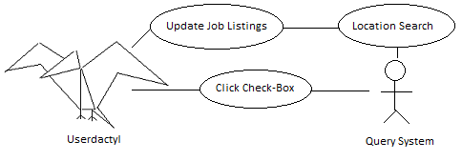

This feature is similar to a feature on yelp.com, which allows the user to interact with a map and redo their search in that area (as seen below and at http://www.yelp.com/search?cflt=restaurants&find_desc=&find_loc=San+Jose%2C+CA ).
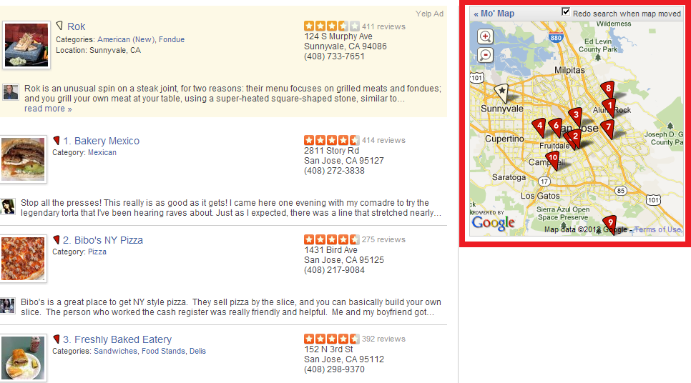
This feature falls under the domain requirement c3, being an additional feature that is not implemented on the mashed-up sites. This is a useful feature because searching by city/zip code can be too narrow of a search. Searching by geographic area allows nearby cities to all be searched concurrently, and gives the user a better approximation of commute time to/from work.

