Job Mash-up Site

Team 2: G-Squared

Victor Frandsen  Sam Lanzo | Search by Job Type  Search via movable map
Hon-ming Chen  Curtis Davis  Jacob Barrick | Search by location  Search by experience and education
Yu-Ching Want  Andrew Miller  Colin Blower | Search by salary  Search by Job title

Feature 1: Search jobs by experience and education

C2: Common Requirements:
  - Job title
  - Location

URL Analysis:

Dice.com URL: http://seeker.dice.com/jobsearch/servlet/JobSearch?op=300&N=0&Hf=0&NUM_PER_PAGE=30&Ntk=JobSearchRanking&Ntx=mode+matchall&AREA_CODES=&AC_COUNTRY=1525&QUICK=1&ZIPCODE=&RADIUS=64.37376&ZC_COUNTRY=0&COUNTRY=1525&STAT_PROV=0&METRO_AREA=33.78715899%2C-84.39164034&TRAVEL=0&TAXTERM=0&SORTSPEC=0&FRMT=0&DAYSBACK=30&LOCATION_OPTION=2&FREE_TEXT=Java&WHERE=San+Jose%2C+CA

Monster.com URL: http://jobsearch.monster.com/search/Java_5?where=San-Jose__2C-CA

linkup.com URL: http://www.linkup.com/b/Java-jobs.html?l=san+jose%2C+CA

Careerbuilder.com URL: http://www.careerbuilder.com/Jobseeker/Jobs/JobResults.aspx?IPath=QH&rs=&_ctl0%3ANavBar1%3AucQuickBar%3As_rawwords=Java&_ctl0%3ANavBar1%3AucQuickBar%3As_freeloc=San+Jose%2C+CA&_ctl0%3ANavBar1%3AucQuickBar%3As_jobtypes=ALL&qsbButton=Find+Jobs

Each URL has the keywords contained in them. These words are “Java” and “San Jose, CA”. In dice.com's URL, you can see that it locates the country, zip-code, coordinates, etc. to provide a better search query to other websites in an attempt to narrow down the results. Monster.com's URL contains simply the “JAVA_5” and “where=San-Jose” for its query with the “5” being a mystery input most likely to signal that no input appeared for the “keywords” text box.

Linkup.com has a similar URL to Monster.com in that it only includes the keyword and the location without extra information to query aggregate websites. Careerbuilder.com is a little bit different; in other words, this URL is quite a bit longer and includes many secret characters which remain unknown to anyone other than the web-master. Careerbuilder.com offers many other features to the user such as recent postings from their location, searching careers by category, and a chance to create an account with the site. These two sites maintain mostly the same information in their results with Careerbuilder.com mentioning salaries associates with the positions.

Feature Explanation:

A new feature of the “experience/education required” output will allow the user to visually see the experience or educational requirements for the positions displayed. This is more user-friendly because often times users will not be interested in jobs outside of their qualifications. With this output feature, our mash-up website will be able to personalize the results more effectively than other sites such as dice.com and monster.com. Additionally, the user will have the option of sorting jobs by experience/education requirements (e.g. no college degree, AA degree, Bachelor's degree, Master's degree).

The result information on our mash-up site will include but is not limited to: job title, company name, location, experience/education requirements, and a brief job description. Dice.com and Monster.com both simply list the job title and the company; however, this information is disorganized and useless if the user is looking for a particular position close-by and would like to scroll through the locations available.

The results will be displayed in an organized fashion without extra irrelevant information. The job title will be displayed first, with the location and company name below it. Below this information will be the experience/education requirements in bold lettering, followed by a brief description of the job opportunity. These results will be 10 to a page with the most relevant towards the top.

These specific results displayed in an organized fashion will allow the user to swiftly scroll through the jobs in search of one that catches their eye. A display of the requirements may also inform the user of any opportunities that just barely fit his or her qualifications and/or opportunities that are a perfect fit for what he or she is looking for.

Use Case and Diagram

Use Case ID | G2-M1-F1
Use Case Name | Output Jobs With Particular Job Requirements (Experience, Education)
Created By | Curtis Davis
Actor | User
Description and  Event flow | Results will display for the user, including the job title, company name, location, experience/educational requirements of the position, and a brief job description.  - User will enter input for job title and location.  - Drop down menu will allow auto-complete to guess what the user would like to search by.  - User will click “search” when he or she is ready to continue to the results.  - Results be displayed by relevance with the following information:  - Job title  - Company name  - Location  - Experience/Education requirements  - Brief job description
Pre-conditions | - User has completed all input fields as required
Post-conditions | - User can click the job title as a hyperlink to visit the actual job posting
Input | - Job title – ASCII characters only  - Location – Must be an actual city and state.
Output | - Results relevant to the inputs with the above information included.
Includes
Notes | - If any required field is blank, notify the user that more information is needed to personalize the search results.

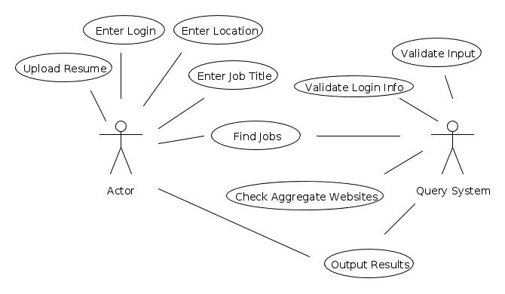

Feature 2: Search via movable map

C3: Additional domain specific feature
Common Requirement
- Location

URL Analysis:

This feature is similar to a feature on yelp.com, which allows the user to interact with a map and redo their search in that area (as seen below and at http://www.yelp.com/search?cflt=restaurants&find_desc=&find_loc=San+Jose%2C+CA).

Feature Explanation:

This feature falls under the domain requirement c3, being an additional feature that is not implemented on the mashed-up sites. This is a useful feature because searching by city/zip code can be too narrow of a search. Searching by geographic area allows nearby cities to all be searched concurrently, and gives the user a better approximation of commute time to/from work.

Use case and Diagram:

Use Case ID | G2-M1-F2.1
Use Case Name | User Searches Jobs Via Movable Map
Created By | Samuel Duckworth-Lanzo
Actor | User
Description and  Event flow | A user wants to do a search by location.  - User checks 'Redo Search When Map Moved' check-box.  - Location search is redone based on area visible on map.  - Job listing is updated with new search results.
Pre-conditions | - User has already done a search by area.
Post-conditions | - Displayed job positions reside within map area.
Input | Required  - Check 'Redo Search When Map Moved' check-box.
Output | - Displayed job listings contain only jobs within the map's area.
Includes
Notes | - Requires all job listings to have a location associated with them.
Use Case ID | G2-M1-F2.2
Use Case Name | User Adjusts Map While Searching For Jobs Via Movable Map
Created By | Samuel Duckworth-Lanzo
Actor | User
Description and  Event flow | A user wants to change the focus of the map.  - User drags the map around, or zooms in/out.  - Location search is redone based on area visible on map.  - Job listing is updated with new search results.
Pre-conditions | - User has already done a search by area.  - User has checked the 'Redo Search When Map Moved' check-box.
Post-conditions | - Displayed job positions reside within map area.
Input | Required  - The map has been moved.
Output | - Displayed job listings contain only jobs within the map's area.
Includes
Notes | - If the user zooms out too far, should stop recalculating.  - The map can be clicked-and-dragged or zoomed in/out.

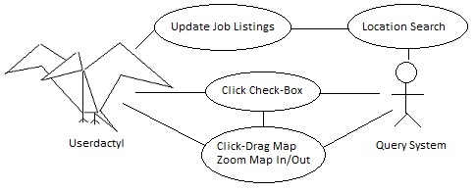

Feature 3: Search by Location

C2: Common Requirement
- Location

URL Analysis:

Dice.com URL:
http://seeker.dice.com/jobsearch/servlet/JobSearch?op=300&N=0&Hf=0&NUM_PER_PAGE=30&Ntk=JobSearchRanking&Ntx=mode+matchall&AREA_CODES=&AC_COUNTRY=1525&QUICK=1&ZIPCODE=&RADIUS=64.37376&ZC_COUNTRY=0&COUNTRY=1525&STAT_PROV=0&METRO_AREA=33.78715899%2C-84.39164034&TRAVEL=0&TAXTERM=0&SORTSPEC=0&FRMT=0&DAYSBACK=30&LOCATION_OPTION=2&FREE_TEXT=Java&WHERE=San+Jose%2C+CA

Monster.com URL:
http://jobsearch.monster.com/search/?where=San-Jose__2C-CA

Linkup.com URL:
http://www.linkup.com/results.php?l=san+jose%2C+ca

Careerbuilder.com URL:
http://www.careerbuilder.com/Jobseeker/Jobs/JobResults.aspx?IPath=QH&rs=&_ctl0%3ANavBar1%3AucQuickBar%3As_rawwords=&_ctl0%3ANavBar1%3AucQuickBar%3As_freeloc=san+jose%2C+ca&_ctl0%3ANavBar1%3AucQuickBar%3As_jobtypes=ALL&qsbButton=Find+Jobs

Each URL has the city and state contained in them. In the above examples “San Jose, CA” is used as the location.

In Dice.com's URL, the keyword used for location is “where” and its value is “San+Jose%2C+CA”. They use “+” to replace a space and “%2C” to replace a comma.

In Monster.com's URL, the keyword used for location is “where” and its value is “San-Jose_2C-CA”. They use “-” to replace a space and “_2C” to replace a comma.

In Linkup.com's URL, the keyword used for location is a lowercase L “l” and its value is “San+Jose%2C+CA”. They use “+” to replace a space and “%2C” to replace a comma.

In Careerbuilder.com's URL, the keyword used for location is “s_freeloc” and its value is “San+Jose%2C+CA”. They use “+” to replace a space and “%2C” to replace a comma.

Feature Explanation:

Searching by location is a core feature needed in every job board website. This is user friendly because the majority of users will want the ability to narrow their search by location. The user will also be able to set a radius around their location of choice to either expand or narrow their search.

Use Case and Diagram:

Use Case ID | G2-M1-F2
Use Case Name | Search jobs based on location
Created By | Hon-ming Chen
Actor | User
Description and  Event flow | A user will search for jobs based on location  - User clicks on location textbox  - User enters a city and state separated by a comma or enters zip code  - User clicks “Search” button
Pre-conditions | - User is on the website and has entered a location or no location.
Post-conditions | - User is shown a list of job titles as hyperlinks to visit the actual job posting
Input | Optional  - Location – city and state or zip code  - Job Title – alphanumeric characters plus spaces, periods, hyphens, apostrophes and underscores.
Output | - A results page is shown with jobs near the location entered  - Results page will be filtered by job type if that textbox is filled
Includes
Notes | - If no location is given, search for jobs throughout America  - If state and city is the wrong combination, match search by city name

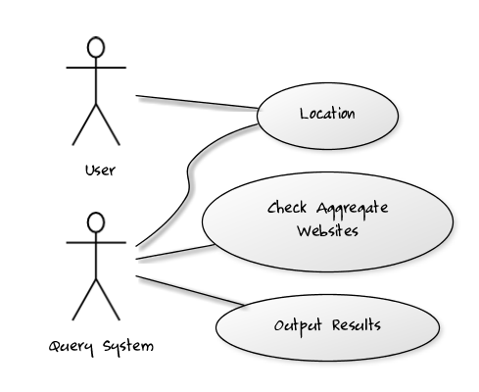

Feature 4: Search by Job Title

C1: Common Search
- Job Title

URL Analyzation:

Example URL's for the job title 'Principal Engineer'.

Monster.com URL:
http://jobsearch.monster.com/search/Principal-Engineer_5?

Dice.com URL:
http://seeker.dice.com/jobsearch/servlet/JobSearch?op=300&N=0&Hf=0&NUM_PER_PAGE=30&Ntk=JobSearchRanking&Ntx=mode+matchall&AREA_CODES=&AC_COUNTRY=1525&QUICK=1&ZIPCODE=&RADIUS=64.37376&ZC_COUNTRY=0&COUNTRY=1525&STAT_PROV=0&METRO_AREA=33.78715899%2C-84.39164034&TRAVEL=0&TAXTERM=0&SORTSPEC=0&FRMT=0&DAYSBACK=30&LOCATION_OPTION=2&FREE_TEXT=Principal+Engineer&WHERE=

Indeed.com URL
http://www.indeed.com/jobs?q=Principal+Engineer&l=

Each URL contains the job title search query. In the above examples the term 'Principal Engineer' is used. In Monster.com's url the search term is encoded in the directory information of the url. Monster uses a '-' to encode a ' '. For Dice.com the URL is rather complicated, but only the 'FREE_TEXT' parameter is relevant to the job title query. Here a '+' is used to encode a ' '. For Indeed.com the job title is again encoded into a parameter. The relevant parameter is 'q' and '+' is used to replace ' ' in the query.

Feature Explanation:

Use Case and Diagram:

Use Case ID | G2-M1-F4
Use Case Name | Output jobs with particular title
Created By | Colin Blower
Actor | User
Description and  Event flow | A new user begins to search the site.  - User clicks search box.  - User enters a job title to search for.  - Auto-completion suggests common job titles.  - User finishes entering a job title and clicks search  - A new results page is displayed.  - The results page will include a count of matching job postings  - Results be displayed by relevance with the following information:  - Job title  - Company name  - Location  - Experience/Education requirements  - Brief job description
Pre-conditions | - User has completed the job title field as required
Post-conditions | - User can click the job posting link to visit the actual job posting  - User can see a job count for the job title
Input | Required  - Job Title – alphanumeric characters plus spaces, periods, hyphens, apostrophes and underscores.
Output | - Results relevant to the input job title  - A count of results displayed on the page
Includes
Notes | - If any required field is changed to blank or any input is ill-formatted, an error message is written to the form and the Employer is prompted to revise it and resubmit.

Feature 5: Search by Job Type

C1: Common Requirements
- Job Type

URL Analysis:

  - http://seeker.dice.com/jobsearch/servlet/JobSearch?caller=0&LOCATION_OPTION=4&EXTRA_STUFF=1&N=0&Hf=0&Ntk=JobSearchRanking&op=300&values=&FREE_TEXT=java&Ntx=mode+matchall&EXCLUDE_KEY1=p_JobTitle&EXCLUDE_TEXT1=&EXCLUDE_KEY2=p_JobTitle&EXCLUDE_TEXT2=&EXCLUDE_KEY3=p_JobTitle&EXCLUDE_TEXT3=&EXCLUDE_KEY4=p_JobTitle&EXCLUDE_TEXT4=&EXCLUDE_KEY5=p_JobTitle&EXCLUDE_TEXT5=&EXCLUDE_KEY6=p_JobTitle&EXCLUDE_TEXT6=&EXCLUDE_KEY7=p_JobTitle&EXCLUDE_TEXT7=&EXCLUDE_KEY8=p_JobTitle&EXCLUDE_TEXT8=&RADIUS=64.37376&WHERE=&COUNTRY=1525&STAT_PROV=0&locationRadio=on&METRO_AREA=33.78715899%2C-84.39164034&AREA_CODES=&AC_COUNTRY=1525&TRAVEL=0&TAXTERM=1001&SORTSPEC=0&FRMT=0&DAYSBACK=30&NUM_PER_PAGE=30

  - http://jobsearch.monster.com/search/Full-Time+Part-Time_88

Feature Explanation:

Both monster and dice offer the ability to search for jobs of a specific type, i.e. full-time or part-time. Both sites, however, differ on types offered. Where monster offers, intern, temp, and other, dice offers none of those, yet has more diverse contract options, which may be equivalent in some sense, but it is not clear.

Use Case and Diagram:

Feature 6: Search by Salary

URL Analysis:

Feature Explanation:

Use Case and Diagram:

