Use Case IDG2-M1-F2Use Case NameSearch For Job Via Moveable MapCreated BySamuel Duckworth-LanzoActorUserDescription and
Event flowA user wants to do a search by location.
- User checks 'Redo Search When Map Moved' check-box.
- Location search is redone based on area visible on map.
- Job listing is updated with new search results.Pre-conditionsUser has already done a search by area.Post-conditionsDisplayed jobs locations reside within map area.
- Moving the map recomputes displayed jobs.InputRequired
- Check 'Redo Search When Map Moved' check-box.OutputDisplayed job listings are recomputed to only jobs within the map's area.IncludesNotesRequires all job listings to have a location associated with them.
- If the user zooms out too far, shouldn't recalculate as too many results.
- The map can be clicked-and-dragged or zoomed in and out.


This feature is similar to a feature on yelp.com, which allows the user to interact with a map and redo their search in that area (as seen below and at http://www.yelp.com/search?cflt=restaurants&find_desc=&find_loc=San+Jose%2C+CA ).
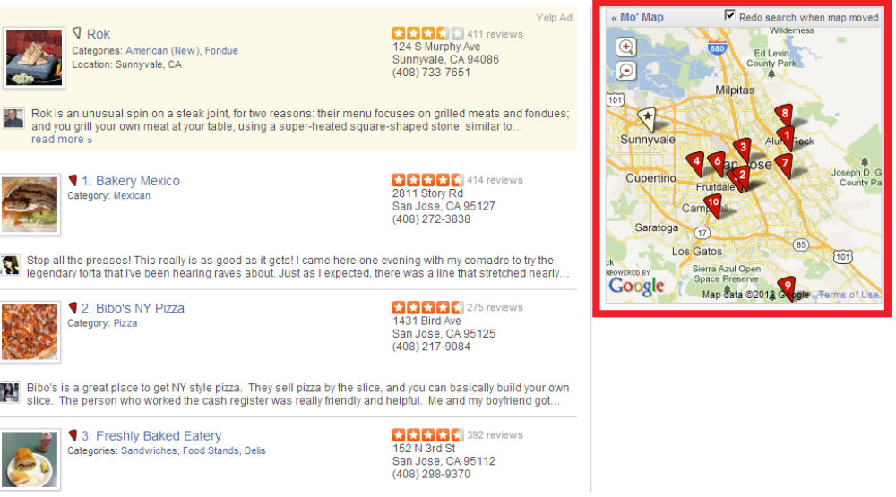
This feature falls under the domain requirement c3, being an additional feature that is not implemented on the mashed-up sites. This is a useful feature because searching by city/zip code can be too narrow of a search. Searching by geographic area allows nearby cities to all be searched concurrently, and gives the user a better approximation of commute time to/from work.

