Job Mashup Website
Milestone 3 Part A

Jacob Barrick
Colin Blower
Honming Chen
Curtis Davis
Victor Frandsen
Sam Lanzo
Andrew Miller
Yu-Ching Wang

November 30, 2012
CS 160
Group 2: G²
Website Images and Flow
Main Page:
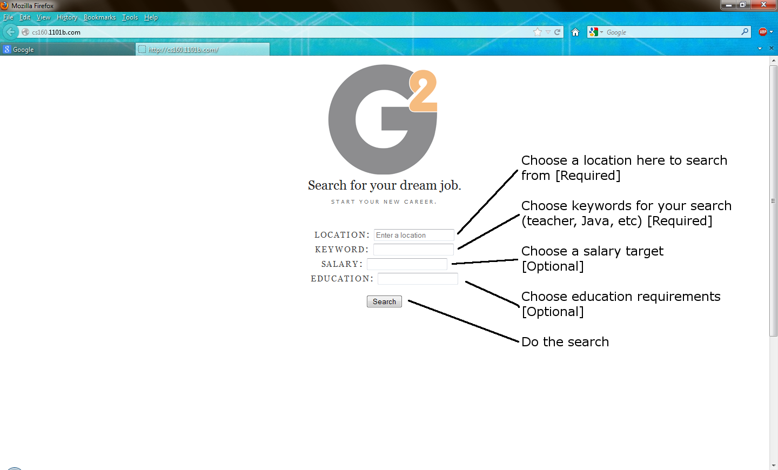

Results Page:
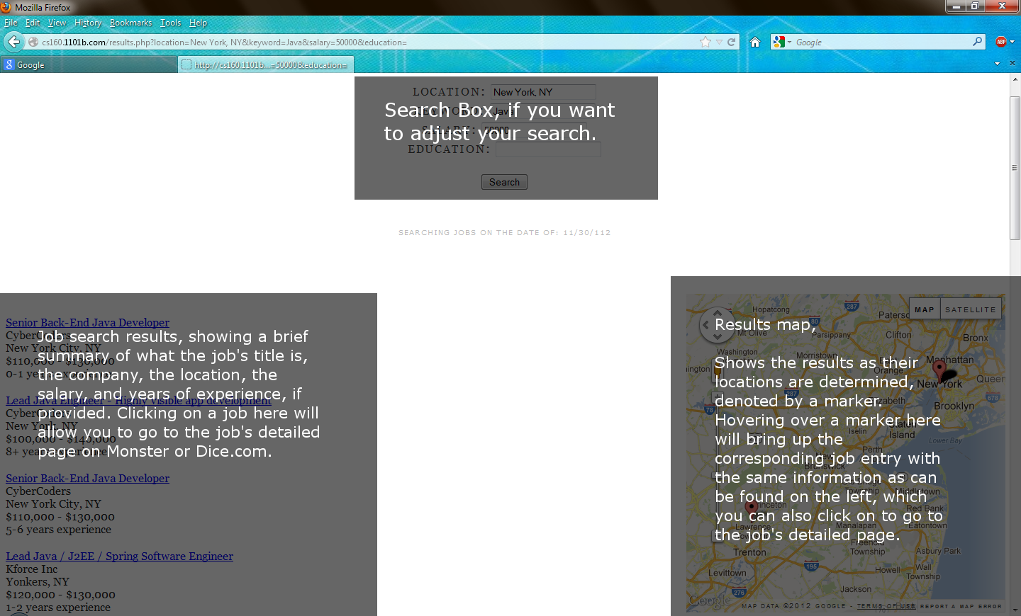

Sequence Diagram:
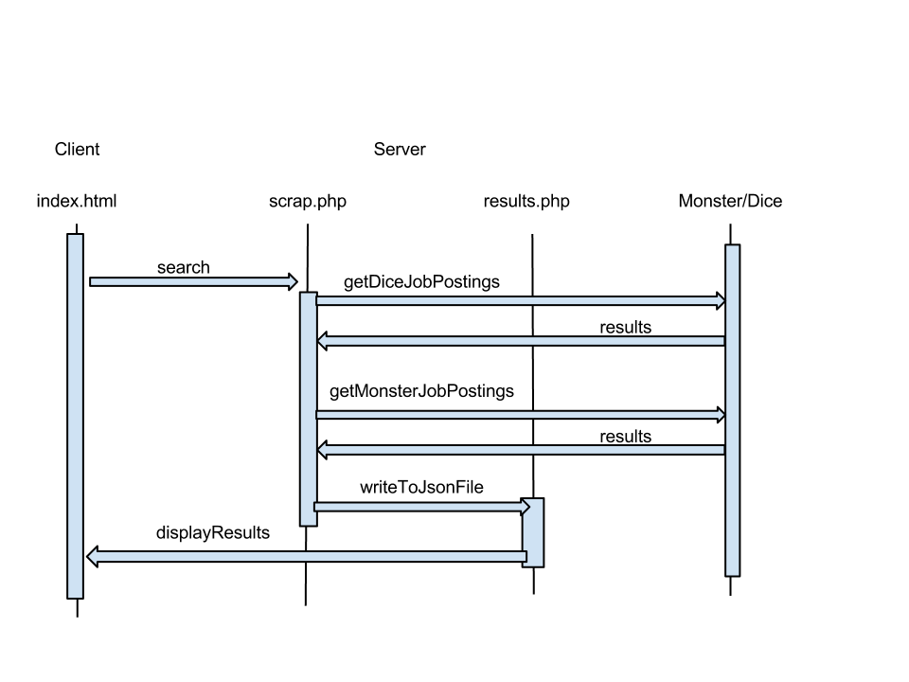
Feature 1: Moveable Map

Interactive Map (map.js), developed by Sam Lanzo using self-written source code:

The interactive map is a way of showing a user where the specific job offers are located. This allows the user to make a more informed decision regarding where they would like to work, with respect to housing options and commute times.

It is implemented via the Google Maps API v3. The API allows me to display a map with markers for each of the job locations. To determine the locations, I do a reverse geocode of the 'city, state' string from the JSON job object to give me a lat/lon location. This lat/lon is then used to do a nearby search for the company name to determine an address within 50km of the city center. The first result is used to make a marker on the map. Currently, the behavior is to display job specifics above the marker when it is moused over, and to hide the specifics when it is moused off. Also, the user may click on the marker to bring them to the job posting on either monster or dice.

Not all job offers create a marker, as many are simply temp agencies offering a job in a given city, and therefore have no office in that location. Also, due to usage restrictions, the pins can take up to 10+ seconds to fully populate. This would be reduced by purchasing a business API key, which would allow many more simultaneous requests. Also, we plan to change the results page to only display 10 results at a time, which will limit the number of concurrent requests and severely reduce the lookup time.

The map can also be used by the user to update the location they wish to search. If the user click-and-drags the map around the screen, the location that is centered on mouse release is recalculated and the location field is updated to match. This also triggers a new search being done given the updated location. I have plans to implement a check-box that the user can select to enable this feature in order to make it more user friendly, instead of the current always on behavior. This will also allow the user to move the map around to view the job specifics without it being cut off the edge of the map.

As has been mentioned, a reduction in the lookup time is planned via a limiting of results displayed at any given time. Also, a check box to enable search by map location is planned to make that a more user friendly feature. I am also exploring options to make the interface more user friendly in regards to displaying the job specifics on the map instead of off the side.

Feature 2: Unified Search Results

The unified search results is part of scrap.php, the part relevant to this function was developed by Hon-ming Chen using self-written source code.

The unified search results is a way of combining the search results from Dice.com and Monster.com such that one can display them as a combined list instead of separately. This feature takes in both the results scraped from Monster and Dice and then performs a comparison across all of the json objects it takes in

By comparing the exact title of the posting, along with the location and what company is providing it, we narrow down and eliminate duplicate entries across the two result sets. This functionality may possible be improved in the future by creating a specialized parser to perform this elimination based on additional criteria, but for the purposes of this project, developing such a parser was not feasible.

Feature 3: Search by Keyword

The search by keyword function is part of scrap.php; the part relevant to this function was developed by Hon-ming Chen using self-written source code.

This grabs the data from the keyword field and feeds it to the scrapers for Dice and Monster along with any additional search criteria, which parses the page and sends back a json object containing the results in sets of Job Title, the Location, the Company posting the job, and the salary, if available.

Feature 4: Search by Salary

The search by keyword function is part of scrap.php; the part relevant to this function was developed by Andrew Miller using self-written source code.

This grabs the data from the salary drop-down menu and feeds it to the scrapers for Dice and Monster along with any additional and required search criteria, which parses the page and sends back a json object containing the results in sets of Job Title, the Location, the Company posting the job, and the salary, if available.

Feature 5: Search by Education

The search by keyword function is part of scrap.php; the part relevant to this function was developed by Andrew Miller using self-written source code.

This grabs the data from the education drop-down menu and feeds it to the scrapers for Dice and Monster along with any additional and required search criteria, which parses the page and sends back a json object containing the results in sets of Job Title, the Location, the Company posting the job, and the salary, if available.

Feature 6: Search by Location

The search by keyword function is part of scrap.php; the part relevant to this function was developed by Hon-ming Chen using self-written source code.

This grabs the data from the location field and feeds it to the scrapers for Dice and Monster along with any additional search criteria, which parses the page and sends back a json object containing the results in sets of Job Title, the Location, the Company posting the job, and the salary, if available. The results from this feature are core to the functionality of Feature 1.

List of Development Task Assignments
Development Area / Tasks | Group Members involved
Feature 1 | Sam Lanzo
Feature 2 | Hon-ming Chen
Feature 3 | Hon-ming Chen
Feature 4 | Andrew Miller
Feature 5 | Andrew Miller
Feature 6 | Hon-ming Chen
Documentation | Jacob Barrick  Victor Frandsen  Yu-Ching Wang
Development Environment Management | Colin Blower
Frontend Layout Development | Curtis Davis  Yu-Ching Wang

