Output: Job Mashup Site

Curtis Davis

C2: Common Requirements:
  - Job title
  - Location

Dice.com URL: http://seeker.dice.com/jobsearch/servlet/JobSearch?op=300&N=0&Hf=0&NUM_PER_PAGE=30&Ntk=JobSearchRanking&Ntx=mode+matchall&AREA_CODES=&AC_COUNTRY=1525&QUICK=1&ZIPCODE=&RADIUS=64.37376&ZC_COUNTRY=0&COUNTRY=1525&STAT_PROV=0&METRO_AREA=33.78715899%2C-84.39164034&TRAVEL=0&TAXTERM=0&SORTSPEC=0&FRMT=0&DAYSBACK=30&LOCATION_OPTION=2&FREE_TEXT=Java&WHERE=San+Jose%2C+CA

Monster.com URL: http://jobsearch.monster.com/search/Java_5?where=San-Jose__2C-CA

linkup.com URL: http://www.linkup.com/b/Java-jobs.html?l=san+jose%2C+CA

Careerbuilder.com URL: http://www.careerbuilder.com/Jobseeker/Jobs/JobResults.aspx?IPath=QH&rs=&_ctl0%3ANavBar1%3AucQuickBar%3As_rawwords=Java&_ctl0%3ANavBar1%3AucQuickBar%3As_freeloc=San+Jose%2C+CA&_ctl0%3ANavBar1%3AucQuickBar%3As_jobtypes=ALL&qsbButton=Find+Jobs

URL Analyzation:

Each URL has the keywords contained in them. These words are “Java” and “San Jose, CA”. In dice.com's URL, you can see that it locates the country, zip-code, coordinates, etc. to provide a better search query to other websites in an attempt to narrow down the results. Monster.com's URL contains simply the “JAVA_5” and “where=San-Jose” for its query with the “5” being a mystery input most likely to signal that no input appeared for the “keywords” text box.

Linkup.com has a similar URL to Monster.com in that it only includes the keyword and the location without extra information to query aggregate websites. Careerbuilder.com is a little bit different; in other words, this URL is quite a bit longer and includes many secret characters which remain unknown to anyone other than the web-master. Careerbuilder.com offers many other features to the user such as recent postings from their location, searching careers by category, and a chance to create an account with the site. These two sites maintain mostly the same information in their results with Careerbuilder.com mentioning salaries associates with the positions.

New Feature: Experience/Education required

A new feature of the “experience/education required” output will allow the user to visually see the experience or educational requirements for the positions displayed. This is more user-friendly because often times users will not be interested in jobs outside of their qualifications. With this output feature, our mash-up website will be able to personalize the results more effectively than other sites such as dice.com and monster.com. Additionally, the user will have the option of sorting jobs by experience/education requirements (e.g. no college degree, AA degree, Bachelor's degree, Master's degree).

The result information on our mash-up site will include but is not limited to: job title, company name, location, experience/education requirements, and a brief job description. Dice.com and Monster.com both simply list the job title and the company; however, this information is disorganized and useless if the user is looking for a particular position close-by and would like to scroll through the locations available.

The results will be displayed in an organized fashion without extra irrelevant information. The job title will be displayed first, with the location and company name below it. Below this information will be the experience/education requirements in bold lettering, followed by a brief description of the job opportunity. These results will be 10 to a page with the most relevant towards the top.

These specific results displayed in an organized fashion will allow the user to swiftly scroll through the jobs in search of one that catches their eye. A display of the requirements may also inform the user of any opportunities that just barely fit his or her qualifications and/or opportunities that are a perfect fit for what he or she is looking for.

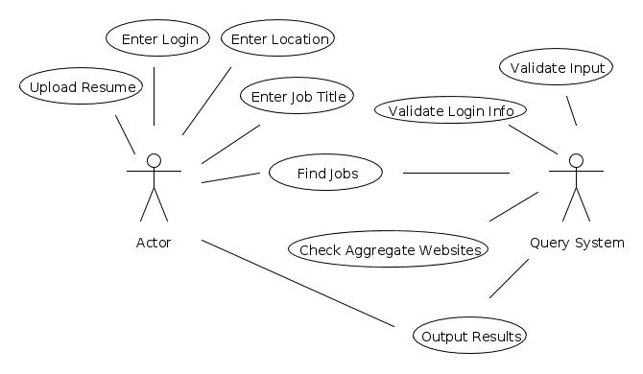

Use Case ID | G2-M1-F1
Use Case Name | Output Jobs With Particular Job Requirements (Experience, Education)
Created By | Curtis Davis
Actor | User
Description and  Event flow | Results will display for the user, including the job title, company name, location, experience/educational requirements of the position, and a brief job description.  - User will enter input for job title and location.  - Drop down menu will allow auto-complete to guess what the user would like to search by.  - User will click “search” when he or she is ready to continue to the results.  - Results be displayed by relevance with the following information:  - Job title  - Company name  - Location  - Experience/Education requirements  - Brief job description
Pre-conditions | - User has completed all input fields as required
Post-conditions | - User can click the job title as a hyperlink to visit the actual job posting
Input | - Job title – ASCII characters only  - Location – Must be an actual city and state.
Output | - Results relevant to the inputs with the above information included.
Includes
Notes | - If any required field is blank, notify the user that more information is needed to personalize the search results.

