

**TOUCH LESS PET FEEDER POWERED BY ARDUINO**

**AND INFRARED PROXIMITY SENSOR**

A Thesis

Presented to the Faculty of Open University System

Polytechnic University of the Philippines

Sta. Maria, Bulacan

In Partial Fulfillment of the Requirements for the Degree of

Bachelor of Science in Computer Engineering

By

Alarcon, Camille L.

Avellanoza, Lanze T.

Barzaga, Danica A.

Fabriag, Yzon B.

Silvestre, Angelica B..

**2022**

**CHAPTER I**

**Introduction**

Since the 17th century, people have started bringing pets inside their houses. Treating their pet as an extra member of the family is a brilliant idea as it gives them a lot of advantages. These includes helping them fight anxiety, helping them to be organized, disciplined and helps them with their mental health and even physical health. Moreover, they also teach us to love and gain new knowledge. (Author, Year)

According to Manoj M.,(2015), most of us have pets at home, some have the patience to feed them regularly but some do not. So, taking care of them during our busy schedule is one of the main problems in maintaining pets. We must even worry about them when we leave our home for some days. Also, Ravu Babu b et al.,(2019) study says that keeping pets takes many commitments. This includes keeping them company, expressing your concerns, and, of course, feeding them properly and on schedule.

By accomplishing this product, the **proponents** will be able to solve multiple problems pet owners have. This includes the issues such as not being able to feed their pets enough while they are away, always having to wash their hands right after feeding their pets and not being able to control the eating habits of their pets. Especially since we know that there are existing pet feeders in the market that will always dispense food while their pet eats some of it.

The purpose of this is for pet owners to be able to make sure that we are always feeding them the right amount of food at the right time. This is the reason why the proponents wanted to create something to resolve all these issues and bring ease to pet lovers as this would be their second-best friend next to their pets of course.

Reading this manuscript will aid in the understanding of the purpose, the process, the factors and the development of the device that would benefit not just the pet lovers but also the pets themselves.

**Background of the Study**

In treating pets as an extra member of the family, pet owners must do everything they can to make sure they are comfortable inside their house. One effective way to do this is by making sure that they are always eating on time as their owners do their best not to skip a meal in a day. The problem is people have different matters to attend to, making them busy throughout the day. It might be their jobs, businesses, family activities or worse, when they are traveling wherein they will be away from home for almost the entire day.

Aside from making their pet lonely during the day, it would be difficult for them to know when to refill their food bowl and feed themselves. They would not be happy if you would pour all the food from the storage into their feeding bowl or maybe a bigger bowl just to consume the food they will need to accommodate for the whole day. Again, we are treating them as an extra member of the family. None of your family members would be happy if you would fill his or her bigger plate with the entire amount of food that he or she needs to eat for the whole day. Our pets wanted to eat normally and comfortably too. This is the first thing that we need a solution for.

The researcher would like to eliminate the problem of pet owners having to manually pour canned or packed pet food to their pet’s feeding bowl and having to wash their hands every single time they feed their beloved pets. All of this gave the researchers the idea to build a device/prototype that will not only allow the pet owners to easily feed their beloved pets without having to physically touch the food, the container or the bowl but also allowing the food bowl to self-sustain by constantly pouring more pet food to the bowl on interval when the pet starts eating to make sure that their pet will never run out of food even if they’re home alone.

**Objectives of the Study**

**General Objective**

The researchers aim to develop a device - Touchless Pet Feeder Powered by Arduino and IR Proximity Sensor.

**Specific Objectives**

The following are the researchers' specific objectives in producing this proposed device:

1. Develop an integrated device operated by a microcontroller board which also includes three system:
2. IR Proximity Sensor to detect movement,
3. Flow system with 3 buttons, and
4. Timer system for feeding.
5. Fabricate a prototype that will perform the following programmed codes from a microcontroller board:
6. Perform the flow system with three choices of buttons, 0 button to turn it off, 1 button to make a flow system fill the feeder at Low amount of feed, and the 2 Button to make the flow system fill the feeder at High amount of feed.
7. Perform the designated situation outcome which is when the Infrared Proximity Sensor senses a movement in a designated distance.
8. Perform the time system in which the feeder will fill the bowl in a designated time frame.
9. Test and evaluate the performance of the project with different parameters.

**Significance of the Study**

The researchers are conducting this study to:

1. **Make feeding job easier and more efficient.**

Acknowledging the problem of pet owners being busy all day, this project is purposely built to make feeding time not only effortless but also fun for the pets. It will also save a lot more time for the pet owners so they can focus more on other urgent or important tasks.

1. **Prevent missed meals.**

We don't want our pets to starve just because we are not attentive to their mealtimes. We know that most pet owners are quite busy, and we cannot deny the fact that pet's mealtimes could possibly be forgotten because of this. This is one of the major reasons why the researchers conducted this project. To create a perfectly working machine that will continuously produce the exact amount of food that the pets need and will be reactive to our pet's eating frequency.

1. **Prevent overfeeding.**

Owners will never want their pets to be overweight. Not only will it make them less healthy but also, they will have difficulties with their physical movement. So, the proponents made sure not to create a machine that will continuously dispense large amounts of food to the point that they will consume more than what they are supposed to consume.

1. **Avoid physical contact to the food or food can.**

Feeding our pet sounds easy but in reality, it still requires enough attention, time and effort to make sure that our pets can always eat on time. So, the researchers added one of the best functions of this project, which is being a touch-less machine, you don't need to physically touch the machine for it to dispense food for your pets, just hover your hand on the sensor to make it do the work. Not only will help you keep your hygiene by feeding your pet but also saves you a lot of time as you can immediately go back to what you were doing right after feeding your pet. Unlike before that you still need to wash your hands after doing it.

**Scope and Limitations**

**Scope:**

This project will include the following devices or program and be integrated into one:

* Proximity sensor system: This device act as movement sensor within designated

distance.

* Time system: This program will fill the bowl in a designated time frame.
* Amount Control system: These buttons have a program that controls the level of amount of fill by the feeder.
* Power System: This device will only use battery as a power source.
* Supporting Infrastructures – This will include all the materials not named, such as the casing of the device and the microcontroller unit.

**Limitations**

The proposed device is limited to the following:

• The device can only detect movement through designated distance.

• The system will only be able to hold any type of pet dry food.

**Definition of Terms**

For a greater understanding of this study, the following terms are defined in the context of this research.

**Integrated**

It used to describe when a hardware device is combined into another device.

**Feeder**

It is a bin or box like device from which farm animals may eat, especially such a device designed to allow a number of chickens to feed simultaneously or to release a specific amount of feed at regular intervals.

**Eating frequency**

It was defined as “the number of daily eating occasions,” and daily eating occasions were defined as “any ingestive event (solid food or beverage, including water) that is either energy yielding or non-energy yielding.

**Hover**

It means to stay in the same position in the air without moving forwards or backwards.

S**ensor**

It is a device which detects or measures a physical property and records, indicates, or otherwise responds to it.

**Touchless**

It is a form of electronics control technology that makes it possible for users to control a digital system without any form of physical contact.

**Starve**

It is the process of perishing or suffering severely from hunger.

**References:**

Manoj M. (2015). AUTOMATIC PET FEEDER. International Journal of Advances in Science Engineering and Technology, 3, 2321–9009.https://ijisrt.com/assets/upload/submitted_files

/1575569700.pdf

**Chapter II**

**Review of Related Literature and Studies**

This chapter provides the gathered supporting information that will help in proving that this project proposal – the Touchless Pet Feeder Powered by Arduino and IR Proximity – is

probable. Numerous research, published journals, online articles and studies were all accumulated and will be presented here.

The researchers wish to produce a device which can be controlled through the device itself. The proposal revolves around a way that can help pet owners to feed their pets even when they are away without the pet being overfeed or being hungry.

**Related Literature**

According to the Centers for Disease Control and Prevention (CDC), a human is defined obesity as having a BMI (body mass index) of 30 or more. Being one of having this weight problem, is associated with a higher risk for serious diseases such as type 2 diabetes, heart disease, and cancer. It is stated that Philippines increased its rate in adult obesity with a note of "very rapid growth" between year 1995 and 2015. World Obesity Federation (WOF) gave the Philippines a national obesity risk score of 6/10 (moderate risk) which also stated that on 2025, it is unlikely to meet United Nations adult obesity.

Obesity is a global health problem and not only people are affected but also pets. As a human, feeding to our pets are seeming act of love to them. In an article on the Fox News, overfeeding is one of the reasons why a pet becomes overweight. But many pet owners are not even noticed that their pets are gradually having an extra weight until the veterinarian notice the physical changes. “More than 20 disease conditions have been linked with pets being overweight. While some may say ‘My pet looks cute being pudgy or plump,’ ultimately carrying those extra pounds contributes to exasperating these diseases.” (Dr. Kirk Breuninger, 2017).

Otherwise, underfeeding is also a concern on having pet. In an online article of Authentica Pets, it discussed that underfeeding of pets is one of the reason for the possible malnutrition of pets and can lead to health issue such as illness or disease that may result of weakening, worst death.Main cause of this are some nutrient deficiency where absorption of essential nutrients or micronutrients are not receiving properly by the body which can really turn into serious health problems.

GSM Controlled Dog Feeder and Automatic Water Dispenser using Raspberry Pi is the system was made to monitor the amount of food and water in the reservoir and bowl. It automatically refill the water bowl using water pump and also refill the food bowl depending on user input in Gsm Module. Also, the amount of food in the system was based on the interviewed veterinarian conducted. This system was studied to make the lives of pet owners, who are busy at work to be more convenient. (Cabaltera et al., 2018)

Flores, Lovely Shane et.al. (2020) believed that most pet owners are too busy with their works and cannot stay at home to watch their pets for several times a day. with this reason, they did design and built a monitoring pet feeder device with precise feeding and accurate time schedule, suitable for the cats and dogs. The thing that made this pet feeder differ from already existing pet feeder is, it works by means of sending keyword through SMS.

M Ibrahim et al. (2019) said that Automated pet feeder will replace manual feeding which feeding amount and feeding time required will be set. Also, author state that the innovation of pet feeder is used to overcome forgetful of the pet owner to feed their pet and to avoid extra spending expenses by leaving them at a pet hotel.Arduino is used as the microcontroller to control the mechanism and to operate the system with a given of set time. In addition, the study of automatic pet feeder by using different sensors can work efficiently. Using distance sensor or a proximity sensor which is connected to arduino board, pet feeder can sense thhe pet then the pet feeder automatically poured pet food in the bowl.(Kank, Aasavari and Gaikwad,Mohite, 2018)

Moreover, Azrin, Shahrul et al.(2015) used RFID scanner to detect the presence of pets from Automatic Pet Feeder. The project is smart and simple so that the pet owner will at ease to feed their pet without worrying the pet's health and amount of the pet eats or which pet eats the food. The project design will make pet owner feed their pet even they leave them at home.M S Z M Suffian et al. (2021) study concerns that the unavailability of pet owners and hygiene aspect in pet feeding lead them to develop an automated pet feeding device focusing on in house pets by utilizing Arduino Uno as its Central Processing Unit (CPU) or microcontroller.

**CHAPTER III**

**METHODOLOGY**

In this chapter, the information and the details of methodology employed by the researchers to build the machine will be covered according to the objectives of the study.

This study aims to initiate and build a machine that is powered by Arduino Uno. The microchip board with firmware installed on it to program the other components and will serve as the main brain of the device to power up connect all the necessary components accordingly such as the IR proximity sensor that keeps the distance as programmed, the motor which will open the dispenser as the program says so or when triggered by the said sensors. All of this to make sure that every component behaves as expected, making touch-less pet feeder reliable.

**Power Supply**

**DC Motor**

**Arduino**

**IR proximity sensor**

**Pin 1**

**Pin 1**

**DC Motor**

**Pin 3**

**IR proximity sensor**

**Designing and developing the device**

The proposed system uses Infrared proximity sensor which is connected to the Arduino to receive input signals from man or pet. A power supply provides 5V power to maintain the whole circuit system and make sure that all components are working as expected. Multiple jumper wires are connected to the Arduino pins connecting all electronic components to each other. The IR proximity sensors are connected to the input pins, one for the pet and one for the man. The IR Proximity for the pet is connected to the input pin which is programmed to have an interval before dispensing again regardless of whether the sensor detects an object or not. Meanwhile, the second IR proximity sensor is connected to another input pin which is programmed to always dispense food as long as the man keeps on showing his hand to the sensor. Both Infrared proximity sensor sends signal to the output pin which we have the motor detected which is the one that opens the dispenser to release the food from the container.

**The Following materials are needed to complete the prototype of the device:**

1. Arduino uno
2. Infrared proximity sensor
3. DC motor
4. LED lights
5. 9V Battery
6. Jumper Wires
7. Plastic container (Body)

**Hardware Requirements**

**Arduino UNO R3**

Arduino Uno R3 is commonly used microcontroller board in the family of Arduino. It is available in DIP (dual-inline-package), detachable and ATmega328 microcontroller. The Operating Voltage of the Arduino is 5V, the recommended input voltage ranges from 7V to 12V and i/p voltage (limit) is 6V to 20V. It comprises 14-digit I/O pins which 6-pins can be utilized like PWM outputs. The board includes 14 digital input/output pins, Analog inputs-6, a USB connection, quartz crystal-16 MHz, a power jack, a USB connection, resonator-16Mhz, a power jack, an ICSP header an RST button. The program can be done using IDE software and the microcontroller on the board will come with pre-burned by a boot loader that permits to upload fresh code without using an exterior hardware programmer. The communication can be done using a protocol like STK500.

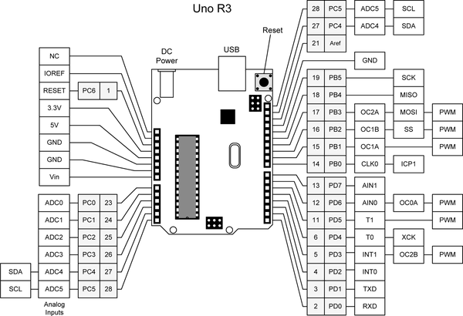

**Infrared Proximity Sensor**

Infrared Proximity Sensor - Objects and obstacles in front of the sensor are detected using proximity sensors. The sensor continuously emits infrared light, and as an object approaches, it is identified by the sensor by keeping track of the light that is reflected from the object.

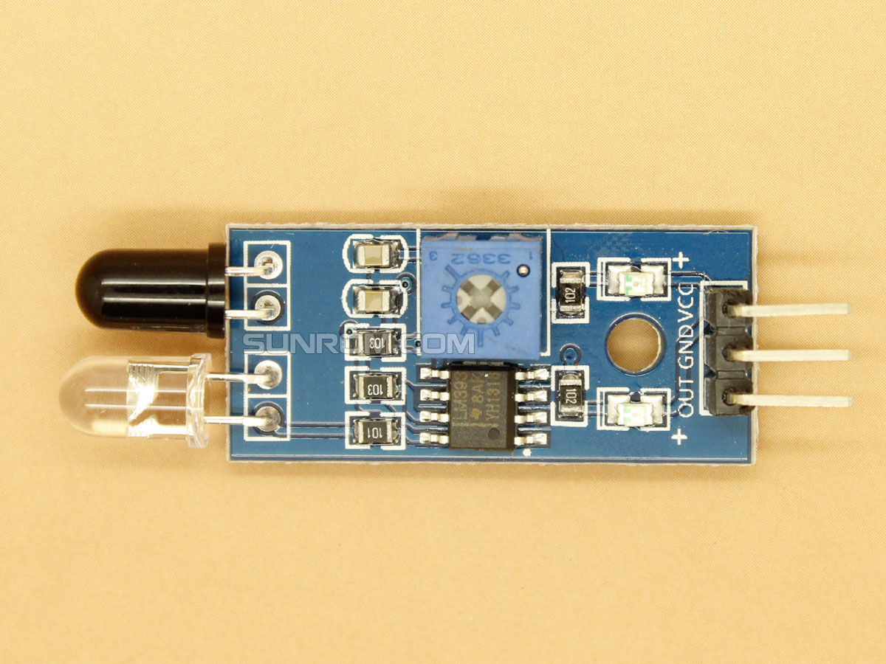

**DC Motor**

A direct current or DC motor is used to convert energy into mechanical energy. It has magnets, either permanent magnets or electromagnetic windings, that produce a magnetic field. It consists of an stator, an armature, a rotor and a commutator with brushes. Opposite polarity between the two magnetic fields inside the motor cause it to turn.

**Source Code**

// C:\Users\Lance\AppData\Local\Temp\arduino_build_957806

// C:\Users\Lance\AppData\Local\Temp\arduino_build_957806

float rVal1;

float rVal2;

void setup() {

pinMode(13, OUTPUT);

pinMode(A1, INPUT);

pinMode(A2, INPUT);

pinMode(7, OUTPUT);

pinMode(8, OUTPUT);

Serial.begin(9600);

}

void loop() {

digitalWrite(7, LOW);

digitalWrite(13, OUTPUT);

rVal1 = digitalRead(A1);

rVal2 = digitalRead(A2);

//digitalWrite(7, rVal1);

//delay(3000);

if (rVal1 > 0)

{

digitalWrite(7, HIGH);

delay(3000);

digitalWrite(7, LOW);

}

if (rVal2 > 0)

{

digitalWrite(8, HIGH);

delay(1000);

digitalWrite(8, LOW);

delay(10000);

}

}