**Final Conclusions of Subproject 1:**

**Cross Sectional Two-Factors Regression Results shown:**

|  |  |  |  |  |  |  |  |  |
| --- | --- | --- | --- | --- | --- | --- | --- | --- |
| **Time (s)** | **Quote Coef.** | **t-stat** | **Order Coef.** | **t-stat** | **Intercept** | **t-stat** | **Adj R2** | **Adj R2 (ex. Dark Pool)** |
| t=10 | 0.46 | 50.51 | 0.01 | 2.68 | 0.02 | 5.28 | 0.0144 | 0.0143 |
| t=60 | 0.51 | 16.52 | -0.07 | -2.61 | 0.10 | 6.86 | 0.0067 | 0.0066 |
| t=120 | 0.52 | 7.94 | -0.22 | -3.44 | 0.24 | 8.23 | 0.0032 | 0.0031 |
| t=180 | 0.55 | 5.70 | -0.54 | -5.11 | 0.32 | 7.51 | 0.0037 | 0.0028 |

|  |  |  |  |  |  |  |  |  |
| --- | --- | --- | --- | --- | --- | --- | --- | --- |
| **Time (s)** | **Quote Coef.** | **t-stat** | **Order Coef.** | **t-stat** | **Intercept** | **t-stat** | **Adj R2** | **Adj R2 (ex. Dark Pool)** |
| t=10 | 7.04E-05 | 49.48 | 4.10E-06 | 5.08 | 3.29E-06 | 5.22 | 0.0142 | 0.0140 |
| t=60 | 8.17E-05 | 16.38 | -8.47E-06 | -1.91 | 1.64E-05 | 6.70 | 0.0065 | 0.0066 |
| t=120 | 8.77E-05 | 8.37 | -3.40E-05 | -3.32 | 3.76E-05 | 8.15 | 0.0035 | 0.0035 |
| t=180 | 9.46E-05 | 6.05 | -8.21E-05 | -4.79 | 5.19E-05 | 7.48 | 0.0038 | 0.0031 |

Findings:

1. Multiple reruns of the code verified that Signed Order Imbalance does have an effect in explaining one period ahead return. However, the order effect kicks much later than the quote effect. The effect of quote imbalance is immediate.
2. The coefficients of quote imbalance are very steady, and slowly increasing with respect to the time bucket used (the effect is much more clear when using quote imbalance as the sole regressor; we have shown this effect also in 12/4’s report), whereas the order imbalance coefficients are downward sloping. Observe from the diagram:

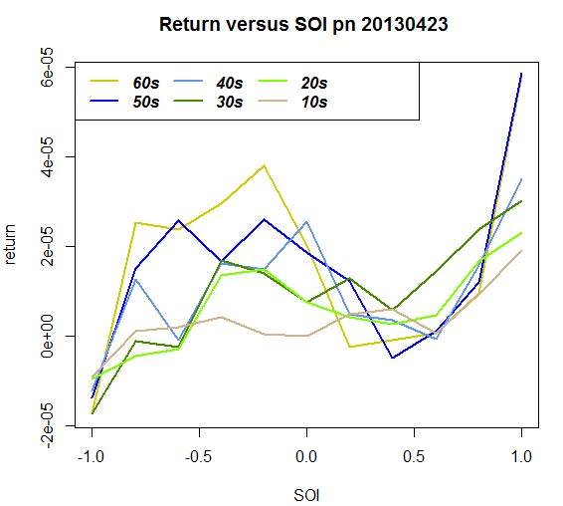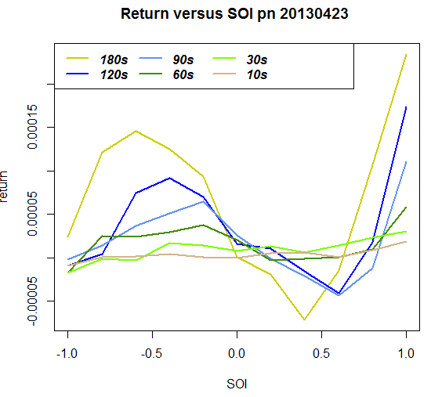

Though the coefficients are downward slowing, as time becomes larger and t-values become more significant, the relationship between SOI and return are more pronounced and do not seem to be linear (we think the negative coefficients are driven by the large samples of SOI values in between -0.5 and 0.5), and perhaps can be better fitted by a sin function. Whereas for QOI, the relationship is very linear (see 12/04 report). (i.e. 

hold for quote imbalance, but not necessarily for order imbalance).

1. Excluding Dark volumes help reducing noise. This is shown through the increased R^2.
2. Using scaled returns as dependent variables reduces the standard errors of coefficients.
3. All the updated codes are uploaded into the “SubProject1_PriceImprovement” folder.