Elliptic Curve Cryptography (ECC)
To explain ECC we must define what is Asymmetric Cryptography, which is a set of mathematical operations that needs two key pairs, one is a private key, and the other one is a public key.
Asymmetric Cryptography can be used in many purposes like:
Digital Signatured
Secure Key Exchange
Encryption and Decryption
To get to use Asymmetric Cryptography we must use any of these algorithms:
RSA: This algorithm can be used for Encryption, Signatures and Key Exchange but is not common and not secure.
Diffie-Hellman (DH) Used only for Key Exchange.
Digital Signature Algorithm (DSA) Only for Signatures
Elliptic Curve Cryptography (ECC) This is a specific type
Asymmetric Cryptography uses the algorithms in plan positive numbers, it uses the private and public keys to do maths and obtain an encryption or a secure exchange, but there is another way to use those algorithms, and is the Elliptic Curve Cryptography, which means we can do the same math that DH and DSA does, but using positions on a curve instead of positive numbers.
Elliptic Curve Cryptography can be defined then, as a kind of Asymmetric Cryptography, that provides strong security and smaller key sizes, which means less storage bandwidth is needed, and that can be traduced as less power usage, faster transactions and computations.
ECC can have some variations, for example, we can use Elliptic Curves to represent Diffie-Hellman and Digital Signature Algorithm, so these variations will be called:
ECDF for Elliptic Curve Diffie-Hellman
ECDSA for Elliptic Curve Digital Signature Algorithm

ECC in a visual representation looks like this:
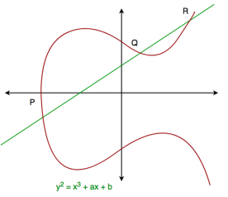
Figure 1. Visual representation of a general Elliptic Curve with its formula

But it can have many variations, some different formulas and can look in many shapes and forms:
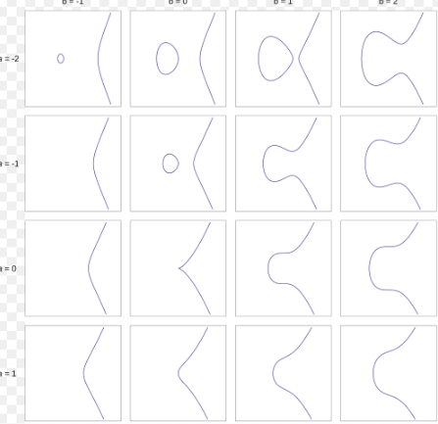
Figure 2. Many shapes of Elliptic Curves

But there is one type of curve that is very commonly used nowadays by blockchains to safety crate Digital Signatures, Secure Key Exchange, Encryption and Decryption; It is the Secp256k1, which is the one used in Bitcoin and Ethereum

Bitcoin and Ethereum
Both are decentralized, public and open-source block chains to store transactions history, and they use cryptography keys Secp256k1 for signatures.
But they have a few strong differences.
Bitcoin was built in a Script that is a bit limited for certain functionalities, it has limited logic and was build in a simple way.
Bitcoin is mainly for digital money/gold, not for running apps, is simple because was made for being minimalistic and predictable.
Ethereum uses high level languages like Solidity, where can run apps, programs and contracts because was built specifically for that.
Ethereum also have EVT Ethereum Virtual Machines, making possible one of its most important characteristics, the smart contract.
In resume, they both are good on what they do, but Bitcoin was build do perform very specific tasks, whereas Ethereum was built to be more versatile, to be used in the world computer, to be fast, secure and powerful.

Smart Contracts
As I said, the smart contracts are a key characteristic of Ethereum, they are a piece of code that runs on a blockchain to provide security to the transaction.
It works checking some conditions we sat in advance, if the conditions are met, it executes an action, this action can be giving a token or grant access to something.
The main magic of this is that is very secure, there is no need of a middleman checking on the conditions or approving the request, the codes enforce the rules, and once is done, it will leave a print foot that cannot be deleted easily, making obvious when someone is acting illegally and letting everyone knows that the transaction was release successfully (or not).
The Elliptic Curve enables the access to smart contracts, in other words Ethereum’s users hold their own private key, they have to use those keys we talked before (private and public key) to perform transactions and interact with the smart contracts requirements.

