Section 3: Complete Documentation
SWEN 661 - Team 1 - Week 12

3.1 User Documentation

Purpose and intended use
CareConnect is an educational care-coordination prototype with React web, Flutter mobile, React Native mobile, and Electron desktop implementations. Users can explore a daily overview, medications, appointments, activity, messages, and accessibility-oriented settings. Features vary by platform.
Use fictional demonstration information only. CareConnect is not a medical device, medical-advice service, secure patient-record system, or emergency service. Authentication is a demonstration; the applications do not synchronize care plans or deliver messages to real clinicians.

Installation and access
Platform | How to access/install | Limitations
Web | Open https://laowai-fi.github.io/careconnect-swen661-T1/ in a modern browser. In Chrome/Edge, use Install app when available. Visit online and allow the service worker to become ready before trying offline reload. | Browser-local demonstration data; installation options depend on browser/OS. Production verification records an offline reload, not a physical phone installation.
Flutter Android | Obtain CareConnect-Flutter-Week12.apk from the team's separately supplied final package. Transfer/install using the course-approved Android process. | Course release-mode APK uses development signing, not a store release. iOS requires macOS/Xcode and signing; no final IPA is established by the delivery record.
React Native Android | Obtain CareConnect-ReactNative-Week12.apk from the final package. It is standalone: Metro and Expo Go are not needed. | Recorded support includes arm64 and x86_64. Course development signing is used. No final iOS IPA is established by the delivery record.
Electron Windows | Verify CareConnect-Setup-0.8.0.exe against the supplied SHA256SUMS.txt, run setup, and launch CareConnect. | Not presented as a publicly signed commercial release. Packaged executable verification does not establish that the installer UI was tested.
Electron macOS | Obtain the Apple Silicon or Intel workflow artifact linked in the delivery guide, extract it, and use the matching DMG. | Unsigned/not notarized. GitHub login may be required and artifacts expire. Retain the download before expiration.
Electron Linux | Build the Linux distribution using the desktop README and npm run dist:linux. | A final Linux installer is not listed in the final package. The assignment requires one desktop platform, not all three.
If Android reports a signature conflict with an older course APK, uninstalling the old build may be necessary; this removes its local demo data. Obtain packages only from the trusted team distribution.
Final build filenames and installation instructions: https://github.com/LaoWai-Fi/careconnect-swen661-T1/blob/main/docs/week12/DELIVERY.md

First use and key features
1. Launch the application and sign in/sign up using fictional information.
2. Open Dashboard/Today to review the sample care plan and upcoming items.
3. Use navigation to access medications, appointments, activity, and messages.
4. Review details before saving a form or confirming deletion. Medication status can be changed through the available controls.
5. Explore settings for larger text, theme, and left/right-hand controls where available.
Messages and check-ins are demonstration interactions, not delivery to clinicians. Flutter and React Native use in-memory mobile state; Electron persists a device-local care plan; web uses browser storage. There is no cross-device synchronization. Electron provides care-plan import/export and native menus/shortcuts. Do not treat local state or exported JSON as a secure clinical record.
The SOS control is a prototype action that asks for confirmation and opens the device dialer where supported. CareConnect cannot place or verify a call. Do not activate emergency calling during course demonstrations; use the device's normal emergency workflow when needed.

Accessibility guidance
Use labeled controls and available text-size, theme, and hand-mode settings. Web and desktop provide keyboard navigation and focus-managed dialogs; Electron additionally provides native shortcuts. Mobile offers labeled touch controls and button alternatives for dashboard reordering.
Week 6 records Android TalkBack walkthroughs; Week 8/9 records desktop macOS keyboard and VoiceOver checks. Week 12 Part 1 records web keyboard and VoiceOver/Safari checks. Final release-APK automated workflows and packaged Windows keyboard verification add functional evidence, not new screen-reader listening results. Mobile iOS VoiceOver and Windows NVDA remain unverified in the reviewed records.
VoiceOver/Safari did not speak the web appointment-deletion status on the recorded retest. The result remains visible, but visual checking is not an equivalent workaround for a blind user. Do not rely on speech for this particular confirmation or claim the limitation is fixed without a genuine retest.
The three VPATs below identify criterion-specific support, limitations, and pending checks. Themes and coverage percentages alone do not prove WCAG conformance.

Week 12 application screenshots
The following images are the team's existing Week 12 evidence on main. Reusing them does not claim a new capture or test session.
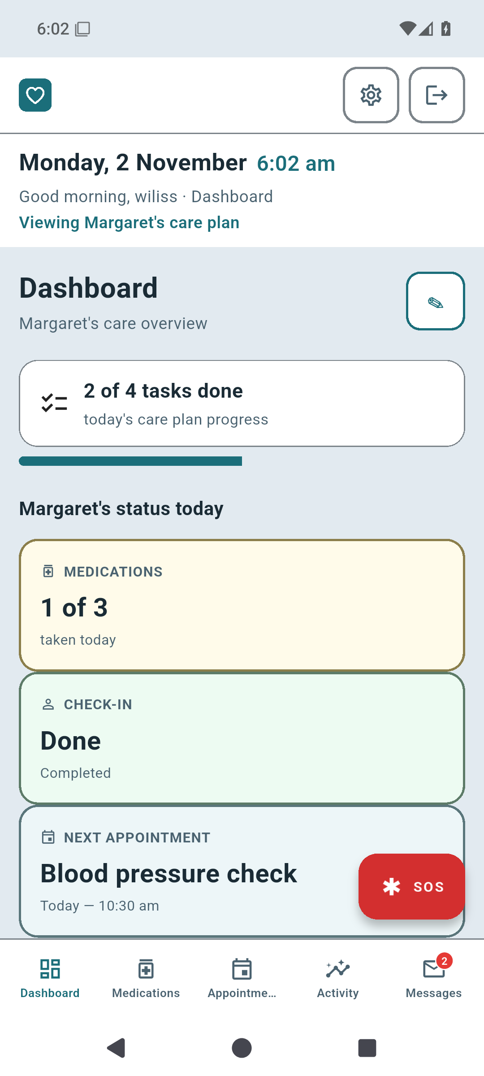
Figure U1. Flutter application screenshot from the team's final integration evidence.
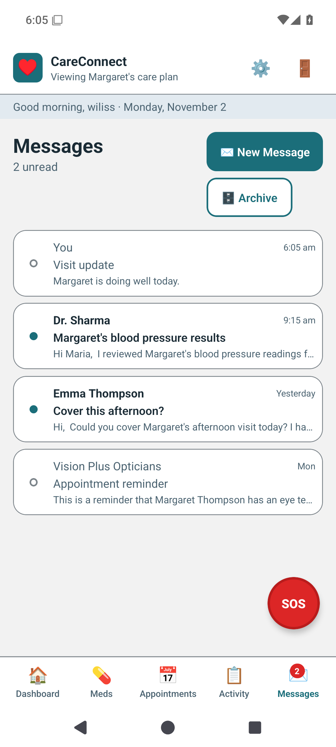
Figure U2. React Native application screenshot from the team's final integration evidence.
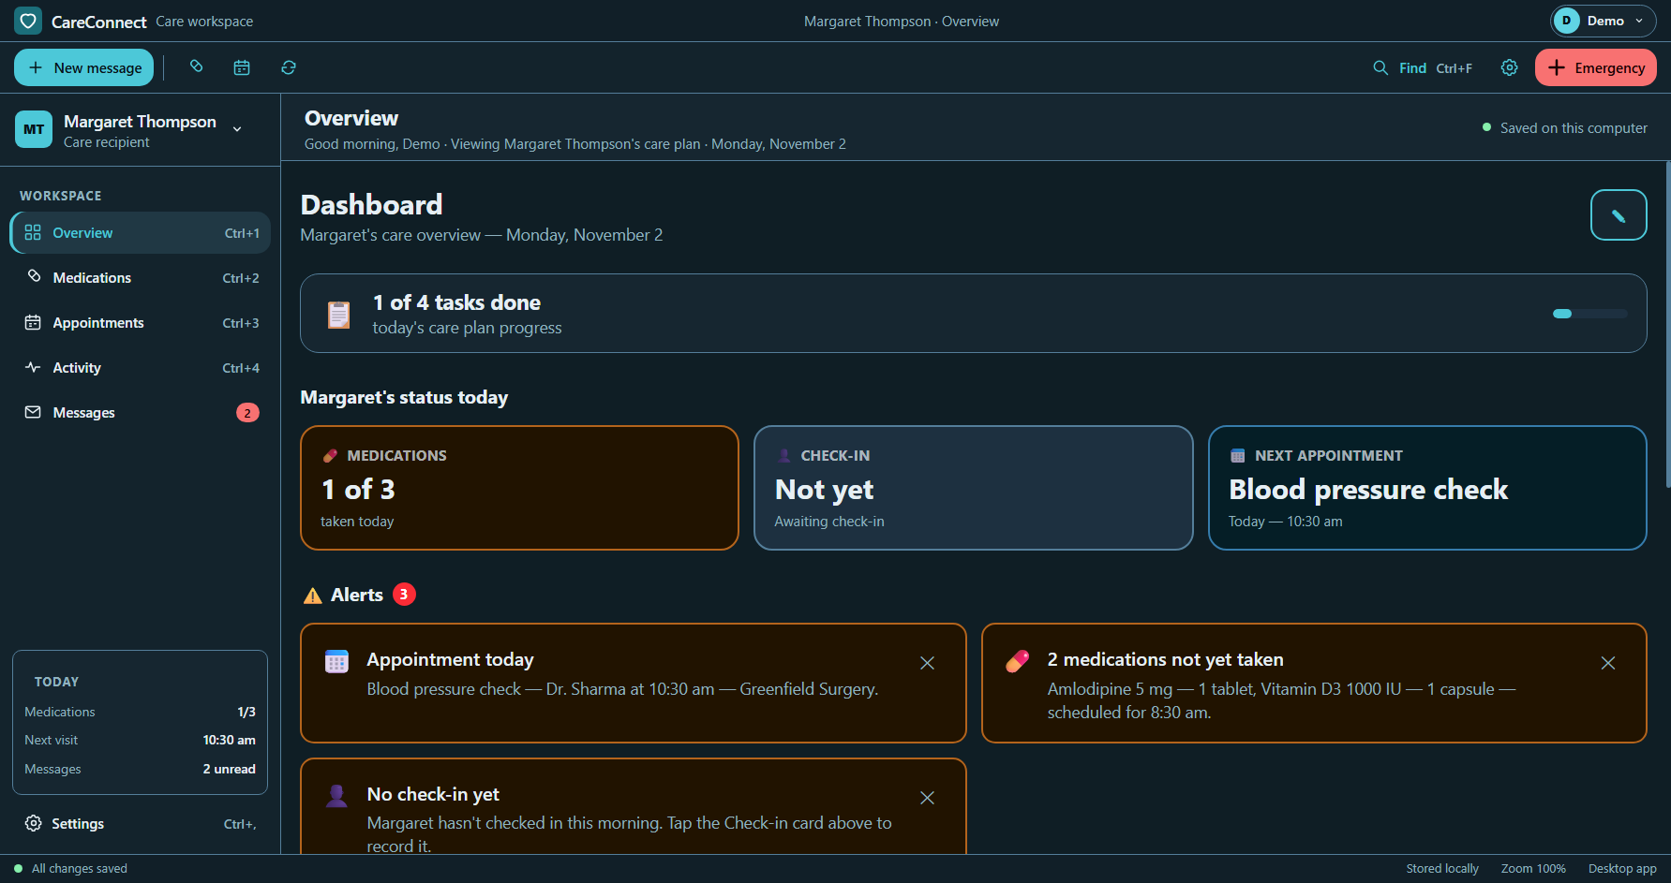
Figure U3. Packaged Electron Windows dashboard from the team's final verification evidence.
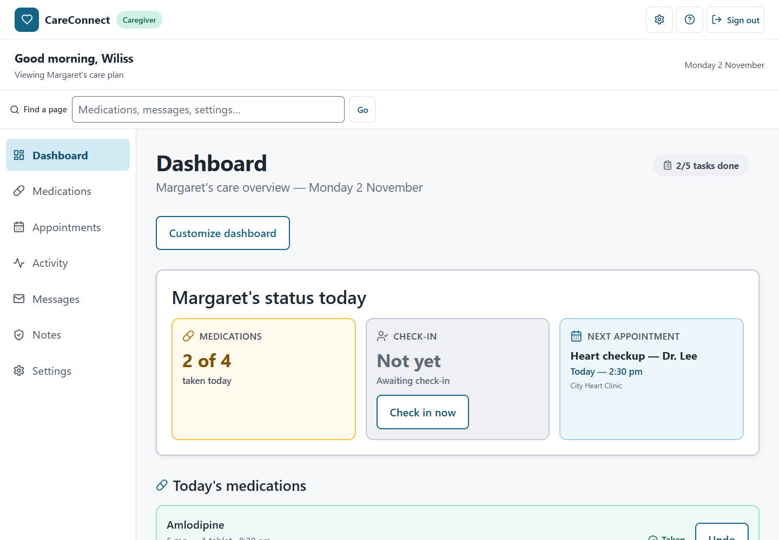
Figure U4. Deployed React web dashboard at desktop width (top-of-page crop for readability).
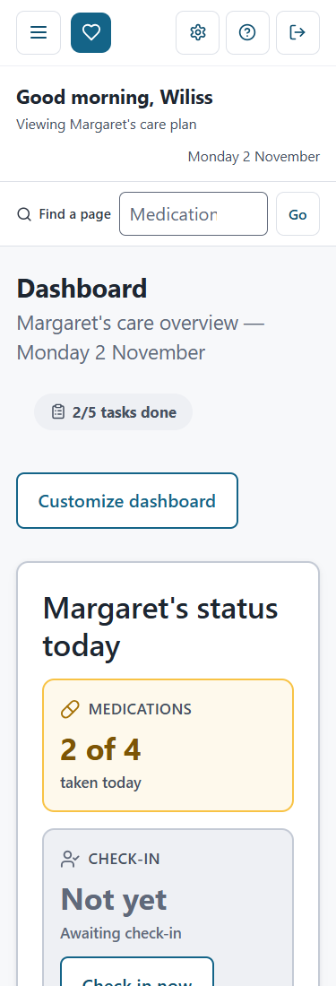
Figure U5. Deployed React web dashboard at narrow width (top-of-page crop for readability).
Source images: https://github.com/LaoWai-Fi/careconnect-swen661-T1/tree/main/docs/week12/evidence

FAQ and troubleshooting
Is sign-in a real account service? No. Use demonstration details; no production password recovery is documented.
Does information synchronize between platforms? No. Each application has separate local demonstration state.
Why does the Android APK refuse to replace an older build? Signing may differ. Follow the delivery guide; uninstalling an old build removes its data.
Why does the desktop installer show a warning? Course builds are not presented as signed commercial releases. Confirm the trusted source and checksum before installing.
How do I try the web app offline? First visit online, wait for service-worker readiness, then reload offline. Installation and offline capability are separate from complete accessibility conformance.
What should I do if controls are hard to read or operate? Try available text-size/theme/hand-mode settings and supported keyboard controls. Consult the VPAT for unresolved issues; do not assume a setting fixes every accessibility problem.
Why does the assistant give limited replies? It is limited to onboarding and explaining CareConnect, not medical advice. It may use scripted responses when the optional remote service is unavailable.
Can I use CareConnect for care decisions or emergency calls? No. Consult appropriate professionals and use normal emergency services.

3.2 Developer Documentation

Architecture
The repository contains independently configured applications with separate local data. The optional web onboarding assistant is the documented remote API integration. Electron separates the sandboxed renderer from OS/file access through its preload bridge and validated IPC.
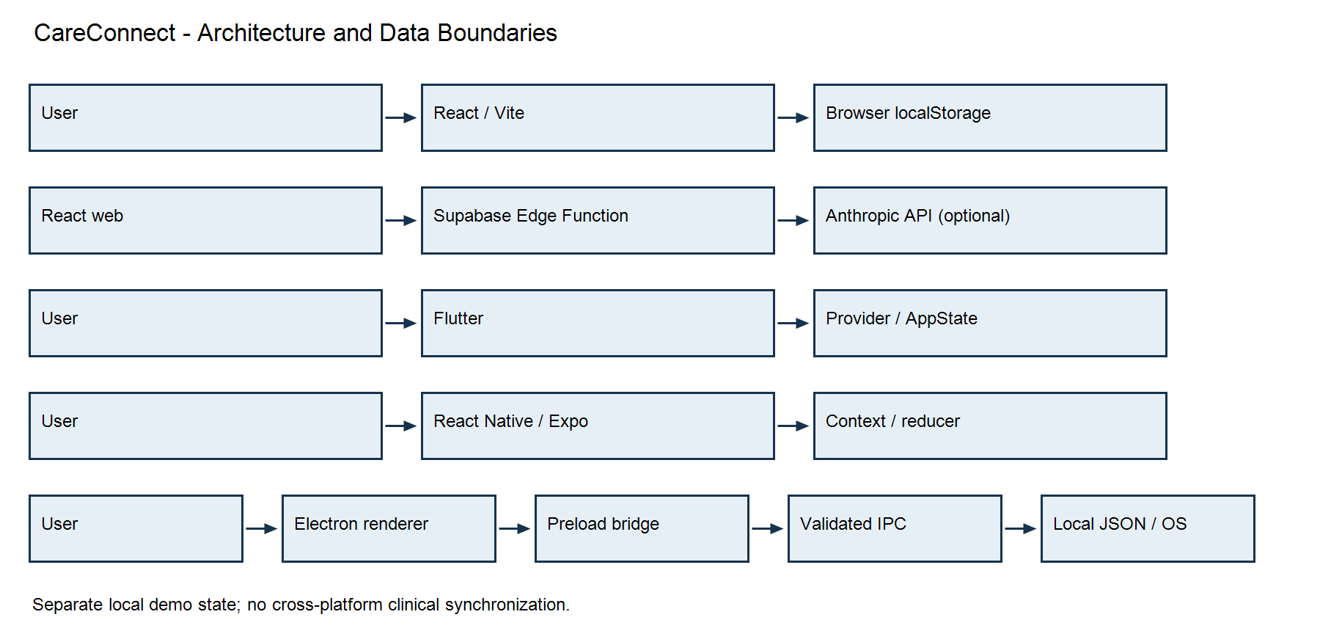
Figure D1. Platform architecture. Arrows represent interaction/data flow, not cross-platform synchronization.

Code structure
Folder | Responsibility
web | React/TypeScript/Vite pages, shared controls, routing, demonstration authentication, browser-local data, and service worker.
mobile-flutter | Flutter screens/widgets, theme, Provider/AppState, routes, and sample data.
mobile-rn | React Native/Expo screens/components, React Navigation, Context/reducer state, and theme.
desktop-electron | Electron main/preload, React renderer, validated IPC, native menus, local care-plan storage, tests, and packaging.
docs/week12 | Final integration/delivery records, evidence, coverage reports, and documentation.

Prerequisites and setup
Use Git, Node 22.12+ and npm for web/desktop, Node 22 and Android tooling for React Native, and Flutter/Java/Android tooling for Flutter. The final checkout guide records Flutter 3.47.8 and Java 17 for CI. iOS development requires macOS/Xcode and signing.
Clone https://github.com/LaoWai-Fi/careconnect-swen661-T1.git and check out the team's approved final revision. Record the SHA when producing evidence. Install dependencies within each platform folder using its lockfile.
Platform folder | Setup/development | Verification
web | npm ci; npm run dev | npm run lint; npm run test:coverage -- --runInBand; npm run build; npm run test:e2e; npm run preview
mobile-flutter | flutter pub get; flutter run | flutter test --coverage; flutter build apk --release
mobile-rn | npm ci; npx expo start for development | npm run coverage -- --runInBand; npx expo prebuild --platform android --no-install; use the release Gradle task in the final mobile workflow
desktop-electron | npm ci; npm start | npm run typecheck; npm run lint; npm run test:coverage -- --runInBand; npm run test:e2e; npm run dist:win
Web E2E starts its own preview; free port 4173 first. Windows Chromium tests default to installed Edge in the final guide. Other hosts require Playwright browser installation for configured engines. Do not combine historical full-browser results with the final local Edge run as if they were one run.
Release-APK Maestro commands: maestro test --format junit --output results.xml --test-output-dir maestro-output maestro/. Install both course release APKs on the target emulator/device before running those workflows.
Authoritative current checkout instructions: https://github.com/LaoWai-Fi/careconnect-swen661-T1/blob/main/docs/week12/FRESH_CHECKOUT_GUIDE.md

API and data safety
The optional web assistant calls POST {VITE_SUPABASE_URL}/functions/v1/chat-assistant. Requests contain a messages array with role and content. Responses contain reply or useFallback; malformed requests return HTTP 400. The client can use scripted replies on API errors.
Keep ANTHROPIC_API_KEY in server-side Supabase secrets, never a VITE_ client variable. No production care-plan API, real authentication, cross-platform clinical synchronization, or remote messaging is claimed. Electron's care-plan JSON is local demonstration data. Never use real patient information in tests or recordings.

Final testing and coverage
These are the team's reported Week 12 final records on main, not tests newly run for this documentation update.
Platform | Recorded final tests | Line coverage
Flutter | 129 Flutter tests | 93.89% (2043/2176)
React Native | 135 Jest/RNTL tests | 85.90% (518/603)
Electron | 224 Jest tests; 5 Windows Electron E2E tests | 98.44% (1389/1411)
Web | 135 Jest/RTL tests; 162 Edge browser tests | 94.56% (922/975)
All six Maestro workflows passed on the installed release APKs on an Android API 35 Pixel 6 emulator after initial failures were repaired and rerun. Four deployed Landing/Dashboard mobile/desktop Lighthouse audits recorded accessibility 100. A production offline reload passed with no browser manifest/installability errors. These records do not establish new complete route-wide production WAVE/axe scans, physical-phone installation, or new assistive-technology listening sessions.
HTML coverage and raw evidence are linked from https://github.com/LaoWai-Fi/careconnect-swen661-T1/blob/main/docs/week12/README.md

Deployment by platform
Platform | Build/distribution
Web | Build using npm run build; deploy web/dist using the repository's hosting configuration. The live URL is https://laowai-fi.github.io/careconnect-swen661-T1/. Verify service-worker readiness, offline behavior, and installability on the actual deployment.
Flutter | flutter build apk --release; AAB/IPA production requires the appropriate build/signing process. The supplied course artifact is CareConnect-Flutter-Week12.apk.
React Native | Expo prebuild plus the Android release Gradle task recorded in the mobile workflow; supplied artifact is CareConnect-ReactNative-Week12.apk. Expo Go is a development option, not required for that standalone APK.
Electron | Windows: npm run dist:win; macOS: npm run dist:mac:arm or npm run dist:mac:intel; Linux: npm run dist:linux. The final package lists the Windows installer; matching Mac artifacts are linked in the delivery guide. Signing/notarization limitations remain.
Retain source SHA, checksums, raw results, and artifact files. GitHub workflow artifacts may expire or require login. The final source ZIP and binaries are supplied separately; filenames do not establish public download URLs.

3.3 VPAT Accessibility Conformance Reports
The following desktop, combined Flutter/React Native mobile, and React web reports cover all 50 WCAG 2.1 Level A and AA success criteria. Historical testing dates and unresolved limitations are retained. Final build/coverage evidence supplements the reports but does not convert pending accessibility checks into passes.

Week 12 Part 3 - CareConnect Desktop VPAT
SWEN 661 - User Interface Implementation
Assignment 12: Final Project - Complete Documentation
Project: CareConnect - Electron Desktop
Prepared for: Team 1 Week 12 submission
Report revision date: 2026-11-02
This Week 12 edition retains the original desktop evaluation baseline. Week 8/9 references below identify historical evidence, not the current assignment number. No new manual testing is claimed.

Accessibility and UI Testing Conformance Summary
This Week 12 Part 3 conformance report covers the CareConnect Electron desktop application against all 50 WCAG 2.1 Level A and AA success criteria, with desktop implementation notes, conformance status, and evidence or known gaps for each. Evidence is drawn from the desktop Week 8 and Week 9 implementation and testing records. Mobile-app evidence is outside this report's scope.
Platform | Accessibility implementation | Evidence
Electron desktop (React/TypeScript renderer) | Semantic HTML/ARIA, labeled forms, keyboard navigation and native shortcuts, focus-managed dialogs, status announcements, light/dark/high-contrast settings, text scaling/zoom, and Left-Hand Mode. | Week 9 axe DevTools screenshots and jest-axe tests; recorded macOS keyboard and VoiceOver checks; automated test and coverage records. Scope and gaps are detailed below.

WCAG 2.1 Level A and AA Criteria
Status terms follow VPAT conformance levels: Supports, Partially Supports, Does Not Support, and Not Applicable. Each criterion includes the desktop implementation and the evidence or limitation behind its status. A pending verification item is not a pass. No manual assistive-technology testing beyond the documented macOS VoiceOver checks is claimed.
Criterion | CareConnect Desktop implementation | Status and verification
1.1.1 Non-text Content (Level A) | Informative imagery and controls have text alternatives or accessible names; decorative artwork is hidden from assistive technology. | Supports. Informative controls use text or accessible names; decorative icons and emoji are hidden from assistive technology. Automated axe checks exercise the recorded pages and dialogs. See Week 9 accessibility tests and the VoiceOver checks.
1.2.1 Audio-only and Video-only (Prerecorded) (Level A) | The desktop application does not provide prerecorded audio-only or video-only media. | Not Applicable. The application does not provide prerecorded audio-only or video-only media.
1.2.2 Captions (Prerecorded) (Level A) | No prerecorded synchronized audio/video is provided. | Not Applicable. The application contains no prerecorded synchronized audio/video.
1.2.3 Audio Description or Media Alternative (Prerecorded) (Level A) | No prerecorded video with an audio track is provided. | Not Applicable. The application contains no prerecorded video with an audio track.
1.2.4 Captions (Live) (Level AA) | No live synchronized audio/video is provided. | Not Applicable. The application provides no live synchronized audio/video.
1.2.5 Audio Description (Prerecorded) (Level AA) | No prerecorded video with audio description needs is provided. | Not Applicable. The application provides no prerecorded video with an audio track.
1.3.1 Info and Relationships (Level A) | Semantic headings, landmarks, form labels, named regions, and dialog relationships structure the renderer. | Supports. The interface uses headings, landmarks, labeled regions, form labels, and dialog relationships. Week 9 added shell landmarks and a landing-page heading; axe scans and VoiceOver rotor checks are documented. An axe Best Practices scan still notes the emergency alert-dialog backdrop region; the report records this as a best-practice note, not an identified WCAG 2.1 A/AA failure.
1.3.2 Meaningful Sequence (Level A) | The renderer DOM and keyboard navigation preserve a meaningful sequence through shell, pages, and dialogs. | Supports. The content follows a meaningful DOM and reading order. Mac keyboard tab order and VoiceOver page/heading navigation were manually exercised; automated renderer tests cover primary pages.
1.3.3 Sensory Characteristics (Level A) | Instructions and action labels use text and programmatic names, not sensory characteristics alone. | Supports. Directions and controls are identified with text, labels, and programmatic names rather than relying solely on shape, color, location, or sound. Relevant axe and VoiceOver evidence is documented; no audio-only instruction is present.
1.3.4 Orientation (Level AA) | The resizable Electron window and responsive renderer styles support portrait/landscape viewport changes. | Supports. The renderer has responsive orientation/viewport styles and does not lock screen orientation. The app is resizable. Landscape/narrow viewport styling is present in src/index.css; exhaustive orientation/device testing remains advisable.
1.3.5 Identify Input Purpose (Level AA) | Account name, email, and password inputs use autocomplete purposes and associated field labels. | Supports. Account name, email, and password controls expose autocomplete purposes (name, email, new-password, current-password). Forms use associated labels. See SignInPage.tsx, SignUpPage.tsx, and FormField.tsx.
1.4.1 Use of Color (Level A) | State is conveyed with text, icons, labels, and programmatic state as well as color. | Supports. Color is supplemented by text, icons, labels, or state semantics for status and controls. Axe and manual VoiceOver checks cover documented states; high-contrast modes are also available.
1.4.2 Audio Control (Level A) | The app does not play audio automatically. | Not Applicable. The application does not play audio automatically.
1.4.3 Contrast (Minimum) (Level AA) | Text color tokens are designed for contrast; rendered text was measured in light and dark themes, with reported fixes rechecked. | Supports. Week 9 records rendered text contrast measurement in both themes and post-fix zero-issue contrast checks for the previously failing appointment, emergency-dialog, and message-count text. Full criterion-specific evidence and scan scope are in ACCESSIBILITY_TESTING.md and PART2_FIXES.md; jsdom axe checks do not measure contrast.
1.4.4 Resize Text (Level AA) | In-app text size and native zoom shortcuts provide resizing up to 200%; macOS testing recorded no clipping or loss of function. | Supports. Manual testing on macOS reports successful 200% zoom and larger app text without clipping or loss of function. The application provides text-size settings and zoom shortcuts (up to 200%). This evidence does not establish WCAG 1.4.10 reflow at 400%.
1.4.5 Images of Text (Level AA) | Primary interface content is live text; no essential text is embedded in images. | Supports. Primary interface content is rendered as text, not images of text. No essential image-of-text content was identified in the recorded screens.
1.4.10 Reflow (Level AA) | Responsive layouts and zoom are implemented; reflow at 320 CSS px/400% has not yet been verified. | Partially Supports. The app has responsive layouts; manual macOS testing at 200% zoom passed, and recorded axe scans used a roughly 431 CSS-pixel-wide renderer viewport. A 320 CSS-pixel viewport or equivalent 400% zoom reflow test is not recorded. Pending: verify all app pages and dialogs at 320 CSS px wide with no two-dimensional scrolling except permitted content, and check at 400% zoom. Until then, use the app's zoom/text-size controls and resize/maximize the window; this is not a substitute for that verification.
1.4.11 Non-text Contrast (Level AA) | Controls define borders and visible focus indicators; high-contrast modes are available. | Partially Supports. Focus indicators were manually observed as visible in light, dark, and in-app high-contrast modes; macOS Increase Contrast was also checked. Numeric 3:1 contrast measurement of component boundaries, states, and focus indicators, including Windows forced-colors/Contrast Themes, is not documented. Pending: measure relevant graphical objects and states, and verify Windows Contrast Themes.
1.4.12 Text Spacing (Level AA) | Text uses scalable layout, but WCAG-defined text-spacing overrides have not yet been tested. | Partially Supports. Normal text sizing and larger app text were exercised, but the WCAG text-spacing overrides (line height, paragraph spacing, letter spacing, and word spacing) were not tested. No conformance claim is made for content under those overrides. Pending: apply the criterion's spacing values across pages and dialogs and verify no content/functionality loss. Users can increase app text size or zoom while that test remains pending.
1.4.13 Content on Hover or Focus (Level AA) | Some controls include native title tooltip text; behavior and persistence on hover/focus have not been verified. | Partially Supports. Some controls set native title tooltip text (for example, delete and navigation controls). Equivalent labels/actions exist, but whether the host tooltip is dismissible, hoverable, and persistent was not verified. Pending: test title tooltips with pointer and keyboard focus on supported operating systems; ensure essential information is available without relying on the native tooltip.
2.1.1 Keyboard (Level A) | Renderer controls, app navigation, Electron menus, and documented keyboard shortcuts provide keyboard operation. | Supports. Mac keyboard-only testing covered the documented workflows, dialogs, menu items, and shortcuts; automated tests cover keyboard navigation, dialog traps, dismissal, and menu commands. Week 9 retested corrected sign-in focus, New Message, and medication controls. Windows and Linux native menu/tray keyboard use still need platform testing.
2.1.2 No Keyboard Trap (Level A) | Dialogs trap focus while open and close by Escape/controls, returning focus to their opener. | Supports. Manual macOS testing reports no keyboard traps; dialog tests verify Escape dismissal and focus return, and focus-trap tests verify contained Tab/Shift+Tab behavior while dialogs are open.
2.1.4 Character Key Shortcuts (Level A) | Documented accelerators use Command/Ctrl modifiers or function keys; no single-character shortcut is documented. | Supports. App shortcuts use Command/Ctrl modifiers or function keys (for example F1); no single-character shortcut is documented. See desktop-electron/README.md keyboard shortcut table.
2.2.1 Timing Adjustable (Level A) | User actions have no time limit or session timeout; the demo sign-in delay is not a task deadline. | Not Applicable. No user-facing time limit or timed session expiration is implemented. Demo sign-in delay is a short response animation, not a limit on task completion.
2.2.2 Pause, Stop, Hide (Level A) | No continuously moving, blinking, scrolling, or periodically updating content requiring pause controls was identified. | Not Applicable. No automatically moving, blinking, scrolling, or periodically updating content requiring a pause/stop/hide control was identified. Status announcements follow user actions.
2.3.1 Three Flashes or Below Threshold (Level A) | No flashing content was identified in the evaluated application. | Not Applicable. No flashing content was identified in the evaluated application.
2.4.1 Bypass Blocks (Level A) | A keyboard-accessible skip-to-main-content link bypasses repeated shell navigation. | Supports. The renderer provides a keyboard-accessible “Skip to main content” link. The macOS manual keyboard record confirms it appears on the first Tab; the Week 9 landmark changes were covered by axe checks.
2.4.2 Page Titled (Level A) | The document and app window identify CareConnect Desktop; rendered pages have headings. | Supports. The document title is “CareConnect Desktop”; the product window is identified as CareConnect. VoiceOver launch testing recorded the window title and page heading.
2.4.3 Focus Order (Level A) | The shell has a logical keyboard order; invalid sign-in moves focus to the first invalid field; dialogs return focus. | Supports. Mac keyboard testing records a logical order through the shell and page content; sign-in errors move focus to the first invalid field. Dialogs trap focus while open and return it to the opener.
2.4.4 Link Purpose (In Context) (Level A) | Links and action controls have descriptive labels or accessible names in context. | Supports. Links and action controls use descriptive labels or accessible names in their context. Axe checks and VoiceOver/keyboard checks cover documented primary flows.
2.4.5 Multiple Ways (Level AA) | Primary pages are reachable through persistent app navigation and native menus/keyboard shortcuts. | Supports. Primary pages can be reached through the app navigation and documented keyboard shortcuts/native menus. The Help and search functions provide additional access paths for applicable content.
2.4.6 Headings and Labels (Level AA) | Pages and dialogs use descriptive headings and controls use labels. | Supports. Pages and dialogs have descriptive headings and controls have labels. Week 9 corrected the landing-page h1; axe checks and VoiceOver heading-rotor testing are recorded.
2.4.7 Focus Visible (Level AA) | Visible focus styling is defined for controls and was manually observed on macOS in light, dark, and high-contrast modes. | Supports. Manual macOS keyboard checks report visible focus rings in light, dark, and in-app high-contrast modes. Automated styles define focus-visible outlines. Windows/Linux appearance has not been manually verified.
2.5.1 Pointer Gestures (Level A) | Primary actions use standard single-pointer controls; no multipoint or path gesture is required. | Not Applicable. No multipoint or path-based gesture is required to operate the application; actions use standard controls.
2.5.2 Pointer Cancellation (Level A) | Standard controls activate on normal press/release; keyboard alternatives are available for app tasks. | Supports. Standard button and control activation is used rather than custom pointer-down-only actions. Keyboard operation provides an equivalent input method. This criterion was not separately tested with a pointer-cancellation test protocol.
2.5.3 Label in Name (Level A) | Visible labels are reflected in accessible names for tested controls; icon-only controls receive names. | Supports. Visible button/control labels are reflected in programmatic names where tested, with additional accessible names for icon-only controls. Axe checks and VoiceOver manual checks cover representative pages and dialogs.
2.5.4 Motion Actuation (Level A) | No device-motion or user-movement actuation is used. | Not Applicable. The application does not use device motion or user movement to trigger functionality.
3.1.1 Language of Page (Level A) | The renderer document declares English (lang="en"). | Supports. The document root declares lang="en". See desktop-electron/index.html.
3.1.2 Language of Parts (Level AA) | The evaluated user interface is English and has no identified passages in another language. | Not Applicable. The evaluated interface contains English content only; no passages in another language requiring a language-of-part declaration were identified.
3.2.1 On Focus (Level A) | Focusing a control does not itself trigger navigation, submission, or another context change. | Supports. Focusing a control does not itself trigger a context change. This is consistent with the native form/control patterns and keyboard test records.
3.2.2 On Input (Level A) | Entering form values does not submit or change context without explicit user activation. | Supports. Changing a form value does not automatically submit or change context. Actions require an explicit button/menu activation; form and workflow tests cover common input flows.
3.2.3 Consistent Navigation (Level AA) | The signed-in shell retains consistent navigation labels and order across its primary pages. | Supports. The signed-in shell presents consistent navigation across the five primary pages. The macOS keyboard and navigation tests exercise those page transitions.
3.2.4 Consistent Identification (Level AA) | Repeated controls and actions use consistent labels and identification patterns across the shell. | Supports. Repeated controls and navigation items use consistent labels and icon/text patterns across the shell. Automated and manual records cover the repeated navigation and common actions.
3.3.1 Error Identification (Level A) | Validation errors identify missing/invalid values, expose invalid state, and focus the first invalid sign-in field. | Supports. Invalid fields expose an error message and invalid state; sign-in errors are associated with fields and focus moves to the first invalid field. Week 9 Part 2 tests these changes; VoiceOver sign-in validation is documented.
3.3.2 Labels or Instructions (Level A) | Form fields have programmatic labels, required status, hints, and associated validation messages. | Supports. Form fields have programmatic labels; required status, hints, and errors are programmatically associated. FormField and screen-reader test records provide evidence.
3.3.3 Error Suggestion (Level AA) | Validation feedback supplies correction guidance where applicable, including password length and matching confirmation. | Supports. Where a correction can be suggested, errors and hints provide it (for example, the password's minimum length and mismatched confirmation). Automated sign-in validation tests and manual VoiceOver sign-in checks are recorded.
3.3.4 Error Prevention (Legal, Financial, Data) (Level AA) | User-controllable care-plan records are entered through forms with explicit Add/Save actions; destructive delete actions use an alert confirmation dialog, and medication taken status can be toggled back. | Supports. The app stores user-controllable care-plan data locally, so this criterion is applicable even though the product is a demo and has no production service. The user reviews form contents before choosing Add/Save; delete operations require a confirmation dialog with Cancel/Delete; reversible status actions can be toggled back. Week 8 keyboard testing records medication/appointment/message add/edit/delete workflows and delete confirmation; automated page/workflow tests cover the forms and dialogs. This evidence applies to the documented demo workflows; it is not a claim about a production account or server.
4.1.1 Parsing (Level A) | The product is a web-rendered Electron application; the renderer uses semantic HTML and React output. | Supports. The React renderer is built and type-checked, and axe checks report no WCAG 2.1 A/AA markup violations in their stated scope. As this criterion concerns programmatically determinable markup, automated checks are relevant evidence but do not cover every OS-rendered surface.
4.1.2 Name, Role, Value (Level A) | Interactive controls expose programmatic names, roles, values, and state; medication toggles include medication-specific state. | Supports. Native controls and ARIA names, roles, states, and values are used; Week 9 fixed the medication toggle name/state and attachment input exposure. Axe checks, control-specific tests, and VoiceOver checks are documented.
4.1.3 Status Messages (Level AA) | Status and live regions announce save, refresh, check-in, and medication updates without moving focus. | Supports. Status and live regions announce save, refresh, check-in, and medication state updates without moving focus. Week 9 tests and VoiceOver manual checks are recorded.

Automated and rendered test evidence
Test | Result and scope
jest-axe | Week 8/9 renderer tests exercise the landing/sign-in experience, five primary signed-in pages, settings, shortcuts, emergency dialogs, and medication/appointment forms. jsdom disables axe color-contrast because rendered colors are not computed there.
Chrome axe DevTools 4.13.0 | Week 9 records seven primary pages in dark theme and selected light theme pages/dialogs at approximately 431 x 730 CSS px, with zero reported issues for those scans. This is not exhaustive coverage of all dialogs, themes, states, packaged builds, or operating systems. Evidence screenshots and precise scope are in docs/week9/ACCESSIBILITY_TESTING.md.
Rendered text contrast | Week 9 records measurement in light/dark themes (4.5:1 normal text, 3:1 large text); previously reported contrast defects were fixed and rechecked. This does not establish non-text contrast.
Historical automated tests | Week 8 report records 224 Jest tests and 5 Electron end-to-end tests passing. Week 9 Part 2 records typecheck, lint, and 224 Jest tests passing at that time. These are historical records, not a current CI result.
Historical CI status (GitHub Actions run on dbbfc338) | npm ci, typecheck, lint, and Jest coverage passed. The xvfb-run -a npm run test:e2e step failed; the packaging job was skipped. This is the historical main-branch run checked for the original desktop evaluation, not the latest Week 12 result. No claim that the E2E suite or overall workflow passes is made. See the Desktop Electron run (https://github.com/LaoWai-Fi/careconnect-swen661-T1/actions/runs/38266297078).

Screen reader testing (VoiceOver)
The desktop Week 9 record states that VoiceOver was tested on macOS 26.6.2 with Full Keyboard Access on, with post-fix checks recorded October 10, 2026. Only the documented test cases below are claimed. NVDA/Windows and Linux screen readers have not been manually tested.
Check | Recorded result | Evidence/notes
Launch and sign-in | Pass | VoiceOver announced window/title, labels, required fields, and validation feedback.
Navigation and rotor | Pass with note | Main landmark, page headings, and regions were navigable. Sidebar label was retested after its Part 2 update.
Medication state and dialogs | Pass | Medication name/state and status change announcements were retested; dialog labels and focus behavior were checked.
Messages and attachments | Pass | Compose fields and Attach action were reachable/announced; keyboard operation also recorded.
Settings, emergency dialog, menus, live updates | Pass | Switch states, alert-dialog name/description, native menu items, and check-in/save announcements were checked. The SOS action was not activated in the axe dialog evidence.

Findings and known limitations
Check / limitation | Result | Workaround / follow-up
WCAG 1.4.10 Reflow | 200% zoom was recorded as passing on macOS. Reflow at 320 CSS pixels / 400% zoom has not been tested. | Pending: verify all screens and dialogs at the criterion's reflow dimensions. Meanwhile, use app zoom/text-size settings and resize or maximize the window; scrolling may be needed.
WCAG 1.4.11 Non-text Contrast | Focus visibility was manually observed in light, dark, and in-app high-contrast modes; macOS Increase Contrast was checked. Numeric 3:1 contrast for components/focus and Windows Contrast Themes are unverified. | Pending: measure applicable graphical objects and states, and test Windows Contrast Themes.
WCAG 1.4.12 Text Spacing | WCAG text-spacing override values were not tested. | Pending: apply the line-height, paragraph-spacing, letter-spacing, and word-spacing thresholds across pages and dialogs; verify no content or functionality is lost. App text-size and zoom settings remain available.
WCAG 1.4.13 Hover or Focus | Some controls provide native title text. Whether tooltips are dismissible, hoverable, and persistent has not been verified. | Pending: test tooltip behavior on supported platforms and ensure essential information is available without relying on tooltips.
Windows/NVDA and Linux AT | No manual Windows/NVDA, Windows Contrast Themes, or Linux screen-reader test is recorded. macOS VoiceOver evidence does not establish results on these platforms. | Pending: test sign-in, landmarks, forms, dialogs, live updates, menus/tray, focus, and keyboard-only workflows with the target OS and assistive technology.
Axe scan coverage | Recorded dark-theme scans cover seven primary pages; light-theme scans cover selected pages and the emergency dialog. Other page/dialog/theme combinations and the final packaged build are not covered. | Pending: scan all pages and dialogs in both themes and the final packaged build. Do not treat unscanned combinations as passing.
Unsigned macOS build notifications | Native notifications are implemented but do not display in the unsigned macOS build, according to the Week 8 report. | Use visible in-app status and activity feedback instead.
Demo-only features | Sign-in and data are sample/demo only; Emergency does not contact emergency services. | Do not rely on this application for real care coordination or emergency response.
Scope of standards | This report assesses WCAG 2.1 A/AA only. Section 508-specific provisions and EN 301 549 were not evaluated. | No conformance claim is made for Section 508-specific requirements or EN 301 549.

Historical Desktop Accessibility Findings and Fixes (Week 9 Evidence)
The Week 9 Part 1 issues were addressed in the merged Part 2 work: appointment/emergency/message text contrast fixes; hidden attachment input accessibility; landing heading and shell/help landmarks; sign-in error focus; Cmd+N compose behavior; activity refresh behavior; and medication toggle accessible name/state/status message. Part 2 describes regression evidence and the remaining emergency-dialog axe Best Practices region note, which is not reported there as a WCAG 2.1 A/AA failure. See PART2_FIXES.md (https://github.com/LaoWai-Fi/careconnect-swen661-T1/blob/89uddinrt-week-9-desktop-vpat/docs/week9/PART2_FIXES.md).

Historical Desktop Testing Evidence (Week 9)
Assignment item | Repository evidence/status
Accessibility testing report and completed testing checklist | ACCESSIBILITY_TESTING.md (https://github.com/LaoWai-Fi/careconnect-swen661-T1/blob/89uddinrt-week-9-desktop-vpat/docs/week9/ACCESSIBILITY_TESTING.md), including the recorded axe scan scope, keyboard checks K1-K23, and VoiceOver checks S1-S12.
Accessibility fixes and regression evidence | PART2_FIXES.md (https://github.com/LaoWai-Fi/careconnect-swen661-T1/blob/89uddinrt-week-9-desktop-vpat/docs/week9/PART2_FIXES.md), including fixes, WCAG mapping, tests, and coverage results.
axe DevTools results | Screenshots under evidence/ (https://github.com/LaoWai-Fi/careconnect-swen661-T1/blob/89uddinrt-week-9-desktop-vpat/docs/week9/evidence), with zero-issue results for the specific screens/themes listed in the testing report. Scans do not cover every possible page/dialog/theme combination.
Screen-reader demonstration | The Week 9 testing report states that the VoiceOver recording is submitted separately. This report does not claim an NVDA/Windows test.
Updated coverage | Week 9 Part 2 records line coverage of 98.44% in its documented test run, above the assignment's 60% minimum. The historical merged-main CI recorded for this evaluation Jest coverage step passed, but the overall workflow failed at E2E.
GitHub build/test status | Historical main run checked for this evaluation is linked in the evaluation evidence above; E2E failed and packaging was skipped.

Use of AI
AI assistance was used to organize the conformance report, map repository-documented desktop findings to WCAG criteria, and format the document. The manual keyboard and VoiceOver results in this report are attributed only to the team's recorded Week 9 testing; AI did not perform those tests or independently verify assistive-technology behavior.

Report scope and provenance
Product baseline: CareConnect Desktop 0.8.0 with Week 9 Part 2 fixes on main merge dbbfc33 (PR #13). This report was compiled from repository implementation and test records; manual tests were not repeated for this report. It uses VPAT conformance terminology and a criterion/implementation/status-and-evidence matrix for the requested WCAG 2.1 A/AA scope. It is not the official unmodified VPAT template, a certification, or an independent evaluation.
Editable source: docs/week12/DESKTOP_VPAT.md. Regenerate all Week 12 Word reports with python docs\week12\generate_vpats.py.
Week 12 supplemental evidence: https://github.com/LaoWai-Fi/careconnect-swen661-T1/blob/main/docs/week12/README.md. Final coverage and functional checks do not replace the historical assistive-technology evaluations or resolve pending WCAG checks. Four final Landing/Dashboard production Lighthouse accessibility audits scored 100; these are not new whole-site WAVE/axe scans.

Week 12 Part 3 — CareConnect Mobile VPAT
Assignment 12: Final Project — Complete Documentation
Product: CareConnect Mobile (Flutter and React Native / Expo)
Project: SWEN 661 Team 1
Report scope: all 50 WCAG 2.1 Level A and AA success criteria for the user interface of both mobile implementations.

Product and evaluation information
Field | Information
Product | CareConnect mobile demonstration app
Versions | Flutter and React Native source in this repository; a single final release version is not identified
Platforms | Android and iOS code targets; the located manual accessibility evidence is Android-only
Report date | 2026-11-02
Evaluation basis | Current source/READMEs plus the committed Week 6 automated and manual evidence records
Evaluator | Team project evidence; this is not an independent certification
CareConnect mobile uses native controls and sample data to demonstrate daily schedule, medication, appointment, activity, and message workflows. Flutter uses Provider/AppState; React Native uses Context/useReducer. Both have accessibility-oriented labels/states, text sizing, and one-handed controls. The app is an educational prototype, not a medical device or secure clinical record.

Conformance terminology and limitations
Status terms: Supports, Partially Supports, Does Not Support, and Not Applicable. “Partially Supports” is used where code or targeted test evidence exists but the criterion has not been established across both apps and supported assistive technologies. It does not claim a known failure unless the notes say so. No criterion is assigned “Does Not Support” because the evidence reviewed does not establish a definitive failure; gaps remain unverified, not silently passed.
The Week 6 report records an Android TalkBack walkthrough for both apps, six passing Maestro flows, Flutter accessibility-guideline tests, and React Native component/workflow tests. It does not record iOS VoiceOver testing or a complete criterion-by-criterion evaluation of both final mobile builds. Current app code may have changed since that evidence. Contrast ratios and text-spacing overrides were not comprehensively measured. See Week 6 evidence (https://github.com/LaoWai-Fi/careconnect-swen661-T1/blob/89uddinrt-week-9-desktop-vpat/docs/week6/ACCESSIBILITY_TEST_REPORT.md), Maestro run record (https://github.com/LaoWai-Fi/careconnect-swen661-T1/blob/89uddinrt-week-9-desktop-vpat/docs/week6/MAESTRO_EVIDENCE.md), and platform READMEs (https://github.com/LaoWai-Fi/careconnect-swen661-T1/blob/89uddinrt-week-9-desktop-vpat/mobile-flutter/README.md), Flutter (https://github.com/LaoWai-Fi/careconnect-swen661-T1/blob/89uddinrt-week-9-desktop-vpat/mobile-rn/README.md) React Native (https://github.com/LaoWai-Fi/careconnect-swen661-T1/blob/89uddinrt-week-9-desktop-vpat/mobile-rn/README.md).

WCAG 2.1 Level A and AA criteria
Criterion | Level | Status | Implementation, evidence, and limitation
1.1.1 Non-text Content | A | Partially Supports. | Icon controls and tappable rows use semantic labels/roles; automated widget/component tests cover representative labels. Android TalkBack was recorded; full image/decorative-content review and iOS VoiceOver are pending.
1.2.1 Audio-only and Video-only (Prerecorded) | A | Not Applicable. | No prerecorded audio-only or video-only content is documented in either app.
1.2.2 Captions (Prerecorded) | A | Not Applicable. | No prerecorded synchronized audio/video is documented.
1.2.3 Audio Description or Media Alternative (Prerecorded) | A | Not Applicable. | No prerecorded video content is documented.
1.2.4 Captions (Live) | AA | Not Applicable. | No live synchronized audio/video is documented.
1.2.5 Audio Description (Prerecorded) | AA | Not Applicable. | No prerecorded video content is documented.
1.3.1 Info and Relationships | A | Partially Supports. | Flutter widgets and React Native controls expose labels, roles, and states; tests exercise semantics. Complete screen-by-screen TalkBack/VoiceOver tree review on current builds remains pending.
1.3.2 Meaningful Sequence | A | Partially Supports. | Named-route navigation (Flutter) and typed React Navigation preserve screen/flow order. Reading order has not been re-audited with screen readers on both final builds.
1.3.3 Sensory Characteristics | A | Partially Supports. | Actions have text labels and visible controls; no sensory-only instruction is documented. Validate every user instruction and status with both platforms' AT.
1.3.4 Orientation | AA | Partially Supports. | Flutter has phone/tablet responsive layouts; React Native app.json sets portrait orientation. Landscape behavior is not established for both apps. Use portrait orientation as a workaround; verify landscape support before claiming full conformance.
1.3.5 Identify Input Purpose | AA | Partially Supports. | Form fields have visible labels and semantic names. A complete audit of platform autofill/input-purpose metadata is not recorded.
1.4.1 Use of Color | A | Partially Supports. | Status text/icons and selected states supplement color in shared controls. A full status-by-status color-independence review on both apps is pending.
1.4.2 Audio Control | A | Not Applicable. | The apps do not document automatically playing audio.
1.4.3 Contrast (Minimum) | AA | Partially Supports. | Design tokens and light/dark themes are implemented. The located mobile evidence does not include comprehensive rendered contrast measurements for every screen/state. Use system/in-app theme choices; record measured contrast before claiming full support.
1.4.4 Resize Text | AA | Partially Supports. | Flutter and React Native include a 200% in-app text-size option and scalable controls. Current-build testing of every screen at 200% plus system text scaling is pending.
1.4.5 Images of Text | AA | Partially Supports. | Primary interface copy is rendered as text; no image-of-text audit covering all assets is recorded.
1.4.10 Reflow | AA | Partially Supports. | Phone/tablet layouts and scrollable screens are implemented. No complete viewport/text-size test record establishes no two-dimensional scrolling or content loss for both builds.
1.4.11 Non-text Contrast | AA | Partially Supports. | Focus rings, control borders, and theme tokens are implemented. Numeric 3:1 measurements for every control boundary, state, and focus indicator are not recorded.
1.4.12 Text Spacing | AA | Partially Supports. | Scalable layouts exist, but WCAG line-height, paragraph, letter, and word-spacing overrides were not tested. Increase app/system text size while a full spacing test remains pending.
1.4.13 Content on Hover or Focus | AA | Partially Supports. | Mobile interfaces are touch-first and expose labels/tooltips where implemented. Verify any hover/focus-triggered content with external keyboard and AT; no complete behavior record is available.
2.1.1 Keyboard | A | Partially Supports. | Native touch controls and keyboard-focus styling are implemented; external-keyboard operation on Android/iOS was not recorded. Touch remains the documented primary interaction.
2.1.2 No Keyboard Trap | A | Partially Supports. | Navigation and dialog controls provide close/cancel routes; no comprehensive hardware-keyboard trap test is recorded on both platforms.
2.1.4 Character Key Shortcuts | A | Not Applicable. | No single-character keyboard shortcuts are documented in the mobile apps.
2.2.1 Timing Adjustable | A | Partially Supports. | No user task deadline or session timeout is documented. Verify that every transient confirmation/undo affordance remains available long enough for users who need more time.
2.2.2 Pause, Stop, Hide | A | Not Applicable. | No automatically moving, blinking, scrolling, or periodically updating media/content requiring pause controls is documented.
2.3.1 Three Flashes or Below Threshold | A | Not Applicable. | No flashing content is documented.
2.4.1 Bypass Blocks | A | Partially Supports. | Native navigation and screen-reader control navigation are present. A dedicated skip-to-content control is not documented in mobile screens; validate long screens with TalkBack/VoiceOver.
2.4.2 Page Titled | A | Partially Supports. | App and route names are set in navigation, but platform window/screen title announcements were not comprehensively checked on current builds.
2.4.3 Focus Order | A | Partially Supports. | React Navigation and Flutter named routes provide ordered flows; tap targets and focus states have targeted tests. Complete screen-reader/external-keyboard order testing is pending.
2.4.4 Link Purpose (In Context) | A | Partially Supports. | Controls use action-oriented accessible labels; a full audit of all linked text/action names is not recorded.
2.4.5 Multiple Ways | AA | Partially Supports. | Main destinations have persistent tab navigation and some dashboard/detail shortcuts. There is no full route-by-route demonstration of multiple ways to locate every screen.
2.4.6 Headings and Labels | AA | Partially Supports. | Forms and controls have names; screen and section heading hierarchy has not been audited across both final apps with AT.
2.4.7 Focus Visible | AA | Partially Supports. | Shared TapButton implements a visible focus ring and tests cover it; a complete external-keyboard visual check on Android/iOS is pending.
2.5.1 Pointer Gestures | A | Partially Supports. | Dashboard reordering has Move Up/Move Down controls as alternatives to optional drag. Verify all gesture-based actions have equivalent single-pointer controls on each platform.
2.5.2 Pointer Cancellation | A | Partially Supports. | Native buttons/pressables are used; a dedicated down/up/cancel interaction audit is not recorded.
2.5.3 Label in Name | A | Partially Supports. | Visible labels and accessibility labels are used on representative controls. Full comparison of visible label text against programmatic names is pending.
2.5.4 Motion Actuation | A | Not Applicable. | No device motion or user movement is used to activate features.
3.1.1 Language of Page | A | Partially Supports. | UI copy is English; platform locale/language announcement was not independently verified with both TalkBack and VoiceOver.
3.1.2 Language of Parts | AA | Not Applicable. | The documented user-interface content is English only; no foreign-language passage is identified.
3.2.1 On Focus | A | Partially Supports. | Focusing native controls is not documented as a navigation trigger. Verify with external keyboard and screen reader on the final builds.
3.2.2 On Input | A | Partially Supports. | Forms use explicit actions and validation; no full test records show that changing every input does not unexpectedly change context.
3.2.3 Consistent Navigation | AA | Partially Supports. | Both apps use a consistent five-destination navigation shell. A complete screen-by-screen consistency review is pending.
3.2.4 Consistent Identification | AA | Partially Supports. | Shared controls and design tokens are used; test evidence covers component behavior but not every repeated action label.
3.3.1 Error Identification | A | Partially Supports. | Form validation and accessible feedback are implemented/tested in both codebases. Current-build TalkBack/VoiceOver review of all error states remains pending.
3.3.2 Labels or Instructions | A | Partially Supports. | Visible labels, hints, and required states are implemented; component tests cover representative forms. Verify every field on current builds.
3.3.3 Error Suggestion | AA | Partially Supports. | Form errors provide guidance where implemented; no full error-message audit across all forms is recorded.
3.3.4 Error Prevention (Legal, Financial, Data) | AA | Partially Supports. | Destructive actions use confirmation dialogs and some state can be reversed. Review all data-changing flows and ensure submitted values can be checked/corrected.
4.1.1 Parsing | A | Not Applicable. | These are native mobile interfaces; no browser markup-language content is evaluated under this criterion.
4.1.2 Name, Role, Value | A | Partially Supports. | Native semantic roles, labels, and selected/pressed states are implemented and covered by tests. Android TalkBack evidence is recorded; iOS VoiceOver and full final-build control-state coverage are pending.
4.1.3 Status Messages | AA | Partially Supports. | Flutter/RN expose polite validation/status feedback in documented flows. Verify all status announcements with TalkBack and VoiceOver; iOS behavior is unknown.

Known limitations and workarounds
• No iOS VoiceOver evidence: use Android builds with TalkBack for the recorded accessibility workflow; do not claim iOS conformance until both iOS builds are tested with VoiceOver.
• Contrast and text-spacing measurements are incomplete: use the available light/dark theme and text-size controls; do not interpret those options as proof of WCAG contrast or text-spacing conformance.
• Week 12 Flutter and React Native screenshots are included in section 3.1; screenshots are not screen-reader test evidence: retain their original evidence provenance.
• Sample data and local state only: do not use the prototype to manage real medications, emergency events, or protected health information.

Evidence references
• Week 6 accessibility report (https://github.com/LaoWai-Fi/careconnect-swen661-T1/blob/89uddinrt-week-9-desktop-vpat/docs/week6/ACCESSIBILITY_TEST_REPORT.md)
• Week 6 TalkBack and Maestro run evidence (https://github.com/LaoWai-Fi/careconnect-swen661-T1/blob/89uddinrt-week-9-desktop-vpat/docs/week6/MAESTRO_EVIDENCE.md)
• Flutter accessibility guideline test (https://github.com/LaoWai-Fi/careconnect-swen661-T1/blob/89uddinrt-week-9-desktop-vpat/mobile-flutter/test/accessibility/accessibility_guidelines_test.dart)
• Flutter README (https://github.com/LaoWai-Fi/careconnect-swen661-T1/blob/89uddinrt-week-9-desktop-vpat/mobile-flutter/README.md)
• React Native README (https://github.com/LaoWai-Fi/careconnect-swen661-T1/blob/89uddinrt-week-9-desktop-vpat/mobile-rn/README.md)
Week 12 supplemental evidence: https://github.com/LaoWai-Fi/careconnect-swen661-T1/blob/main/docs/week12/README.md. Final coverage and functional checks do not replace the historical assistive-technology evaluations or resolve pending WCAG checks. Four final Landing/Dashboard production Lighthouse accessibility audits scored 100; these are not new whole-site WAVE/axe scans.

Week 12 Part 3 — CareConnect Web VPAT
Assignment 12: Final Project — Complete Documentation
Product: CareConnect Web (React/Vite)
Project: SWEN 661 Team 1
Report scope: all 50 WCAG 2.1 Level A and AA success criteria for the responsive web application.

Product and evaluation information
Field | Information
Product | CareConnect responsive web app / installable web experience
Version baseline | Week 12 Part 1 accessibility fix branch; PR #19 was reported merged to main on 2026-10-30
Public URL | https://laowai-fi.github.io/careconnect-swen661-T1/
Report date | 2026-11-02
Evaluation basis | Team-supplied Week 12 Part 1 results, current implementation documentation, and the single live homepage Lighthouse report in docs/week11/evidence/
Evaluator | Team project evidence; this is not an independent certification
The product uses React and browser-local demonstration data with mock sign-in. A scoped onboarding assistant may use a Supabase Edge Function. It is not a medical-advice or production clinical service.

Conformance terminology and evidence limits
Status terms: Supports, Partially Supports, Does Not Support, and Not Applicable. The report's audit claims are limited to recorded evidence. WAVE and axe DevTools were run against the local production build of the fix branch on 12 routes; they were not post-merge scans of the public URL. The submitted Part 1 document retains a placeholder for a live re-audit. The separate November 1 Lighthouse run is a single live homepage lab audit, not a whole-site accessibility test.
The team report records WAVE with 0 errors/contrast errors and axe DevTools with 0 issues on 12 routes, 24 route/mode Lighthouse accessibility scores of 100 on the local production build, 455 Playwright passes / 0 failures / 23 documented WebKit skips, 135 Jest/RTL passes, keyboard-only testing, and a VoiceOver/Safari session. One known limitation remains: VoiceOver did not speak the appointment-deletion status message, though it was visible and exposed as a polite status region. This is reported as partial support for 4.1.3 rather than a pass.

WCAG 2.1 Level A and AA criteria
Criterion | Level | Status | Implementation, evidence, and limitation
1.1.1 Non-text Content | A | Supports. | Week 12 route and overlay axe scans reported no violations; icon controls have accessible names and decorative icons are hidden. Evidence is the local fix-branch production build.
1.2.1 Audio-only and Video-only (Prerecorded) | A | Not Applicable. | No prerecorded audio-only or video-only media is documented in the app.
1.2.2 Captions (Prerecorded) | A | Not Applicable. | No prerecorded synchronized audio/video is documented.
1.2.3 Audio Description or Media Alternative (Prerecorded) | A | Not Applicable. | No prerecorded video is documented.
1.2.4 Captions (Live) | AA | Not Applicable. | No live synchronized audio/video is documented.
1.2.5 Audio Description (Prerecorded) | AA | Not Applicable. | No prerecorded video is documented.
1.3.1 Info and Relationships | A | Supports. | Semantic landmarks, headings, labels, and dialog relationships are tested across 12 routes, themes, and overlays; VoiceOver/Safari landmark and heading checks are recorded.
1.3.2 Meaningful Sequence | A | Supports. | The Part 1 report records logical keyboard order and screen-reader heading/navigation behavior; automated route tests check headings and controls.
1.3.3 Sensory Characteristics | A | Partially Supports. | Controls use text labels, but no dedicated audit of every instruction for sensory-only references is recorded. Review each route's instructions and help text.
1.3.4 Orientation | AA | Partially Supports. | Responsive web layouts were exercised at mobile and desktop widths and no orientation lock is documented. Separate portrait/landscape verification for all routes is not recorded.
1.3.5 Identify Input Purpose | AA | Partially Supports. | Forms have labels and validation. A field-by-field audit of autocomplete/input-purpose tokens is not included in the submitted evidence.
1.4.1 Use of Color | A | Supports. | Statuses include text/icons and are not represented by color alone; route and theme accessibility checks are recorded.
1.4.2 Audio Control | A | Not Applicable. | The app does not document automatically playing audio.
1.4.3 Contrast (Minimum) | AA | Supports. | The Week 12 fix-branch report records contrast corrections and WAVE 0 contrast errors on 12 local production routes. The report also includes the VoiceOver status limitation, unrelated to text contrast.
1.4.4 Resize Text | AA | Supports. | Text scaling/zoom behavior and responsive screens are documented; the team manually tested larger text and browser layouts.
1.4.5 Images of Text | AA | Partially Supports. | Main interface content is live text; a comprehensive audit of every image asset for essential embedded text is not recorded.
1.4.10 Reflow | AA | Supports. | Team evidence reports narrow and wide viewport tests, including 320px–1440px coverage in existing web accessibility documentation, without horizontal scrolling.
1.4.11 Non-text Contrast | AA | Partially Supports. | Focus rings and non-text controls were retested; there is no complete numeric 3:1 inventory for all graphical objects and states.
1.4.12 Text Spacing | AA | Partially Supports. | Text resizing is tested, but the specified WCAG line, paragraph, letter, and word-spacing override combination is not documented.
1.4.13 Content on Hover or Focus | AA | Partially Supports. | Keyboard focus behavior is tested; no inventory verifies dismissibility, hoverability, and persistence for every hover/focus-triggered tooltip or popover.
2.1.1 Keyboard | A | Supports. | The team reports a manual keyboard-only pass and Playwright coverage of every route, visible focus, and keyboard-operable assistant/dialog flows.
2.1.2 No Keyboard Trap | A | Supports. | Automated and manual evidence records dialogs/drawers closing with Escape and focus restoration; no keyboard traps were found.
2.1.4 Character Key Shortcuts | A | Not Applicable. | No single-character keyboard shortcuts are documented; Enter in the assistant field is a conventional form action, not a single-character command shortcut.
2.2.1 Timing Adjustable | A | Supports. | No user task deadline or session timeout is reported. The assistant's response delay is not a task time limit.
2.2.2 Pause, Stop, Hide | A | Partially Supports. | No moving or flashing content is documented, but a header time/date indicator may update automatically. Confirm whether updates are exposed continuously and whether users can pause/hide them before making a full claim.
2.3.1 Three Flashes or Below Threshold | A | Not Applicable. | No flashing content is documented.
2.4.1 Bypass Blocks | A | Supports. | A skip link is first in keyboard order and targets main content; automated tests and manual keyboard evidence are recorded.
2.4.2 Page Titled | A | Supports. | Per-route document titles and headings are exercised in route semantics tests; screen-reader navigation reports new page headings on navigation.
2.4.3 Focus Order | A | Supports. | Keyboard tests cover all 12 routes, focus visibility/order, overlays, route heading focus, validation focus, and modal restoration.
2.4.4 Link Purpose (In Context) | A | Supports. | Route and form tests plus the manual keyboard/screen-reader evidence cover labeled links and controls.
2.4.5 Multiple Ways | AA | Partially Supports. | Persistent navigation and dashboard links provide multiple paths to some screens; evidence does not show two ways to locate every page in the site.
2.4.6 Headings and Labels | AA | Supports. | Team tests check one h1, heading order, semantic labels, and named controls across routes; VoiceOver heading navigation is documented.
2.4.7 Focus Visible | AA | Supports. | A scripted test checks a visible computed focus outline on all route tab stops, and manual keyboard testing reports a clear focus ring.
2.5.1 Pointer Gestures | A | Supports. | Common actions use single-pointer controls; dashboard rearrangement has tap/keyboard Move Up/Down alternatives rather than a drag-only requirement.
2.5.2 Pointer Cancellation | A | Partially Supports. | Standard buttons are used; the evidence does not include a dedicated pointer-down/up/cancel test for all custom controls.
2.5.3 Label in Name | A | Supports. | The Week 12 report records correction of the assistant input's competing accessible names to one visible/programmatic label and tests icon controls.
2.5.4 Motion Actuation | A | Not Applicable. | No feature is documented as being activated by device motion or user movement.
3.1.1 Language of Page | A | Supports. | The web document declares English and route-level semantics tests check document language.
3.1.2 Language of Parts | AA | Not Applicable. | The documented interface content is English only; no foreign-language passages are identified.
3.2.1 On Focus | A | Supports. | Focusing a control does not trigger a documented context change; keyboard/manual workflow tests cover the principal screens.
3.2.2 On Input | A | Supports. | Forms require explicit submission; the team records successful manual/automated validation flows without unexpected input-triggered navigation.
3.2.3 Consistent Navigation | AA | Supports. | The same main navigation is used across the app routes; route coverage and cross-browser checks are recorded.
3.2.4 Consistent Identification | AA | Supports. | Shared form, button, navigation, and status patterns are used; route and component tests cover repeated controls.
3.3.1 Error Identification | A | Supports. | The report records inline and summary errors, invalid states, associated descriptions, and focus movement to the first invalid field.
3.3.2 Labels or Instructions | A | Supports. | Visible labels, required states, and form instructions are used; axe and screen-reader tests cover forms across routes.
3.3.3 Error Suggestion | AA | Supports. | Reported form errors provide corrective guidance for invalid/missing values; Jest/RTL and VoiceOver validation evidence is documented.
3.3.4 Error Prevention (Legal, Financial, Data) | AA | Partially Supports. | Destructive appointment actions use confirmation dialogs and forms provide review/error correction; no complete audit of every data-change flow is recorded.
4.1.1 Parsing | A | Supports. | axe and HTML_CodeSniffer runs over the 12-route local production build reported no WCAG markup errors in the stated scope; this does not cover every future state or OS surface.
4.1.2 Name, Role, Value | A | Supports. | axe scans and VoiceOver checks cover roles, names, selected/current states, dialogs, and forms; the assistant's competing input names were corrected.
4.1.3 Status Messages | AA | Partially Supports. | Status regions are implemented and automated tests pass, but VoiceOver with Safari did not speak the appointment deletion confirmation on manual retest. The confirmation remains visually available; confirm by checking the page after deletion.

Known limitations and workarounds
• Appointment deletion status: the visible “deleted” message is exposed as a polite status region but was not spoken by VoiceOver/Safari. Visually confirm the result; do not rely on speech for this specific confirmation.
• Live-site tool scans: the reported WAVE/axe DevTools runs used the local production build of the fix branch. Run fresh WAVE/axe scans on the deployed version and replace the placeholder in the supplied Week 12 Word report before claiming they passed live.
• Partial manual retest scope: keyboard and VoiceOver tests are valuable evidence but do not establish exhaustive conformance for every state, browser, or assistive technology.
• Local demo data/auth: the web app is not a production health-data service. Avoid real PHI.

Evidence references
• Submitted Week 12 Part 1 results (https://github.com/LaoWai-Fi/careconnect-swen661-T1/blob/89uddinrt-week-9-desktop-vpat/docs/week12/README.md) (details are also in the supplied Team1_Week12_Submission_Items.docx)
• Web accessibility implementation notes (https://github.com/LaoWai-Fi/careconnect-swen661-T1/blob/89uddinrt-week-9-desktop-vpat/web/ACCESSIBILITY.md)
• Part 4 live Lighthouse evidence (https://github.com/LaoWai-Fi/careconnect-swen661-T1/blob/89uddinrt-week-9-desktop-vpat/docs/week11/evidence)
• Current web application README (https://github.com/LaoWai-Fi/careconnect-swen661-T1/blob/89uddinrt-week-9-desktop-vpat/web/README.md)
Week 12 supplemental evidence: https://github.com/LaoWai-Fi/careconnect-swen661-T1/blob/main/docs/week12/README.md. Final coverage and functional checks do not replace the historical assistive-technology evaluations or resolve pending WCAG checks. Four final Landing/Dashboard production Lighthouse accessibility audits scored 100; these are not new whole-site WAVE/axe scans.

