# Report 1

**team members：**

白明松 16301059

**technical features applied：**

Use Case Scenario:

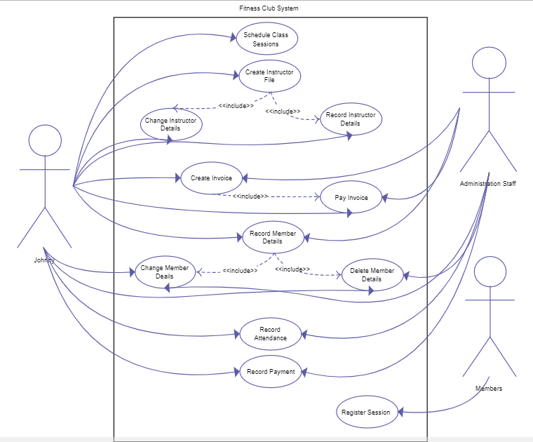

1, Provide the dashboard UI plus UI for registering as club member, looking for and booking trainers and training classes, more features such as club news and activity posters, sign-up/sign-in are prefered.

2, Navigations through each screens and feature UIs are also highly recommended.

登录界面UI设计

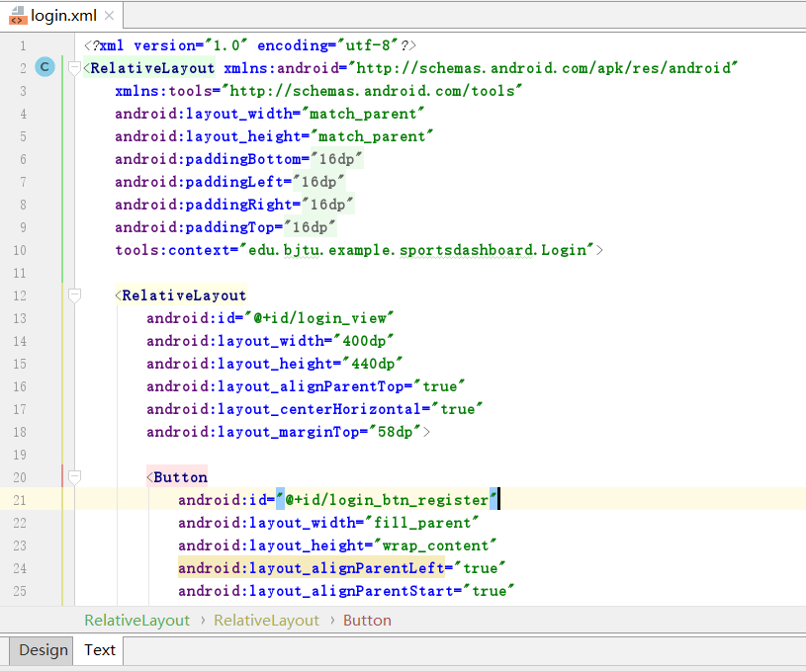

注册界面UI设计

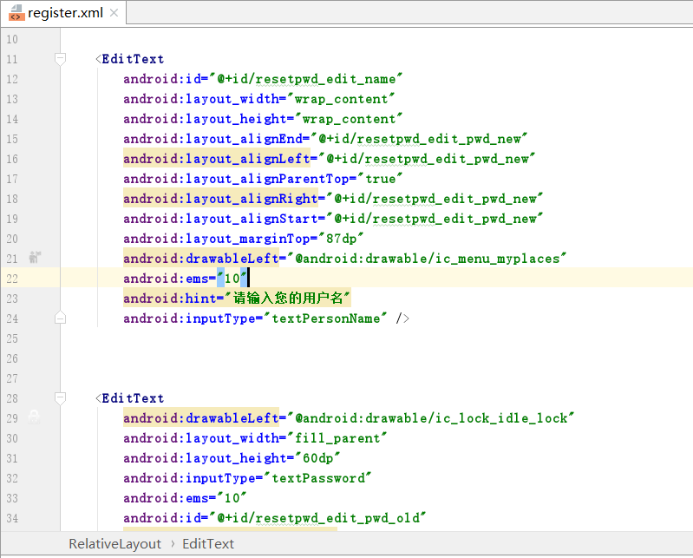

主界面UI设计

