**NAMA KELOMPOK : 1 (SATU)**

**ANGGOTA :**

1. **E1E122064_LM. YUDHY P**
2. **E1E122063_LA ODE ALVIN RAHMAT SAPUTRA**
3. **E1E122082_ABDUL FATH RAMADHAN**
4. **E1E122038_ALFI ZAHRAH MUHARRAMAH**
5. **E1E122040_ALVIANTO RAMADHANA**
6. **E1E122009_DEWI RAHMI**

**KELAS : A**

1. **NAMA : LM. YUDHY P**

**NIM : E1E1 22 064**

* **LINK TEMPLATE:**
* <https://themewagon.com/themes/hightechit/>
* **TEMPLATE**



* **TUGAS**

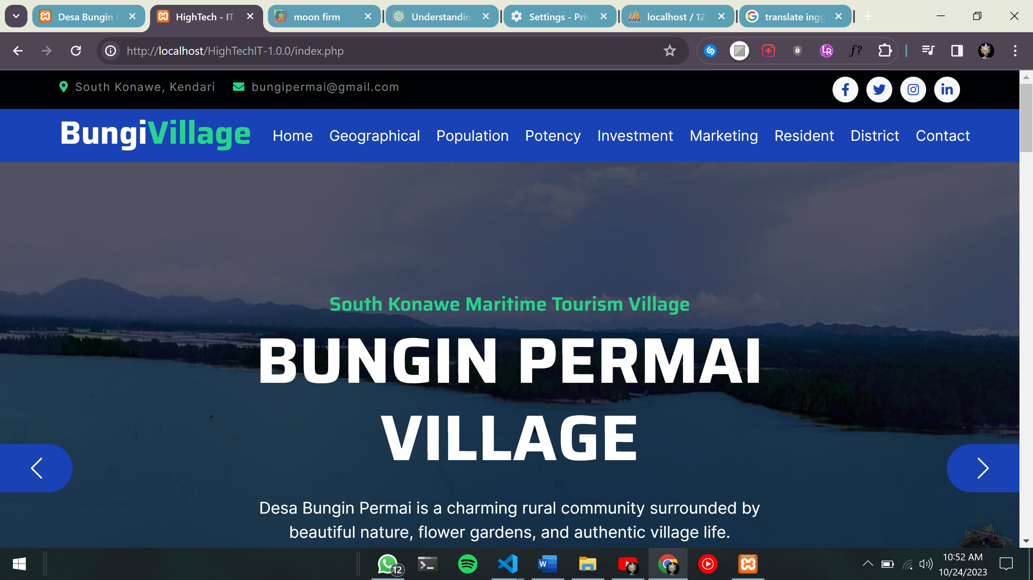

1. **NAMA : LA ODE ALFIN SAPUTRA**

**NIM : E1E1 22 063**

* **LINK TEMPLATE:**
* <https://www.free-css.com/free-css-templates/page295/sbs>
* **TEMPLATE**

* **TUGAS**

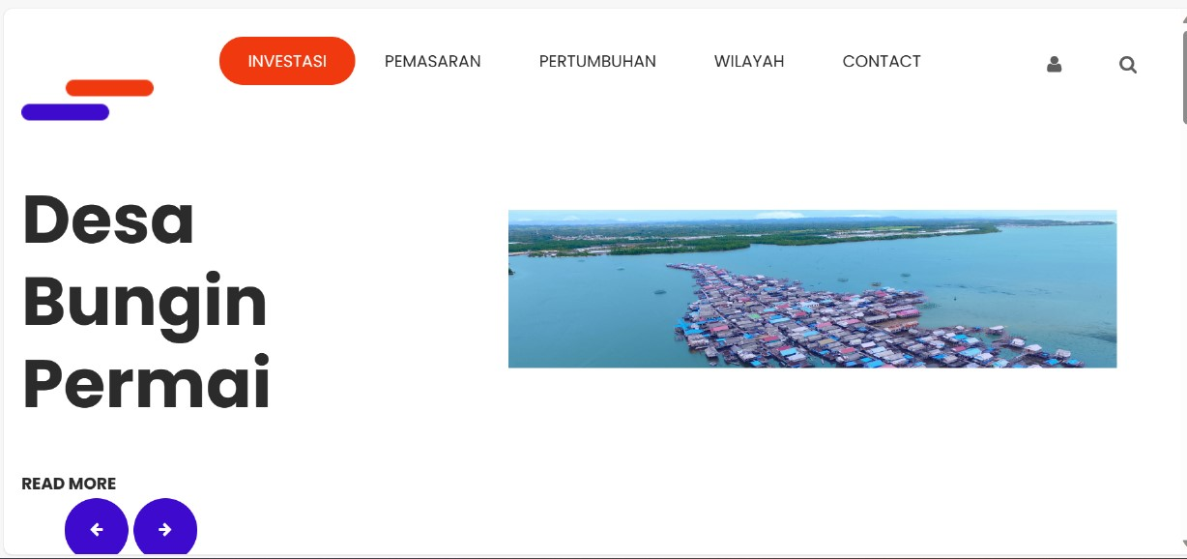

1. **NAMA : ABDUL FATH RAMADHAN**

**NIM : E1E122082**

* **LINK TEMPLATE:**
* **TEMPLATE**
* **TUGAS**

1. **NAMA : ALFI ZAHRAH MUHARRAMAH**

**NIM : E1E122038**

* **LINK TEMPLATE:**
* <https://www.free-css.com/free-css-templates/page290/digimedia>
* **TEMPLATE**



* **TUGAS**

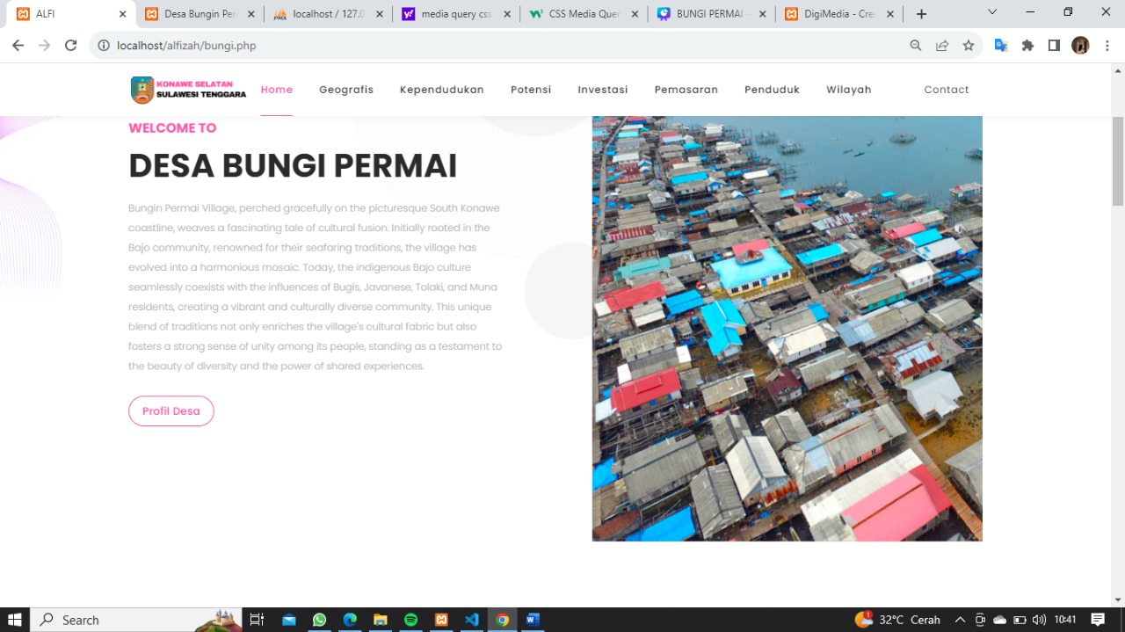

1. **NAMA : ALVIANTO RAMADHANA**

**NIM : E1E122040**

* **LINK TEMPLATE:**
* <https://bootstrapmade.com/gp-free-multipurpose-html-bootstrap-template/>
* **TEMPLATE**

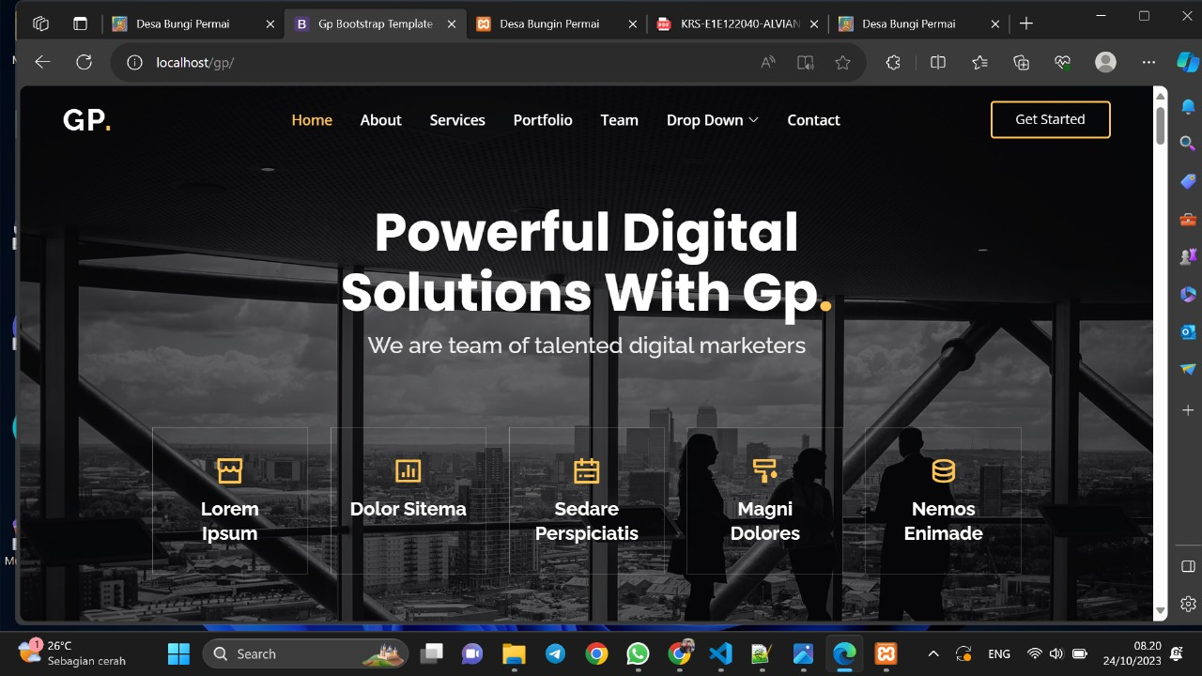

* **TUGAS**

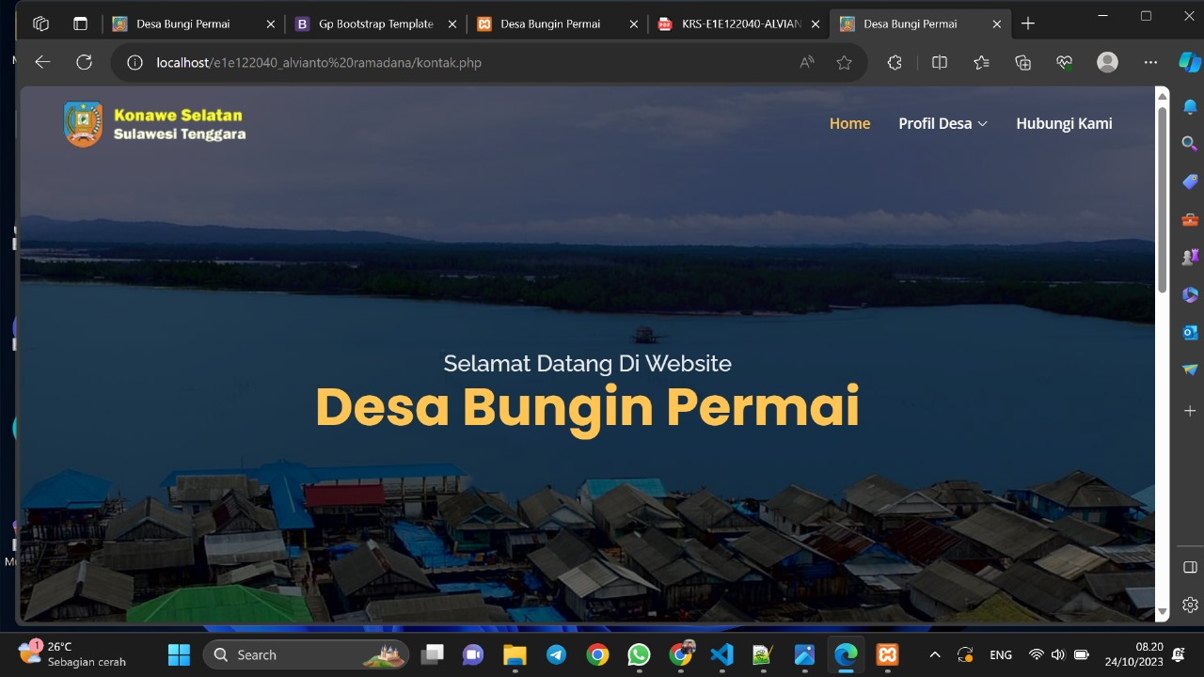

1. **NAMA : DEWI RAHMI**

**NIM : E1E1 22 009**

* **LINK TEMPLATE:**
* <https://bootstrapmade.com/demo/Impact/>
* **TEMPLATE**

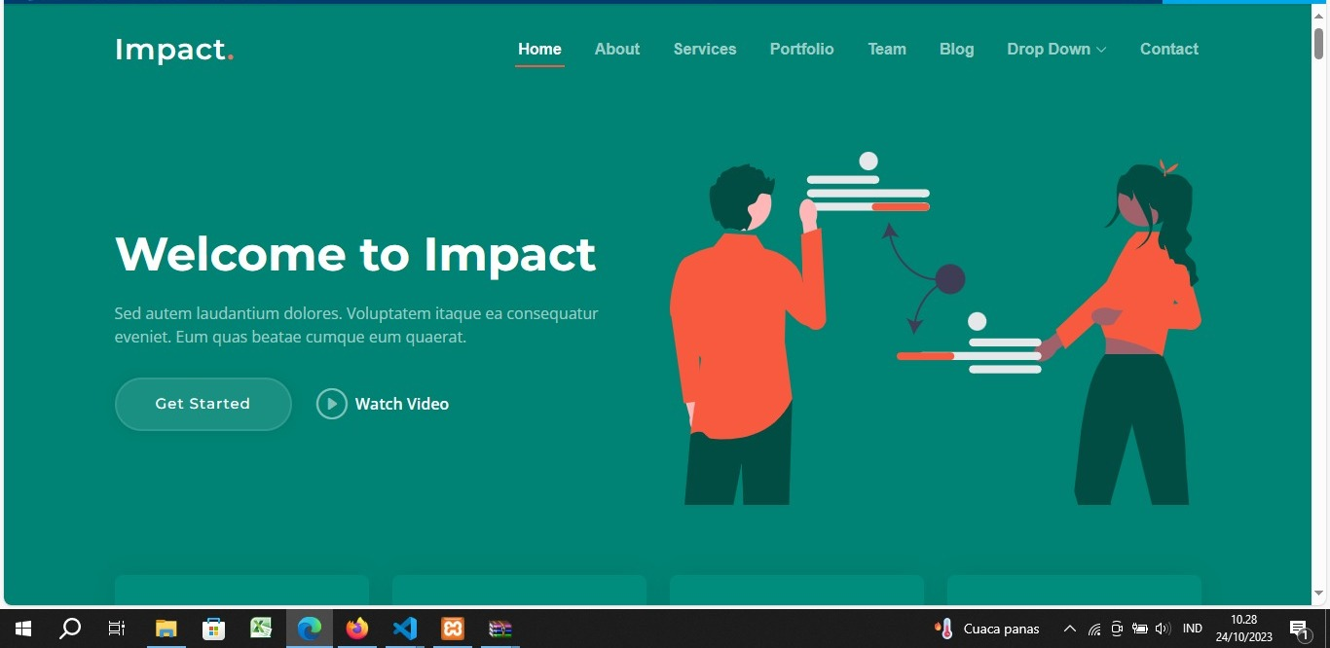

* **TUGAS**

