Reverse engineering the Suda Laser System @ Protospace
Peter Brier

The suda laser system is a very basic CO2 laser cutter/marker. This system can be used as a proof of concept platform for the LaOS driver software and hardware.
Specs:
- CO2 glass tube laser (approx 30W?)
- 3x 45degrees beam bender (two adjusteable) 1 axis flying optics (with air purge)
- 3 axis (open loop stepper). X,Y (H-bridge) with height adjustable substrate table (Z axis).
- 36V microstepping stepper drives (2A max). Set at 32 microsteps.
- DSP controller with USB host/slave and internal flash. 3xPulse/dir output, lase routput, limit inputs, GPIO outputs, display/keyspad interface. 12..24V power supply input (5V output)
- Inductive (omron) home sensors on X and Y axis (12V)
- Microswitch limit switches on Z axis
- LCD display
- 16 key keypad (manual X,Y,Z and laser control, menu navigation)
- Integrated exhaust and purge pump. Integrated water cooler with pump.
- 4 key manual control for laser power, exhaus pump, water pump and purge pump (no signal lights)
- E-Stop button (acts as ON/OFF switch for complete equipment)
- Alarm buzzer (switches on when laser power is enabled, without switching on water cooling) does not interrupt the laser power!
- NO FEEDBACK on any sensor for the correct functioning of the exhaust or cooling system.
- NO SAFETY SWITCH ON COVER: Laser can switch on even if cover is opened. Z-axis can move and cut off fingers when substrate table is raised!
- NO Switch-off for the the motors when cover is open. Allways enabled (hard-wired) drives
- NO CE MARKING. Basically: not allowed to be sold on european market, and not allowed to be used.

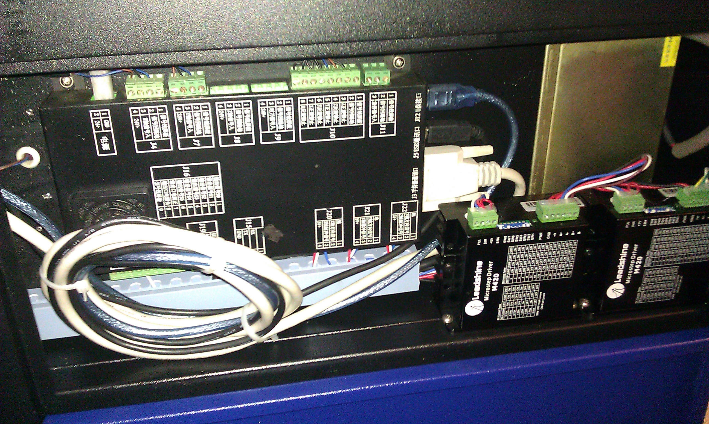
Controller cabinet with 3-axis laser/motion controller (two microstepper drives shown on the right)
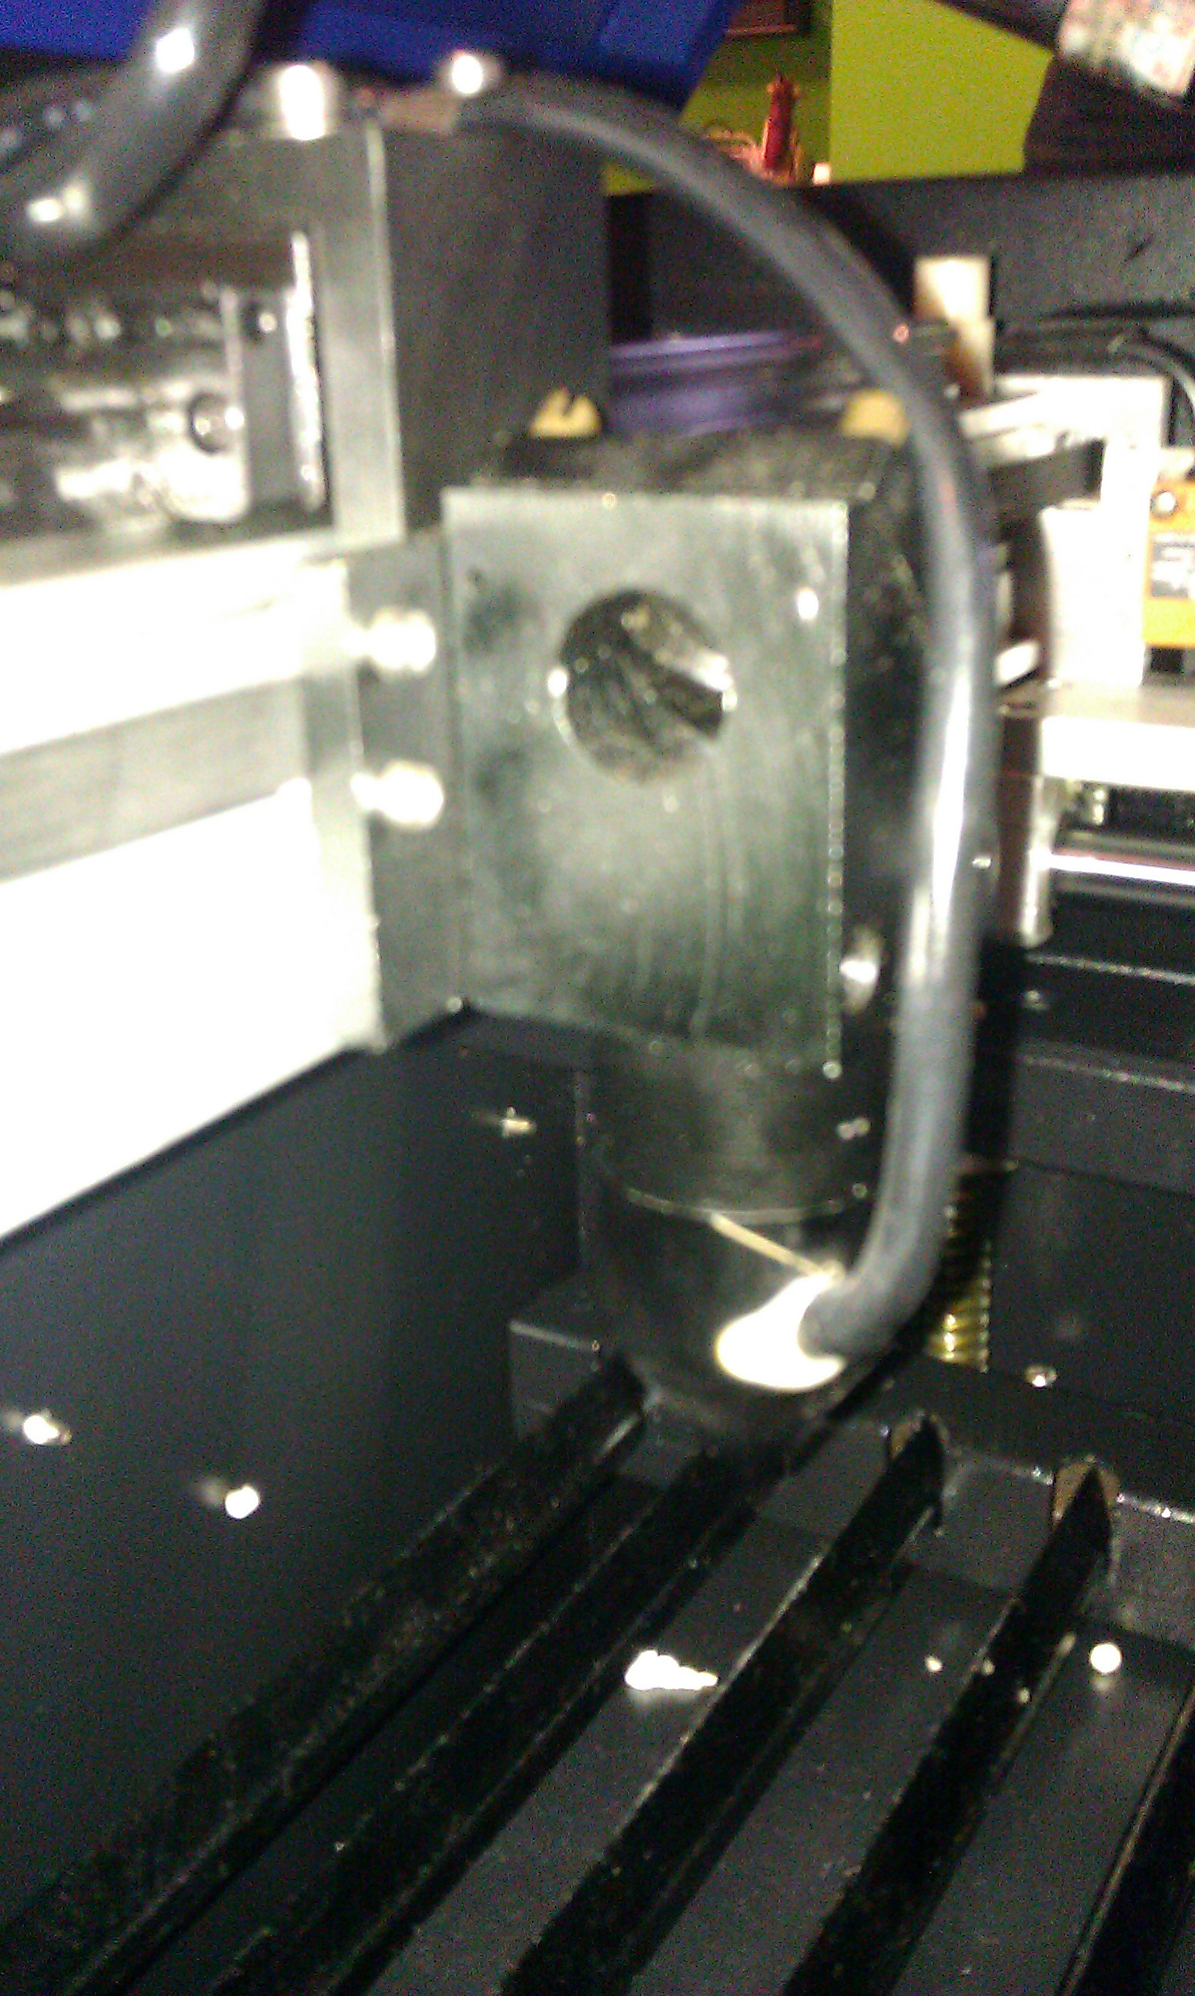
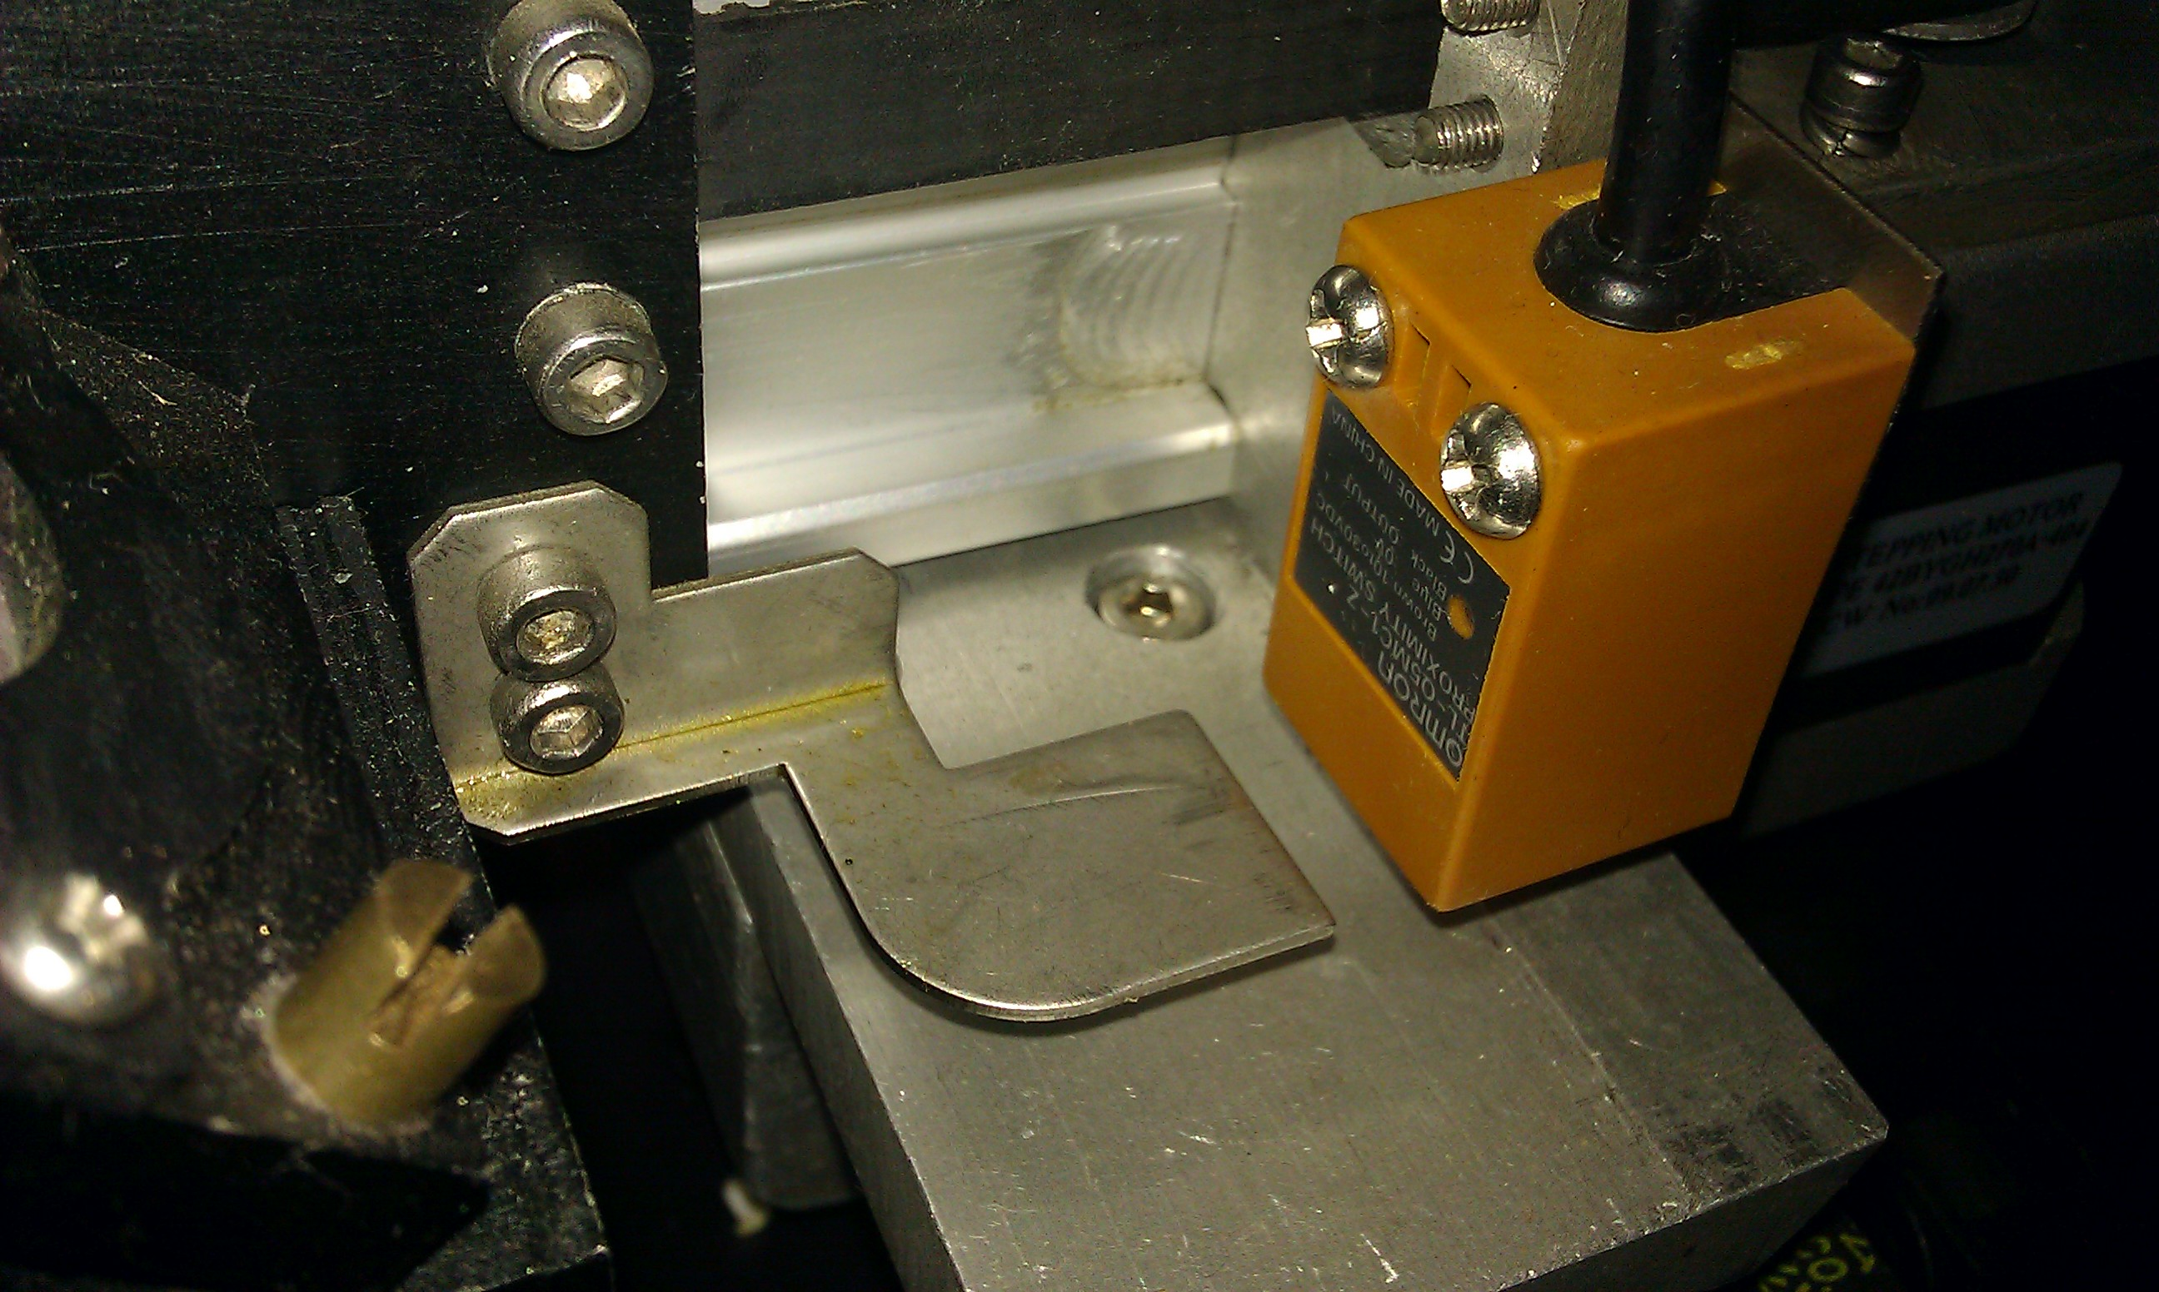
Left: Moving optics (x-axis) and home sensor (right)

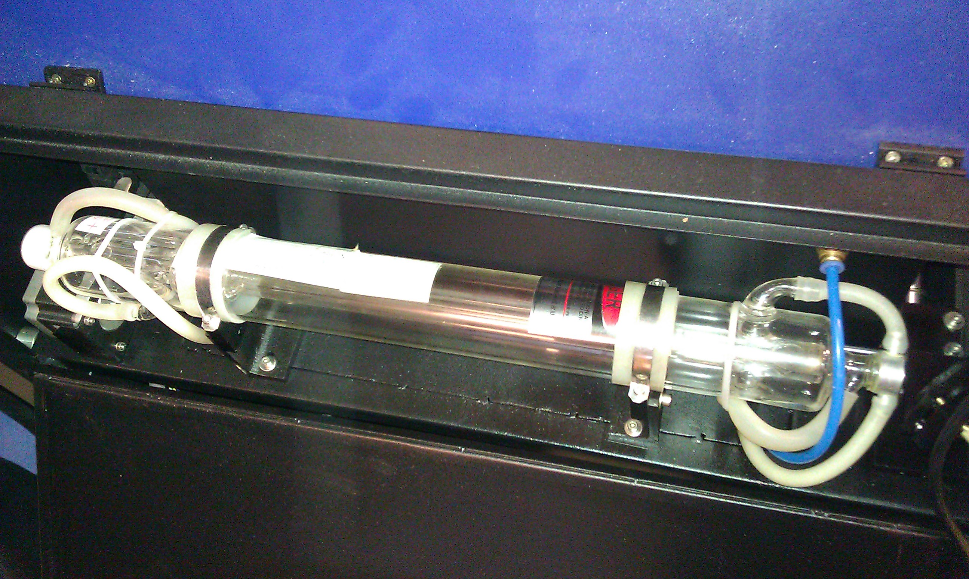
Laser tube

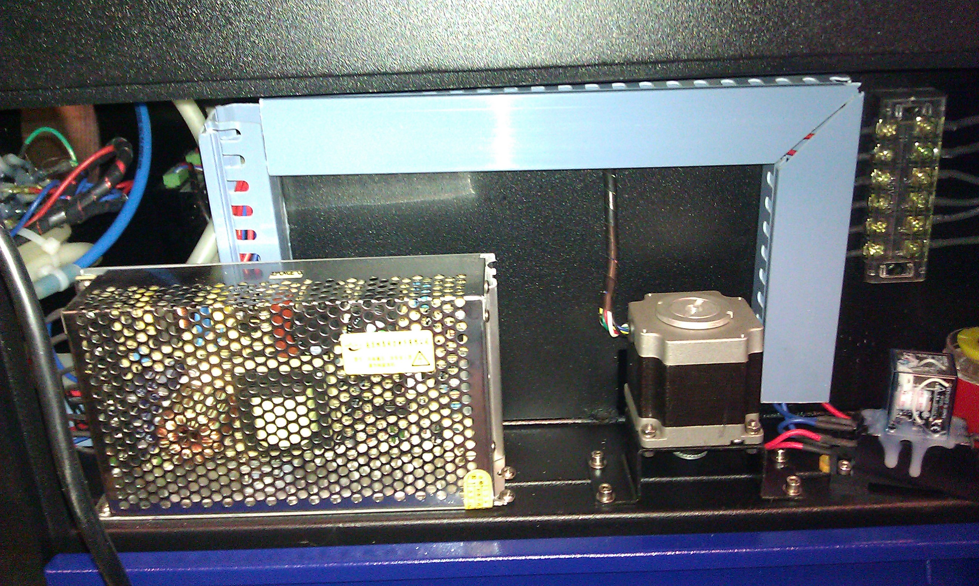
Left: Motor power supply (36V) Z-axis motor (middle). Relay and buzzer (right).

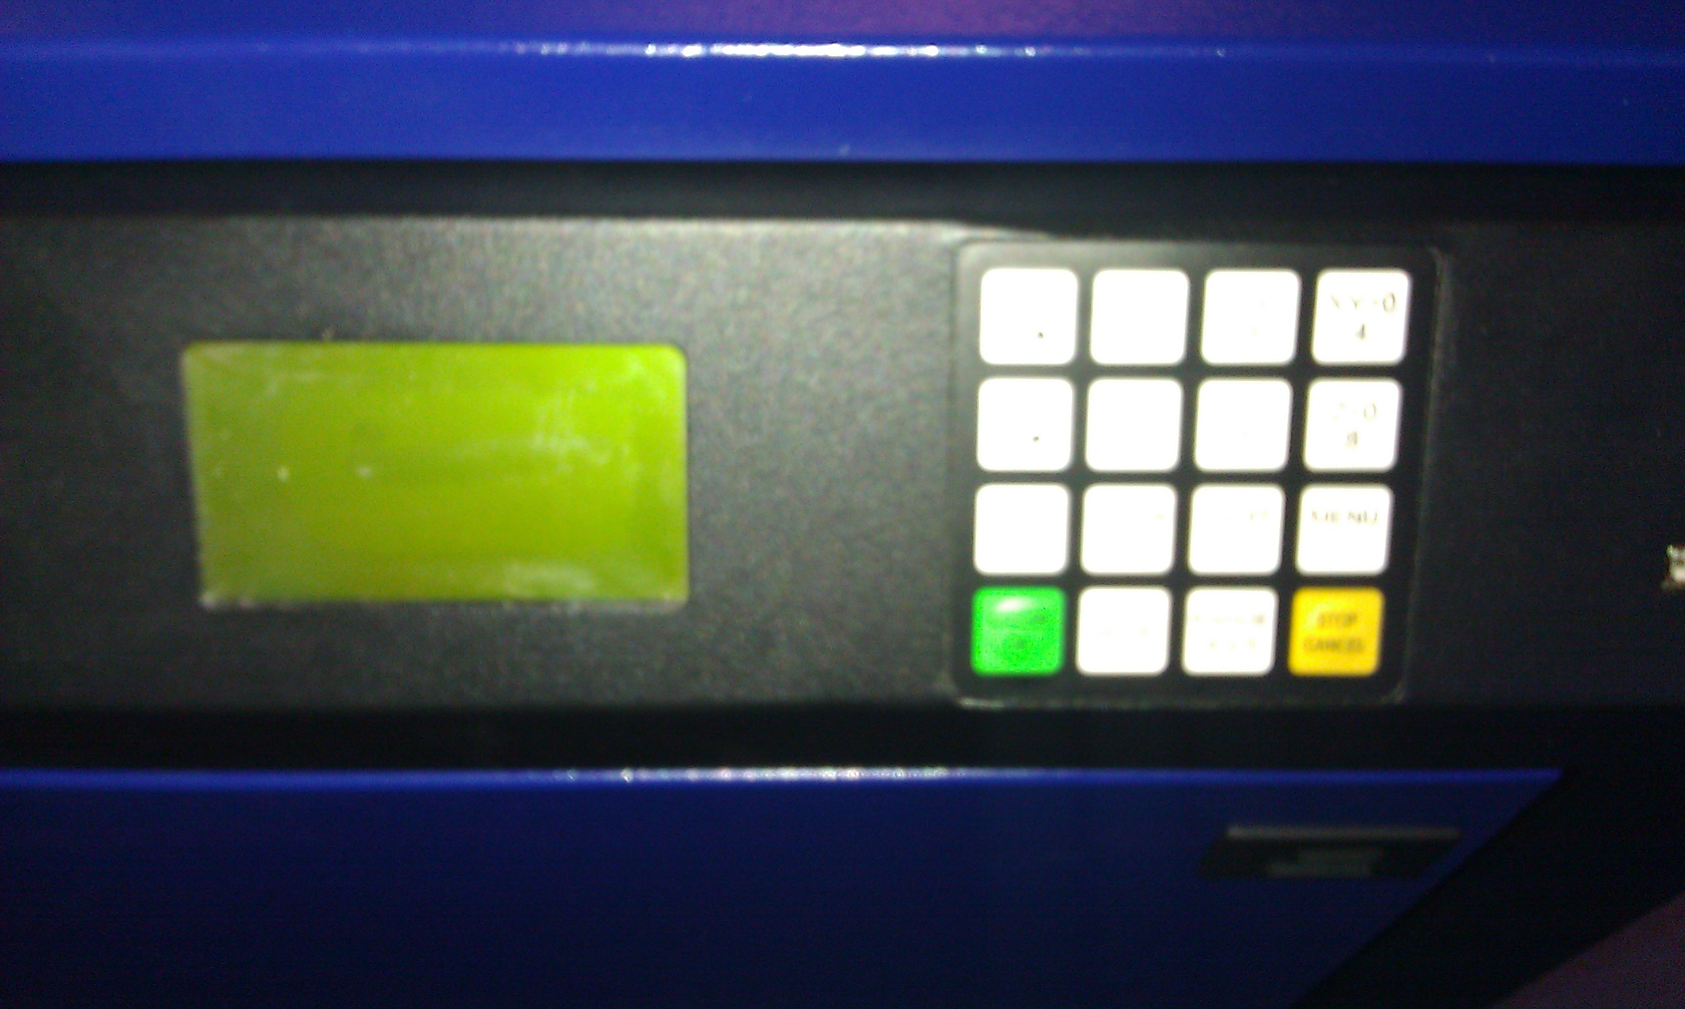
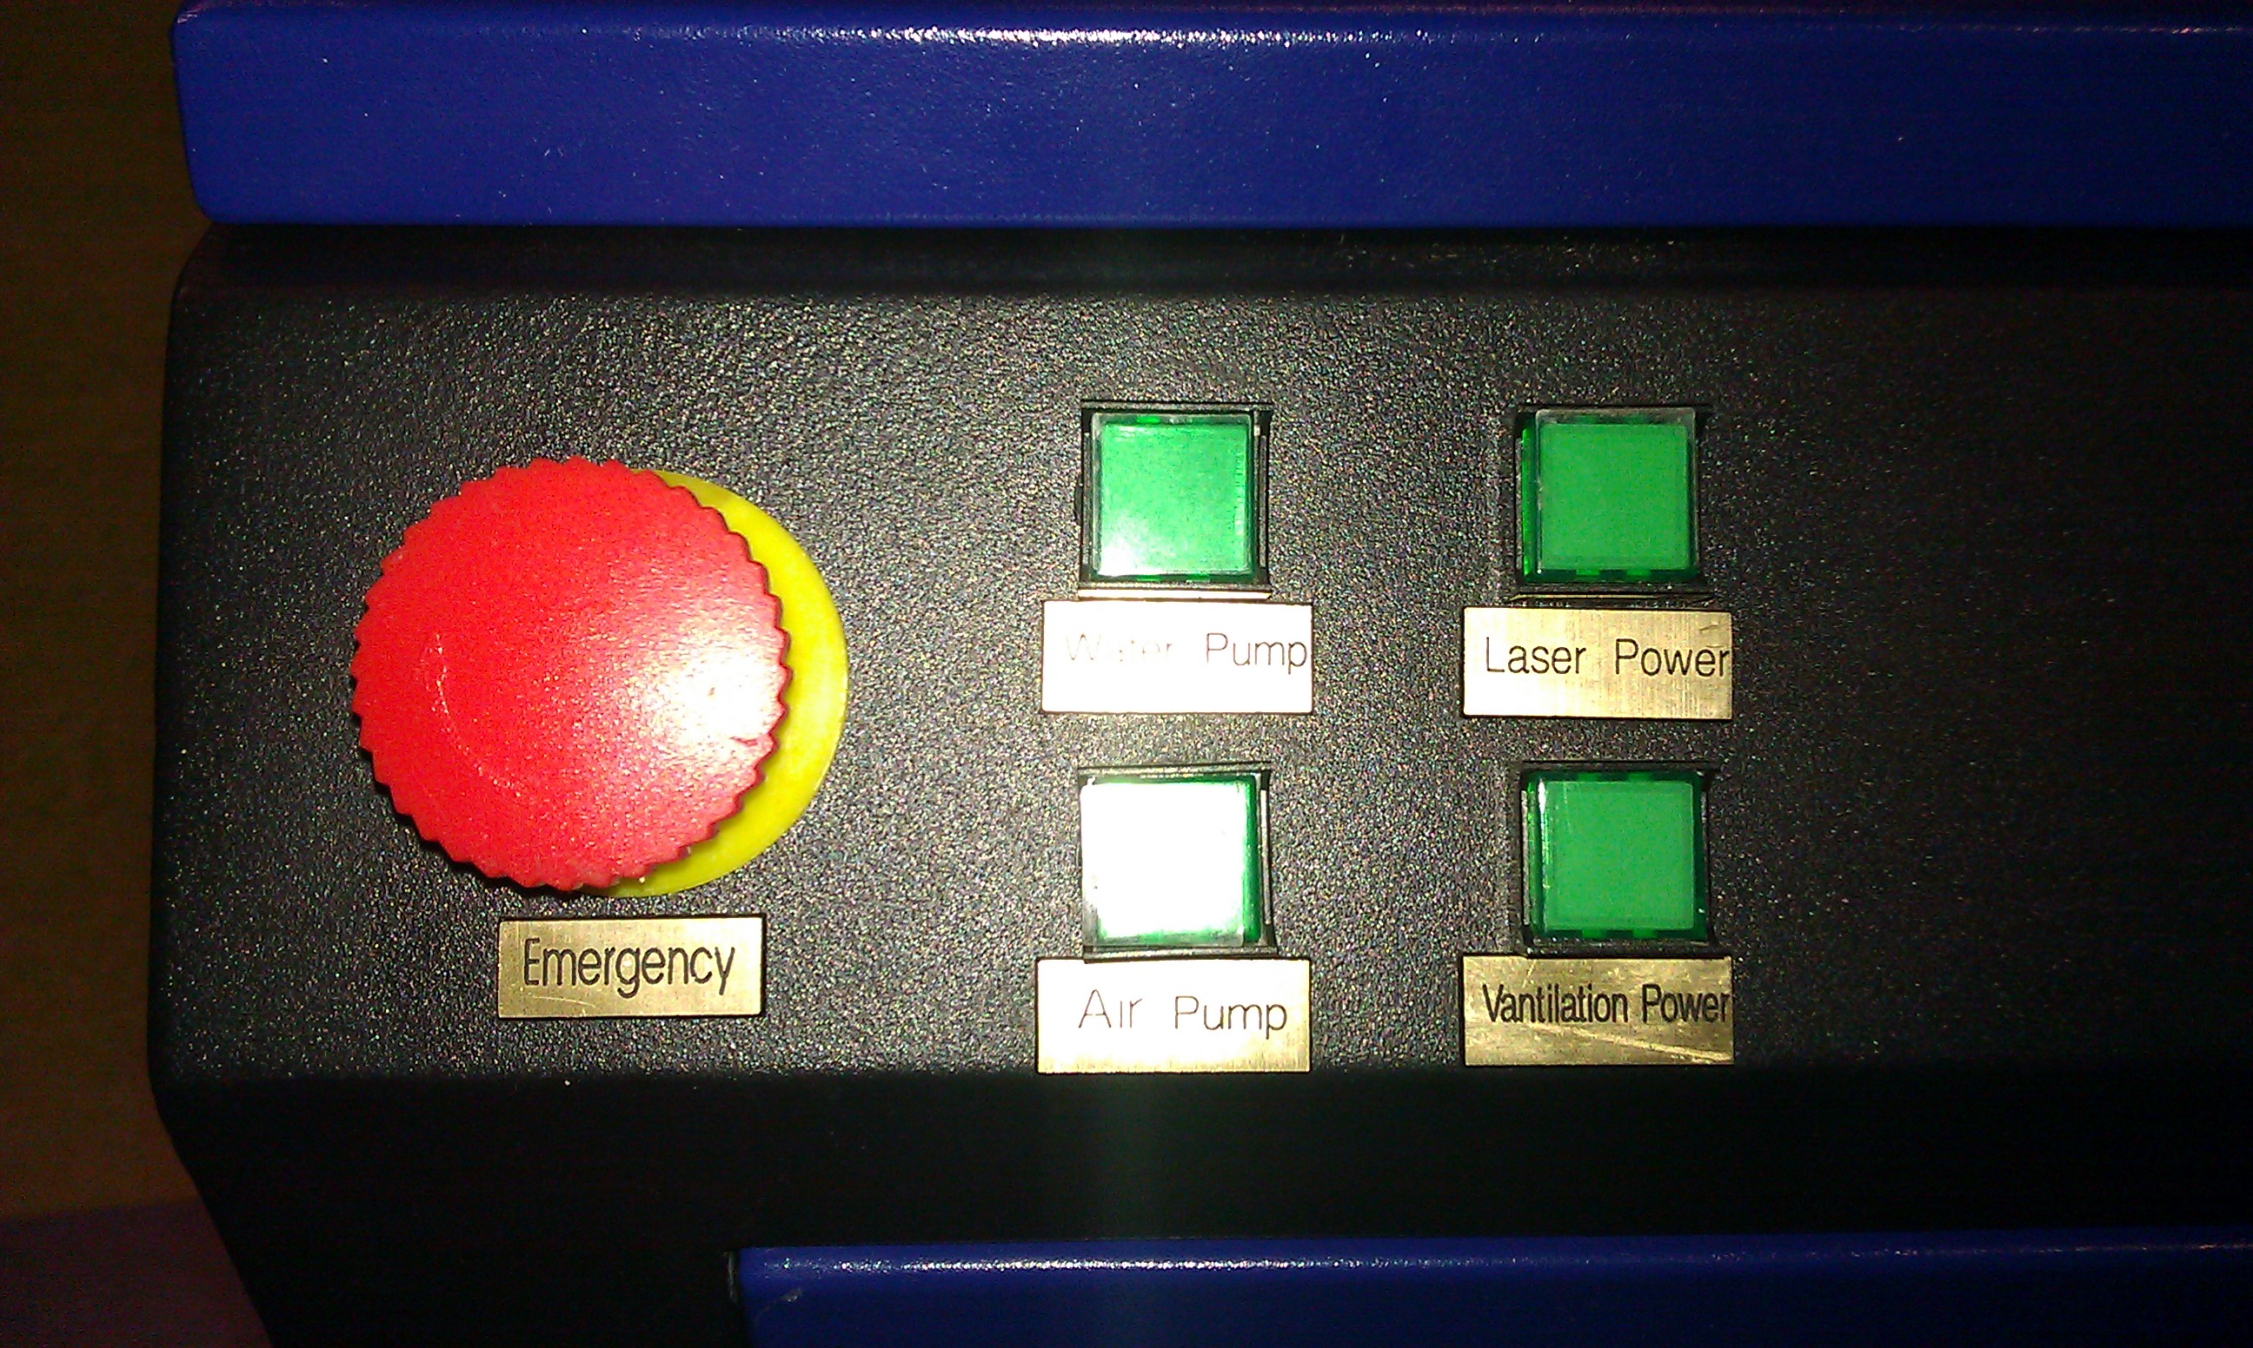
LCD and Control panel

E-Stop and power butons.

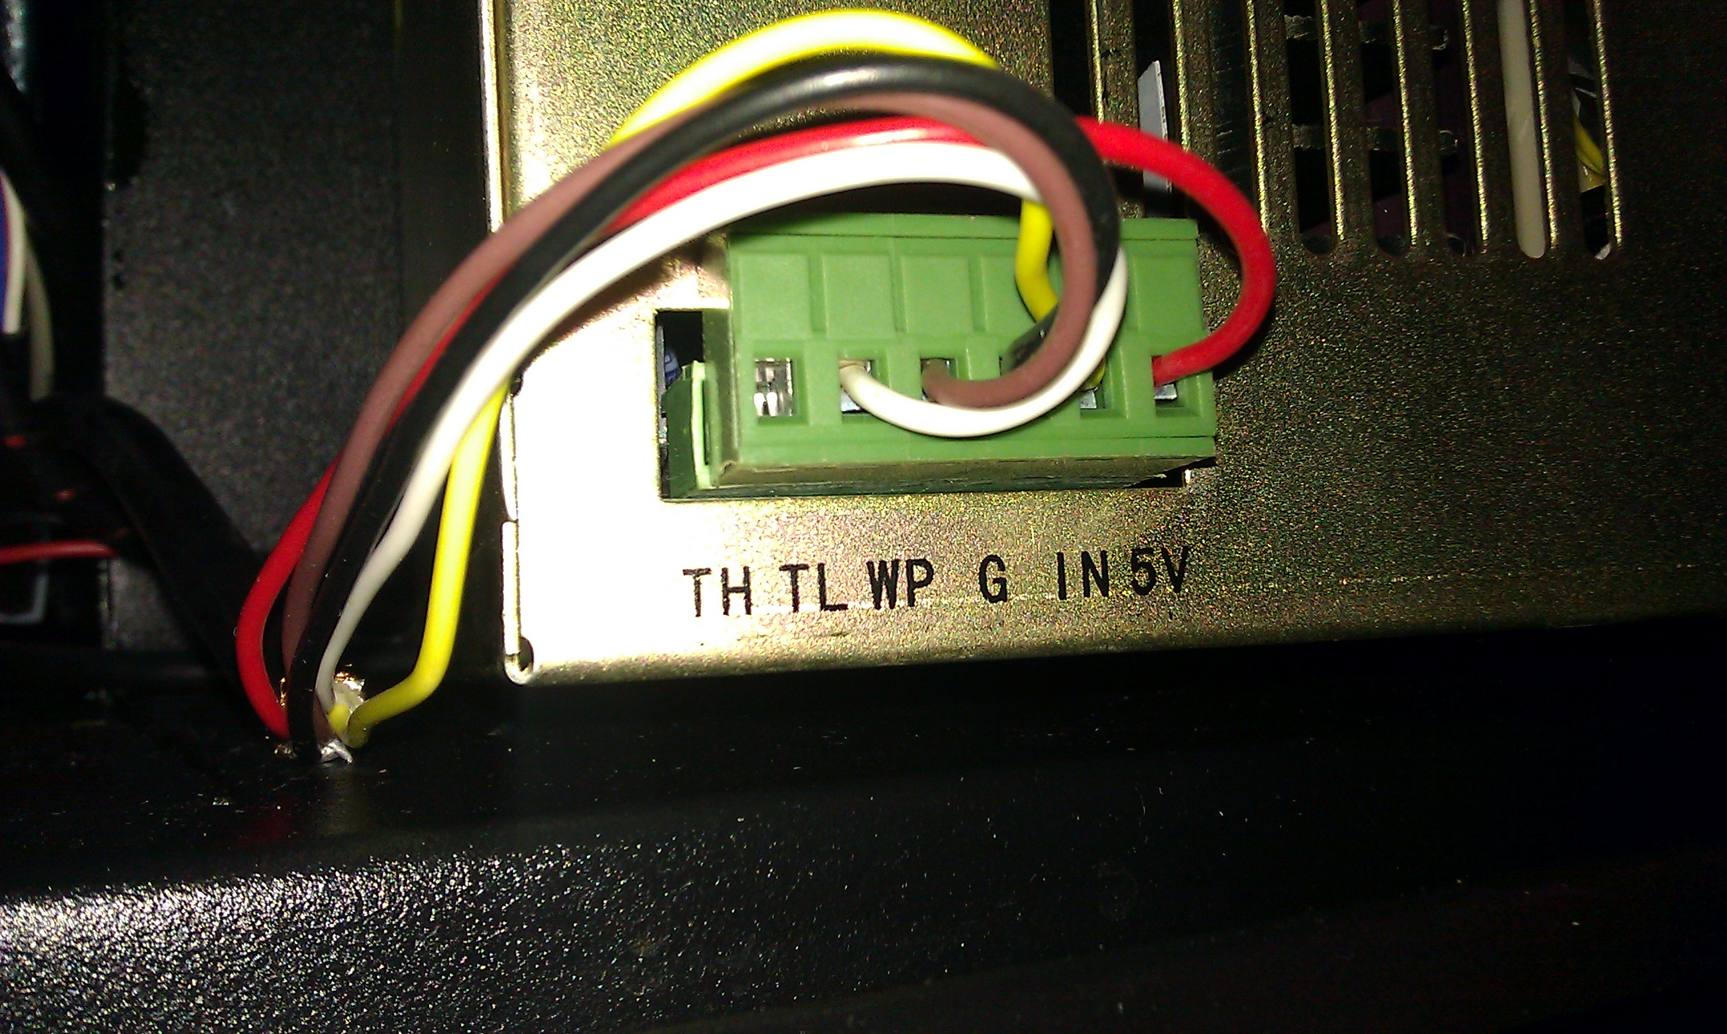
Laser power supply. Note: WP & G tied together on conroller side output ground. TL connected to "Switch" output of controller. IN connected to J14 (laser) connection of controller. Inputs seem to have internal pull-ups and laser is switched on when TL is tied to GND.

The laser seems to be connected in the following way:
- WP (protection/interlock) always ON (tied to ground)
- Negative logic on TL to enable the laser (via switch output of controller)
- IN supplied with PWM modulated power signal
- 5V connected to the controller to supply the isolated outputs (ADUM1300)
- GND connected to the common ground of the LASER and SWITCH output of the controller

See next page for some (unconfirmed) info on the laser power supply signal.
Laser power supply connections (from documentation of "similar" component):

PIN | Signal (on laser) | Notes
TH | enable/on (logic HIGH) | Apply 5V to enable laser
TL | enable/on (logic LOW) | Tie to GND to enable laser
WP | Protection | Tie to GND to enable laser
G | Ground | Signal ground for all other signals.
IN | Laser power input | 0..5V or TTL PWM > 20kHz. < 1 msec response to laser power
+5V | 5V output | < 20 mA
Note: it is mentioned somewhere (but not verified) that the inputs TH,TL,WP have opto-couplers inside the laser power supply.

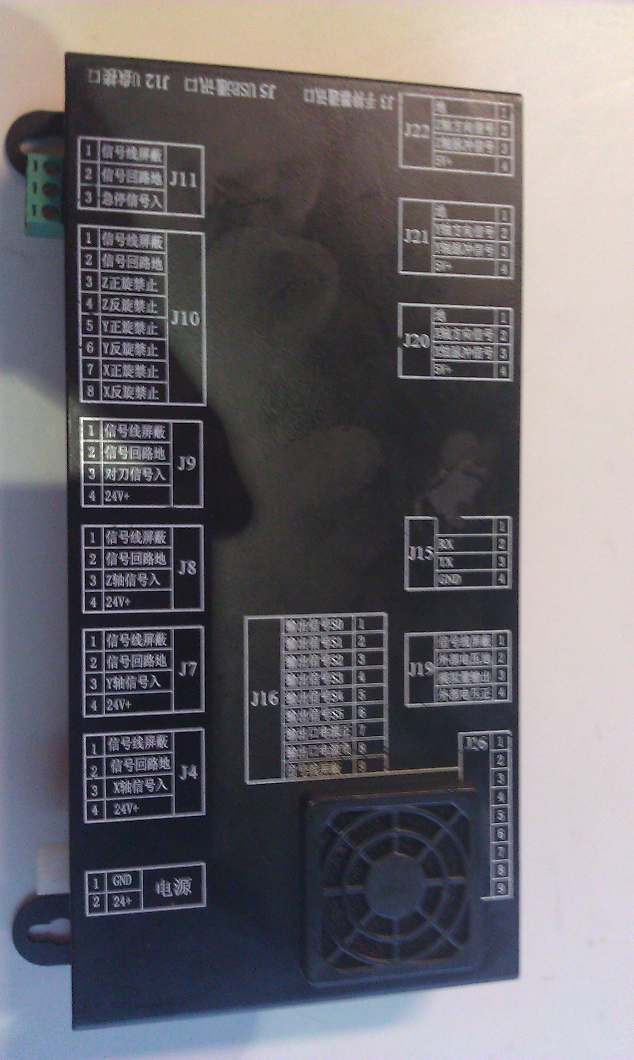
Controller connector layout.

Stepper motor driver (M420) interface (note: from M415B stepper motor driver documentation)
Umotor = 36VDC

Switches
 | X | Y | Z
SW1 | ON | OFF | ON | X = 1.25 Amp  Y = 1.50 Amp  Z = 2.0 Amp (max)
SW2 | ON | ON | OFF | X = 1.25 Amp  Y = 1.50 Amp  Z = 2.0 Amp (max)
SW3 | OFF | OFF | OFF | X = 1.25 Amp  Y = 1.50 Amp  Z = 2.0 Amp (max)
SW4 | OFF | OFF | OFF | Full current
SW5 | OFF | OFF | OFF | 32 microsteps/step == 6400 steps/rev
SW6 | ON | ON | ON | 32 microsteps/step == 6400 steps/rev
SW7 | OFF | OFF | OFF | 32 microsteps/step == 6400 steps/rev
SW8 | ON | ON | ON | 32 microsteps/step == 6400 steps/rev

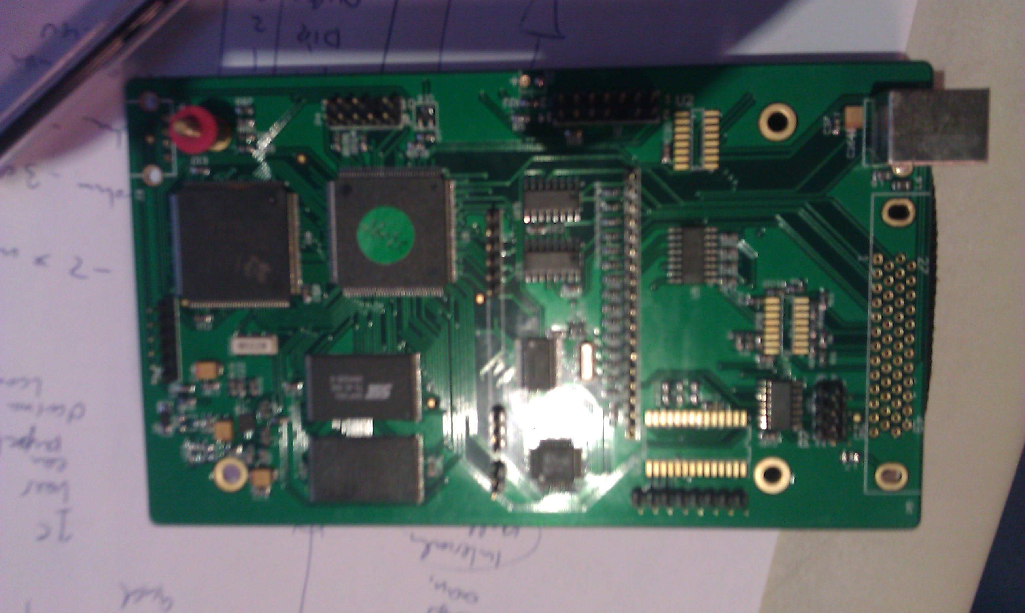
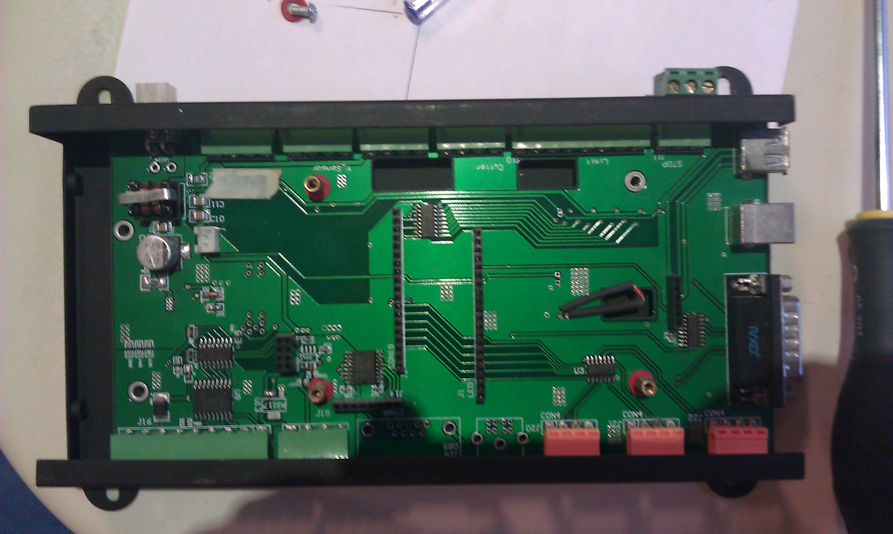
Controller board

Base board

Electronic components:

Controller board
TI TMS 160 (320VC5416PGE) | DSP
Altera MAX II (EPM 1270T) | CLPD
Samsung 710 K9F160840B | 128M x 8 bit NAND flash memory
SST39VF16F | 16 Mbit / 32 Mbit / 64 Mbit (x16) Multi-Purpose Flash Plus
Cypress SL811 HST | Cypress’ SL811HS is the world's first Dual Role Device (DRD) and can act as an embedded USB host or slave controller. It can communicate in both full speed and low speed USB modes. SL811HS incorporates USB Serial Interface Engine (SIE) functionality along with internal transceivers to function at Full or Low-Speed USB, and is configurable to USB host and peripheral modes. The flexible 8-bit interface allows connectivity to a variety of microcontrollers, microprocessors, and DSPs.
DS26LV31 | 3V ENHANCED CMOS QUAD DIFFERENTIAL LINE DRIVER
NEC PS2801 | SSOP16 SMT Quad Channel 70 V 2500 Vrms Transistor Output Photocoupler
PDI 488D12 | ??
6Ad5 kkk lvc07 | ??

Base board
UNC2803L (J16 == Switch out, to laser TL signal) | OCTAL HIGH-VOLTAGE, HIGH-CURRENT  DARLINGTON ARRAYS (95V / 500mA)
NEC PS2801 | SSOP16 SMT Quad Channel 70 V 2500 Vrms Transistor Output Photocoupler
ADUM1300 (J19 == laser) | Triple-Channel Digital Isolator
TI 7407 | HEX BUFFER  with OPEN-COLLECTOR HIGH-VOLTAGE outputs (30V / 30mA)
TI 64C6RW MC3487 | Quadruple Differential Line Driver
LM2596 (power supply) | SIMPLE SWITCHER® Power Converter 150 kHz  3A Step-Down Voltage Regulator
65C757 MC3486 (to keypad/display) | Quadruple Differential Line Receiver With 3-State Outputs (RS422)

Interfaces:

J20 Y-axis
J21 X-axis
J22 Z-axis
PIN | Signal
1 | GND
2 | DIR
3 | PULSE
4 | +5V OUT

J14 Laser
PIN | Signal (on laser
1 | NC
2 | G + WP
3 | IN
4 | +5V OUT

Stepper drive M420 (opto coupler)
PIN | Signal (on laser
1 | ENA (LOW=disable)
2 | +5V (Common anode)
3 | DIR
4 | PULSE (LOW=pulse)

